TEST SCHEDULE
FOR
PRE-INSTALLATION CHECKS OF INTEGRATED STANDBY INSTRUMENT SYSTEM (ISIS) ON IAT-RIG
FOR
HTT-40 Aircraft

HAL Part. No: 11F-07-AVI1-001-A
SHDS Part. No: AT16000000000

TITLE: Software Requirement Specifications of Integrated Avionics Tester
SUMMARY: This document covers the Software Requirement Specifications of Integrated Avionics Tester.
Co-ordination | Group | Name/Designation | Signature
Prepared by | SHDS  (Development Agency) | Prafull Srivastava,  Software Engineer
Checked by | SHDS  (Development Agency) | Garima Saxena,  QA
Proposed by | SHDS  (Development Agency) | Chaman Lal,  Head ATE
Coordinated by | HAL-ARDC | Sharath KV  SM (EAV)
Coordinated by | HAL-AMD | Jitendra Kumar Sharma  SM (Projects)

Revision Record
S. No. | Rev  No. | Reference | Date | Change Section | Description of change
1. | 00 | - | 25.08.26 |  | Initial Release
TABLE OF CONTENTS
1. Chapter 1 – Introduction 5
1.2. SEQUENCE OF TESTS 6
2. Chapter 2 - Physical & Functional test 7
2.1. TEST SPECIFICATIONS 7
2.2. VISUAL INSPECTION 11
2.3. FUNCTIONAL CHECKS 13
3. Chapter 3 – Test report 21
ANNEXURE- I - IAT UNIVERSAL TESTER 24
ANNEXURE- II – ACCEPTANCE TEST REPORT 25

List of Abbreviations

A/C | Air Craft
AMLCD | Active Matrix Liquid Crystal Display
ATE | Automated Test Equipment
ATI | Air Transport Indicator
ATP | Acceptance Test Procedure
ATR | Acceptance Test Report
BITE | Built-In Test Evaluation
BLGM | Backlight Generation Module
BSIM | Bezel Signal Interface Module
CBIT | Continuous Built In Test
DU | Display Unit
DUT | Display Unit under Test
ESS | Environmental Stress Screening
FT | Functional Test
FTR | Functional Test Report
GPU | Graphics Processor Unit
GUI | Graphics User Interface
I/O | Input / Output
IBIT | Initiated Built In Test
LED | Light Emitting Diode
NVG | Night Vision Goggles
NVIS | Night Vision Imaging System
PC | Performance Check
POST | Power On Self-Test
PQT | Product Qualification Test
PSGM | Power Supply Generation Module
TDU | Treat Detection Unit
ISIS | INTEGRATED STANDBY INSTRUMENT SYSTEM

Chapter 1 – Introduction

General

SCOPE & OBJECTIVE
This Acceptance Test Procedure (ATP) document defines the for serial production defines the requirements for tests to be performed with measuring equipment (Hardware & or S/W) as final acceptance tests before delivery to customer. This document defines what the test engineer shall observe as a result of final test according to the test means available. This Document will cover all the performance requirements defined in the “Technical Specification of 3ATI DU (Threat Detection Unit).

INTRODUCTION AND OVERVIEW
ATP document describes the parameters such as Visual, Mechanical, Electrical, Optical and ESS profile to be checked /conducted on 3ATI DU – TDU, to verify the compliance of the output of the equipment under test with the Technical Specification. ATP document also defines the sequence of tests to be carried out.

Applicable Documents
S No. | Document Name | Part Number | DOCUMENT NO.
 | System requirement document of integrated avionics tester (IAT Rig) | 11F-07-AVI1-001-A | AMD/RD/HTT40/PROJ/IAT/001  Issue 00 Date 10 March 2025
 | Technical Specifications for IAT | NA | D/SHDS/ATE/12/HT/0/24/TSS/001  Rev: 00, Dated: 21.02.2025.
 | Test Schedule For Pre-Installation Checks of Integrated Standby Instrument System (ISIS) ON IAT-RIG | HAL Part No:  11F-07-AVI1-001-A  SHDS Part No: AT16000000000 | HAL/ARDC/HTT-40/AVI/214  Issue : A, Date : 11/05/2023

TEST SETUP
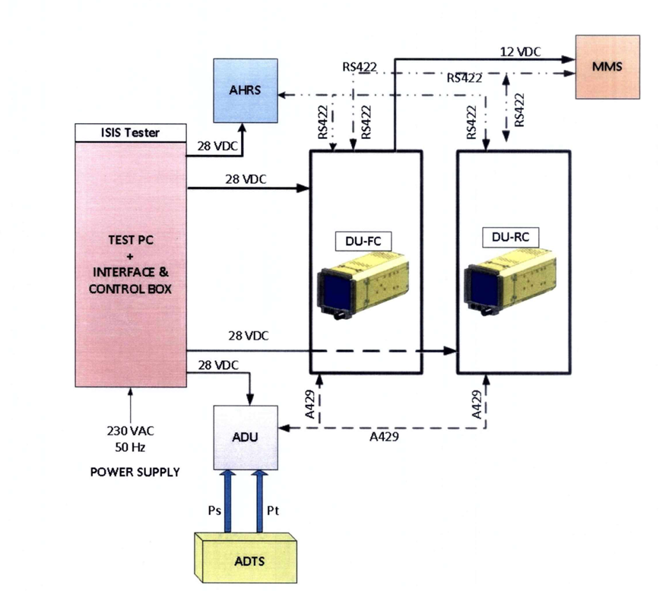

SEQUENCE OF TESTS
After assembly of the unit the following test sequence is to be followed:
Sr. No. | Test | Remarks
1 | Visual Inspection | Refer to chapter 2
2 | Power Consumption Checks | Refer to chapter 2
3 | Software Verification Checks | Refer to chapter 2
4 | IBIT Checks | Refer to chapter 2
5 | Brightness Control Checks | Refer to chapter 2
6 | Alignment Mode Checks | Refer to chapter 2
7 | Navigation Mode Selection Check | Refer to chapter 2
8 | Attitude and Heading Checks | Refer to chapter 2
9 | Air Data Parameter Checks | Refer to chapter 2

Chapter 2 - Physical & Functional test

TEST SPECIFICATIONS
TEST NO. | TEST NAME | SPECIFICATION | UNITS
VISUAL INSPECTION
 | Display Unit FC PN | IS2100000000 | NA
 | Display Unit RC PN | IS2100000000
 | Air Data Unit PN | AN-014-ADU-V00 | NA
 | Magnetometer PN | AN-015-MMS-V00 | NA
 | AHRS PN | 1901400000000 | NA
 | Any Damages | - | NA
 | Visible Scratches | - | NA
 | Loose Screws | - | NA
 | Bend Pins | - | NA

FUNCTIONAL CHECKS
POWER CONSUMPTION
2.01 | Current Rating ISIS-DU FC | <1.08 | A
2.02 | Current Rating ISIS-DU RC | <1.08 | A
2.03 | Current Rating ISIS ADU | <0.3 | A
2.04 | Current Rating ISIS AHRS | <1 | A
SOFTWARE VERIFICATION CHECKS
3.01 | ISIS-DU FC MPM Version | 01.00 | NA
3.02 | ISIS-DU FC MPM Checksum | 0xCA347B86 | NA
3.03 | ISIS-DU FC BLGM Version | 01.00 | NA
3.04 | ISIS-DU FC BLGM Checksum | 0x43760D0A | NA
3.05 | ISIS-DU RC MPM Version | 01.00 | NA
3.06 | ISIS-DU RC MPM Checksum | 0xCA347B86 | NA
3.07 | ISIS-DU RC BLGM Version | 01.00 | NA
3.08 | ISIS-DU RC BLGM Checksum | 0x43760D0A | NA
IBIT Checks
5.01 | ISIS-DU FC | Operational | NA
5.01 | ISIS-DU RC | Operational
Brightness and Set knob Checks
6.01 | ISIS-DU FC | Operational | NA
6.02 | ISIS-DU RC | Operational | NA
ALIGNMENT MODE CHECKS
7.01 | ISIS-DU FC | Operational | NA
7.02 | ISIS-DU RC | Operational | NA
NAVIGATION MODE CHECKS
8.01 | ISIS-DU FC | Operational | NA
8.02 | ISIS-DU RC | Operational | NA
ALTITUDE & HEADING CHECKS - AHRS
9.01 | Roll FC | Operational | NA
9.02 | Pitch FC | Operational | NA
9.03 | Heading FC | Operational | NA
9.04 | Roll RC | Operational | NA
9.05 | Pitch RC | Operational | NA
9.06 | Heading RC | Operational | NA
AIR DATA PARAMETER CHECKS
10.01 | Air Speed Check | 192 ± 5 | Knots
10.02 | Altitude Check | 9980 ± 30 | Ft
10.03 | Mach Number Check | 0.37 ± 0.012 | M
10.04 | Vertical Speed Marker Check | Operational | NA

PROCEDURE FOR RUNNING TEST SEQUENCE
- Go to desktop and double click on “IAT.exe”. Verify that the Login screen is displayed.
- Log in as User or Administrator using valid credentials.
- From the Main Screen, select “IAT LRUs TEST”, “Tester Self-Test”, or “Simulation Mode” as applicable and press “Continue”.
- On the Test Execution Mode screen, select Execution Mode as “Standalone” and LRU Type as “ISIS”. Enter the Test Description and the serial numbers for ISIS-DU FC, ISIS-DU RC, ADU, AHRS and MMS units in the respective fields.
- Click “START” to begin the test sequence. The applicable test dialog shall be displayed automatically .

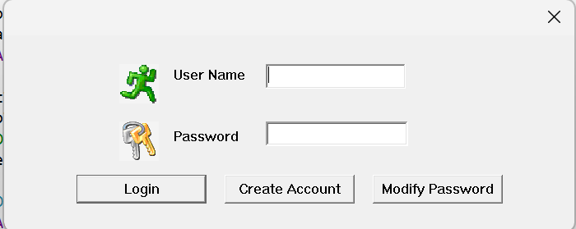

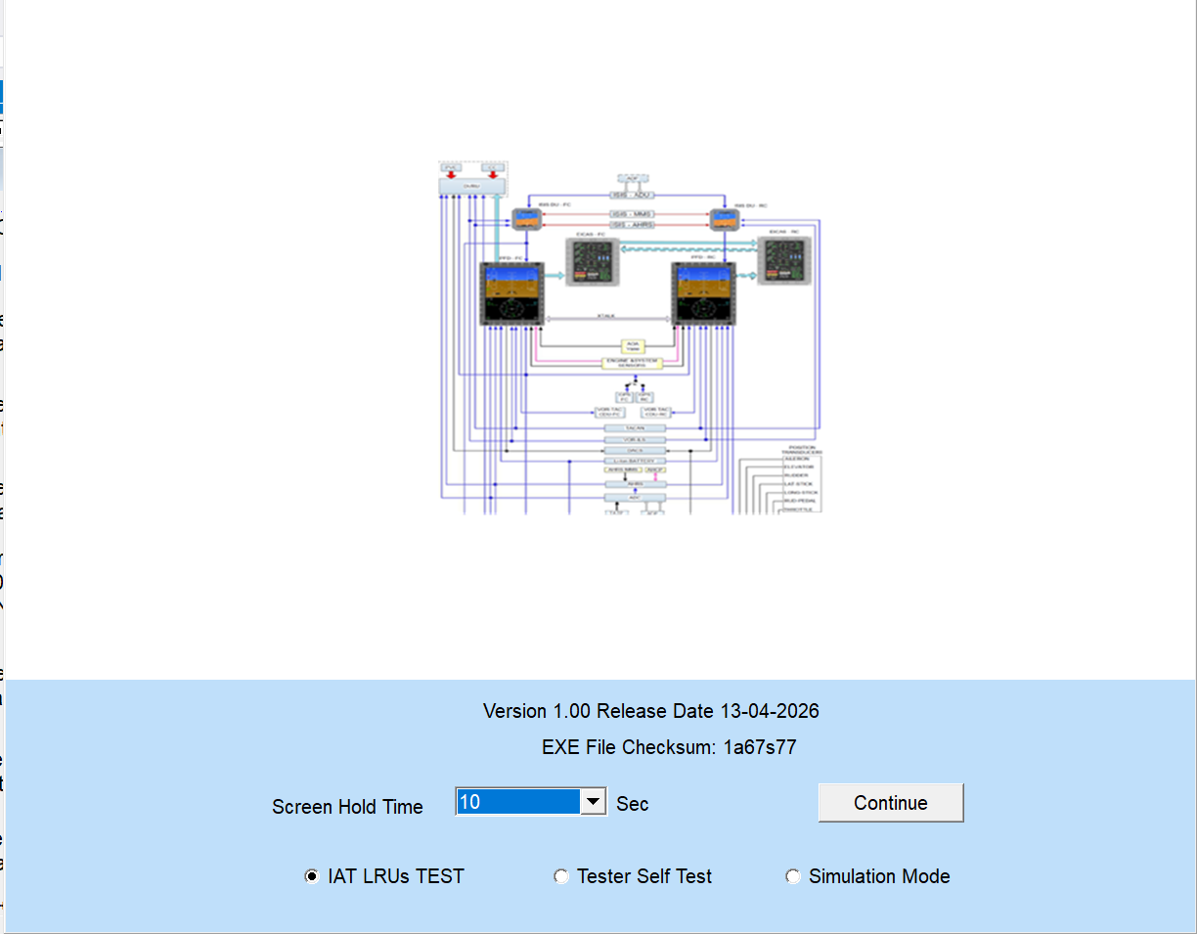
Figure: 3 Main Screen
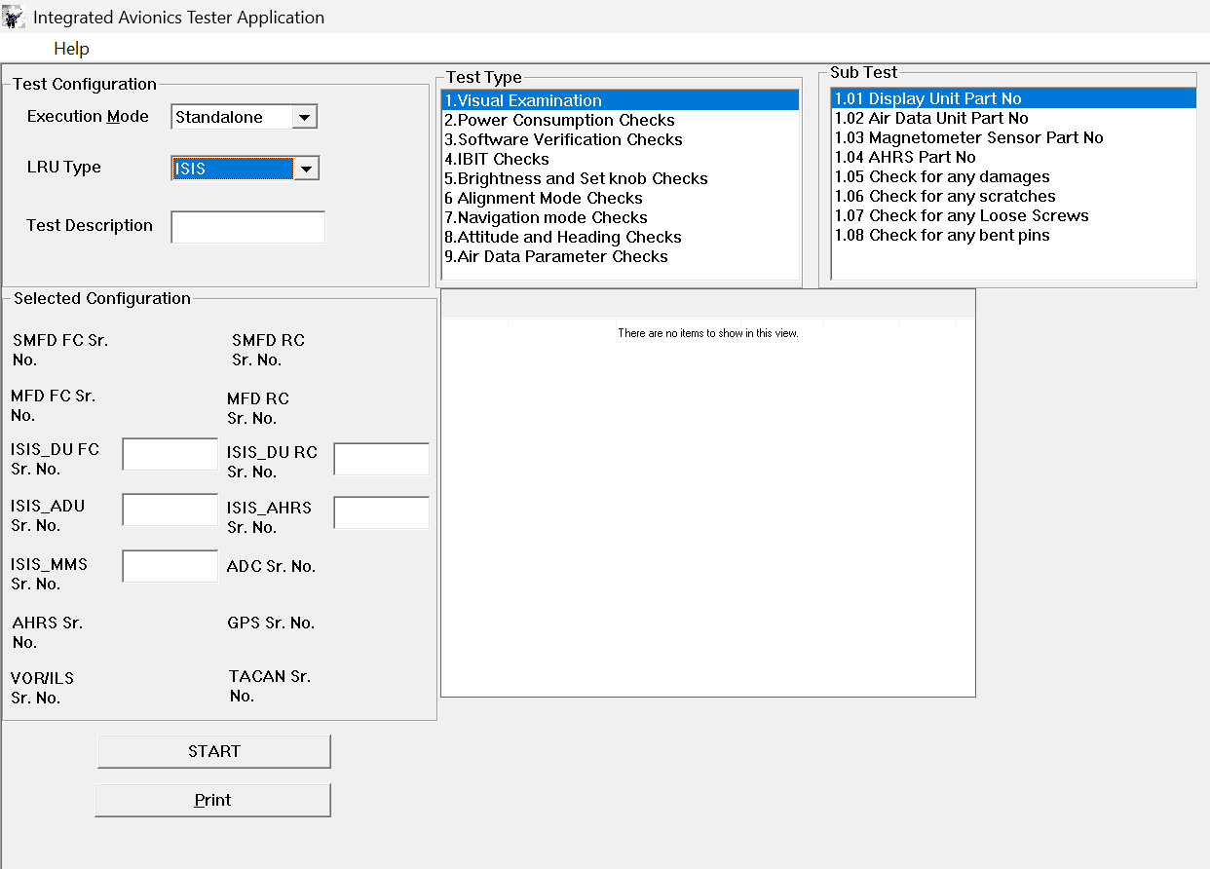
Figure: 4 Test Execution Mode Screen

VISUAL INSPECTION

Test No. | Parameter | Specifications | Measurement Method
 | Display Unit FC PN | Part No.:IS2100000000 | Visual
 | Display Unit RC PN | Part No.:IS2100000000 | Visual
 | Air Data Unit PN | Part No.: AN-014-ADU-V00 | Visual
 | Magnetometer PN | Part No.: AN-015-MMS-V00 | Visual
 | AHRS PN | Part No.: 1901400000000 | Visual
 | Any Damages | - | Visual
 | Visible Scratches | - | Visual
 | Loose Screws | - | Visual
 | Bend Pins | - | Visual

TEST PROCEDURE FOR VISUAL INSPECTION DIALOG
- Verify that the Visual Inspection dialog is displayed by the IAT GUI.
- Inspect the identification label/marking provided on ISIS-DU FC, ISIS-DU RC, Air Data Unit, Magnetometer/MMS and AHRS units.
- Read the part number from each unit and enter the part number in the corresponding GUI field. The part numbers shall be verified against the ATP specification table prior to validation.
- Check the units for any damage, visible scratches, loose screws and bent pins. If any abnormality is observed, do not select the check box and record the observation as NOT OK/FAIL as applicable.
- After completing all entries and selections, press “Continue” to validate the data and proceed to the next test dialog.

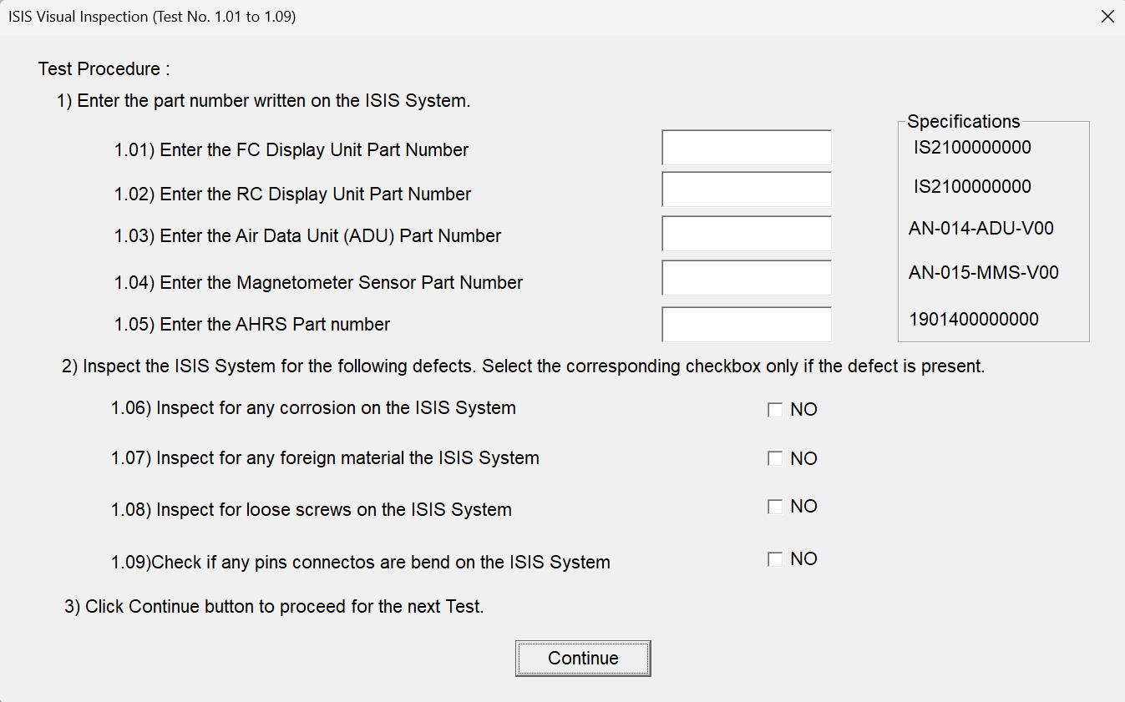

FUNCTIONAL CHECKS

TEST PROCEDURE FOR POWER CONSUMPTION DIALOG
- Verify that the ISIS Power Consumption dialog is displayed.
- Press the “Test” button in the dialog to acquire current consumption values from the test setup.
- Observe the measured current values displayed in the fields for ISIS-DU FC, ISIS-DU RC, ISIS ADU and ISIS AHRS.
- Verify ISIS-DU FC and ISIS-DU RC current values are less than 1.08 A, ISIS ADU current value is less than 0.3 A, and ISIS AHRS current value is less than 1 A.
- Press “Continue” to validate the result and proceed to the next test dialog.

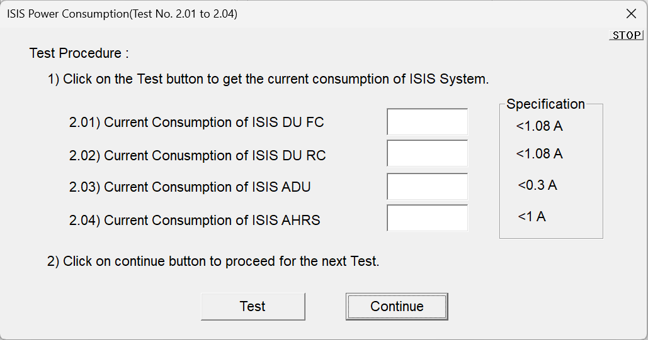

TEST PROCEDURE FOR SOFTWARE VERIFICATION CHECKS DIALOG
- Verify that the Software Verification Checks dialog is displayed.
- Press the “Test” button to acquire software version and checksum details from ISIS-DU FC and ISIS-DU RC.
- Observe the displayed MPM version, MPM checksum, BLGM version and BLGM checksum values in the corresponding GUI fields.
- Verify the displayed values against the ATP specification table: MPM Version 01.00, MPM Checksum 0xCA347B86, BLGM Version 01.00 and BLGM Checksum 0x43760D0A for the applicable FC/RC unit.
- Press “Continue” to validate the data and proceed to the next test dialog.

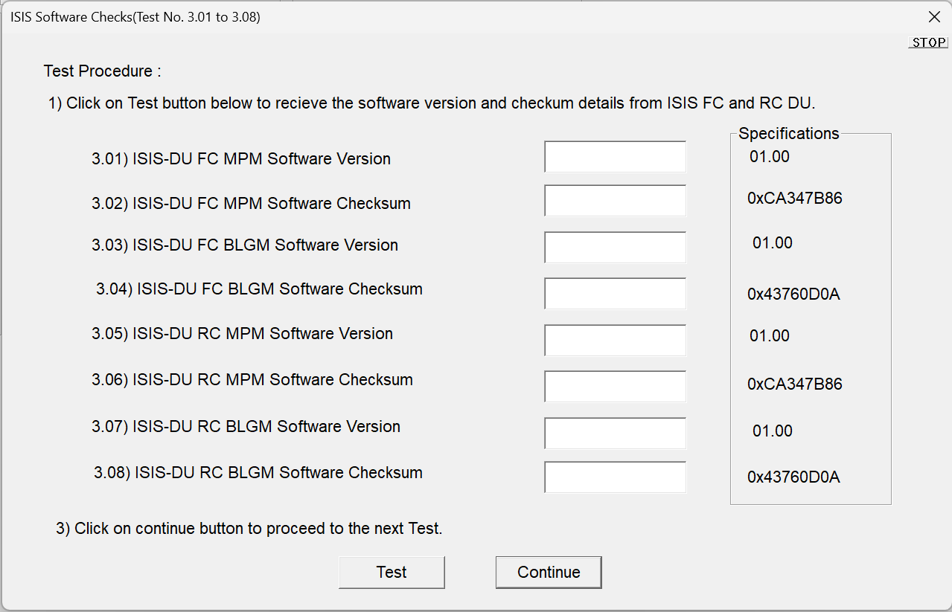

TEST PROCEDURE FOR ISIS IBIT CHECKS DIALOG
- Verify that the ISIS IBIT Checks dialog is displayed.
- Follow the instruction displayed in the dialog and initiate the IBIT check from the GUI.
- Observe the response/status for ISIS-DU FC and ISIS-DU RC in the corresponding fields.
- Select the applicable check box/result as “Operational” if the IBIT response is satisfactory. Select/update “Not Operational” if the expected response is not received.
- Press “Continue” to validate the selected status and proceed to the next test dialog.

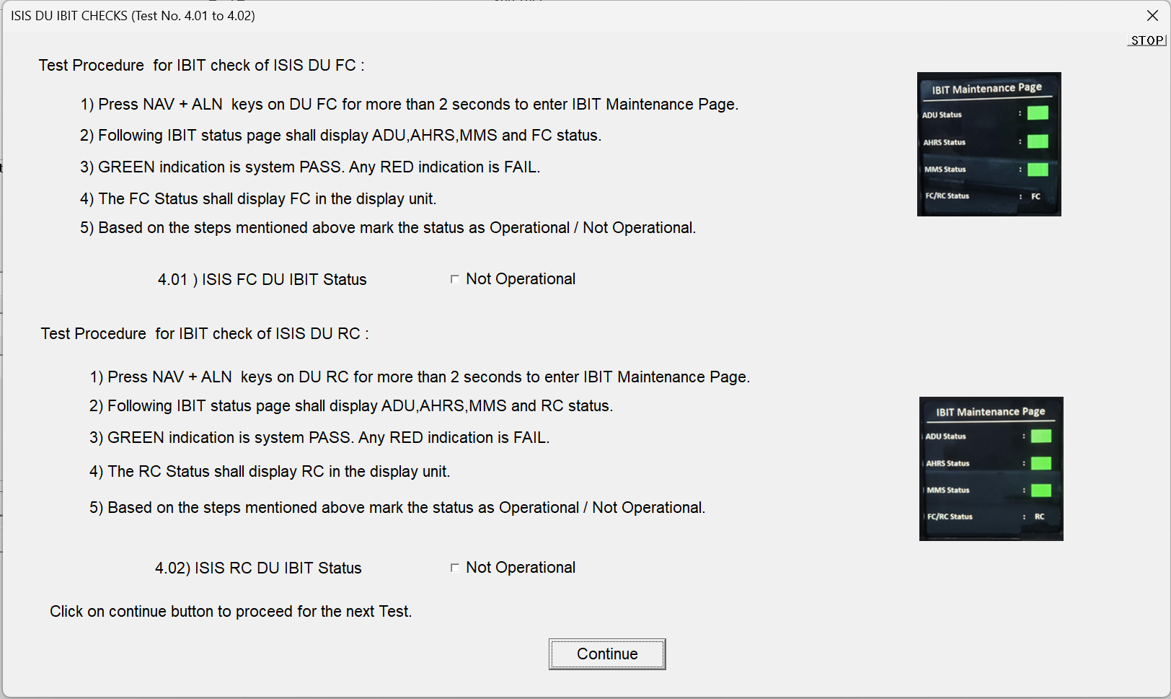

TEST PROCEDURE FOR BRIGHTNESS AND SET KNOB CHECKS DIALOG
- Verify that the Brightness and Set Knob Checks dialog is displayed.
- Operate the brightness/set knob or applicable bezel controls as instructed in the dialog for ISIS-DU FC and ISIS-DU RC.
- Observe the change in display brightness or corresponding GUI indication during knob/control operation.
- Update the result as “Operational” if brightness/set knob operation is satisfactory for the applicable unit. Otherwise record as “Not Operational”.
- Press “Continue” to validate the result and proceed to the next test dialog.

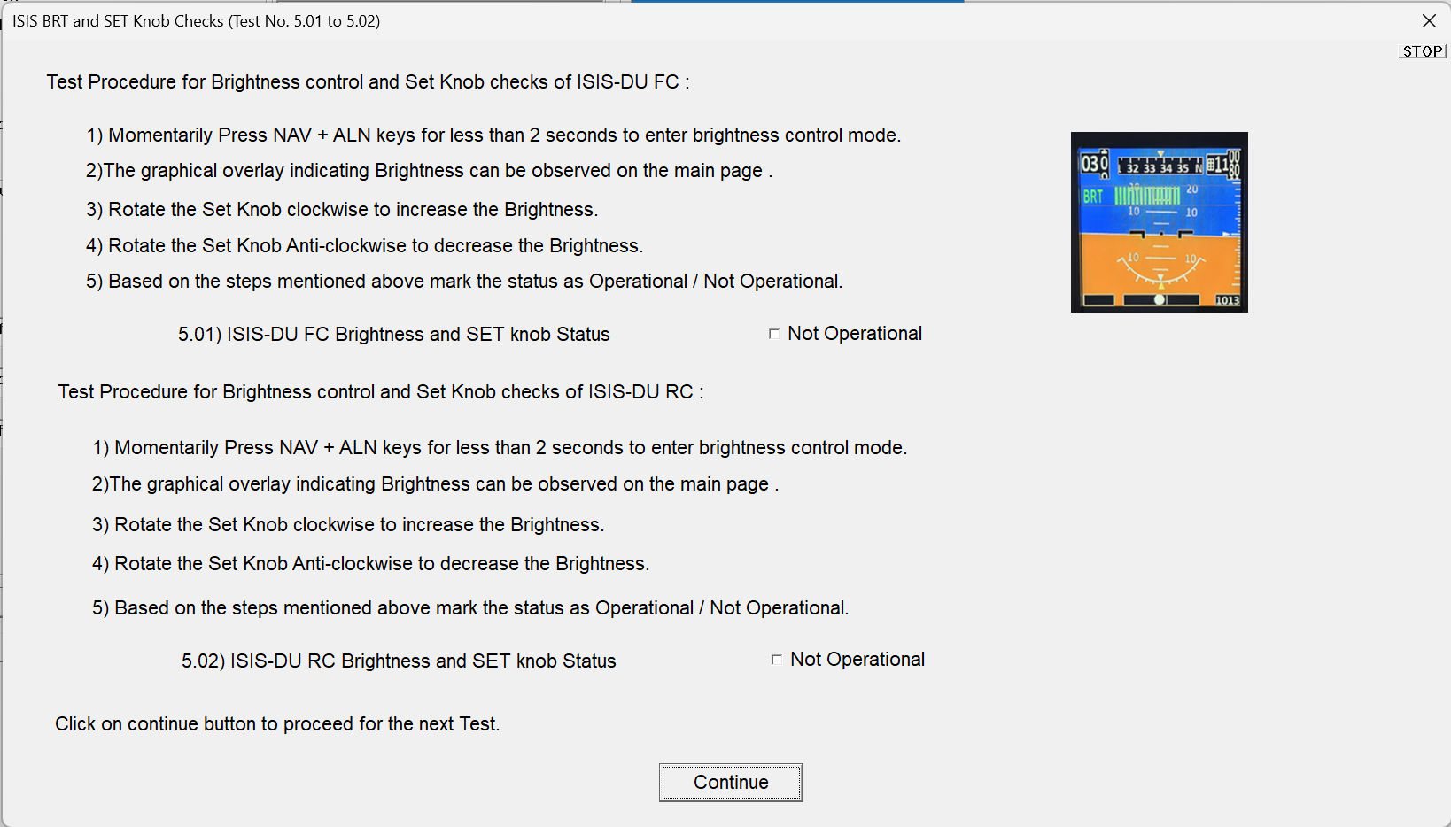

TEST PROCEDURE FOR ALIGNMENT MODE CHECKS DIALOG
- Verify that the Alignment Mode Checks dialog is displayed.
- Perform the alignment mode operation as instructed in the displayed dialog for ISIS-DU FC and ISIS-DU RC.
- Observe the ISIS display and GUI indication to confirm that alignment mode response is available and stable.
- Mark the applicable result as “Operational” if the expected alignment mode indication is obtained. Otherwise mark “Not Operational”.
- Press “Continue” to validate the status and proceed to the next test dialog.

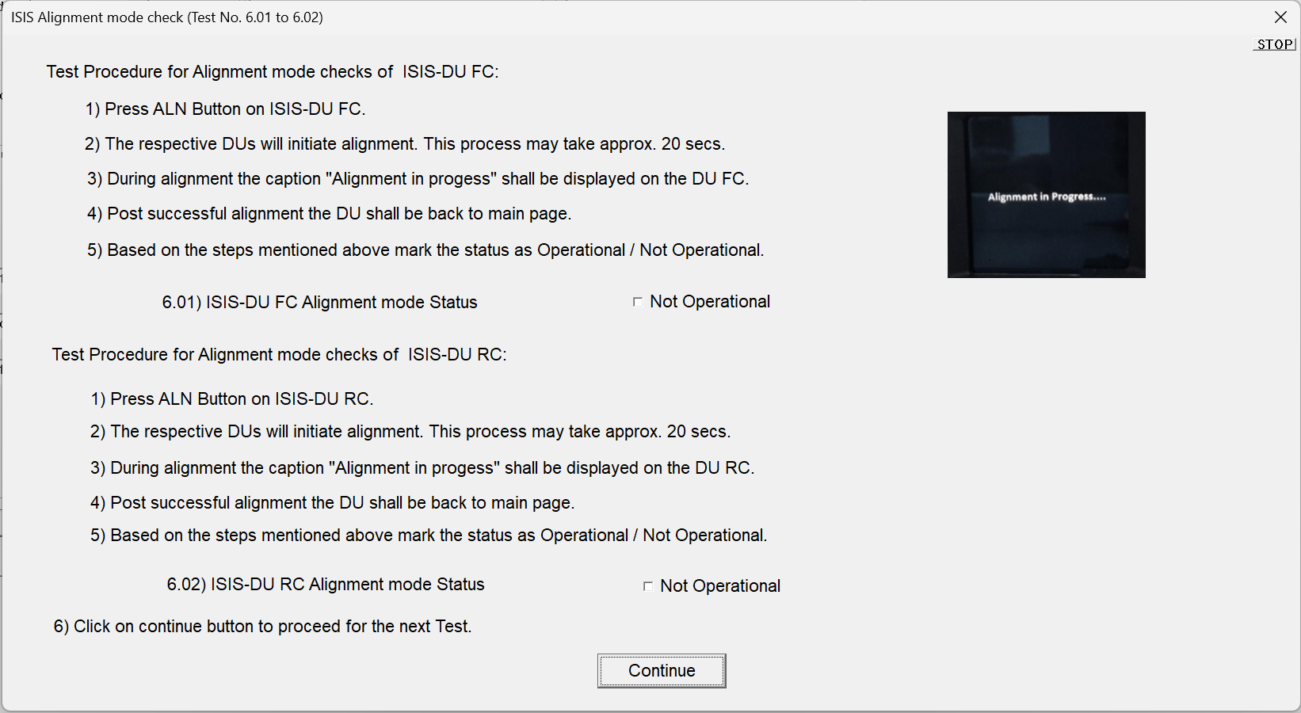

TEST PROCEDURE FOR NAVIGATION MODE CHECKS DIALOG
- Verify that the Navigation Mode Checks dialog is displayed.
- Select/operate the navigation mode as instructed in the dialog for ISIS-DU FC and ISIS-DU RC.
- Observe the corresponding navigation mode indication on the ISIS display and GUI.
- Update the result as “Operational” when the expected navigation mode indication is obtained. If the response is not observed, update the result as “Not Operational”.
- Press “Continue” to validate the result and proceed to the next test dialog.

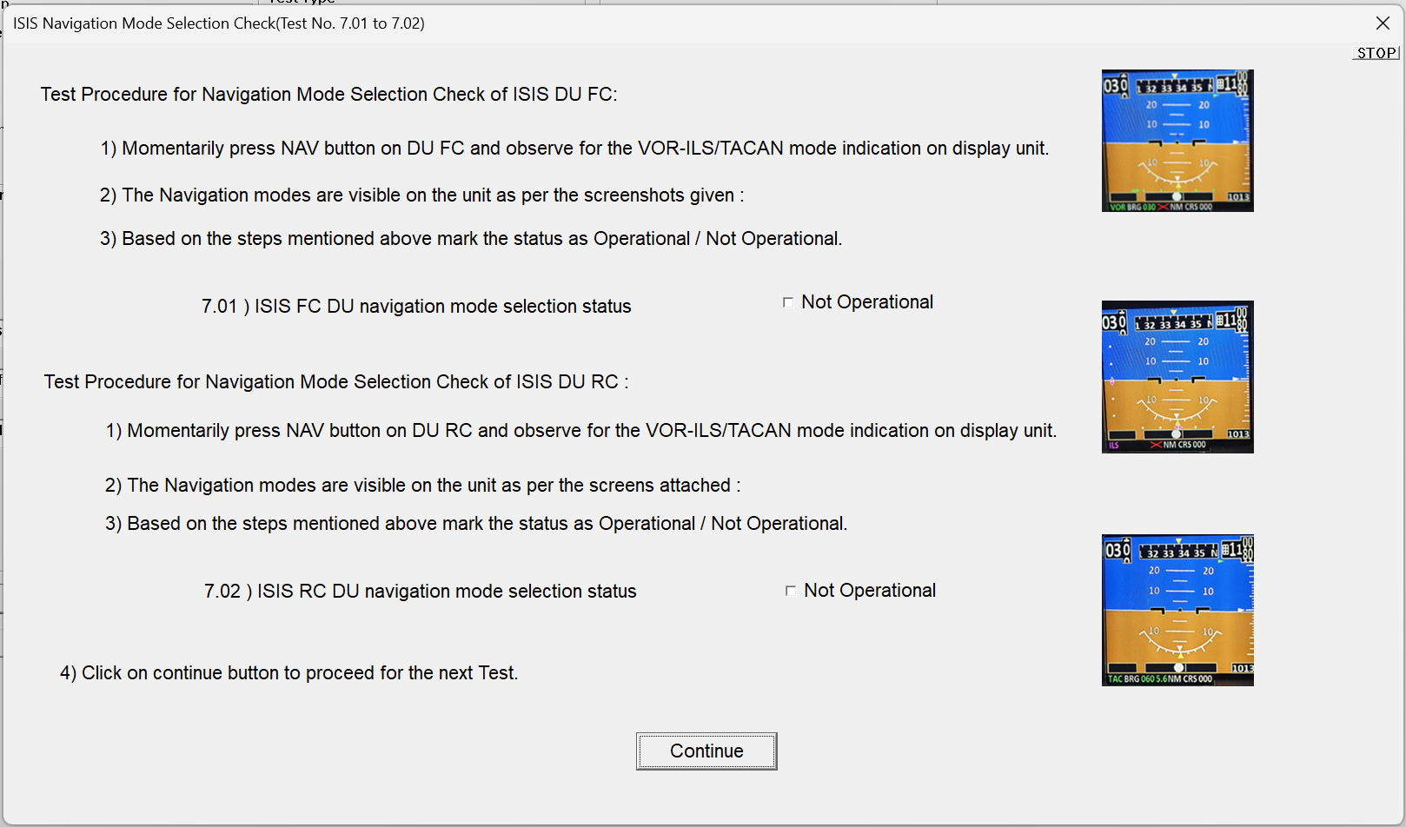

TEST PROCEDURE FOR ALTITUDE & HEADING CHECKS - AHRS DIALOG
- Verify that the Altitude & Heading Checks - AHRS dialog is displayed.
- Follow the dialog instruction to acquire/verify Roll, Pitch and Heading parameters for ISIS-DU FC and ISIS-DU RC.
- Observe Roll FC, Pitch FC, Heading FC, Roll RC, Pitch RC and Heading RC indications in the ISIS GUI/display.
- Mark each applicable result as “Operational” when the expected AHRS response is obtained. If any indication is missing or invalid, mark as “Not Operational”.
- Press “Continue” to validate the AHRS check result and proceed to the next test dialog.
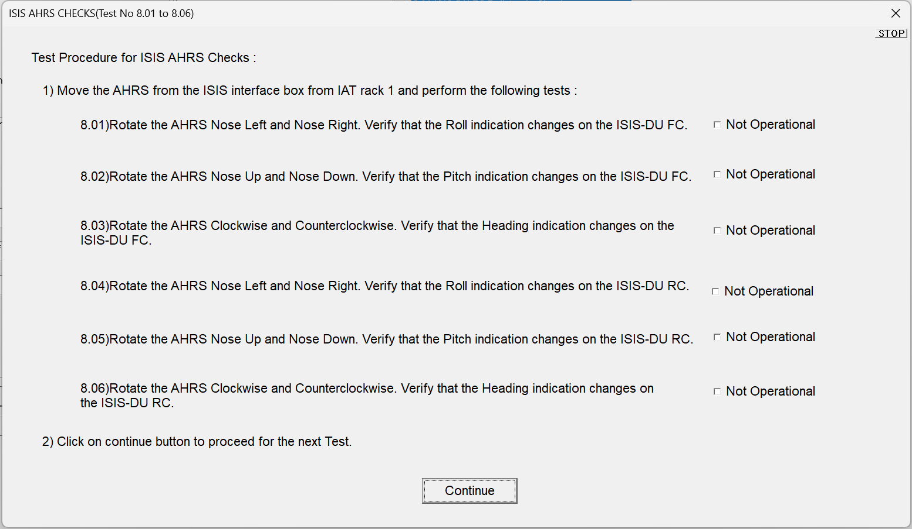

TEST PROCEDURE FOR AIR DATA PARAMETER CHECKS DIALOG
- Verify that the Air Data Parameter Checks dialog is displayed.
- Perform the air data check as instructed in the dialog and observe the Air Speed, Altitude, Mach Number and Vertical Speed Marker indications.
- Verify that Air Speed is 192 ± 5 knots, Altitude is 9980 ± 30 ft, Mach Number is 0.37 ± 0.012 M and Vertical Speed Marker is operational.
- Update the corresponding check box as OPERATIONAL when the observed values are within limits. If any value is outside the specified limit, record the result as NOT OPERATIONAL.
- Press “Continue” to validate the entered/selected data.
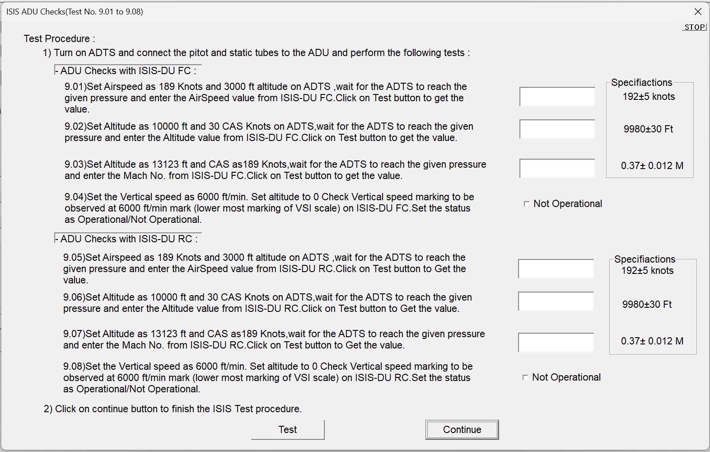

Chapter 3 – Test report
- Upon successful completion of all test cases, click the “Print” button available in the IAT application.
- Browse to the location where the test result BIN file is generated and stored.
- Select the required BIN file corresponding to the test session and click “Open”.
- Verify that the Print Dialog window is displayed.
- To generate the report in PDF format, select “Microsoft Print to PDF” from the list of available printers.
- Alternatively, select the desired physical printer to obtain a hard copy of the test report directly.
- Click “OK” to initiate report generation.
- When the Save Print Output As dialog is displayed, enter an appropriate file name for the report.
- Select the desired storage location and click “Save”.
- Verify that the PDF report file is successfully generated at the selected location.
- Navigate to the saved location and open the generated PDF file.
- Verify that the report contains the following information:
  - Test Name/Description
  - Date and Time of Test Execution
  - Unit Details (Part Number and Serial Number)
  - Individual Test Results
  - Overall Test Status (PASS/FAIL)
  - Operator Information, if applicable
- Confirm that all recorded test results are correctly displayed in the generated report.
- Archive or print the report as required by the applicable ATP documentation and record-keeping procedure.
Expected Result:
The test report shall be generated successfully in PDF format or printed through the selected printer, and the report shall contain all executed test results with the correct PASS/FAIL status.

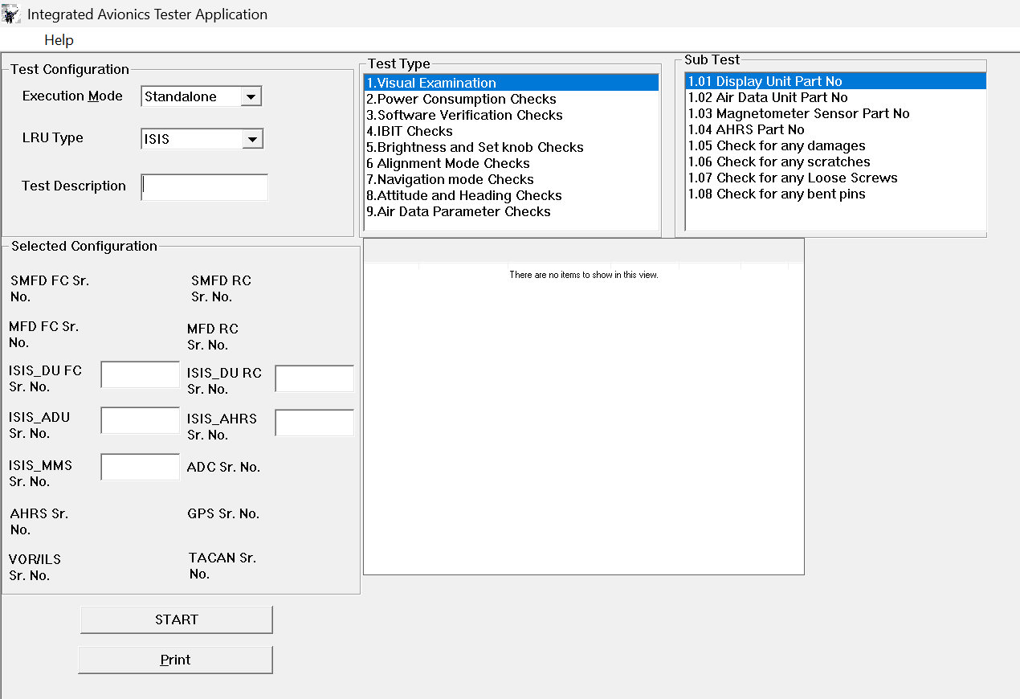

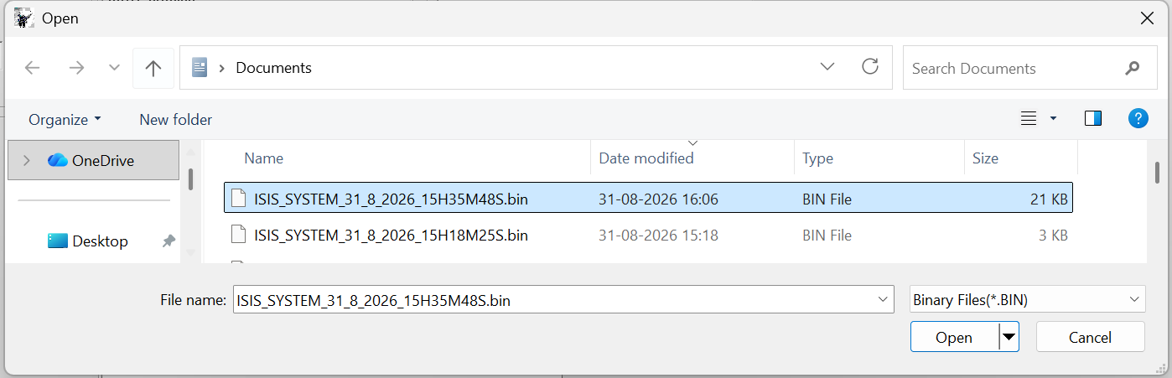

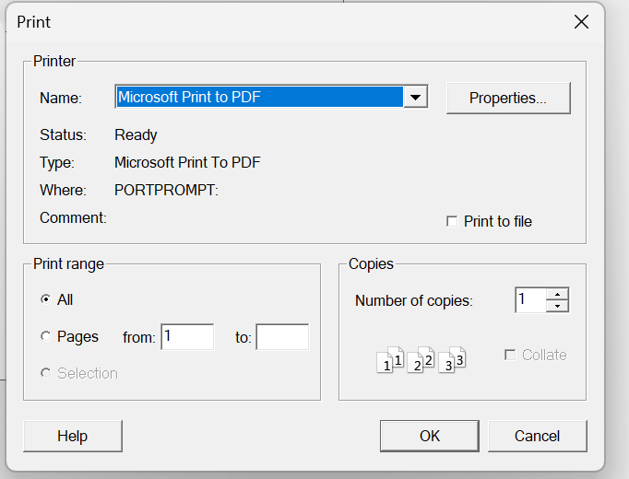

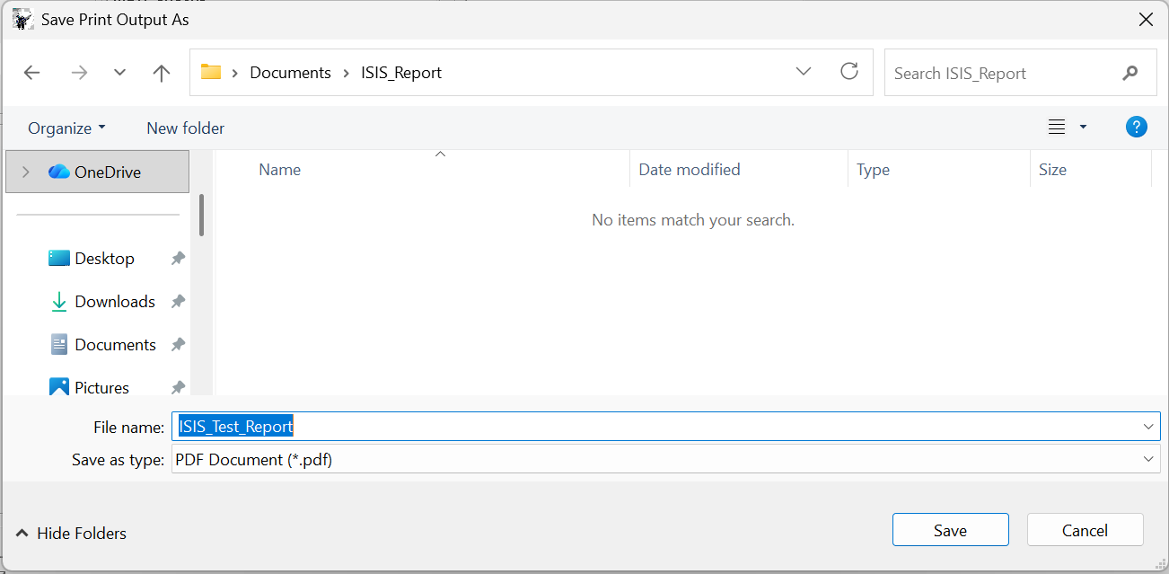

ANNEXURE- I - IAT UNIVERSAL TESTER
In figure 14(a),3ATI Test Setup (Universal Tester interfaced with Display Unit) is shown.
Block diagram of the Universal Tester interfaced with Display Unit is shown in Figure 14(b).

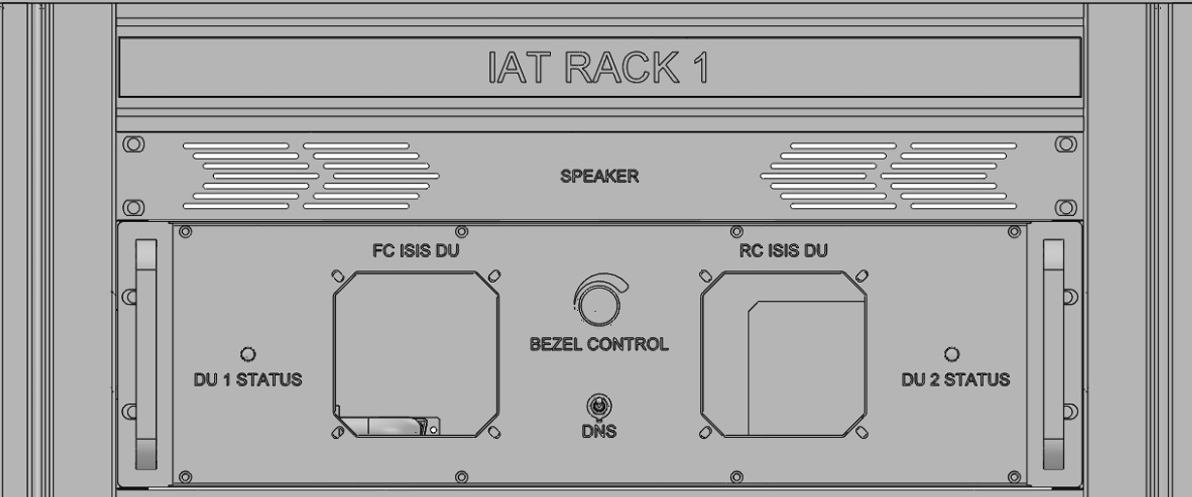

Figure 14 (a) Typical ATE for Testing IS

ANNEXURE- II – ACCEPTANCE TEST REPORT
