**Assignment 2**

1.What are the two values of the Boolean data type? How do you write them?

a) True

b) False

We write first letter as uppercase (T , F) and rest of all in lowercase

2. What are the three different types of Boolean operators?

a) AND

b) OR

c) NOT

3. Make a list of each Boolean operator's truth tables (i.e. every possible combination of Boolean values for the operator and what it evaluate ).

Truth table for **AND** operator

|  |  |  |
| --- | --- | --- |
| True | True | **True** |
| True | False | **False** |
| False | True | **False** |
| False | False | **False** |

Truth table for **OR** operator

|  |  |  |
| --- | --- | --- |
| True | True | **True** |
| True | False | **True** |
| False | True | **True** |
| False | False | **False** |

Truth table for **NOT** operator

**Ans:**

True not is False

False not is True

4. What are the values of the following expressions?

(5 > 4) and (3 == 5)

not (5 > 4)

(5 > 4) or (3 == 5)

not ((5 > 4) or (3 == 5))

(True and True) and (True == False)

(not False) or (not True)

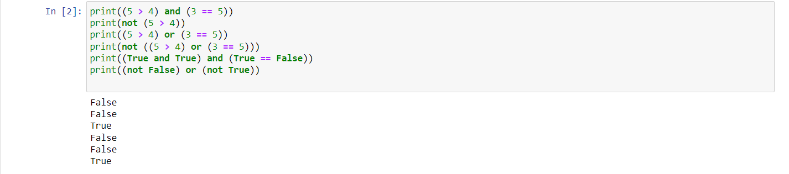

5. What are the six comparison operators?

1) Equal to: ==

2) Not equal to: !=

3) Greater than : >

4) Less than : < :

5) Greater than equal to : >=

6) Less than equal to : <=

6. How do you tell the difference between the equal to and assignment operators?Describe a condition and when you would use one

**Ans:**

Difference Between Equal to operator and assignment operator

|  |  |
| --- | --- |
| **Equal to operator** | **Assignment operator** |
| Equal to operator is used to compare two variable or expression, It can numbers, strings, Boolean values, variables, objects, arrays or functions. | Assignment operator is used to store a value in variables. |

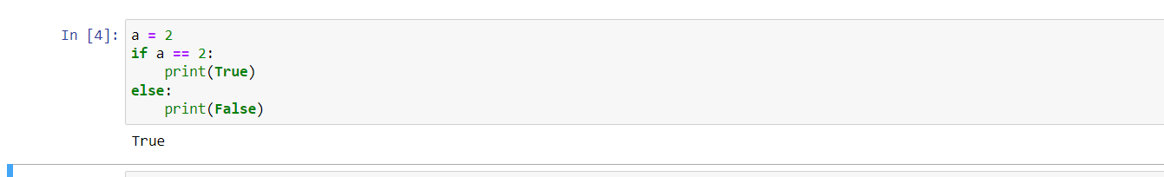

7. Identify the three blocks in this code:

spam = 0

if spam == 10:

print('eggs')

if spam > 5:

print('bacon')

else:

print('ham')

print('spam')

print('spam')

**Ans:**

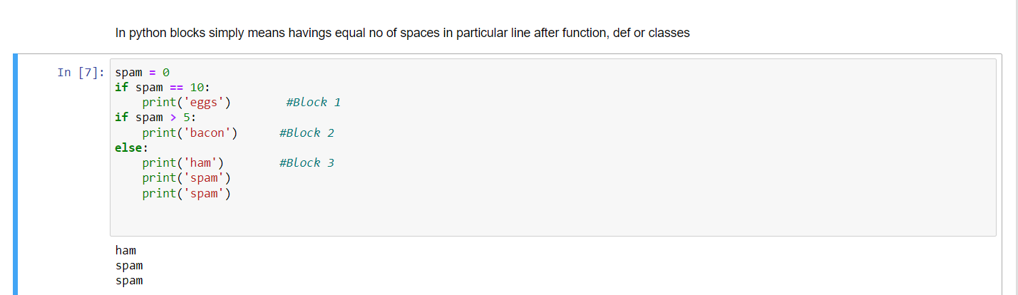

8. Write code that prints Hello if 1 is stored in spam, prints Howdy if 2 is stored in spam, and prints Greetings! if anything else is stored in spam.

**Ans:**

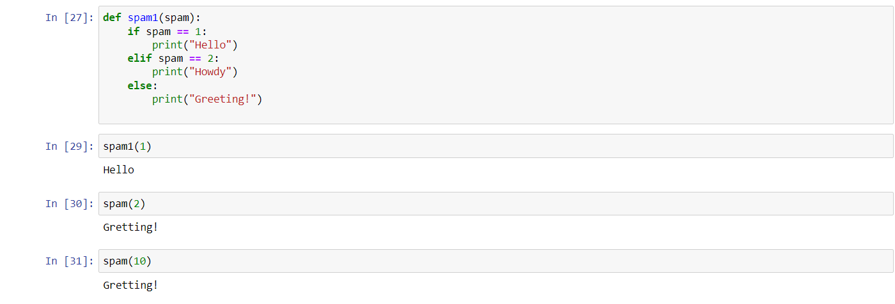

9.If your programme is stuck in an endless loop, what keys you’ll press?

**Ans** : Press **ctrl + c** if your program stuck endless loop.

10. How can you tell the difference between break and continue?

**Ans**: break stop the whole process for loop after code get executed, while continue used to end the current statement and move to next line of code or loop.

11. In a for loop, what is the difference between range(10), range(0, 10), and range(0, 10, 1)?

**Ans**: range(10) – It tells to python take all value till excluding 10

range(0,10) – It tells python to start from 0 till 10 excluding 10

range(0,10,1) – It tells python to start from 0 till 10 excluding 10 and increase next value by 1

12. Write a short program that prints the numbers 1 to 10 using a for loop. Then write an equivalent program that prints the numbers 1 to 10 using a while loop.

**Ans:**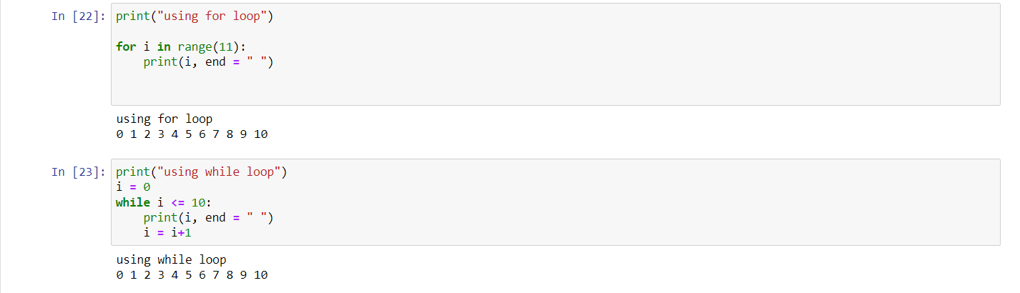

13. If you had a function named bacon() inside a module named spam, how would you call it after importing spam?

**Ans**: spam.bacon()