Hello, I am Praful. I am an experienced software engineer. I had worked on CRM tool

Called siebel, using which we used to provide complete business solution, It was about building complete application using different components of the siebel tool, We had tables, business components, applets, views, screens, and all together into application. There, I had worked on tolling and railways solution projects in my previous company for 2.5 years. I worked on building workflows, triggers, and handled various tickets, on debugging codes. Created various SQL queries and PL/SQL codes for the project to update the existing customer records.

Apart from that, I have done 3 personal projects on data analytics, Zomato business, Motorcycle sales based on age. I have done certifications on data science and python. In the past 6 months I have done data analysis of stocks to find patterns in them, i have built strategies to take swing trades, I have built algo strategies to do live automatic trading.

I am a driven self-starter, go getter, enthusiastic about data patterns, analyzing large data, building visually great dashboards, and I am planning to channelizing my skills to find insights for the business growth of a company.

============================Data Engineer ==============================

Hello everybody, firstly thank you for the opportunity.

Hello, I am Praful. I am an experienced software engineer. I had worked on CRM tool

Called siebel, using which we used to provide complete business solution, It was about building complete application using different components of the siebel tool, We had tables, business components, applets, views, screens, and all together into application. There, I had worked on tolling and railways solution projects in my previous company for 2.5 years. I worked on building workflows, triggers, and handled various tickets, on debugging codes. Created various SQL queries and PL/SQL codes for the project to update the existing customer records.

Apart from that, I have done personal project YouTube Ad Campaign, where I got to learn about AWS service like AWS S3 AWS RDS, AWS DynamoDB, AWS Glue, AWS Athena, AWS Lambda, REdshift. I have done certifications on data science and python. In the past 6 months I was actively trading in stock market where i learned technical skills and how to patience, Things didn’t work as i wanted. So i accepted my failure and wanted come back to technology. i have built strategies to take swing trades, I have built algo strategies to do live automatic trading.

I am a self driven starter, enthusiastic to learn new technologies and skills. And I am here give my 100% to my work. And there by building reliable pipelines from source to destination, and I am planning to channelizing my skills to work in great organization and grow from strength to strength.

==========================Career Gap=================================

I was hit by covid, I was not working for 20 days. I wanted to get out of comfort zone, so I decided to develop new skills in financial domain for better future career opportunities. After a brief discussion with my previous manger and colleagues, I started my new career in stock market by learning Technical Analysis to actively trade in stock market. And also I did investment analysis and portfolio management certificate from NSE india to learn more about personal finance. It was that time that prepared me to take on new challenges and mentally strong. Now I’m incredibly excited about the new opportunities that lie ahead.

=============================Product Analytics===========================

**What is product analytics?**

Product analytics is about understanding how people are using our product so that we can understand how to improve the customer experience and positively impact our business.

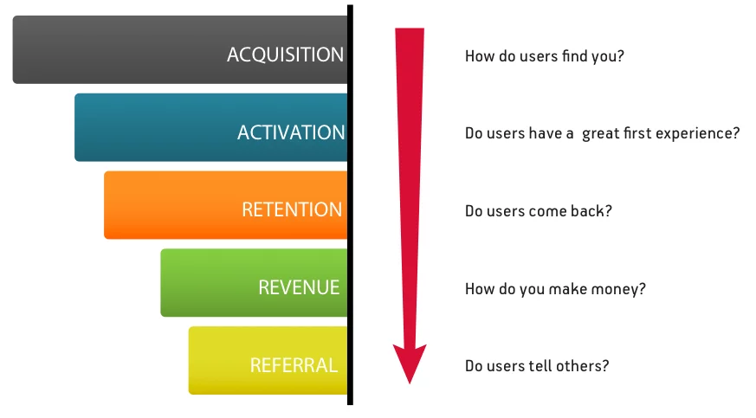

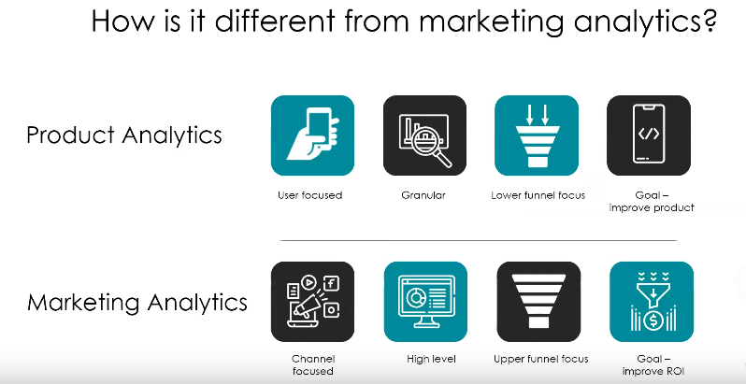

How can we change product experience to reach business goals?

Finding bottleneck in the product funnel.

Understanding how people are using our product.

Analyzing A/B test performance.

Identifying what makes some users our best customers.

-----------------------------------------------------------------------------------------------------------

**How does it work?**

Building blocks of product analytics.

1.Events - Things that happen in our product(button tab, screen view).

2.Users - People interacting with our product.

Event properties tell you context behind the event that occurred like CHECKOUT event

Tell about **trackable properties like Cart value, items in cart, promo code** applied or not.

User properties help to understand more about the user like Name, Age, Email, operating system, App version, Number of purchase, signup date, Acquisition channel(marketing channel).

------------------------------------------------------------------------------------------------------------------

**How can it help to build better business?**

Suppose you are an e-comerse company

Goal: Increase the revenue of the company.

Step 1: Increase the no of user installing app.

Step 2: Increase the conversion rate.

Step 3: Increase the avg baset size.

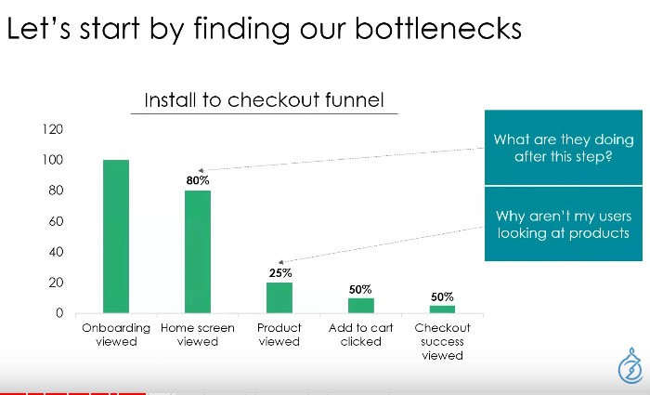

Then we can experiment with hypothesis like.

1. Altering the home screen for few region.
2. Male and female users or age based users properties.
3. Acquisition change social, paid search, organic.

Other analysis to built better business.

**User flow** - How users are moving in side the app.

**Retention Analysis** -How long the users has stayed as customer.

------------------------------------------------------------------------------------------------------------------------

**Tools**

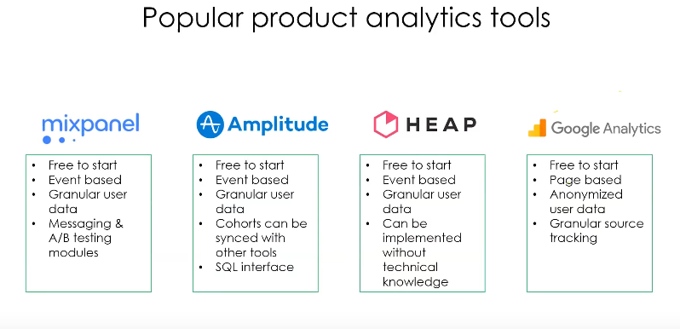

**-------------------------------------------------------------------------------------------------------------------------**

**How to implement?**

1. Define goal of our business.
2. Develop a tracking plan.
3. Choose the right tool.
4. Follow a consistent process.

-------------------------------------------------------------------------------------------------------------------