**Tableau**

KP I- Key Performance Indicator.

https://public.tableau.com/app/profile/praful.bs/viz/EcommersSalesReportofUSA_/Dashboard1?publish=yes

Agenda: Analyzing the factors that affect sales of the ecommerce store.

Q1. Top profitable states in the US.

Q2. Share(contribution) of each state in profit.

Q3. Most profitable item and loss making profit and its category.

* Used scatter plot to find outliers.
* 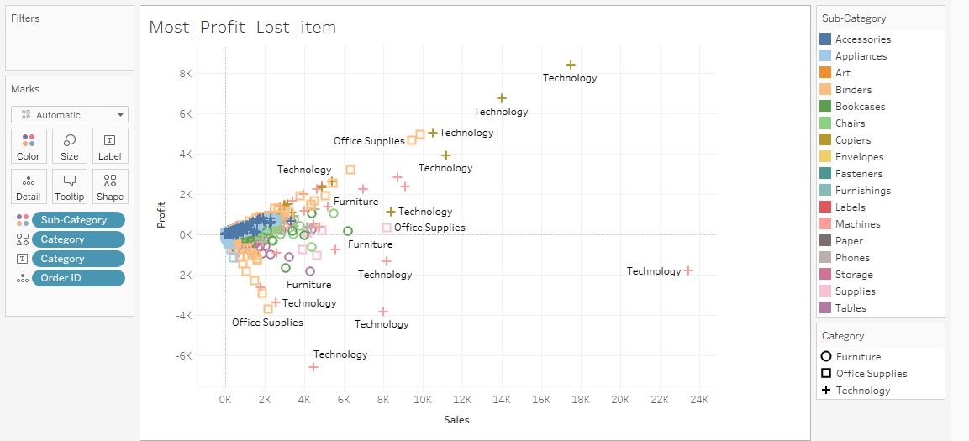

Q4. Trend of profit and sales for the store on month wise.