**Documentation**

**Assignment- Document Management System**

**Tools Used**

* Django 1.4 (Python Web Based Framework)
* PostgreSQL (Relational Database)
* Jinja as the templating language

**Database Design**

Following tables were designed :-

1. **Document1-** For uploading up of various kinds of documents. It takes in the file and uploads on the system, rather than saving files inside the DB.
2. **UserProfile:-** On registering, it stores the fields filled upon registering .

Various fields are :-

* **Username**
* **Password**
* **Gender**

**Steps to configure the project**

1. Download the project. Open the command prompt and change it to the directory of the project downloaded.
2. Run the following the command.

***python manage.py runserver***

1. Django will validate the models built and within a few seconds, the server will be up and running.
2. Now, browse to the url ***127.0.0.1:8000/login*** and use the project DMS.

**Screenshots**

This is the first page. Upon browsing to the link 127.0.0.1:8000/login, the user will be directed to this page. Here user will either sign in into his/her account or click the link to get register.

On signing in, it checks the username and password from the Document1 model. If the match is found, then the user is directed to his/her profile page else respective errors are being thrown.

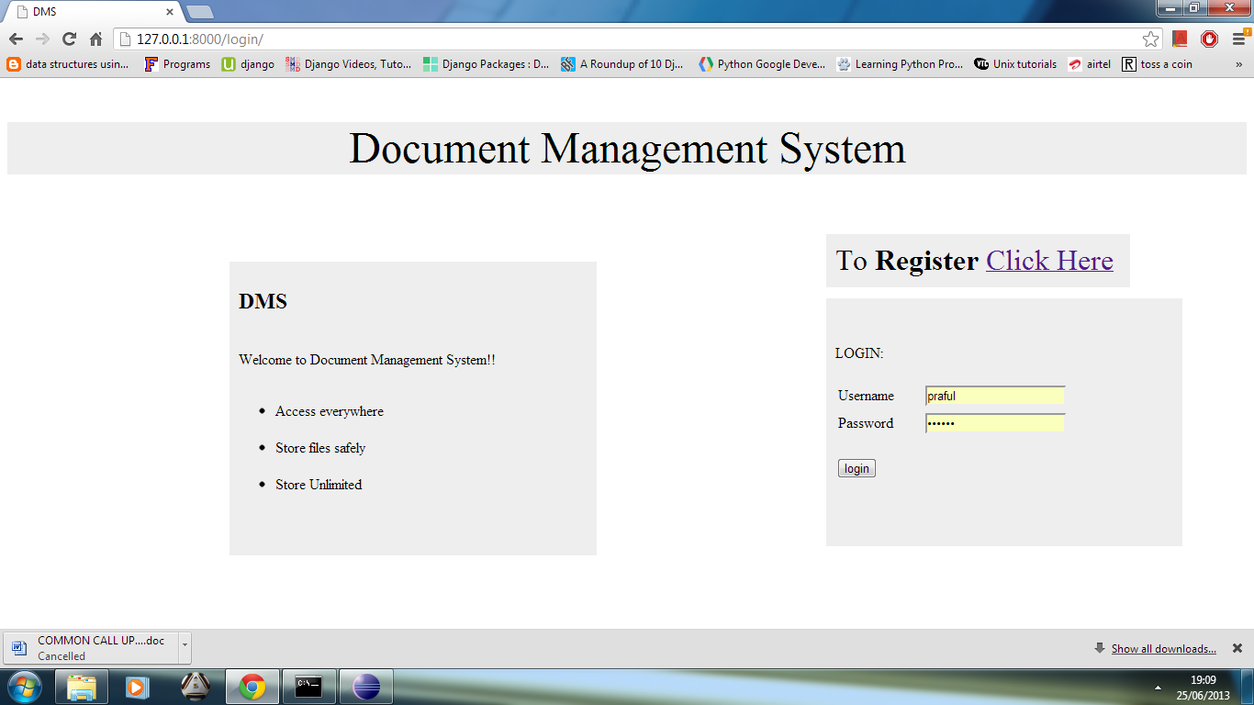

**Fig 1 :** Login page

Upon signing in, the user is directed to his/her profile, where he/she can browse through the documents, download or upload them .

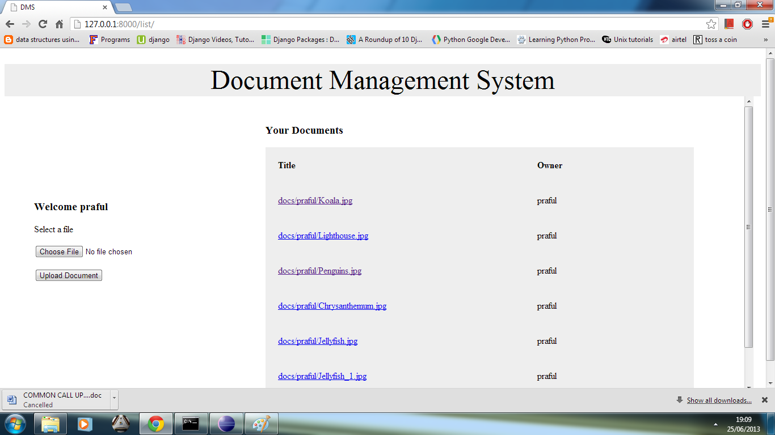

**Fig 2:** User Profile Page

If the user is not registered, then he/she has to get himself/herself registered in order to get access to the DMS. Various validation has been provided with, for eg:- if the username exists or not, if the password matches or not etc.

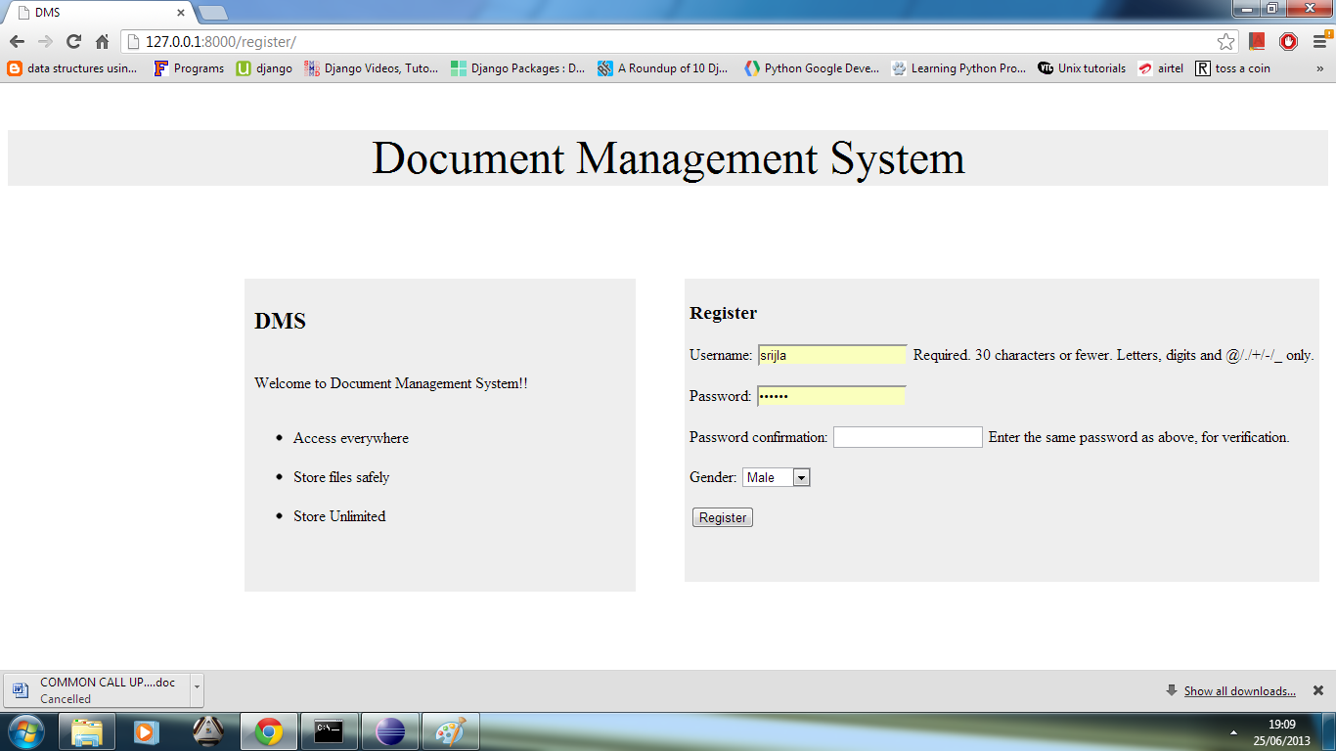

**Fig 3 :** Register Page