ME 759: Nonlinear FEM

Assignment 4: 2-D Elasto-plasticity

# Equations used for coding

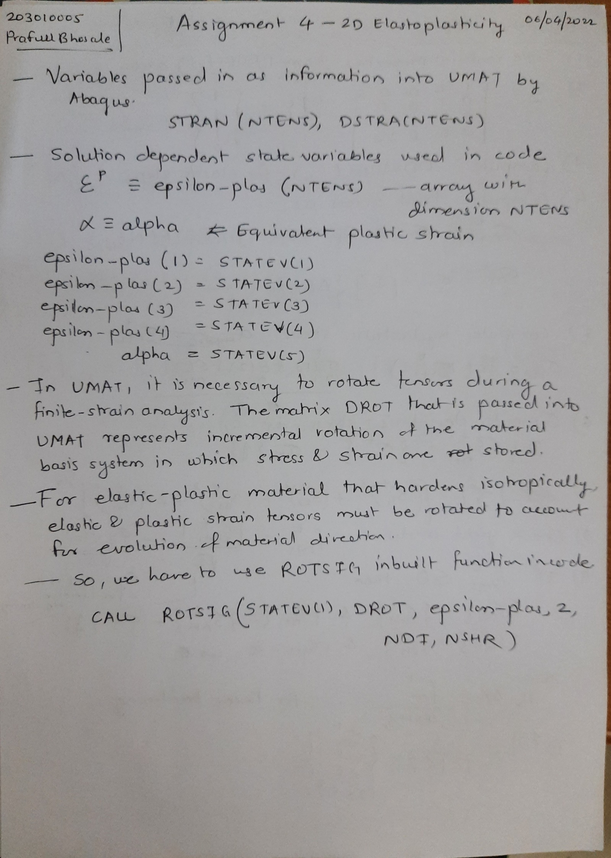

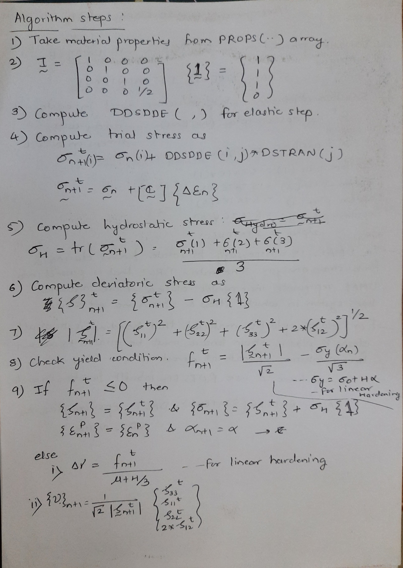

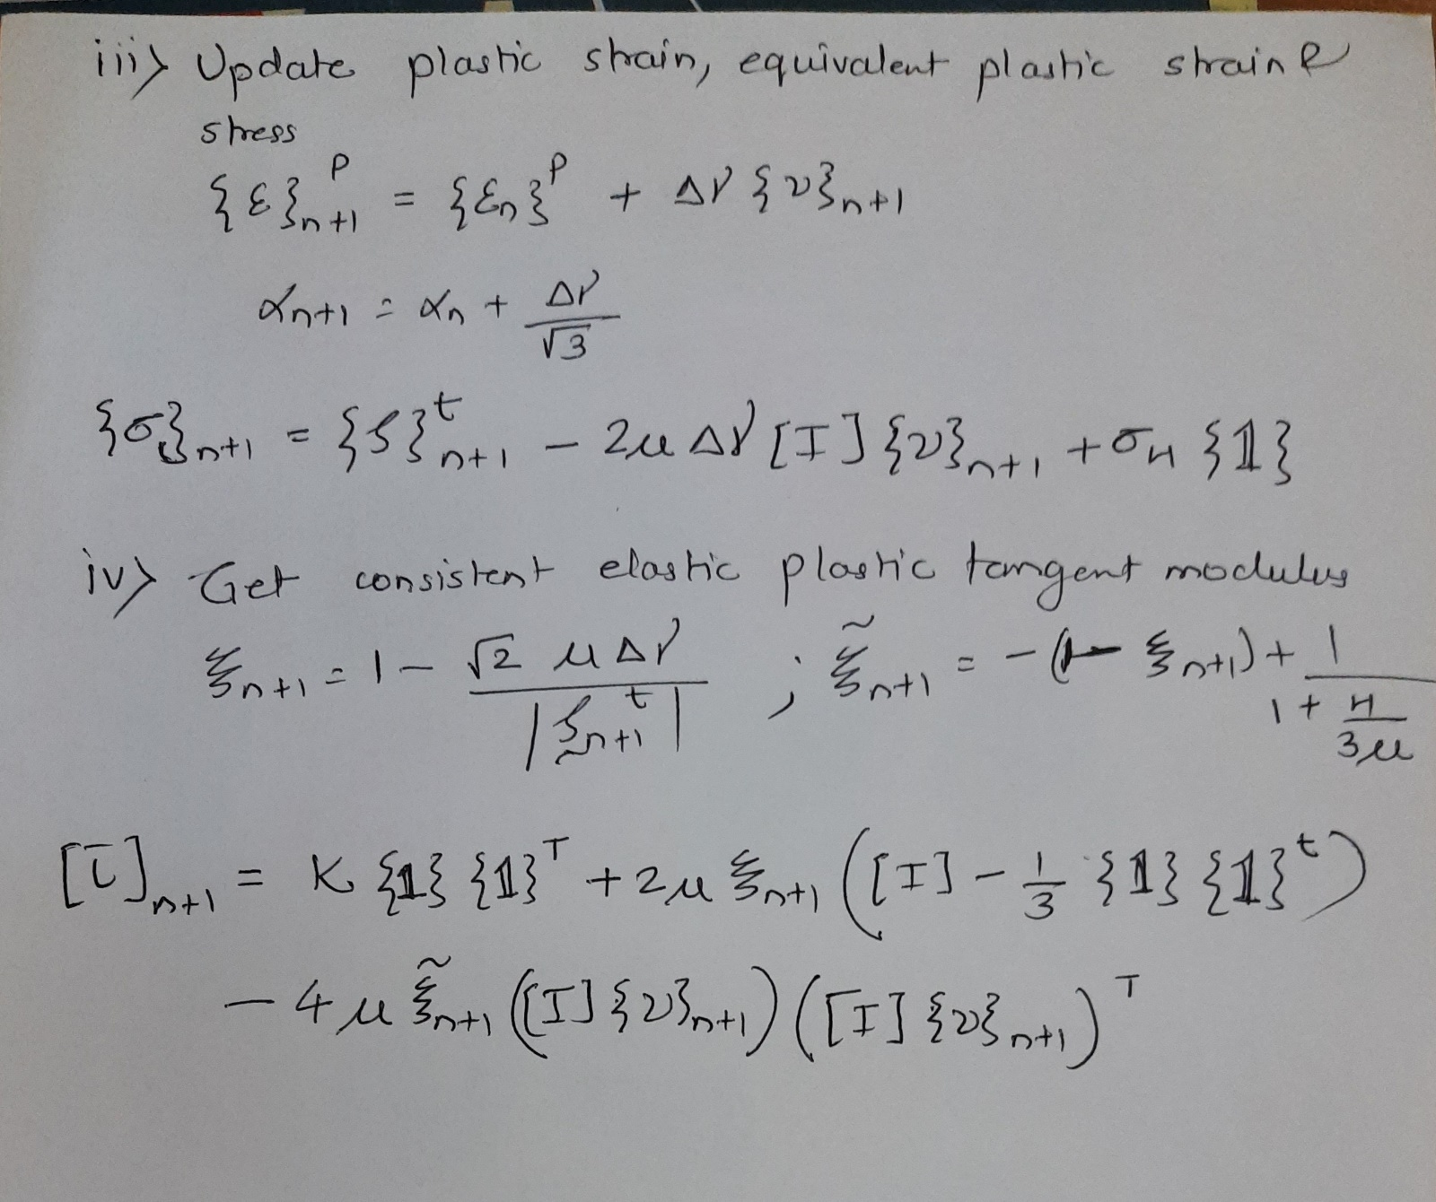

# Part a

## Plot of vs

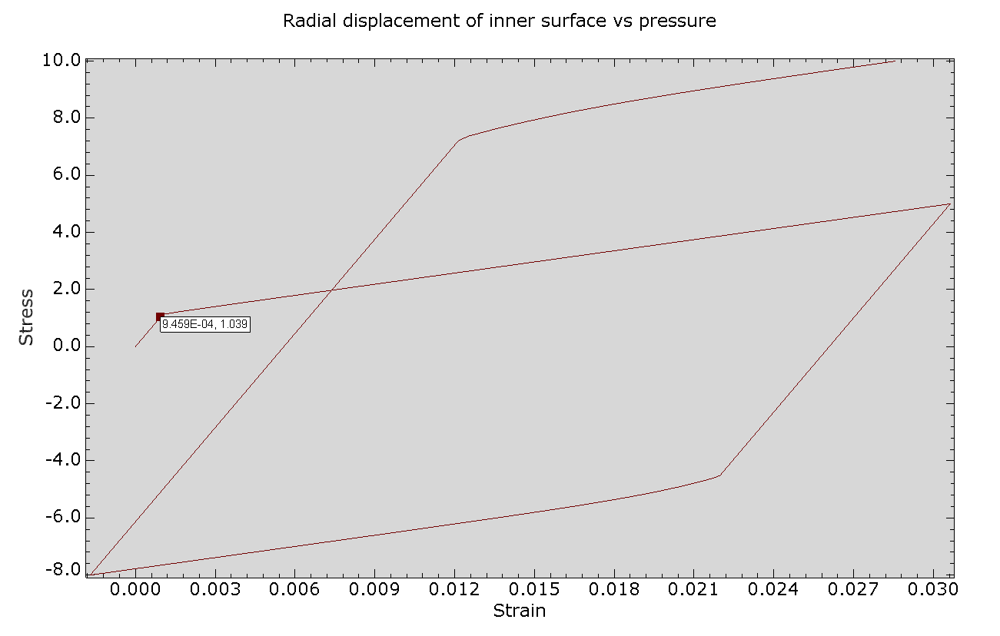

### Observations:

Since we are using von-mises stress criteria, we can see that the yielding starts at for when we apply normal traction on top surface.

## Plot of yield stress vs equivalent plastic strain

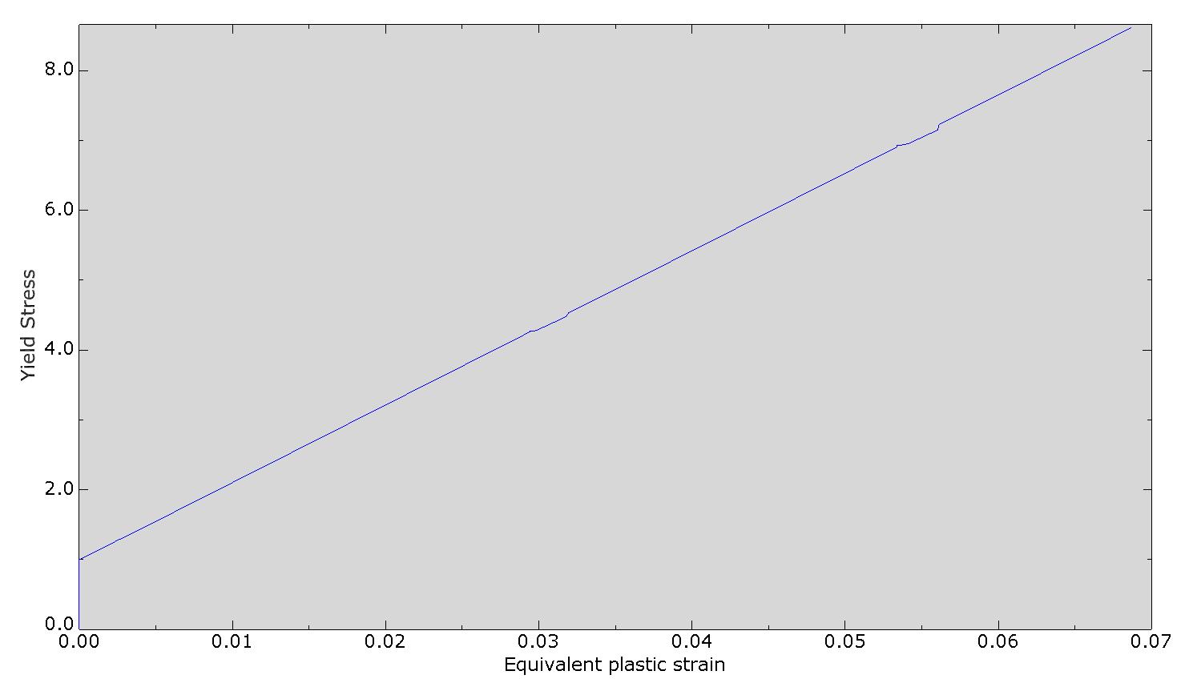

# Part b

## Plot of vs

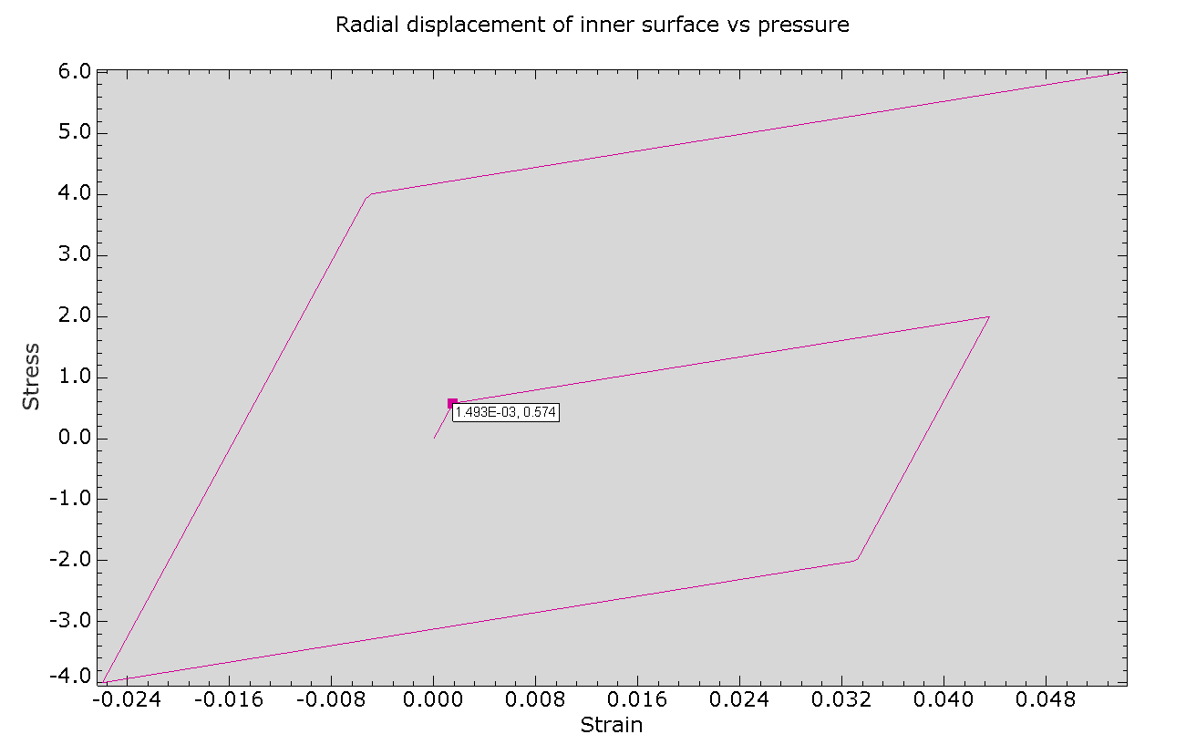

### Observations:

Since we are using von-mises stress criteria, we can see that the yielding starts at 0.577* for pure shear.

## Plot of yield stress vs equivalent plastic strain

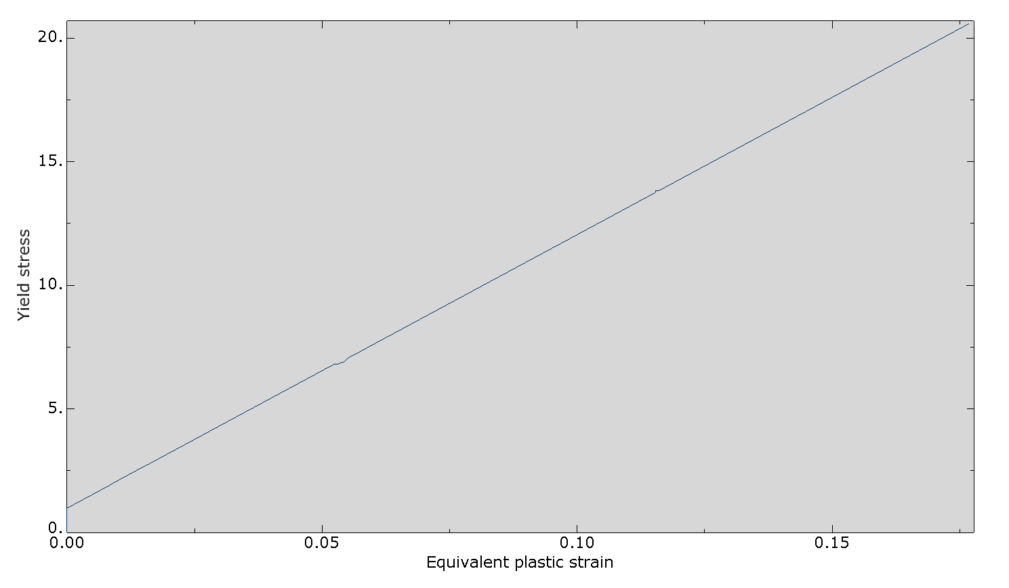

# Part c

## Variation of through the thickness of the cylinder

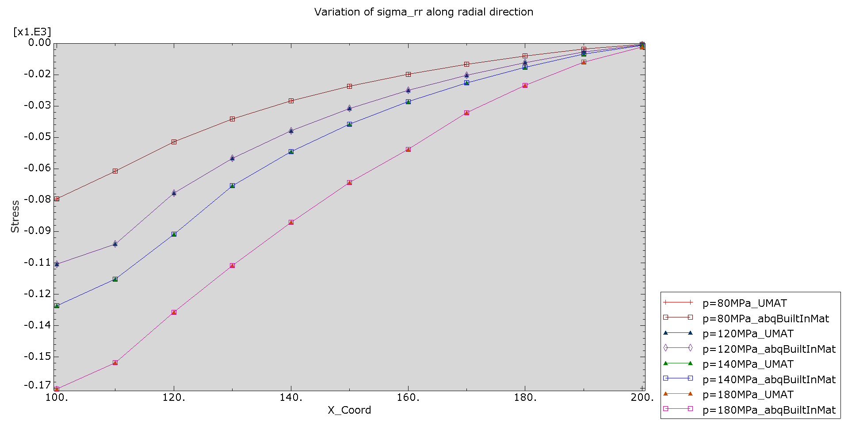

## Variation of through the thickness of the cylinder

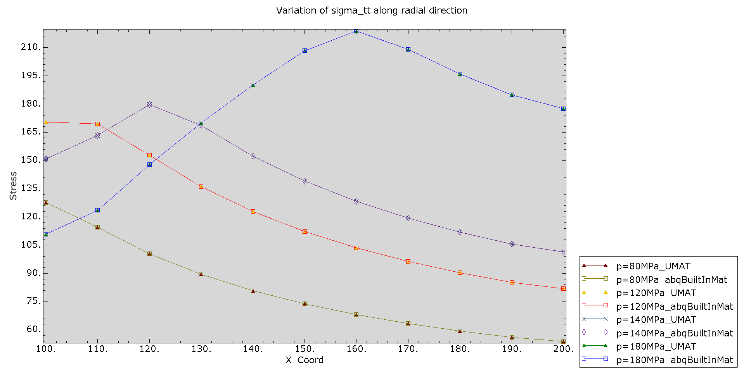

## Plot of radial displacement of inner surface of the cylinder vs pressure

