**STEPS FOR CREATING A “BASTION”**

1. **The Architecture of Virtual Private Cloud (VPC)**

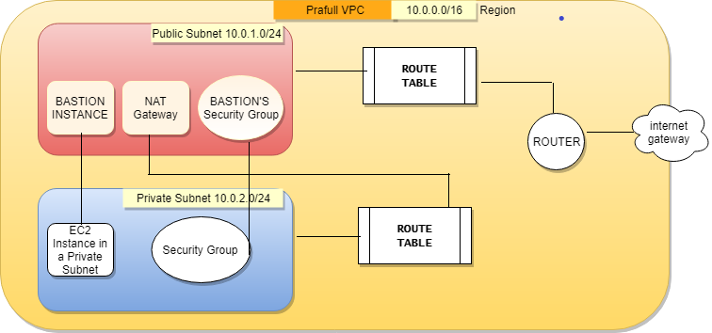

**Steps to Create –**

1. **Created a Virtual Private Cloud (VPC), via AWS console.**

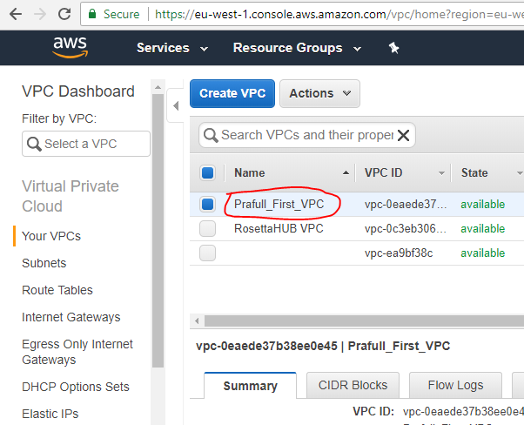

1. **PRIVATE AND PUBLIC SUBNET INSIDE VPC –**

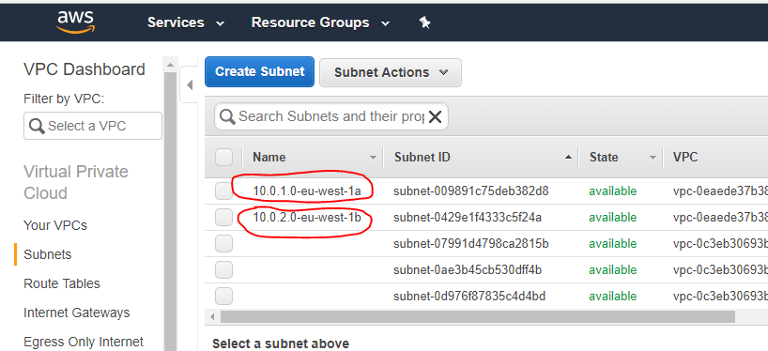

**3.) Route Tables**

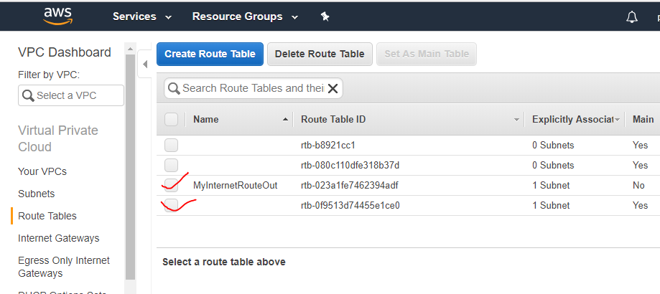

Created two route tables –

* One for Public Subnet which is main, and connected to Internet Gateway.
* Other route table is not connected to main to internet gateway, rather, its source for internet traffic route is NAT gateway In Public Subnet

**4.) Created an Internet Gateway for the VPC.**

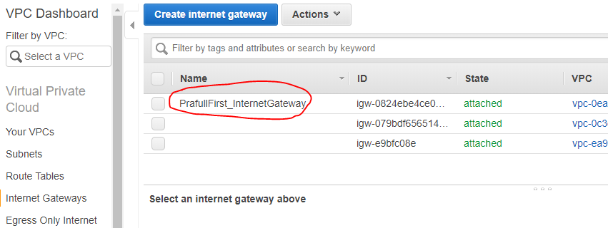

**5.) Bastion Security Group and Private Subnet Security Group**

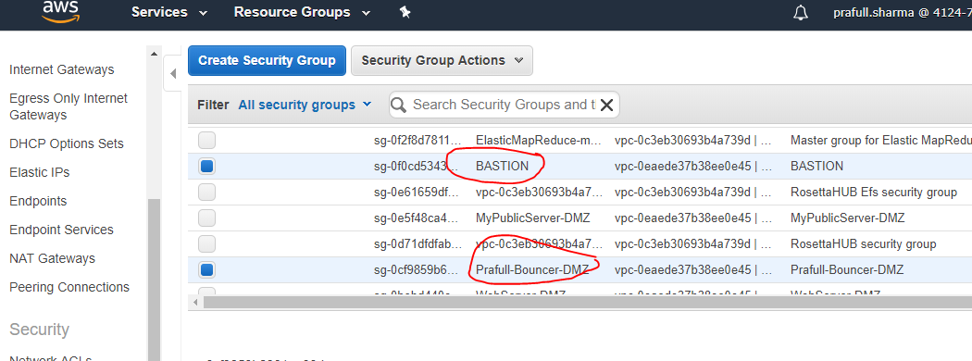

**6.) NAT GATEWAY -**

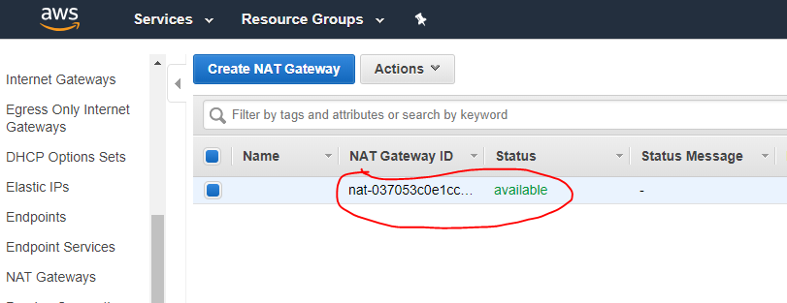

**-----------------------------------------------------------------------------------------------**

**7.) EC2 INSTANCES**

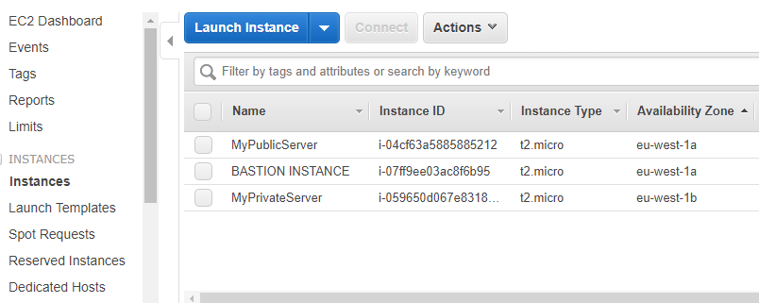

**Where,**

* **Bastion Instance - is in Public Subnet of VPC**
* **MyPrivateServer – is in Private Subnet of VPC**