**YouTube in28minutes video –**

https://www.youtube.com/watch?v=BjNhGaZDr0Y

**General flow -**

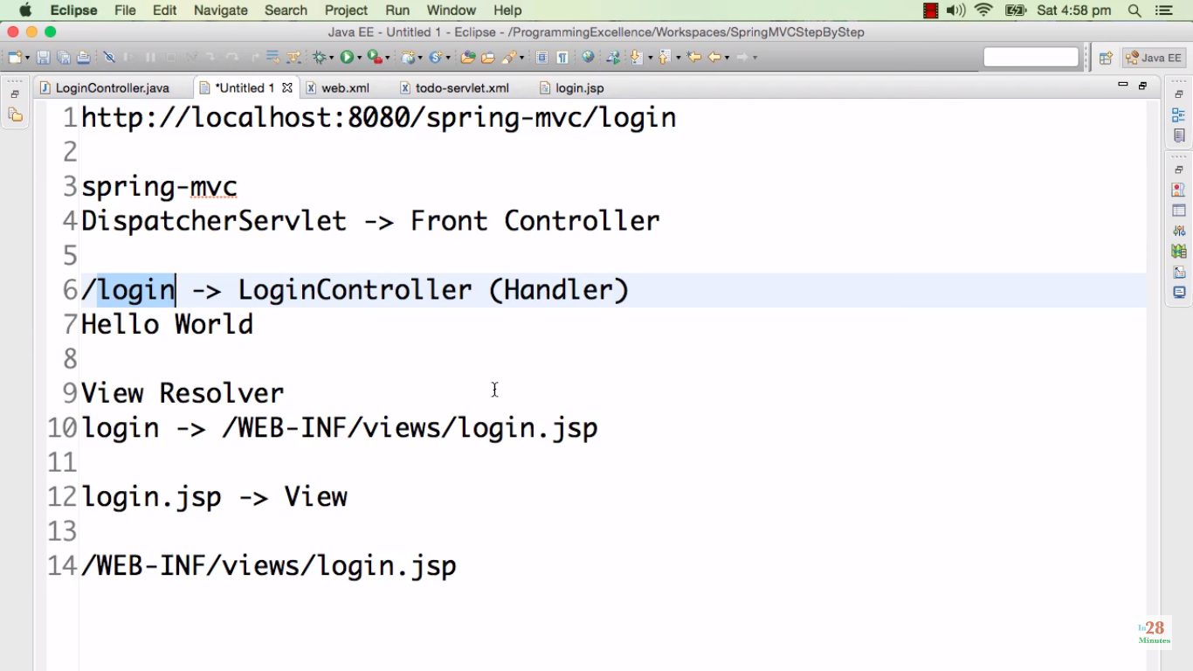

**Spring MVC Architecture -**

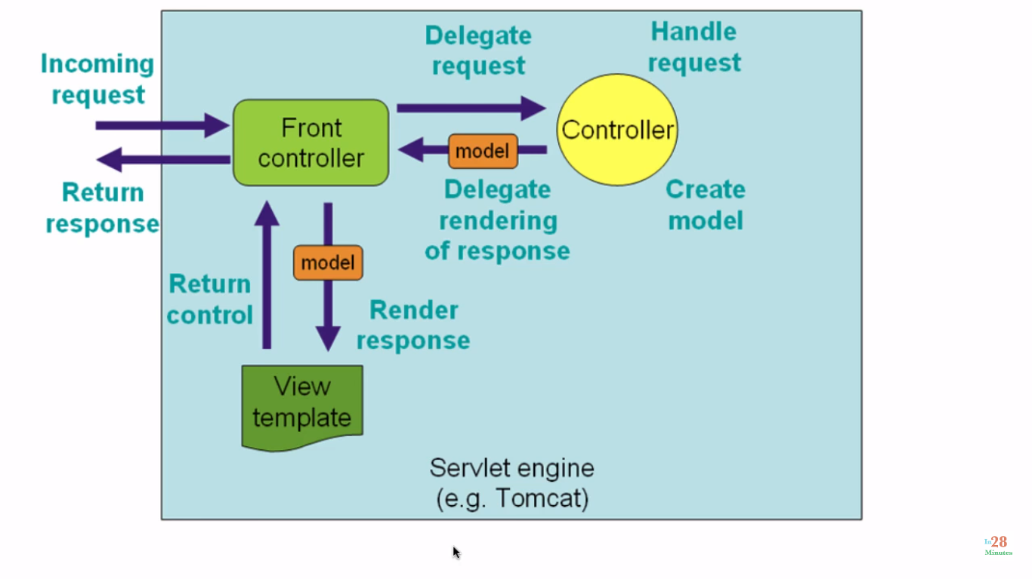

**Standard flow -**

DispatcherServlet receives HTTP Request.

DispatcherServlet identifies the right Controller based on the URL.

Controller executes Business Logic.

Controller returns a) Model b) View Name Back to DispatcherServlet.

DispatcherServlet identifies the correct view (ViewResolver).

DispatcherServlet makes the model available to view and executes it.

DispatcherServlet returns HTTP Response Back.

Flow : <http://docs.spring.io/spring-framework/docs/2.0.8/reference/images/mvc.png>

In this example –

Front controller (DispatcherServlet) finds the right controller to redirect a request to.

It is called when /spring-mvc/ - root folder of the project is invoked/ called – from browser or API call from postman etc.

It is configured in web.xml

Controller (LoginController) annotated with @Controller decides which view has to be rendered to front controller.

View Resolver - Front controller uses to find the actual view (JSP) to render. -> /WEB-INF/views/login.jsp

Front controller then renders that jsp.