Practical No. 3

Name: **Nalawade Prafulla Chandrashekhar.**

Roll No. : 42

Batch:B3

Step 1: Extract (Load Data)

* Open Power BI Desktop.
* Click Home > Get Data > Text/CSV.
* Browse to select your sales_data.csv.
* Click Load to import it into Power BI

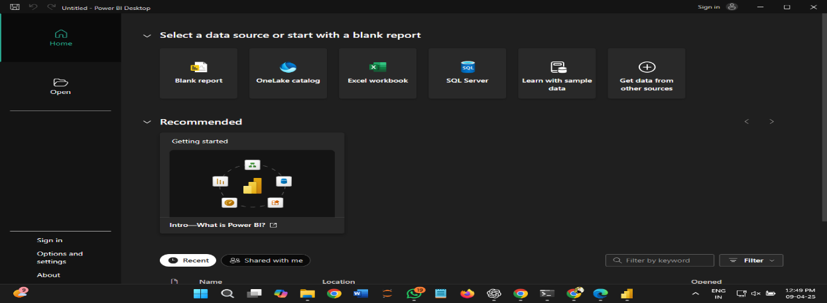

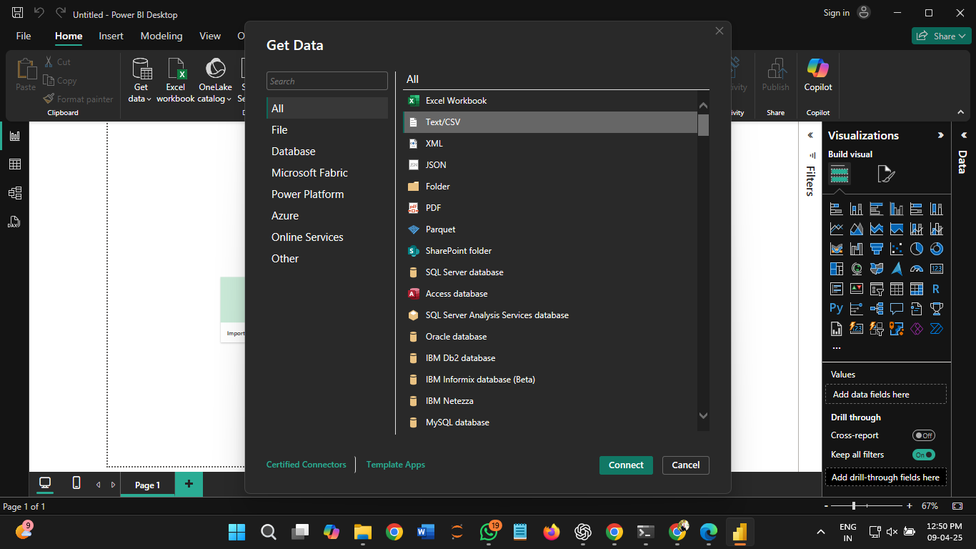



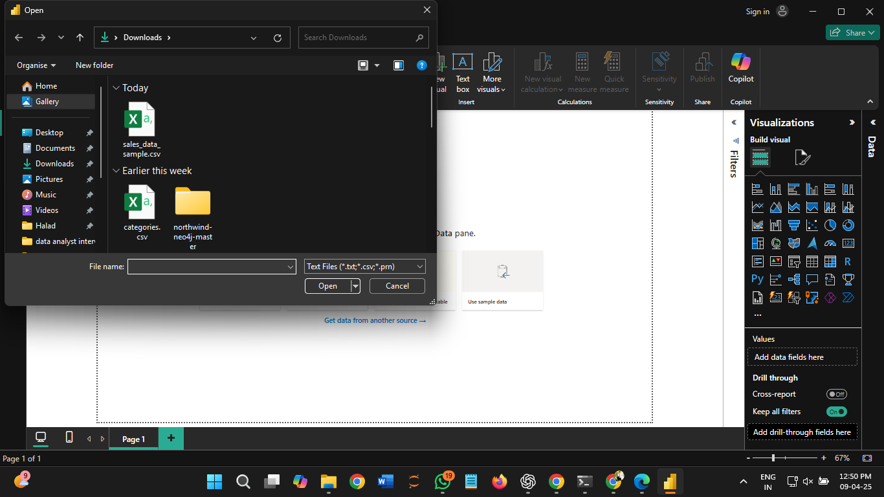

Step 2: Transform (Clean & Modify Data)

* Click Transform Data (Power Query Editor opens).
* Rename Columns (if needed):

Double-click column headers to rename (e.g., Sales Amount → sales).

* Change Data Types:

Right-click column headers → Change Type → Choose appropriate type (e.g., sales to Decimal, date to Date).

* Normalize the Sales Column:

Go to Add Column > Custom Column.

* Enter a name: normalized_sales Click OK – this will create a new normalized column.

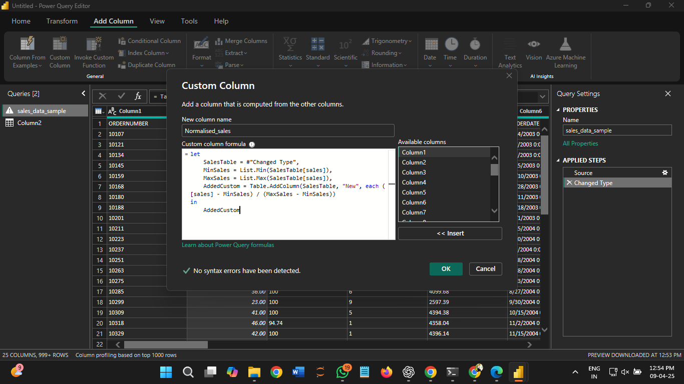

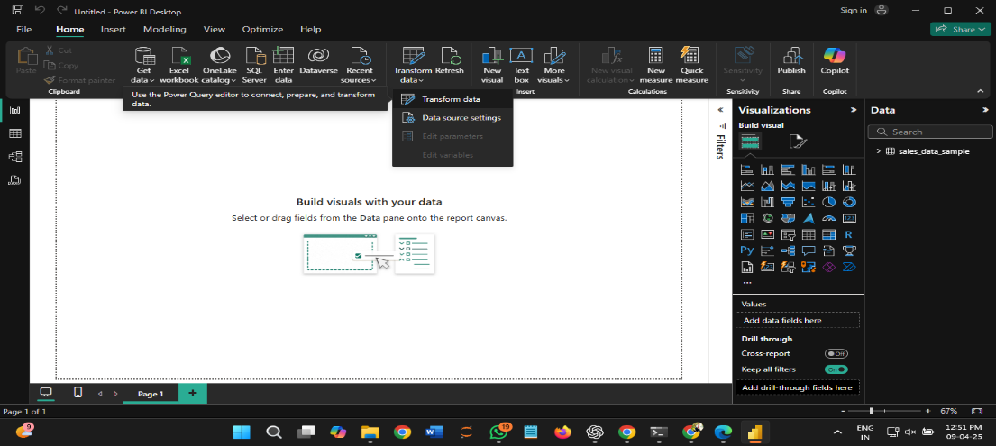

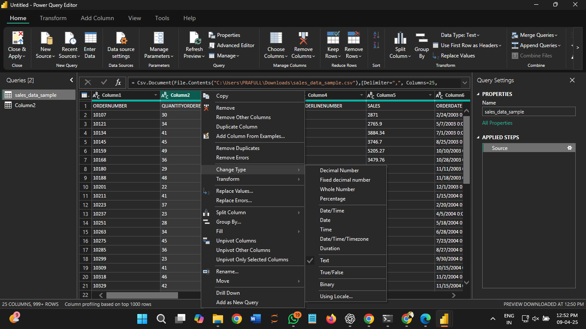

Step 3: Load (Apply to Data Model)

* Click Close & Apply.

