

**Institute of Engineering & Technology**

MINI PROJECT REPORT

**On**

**ICC Cricket World Cup**

**PREDICTION**

**Submitted by**

**PRAFULLIT SHUKLA**

**Roll No: 171500222**

**SEC-A**

**NITIN KUMAR SRIVASTAVA**

**ROLL NO:171500208**

**SEC-A**

**ROHAN YADAV**

**ROLL NO:171500266**

**SEC-C**

Department of Computer Engineering & Applications

**Institute of Engineering & Technology**



**Department of computer Engineering and Applications**

**GLA University, Mathura**

**17 km. Stone NH#2, Mathura-Delhi Road, P.O. – Chaumuha,**

**Mathura – 281406**

**Declaration**

We hereby declare that the work which is being presented in the S Mini Project **“ICC Cricket World Cup Prediction”,** in partial fulfillment of the requirements for Mini project, is an authentic record of our own work carried under the supervision of **“Department of Computer Engineering & Applications, GLA University” .**

**Signature of Candidates:**

**Name of Candidates: Prafullit Shukla,Nitin Kumar Srivastava,Rohan Yadav**

**Course: B.TECH CSE**

**Year: 3rd Year**

**Semester: Vth Semester**

ABSTRACT

Prediction about the result of cricket matches astonishing as a research problem, especially due to its complexity, unpredictable assumption (weather and pitch conditions). Because the ultimate outcome of a cricket match is based on many aspect and unaccepted bearings therefore it is difficult responsibility to predict the exact and partial truth-based outcomes of cricket matches such a research expects a multi criteria decision making approach. The main objective of the project is to present and analyze thoroughly some interesting historical stats about the World Cup, by making an extensive flashback to its history. The span of the flashback starts in 1975, the year that the first World Cup took place. The last part of the research presents some useful information about the current World Cup of 2019.

**Table of Contents**

1.Introduction………………………………………………………...

**2. REQUIREMENT SPECIFICATION………….……………………….**

2.1 HARDWARE REQUIREMENTS…………………………………

2.2 SOFTWARE REQUIREMENT…………………………………..,,.

# **3.** **DATA VISUALIZATION………………………………………………...**

3.1INTRODUCTION..………………………………………..……….....

3.2 KEY PLOTS……………………………………………………….…...…

**4. SNAPSHOTS OF THE PROJECT………………………….…………..**

**5. POSSIBLE FUTURE WORK………………………………..…………**

**6. REFERENCES…………….……………………………………………....**

1. **INTRODUCTION**

Prediction about the result of cricket matches astonishing as a research problem, especially due to its complexity, unpredictable assumption (weather and pitch conditions). Because the ultimate outcome of a cricket match is based on many aspect and unaccepted bearings therefore it is difficult responsibility to predict the exact and partial truth-based outcomes of cricket matches such a research expects a multi criteria decision making approach.

The main objective of the project is to present and analyze thoroughly some interesting historical stats about the World Cup, by making an extensive flashback to its history. The span of the flashback starts in 1975, the year that the first World Cup took place. The last part of the research presents some useful information about the current World Cup of 2019.

The first part is consisted of a thoroughly analysis about the best teams in the history of the Cup, simultaneously with a briefly introductory information about the pitches history. Additionally, the second part, contains some more complicated stats and analyses, such as some useful graphs about the World Cup players and the number of wins.

Data analytics has changed the way we are watching the matches but we don't even know that. If we introspect for a moment, we will be surprised at seeing the transformation and how the landscape of current times have changed - mostly due to how data science has helped in this analytics domain to take the game to another dimension altogether.

1. **REQUIREMENT SPECIFICATION**
   1. **HARDWARE REQUIREMENTS:**

The most common set of requirements defined by any operating system or software application is the physical computer resources, also known as hardware. A hardware requirements list is often accompanied by a hardware compatibility list (HCL), especially in case of operating systems. An HCL lists tested, compatibility and sometimes incompatible hardware devices for a particular operating system or application. The following sub-sections discuss the various aspects of hardware requirements.

HARDWARE REQUIREMENTS FOR PRESENT PROJECT:

PROCESSOR : Intel dual Core i3

RAM : 1 GB

HARD DISK : 80 GB

* 1. **SOFTWARE REQUIREMENTS:**

Software Requirements deal with defining software resource requirements that need to be installed on a computer to provide optimal functioning of an application. These requirements or pre-requisites are generally not included in the software installation package and need to be installed separately before the software is installed.

**3. DATA VISUALIZATION**

**3.1) INTRODUCTION**

It is a technique that uses an array of static and interactive visuals within a specific context to help people understand and make sense of large amount of data. The data is often displayed in a format that visualizes patterns, trends and correlations. The images may include interactive capabilities, enabling users to manipulate them or drill into the data for querying and analysis.

It describes the effort to help people understand the significance of data by placing it in a visual context. There may be several languages on which we can perform the Data Visualization, but the ones that are much widely used in the field of Data Science are Python and R. Python is a general purpose programming language as well as for Data Visualization and Machine Learning.

**3.2) KEY PLOTS**

**1) Bar Chart**

This is one of the widely used plot, that we would have saw multiple times not just in data analysis, but wherever there is a trend analysis in many fields. Though it may seem simple it is powerful in analyzing data like sales figure every week, revenue from a product, Number of visitors to a site on each day of a week etc.

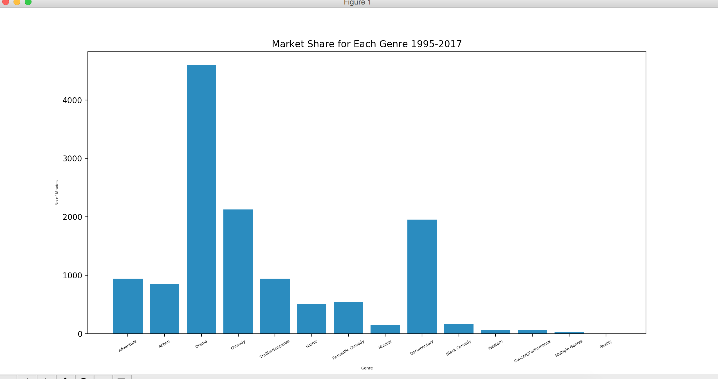

**2) Histogram Plot**

A histogram is a display of statistical information that uses rectangles to show the frequency of data items in successive numerical intervals of equal size. Some histograms are presented with the independent variable along the vertical axis and the dependent variable along the horizontal axis.

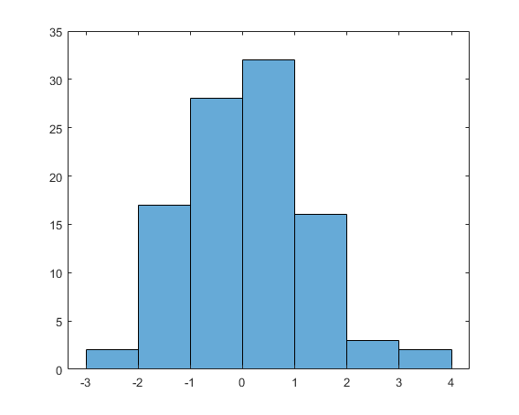

**4. SNAPSHOTS OF THE PROJECT**

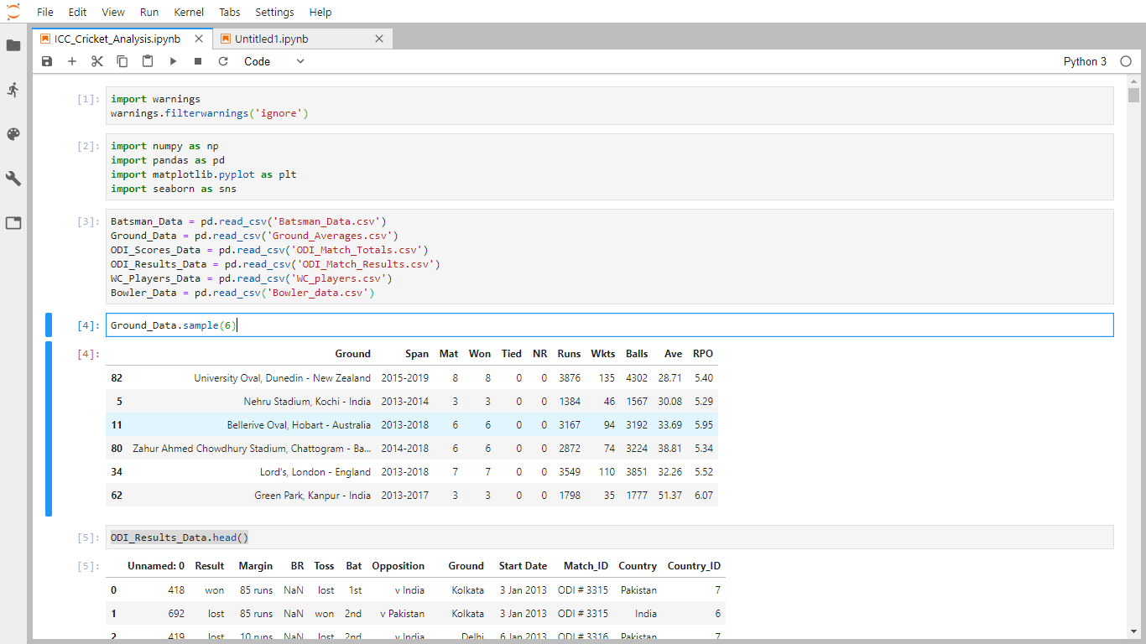

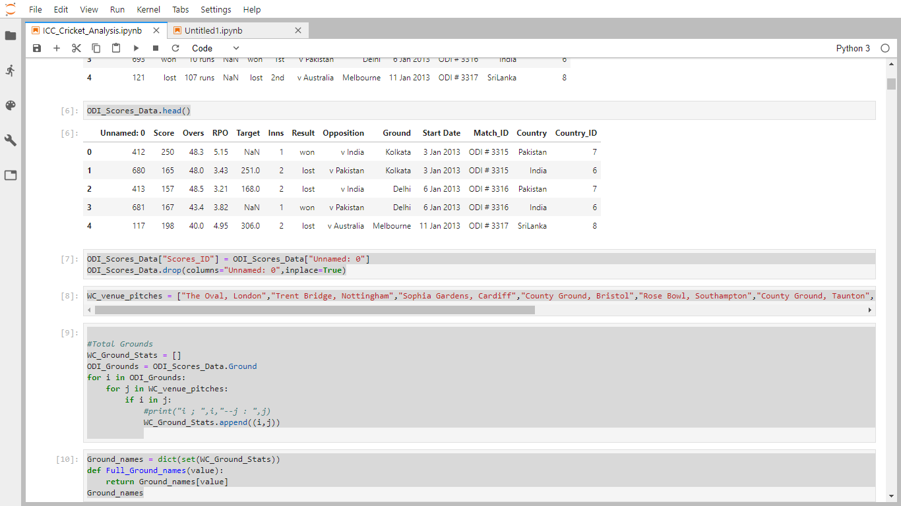

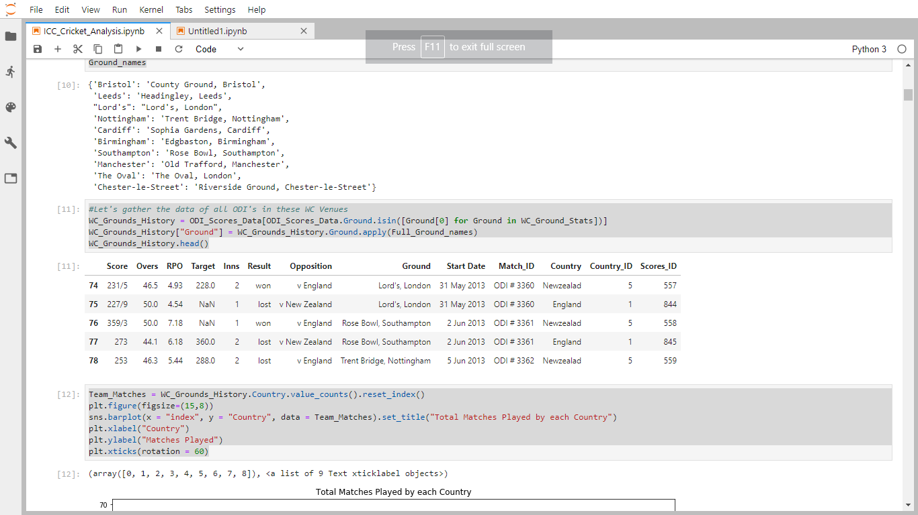

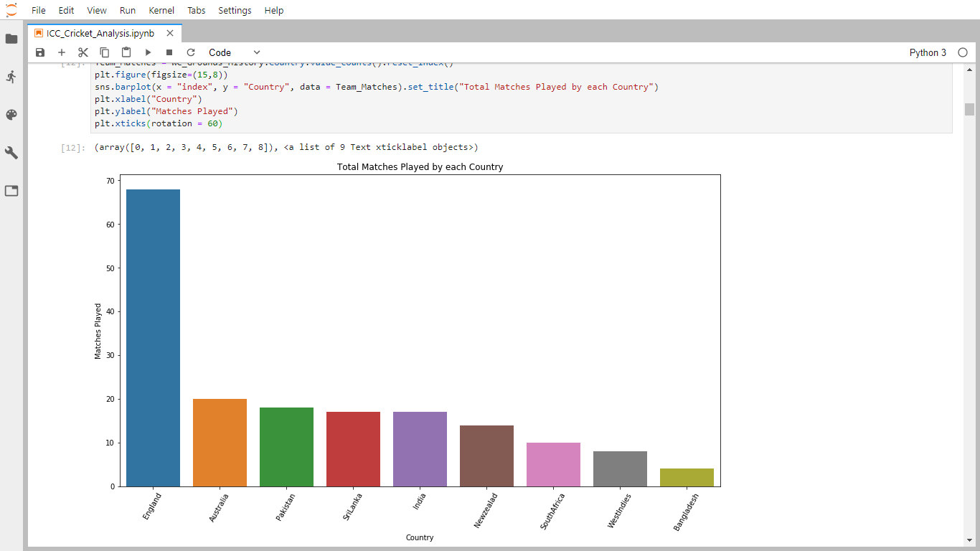

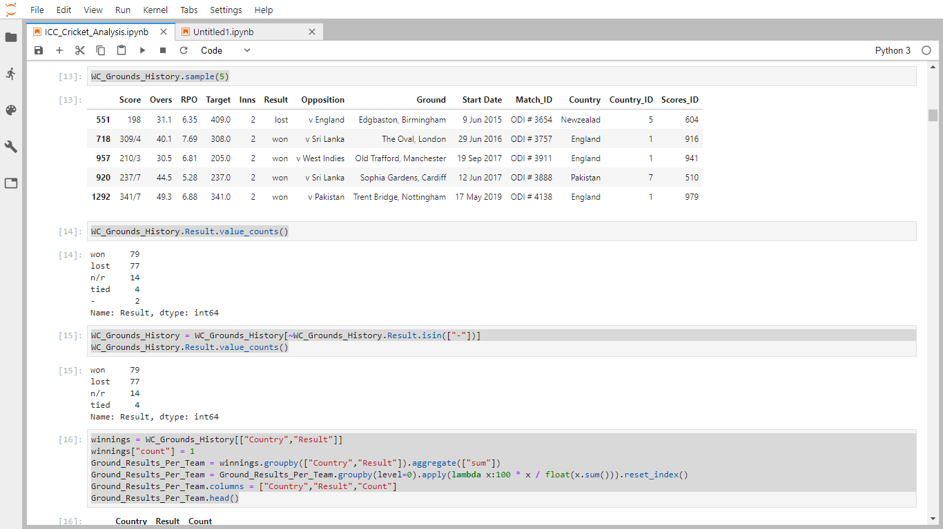

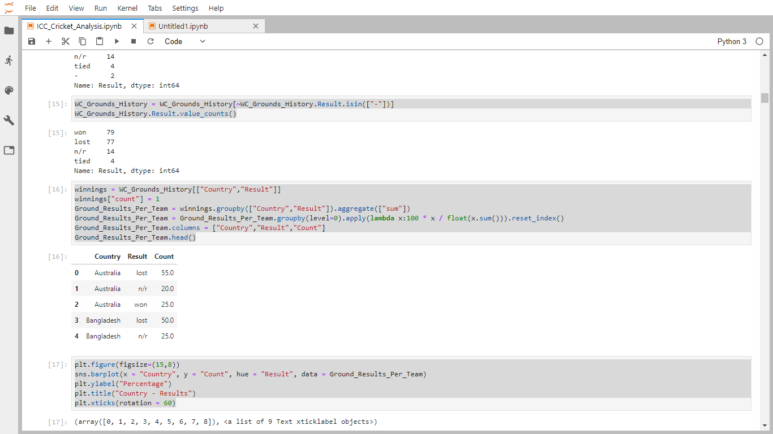

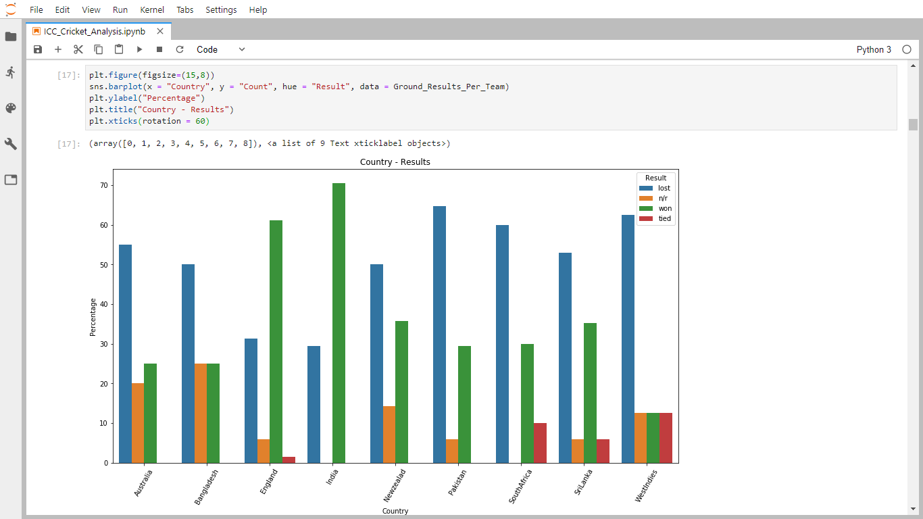

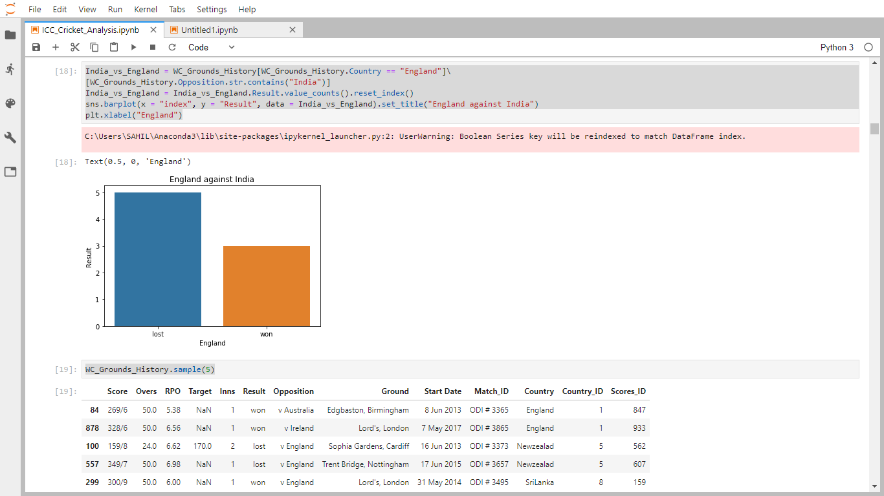

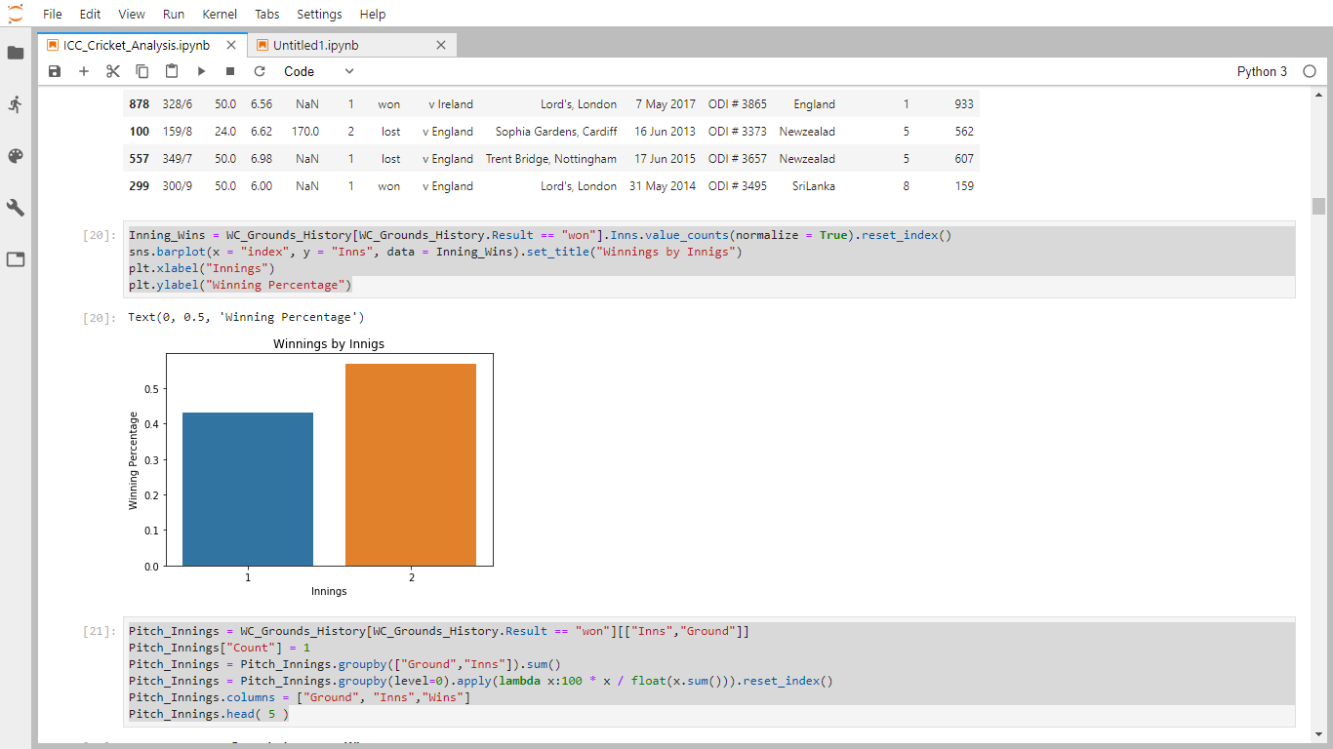

**5.POSSIBLE FUTURE WORK**

Predictiveanalytics is a category of data analytics aimed at making predictions about future outcomes based on historical data and analytics techniques such as statistical modeling and machine learning. The science of predictiveanalytics can generate future insights with a significant degree of precision.Predictiveanalytics are used to determine customer responses or purchases, as well as promote cross-sell opportunities. Predictive models help businesses attract, retain and grow their most profitable customers. Improving operations. Many companies use predictive models to forecast inventory and manage resources. The benefits of video analysisinsports.is one of the obvious benefits of using video analysisinsports is having the ability to hone in and work on the points where players need correcting or need to improve. When players are able to see where they need to improve they are more likely to correct their technique. Performanceanalysis can also be a very useful tool when used to monitor individual player’s skills, and their ability to carry out game-plans and strategies. Stats can be produced to point out players strengths and weaknesses, which is essential when optimizing performances. The data is beneficial to many in the industry including coaches, managers, agents, scouts, marketing professionals, medical personnel and the analytics staff.

# **6. REFRENCES**

* + - 1. <https://www.kaggle.com/>
      2. <https://www.researchgate.net/publication/331399453_Prediction_of_Cricket_World_Cup_2019_by_TOPSIS_Technique_of_MCDM-A_Mathematical_Analysis>
      3. <https://towardsdatascience.com/data-cleaning-with-python-and-pandas-detecting-missing-values-3e9c6ebcf78b>
      4. <https://www.invensis.net/blog/data-processing/5-steps-data-cleansing-customer-data/>
      5. <https://www.samford.edu/sports-analytics/fans/2018/Why-is-Data-Analytics-So-Important-in-Sports>