BEEE LAB EVALUATION

**Aim :** To design a system with two buttons such that a. Red light when any button is pressed during day. b. Green light when both buttons are pressed during day.

**Circuit Diagram:**

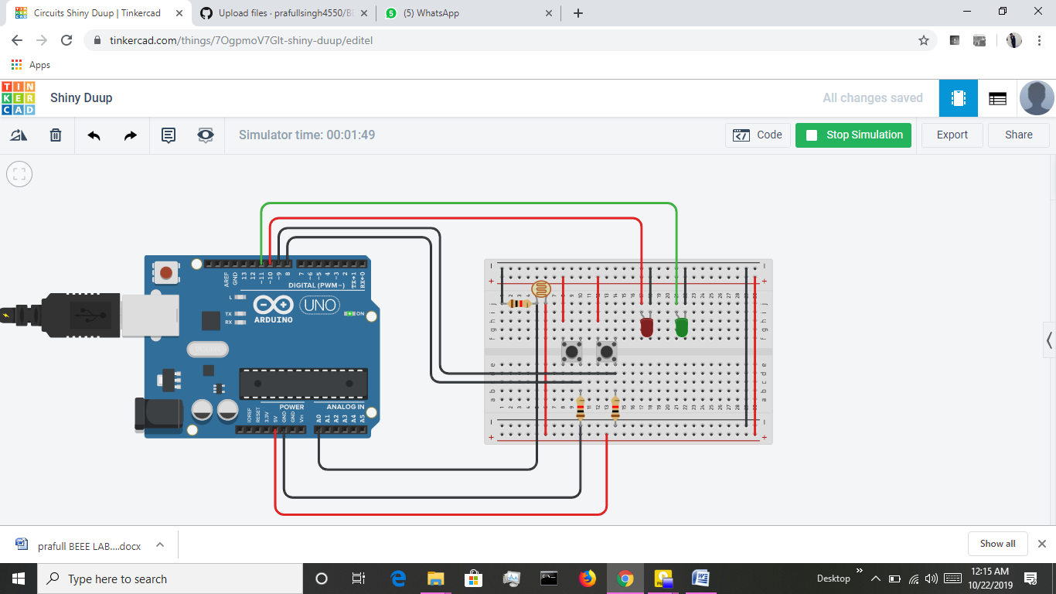

**Theory:**

A Light Dependent Resistor (LDR) is also called a photoresistor or a cadmium sulfide (CdS) cell. It is also called a photoconductor. It is basically a photocell that works on the principle of photoconductivity. The passive component is basically a resistor whose resistance value decreases when the intensity of light decreases. This [**optoelectronic device**](http://www.circuitstoday.com/optoelectronic-devices) is mostly used in light varying sensor circuit, and light and dark activated switching circuits. Some of its applications include camera light meters, street lights, clock radios, light beam alarms, reflective smoke alarms, and outdoor clock.

The **Arduino Uno** is an open-sourcemicrocontroller board based on the MicrochipATmega328P microcontroller and developed by Arduino.cc. The board is equipped with sets of digital and analog input/output (I/O) pins that may be interfaced to various expansion boards (shields) and other circuits. The board has 14 Digital pins, 6 Analog pins, and programmable with the Arduino IDE (Integrated Development Environment) via a type B USB cable. It can be powered by the USB cable or by an external 9-volt battery, though it accepts voltages between 7 and 20 volts.

**Concept Used:**

The Light intensity is being calculated using the LDR , as the light intensity is enough switch will work otherwise switch will not work for both leds.

**Learning and Observations :**

* Making circuits using Breadboard.
* Using Multimeter to apply Resistance on a given LED.
* Working of Arduino UNO.
* Coding to be done on Arduino.exe for stimulation of the experiment.

**Problems & Troubleshooting –**

No problems were occurred during the execution of the experiment.

**Precautions –**

1. The circuit made on breadboard can be wrong.
2. Any Element used can be defective.
3. Resistance of high value used therefore resulting in no current for LED to glow.
4. The coding done for Arduino Board can be incorrect due to which stimulation can be failed.
5. Port Selection for Arduino can be incorrect due to which it wont upload on Arduino Board and resulting in failure of experiment.

**Learning Outcomes –**

1. Setting up circuit on a Breadboard.
2. Using Multimeter.
3. Working and coding of Arduino and its IDE.
4. Using LDR and learning its features .

**Result :** The system made is able to light up first LED in the day by pressing any of switches &

Also when both switches are on second LED works in the day.