**Docker Desktop App & Docker Site profile page must be logged in before start**

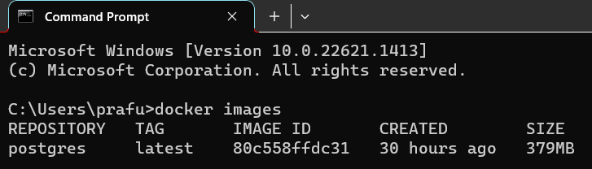

1.docker images: - To see available docker images

2.docker image rm postgres: - to delete postgres image

3.docker image rm postgres -f: - to delete postgres image forcefully

** To pull any image to local repository: -

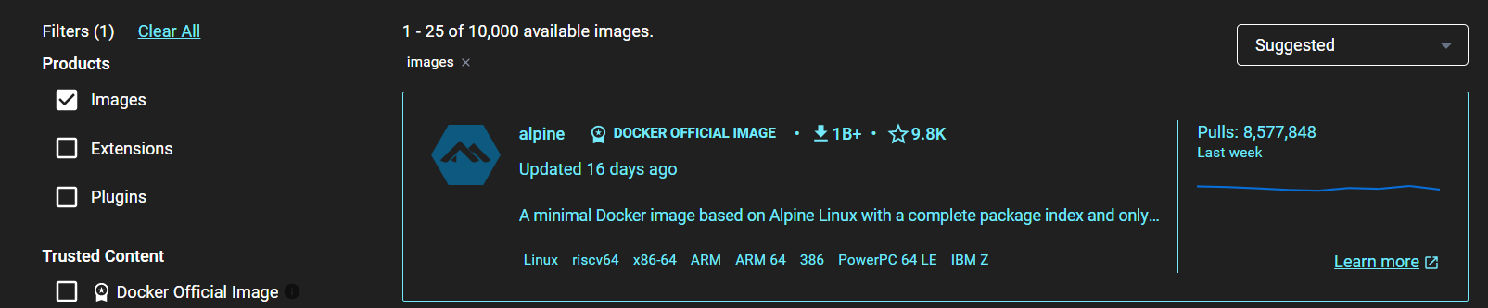

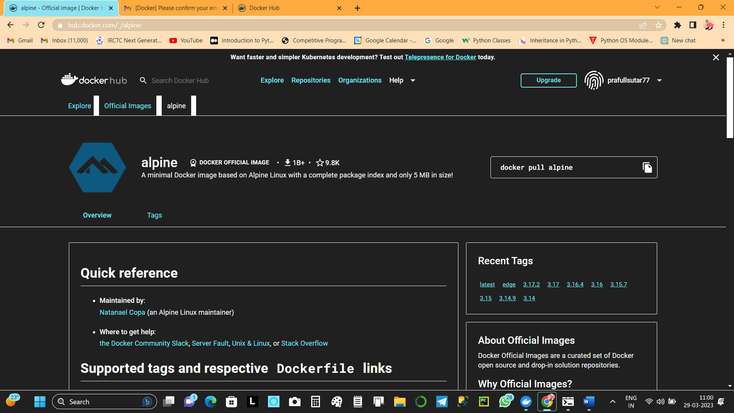

4. docker pull alpine: - To pull image alpine to local repo

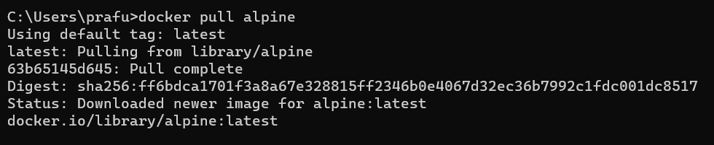

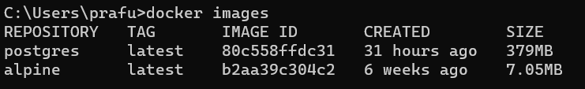

5.docker run: - is used to create new container of latest image by using

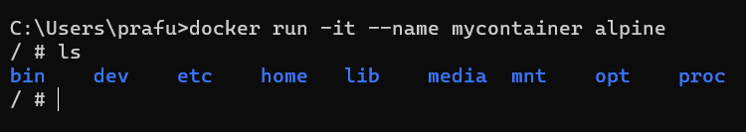

docker run -it --name mycontainer alpine

command rename new name from which image

***NOW WE ARE INSIDE ALPINE***

a.ls to see available file

b.touch test.txt : - to create text file

c.vi test.txt : - to write inside of that file

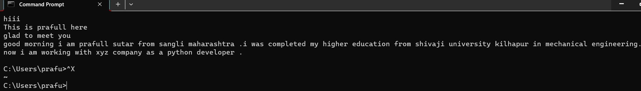

Important commands:-

1.Ctrl x – direct exit from container without make it down (running in background)

2.Ctrl c + ctrl d – to exit from container without running it in background

3.vi test.txt – go inside test.txt file + escape(Esc) +:q! to exit from from container without running it in background

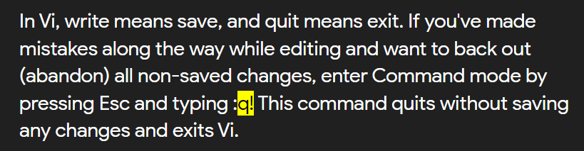

4. 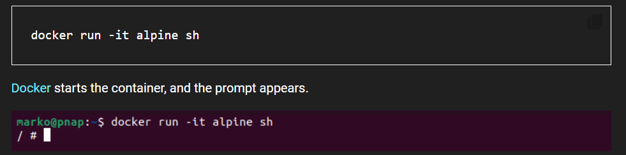

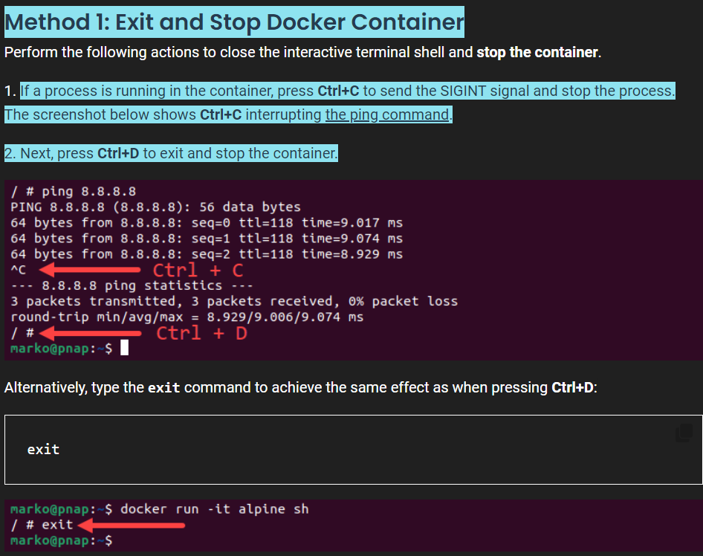

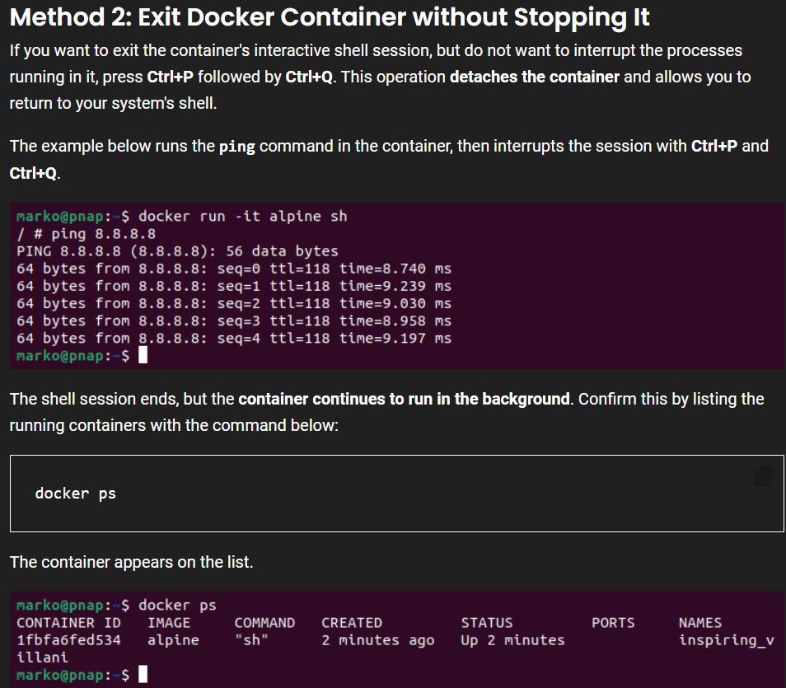

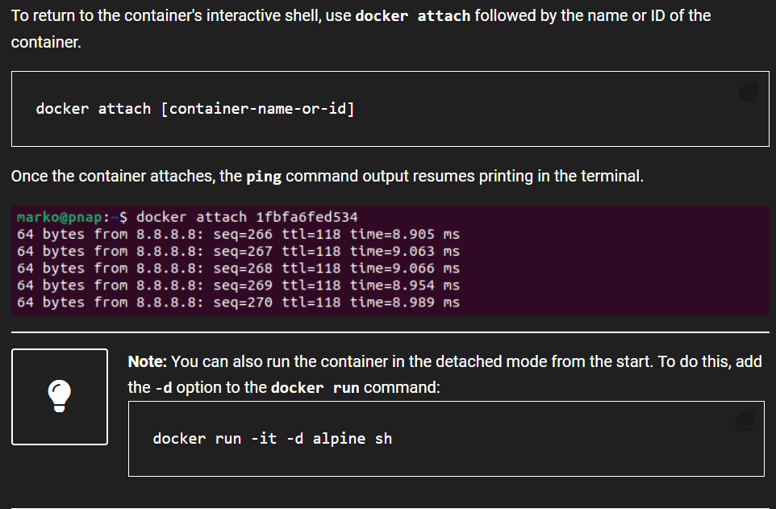

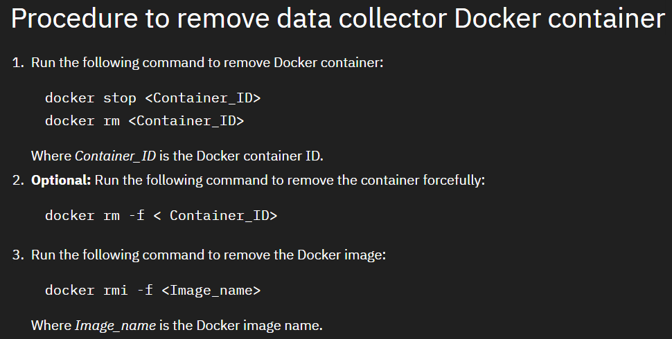

**CODE TO IMAGE:-**

**1.1ST GO INSIDE THE DIRECTORY (C:\Users\prafu\OneDrive\Desktop\docker\test) by using cd command**

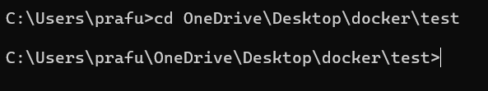

2.Create folders

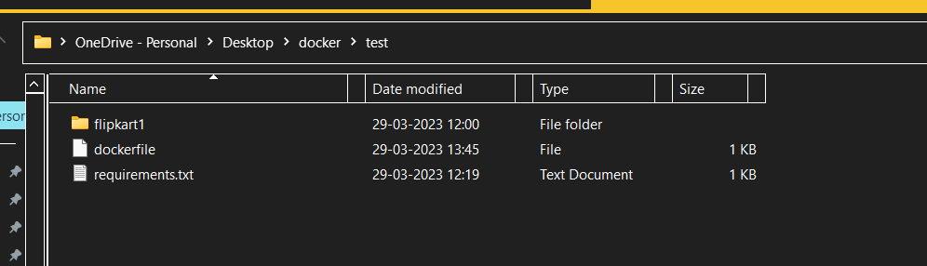

4.**dockerfile**-Must be without extension

Add all the run command inside this

From below folder and also add local local repo address

Site-https://dev.to/foadlind/dockerizing-a-django-mysql-project-g4m

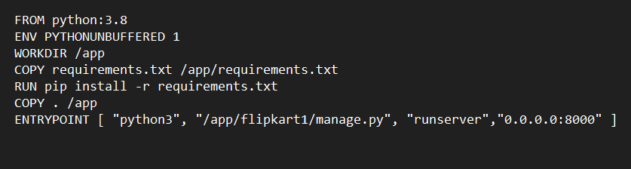

5.Inside the ***Requirements.txt***

At Pycharm CMD prompt

Run below command

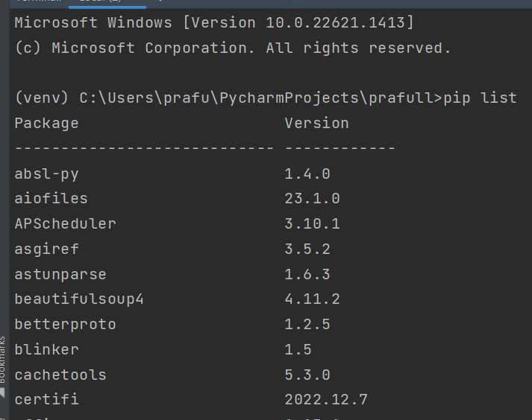

Then to create requirements.txt file & it will automatically create a file of text

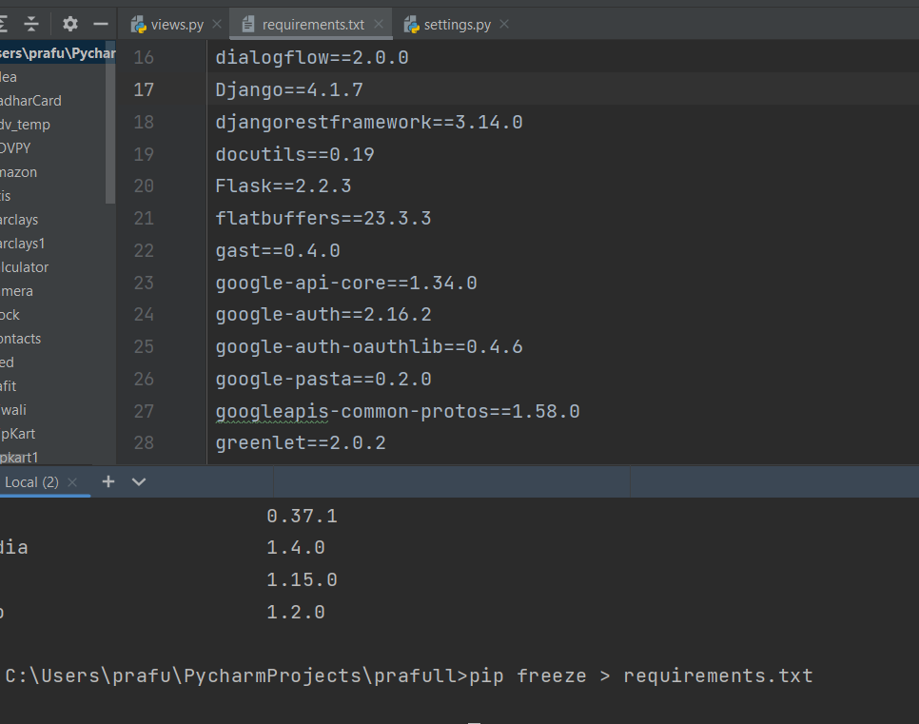

Copy this requirements.txt file at our located file in desktop

5. docker build .(space must after build ->space + full stop)

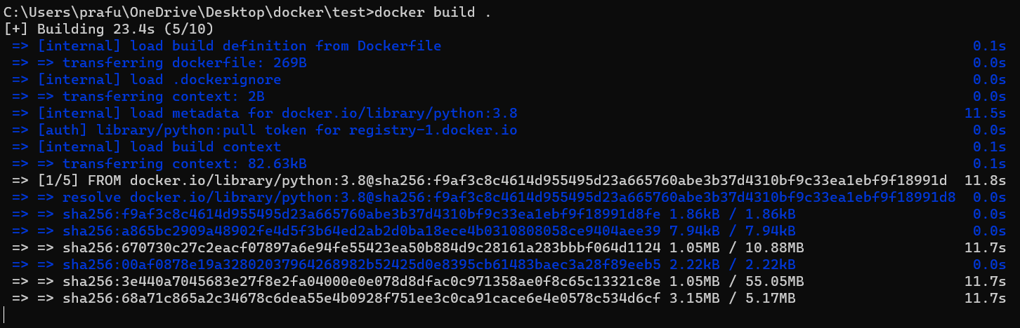

6. docker images

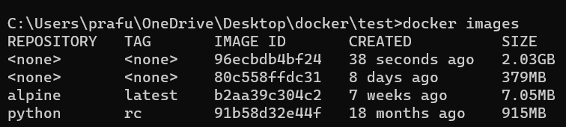

7. **docker build -t myimg1:latest .(space + full stop)**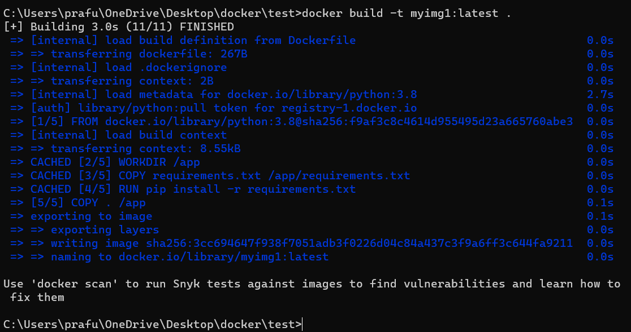

8. docker run -it - -name mydjangoproject myimg1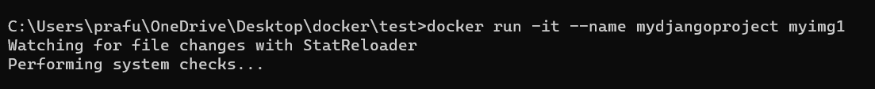

9. 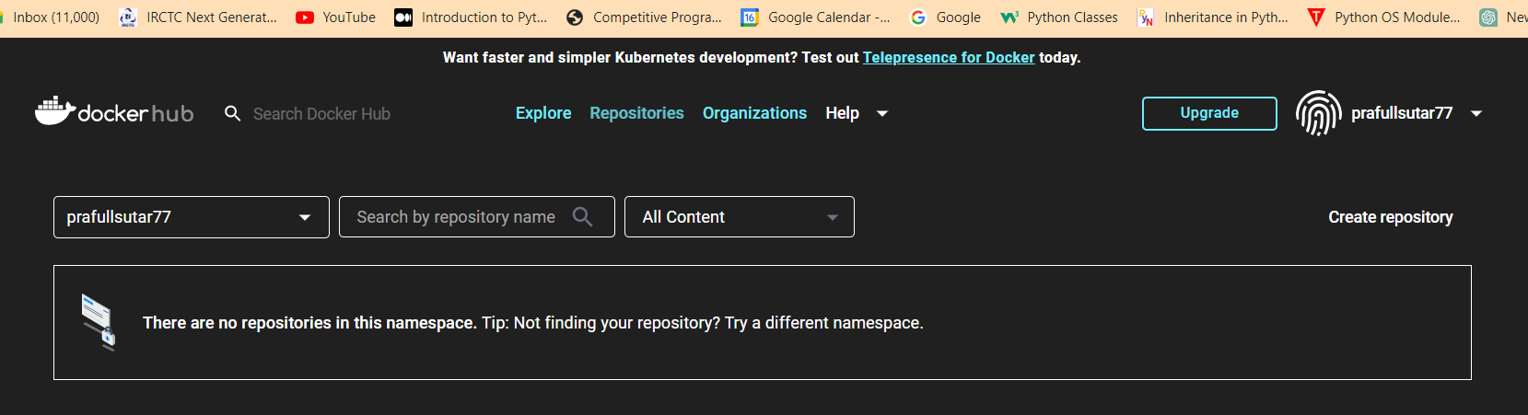

10. 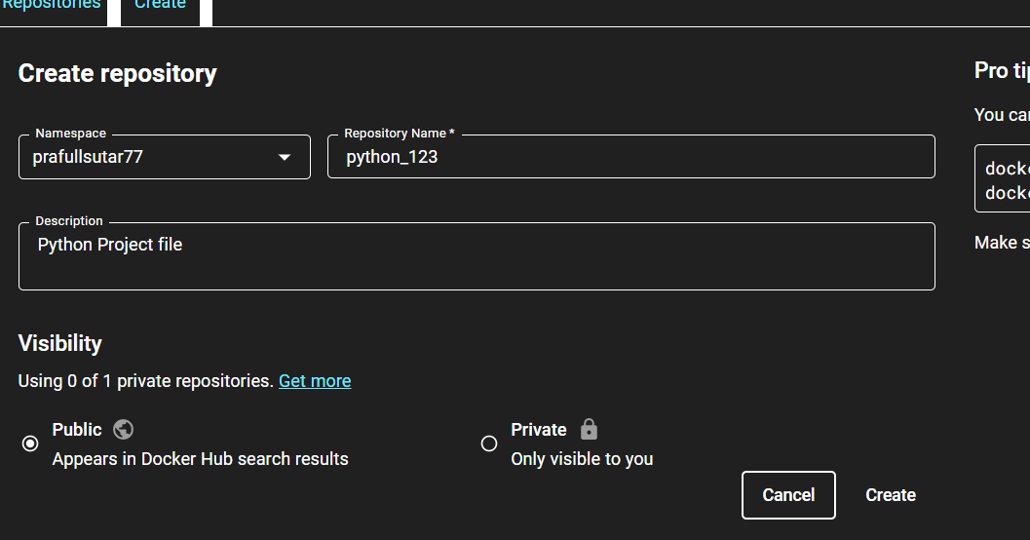

11.to create tag



12. 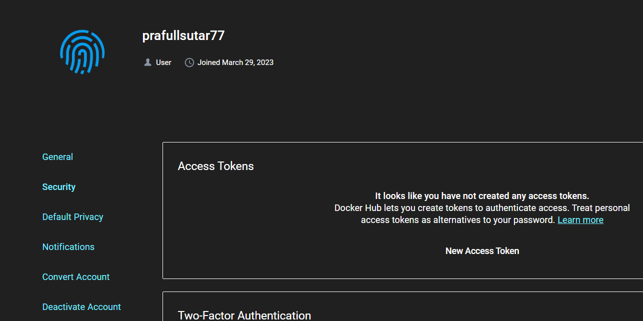

13. 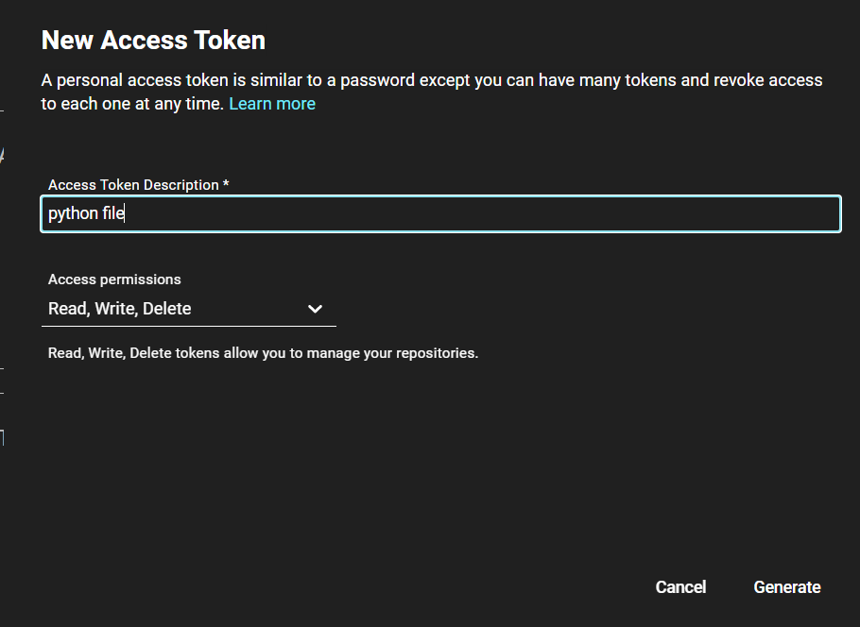

14.

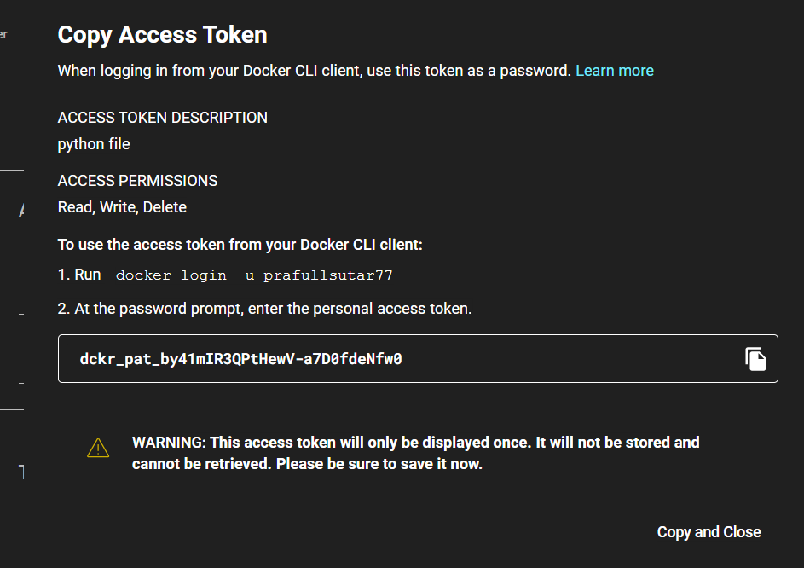

15.

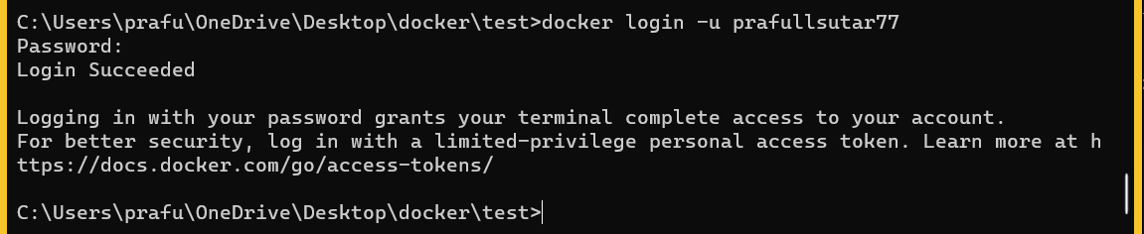

16

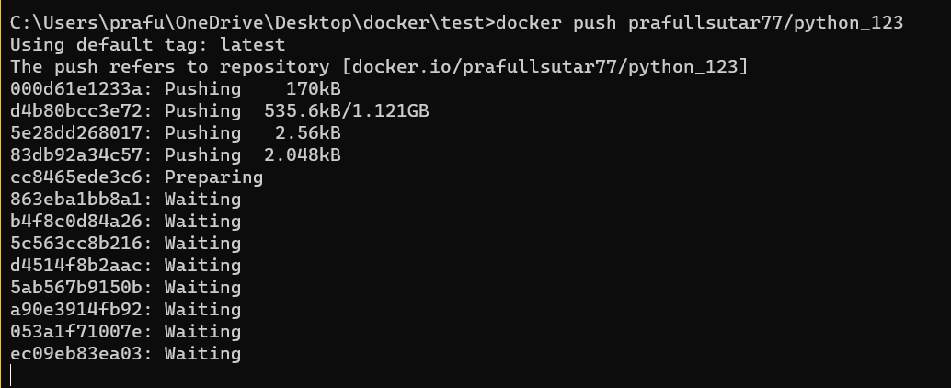

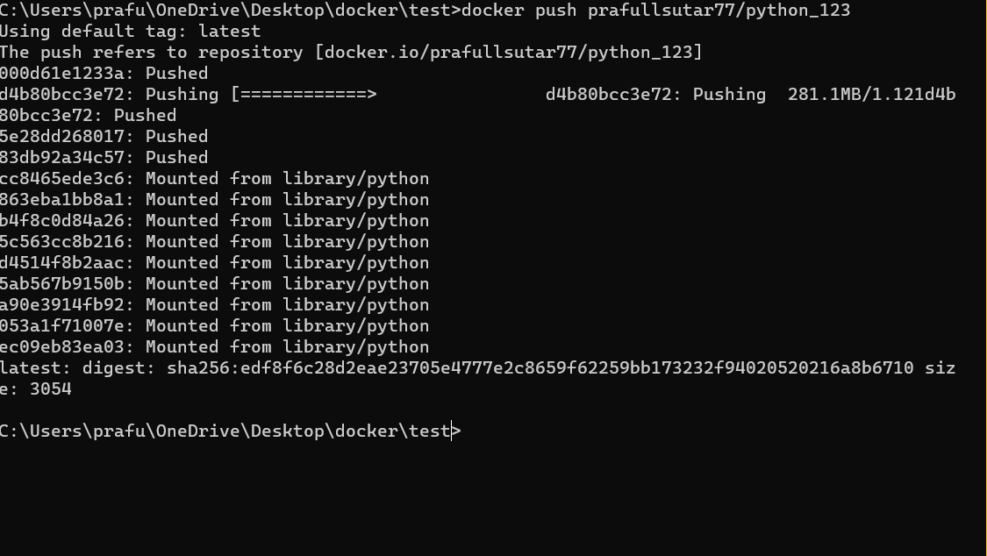

Completed.

