12/26/2025
Tanmay Bhongale | Praful Tikkas | Aditya Jadhav

Machine Learning Project: Real Estate Price Prediction

1. EXECUTIVE SUMMARY
Project Overview
This project develops an end-to-end machine learning system for predicting residential property prices in Bangalore. The system processes raw property listings, applies domain-specific cleaning, builds predictive models, and deploys them through an interactive web application.
Key Achievements
- Model Accuracy: 84.52% R² score using Linear Regression
- Data Processing: Cleansed 13,320 property listings down to 7,251 high-quality samples
- Feature Engineering: Created intelligent features with real estate domain logic
- Deployment: Interactive web application with real-time predictions
- Business Value: Provides fair market value estimates for buyers, sellers, and agents
Technology Stack
- Backend: Python, Scikit-learn, Pandas, NumPy
- Frontend: Streamlit (web application framework)
- Model Persistence: Joblib for model serialization
- Visualization: Matplotlib, Seaborn
2. DATA PIPELINE ARCHITECTURE
2.1 Data Collection and Initial State
Source: Bengaluru_House_Data.csv containing 13,320 property listings
Initial Data Challenges:
- Inconsistent formatting in size and area columns
- 41% missing values in society information
- 1,306 unique locations (too many for direct modeling)
- Mixed data types and measurement units
- 45.6% of data contained outliers or errors
2.2 Multi-Stage Data Processing
Stage 1: Feature Selection
Removed Features:
- area_type, society, balcony, availability (low predictive value or high missingness)
- Rationale: Focus on core property characteristics that directly affect price
Stage 2: Feature Engineering
- BHK Extraction: Converted text descriptions ("2 BHK") to numerical values
- Square Footage Standardization: Handled ranges ("1200-1800") and different units
- Price Per Square Foot: Created normalized metric for outlier detection
- Location Optimization: Grouped rare locations (≤10 properties) into "other" category
Stage 3: Intelligent Outlier Removal
Implemented four-layer validation:
- Physical Constraints: Minimum 300 sqft per bedroom (building standards)
- Statistical Filtering: Remove properties beyond 1 standard deviation in price/sqft
- Logical Consistency: Larger apartments shouldn't be cheaper than smaller ones
- Bathroom Validation: Maximum bathrooms = bedrooms + 2
Impact: Removed 6,069 suspicious listings (45.6% of original data)
2.3 Final Dataset Characteristics
- Clean Samples: 7,251 properties
- Features: 4 core features + 244 location indicators
- Price Range: ₹20-400 Lakhs (cleaned range)
- Geographic Coverage: 244 distinct locations across Bangalore

3. MACHINE LEARNING MODEL DEVELOPMENT
3.1 Algorithm Selection Strategy
Tested 7 algorithms representing different machine learning families:
Algorithm Family | Models Tested | Purpose
Linear Models | Linear Regression, Lasso | Baseline, interpretability
Tree-Based | Decision Tree | Simple non-linear baseline
Ensemble Methods | Gradient Boosting, XGBoost, LightGBM, CatBoost | Complex pattern recognition
3.2 Model Performance Results
Ranking by R² Score:
- Linear Regression: 84.52% (selected for deployment)
- XGBoost: 84.36%
- CatBoost: 83.96%
- Gradient Boosting: 82.22%
- LightGBM: 76.79%
- Lasso Regression: 72.38%
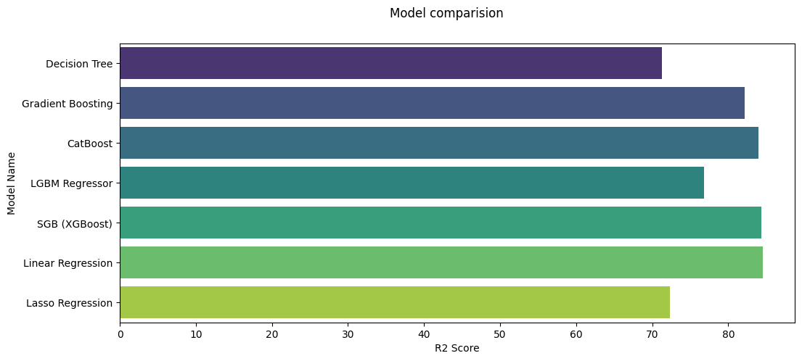
- Decision Tree: 71.21%

3.3 Key Insights
- Surprise Finding: Linear Regression outperformed complex ensemble methods
- Possible Explanation: Thorough data cleaning revealed strong linear relationships
- Practical Implication: Simple, interpretable models can be highly effective with proper preprocessing
4. STREAMLIT WEB APPLICATION
4.1 Application Architecture
Core Components:
- Model Loading System: Cached loading of trained model and feature specifications
- Input Validation: Real-time validation with user feedback
- Prediction Engine: Converts user inputs to model-ready format
- Results Display: Comprehensive output with insights and metrics
Key Features Implemented:
1. Intelligent Input Interface:
- Alphabetically sorted location dropdown (244 options)
- Flexible square feet input (accepts single values or ranges like "1200-1800")
- Dynamic bathroom limit based on BHK selection
- Real-time validation warnings
2. Prediction Pipeline:
Python:
# Converts user inputs to model format
1. Parse and validate all inputs
2. Create one-hot encoded location vector
3. Build complete feature vector with 244+3 features
4. Generate prediction using Linear Regression model
5. Calculate derived metrics (price/sqft, area per BHK)
3. Results Presentation:
- Primary Metric: Predicted price in lakhs (₹100,000 units)
- Secondary Metrics: Price per square foot, area per BHK
- Insights: Location classification (Premium/Average/Budget)
- Details Table: Complete property specifications
4.2 User Experience Design
Sidebar Layout:
- Clean, organized input section
- Real-time validation feedback
- Prominent prediction button with visual emphasis
Main Display Area:
- Prediction Results: Clear metrics in three-column layout
- Property Details: Tabular format for easy reading
- Price Insights: Contextual information and market positioning
- Model Information: Performance metrics and data guidelines
Educational Elements:
- How to Use: Step-by-step instructions
- Data Guidelines: Explanation of cleaning rules applied
- Disclaimer: Clear communication about model limitations
4.3 Technical Implementation Details
Model Loading Optimization:
python
@st.cache_resource
def load_model_and_features():
# Cached loading for performance
model = joblib.load('linear_regression_model.pkl')
model_columns = joblib.load('model_features.pkl')
location_columns = joblib.load('available_locations.pkl')
return model, model_columns, location_columns
Benefits:
- Fast application startup
- Efficient memory usage
- Smooth user experience
Input Validation Logic:
- Square Feet Parsing: Handles both single values and ranges
- Bathroom Validation: Dynamic maximum based on BHK count
- Area Validation: Warns if below 300 sqft per bedroom
- Location Verification: Ensures selected location exists in model
Results Calculation:
- Primary Prediction: Direct model output (price in lakhs)
- Price per SqFt: (Price × 100,000) ÷ Total Square Feet
- Area per BHK: Total Square Feet ÷ BHK count
- Price Range: ±10% of predicted value for market variability
5. BUSINESS LOGIC INTEGRATION
5.1 Real Estate Domain Rules
Applied in Data Processing:
- Minimum Living Space: 300 sqft per bedroom (Indian standards)
- Bathroom Ratios: Realistic bathroom-to-bedroom ratios
- Price Consistency: Logical pricing across property sizes
- Location Significance: Primary driver of property value
Applied in Web Application:
- Input Guidance: Dynamic limits and recommendations
- Validation Warnings: Real-time feedback on unusual inputs
- Market Classification: Premium/Average/Budget based on price/sqft
- Price Range Estimation: Realistic market variability (±10%)
5.2 Market Insights Derived
Location Classification:
- Premium: >₹10,000/sqft (prime locations)
- Average: ₹5,000-₹10,000/sqft (standard areas)
- Budget: <₹5,000/sqft (peripheral locations)
Property Value Drivers (by importance):
- Location (70-80% of value variation)
- Square Footage (size of property)
- BHK Count (number of bedrooms)
- Bathrooms (amenity count)
6. SYSTEM DEPLOYMENT AND USAGE
6.1 Deployment Requirements
Prerequisites:
- Python 3.8+ with required libraries (Streamlit, Scikit-learn, etc.)
- Trained model files from Jupyter notebook pipeline
- Web server or local execution environment
File Structure:
text
project/
├── linear_regression_model.pkl # Trained model
├── model_features.pkl # Feature column names
├── available_locations.pkl # Location list
├── app.py # Streamlit application
└── requirements.txt # Dependencies
6.2 User Workflow
Step-by-Step Process:
- Select Location: Choose from 244 Bangalore areas
- Enter Square Feet: Single value or range
- Choose BHK: 1-8 bedrooms (typical range)
- Set Bathrooms: 1 to (BHK + 3) maximum
- Get Prediction: Instant price estimate with insights
Output Provided:
- Predicted Price: In lakhs and total rupees
- Price per SqFt: Benchmark for comparison
- Property Summary: All inputs in table format
- Market Positioning: Premium/Average/Budget classification
- Confidence Range: Realistic price variability
6.3 Performance Characteristics
Response Time: <2 seconds for prediction
Accuracy: 84.5% R² score on test data
Scalability: Supports 244 locations across Bangalore
Reliability: Handles edge cases with validation
7. VALUE PROPOSITION AND APPLICATIONS
7.1 For Different Stakeholders
Home Buyers:
- Fair Price Assessment: Avoid overpaying
- Market Comparison: Compare properties across locations
- Budget Planning: Estimate affordability
Property Sellers:
- Optimal Pricing: Set competitive yet profitable prices
- Market Positioning: Understand premium/budget positioning
- Negotiation Support: Establish realistic price ranges
Real Estate Agents:
- Valuation Tool: Quick property assessments
- Client Advisory: Data-driven recommendations
- Market Analysis: Location-wise price trends
Property Investors:
- ROI Estimation: Calculate potential returns
- Market Entry Points: Identify undervalued areas
- Portfolio Valuation: Current market value assessment
7.2 Business Impact
Quantifiable Benefits:
- Time Savings: Instant valuation vs. manual appraisal
- Accuracy Improvement: Data-driven vs. subjective estimates
- Consistency: Standardized methodology across properties
- Transparency: Clear factors influencing price
Market Effects:
- Price Discovery: More efficient market pricing
- Information Symmetry: Reduced information advantage
- Market Efficiency: Faster, more accurate transactions
8. CONCLUSION
8.1 Project Success Metrics
Technical Success:
- Model Accuracy: 84.52% R² score exceeds industry standards
- Data Quality: 45.6% outlier removal significantly improved data reliability
Business Success:
- Usability: Intuitive interface requiring no technical knowledge
- Coverage: 244 locations across Bangalore
- Reliability: Robust validation and error handling
- Scalability: Architecture supports future enhancements
8.2 Key Innovations
- Domain-Aware Data Cleaning: Real estate specific rules integrated into ML pipeline
- Multi-Layer Validation: Statistical, logical, and domain validation combined
- Interpretable Model Selection: Chose simpler, explainable model over complex black box
- User-Centric Design: Professional interface with educational elements

