GRAD695 – Unit Testing – Test Case 1.1

Authors: Prafulla Chandra Munugoti

# General Information

|  |  |
| --- | --- |
| Unit | Check Song Existence |
| Source Files | ./MUSICON.py , tests/library.py |
| Function name | check_if_title_exists_in_musicon_library(self, title) |
| Date | Apr 1st, 2023 |
| Engineers | Prafulla Chandra Munugoti |

# Test Code

Source Code:

Test Code:

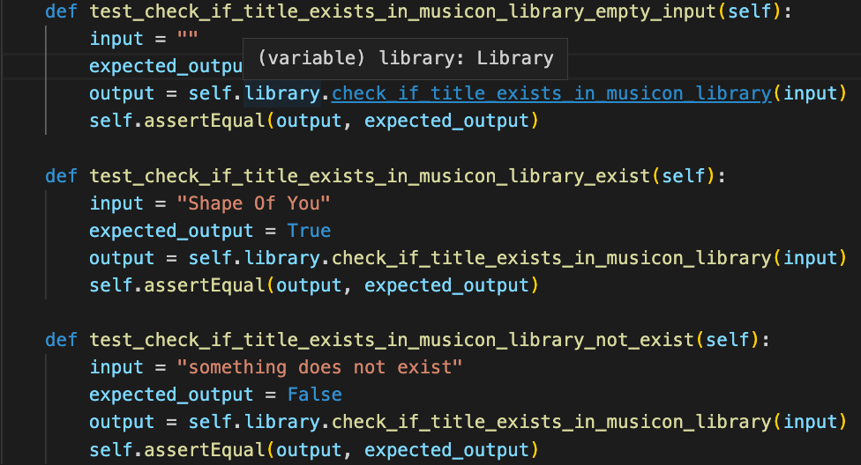Test Results

|  |  |  |  |  |
| --- | --- | --- | --- | --- |
| ID | Inputs | Expected Outputs | Actual Outputs | Result |
| 1 | “”, empty string | False | False | Pass |
| 2 | “Shape Of You”, a title exists in the library | True | True | Pass |
| 3 | “something does not exist” | False | False | Pass |

# Test Methodology & Coverage

White box testing with statement coverage, covering existed and non-existed inputs which will have different outcomes from the program statement.