GRAD695 – Unit Testing – Test Case 1.2

Authors: Prafulla Chandra Munugoti

# General Information

|  |  |
| --- | --- |
| Unit | Add a song into library |
| Source Files | MUSICON.py or tests/library.py |
| Function name | add_song_attributes_into_library_list(self,artist,title,length,genre,year,lyrics,album_name) |
| Date | April 1st, 2023 |
| Engineers | Prafulla Chandra Munugoti |

# Test Code

Source Code:

Test Code:

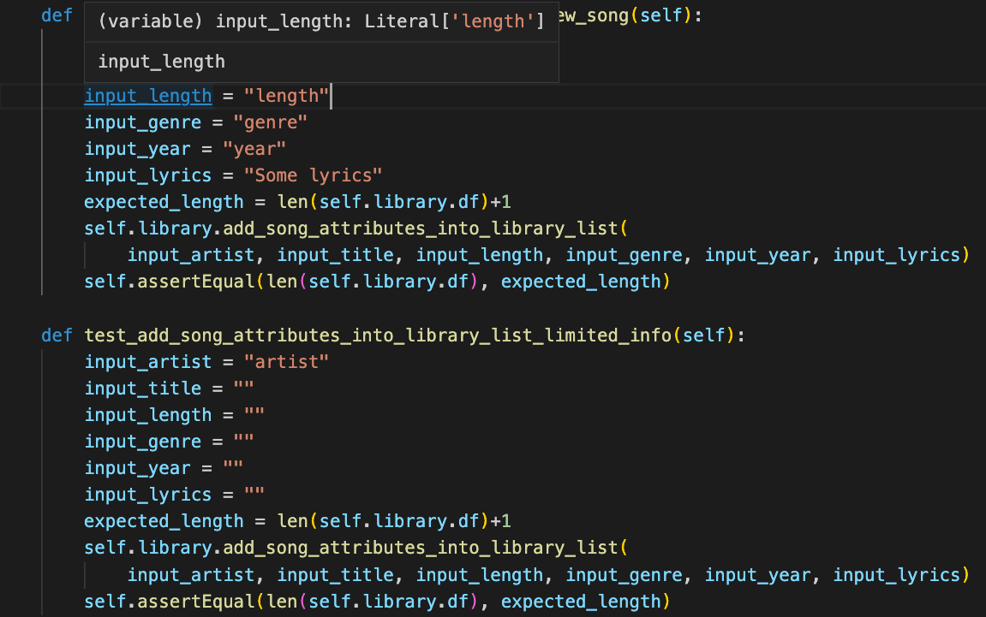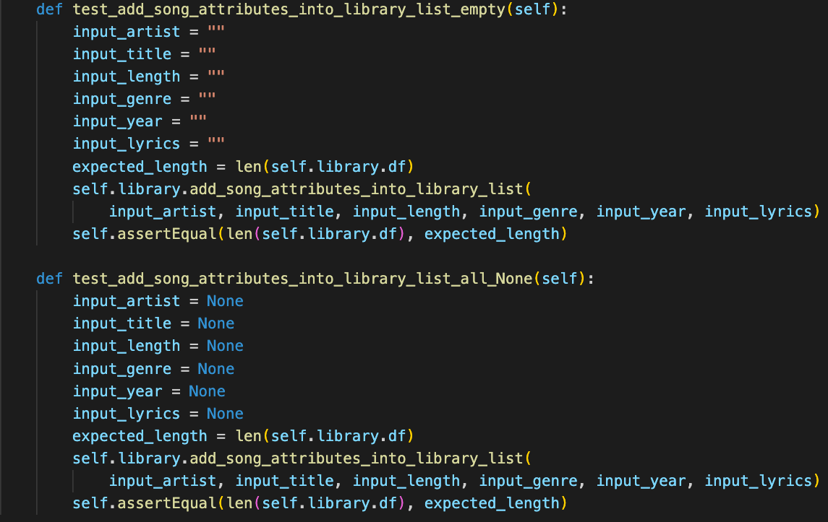

Test Results

|  |  |  |  |  |
| --- | --- | --- | --- | --- |
| ID | Inputs | Expected Outputs | Actual Outputs | Result |
| 1 | Artist  Title  Length  Genre  Year  Some lyrics  Album_name | Library length +1 | Library length +1 | Pass |
| 2 | Artist only | Library length +1 | Library length +1 | Pass |
| 3 | All empty Strings | Library length keeps the same | Library length keeps the same | Pass |
| 4 | All Non-Strings | Library length keeps the same | Library length keeps the same | Pass |

# Test Methodology & Coverage

White box testing with statement coverage.