CISC593 – Unit Testing – Test Case 1.3

Authors: Prafulla Chandra Munugoti

# General Information

|  |  |
| --- | --- |
| Unit | Delete a song from the library |
| Source Files | ./tests/library.py or MUSICON.py |
| Function name | delete_song_attributes_from_library_with_title(self, title) |
| Date | April 1st, 2023 |
| Engineers | Prafulla Chandra Munugoti |

# Test Code

Source Code:

Test Code:

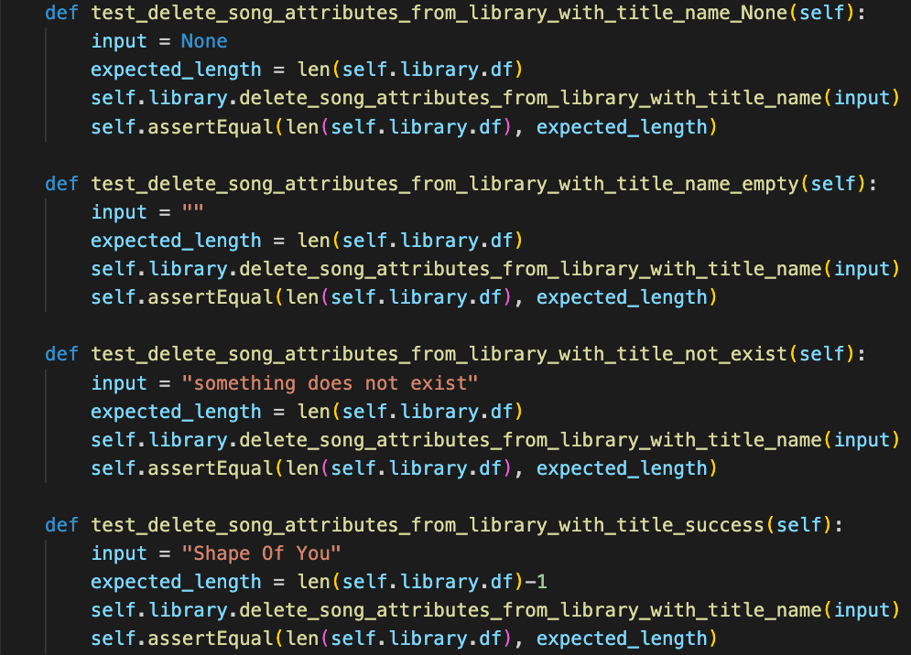

Test Results

|  |  |  |  |  |
| --- | --- | --- | --- | --- |
| ID | Inputs | Expected Outputs | Actual Outputs | Result |
| 1 | None | Library length keeps the same | Library length keeps the same | Pass |
| 2 | Empty String | Library length keeps the same | Library length keeps the same | Pass |
| 3 | A title does not exist in library | Library length keeps the same | Library length keeps the same | Pass |
| 4 | "Shape Of You”, one that exists in library | Library length - 1 | Library length - 1 | Pass |

# Test Methodology & Coverage

White box testing with statement coverage.