GRAD695 – Unit Testing – Test Case 1.4

Authors: Prafulla Chandra Munugoti

# General Information

|  |  |
| --- | --- |
| Unit | Search songs in library by artist’s name |
| Source Files | ./tests/library.py or MUSICON.py |
| Function name | searching_for_titles_in_musicon_library_by_artist(self, artist) |
| Date | April 1st, 2023 |
| Engineers | Prafulla Chandra Munugoti |

# Test Code

Source Code:

Test Code:

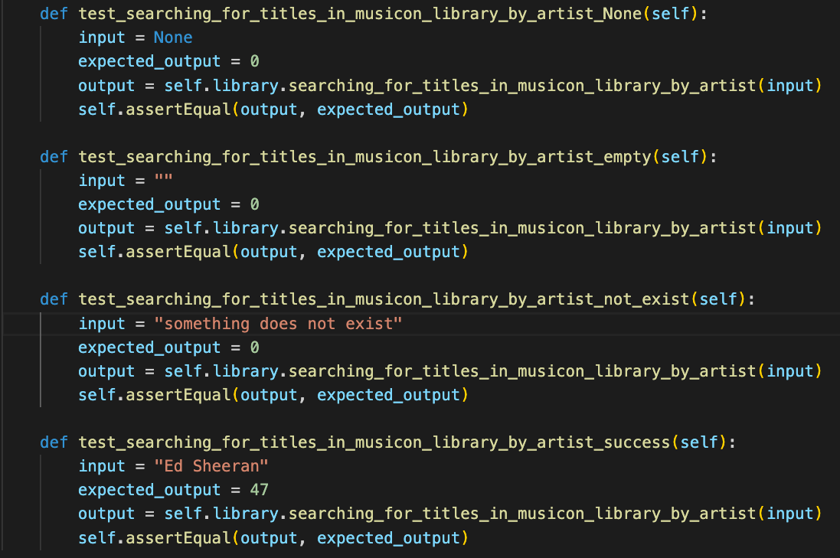Test Results

|  |  |  |  |  |
| --- | --- | --- | --- | --- |
| ID | Inputs | Expected Outputs | Actual Outputs | Result |
| 1 | None | 0 | 0 | Pass |
| 2 | Empty String | 0 | 0 | Pass |
| 3 | An artist does not exist in library | 0 | 0 | Pass |
| 4 | " Ed Sheeran”, one that exists in library | 47 | 47 | Pass |

# Test Methodology & Coverage

White box testing with statement coverage.