CISC593 – Unit Testing – Test Case 1.5

Authors: Prafulla Chandra Munugoti

# General Information

|  |  |
| --- | --- |
| Unit | Display titles as requested |
| Source Files | ./tests/library.py or ./MUSICON.py |
| Function name | show_all_titles_present_in_musicon_library(self)  show_info_about_song_title_from_musicon_library(self, title) |
| Date | April 1st, 2023 |
| Engineers | Prafulla Chandra Munugoti |

# Test Code

**show_all_titles_present_in_musicon_library**

Source Code:

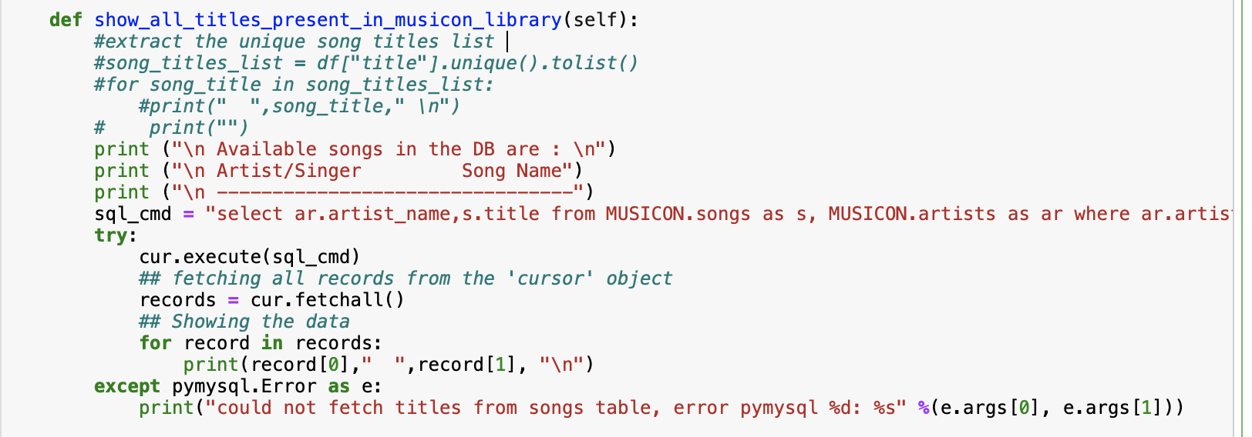 Test Code:

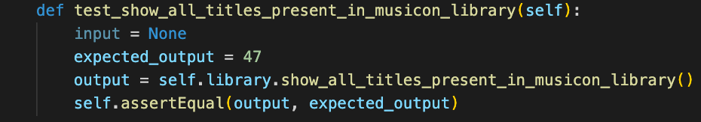**show_info_about_song_title_from_musicon_library**

Source Code:

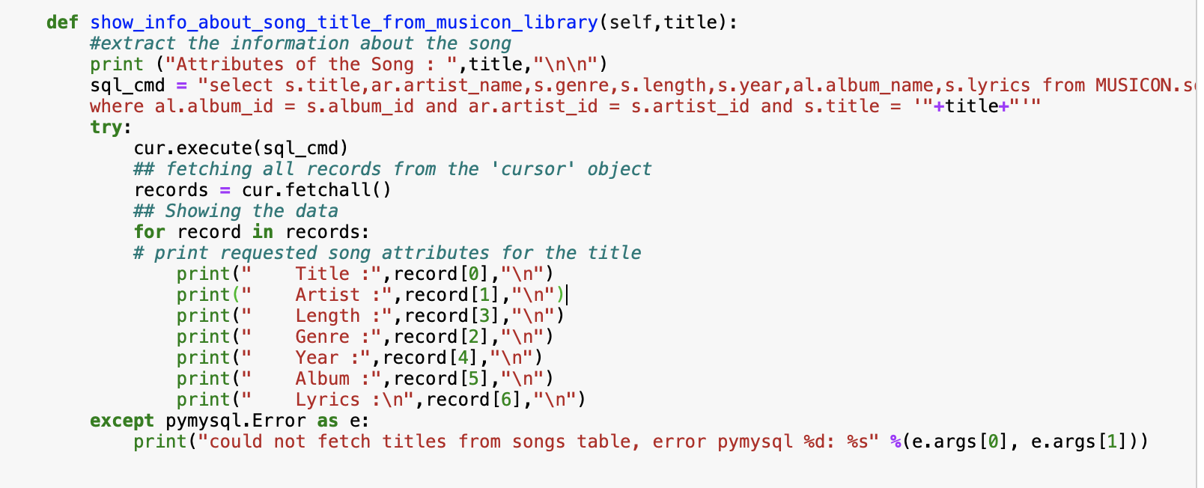

Test Code:

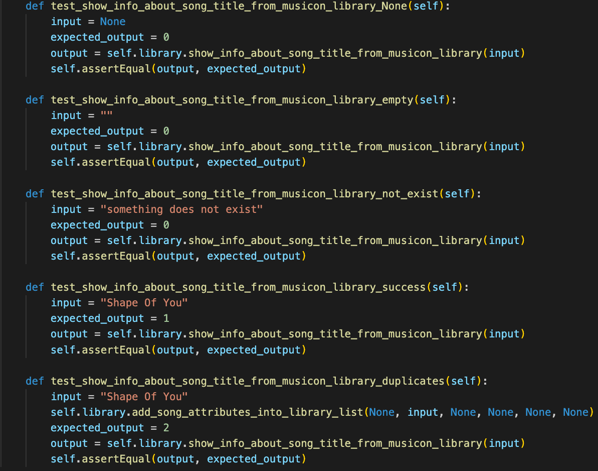

Test Results

|  |  |  |  |  |
| --- | --- | --- | --- | --- |
| ID | Inputs | Expected Outputs | Actual Outputs | Result |
| 1 | None -> show all titles | 47 | 47 | Pass |
| 2 | None -> show info | 0 | 0 | Pass |
| 3 | Empty String | 0 | 0 | Pass |
| 4 | An artist does not exist in library | 0 | 0 | Pass |
| 5 | " Shape Of You”, one that exists in library | 1 | 1 | Pass |
| 6 | “Shape Of You”, after adding a duplicate into library | 2 | 2 | Pass |

# Test Methodology & Coverage

White box testing with statement coverage.