GRAD695 – Unit Testing – Test Case 2.4

Authors: Prafulla Chandra Munugoti

# General Information

|  |  |
| --- | --- |
| Unit | Display all songs in a playlist |
| Source Files | ./tests/playlist.py or ./MUSICON.py |
| Function name | display_songs_in_playlist (self, playlist) |
| Date | April 1st, 2023 |
| Engineers | Prafulla Chandra Munugoti |

# Test Code

Source Code:

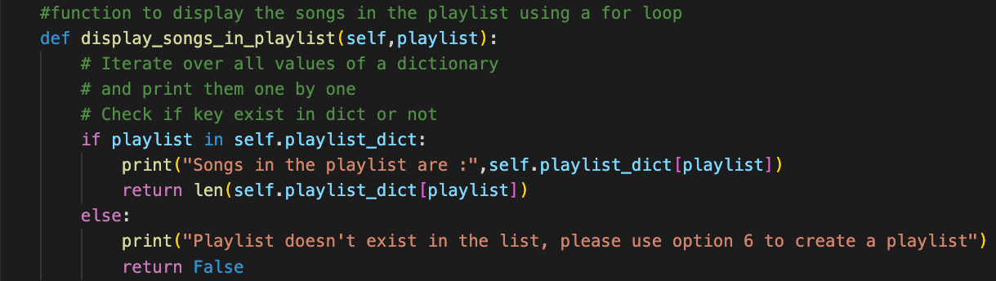Test Code:

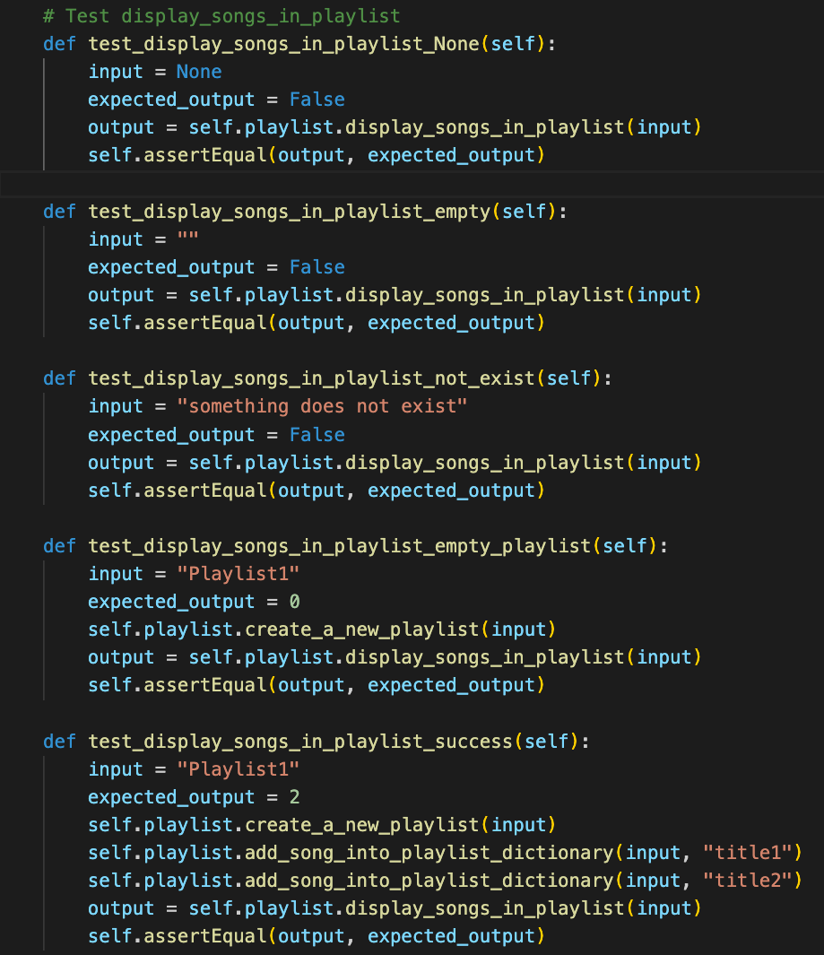

Test Results

|  |  |  |  |  |
| --- | --- | --- | --- | --- |
| ID | Inputs | Expected Outputs | Actual Outputs | Result |
| 1 | None | False | False | Pass |
| 2 | Empty String | False | False | Pass |
| 3 | “Something does not exist” | False | False | Pass |
| 4 | “Playlist1”, without songs | 0 | 0 | Pass |
| 5 | “Playlist1”, with 2 songs added | 2 | 2 | Pass |

# Test Methodology & Coverage

White box testing with statement coverage.