GRAD695 – Unit Testing – Test Case 2.5

Authors: Prafulla Chandra Munugoti

# General Information

|  |  |
| --- | --- |
| Unit | Shuffle all songs in a playlist |
| Source Files | ./tests/playlist.py or ./MUSICON.py |
| Function name | shuffle_songs_in_the_playlist (self, playlist_name, playlist) |
| Date | April 1st, 2023 |
| Engineers | Prafulla Chandra Munugoti |

# Test Code

Source Code:

Test Code:

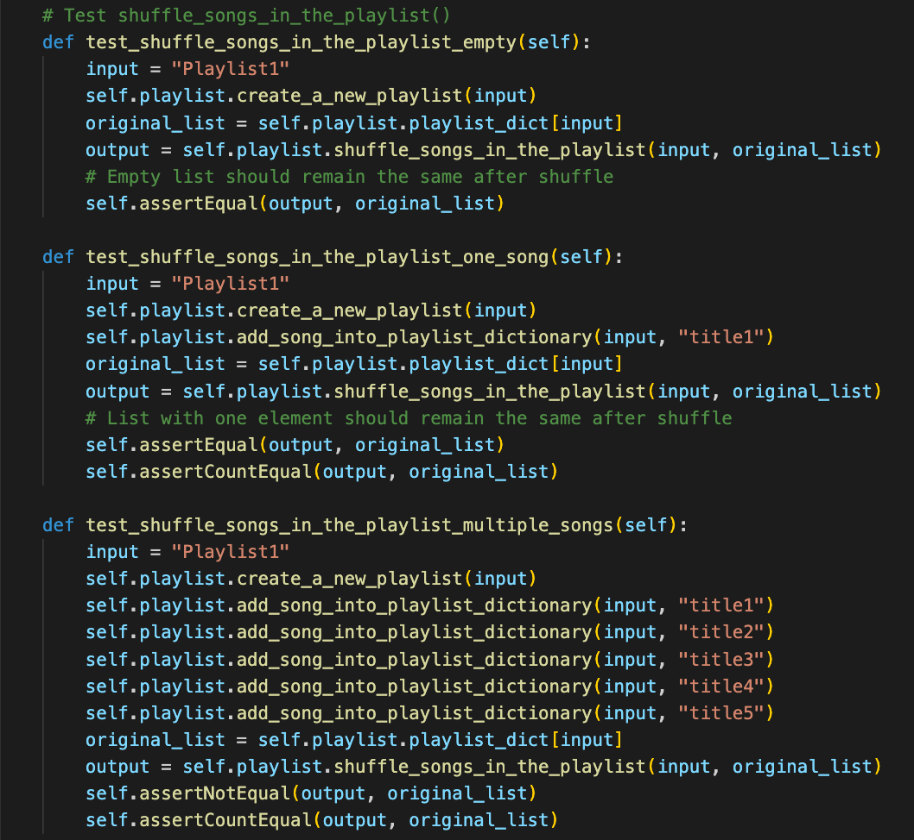

Test Results

|  |  |  |  |  |
| --- | --- | --- | --- | --- |
| ID | Inputs | Expected Outputs | Actual Outputs | Result |
| 1 | Empty playlist | Order remains the same | Order remains the same | Pass |
| 2 | Playlist with one song | Order remains the same | Order remains the same | Pass |
| 3 | Playlist with 5 songs | Order is shuffle | Order is shuffle | Pass |

# Test Methodology & Coverage

Black box testing with equivalent partition.