GRAD695 – Unit Testing – Test Case 3.4

Authors: Prafulla Chandra Munugoti

# General Information

|  |  |
| --- | --- |
| Unit | Push song to history |
| Source Files | .tests/playlist.py or MUSICON.py |
| Function name | push_to_recently_played_stack (self, title,playlist_name) |
| Date | April 1st, 2023 |
| Engineers | Prafulla Chandra Munugoti |

# Test Code

Source Code:

Test Code:

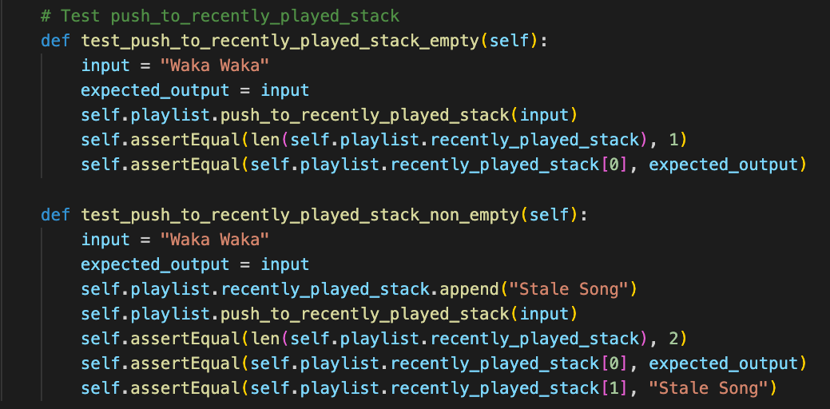

Test Results

|  |  |  |  |  |
| --- | --- | --- | --- | --- |
| ID | Inputs | Expected Outputs | Actual Outputs | Result |
| 1 | "shape of you”, push into empty history | History list length 1, stack head “shape of you” | History list length 1, stack head “shape of you” | Pass |
| 2 | "shape of you”, push into non-empty history | History list length 2, stack head “shape of you” | History list length 2, stack head “shape of you” | Pass |

# Test Methodology & Coverage

White box testing with statement coverage.