CISC593 – Unit Testing – Test Case 3.6

Authors: Prafulla Chandr Munugoti, Jingjing Guo, Chenyuan Jin

# General Information

|  |  |
| --- | --- |
| Unit | Enqueue the played song into the loop list |
| Source Files | ./tests/playlist.py or ./MUSICON.py |
| Function name | enqueue_the_song_recently_played_into_start_of_the_queue (self, data) |
| Date | April 1st, 2023 |
| Engineers | Prafulla Chandra Munugoti |

# Test Code

Source Code:

Test Code:

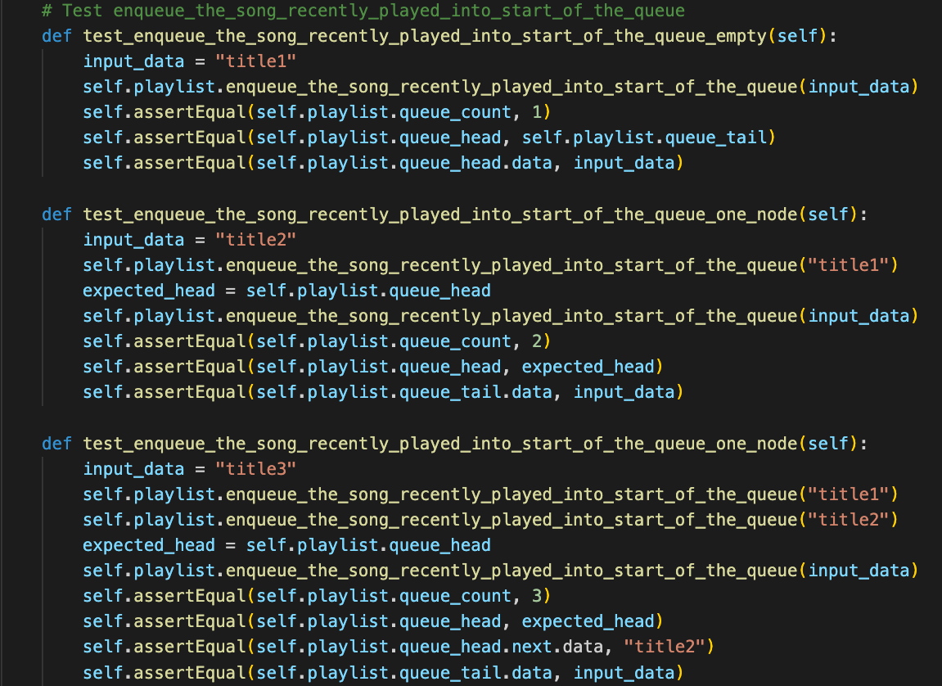

Test Results

|  |  |  |  |  |
| --- | --- | --- | --- | --- |
| ID | Inputs | Expected Outputs | Actual Outputs | Result |
| 1 | "shape of you”, into empty queue | Queue count = 1,  Queue head = queue tail = new song of “title 1” | Queue count = 1,  Queue head = queue tail = new song of “title 1” | Pass |
| 2 | "perfect”, into queue of 1 song | Queue count = 2,  Queue head remains the same,  Queue tail = new song if “title 2” | Queue count = 2,  Queue head remains the same,  Queue tail = new song if “title 2” | Pass |
| 3 | “Believer”, into queue of 2 songs | Queue count = 3,  Queue head remains the same,  Queue tail = new song if “title 3” | Queue count = 3,  Queue head remains the same,  Queue tail = new song if “title 3” | Pass |

# Test Methodology & Coverage

White box testing with data flow testing.