**Git task : Git Revert Some Changes**

The Nautilus application development team was working on a git repository /usr/src/kodekloudrepos/cluster present on Storage server in Stratos DC. However, they reported an issue with the recent commits being pushed to this repo. They have asked the DevOps team to revert repo HEAD to last commit. Below are more details about the task:

1. In /usr/src/kodekloudrepos/cluster git repository, revert the latest commit ( HEAD ) to the previous commit (JFYI the previous commit hash should be with initial commit message ).
2. Use revert cluster message (please use all small letters for commit message) for the new revert commit.

ststor01

172.16.238.15

ststor01.stratos.xfusioncorp.com

natasha

Bl@kW

Nautilus

Storage Server

Login to storage server using SSH and switch to root user

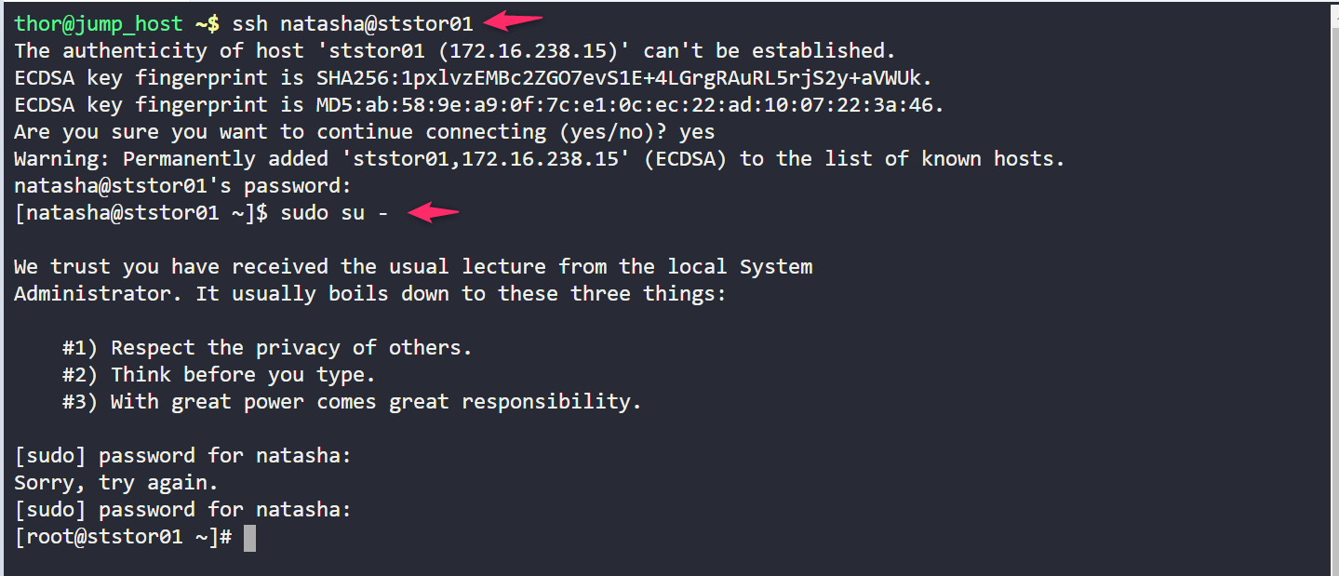

Check git status

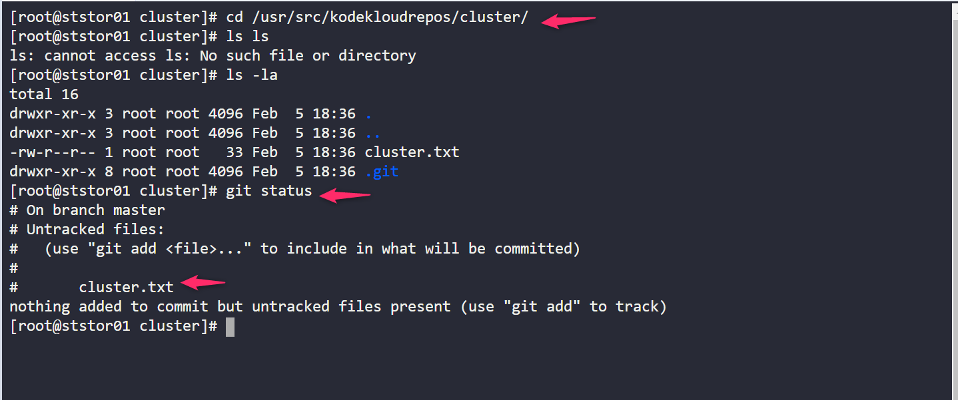

Check git logs

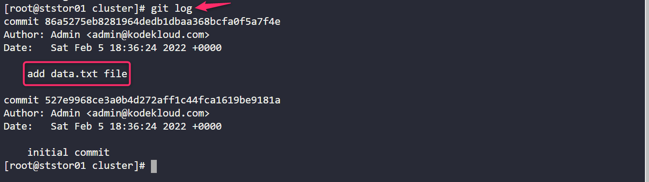

Run command revert HEAD and Add , Commit with given message in task

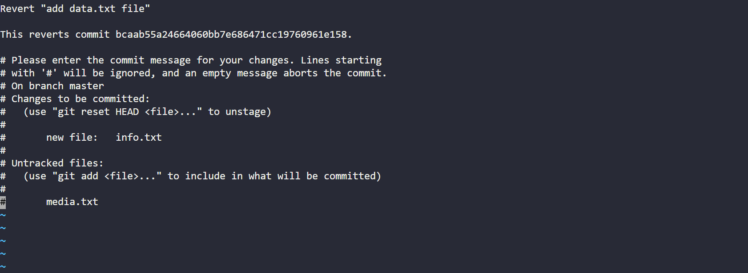

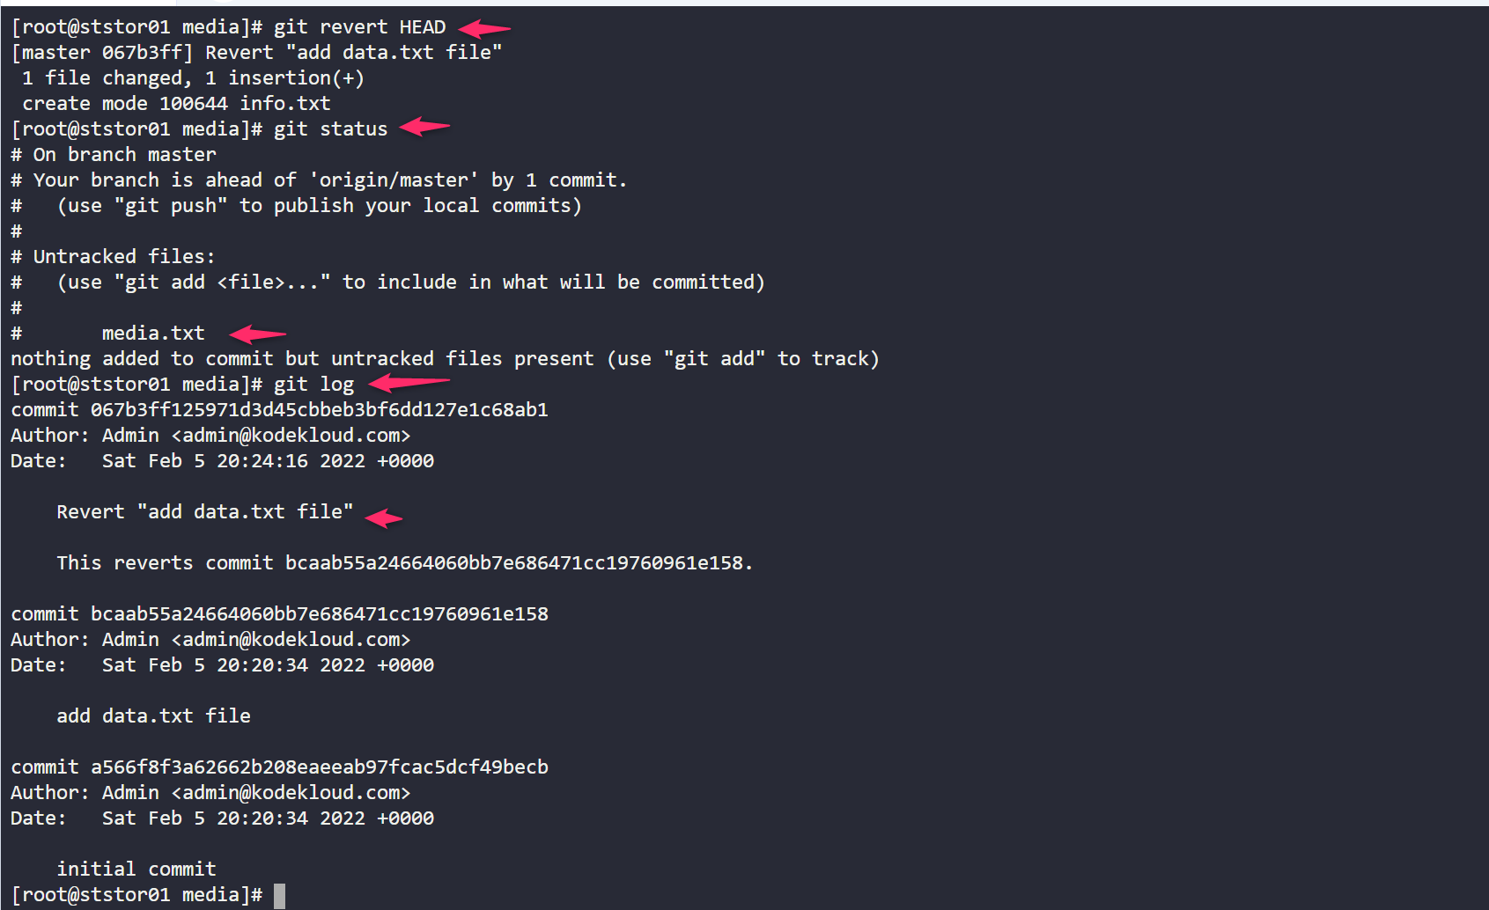

Git add, commit

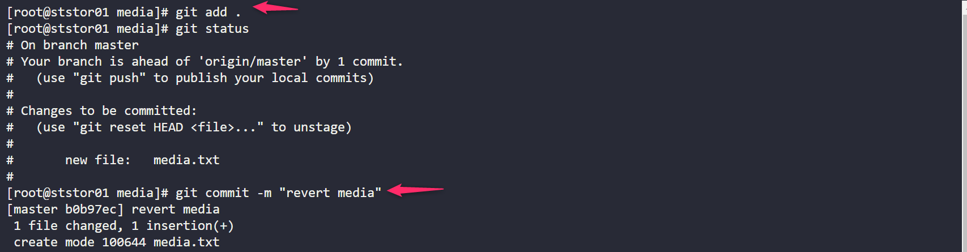

Git status & log

