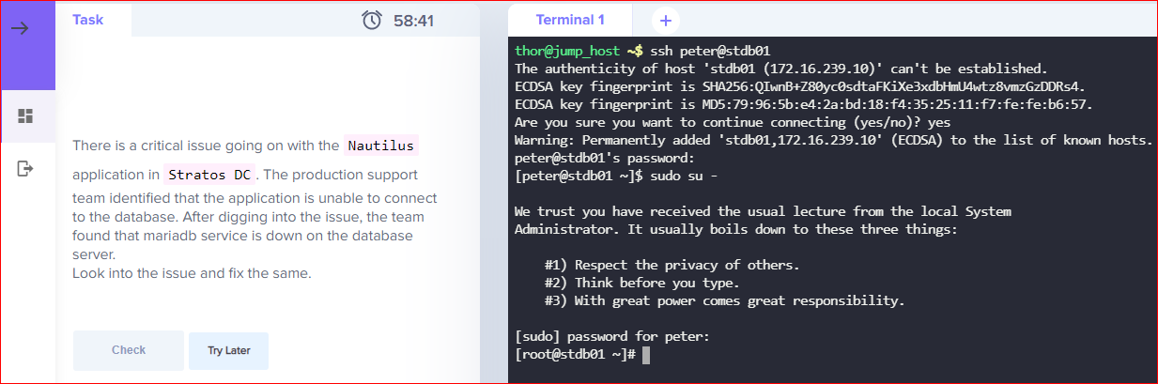

systemctl status mariadb

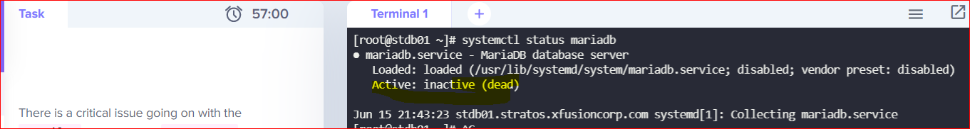

Systemct start mariadb



systemctl status mariadb

To know the detail error run status -l

systemctl status mariadb -l

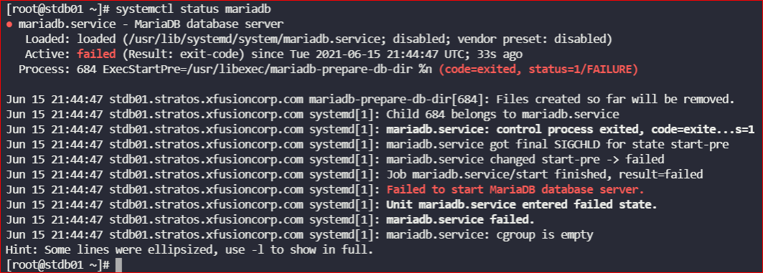

cd /var/lib/

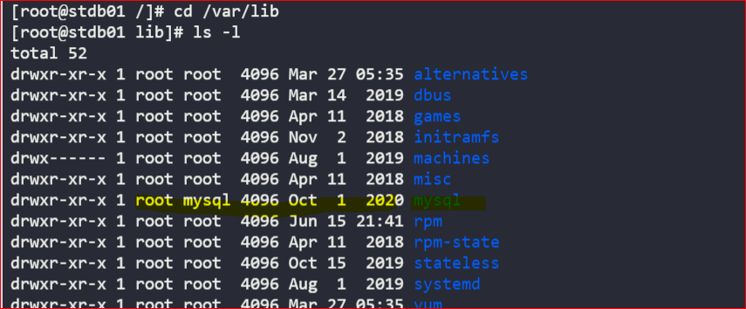

Change the ownership of the mysql directory from root to mysql

chown mysql:mysql mysql

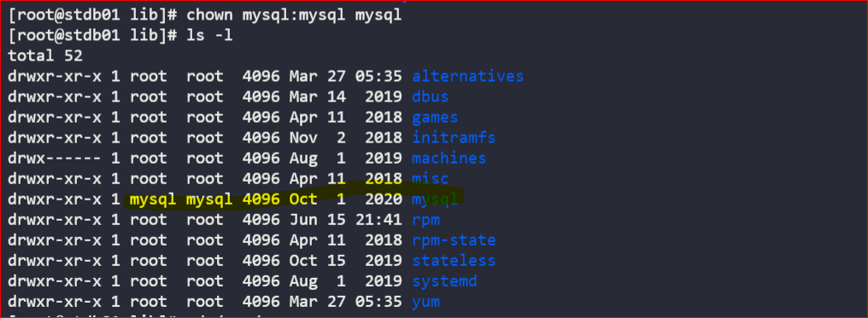

Go to /var/run directory and check that the mariadb has the correct owner and permission

