**-IMDb Management system-**

Praful Praveen Badami

NUID:001839495

INFO 6210-Database Management and

Database design Final Project

**Problem Statement:**

* IMDb is made use by millions of users where there is thousands of movies information stored in one common website.
* IT has all the information regarding Films, TV shows, Cast, reviews, and ratings etc. It stores all the information across all the movies in multiple countries and languages.
* The user can make use of all the information provided to purchase or watch whichever kind of movie they are interested.
* By going through all the reviews, ratings, and information provided any user can make the best decision.
* To maintain all these information, we need a database to store all the information.

**Entities:**

The Entities that are included in the database are:

* Movies
* Actors
* Director
* Country
* Language
* Awards
* Genre
* Plot
* writer
* cast

**ER Diagram:**

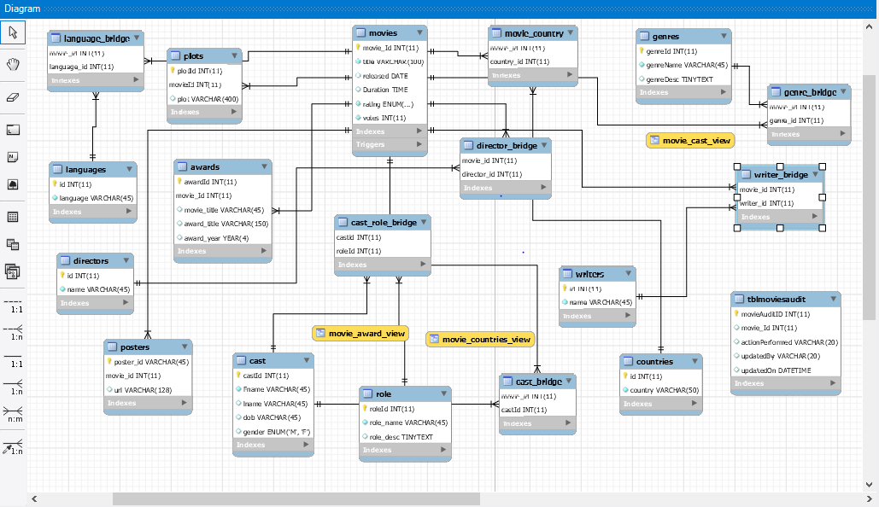

**Triggers Implementes:** 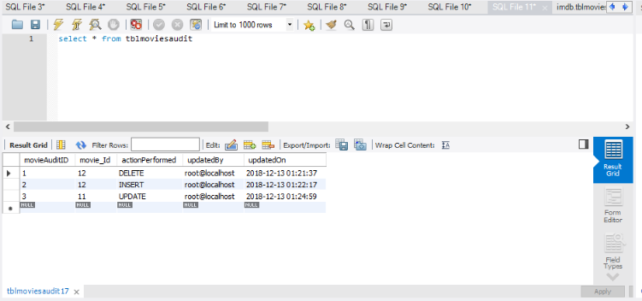

**Three** types of **trigger** implemented on one table. They are Insert,Update and Delete.

**1.Update Trigger on Movies:**

DELIMITER //

create trigger tblmoviesauditUpdate

before update

on movies

FOR EACH ROW

Begin

#set @productId= Old.productID;

insert into tblmoviesaudit

(

movie_Id,

actionPerformed ,

updatedBy,

updatedOn) values (movie_Id,"UPDATE",user(),now());

END;

//

**2.Delete trigger on Movies:**

DELIMITER //

create trigger tblmoviesauditDelete

before delete

on movies

FOR EACH ROW

Begin

insert into tblmoviesaudit

(

movie_Id,

actionPerformed ,

updatedBy,

updatedOn) values (OLD.movie_Id,"DELETE",user(),now());

END;

//

**3.INSERT trigger on Movies:**

DELIMITER //

create trigger tblproductsauditInsert

after insert

on movies

FOR EACH ROW

Begin

insert into tblmoviesaudit

(

movie_Id,

actionPerformed ,

updatedBy,

updatedOn) values (NEW.movie_Id,"DELETE",user(),now());

END;

//

**Stored Procedure: using cursors**

**Before calling: procedure Award_set_Movie_name()**

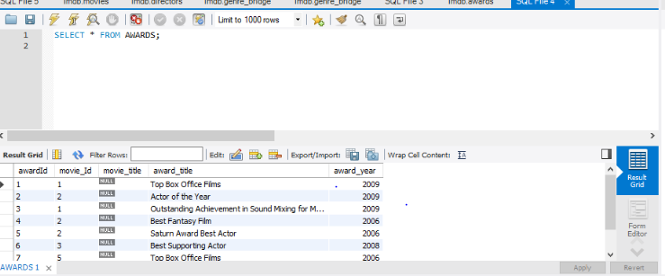

**After calling:**

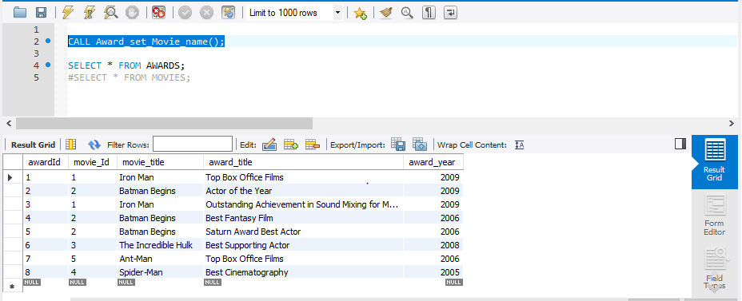

DELIMITER //

CREATE PROCEDURE **Award_set_Movie_name()**

BEGIN

DECLARE done INT DEFAULT 0;

DECLARE id INT;

DECLARE set_title CURSOR FOR SELECT movie_Id from awards WHERE movie_title IS NULL;

DECLARE CONTINUE HANDLER FOR NOT FOUND SET done = 1;

OPEN set_title;

search_loop: LOOP

IF done THEN

LEAVE search_loop;

END IF;

FETCH set_title INTO id;

UPDATE awards SET movie_title = (SELECT title from movies WHERE movie_Id = id)

WHERE movie_Id = id;

END LOOP;

close set_title;

END;

//

DELIMITER ;

**Stored procedure to generate list of movies using cursor**:

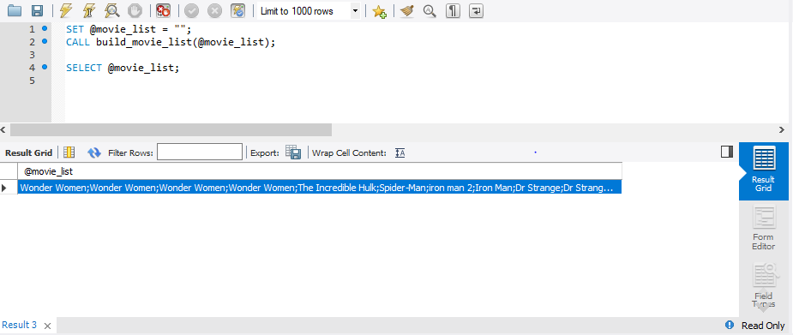

BEGIN

DECLARE done INT DEFAULT 0;

DECLARE movie_id INT;

DECLARE set_title CURSOR FOR SELECT awards.movie_Id from awards WHERE movie_title IS NULL;

DECLARE CONTINUE HANDLER FOR NOT FOUND SET done = 1;

OPEN set_title;

search_loop: LOOP

IF done THEN

LEAVE search_loop;

END IF;

FETCH set_title INTO movie_id;

UPDATE awards SET movie_title = (SELECT title from movies WHERE movies.movie_Id = ovie_id)

WHERE movies.movie_Id = movie_id;

END LOOP;

close set_title;

END;

//

DELIMITER ;

**Procedure to create user:**

DELIMITER //

CREATE PROCEDURE **create_user**

(IN user_nm CHAR(20), IN user_ps CHAR(20))

BEGIN

SET @host_name := 'localhost';

SET @user_name := user_nm;

SET @pass := user_ps;

SET @db_nm:='imdb';

SET @sql:= CONCAT("CREATE USER ", QUOTE(@user_name), "@", QUOTE(@host_name), "IDENTIFIED BY ", QUOTE(@pass));

PREPARE stmt FROM @sql;

EXECUTE stmt;

SET @GRANT_PERMISSIONS = CONCAT("GRANT ALL ON ", @db_nm, ".* TO ", QUOTE(@user_name), "@",QUOTE(@host_name));

PREPARE statement FROM @GRANT_PERMISSIONS;

EXECUTE statement;

END //

DELIMITER ;

**Procedure to find movies:**

CREATE INDEX by_movies_name ON movies (title);

DELIMITER $$

CREATE PROCEDURE Search_movie_bytitle(IN m varchar(45))

BEGIN

SELECT title,rating

FROM movies

WHERE title = m;

END $$

DELIMITER ;

**Procedure for analysis:**

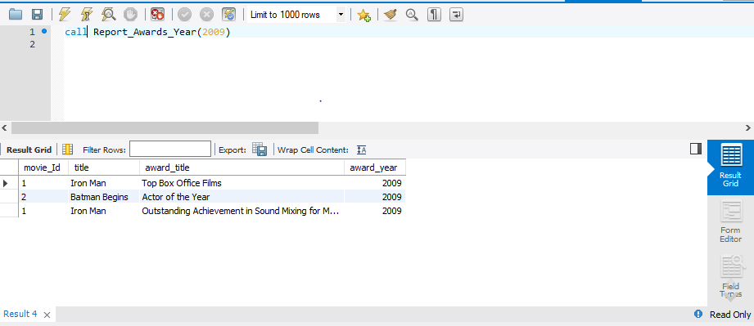

DELIMITER $$

CREATE PROCEDURE Report_Awards_Year(IN yr year)

BEGIN

SELECT movies.movie_Id, movies.title, awards.award_title,awards.award_year

FROM movies

INNER JOIN awards

on movies.movie_Id = awards.movie_Id where award_year=yr;

END $$

DELIMITER ;

**VIEWS:**

**movie_cast_view-**

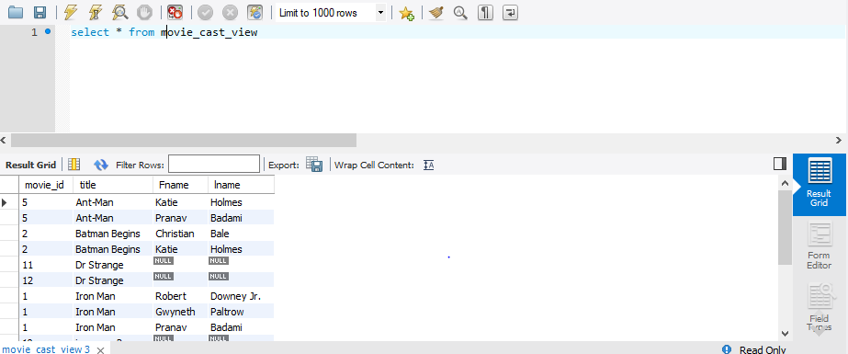

create view movie_cast_view as SELECT movies.movie_id, movies.title, cast.Fname,cast.lname

FROM movies

LEFT OUTER JOIN cast_bridge

ON movies.movie_id = cast_bridge.movie_id

LEFT OUTER JOIN cast

ON cast_bridge.castId = cast.castId;

**movie_award_view--**

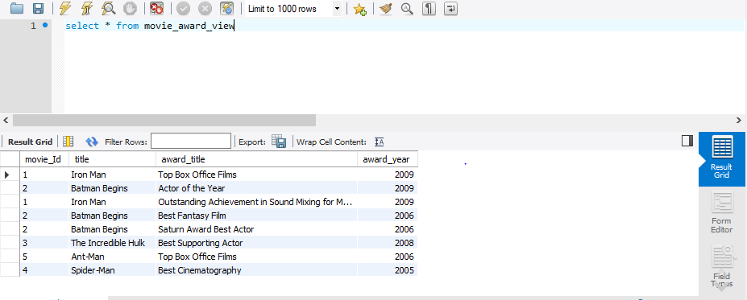

Create View movie_award_view as SELECT movies.movie_Id, movies.title, awards.award_title,awards.award_year

FROM movies

INNER JOIN awards

ON movies.movie_Id = awards.movie_Id;

**movie_countries_view--**

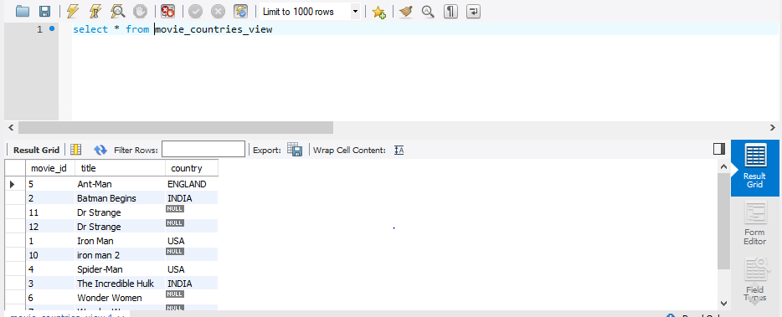

**Transactions:**

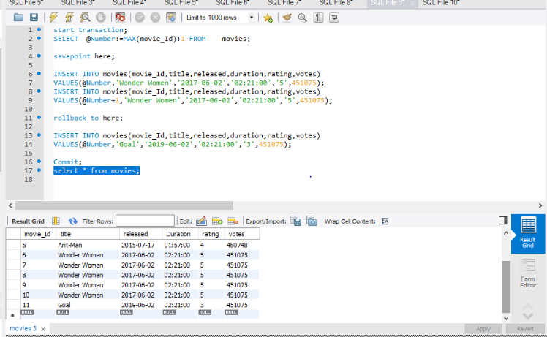

**User Defined Functions:**

**MovieRating--**

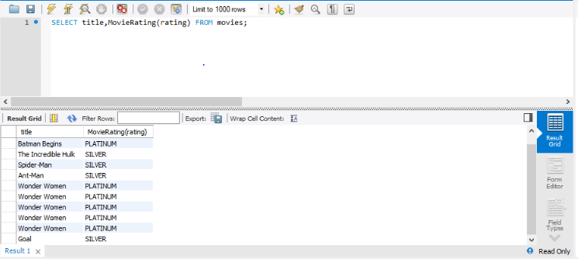

DELIMITER $$

CREATE FUNCTION MovieRating(movie_class ENUM('1','2','3','4','5')) RETURNS VARCHAR(10)

DETERMINISTIC

BEGIN

DECLARE rating varchar(10);

IF movie_class = '5'THEN

SET rating = 'PLATINUM';

ELSEIF (movie_class ='4' AND movie_class = '5') THEN

SET rating = 'GOLD';

ELSE

SET rating = 'SILVER';

END IF;

RETURN (rating);

END

$$

**castAge--**

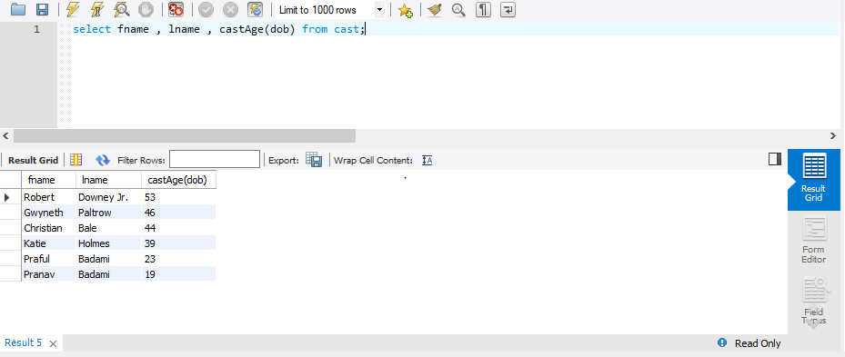

CREATE DEFINER=`root`@`localhost` FUNCTION `CastAge`(dob date) RETURNS varchar(10) CHARSET utf8mb4

DETERMINISTIC

BEGIN

DECLARE age varchar(10);

set age=Date_format( From_Days( To_Days(Curdate()) - To_Days(dob) ), '%Y' ) + 0 ;

RETURN (age);

END

**Out File Report Generation:** 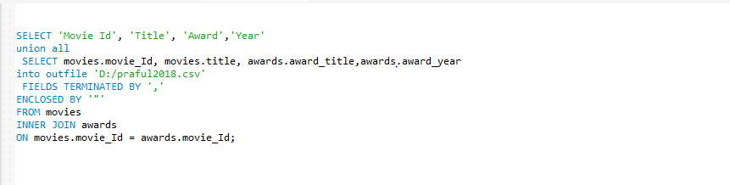

**File saved in local system:**

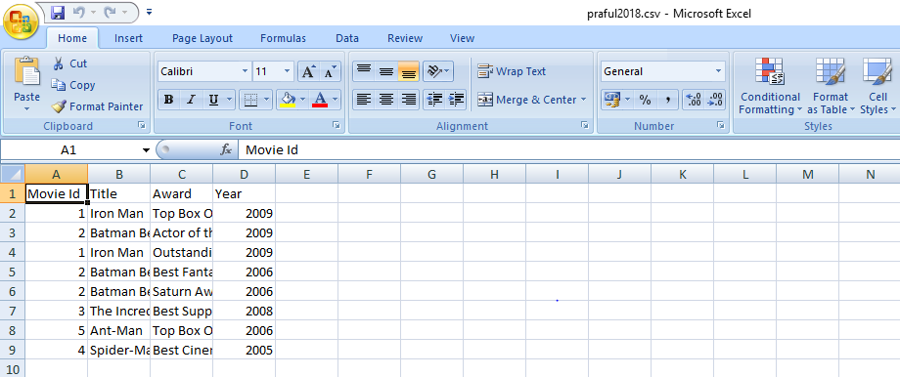

___________________x_________________________x____________________x_______