Checklist for Server Preparation after Installation

- Disable CTRL+ALT+Del

Edit the control-alt-delete.conf file & put the comment at the beginning of the following line to avoid reboot from these keyboard keys.

“/etc/inittab” inittab is no longer used when using systemd

- Create symlink to /dev/null to avoid reboot from these keyboard keys

ln -sf /dev/null /etc/systemd/system/ctrl-alt-del.target

To check changes symlink after using above command

[root@RHEL7 ~]# ll /etc/systemd/system/ctrl-alt-del.target

lrwxrwxrwx 1 root root 9 Jan 22 16:23 /etc/systemd/system/ctrl-alt-del.target -> /dev/null

- Disable the SSH Protocol 1 & SFTP Also enable banner

- Edit /etc/ssh/sshd_config file & comment the following lines for disabling the old ssh protocols & sftp.

#Protocol 2,1
#Subsystem sftp /usr/libexec/openssh/sftp-server

Keep it only Protocol 2.

Protocol 2

- Add below entry to /etc/ssh/sshd_config

AllowUsers root sha

- And add following line in the file /etc/ssh/sshd_config

Banner /etc/ssh/sshd_banner

Create a new file as following “/etc/ssh/sshd_banner” and add below entries.

********************* W A R N I N G ****************************
THIS SYSTEM IS RESTRICTED TO AUTHORIZED USERS FOR AUTHORIZED USE
ONLY. UNAUTHORIZED ACCESS IS STRICTLY PROHIBITED AND MAY BE
PUNISHABLE UNDER THE COMPUTER FRAUD AND ABUSE ACT OF 1986 OR
OTHER APPLICABLE LAWS. IF NOT AUTHORIZED TO ACCESS THIS SYSTEM,
DISCONNECT NOW. BY CONTINUING, YOU CONSENT TO YOUR KEYSTROKES
AND DATA CONTENT BEING MONITORED. ALL PERSONS ARE HEREBY
NOTIFIED THAT THE USE OF THIS SYSTEM CONSTITUTES CONSENT TO
MONITORING AND AUDITING.
****************************************************************
Check if the changed configuration is correct by using sshd –t. Reload the service ONLY if no error is shown.

- Enable Date and Time in History Command

- Add 'HISTTIMEFORMAT="%F %T " in /etc/profile file

# echo 'HISTTIMEFORMAT="%F %T "' >> /etc/profile

# source /etc/profile

- Check using below command

# history

- Run the Activity Account Tool

- Edit the /etc/cron.d/sysstat to run activity accounting tool for every 1 minute instead of 10 minutes.

Default line comment it

*/10 * * * * root /usr/lib64/sa/sa1 1 1

And add below line

*/1 * * * * root /usr/lib64/sa/sa1 1 1

- Time Out to Run the OS

- Edit the grub.conf file to boot the kernel if server supports that and time-out to 3 sec.

Specific information about grub.conf

Default timeout as below line following file comment it /etc/default/grub

#GRUB_TIMEOUT=5

Changed timeout to

GRUB_TIMEOUT=3

Run below mentioned command after changes

# grub2-mkconfig -o /boot/grub2/grub.cfg

- To switch between the run levels, you should type the following commands:

Run server to run level 3 after reboot (command line):
# ln -sf /usr/lib/systemd/system/multi-user.target /etc/systemd/system/default.target
OR the easy way

systemctl set-default multi-user.target

- Enable ARP Packet Filtering and TCP syn cookies

Add the following line at end of /etc/rc.d/rc.local.

echo 1 > /proc/sys/net/ipv4/conf/all/arp_filter
echo 1 > /proc/sys/net/ipv4/tcp_syncookies
echo 1 > /proc/sys/net/ipv4/tcp_tw_recycle

Also run the same below commands.

echo 1 > /proc/sys/net/ipv4/conf/all/arp_filter
echo 1 > /proc/sys/net/ipv4/tcp_syncookies
echo 1 > /proc/sys/net/ipv4/tcp_tw_recycle

- Service to run at Startup

Only enable below mentioned services that needs to be run on OS startup.

To check services:

systemctl list-unit-files --type service | grep enabled

To disable service:

systemctl disable service_name

To enable service:

systemctl disable service_name

abrt-ccpp.service | enabled
abrt-oops.service | enabled
abrt-vmcore.service | enabled
abrt-xorg.service | enabled
abrtd.service | enabled
auditd.service | enabled
crond.service | enabled
dbus-org.freedesktop.NetworkManager.service | enabled
dbus-org.freedesktop.nm-dispatcher.service | enabled
getty@.service | enabled
irqbalance.service | enabled
kdump.service | enabled
microcode.service | enabled
NetworkManager-dispatcher.service | enabled
NetworkManager.service | enabled
rngd.service | enabled
rsyslog.service | enabled
smartd.service | enabled
sshd.service | enabled
sysstat.service | enabled
systemd-readahead-collect.service | enabled
systemd-readahead-drop.service | enabled
systemd-readahead-replay.service | enabled
tuned.service | enabled

- Custom System Monitoring Tool

1] Copy loadavgmonitor to /home/sha from below path

\\dumpserver.kotakseconline.com\allbackups\$Previous_Date\admin_stuff\Repository\Centos7\loadavgmonitor

e.g:- \\dumpserver.kotakseconline.com\allbackups\2015-07-02\admin_stuff\Repository\Centos7\loadavgmonitor

cd /home/sha/loadavgmonitor

chmod 755 ./*.sh
chmod 755 ./*.pl

Add the below line into /etc/rc.local

/home/sha/loadavgmonitor/loadavgmonitor.sh > /home/sha/loadavgmonitor/loadavgmonitor.sh.err 2>&1 &

2] Copy Serveralertv2 to /home/sha from below path

\\dumpserver.kotakseconline.com\allbackups\$Previous_Date\admin_stuff\Repository\Centos7\ServerAlert\serveralertv2

e.g:- \\dumpserver.kotakseconline.com\allbackups\2015-07-02\admin_stuff\Repository\Centos7\ServerAlert\serveralertv2

cd /home/sha/serveralertv2/

chmod 755 ./*.sh
chmod 755 ./*.pl

Add the below line into /etc/rc.local

su -l sha --command='/home/sha/serveralertv2/serveralertv2.sh <<SERVER NAME>>' > /home/sha/serveralertv2/serveralertv2.log 2>&1 &

- Edit the /etc/rc.local

- And also copy “serverrebootstatus” into the /home from below path

\\dumpserver.kotakseconline.com\allbackups\$Previous_Date \admin_stuff\Repository\Centos7\serverrebootstatus

e.g:- \\dumpserver.kotakseconline.com\allbackups\2015-07-02\admin_stuff\Repository\Centos7\serverrebootstatus

- Put the following lines into /etc/rc.local to run the script which is the below mentioned path.

/home/serverrebootstatus/serverrebootstatus.sh >> /home/serverrebootstatus/serverrebootstatus.err 2>&1 &

- Change permisions

chmod 755 ./*.sh
chmod 755 ./*.pl

This is for, when server will get reboot and get it up, it will give the status of the server.

- Copy Aide Script for Check System Logs.

- Install aide

#yum install aide

- Copy aide folder from below mention location to /home/

\\dumpserver.kotakseconline.com\allbackups\$Previous_Date\admin_stuff\Repository\Centos7\AIDE\aide

e.g:- \\dumpserver.kotakseconline.com\allbackups\2015-07-02\admin_stuff\Repository\Centos7\AIDE\aide

- Copy aide.conf Script from below mention location to /etc/

\\dumpserver.kotakseconline.com\allbackups\$Previous_Date\admin_stuff\Repository\Centos7\AIDE\aide.conf

e.g:- \\dumpserver.kotakseconline.com\allbackups\2015-07- 02\admin_stuff\Repository\Centos7\AIDE\aide.conf

- Add in crontab

01 00 * * * /home/aide/aidecheck.sh
- Copy Nmon Log rotation script.

- Copy nmonrotate folder from below mention location to /home

\\dumpserver.kotakseconline.com\allbackups\admin_stuff\application\nmonrotate

- Enable compress option in /etc/logrotate.conf by uncomment the “compress”

- Change rotate from 4 week to 52 Week in /etc/logrotate.conf

Default line comment it

# keep 4 weeks worth of backlogs
# rotate 4

- And add below line

# keep 4 weeks worth of backlogs
rotate 52

This is for compress logs of server for 52 Weeks

- Disable Security Enhanced Linux by the following command.

- To disable selinux comment below line in the file /etc/sysconfig/selinux

#SELINUX=enforcing

- And below line

SELINUX=disabled

After reboot the server check selinux status by executing below command:

Output should be as below with following command sestatus

[root@localhost ~]# sestatus
SELinux status: disabled

- Block access to all accounts to login from anywhere other than specific machines

- Add the following line to /etc/pam.d/sshd file

account required pam_access.so

2) Comment the following line to /etc/pam.d/system-auth file

#password requisite pam_cracklib.so try_first_pass retry=3

3) Add the following line to /etc/pam.d/system-auth file

password requisite pam_cracklib.so try_first_pass retry=3 minlen=12 difok=3 dcredit=-1 ucredit=-1 lcredit=-1 ocredit=-1
- Set up ntpclient to sync time every 5 minutes

# vim /etc/cron.d/ntpclient

*/5 * * * * root /usr/sbin/ntpdate -u 10.230.12.54 > /dev/null 2>&1

Check with: /usr/sbin/ntpdate -u 10.230.12.54

- Add nmon in crontab

- Copy nmon rpm from below path into /root/temp

\\dumpserver.kotakseconline.com\allbackups\admin_stuff\application\nmon\ \nmon_tool\nmon_tool_all\nmon-14g-1.el7.rf.x86_64.rpm

Create nmonreport folder

mkdir /home/sha/nmonreport

Install RPM

cd /root/temp

rpm –ivh nmon-14g-1.el7.rf.x86_64.rpm

Change ownership of /home/sha/nmonreport to sha

chown -R sha.sha /home/sha/nmonreport

chmod 755 /bin/nmon

Add below entry in crontab

00 00 * * * su -l sha --command='nmon -f -m /home/sha/nmonreport -s30 -c2880'

- Badblocks Check (Don’t run on VM server)

Check for badblocks using following command :

badblocks -v -v -c 1 /dev/sda

Options :--

-v --- Verbose Mode,
-v --- Verbose Mode,
-c --- Count the Number of Blocks
1 --- Count from the Start Block

/dev/sda --- Check the partition for Badblocks

Run it in the screen command as follows

screen --- It is a full screen window manager that will create physical terminal between the processes in the same shell where
you can use the program as you normally would.

screen
then new window manager will open.

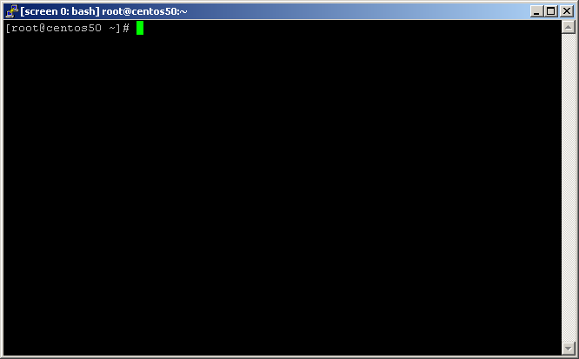
Screen 0: bash

Give the command

badblocks -v -v -c 1 /dev/sda

E.g badblocks -v -v -c 1 /dev/sda

badblocks -v -v -c 1 /dev/sdb

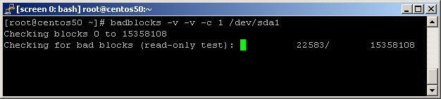

For detaching the screen press CTRL+A,CTRL+D

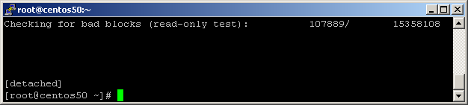

For attaching the screen give the command,

screen –r

19) To create a 5GB tmp partition, remember to choose right file system marked in red (ext4 or xfs)

# dd if=/dev/zero of=/tmpfs bs=1024 count=5010000
# mkfs.xfs /tmpfs
or
# mkfs.ext4 /tmpfs
# mkdir /tmp.new
# mount -o loop,noexec,nosuid,nodev,rw /tmpfs /tmp.new
# cp -av /tmp/* /tmp.new
# umount /tmp.new
# mount -o loop,noexec,nosuid,nodev,rw /tmpfs /tmp ; chmod 1777 /tmp

Edit fstab and add

/tmpfs /tmp xfs defaults,loop,nodev,nosuid,noexec 0 0

Or

/tmpfs /tmp ext4 defaults,loop,nodev,nosuid,noexec 0 0

- Disable TLS Older than TLSv1.2

Change SSLProtocol in /etc/httpd/conf.d/ssl.conf to below for disabling older TLS versions.

SSLProtocol all -TLSv1.1 -TLSv1 -SSLv3 -SSLv2

After changing, verify with httpd –t & restart http service.

