**Vedas College**

**Department of Computer Science and Information Technology**



**Project Proposal on:**

Freelancing Website (FlexiHire)

**Submitted by:**

Ajay Nemkul Shrestha(6-2-149-1-2020)

Praful Shrestha(6-2-149-05-2020)

Vedas College

Department of Computer Science and Technology

Jawalakhel, Lalitpur

**Submitted to:**

Vedas College

Department of Computer Science and Technology

Jawalakhel, Lalitpur

Table of Contents

Chapter 1: Introduction 1

1.1 Background 1

1.2 Problem Statement 1

1.3 Objectives 2

i. Connect Freelancers and Employers 2

ii. Streamline Job Search and Project Matching 2

iii. Promote Trust and Reputation 2

iv. Enhance User Experience 2

1.4 Scope 2

1.4.1 User Registration and Profiles 2

1.4.2 Job Posting and Search 2

1.4.3 Proposal Submission and Selection 2

1.4.4 Project Management Tools 3

1.4.5 Professional Networking 3

1.4.6 Feedback and Ratings 3

Chapter 2: Requirement Analysis 4

2.1 Requirement Specification 4

2.1.1 Hardware and Software Requirements 4

2.1.2 Functional Requirements 4

2.1.3 Performance Requirements 5

2.2 Feasibility Analysis 6

2.2.1 Technical Feasibility 6

2.2.2 Economic Feasibility 6

2.2.3 Operational Feasibility 6

2.2.4 Legal and Ethical Feasibility 6

Chapter 3: System Analysis 7

3.1 Software Development Model 7

3.2 Project Management Tool 10

Chapter 4: System Design 11

4.1 System Design and Overview 11

4.1.1 Flow Chart 12

4.1.2 DFD 13

4.1.3 Logical ER Diagram 15

Chapter 5: System Development and Testing 16

5.1 Coding Tools 16

5.1.1 Front End 16

5.1.2 Back End 16

5.2 Coding Platform 17

5.3 Development and Testing 17

5.4 Deployment and Launch 17

5.5 Ongoing Maintenance and Updates 17

Chapter 6: Expected Result 18

6.1 Result and Conclusion 18

6.1.1 Result 18

6.1.2 Conclusion 20

# Chapter 1: Introduction

## Background

Freelancing websites are on-line platforms that connect businesses or individuals with freelance workers who provide a variety of services, ranging from writing and design to programming and marketing. These sites have become increasingly popular in recent years due to the growing demand for remote work and the flexibility it provides. One of the most well-known freelancing websites is Up-work.

FlexiHire is a freelancing website that aims to combine the functionalities of Upwork and LinkedIn. It provides a comprehensive platform for freelancers and employers, merging job search and project management features with professional networking capabilities.

## Problem Statement

The freelancing system encounters an issue of not having a unified and easy, to use platform that effectively caters to the requirements of both freelancers and employers. This system may have limitations when it comes to job search capabilities, project management functionalities, professional networking features and mechanisms for building trust.

Freelancers often face challenges in finding job opportunities that align with their skills and preferences. The existing system might have limited search capabilities resulting in matching between freelancers and available projects.

Similarly employers encounter difficulties in identifying and hiring freelancers. The current system may lack mechanisms for evaluating the skills, experience and reliability of freelancers.

Trustworthiness and reputation play a role in the freelancing industry; however the existing system may not have mechanisms to verify the abilities of freelancers or ensure reliable performance. Freelancers and employers may struggle to evaluate each others trustworthiness often relying on factors or external references.

In summary there is a gap in the freelancing system as it lacks a comprehensive and user friendly approach to address the challenges faced by both freelancers and employers. An improved system is needed that offers job search functionality, project management tools robust professional networking features, as well as reliable mechanisms, for building trust and managing reputation.

## Objectives

The objectives for the proposed FlexiHire website, which combines features of Upwork and LinkedIn, are as follows:

### Connect Freelancers and Employers

### Streamline Job Search and Project Matching

### Promote Trust and Reputation

### Enhance User Experience

## Scope

### User Registration and Profiles

The website would include user registration functionality, allowing freelancers and employers to create personalized profiles. Users can provide information about their skills, experience, qualifications, and portfolio.

### Job Posting and Search

FlexiHire would enable employers to post job listings, specifying project requirements, budgets, and timelines. Freelancers can search for relevant projects based on their skills, location, and preferences.

### Proposal Submission and Selection

Freelancers would have the ability to submit proposals for job listings, including details about their qualifications, experience, and proposed pricing. Employers can review proposals and select the most suitable freelancers for their projects.

### Project Management Tools

FlexiHire would provide project management features, including task assignment, milestone tracking, file sharing, and communication channels. These tools facilitate effective collaboration and ensure smooth project execution.

### Professional Networking

The platform would enable users to connect with other professionals, expand their networks, and build industry relationships. Users can communicate, seek advice, and explore potential collaborations.

### Feedback and Ratings

FlexiHire would include a feedback and rating system, allowing freelancers and employers to provide reviews and ratings based on their experiences. This system promotes transparency and helps users make informed decisions.

# Chapter 2: Requirement Analysis

## 2.1 Requirement Specification

System requirements are a critical aspect of any software development project. These requirements define the technical specifications of the system, including the hardware and software requirements, functional requirements, and performance requirements. Here's a report on the system requirements for the proposed freelancing website that combines features of Linked-in and Freelancer with the existing system of Up-work:

### 2.1.1 Hardware and Software Requirements

The proposed system would be web-based and would require a stable and reliable internet connection. Users would be able to access the platform from any device with a web browser, such as a desktop computer, laptop, tablet, or smartphone. The platform would need to be compatible with the most popular web browsers, including Google Chrome, Mozilla Firefox, and Safari. The server infrastructure would need to be scalable and reliable, capable of handling a large number of concurrent users.

### 2.1.2 Functional Requirements

The proposed system would need to include the following features:

**Job Posting**

Employers would be able to post job listings, specifying the requirements and qualifications for the position.

**Proposal Submission**

Freelancers would be able to submit proposals for job listings, providing their qualifications and experience.

**Project Management**

Employers and freelancers would be able to manage their projects on the platform, including communication, progress tracking, and file sharing.

**Payment Processing**

The platform would facilitate secure and reliable payment processing for employers and freelancers, including escrow payments and invoicing.

**Professional Networking**

The platform would include features for professional networking, such as user profiles, messaging, and groups.

**User Verification**

The platform would need to verify the identity of users to ensure the safety and security of the platform.

**Use case diagram**

# 

Figure 1 Use Case Diagram

### 2.1.3 Performance Requirements

The proposed system would need to meet the following performance requirements:

**Availability**

The platform would need to be available to users 24/7, with minimal downtime.

**Response Time**

The platform would need to have fast response times, ensuring that users can access and interact with the platform without delays

**Scalability**

The platform would need to be scalable, able to handle a large number of concurrent users without compromising performance.

**Security**

The platform would need to have robust security measures in place to protect user data and prevent unauthorized access.

## 2.2 Feasibility Analysis

Feasibility analysis is an important process in determining whether a proposed system is practical and viable. Here's a feasibility analysis for the proposed freelancing website that combines features of Linked-in and Freelancer with the existing system of Up-work:

### 2.2.1 Technical Feasibility

The proposed system would require the integration of the features of Linked-in and Freelancer into the existing system of Up-work, which would require significant technical expertise. The integration process would need to be seamless and without any disruptions to the current system. However, the technical feasibility is high, given that Up-work has a robust API that enables third-party integrations, and the required technologies are widely available.

### 2.2.2 Economic Feasibility

The economic feasibility of the proposed system is high. The addition of new features and improvements to the existing system would increase the platform's appeal and attract new users. This would result in increased revenue from fees and commissions charged to employers and freelancers, as well as from premium subscription plans.

### 2.2.3 Operational Feasibility

The operational feasibility of the proposed system is high. The platform's core functionality, such as job posting, proposal submission, and payment processing, is already in place in the existing system of Up-work. The proposed features, such as project management and professional networking, would require additional resources, but the benefits of these features would significantly improve the platform's usability and functionality.

### 2.2.4 Legal and Ethical Feasibility

The legal and ethical feasibility of the proposed system is also high. The platform would need to comply with the relevant laws and regulations governing freelancing websites, such as data privacy and security laws. Ethically, the platform would need to ensure that its users are not subjected to any kind of harassment, discrimination, or unfair treatment.

# Chapter 3: System Analysis

For the proper development of any project, an effective planning is most important. It is very important to plan a proper system before the initiation of any other work for the project. Both of the team member were involved for a structured plan and smooth work flow of the project.

## Software Development Model

Software development models, also known as software development methodologies or software development processes, are structured approaches or frameworks that guide the processes and activities involved in creating software applications or systems. These models help software development teams plan, execute, and manage projects effectively while ensuring the quality and reliability of the software product.

For the development of our project we have decided to use iterative model as it focuses on the incremental and repetitive development of a software product.

The primary advantages of the iterative model include its flexibility, adaptability to changing requirements, early risk identification and mitigation, and the ability to incorporate stakeholder feedback throughout the development process.

Some of the advantages of iterative model are:

* Easily adapts to changing requirements.
* Delivers a working product with each iteration.
* Identifies and addresses risks early in the process
* Focus on delivering a high-quality product
* Promotes regular and clear communication
* Easily accommodates new features or changes
* Allows for thorough testing of individual components

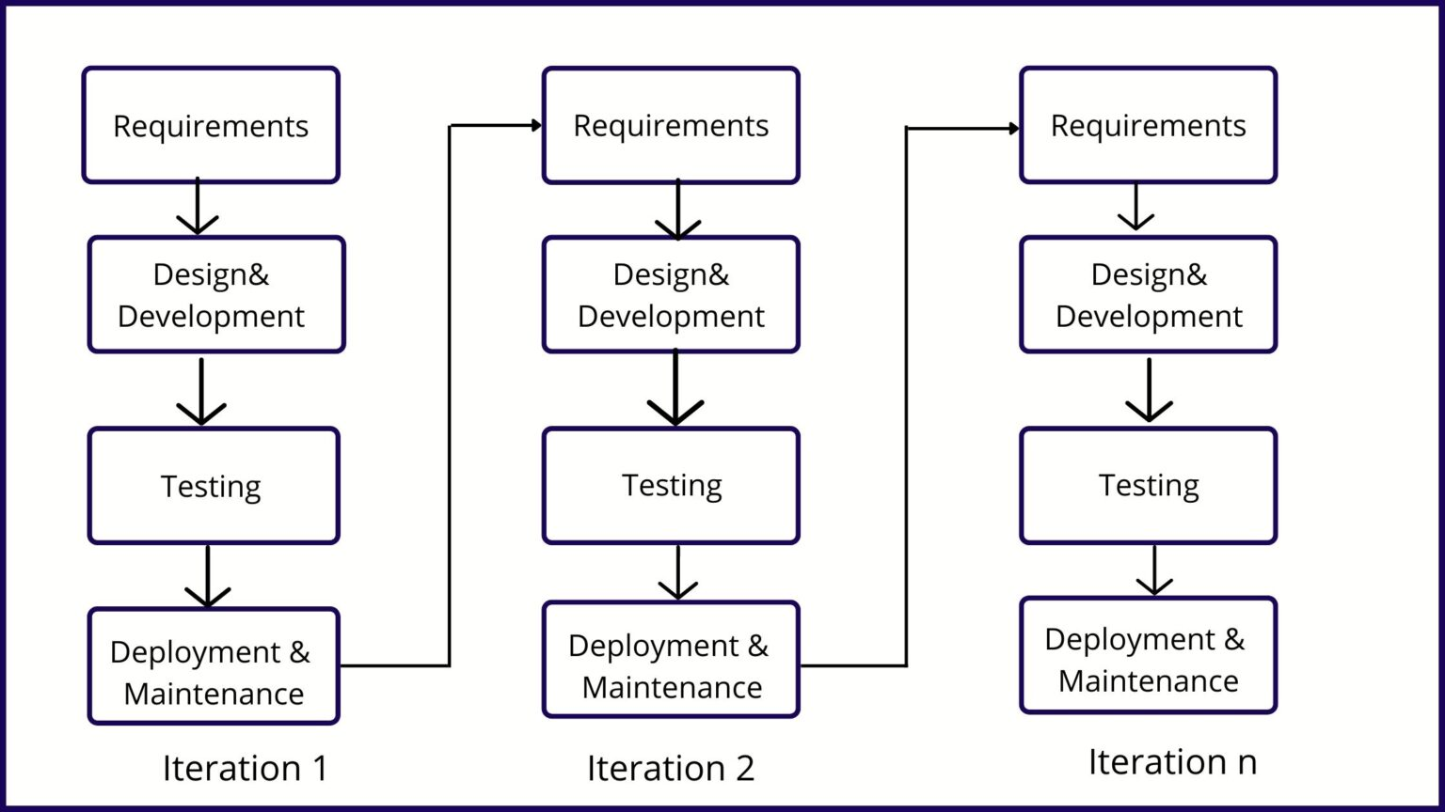

Figure 2 Iterative Model

Each iteration goes through a subset of the SDLC phases,and the process repeats until the software meets the desired level of functionality and quality.Here are the steps involved in the SDLC of an Iterative Model:

**Requirements Gathering and Analysis**

Gather and analyze initial requirements from stakeholders. Identify the highest-priority features and functionalities to be developed in the first iteration.

**Planning**

Create a high-level project plan,outlining the overall scope and objectives. Define the goals and deliverables for the current iteration. Allocate resources and estimate timeframes for the iteration.

**System Design**

Develop a design based on the requirements of the current iteration. Create detailed technical specifications for the features to be implemented. Design data structures,interfaces,and algorithms relevant to the current iteration's scope.

**Implementation**

Write code for the features and functionalities defined in the current iteration. Follow coding standards and best practices. Perform unit testing for the code developed during this iteration.

**Iteration Review**

At the end of the iteration,conduct a review meeting to assess the work completed. Demonstrate the functionality developed during the iteration to stakeholders. Gather feedback from stakeholders and end-users.

**Feedback and Evaluation**

Based on the feedback received during the iteration review,make adjustments to the requirements and design. Prioritize any changes or additions based on stakeholder input.

**Planning for Next Iteration**

Plan the next iteration based on the refined requirements and design. Define new goals and deliverables for the next iteration. Allocate resources and estimate timeframes for the upcoming iteration.

**Repeat Iterations**

Repeat the iterative process,starting with the requirements gathering and analysis phase,followed by planning,design,implementation,iteration review,feedback,and planning for the next iteration. Continue iterating until the software meets the desired level of functionality and quality.

**Integration and Testing**

Periodically integrate the features developed in each iteration into the overall system. Conduct integration testing to ensure that different components work together cohesively. Perform system-level testing as the software evolves.

**Deployment**

Once the software reaches a stable and usable state,deploy it to the production environment. Continue to release updates and enhancements in subsequent iterations.

**Maintenance and Support**

Provide ongoing support and maintenance,addressing any issues or defects that arise. Enhance the software based on feedback and changing requirements in future iterations.

## Project Management Tool

For the management of the project work flow, GitHub, a software management tool was used. The main reason of GitHub as project management tool in our project is it’s a web-based platform and service that provides a range of tools and features for software developers and teams. It is primarily used for version control, collaboration, and code hosting. Working in team was made easier through the help of this and was of a great help.

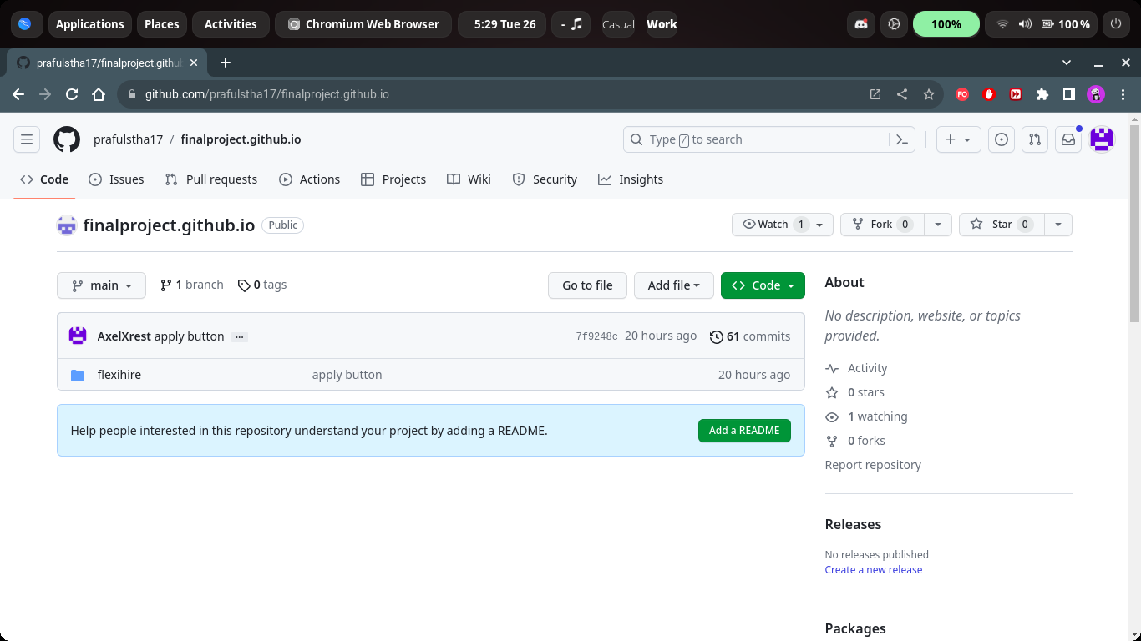

Image 1 Project Management Tool (GitHub)

# Chapter 4: System Design

## System Design and Overview

Our system is composed of four major components, User, System, Admin, and Database.The communication of all these components is done via internet. User are the people who creates or surfs the website for freelancing purpose. They register themselves in our system, search or creates the opening for the job/tasks they needs to make public. The system is meant to provide all the functionality to user and admin. System provides the information of all provided opening for jobs and provides control over deletion of the openings. Admin maintains the functionality of the system. They check the user authorization and authentication. Database store all the information of data. Firebase database is used in our system.

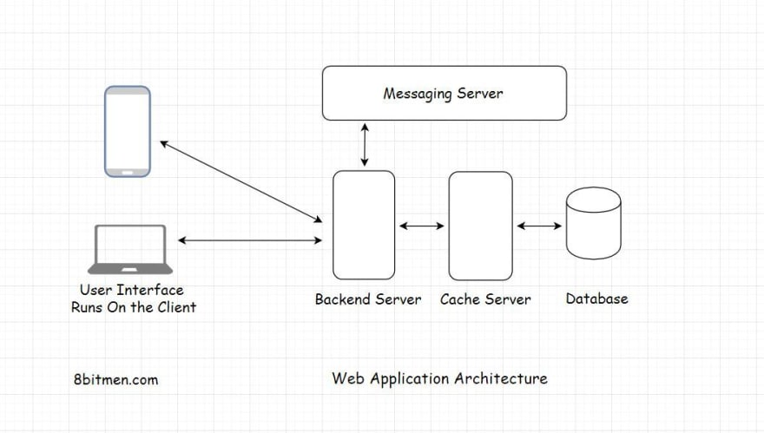

Internet

Figure 3 System Architecture

### 4.1.1 Flow Chart

Figure 4 Flow Chart

### 4.1.2 DFD

**Level 0**

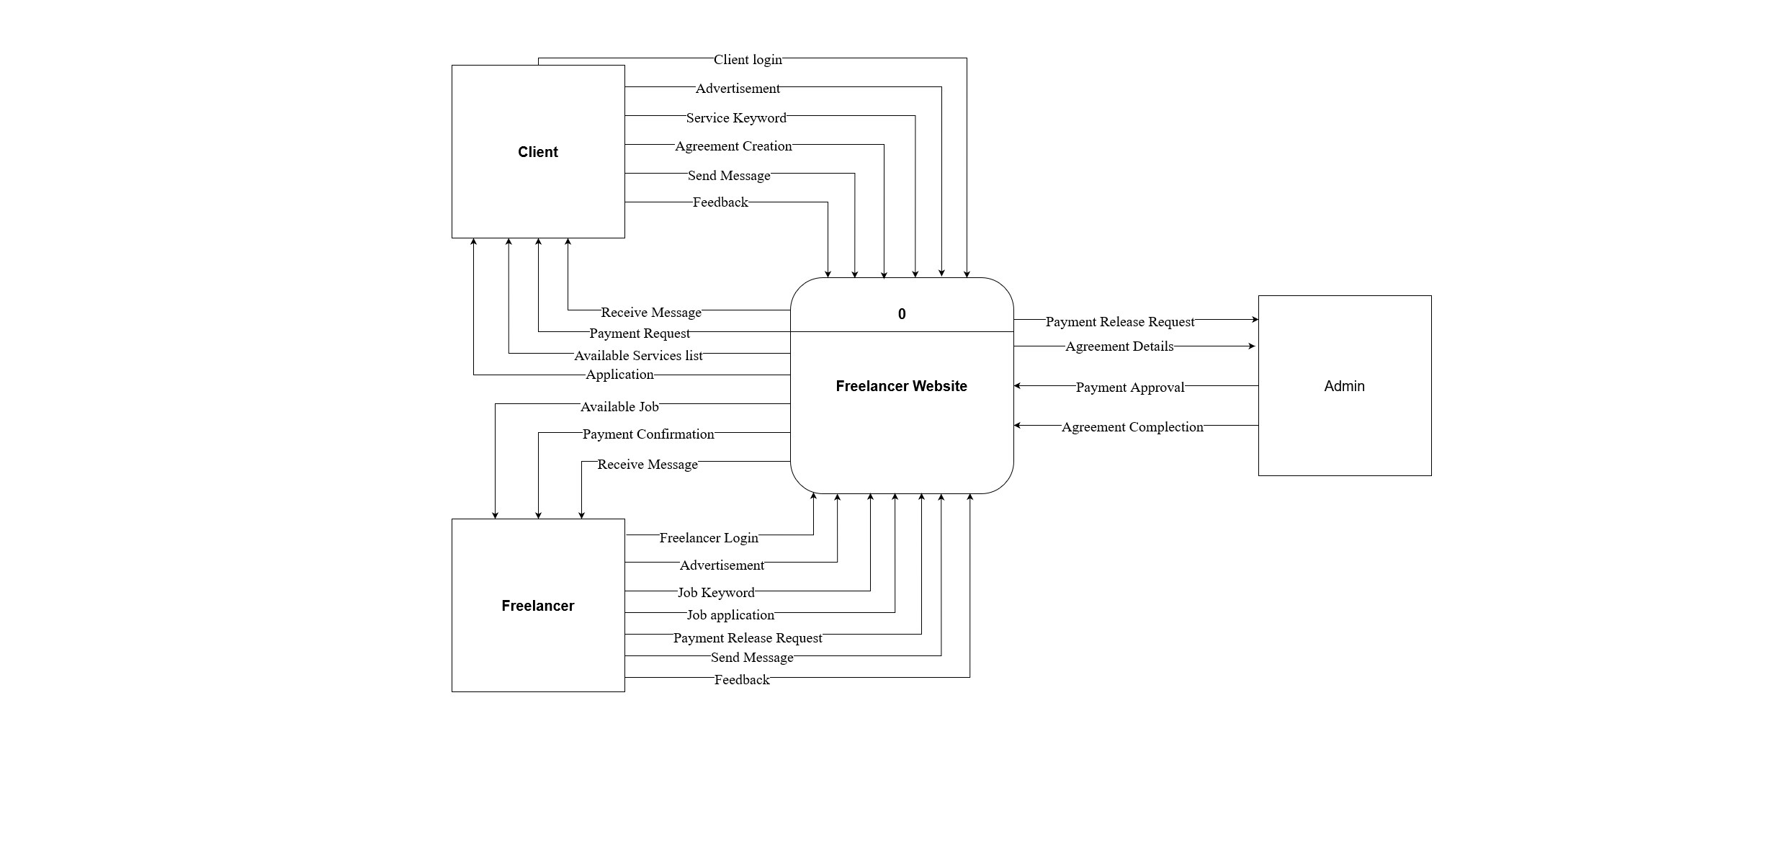

Figure 5 DFD Level 0

It is the context diagram which provides the basic overview of our whole system. As shown in the above figure there are their main entities and they have a direct relationship with the system.

**Level 1**

Figure 6 DFD Level 1

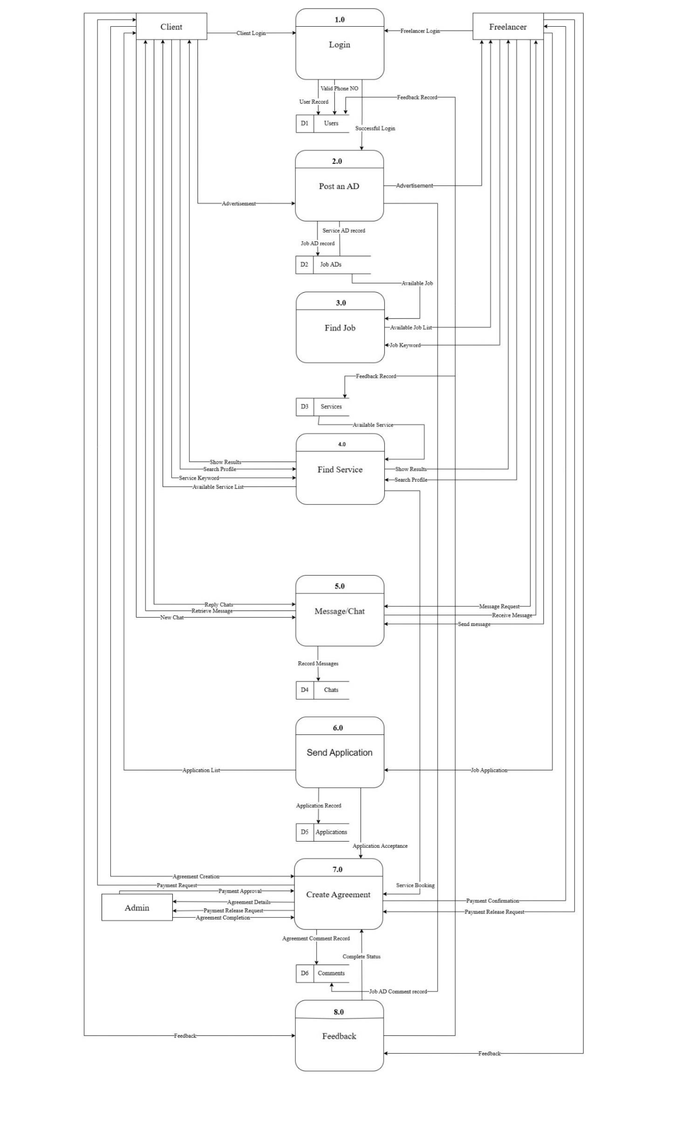

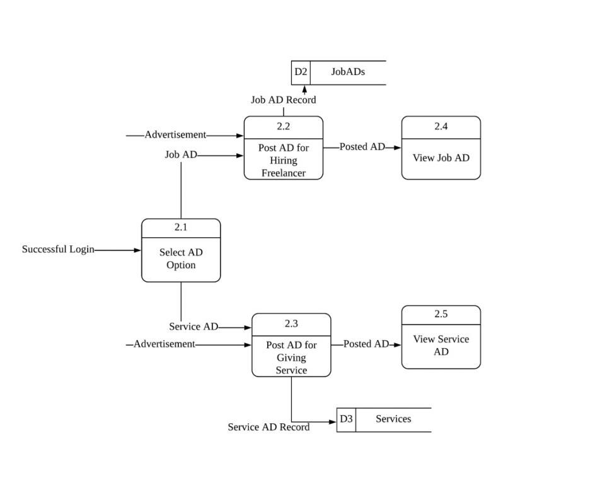**Level 2**

Figure 7 DFD Level 2

### er4.1.3 Logical ER Diagram

Figure 8 ER Diagram

# Chapter 5: System Development and Testing

## 5.1 Coding Tools

### 5.1.1 Front End

The front end of application is actually what user sees. It interacts directly with the user. It is an interface between the user and the back end. Front End development is mainly concerned with the designing the webpage and its styling. The client part of the program is called front end in client server architecture. The front-end development tools that we used for the system is listed below:

**React**

React makes it painless to create interactive UIs. React designs a simple view for each state in our application and efficiently update and render just the right component when our data changes. Using React we build bunch of isolated and reusable components and they are combined together to build user interfaces. There are several components in our application, among which the app.js is main component. This component represents the entire application and contains other child components. To work with these many components, react is the best option for us.

**Material UI**

Material UI is an open-source project that features React components that implements Google’s Material Design. Material UI is a component library for teeming with powerful components that we can use in our projects. We have used Material UI in our project as it has more customizable option.We have implemented Material UI for creating eye catching website with bold color.

### 5.1.2 Back End

**Firebase**

Firebase is a comprehensive cloud-based platform provided by Google for building web and mobile applications. It offers a variety of tools and services that simplify and accelerate the development process. Firebase includes features like real-time database, authentication, hosting, storage, cloud functions, and more. In your project, you are already using Firebase for Firestore (a NoSQL database) and Firebase Authentication.

## 5.2 Coding Platform

**Visual Studio** **Code**

Visual studio code is a light weight but powerful source code editor which runs on our desktop and is available for all operating systems. It comes with built in support for JavaScript, TypeScript and Node.js and has rich ecosystem of extension for other languages and runtimes.

## 5.3 Development and Testing

The development phase involves coding the frontend and backend components of the FlexiHire website. The frontend is developed using ReactJS to create the user interface and implement interactivity. Throughout the development process, rigorous testing is conducted to identify and fix any bugs or issues.

## 5.4 Deployment and Launch

Once the development and testing phases are complete, the FlexiHire website is to be deployed on a production environment. This involves setting up servers, configuring the necessary infrastructure, and ensuring the website is accessible to users. A well-defined launch plan is implemented to promote the website and attract freelancers and employers to join the platform.

## 5.5 Ongoing Maintenance and Updates

After the launch, continuous maintenance and updates are performed to ensure the optimal performance, security, and scalability of the FlexiHire website. Regular monitoring, bug fixes, security patches, and performance optimizations are implemented. User feedback and analytics data are analyzed to identify areas for improvement and introduce new features that enhance the overall user experience.

# Chapter 6: Expected Result

## 6.1 Result and Conclusion

### 6.1.1 Result



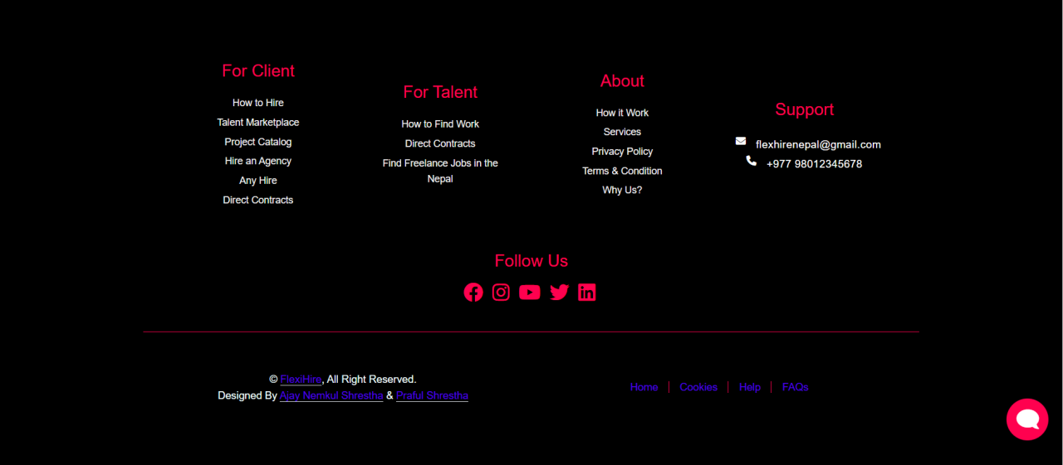

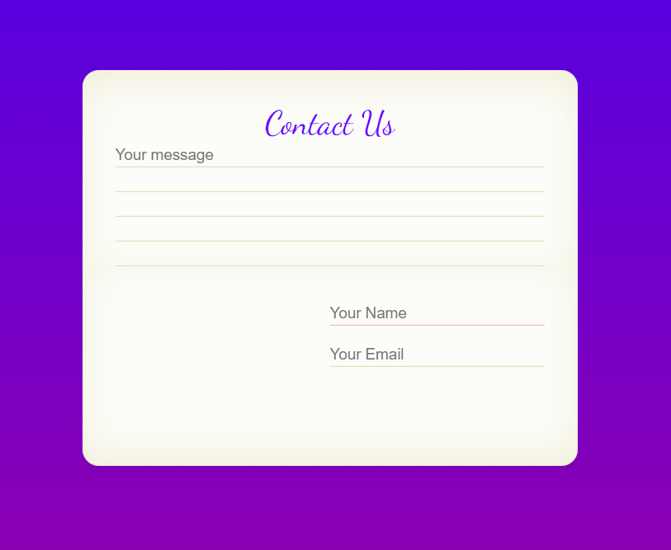

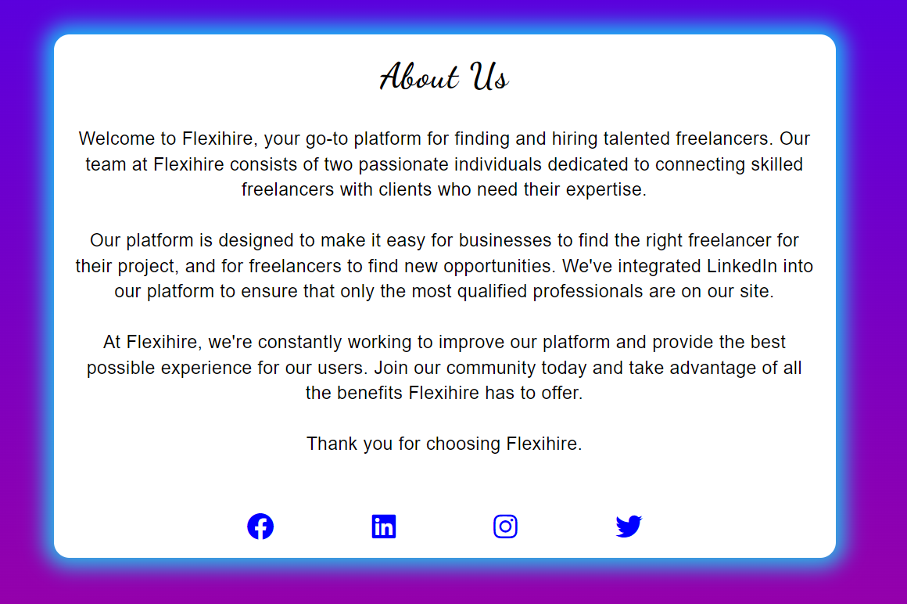

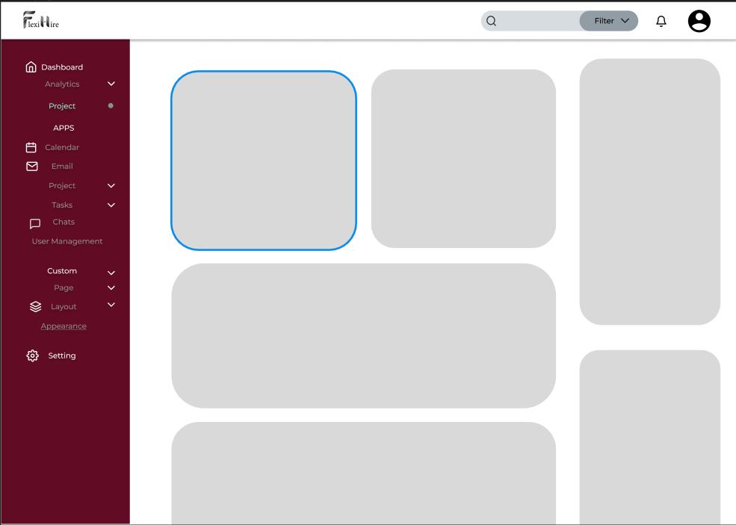



### 6.1.2 Conclusion

Based on the analysis conducted, the proposed freelancing website that merges features of Linked-in and Freelancer is feasible and has the potential to be a successful platform.

The proposed system would provide a unique combination of professional networking and freelance job opportunities, making it appealing to both freelancers and employers. The system would incorporate a variety of features such as job listings, project management tools, proposal management, and a rating system for both freelancers and employers, which would help to build trust and reputation within the community.

In terms of system requirements, the proposed system would require a robust and scalable technology infrastructure, including a web server, database server, and cloud hosting services. The system would also require secure authentication and authorization protocols to protect user data and prevent unauthorized access.

An ER diagram could be used to visualize the database schema, and a UML diagram could be used to model the architecture and interactions between the different components of the system. A flowchart could be used to illustrate the key workflows and decision points involved in the platform.

Overall, the proposed system has the potential to fill a gap in the market by providing a platform that combines professional networking and freelance job opportunities in a single platform. With careful planning, design, and implementation, the proposed system could become a successful and valuable platform for both freelancers and employers

**References**

|  |  |
| --- | --- |
| [1] |  |
| [2] |  |
| [3] |  |
| [4] |  |
| [5] |  |
| [6] |  |
| [7] |  |
| [8] |  |