Fundamentals of Data Science – Assignment Documentation (Week 7 & 8)

Module Code: UFCFK1-15-0

Module Title: Fundamentals of Data Science

Student Name: Praful Tiwari

Submission Date: 07-July-2025

## Program 1: NumPy Array Operations

Description:

This program generates a NumPy array of numbers (e.g., [1, 2, 3, 4, 5]) and performs operations such as sum, average, maximum, and minimum value identification.

Screenshot:

## Program 2: Array Input, Sorting and Slicing

Description:

This program takes an array of at least 10 numbers as input, sorts the array, and performs slicing operations to extract elements between specific index ranges like 2-5, 5-8, and 2-9.

Screenshot:

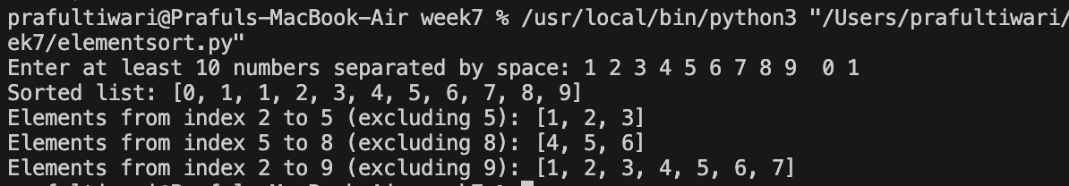

## Program 3: Random Integer Array – Sort and Reshape

Description:

This program creates a NumPy array of random integers, sorts them, and reshapes the array into a matrix with feasible dimensions (e.g., reshaping a 1×10 array into a 2×5 or 5×2 matrix).

Screenshot:

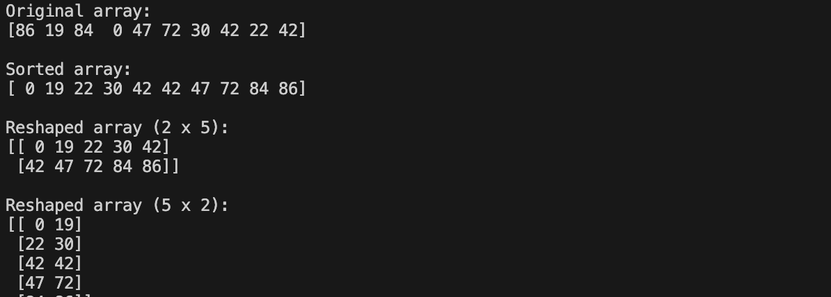

## Program 4: Matrix Operations with Validation

Description:

This program inputs two matrices of specific dimensions and performs addition, subtraction, and multiplication using NumPy. It includes validation to ensure compatible dimensions and raises exceptions for mismatches.

Screenshot:

## Program 5: Scatter Plot using Matplotlib and Pandas

Description:

This program reads data from `weight_height.csv` using Pandas and plots scatter plots such as weight vs height, age vs weight, height vs age, gender vs height, and gender vs weight using Matplotlib.

Screenshot:

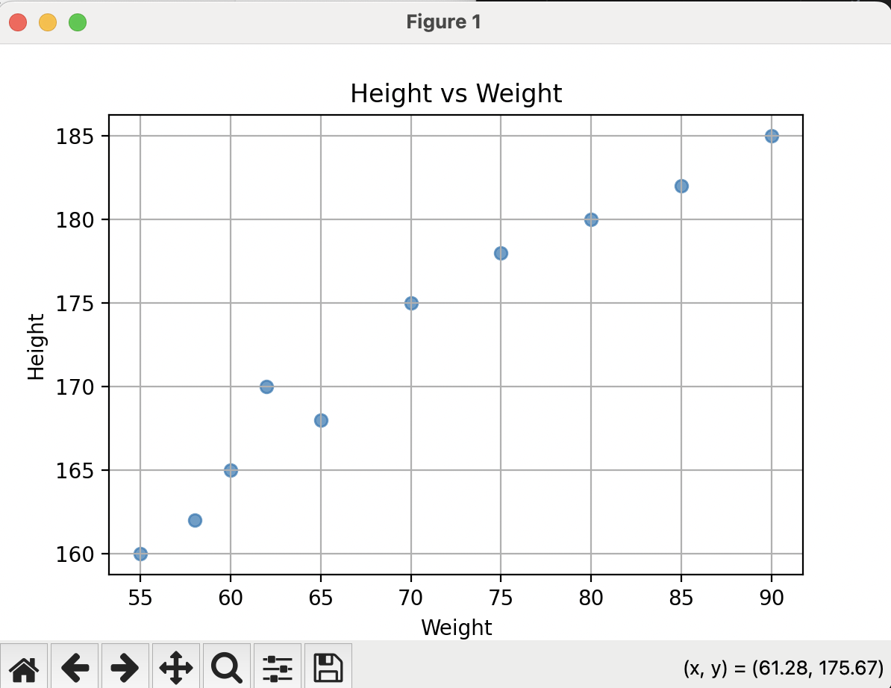

## Program 6: Add BMI and Risk Columns to CSV Data

Description:

This program reads data from `weight_height.csv` into a Pandas DataFrame and adds two new columns: BMI and Risk. The BMI is calculated as Weight/Height and the Risk level is categorized based on the BMI value using predefined conditions.

