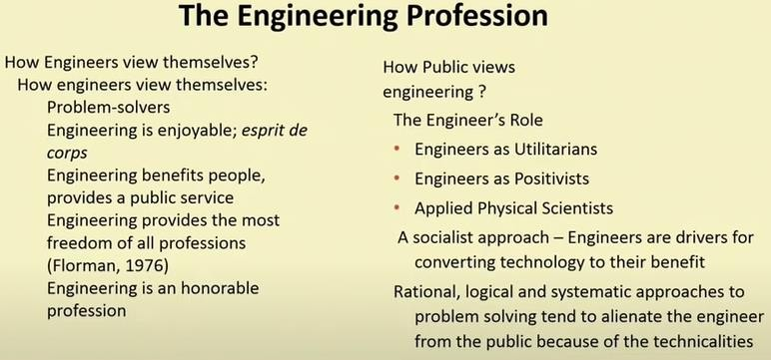

**NSPE Code of Conduct for Engineers(2007)**

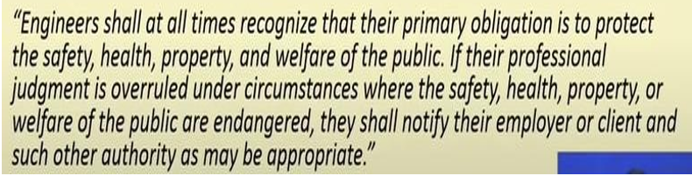

**What is Engineering Ethics?**

1. It is the study of moral issues of individuals involved in Engineering
2. It is the study of moral conduct, character and policies of people involved in technological activates

**Situations where ethical issues can arise**

1. Design, Testing, Manufacturing
2. Supervision and Project Teams: Project Timelines and Budgets
3. Products: Unsafe or Less Useful products, Harmful effects to the society
4. Other fields where ethics is important

* Medical Ethics
* Business Ethics
* Legal Ethics

**Profession and Professionalism**

Professions are the occupations that advanced study of a specialized body of knowledge, and undertake to ensure, or safeguard some aspects of others’ well-being.

Professionalism involves **consistently achieving high standards, both in the work you do and the way you behave**. Being professional helps you to achieve high-quality results, while impressing and inspiring others.

Characteristics of a profession are:

Advanced expertise: Requires sophisticated skills and theoretical knowledge

Self-regulation: Professional societies play important role in setting standards for admission to profession

Public good: Occupation provides some important public good by concerted efforts to maintain ethical standards.

**Morals:** It refers to the principles of Right and Wrong. They were edited, changed or modified or evolved to suit the geography of the region in accordance with the rulers in that time. Morality is concerned with principles and practices of morals such as:

* What should or should not to be done in a given situation?
* What is right or wrong about the handling of a situation? and
* What is good or bad about the people or policies involved?

**Values**: It is a principle that promotes well-being or prevents harm. **Personal values** are defined as the **emotional beliefs** in principles important for an individual. Eg: People have gone to great heights for showing their beliefs including wars and sacrificing their own life.

The 5 core human values involve:

1. Right conduct
2. Peace
3. Truth
4. Love
5. Nonviolence

Values related to Right Conduct involve:

1. Self-Help skills: Care of diet, hygiene
2. Social Skills: Good behaviour, good manners
3. Ethical Skills: Duty, taking initiatives, punctuality
4. Values related to Peace: Calmness, Concentration, Contentment, Equality
5. Values related to Truth: Fairness, Honesty
6. Values related to Love: Care, Compassion
7. Values related to Non-Violence:

* Psychological: Compassion, Forgiveness
* Social: Appreciation of other cultures, Care of environment

Types of Values:

1. Perseverance: It is defined as persistence, determination or commitment. It builds a character
2. Accuracy: It means freedom from mistakes and ensuring exactness. Accuracy includes telling the truth and not exaggerating
3. Discernment: It means discrimination. It stresses accuracy, especially in reading character or motives.

Why do human values evolve?

* The impact of norms of the society
* Developed or modified by one’s own choice for fulfilling the needs.
* By the teachings and practice of Gurus
* If modified by the ruler or the government

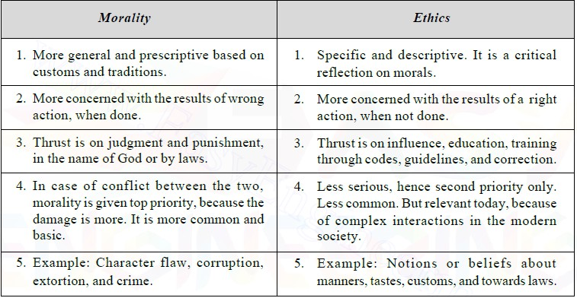

**Ethics:** A set of Moral principles guiding behaviour and action. Ethics is mainly used to set norms of behaviour.

Types of Ethics:

1. Utilitarianism: It is defined as a balance between good and bad consequences of an action
2. Duty ethics: It involves performing certain duties (for example, the duty to treat others fairly or the duty not to injure others)
3. Rights ethics emphasizes that we all have moral rights, and any action that violates these rights is ethically unacceptable.
4. Virtue ethics regards actions as right that manifests good character traits or virtues.

**Law:** Binding Codes of Conduct

**Engineering Ethics**: It is defined by the codes and standards of conduct endorsed by engineering societies with respect to the particular set of beliefs. It is the activity and discipline aimed at:

* Understanding the moral values that guides engineering profession
* Resolving moral issues in engineering
* Justifying the moral judgments in engineering. It deals with set of moral problems and issues connected with engineering.

**Roles of Engineer:**

1. Promotion of public good is the primary concern of the professional engineers.
2. Saviour: The engineer acts as a saviour by saving the society from wastage and inefficiency through technological development
3. Guardian: He guards the interests of the general public. Every person befitting his expertise is given the authority to determine what is best suited to the society.
4. Bureaucratic Servant: He serves the organization and the employers.
5. Social Servant: It is one who exhibits social responsibility. The engineer translates the interest and aspirations of the society into a reality
6. Game Player: He is neither a servant nor master. He plays a unique role successfully within the organization, enjoying the excitement of the profession
7. Social Enabler and Catalyst: One who changes the society through technology.

