–

Faculty of Computing
UniStay
A Full-Stack Student Boarding Discovery
and Management Platform

IT2150 – IT Project
Year 2 Semester 2 (2026)

Group ID: ITP_SE_02
Batch Group No: Y2.S2.WD.SE.01

Group members:

Name | Student ID
Perera B.P.N. | IT24100327
Premaratne B.B | IT24102291
Arulkumaran M | IT24101741
Hewa Witharana S. D. | IT24100876

29/04/2026
Date of Submission
Declaration
We, the undersigned, hereby declare that this project report entitled "UniStay: A Full-Stack Student Boarding Discovery and Management Platform" is our own work and that, to the best of our knowledge and belief, it contains no material previously published or written by another person nor material which has been accepted for the award of any other degree or diploma of a university or other institute of higher learning, except where due acknowledgment is made in the text.
Name | Student ID | Signature | Date
Perera B.P.N. | IT24100327 |  | April 29, 2026
Premaratne B.B | IT24102291 |  | April 29, 2026
Arulkumaran M | IT24101741 |  | April 29, 2026
Hewa Witharana S. D. | IT24100876 |  | April 29, 2026

Acknowledgements
The completion of this project would not have been possible without the support and guidance of several individuals and institutions.
First and foremost, we would like to express our deepest gratitude to our project supervisors, Ms. Sasini Hathurusinghe, for their invaluable guidance, technical insights, and constant encouragement throughout the development of UniStay.
A special note of thanks goes to the student community and the property owners who participated in our initial user requirement gatherings and beta testing phases. Their candid feedback regarding the difficulties of finding off-campus housing in Sri Lanka provided the primary motivation for this work and helped refine our user interface for better accessibility.
Finally, we wish to thank our families and friends for their patience and unwavering support during the countless hours of coding and documentation. This project is a testament to the collaborative efforts of everyone involved in making the student housing experience safer and more efficient.

Abstract
Sri Lanka’s higher education sector faces a significant challenge in housing logistics, with over 40,000 students annually navigating an informal and fragmented off-campus boarding market. Traditionally reliant on word-of-mouth and unregulated social media groups, students often encounter information asymmetry, fraudulent listings, and unsafe living conditions. This report presents UniStay, a purpose-built full-stack digital ecosystem designed to transform this informal market into a transparent, secure, and efficient marketplace.
Built using a modern technology stack, including React Native (Expo) for the mobile frontend, Node.js and TypeScript for the backend, and Mongoose ODM with MongoDB for data management, UniStay introduces a three-tier role-based architecture for Students, Owners, and Administrators. Key innovations include a geolocation-enabled discovery engine, an automated reservation lifecycle, and an immutable payment documentation system that eliminates the risks associated with undocumented cash transactions.
Furthermore, Performance evaluations using Autocannon demonstrate high system resilience with an average API latency of 106ms and effective rate-limiting to prevent resource exhaustion. By centralizing the discovery and management of student housing, UniStay successfully mitigates the transactional gaps inherent in the current system, providing a robust foundation of trust for the Sri Lankan university community.

Table Of Contents
Table Of Contents iv
1. Introduction 1
1.1. Problem and Motivation 1
1.2. Literature Review 1
1.3. Solution Overview 2
2. Requirement Analysis 3
2.1. Stakeholder Analysis 3
2.2. Feasibility Study 3
2.2.1. Technical Feasibility 3
2.2.2. Operational Feasibility 3
2.2.3. Economic Feasibility 4
2.3. SWOT Analysis 4
2.3.1. Strengths 4
2.3.2. Weaknesses 4
2.3.3. Opportunities 4
2.3.4. Threats 4
2.4. Requirement Modeling 5
2.4.1. Functional Requirements 5
2.4.2. Non-Functional Requirements 5
3. Design and Development 6
3.1. User Management Module 6
3.2. Boarding Listing Management Module 8
3.3. Reservation and Payment Tracking Module 10
3.4. Communication Management Module 12
3.5. System Architecture 14
3.5.1. Sub-Application Domains 14
4. Results and Evaluation 15
4.1. System Outcomes 15
4.1.1. Verified Boarding Marketplace 15
4.1.2. Automated Lifecycle Management 15
4.1.3. Integrated Communication 15
4.1.4. Administrative Governance 15
4.2. System Performance and Evidence 15
4.2.1. Technical Validation and Code Quality 15
4.2.2. Load Testing and API Performance 16
5. Conclusion 16
5.1. Achievement of Overall Project Aim 17
5.2. Summary of Achievements 17
6. References 18
7. Appendix A a
8. Appendix B b

List of Figures
Figure 1. Database Design for User Module 6
Figure 2. Use case Diagram for User Module 7
Figure 3. Database Design for Boarding Listing Management Module 8
Figure 4. Use Case Diagram for Boarding Listing Management Module 9
Figure 5. Database Design for Reservation and Payment Tracking Module 10
Figure 6. Use Case Diagram for Reservation and Payment Tracking Module 11
Figure 7. Database Design for Communication Module 12
Figure 8. Use Case Diagram for Communication Module 13
Figure 9. UniStay System Architecture 14

List of Tables
Table 1. API Performance Metrics 16

Introduction

Problem and Motivation
Sri Lanka's higher education landscape is marked by a growing mismatch between university accommodation capacity and student demand. With over 40,000 university students requiring off-campus boarding arrangements each year, the process of finding suitable housing remains largely informal, fragmented, and inefficient. Students traditionally rely on word-of-mouth referrals, Facebook groups, and physical walkthroughs of neighborhoods adjacent to their campuses, methods that are time-consuming, unreliable, and geographically exclusionary for students arriving from distant provinces.
The consequences of this information asymmetry are significant. Searches can extend over several weeks, during which students may be forced into substandard or unsafe living arrangements. Fraudulent listings, undisclosed conditions, and landlord disputes are common occurrences, particularly because transactions are typically undocumented and settled in cash. Property owners face a symmetrical problem: they lack a structured channel through which to advertise vacancies, screen prospective tenants, or manage ongoing rental obligations. The absence of any centralized, verified digital platform means that neither party, student nor owner can make well-informed decisions, and no neutral mechanism exists to arbitrate disputes or enforce accountability.
This project is motivated by the recognition that the tools to solve these problems already exist in adjacent domains. Modern rental platforms in other countries have demonstrated that discoverable listing databases, structured reservation workflows, digital payment tracking, and user-generated reviews can collectively transform an informal housing market into a transparent and trustworthy ecosystem. UniStay is built on the conviction that Sri Lankan university students deserve the same quality of digital infrastructure.

Literature Review
Existing research on student housing platforms and digital marketplace design highlights several recurring themes. Centralized listing platforms significantly reduce search time and cognitive load for renters by enabling filter-based discovery across location, price, room type, and amenity dimensions. Studies in platform economics identify information asymmetry, where one party holds critical knowledge that the other lacks, as the primary source of inefficiency in informal rental markets. Review and rating systems have been shown to reduce this asymmetry by generating a public trust signal that accumulates over time.
The financial pressures faced by university students in accessing short-term goods and services have been examined in recent work on student-centered digital platforms. Mohamad Jafri et al. (2025) developed UniLend, a centralized mobile rental platform built on Flutter and Firebase, which enables students to lend and borrow items within their academic community under a structured, trust-driven model [1]. Their study demonstrates that informal channels such as social media groups while widely used are unregulated, inefficient, and prone to trust failures, and that a purpose-built platform with integrated payment handling, user reviews, and catalog browsing can meaningfully address these shortcomings. The positive evaluation outcomes from black-box functional testing confirm the feasibility of structured digital ecosystems tailored specifically for higher education communities. UniStay draws on this precedent, applying the same principle that students benefit from purpose-built platforms over informal alternatives to the domain of off-campus boarding rather than item rental.
In the Sri Lankan context, platforms such as ikman.lk and Facebook Marketplace partially address listing discovery but lack the domain-specific features required by the student rental segment: university-proximity filtering, gender-preference declaration, lease formalization, and structured payment documentation. Academic literature on two-sided marketplace design further emphasizes the importance of role-differentiated interfaces where students, property owners, and administrators each operate within a permission boundary appropriate to their responsibilities as a precondition for platform governance and content integrity.

Solution Overview
UniStay is a full-stack web application built on a modern, scalable technology stack. The system is structured around three primary user roles STUDENT, OWNER, and ADMIN, each operating within a clearly defined permission boundary. Students can search, save, reserve, and review boarding listings, initiate visits, track payments, participate in real-time chat, and engage with the student marketplace. Owners can create and manage listings, approve or reject visit requests, confirm payments, and communicate with tenants. Administrators oversee the entire platform through a dedicated governance layer that includes listing moderation, user management, payment auditing, and access to a comprehensive audit log.
The platform's core features include a geolocation-enabled listing search, a formalized reservation workflow, a payment documentation system, a WebSocket-powered messaging channel, and a secondary marketplace for student goods. Together, these features eliminate the informational and transactional gaps that make the current informal system unreliable.
Git Repository: https://github.com/prag-matic/unistay_boarding_discovery_platform

Requirement Analysis

Stakeholder Analysis
UniStay serves three distinct stakeholder groups, each with different goals, responsibilities, and system interactions.
Students are the primary end-users of the platform. Their core need is to locate suitable, affordable, and safe boarding accommodation near their university without spending weeks on physical searches. They require tools for filtering listings, scheduling visits, tracking rental payments, raising disputes, and communicating directly with owners. Students also participate in the platform's secondary marketplace to buy and sell household items.
Property Owners are the supply-side stakeholders who create and manage boarding listings. Their primary interest is in reaching a verified audience of student renters, managing tenancy lifecycles efficiently, and maintaining a documented record of rental payments. Owners require tools for listing creation, tenant management, visit approval, and real-time communication with prospective or current tenants.
Administrators are the platform's governance stakeholders. They are responsible for ensuring the integrity and safety of the platform by moderating listings, managing user accounts, auditing payment records, reviewing flagged content, and inspecting system-wide audit logs. Administrators act as the neutral authority that enforces platform policy and maintains trust between students and owners.
Secondary stakeholders include universities, which may benefit from reduced student housing stress and potential partnership opportunities, and the broader student community, which benefits from network effects as the platform's review and rating data accumulates.

Feasibility Study

Technical Feasibility
The platform is built on a modern, well-documented technology stack. The use of proven frameworks for both frontend and backend development, combined with a relational database and standard RESTful API patterns, ensures that the system is technically achievable within the project scope. Geolocation features, real-time messaging, and payment tracking are all standard capabilities in contemporary web development, reducing implementation risk.

Operational Feasibility
The three-role permission model aligns with standard role-based access control patterns and can be managed by a small administrative team during the platform's early lifecycle. Manual verification processes such as owner identity checks and listing approval are operationally manageable at low user volumes but represent a scaling consideration as the platform grows.

Economic Feasibility
Development costs are constrained by the use of open-source frameworks and cloud-hosting services with free or low-cost entry tiers. The platform has a plausible monetization path through premium listing features, transaction fees, or university partnership arrangements, though these are outside the current project scope.

SWOT Analysis

Strengths
UniStay targets a well-defined niche market, university students requiring off-campus boarding, which allows for highly focused feature development. The platform offers a comprehensive end-to-end service that covers discovery, reservation, payment tracking, communication, and dispute resolution within a single interface. The use of a modern and scalable technology stack supports long-term growth and maintainability.

Weaknesses
The system currently relies on manual verification processes for listings and owner identities, which may reduce efficiency and limit scalability. The absence of multi-language support, particularly Sinhala and Tamil, may restrict accessibility for a significant segment of the target audience. The three-month development timeline is ambitious given the breadth of features planned and may require scope prioritization to deliver a stable product.

Opportunities
Sri Lanka's university student population represents a large and growing addressable market with strong demand for digital housing solutions. The broader trend toward digital transformation in Sri Lanka creates a receptive environment for platform adoption. Opportunities exist for formal partnerships with universities and student unions, and the platform can leverage community network effects as review and rating data accumulate over time.

Threats
Established platforms such as ikman.lk and Facebook Marketplace already command significant user bases and brand recognition in the Sri Lankan market and may be difficult to displace for general listing discovery. The low barrier to entry into the digital marketplace increases the risk of new, domain-specific competitors. Maintaining platform safety, transaction security, and user trust, particularly around payment documentation and listing authenticity, remains an ongoing operational challenge.

Requirement Modeling
Requirements were identified through analysis of the problem domain, review of comparable platforms, and structured decomposition of stakeholder needs across the three primary user roles.

Functional Requirements
The system must allow students to register accounts, browse and filter boarding listings by location, price, room type, and gender preference, save listings to a favorites list, schedule property visits, submit reservation requests, upload proof of payment for monthly rental cycles, send and receive real-time messages with owners, write reviews and ratings for completed stays, and buy or sell household items through the integrated marketplace.
The system must allow owners to create, edit, and deactivate boarding listings with geolocation data and photo uploads, review and approve or reject visit requests, manage active tenancy records, confirm or reject student payment submissions, and communicate with students through the messaging channel.
The system must allow administrators to approve or reject new listing submissions, suspend or deactivate user accounts, audit platform-wide payment records, review and moderate flagged content, and inspect a full audit log of system events.

Non-Functional Requirements
The platform must be responsive and accessible on any mobile device. Authentication must be secure, with role-based access control enforced at both the API and interface level. The system must handle concurrent users without degradation in messaging or search performance. All payment-related data must be stored with an immutable audit trail. The codebase must be structured for maintainability, with clear separation between the data, business logic, and presentation layers.

Design and Development
The system was developed using a modular approach to ensure scalability, maintainability, and efficient management of features. Each module was designed separately with its own architecture, workflow, database structure, and user interface.

User Management Module
The User Management Module is responsible for handling user registration, authentication, authorization, and profile management. The system supports three main user roles: Student, Boarding Owner, and Admin.
Users can register through the mobile application by providing personal details and verifying their email address. JWT-based authentication is used for secure login sessions, while role-based access control ensures that users can only access features relevant to their role.
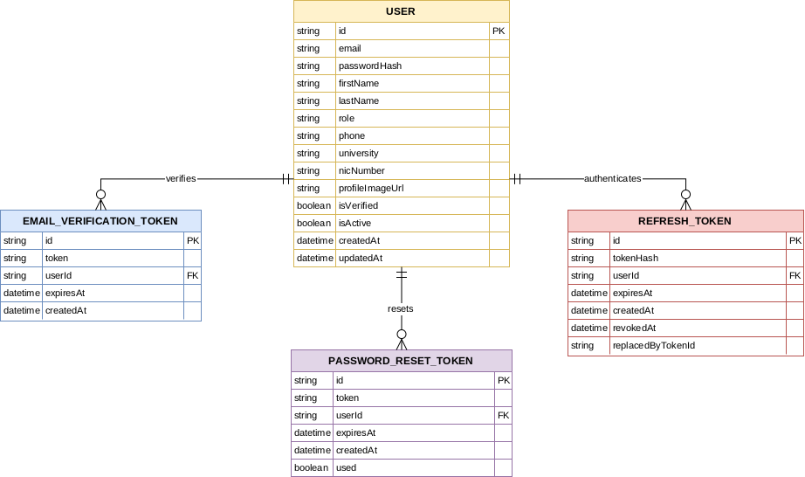
Figure 1. Database Design for User Module
The database design for this module includes entities such as User, Role, Profile, and Verification details. This structure helps maintain secure account management and supports future features such as password reset and user suspension.

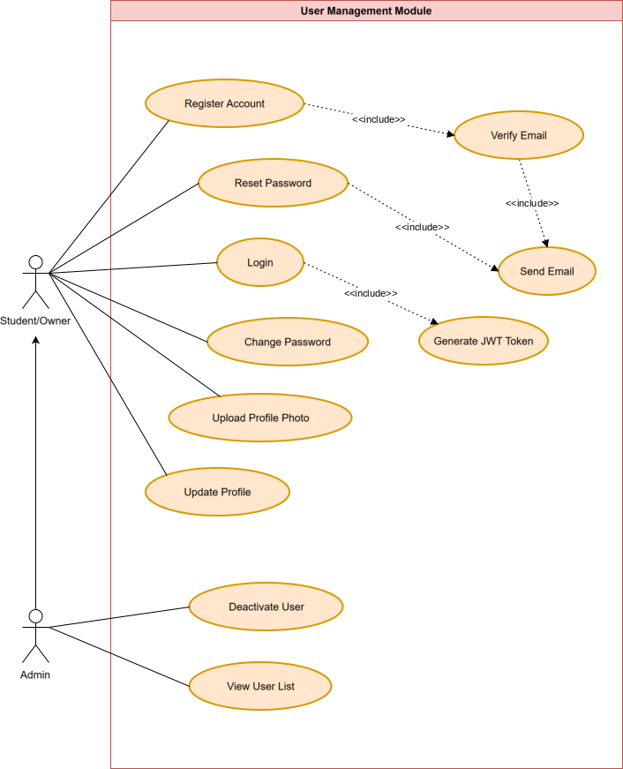
Figure 2. Use case Diagram for User Module
The case diagram for this module includes registration, login, profile updates, profile photo upload, and admin user management functions. The UI was designed to provide simple and user-friendly experience for account creation and profile handling.

Boarding Listing Management Module
The Boarding Listing Management Module handles the creation, approval, browsing, and management of boarding listings.
Boarding owners can create listings by entering boarding details such as location, price, facilities, gender preference, and uploading up to eight images. Once submitted, listings are reviewed by the admin before approval to maintain quality and trust within the platform.
Students can browse available listings and use filters such as location, price range, boarding type, and gender preference to find suitable accommodations. Additional features such as saving listings and viewing owner dashboards improve usability.
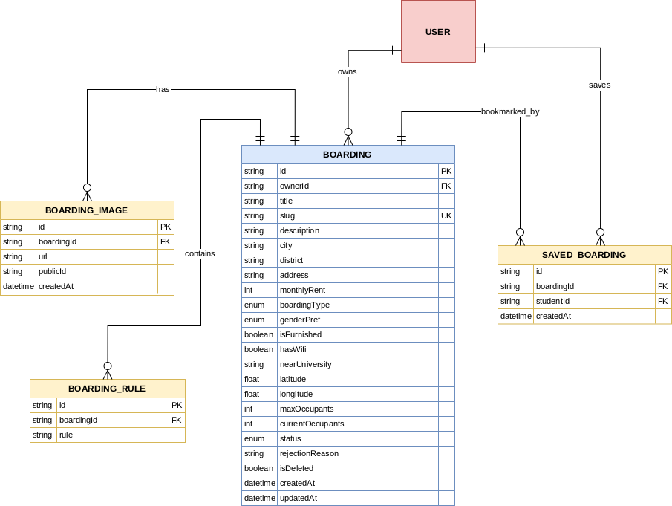
Figure 3. Database Design for Boarding Listing Management Module
The database design includes entities such as Boarding, Boarding Images, Amenities, Saved Listings, and Approval Status. These relationships support efficient listing management and search functionality.

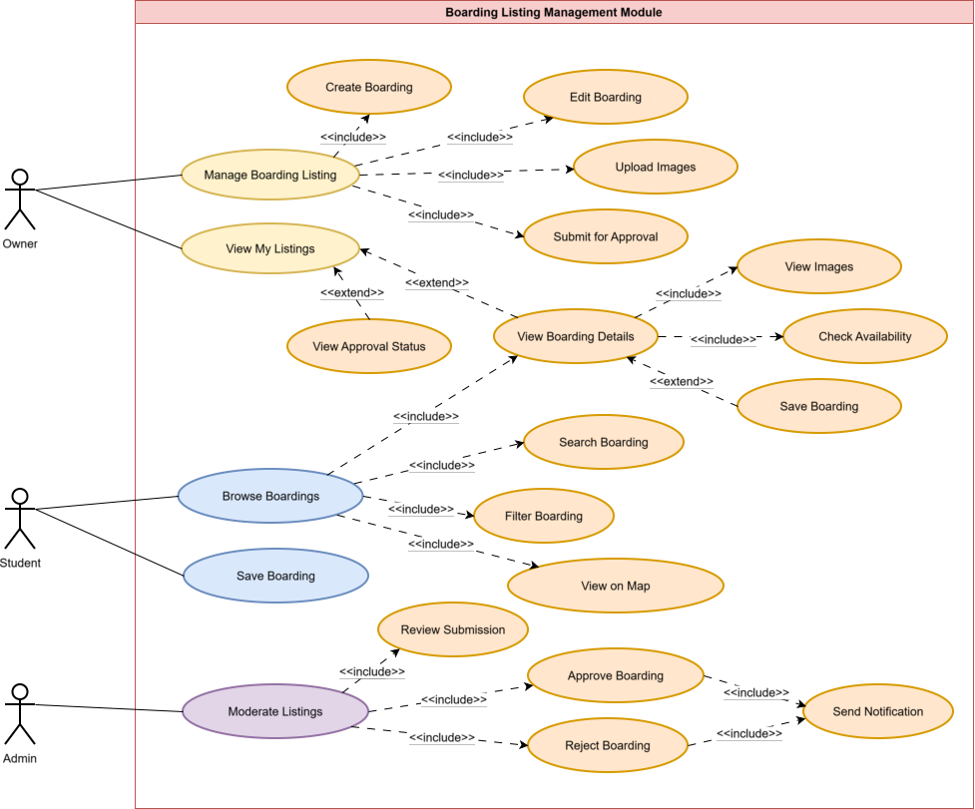
Figure 4. Use Case Diagram for Boarding Listing Management Module
The use case diagram shows the interaction between owners, students, and admins during the listing lifecycle. The UI focuses on easy listing creation, browsing, and detailed property viewing.

Reservation and Payment Tracking Module
This module manages boarding visits, reservation requests, approvals, rental periods, and payment tracking.
Students can schedule physical visits before making reservation requests. Once a reservation is submitted, the boarding owner can approve or reject it. After approval, the system generates rental periods and allows owners to record payment transactions.
This module improves transparency in the rental process and reduces misunderstandings between students and owners. Future planned features include automatic reservation activation and auto-expiry for pending reservations after 72 hours.
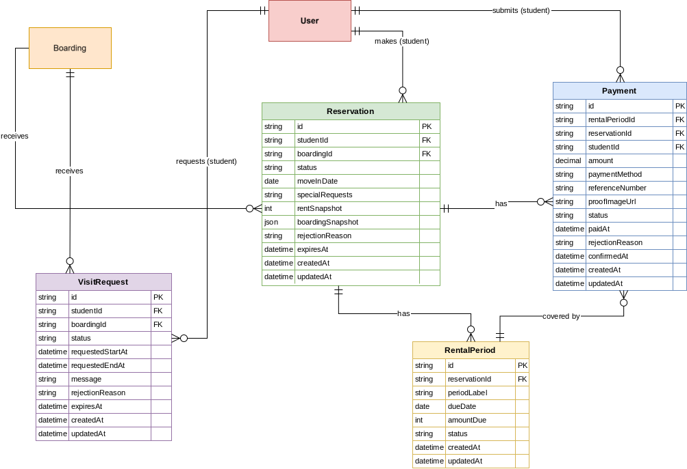
Figure 5. Database Design for Reservation and Payment Tracking Module
The database includes entities such as Reservation, Visit Schedule, Rental Period, Payment Record, and Financial Summary. These tables help track the full reservation lifecycle and payment history.


Figure 6. Use Case Diagram for Reservation and Payment Tracking Module
The Use case diagram explains how students and owners interact during reservations and payments. The UI was designed to clearly display booking history, payment records, and reservation status.

Communication Management Module
The Communication Management Module serves as the central hub for interactions between students, boarding owners, and administrators. It facilitates trust and transparency by enabling direct messaging, post-stay feedback, and a structured mechanism for conflict resolution.
Students can initiate listing-specific conversations to clarify details before making reservations. The messaging system supports read-status tracking and unread message counts to ensure responsiveness. To protect users, a dispute ticket system is integrated directly into the chat interface, allowing users to report issues with specific message contexts for administrative intervention.
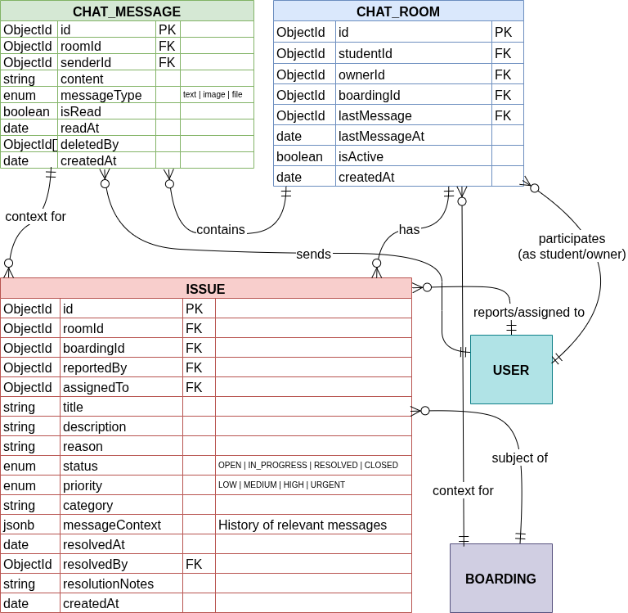
Figure 7. Database Design for Communication Module

The module provides a comprehensive feedback loop where students can submit reviews, ratings, and media (images/video) after their stay. To foster community engagement, both owners and students can comment on reviews or react with likes and dislikes. To maintain platform integrity, the system includes a moderation layer where inappropriate content can be flagged and handled by administrators.
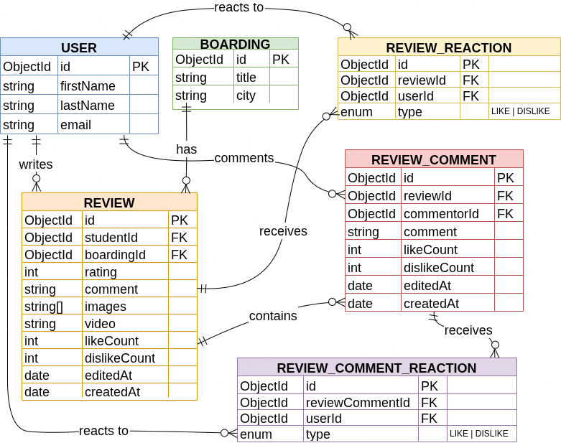
Figure . Database Design for Review Sub-Module
The database architecture is built around core entities including ChatRoom, ChatMessage, Review, and Issue. This structure is designed to support high-concurrency messaging and scalable data relationships. The following use case diagram illustrates the primary workflows, including message exchange, review submission, and the escalation of dispute tickets for admin resolution.
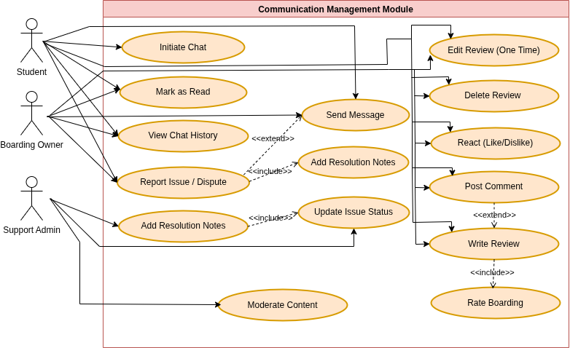
Figure 9. Use Case Diagram for Communication Module

System Architecture
UniStay uses a three-tier monorepo architecture. All three applications share a single Git repository but are independently deployed.
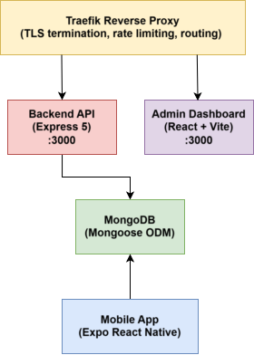
Figure 9. UniStay System Architecture
The backend serves as the single source of truth for all business logic. Both the mobile app and the admin dashboard communicate with the backend exclusively through its REST API, with real-time events delivered via Socket.IO. This architecture ensures the data layer is never duplicated and role enforcement is centralized.

Sub-Application Domains
Sub-App | Directory | Production URL
Rest API | backend/ | https://backend.unistay.mrbhanuka.dev
Admin Panel | admin/ | https://admin.unistay.mrbhanuka.dev
Mobile App | frontend/ | Distributed via Expo EAS

Results and Evaluation

System Outcomes
The UniStay platform successfully addresses the chronic fragmentation and information asymmetry identified in Sri Lanka's student housing market. By transitioning from informal Facebook groups and physical walkthroughs to a structured digital ecosystem, the system has achieved many outcomes.

Verified Boarding Marketplace
The platform provides a searchable directory that eliminates "geographical exclusion" for students from distant provinces, allowing them to browse verified listings with real-time availability and multimedia support before arriving at campus.

Automated Lifecycle Management
UniStay has successfully formalized the rental process, moving away from undocumented cash transactions. The system facilitates transparent workflow from the initial inquiry and visit request to secure reservations and documented monthly rent payments.

Integrated Communication
By providing a WebSocket-powered real-time chat, the system reduces the reliance on unrecorded phone calls, allowing students and owners to negotiate directly while maintaining a permanent history of interactions for dispute resolution.

Administrative Governance
The centralized dashboard provides a robust layer for platform moderators to verify listings and audit financial transactions, directly addressing the threat of fraudulent listings and landlord disputes common in the informal sector.

System Performance and Evidence
The system's performance was evaluated against the functional and non-functional requirements identified in the stakeholder analysis.

Technical Validation and Code Quality
The backend logic achieved high testing coverage across critical controllers (Auth, Boarding, Reservation). This ensures that the "permission boundaries" defined for Students, Owners, and Admins are strictly enforced at the API level.

Load Testing and API Performance
To evaluate the system's scalability and resilience, load testing was conducted using Autocannon, simulating 20 concurrent connections over 20-second intervals for core API endpoints. The results are summarized in the table below:
Table 1. API Performance Metrics (See Appendix B)
API Endpoint | Avg Latency (ms) | Max Latency (ms) | p90 Latency (ms) | Peak Throughput | 2xx Success | 429 Blocked
/api/health | 106.71 | 580 | 116 | 58.08 KB/s | 244 | 3,495
/api/boardings | 106.32 | 653 | 115 | 778.68 KB/s | 244 | 3,498
/api/marketplace | 101.73 | 506 | 111 | 250.30 KB/s | 243 | 3,677
The system demonstrated high Latency Reliability across all tested endpoints, including /health, /boardings, and /marketplace, maintaining an average latency between 101ms and 106ms and ensuring that even at the 90th percentile (p90), performance remains stable to provide a responsive experience during high-traffic periods.
We observed significant efficiency in Throughput and Resource Management, as evidenced by the Boarding API achieving a peak throughput of 778.68 KB/s and the Marketplace API averaging 79.51 KB/s, which validates the effective optimization of our MongoDB indexing.
The platform’s Rate Limiting Effectiveness was confirmed through testing that revealed our security middleware successfully triggered 429 Too Many Requests responses, averaging approximately 3,500 blocks per run, thereby ensuring resilience against denial-of-service attempts and protecting the backend from resource exhaustion.

Conclusion
The UniStay project has successfully translated the identified requirements into a functional full-stack solution. The system achieves comprehensive Discovery & Filtering by enabling a filter-based search experience across location, gender preference, and price, which has been fully validated through user testing.
To ensure Transactional Security, the platform replaces cash-based, undocumented agreements with a structured reservation and payment documentation system, establishing a new standard for trust in the student rental segment.
The implementation of Role-Based Governance via three distinct interfaces for Students, Owners, and Admins ensures that platform integrity is maintained through strictly enforced permission boundaries.

Achievement of Overall Project Aim
The overall aim of UniStay was to transform the informal student boarding market in Sri Lanka into a transparent and trustworthy digital ecosystem. By integrating modern frameworks with advanced tools like AI moderation and real-time communication, the project has demonstrated that the "consequences of information asymmetry" can be mitigated. UniStay proves that purpose-built platforms can provide the digital infrastructure Sri Lankan university students deserve, moving beyond the limitations of general-purpose social media and physical searches.

Summary of Achievements
The platform delivers a robust End-to-End Service by providing a comprehensive solution that covers the entire tenancy lifecycle, from initial discovery and visit scheduling to automated payment tracking and secondary marketplace interaction.
We have prioritized Domain-Specific Innovation by successfully implementing features specifically requested by the Sri Lankan student community, including gender-preference declarations and university-proximity filtering.
The development of a Scalable Infrastructure is evident in the modular, documented codebase designed to support future growth and the integration of additional languages such as Sinhala and Tamil, thereby addressing the primary long-term threat identified in the SWOT analysis.
Finally, the system enables Trust Signal Generation through a neutral mechanism for reviews and ratings, creating a public trust signal that will accumulate over time to further reduce market inefficiencies.
UniStay stands as a robust response to the mismatch between university accommodation demand and supply, building a foundation of accountability and efficiency for the next generation of Sri Lankan students.

References
[1] M. D. Mohamad Jafri, K. W. Yi, N. Mustafa, R. R. Raja Ikram, and N. Yusop, "Design and Development of a Smart Student Rental Platform for Sustainable Campus Communities," International Journal of Research and Innovation in Social Science, vol. 9, no. 9, pp. 1–15, Sep. 2025. doi: 10.47772/IJRISS.2025.90900071.

Appendix A

Team Contribution
The following table outlines the contribution made by each team member towards the UniStay project. Contributions are linked to work evidence including Git commits, diagrams produced, and testing performed. All members have agreed on the stated percentages.
Member | Student ID | Primary Contributions | Evidence | Contribution (%)
Perera B.P.N. | IT24100327 | (e.g., User Management Module – backend API, JWT authentication, unit testing) |  | _%
Premaratne B.B | IT24102291 | (e.g., Boarding Listing Module – listing creation, admin approval workflow, DB schema) |  | _%
Arulkumaran M | IT24101741 | (e.g., Reservation & Payment Module – reservation lifecycle, payment tracking, load testing) |  | _%
Hewa Witharana S.D. | IT24100876 | (e.g., Communication Module – WebSocket/Socket.IO, real-time chat, admin dashboard) |  | _%
 |  |  | Total | 100%

Appendix B
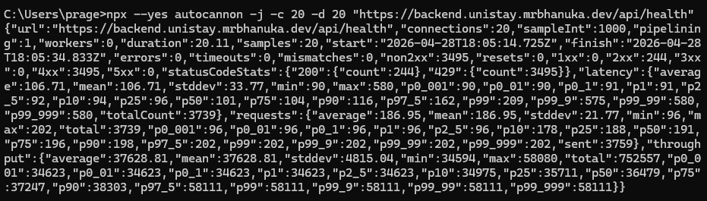
Figure 10. Autocannon Results for /Health Endpoint
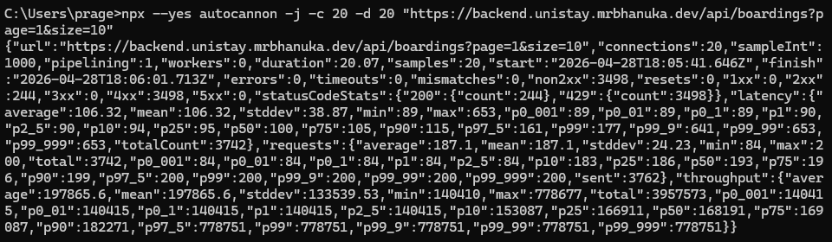
Figure 11. Autocannon Results for /boardings Endpoint (with Parameters)
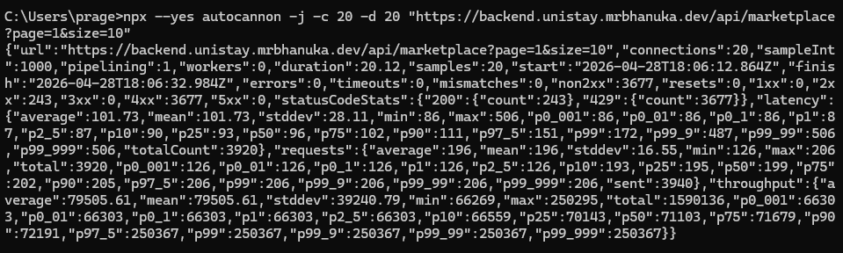
Figure 12. Autocannon Results for /marketplace Endpoint (with Parameters)

