AI Usage DISCLOSURE FORM

1. Team Details
Team Name: Koffee with Kernal
Project / Product Name: Smart Guided Troubleshooting Engine
Organization / Institution : Vellore Institute of Technology, Vellore
Submission Date: 30-09-2026

2. AI Usage Declaration
Did your team use any Artificial Intelligence (AI) in developing this project? Yes

3. Purpose of AI Usage ( Brief Details)
- Code generation or assistance
- Data analysis
- Testing / debugging

4. Feature Origin Classification ( Please add/delete based on the number of the feature)
1. Feature Name: LLM Troubleshooting Extraction Pipeline
2. Self-Generated/AI-Generated/Both: Both
3. Description ( include AI tools/platform Used, prompt used , Output Summary, Modification):
Used Groq APIs to parse vague user queries against the SIIS JSON context. Prompt engineering was heavily modified to enforce strict JSON schema outputs and prevent hallucinated steps.

1. Feature Name: Query Enrichment & Paraphrasing
2. Self-Generated/AI-Generated/Both: AI-Generated
3. Description (include AI tools/platform Used, prompt used , Output Summary, Modification):
Implemented a system prompt requiring the LLM to generate 8 to 10 distinct, lexically diverse paraphrases for user complaints.

5. Ethical & Compliance Confirmation
AI usage complies with guidelines and policies. Yes
No proprietary or copyrighted data misused. I Agree

6. Declaration & Sign-Off
Name of Team Representative: Hariprannav S
Role: Team Representative & LLM / Prompt Engineer
Signature:
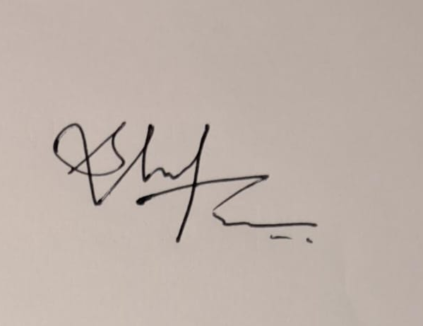
Date: 30-09-2026

