ACADEMIC SUBMISSION

ASSIGNMENT - 1
  - Event-Driven Microservices Design and Development
Case Study: Online Food Delivery System
Student Name: ____________________________
Register Number: ____________________________
Course / Section: ____________________________
Submission Date: ____________________________

Contents
- Question 1 - Scalable Microservices Design
- Question 2 - Messaging Patterns and Protocols
- Question 3 - Event-Driven and Domain-Driven Development
- Programs 1-15
- Verification Summary
Word tip: Use References > Table of Contents if an automatically numbered table of contents is required by your institution.

Course Outcome Mapping
CO | Outcome | Marks
CO1 | Scalable microservices strategies and best practices | 30
CO2 | Event-driven messaging patterns and protocols | 35
CO3 | Event-driven and domain-driven microservice development | 35

Question 1 - CO1: Scalable Microservices Design
The application is divided by business capability so that each service can be developed, deployed, scaled and recovered independently. Clients enter through one API Gateway. Business state changes are shared asynchronously through RabbitMQ, while each service owns its database.
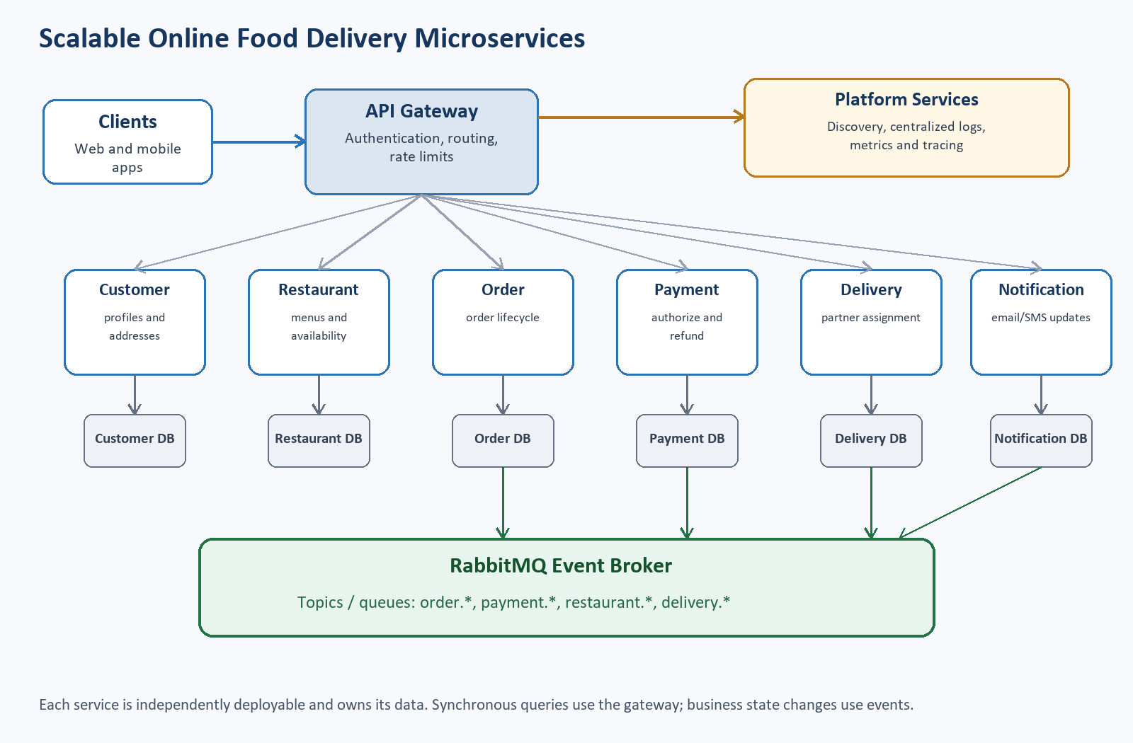
Figure 1. Scalable architecture for the online food delivery system.

Microservice responsibilities
Service | Main responsibility | Example data
Customer | Registration, profile, saved addresses | Customer, Address
Restaurant | Restaurant details, menus, prices, availability | Restaurant, MenuItem
Order | Create orders and control the order lifecycle | Order, OrderItem
Payment | Authorize, complete and refund payments | Payment, Transaction
Delivery | Assign partners and track delivery | Delivery, Partner
Notification | Send email, SMS or push updates | Notification log

Strategies and best practices
Independent deployment. Each service has its own Spring Boot project, build artifact and configuration. A change to Notification Service does not require rebuilding Order Service.
Loose coupling. Services exchange small API contracts or immutable events instead of sharing implementation classes or database tables.
Service discovery. In a larger deployment, instances register with Eureka, Consul or Kubernetes DNS. The gateway resolves a logical service name rather than a fixed IP address.
API gateway. The gateway provides one client-facing address, routes requests, applies authentication, rate limiting and correlation IDs, and hides internal ports.
Database per service. Every service owns its schema. Cross-service reporting is built from events or read models, not direct joins across service databases.
Load balancing and horizontal scaling. Stateless instances can be replicated. The gateway/load balancer distributes HTTP calls; competing consumers distribute queued work.
Fault tolerance. Use timeouts, limited retries, circuit breakers, bulkheads and fallbacks for synchronous calls. Use durable queues, retry policies and DLQs for messaging.
Security. Validate JWTs at the gateway, enforce service authorization, use TLS and secrets management, and do not place sensitive payment details in events.
Logging and monitoring. Propagate a correlation ID and event ID. Centralize logs and collect request latency, error rate, queue depth and consumer failure metrics.

Question 2 - CO2: Event-Driven Messaging Patterns and Protocols
RabbitMQ with AMQP is selected because the assignment needs queues, routing keys, acknowledgements, competing consumers, retries and dead-letter routing. A topic exchange supports publish-subscribe and keeps producers independent of consumers.
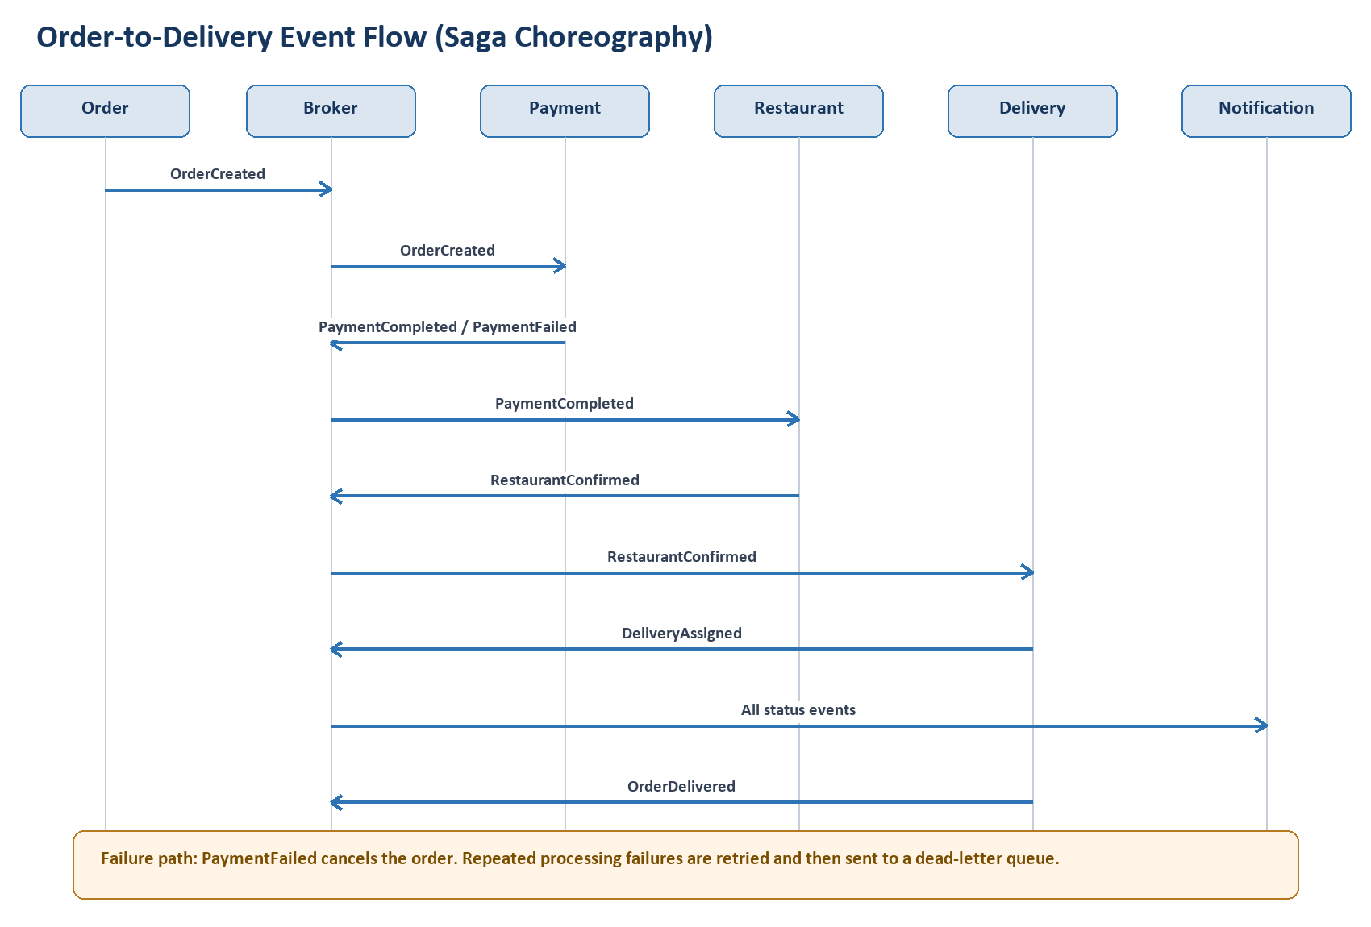
Figure 2. Message flow from order placement to delivery, including failure handling.

Successful choreography
- Order Service accepts the request, stores the new order and publishes OrderCreated.
- Payment Service consumes OrderCreated and publishes PaymentCompleted or PaymentFailed.
- Restaurant Service consumes PaymentCompleted and publishes RestaurantConfirmed.
- Delivery Service consumes RestaurantConfirmed and publishes DeliveryAssigned.
- Delivery Service publishes OrderDelivered when the partner completes delivery.
- Order Service updates its local state from each event; Notification Service subscribes to status events.

Patterns
- Publisher-subscriber: OrderCreated is copied to independent queues for Payment, Notification and Analytics.
- Topics and queues: routing keys such as order.created and payment.completed describe event meaning. Each subscriber owns a queue.
- Saga choreography: no central orchestrator is required; each service reacts to an event and emits the next event.
- Competing consumers: multiple worker instances listen to one work queue, so each message is handled by one worker.
- Retry and DLQ: transient failures are retried a small number of times. A permanently failing message is rejected and dead-lettered for inspection.

Failure and compensation
PaymentFailed: Order Service changes the order to CANCELLED and Restaurant/Delivery processing does not start.
Delivery assignment failure: The saga marks the order for refund. Payment Service performs the compensating refund and publishes PaymentRefunded.

Event structure
{
"eventId": "EVT-1001",
"eventType": "OrderCreated",
"occurredAt": "2026-08-10T15:38:51Z",
"aggregateId": "ORD-101",
"version": 1,
"payload": {
"customerId": "CUS-1",
"restaurantId": "RES-9",
"amount": 499.00
}
}
The event ID enables idempotency, aggregate ID groups events for one order, occurredAt supports auditing, and version allows compatible schema evolution. AMQP is appropriate here because RabbitMQ provides durable queues, acknowledgements, flexible exchanges and operationally simple routing for a classroom implementation.

Question 3 - CO3: Event-Driven and Domain-Driven Development
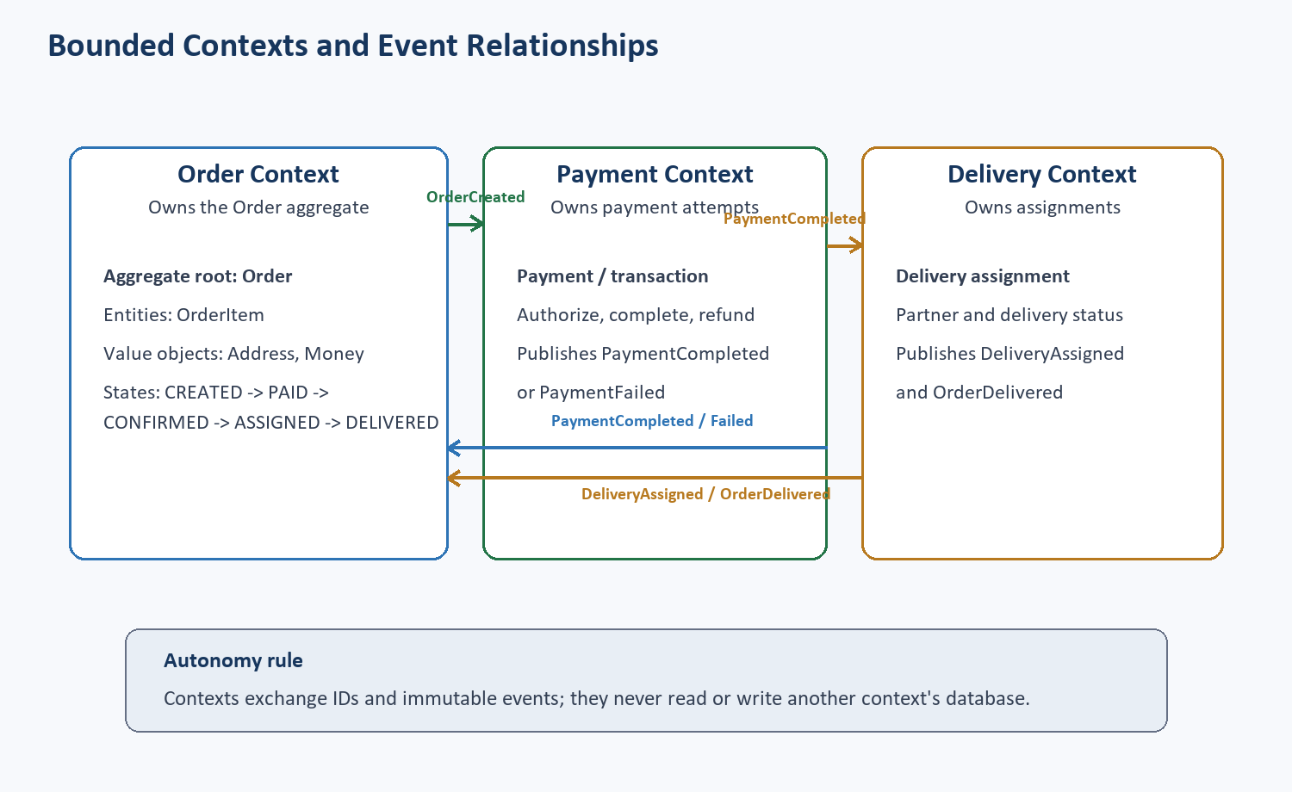
Figure 3. Order, Payment and Delivery bounded contexts and their event relationships.

Bounded contexts and relationships
Order Management is the upstream context for order identity and lifecycle. Payment and Delivery are separate downstream contexts. They translate incoming events into their own models and return facts as new events. Shared database access is not permitted.

Order aggregate
- Aggregate root - Order: protects order state transitions and contains the list of items.
- Entity - OrderItem: has identity inside an order and records menu item, quantity and price.
- Value objects - Address and Money: immutable values validated when created.
- Invariant examples: an order must contain at least one item; quantity must be positive; a delivered order cannot return to CREATED.

Commands, events and handlers
Command | Handler action | Published event
CreateOrder | Validate items, create aggregate, save order | OrderCreated
CompletePayment | Record successful payment | PaymentCompleted
ConfirmRestaurant | Accept the order for preparation | RestaurantConfirmed
AssignDelivery | Choose an available delivery partner | DeliveryAssigned
MarkDelivered | Close delivery and order | OrderDelivered

State transitions
CREATED -> PAYMENT_PENDING -> PAID -> RESTAURANT_CONFIRMED -> DELIVERY_ASSIGNED -> DELIVERED
\-> PAYMENT_FAILED -> CANCELLED
\-> DELIVERY_FAILED -> REFUND_REQUIRED

Creating an order and publishing a domain event
OrderService.java (Experiment 11)
package com.example.orderdomain.service;
import java.time.Instant;
import java.util.UUID;
import org.springframework.context.ApplicationEventPublisher;
import org.springframework.stereotype.Service;
import com.example.orderdomain.event.OrderPlacedEvent;
@Service
public class OrderService {
private final ApplicationEventPublisher publisher;
public OrderService(ApplicationEventPublisher publisher) {
this.publisher = publisher;
}
public OrderPlacedEvent placeOrder(String itemName, int quantity) {
OrderPlacedEvent event = new OrderPlacedEvent(
UUID.randomUUID().toString(), UUID.randomUUID().toString(),
itemName, quantity, Instant.now());
publisher.publishEvent(event);
return event;
}
}

Consumer and idempotency
IdempotentEventProcessor.java (Experiment 14)
package com.example.idempotent.service;
import java.util.Set;
import java.util.concurrent.ConcurrentHashMap;
import java.util.concurrent.atomic.AtomicInteger;
import org.springframework.stereotype.Service;
import com.example.idempotent.event.OrderEvent;
@Service
public class IdempotentEventProcessor {
private final Set<String> processedEventIds = ConcurrentHashMap.newKeySet();
private final AtomicInteger businessUpdates = new AtomicInteger();
public Result process(OrderEvent event) {
boolean firstDelivery = processedEventIds.add(event.eventId());
if (firstDelivery) {
businessUpdates.incrementAndGet();
System.out.println("Processed event " + event.eventId());
return new Result("PROCESSED", businessUpdates.get());
}
System.out.println("Ignored duplicate event " + event.eventId());
return new Result("DUPLICATE_IGNORED", businessUpdates.get());
}
public record Result(String result, int businessUpdateCount) { }
}
The processedEventIds set is the classroom substitute for a database table with eventId as a unique key. In a production service, the event ID and business update should be committed in the same local transaction. This prevents duplicate broker delivery from applying the business change twice.
Autonomy and consistency: Each service commits only its own data and publishes facts for other services. The system is eventually consistent: temporary differences are accepted, while retries, idempotency and compensating events converge the workflow.

Programs 1-15: Source, Input and Verified Output
All 15 programs were implemented and demonstrated. In accordance with the stated submission rule, detailed code listings are included for five selected programs: 3 (CO1), 7 and 9 (CO2), and 11 and 14 (CO3). Every program still includes a concise explanation, sample action and verified demo screenshot. Complete source for all 15 remains in the accompanying source folder.
No. | Program | CO | Submission evidence
1 | Basic Restaurant Service REST endpoint | CO1 | Demo
2 | Independent Customer and Order services | CO1 | Demo
3 | Service-to-service call using RestTemplate | CO1 | Code + demo
4 | API Gateway routes | CO1 | Demo
5 | Publish OrderCreated with RabbitMQ | CO2 | Demo
6 | Payment Service consumes OrderCreated | CO2 | Demo
7 | Publish-subscribe to Notification and Analytics | CO2 | Code + demo
8 | Work queue with two competing consumers | CO2 | Demo
9 | Retry and dead-letter queue | CO2 | Code + demo
10 | Order aggregate with items and address | CO3 | Demo
11 | Create and publish OrderPlacedEvent | CO3 | Code + demo
12 | Handle PaymentCompletedEvent | CO3 | Demo
13 | Saga choreography | CO3 | Demo
14 | Idempotent event processing | CO3 | Code + demo
15 | Order, Payment and Delivery bounded contexts | CO3 | Demo

Program 1: Basic Restaurant Service REST endpoint
Mapping: CO1 | Spring Boot | Source folder: springboot\springboot\exp1\restaurant-service

Brief explanation
A small Restaurant Service exposes one REST endpoint that returns the service name, health state and purpose.

Source location
springboot\springboot\exp1\restaurant-service\src\main\java\com\example\restaurantservice\RestaurantController.java

Sample input / action
GET http://localhost:8080/api/info

Verified output
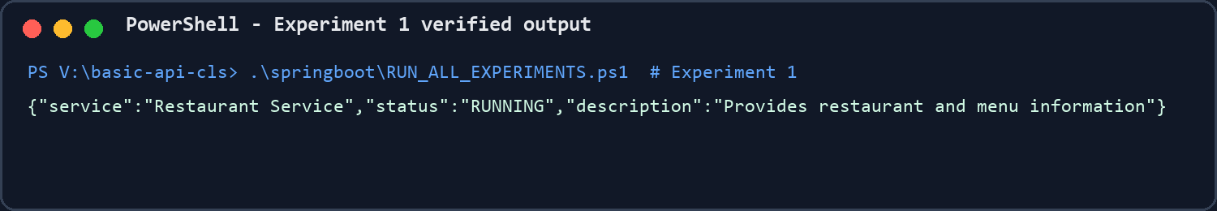
Figure 4. Successful execution evidence for Program 1.
Result: The program executed successfully and demonstrated the stated concept.

Program 2: Independent Customer and Order services
Mapping: CO1 | Spring Boot | Source folder: springboot\springboot\exp2

Brief explanation
Customer and Order are separate Spring Boot processes with separate ports, codebases and in-memory data stores.

Source location
springboot\springboot\exp2\order-service\src\main\java\com\example\orderservice\controller\OrderController.java

Sample input / action
GET ports 8081 and 8082

Verified output
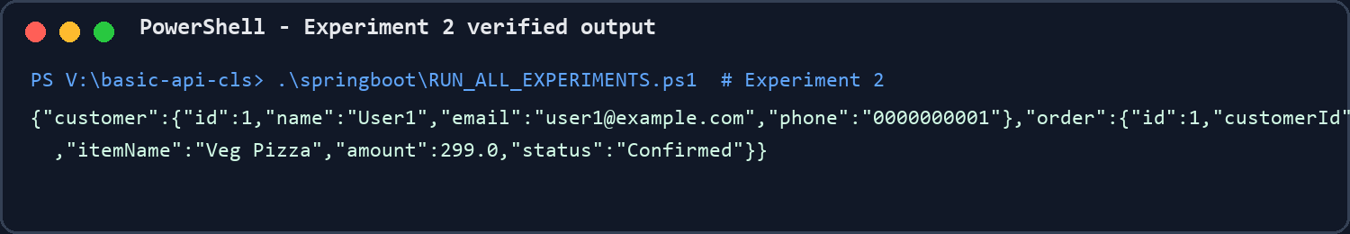
Figure 5. Successful execution evidence for Program 2.
Result: The program executed successfully and demonstrated the stated concept.

Program 3: Service-to-service call using RestTemplate
Mapping: CO1 | Spring Boot | Source folder: springboot\springboot\exp3

Brief explanation
Order Service uses RestTemplate to request customer details from Customer Service using the customer ID stored on the order.

Selected source code
springboot\springboot\exp3\order-service\src\main\java\com\example\orderservice\service\OrderService.java
package com.example.orderservice.service;
import java.util.ArrayList;
import java.util.List;
import org.springframework.stereotype.Service;
import org.springframework.web.client.RestTemplate;
import com.example.orderservice.model.Customer;
import com.example.orderservice.model.Order;
@Service
public class OrderService {
private final List<Order> orders = new ArrayList<>();
private final RestTemplate restTemplate;
public OrderService(RestTemplate restTemplate) {
this.restTemplate = restTemplate;
orders.add(new Order(
1,
1,
"Veg Pizza",
299.00,
"Confirmed"
));
orders.add(new Order(
2,
2,
"Paneer Biryani",
249.00,
"Shipped"
));
}
public List<Order> getAllOrders() {
return orders;
}
public Order getOrderById(int id) {
for (Order order : orders) {
if (order.getId() == id) {
return order;
}
}
return null;
}
// ... remaining boilerplate is in the source folder

Sample input / action
GET http://localhost:8082/api/orders/1/customer

Verified output
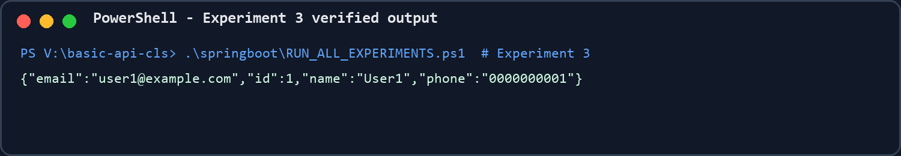
Figure 6. Successful execution evidence for Program 3.
Result: The program executed successfully and demonstrated the stated concept.

Program 4: API Gateway routes
Mapping: CO1 | Spring Cloud Gateway | Source folder: springboot\springboot\exp4

Brief explanation
Spring Cloud Gateway matches URL paths and forwards requests to the correct internal service.

Source location
springboot\springboot\exp4\api-gateway\src\main\resources\application.properties

Sample input / action
GET http://localhost:8080/api/customers/1

Verified output
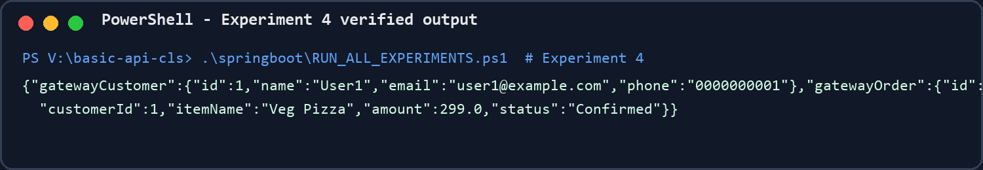
Figure 7. Successful execution evidence for Program 4.
Result: The program executed successfully and demonstrated the stated concept.

Program 5: Publish OrderCreated with RabbitMQ
Mapping: CO2 | Spring Boot + RabbitMQ | Source folder: springboot\springboot\exp5\order-service

Brief explanation
Order Service creates an immutable OrderCreatedEvent and sends it to a RabbitMQ topic exchange.

Source location
springboot\springboot\exp5\order-service\src\main\java\com\example\orderservice\service\OrderService.java

Sample input / action
POST /orders?product=Veg%20Pizza&quantity=2

Verified output
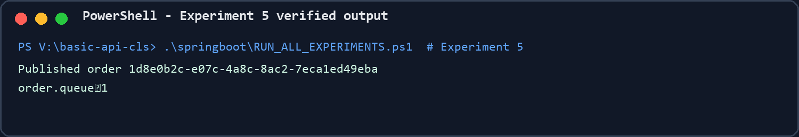
Figure 8. Successful execution evidence for Program 5.
Result: The program executed successfully and demonstrated the stated concept.

Program 6: Payment Service consumes OrderCreated
Mapping: CO2 | Spring Boot + RabbitMQ | Source folder: springboot\springboot\exp6

Brief explanation
Payment Service listens on order.queue and converts the JSON message into its local OrderCreatedEvent class.

Source location
springboot\springboot\exp6\payment-service\src\main\java\com\example\paymentservice\consumer\OrderCreatedConsumer.java

Sample input / action
POST through Order Service; observe Payment log

Verified output
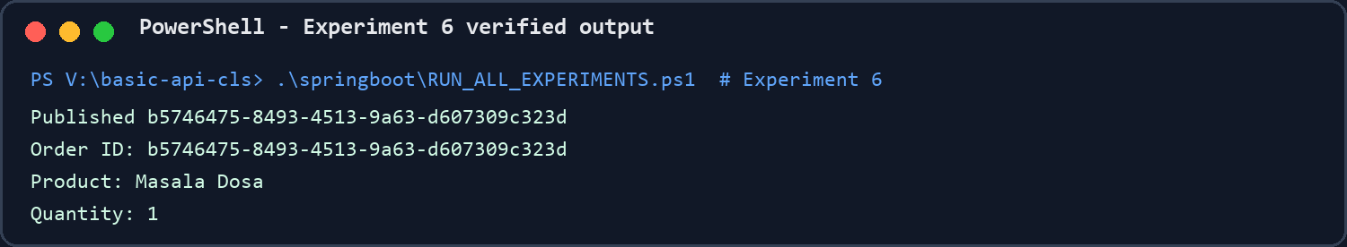
Figure 9. Successful execution evidence for Program 6.
Result: The program executed successfully and demonstrated the stated concept.

Program 7: Publish-subscribe to Notification and Analytics
Mapping: CO2 | Spring Boot + RabbitMQ | Source folder: springboot\springboot\exp7

Brief explanation
One published event is routed to two different queues, so both Notification and Analytics receive their own copy.

Selected source code
springboot\springboot\exp7\analytics-service\src\main\java\com\example\analyticsservice\consumer\OrderCreatedAnalyticsConsumer.java
package com.example.analyticsservice.consumer;
import org.springframework.amqp.rabbit.annotation.RabbitListener;
import org.springframework.stereotype.Component;
import com.example.analyticsservice.event.OrderCreatedEvent;
@Component
public class OrderCreatedAnalyticsConsumer {
@RabbitListener(queues = "analytics.queue")
public void handleOrderCreated(OrderCreatedEvent event) {
System.out.println("===== Analytics Service =====");
System.out.println("Order Created Event Received");
System.out.println("Order ID: " + event.getOrderId());
System.out.println("Product: " + event.getProduct());
System.out.println("Quantity: " + event.getQuantity());
// Analytics processing can be performed here
System.out.println("Analytics updated for product: "
+ event.getProduct());
System.out.println("=============================");
}
}

Sample input / action
Publish once; observe both consumer logs

Verified output
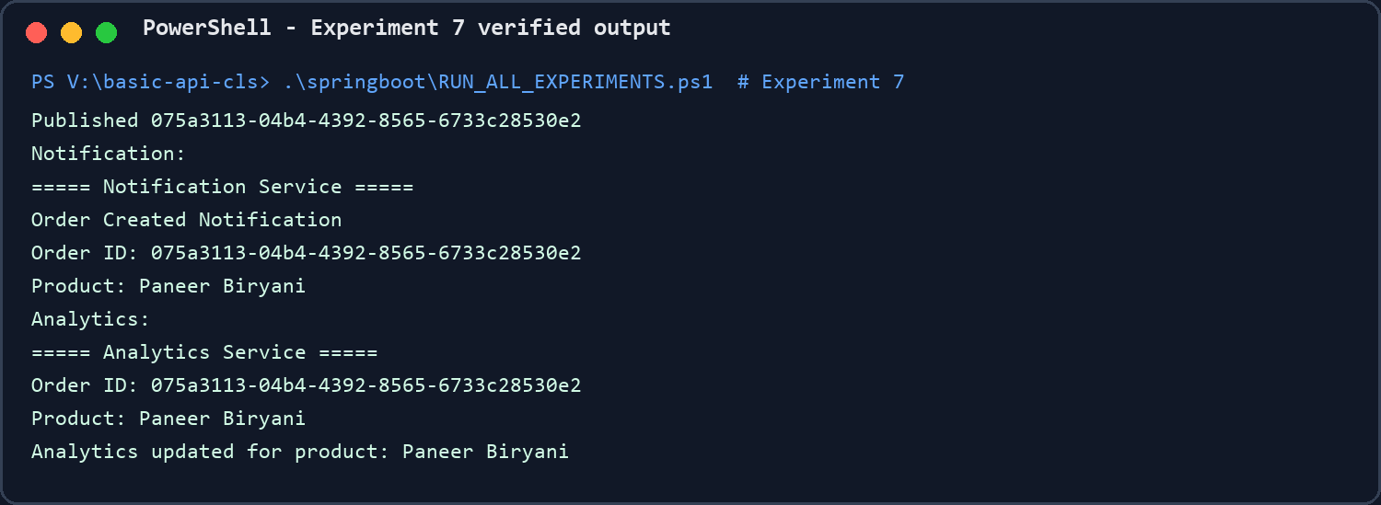
Figure 10. Successful execution evidence for Program 7.
Result: The program executed successfully and demonstrated the stated concept.

Program 8: Work queue with two competing consumers
Mapping: CO2 | Spring Boot + RabbitMQ | Source folder: springboot\springboot\exp8

Brief explanation
Two listeners consume from one queue. RabbitMQ distributes messages so only one worker handles each order.

Source location
springboot\springboot\exp8\order-worker-service\src\main\java\com\example\orderworkerservice\consumer\OrderProcessingConsumer.java

Sample input / action
Publish six orders; Worker-1 and Worker-2 share them

Verified output
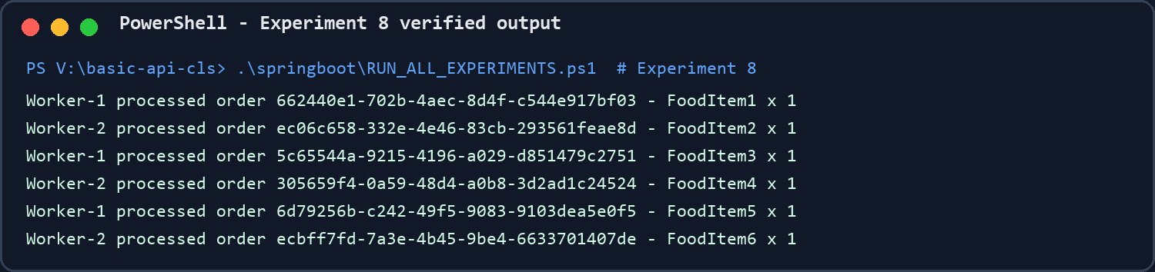
Figure 11. Successful execution evidence for Program 8.
Result: The program executed successfully and demonstrated the stated concept.

Program 9: Retry and dead-letter queue
Mapping: CO2 | Spring Boot + RabbitMQ | Source folder: springboot\springboot\exp9

Brief explanation
A demo failure is retried and then rejected to a dead-letter exchange and queue for later inspection.

Selected source code
springboot\springboot\exp9\order-worker-service\src\main\java\com\example\orderworkerservice\consumer\OrderProcessingConsumer.java
package com.example.orderworkerservice.consumer;
import java.util.Map;
import java.util.concurrent.ConcurrentHashMap;
import org.springframework.amqp.rabbit.annotation.RabbitListener;
import org.springframework.stereotype.Component;
import com.example.orderworkerservice.config.RabbitMQConfig;
import com.example.orderworkerservice.event.OrderCreatedEvent;
@Component
public class OrderProcessingConsumer {
private final Map<String, Integer> attempts = new ConcurrentHashMap<>();
@RabbitListener(queues = RabbitMQConfig.QUEUE)
public void processOrder(OrderCreatedEvent event) {
int attempt = attempts.merge(event.getOrderId(), 1, Integer::sum);
System.out.println("Processing " + event.getOrderId() + ", attempt " + attempt);
if ("FAIL".equalsIgnoreCase(event.getProduct())) {
throw new IllegalStateException("Demo failure requested");
}
attempts.remove(event.getOrderId());
System.out.println("Order processed successfully: " + event.getProduct());
}
@RabbitListener(queues = RabbitMQConfig.DLQ)
public void inspectDeadLetter(OrderCreatedEvent event) {
System.out.println("DLQ received failed order: " + event.getOrderId());
attempts.remove(event.getOrderId());
}
}

Sample input / action
Publish product=FAIL; observe retries and DLQ

Verified output
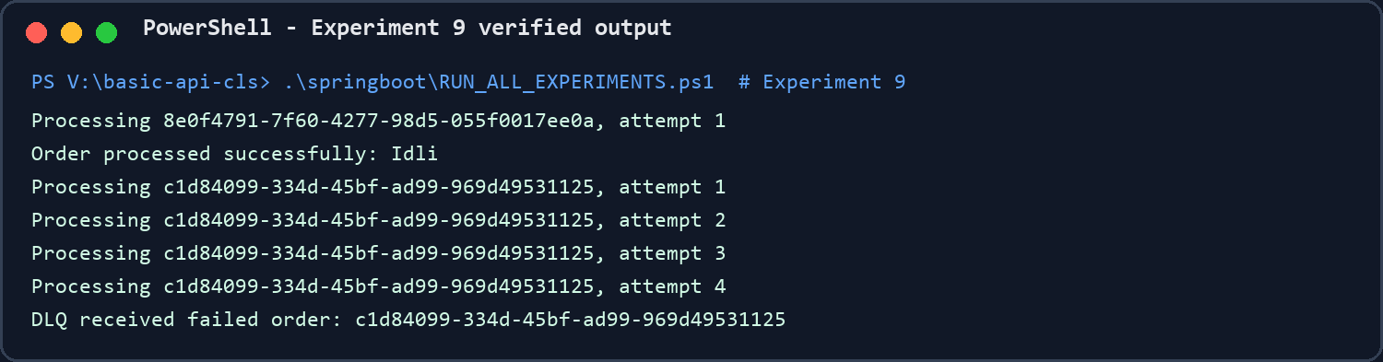
Figure 12. Successful execution evidence for Program 9.
Result: The program executed successfully and demonstrated the stated concept.

Program 10: Order aggregate with items and address
Mapping: CO3 | Spring Boot | Source folder: springboot\springboot\exp10\order-management

Brief explanation
Order is the aggregate root and contains OrderItem entities plus an Address value object.

Source location
springboot\springboot\exp10\order-management\src\main\java\com\example\ordermanagement\model\Order.java

Sample input / action
POST http://localhost:8080/api/orders

Verified output
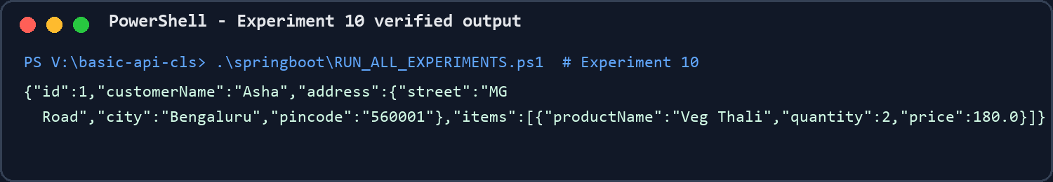
Figure 13. Successful execution evidence for Program 10.
Result: The program executed successfully and demonstrated the stated concept.

Program 11: Create and publish OrderPlacedEvent
Mapping: CO3 | Spring Boot events | Source folder: springboot\springboot\exp11\order-domain-events

Brief explanation
OrderService publishes OrderPlacedEvent through Spring's ApplicationEventPublisher after creating event and order IDs.

Selected source code
springboot\springboot\exp11\order-domain-events\src\main\java\com\example\orderdomain\service\OrderService.java
package com.example.orderdomain.service;
import java.time.Instant;
import java.util.UUID;
import org.springframework.context.ApplicationEventPublisher;
import org.springframework.stereotype.Service;
import com.example.orderdomain.event.OrderPlacedEvent;
@Service
public class OrderService {
private final ApplicationEventPublisher publisher;
public OrderService(ApplicationEventPublisher publisher) {
this.publisher = publisher;
}
public OrderPlacedEvent placeOrder(String itemName, int quantity) {
OrderPlacedEvent event = new OrderPlacedEvent(
UUID.randomUUID().toString(), UUID.randomUUID().toString(),
itemName, quantity, Instant.now());
publisher.publishEvent(event);
return event;
}
}

Sample input / action
POST http://localhost:8091/orders/place

Verified output
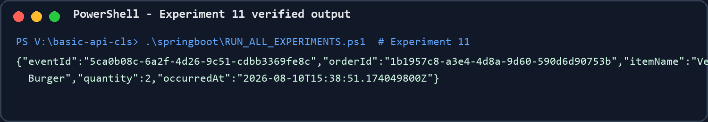
Figure 14. Successful execution evidence for Program 11.
Result: The program executed successfully and demonstrated the stated concept.

Program 12: Handle PaymentCompletedEvent
Mapping: CO3 | Spring Boot events | Source folder: springboot\springboot\exp12\payment-status-handler

Brief explanation
PaymentCompletedHandler reacts to the event and changes the matching order from PAYMENT_PENDING to PAID.

Source location
springboot\springboot\exp12\payment-status-handler\src\main\java\com\example\paymentstatus\handler\PaymentCompletedHandler.java

Sample input / action
POST payment-completed; status becomes PAID

Verified output
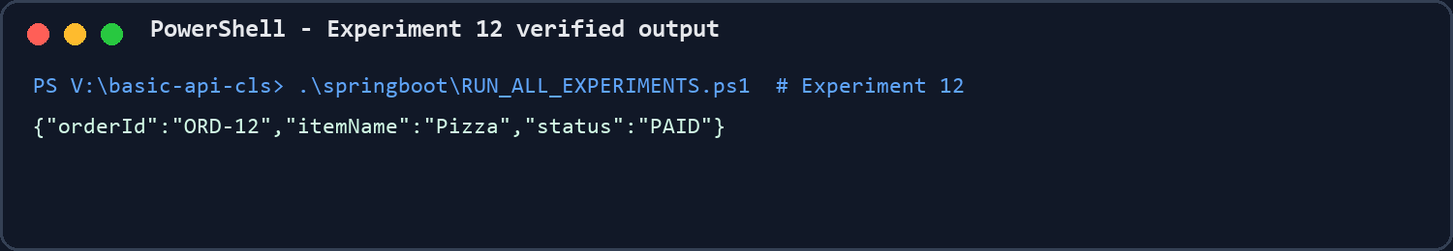
Figure 15. Successful execution evidence for Program 12.
Result: The program executed successfully and demonstrated the stated concept.

Program 13: Saga choreography
Mapping: CO3 | Spring Boot events | Source folder: springboot\springboot\exp13\saga-choreography

Brief explanation
Independent handlers form a choreography: payment reacts to OrderCreated, then delivery reacts to PaymentCompleted. Failure events select compensation states.

Source location
springboot\springboot\exp13\saga-choreography\src\main\java\com\example\saga\handler\SagaHandlers.java

Sample input / action
POST http://localhost:8093/saga/start

Verified output
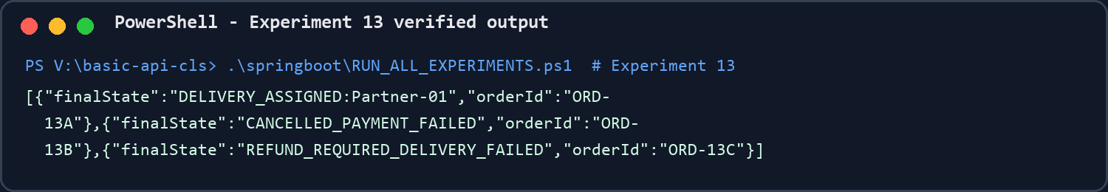
Figure 16. Successful execution evidence for Program 13.
Result: The program executed successfully and demonstrated the stated concept.

Program 14: Idempotent event processing
Mapping: CO3 | Spring Boot | Source folder: springboot\springboot\exp14\idempotent-consumer

Brief explanation
The consumer stores event IDs. Re-delivery of the same event returns DUPLICATE_IGNORED without repeating the business update.

Selected source code
springboot\springboot\exp14\idempotent-consumer\src\main\java\com\example\idempotent\service\IdempotentEventProcessor.java
package com.example.idempotent.service;
import java.util.Set;
import java.util.concurrent.ConcurrentHashMap;
import java.util.concurrent.atomic.AtomicInteger;
import org.springframework.stereotype.Service;
import com.example.idempotent.event.OrderEvent;
@Service
public class IdempotentEventProcessor {
private final Set<String> processedEventIds = ConcurrentHashMap.newKeySet();
private final AtomicInteger businessUpdates = new AtomicInteger();
public Result process(OrderEvent event) {
boolean firstDelivery = processedEventIds.add(event.eventId());
if (firstDelivery) {
businessUpdates.incrementAndGet();
System.out.println("Processed event " + event.eventId());
return new Result("PROCESSED", businessUpdates.get());
}
System.out.println("Ignored duplicate event " + event.eventId());
return new Result("DUPLICATE_IGNORED", businessUpdates.get());
}
public record Result(String result, int businessUpdateCount) { }
}

Sample input / action
POST the same eventId twice

Verified output
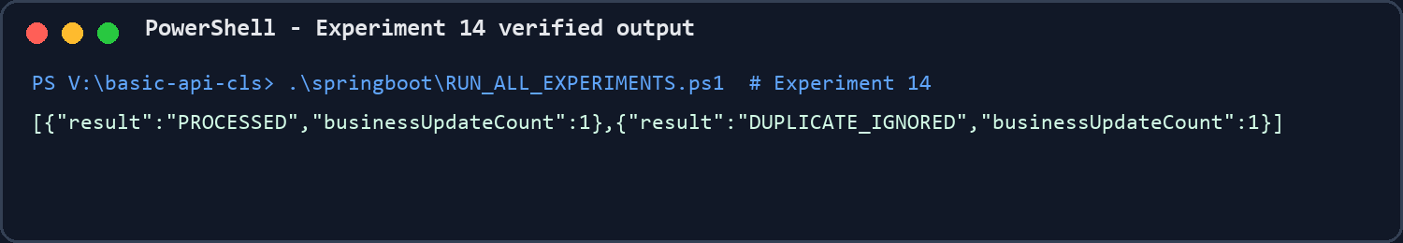
Figure 17. Successful execution evidence for Program 14.
Result: The program executed successfully and demonstrated the stated concept.

Program 15: Order, Payment and Delivery bounded contexts
Mapping: CO3 | Spring Boot events | Source folder: springboot\springboot\exp15\bounded-contexts

Brief explanation
Order, Payment and Delivery use separate packages and stores. They communicate using events and do not access one another's state directly.

Source location
springboot\springboot\exp15\bounded-contexts\src\main\java\com\example\contexts\payment\PaymentContextService.java

Sample input / action
POST http://localhost:8095/contexts/demo

Verified output
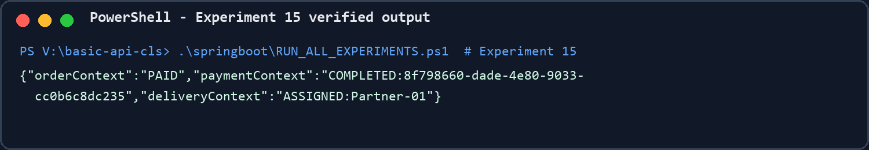
Figure 18. Successful execution evidence for Program 15.
Result: The program executed successfully and demonstrated the stated concept.

Verification Summary
Scope | Verification performed | Result
Source | 24 service modules plus the new Restaurant Service were packaged with Maven | Pass
REST | Experiments 1-4 and 10-15 called through real HTTP endpoints | Pass
RabbitMQ | Experiments 5-9 executed against rabbitmq:3-management | Pass
Publish-subscribe | Notification and Analytics both received the same event | Pass
Competing consumers | Worker-1 and Worker-2 shared six messages | Pass
Retry / DLQ | Failing event retried and appeared in the DLQ consumer | Pass
Idempotency | Second delivery of EVT-100 did not increase business update count | Pass

Conclusion
The solution demonstrates scalable service separation, gateway routing, synchronous service communication, RabbitMQ messaging patterns, saga choreography, DDD aggregates, domain events, state handlers and idempotent processing. The implementations intentionally use in-memory storage and basic configuration so each concept is easy to explain and demonstrate in a classroom setting.

