**NAME:PRAGADHEESHWARI S**

**ROLLNO:731621205039**

**EMAIL ID:pragadheeshwarisaravanan@gmail.com**

**DAY3-ASSIGNMENT**

1. First, one person in the group should create a public repository using their GitHub account



2. This same person should then follow the instructions from GitHub to add a **remote**, and

then **push** their repository. Do not forget the **–u** flag, as suggested by GitHub!

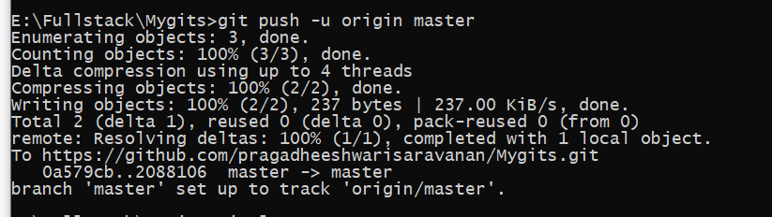

3. All of the other members of the group should then be added as collaborators, so they can

commit to the repository also

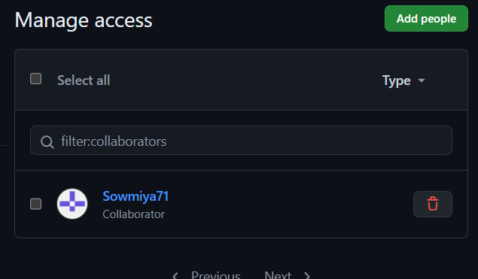

4. Next, everyone else in the group should **clone** the repository from GitHub. Verify that the

context of the repository is what is expected.

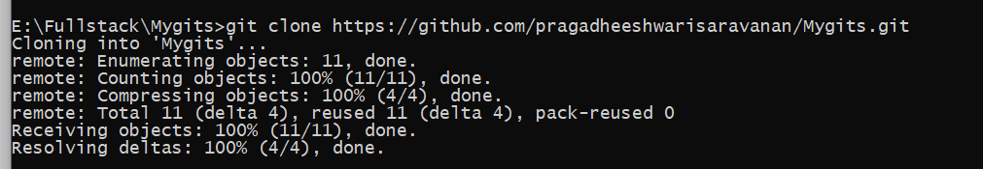

5. One of the group members who just cloned should now make a local **commit**, then **push** it.

Everyone should verify that when they **pull**, that commit is added to their local repository

(use **git log** to check for it).

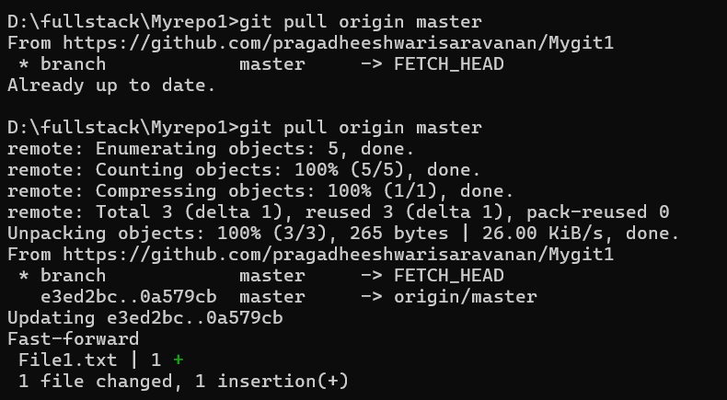

6. Look at each other’s **git log** output. Notice how the SHA-1 is the same for a given commit

across every copy of the repository. Why is this important?

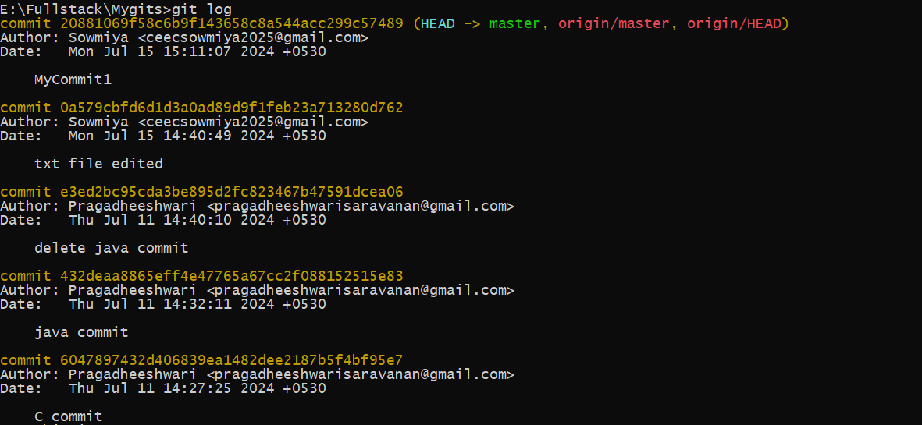

7. Two members of the group should now make a **commit** locally, and race to **push** it. To keep

things simple, be sure to edit different files. What happens to the runner-up?

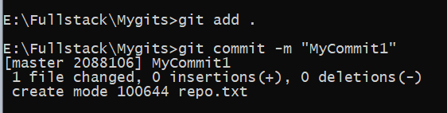

8. The runner-up should now **pull**. As a group, look at the output of the command.

Additionally, look at the **git log**, and notice that there is a merge commit. You may also

wish to view the DAG in **gitk**.



9. Repeat the last two steps a couple of times, to practice.

