**NAME : PRAGADHEESHWARI S**

**REG NO : 731621205039**

**EMAIL ID : pragadheeshwarisaravanan@gmail.com**

**ASSIGNMENT-1**

Create a local git repo with the name "MyRepo".

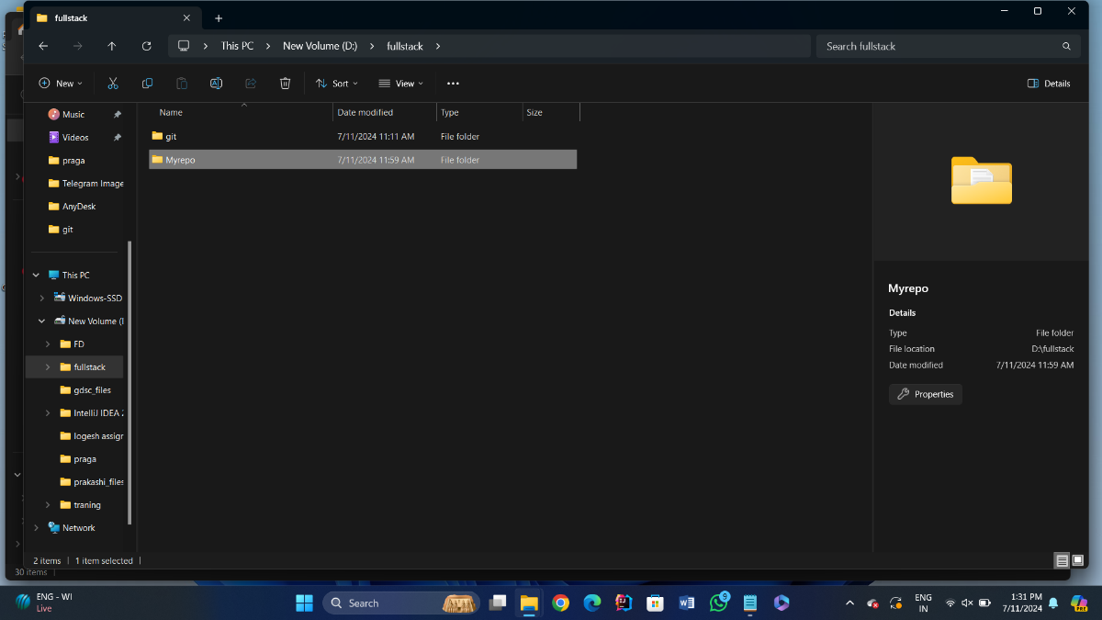

create one .txt file, five .c files and five .java files in the working area.

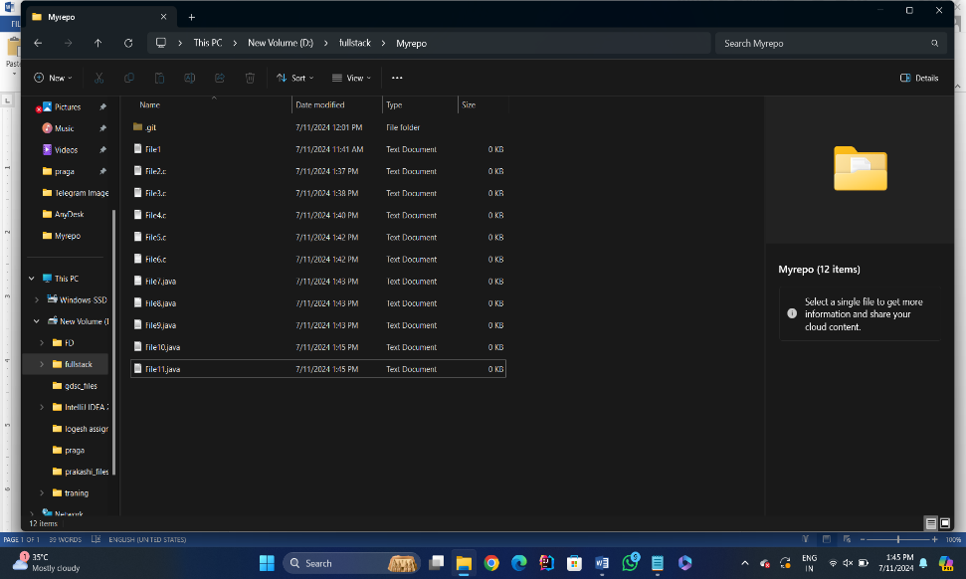

Verify the git status

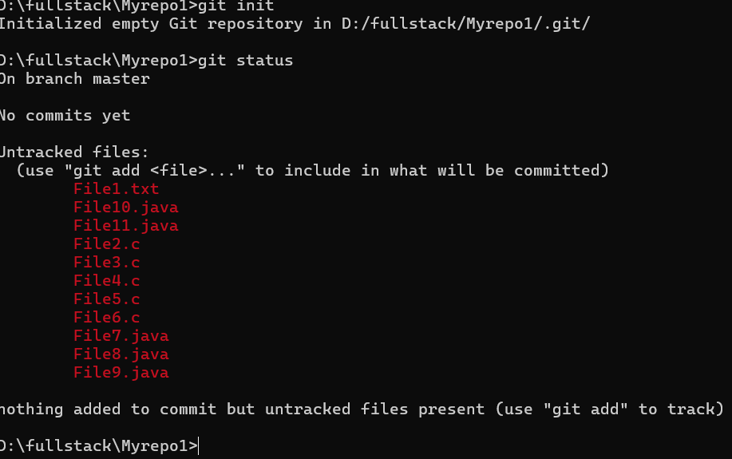

Add only the .txt into the staging area

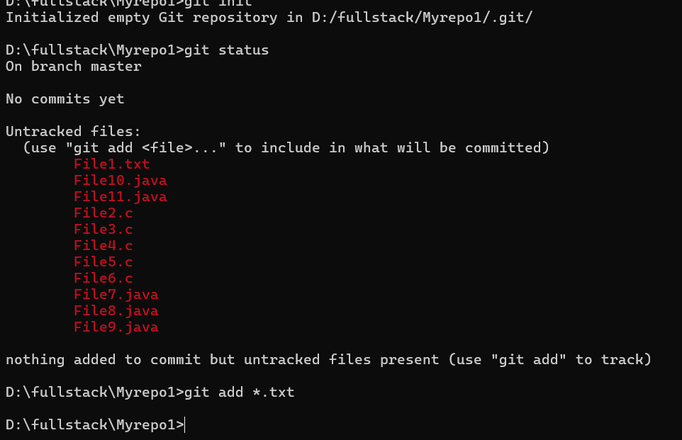

verify the git status

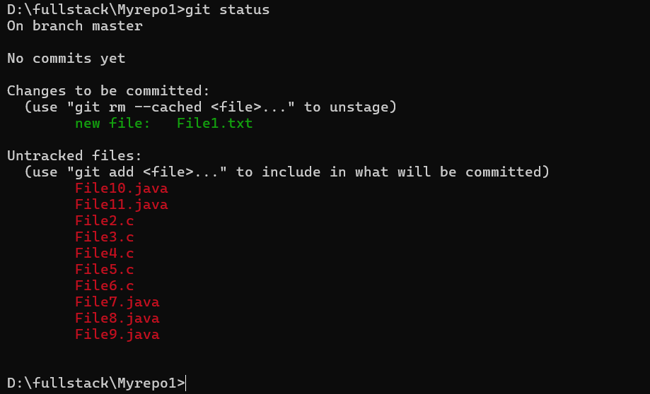

Make a commit with the name "TXT Commit"

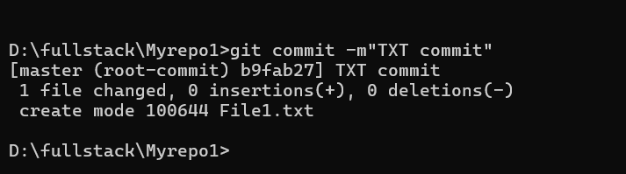

Add all .c files into the staging area

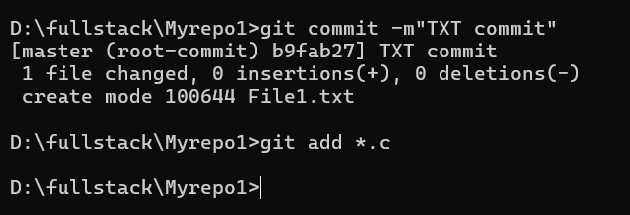

verify the git status

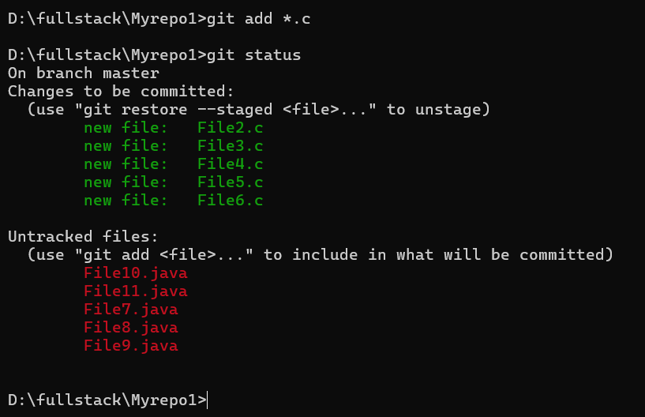

Make a commit with the name "C Commit"

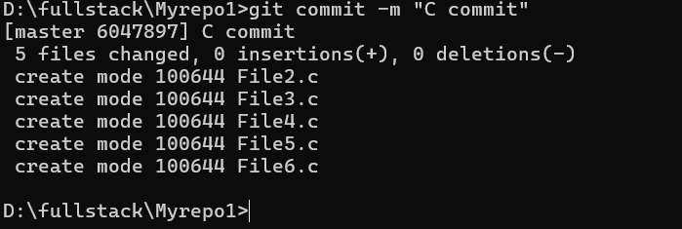

Add all .java files into the staging area

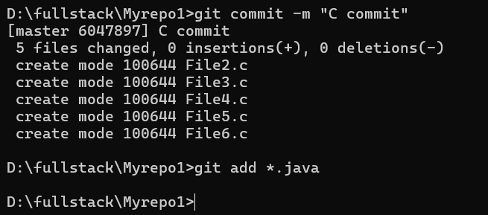

verify the git status

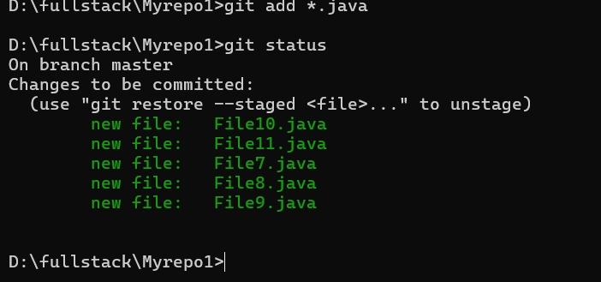

Make a commit with the name "Java Commit"

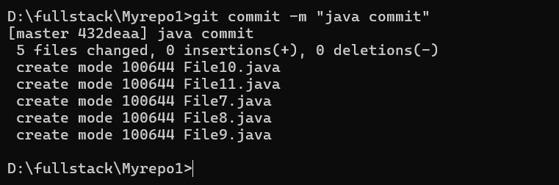

Delete all .java files from working area

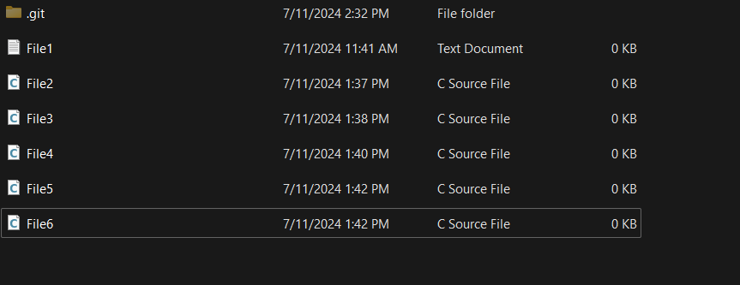

Now see the status

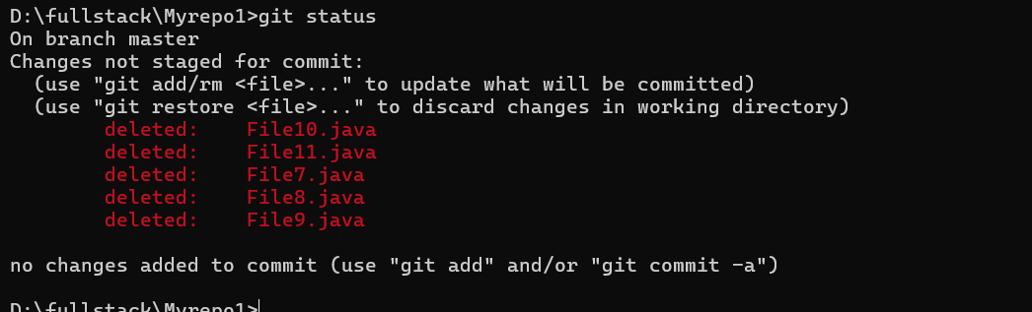

add the changes into the staging area

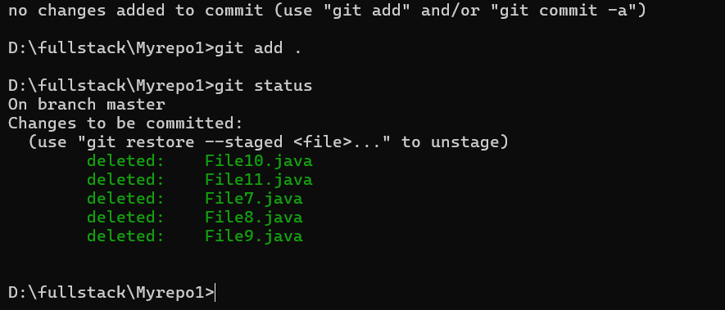

Make a commit with the name "Delete Java Commit"

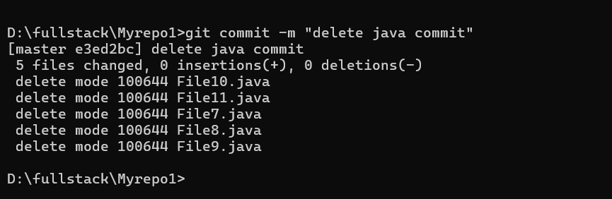

display all commit details

