**RS Components - AddToCart**

**Scenario:**

The solutions architect urgently needs testing completed for an e-commerce website prior to code release. On short notice, he has requested you to create a performance test for the same.

**User Journey**

Homepage->Category Page 1->Category Page 2->Category Page 3->Product Page->Basket Page

**Test Data Consideration**

The current script RS_AddToCart_v01 will pick an item randomly from Category 3. On manual browsing, there were very few items that did not have stock. This condition is not considered depending on the timelines that the architect wants testing on a short notice.

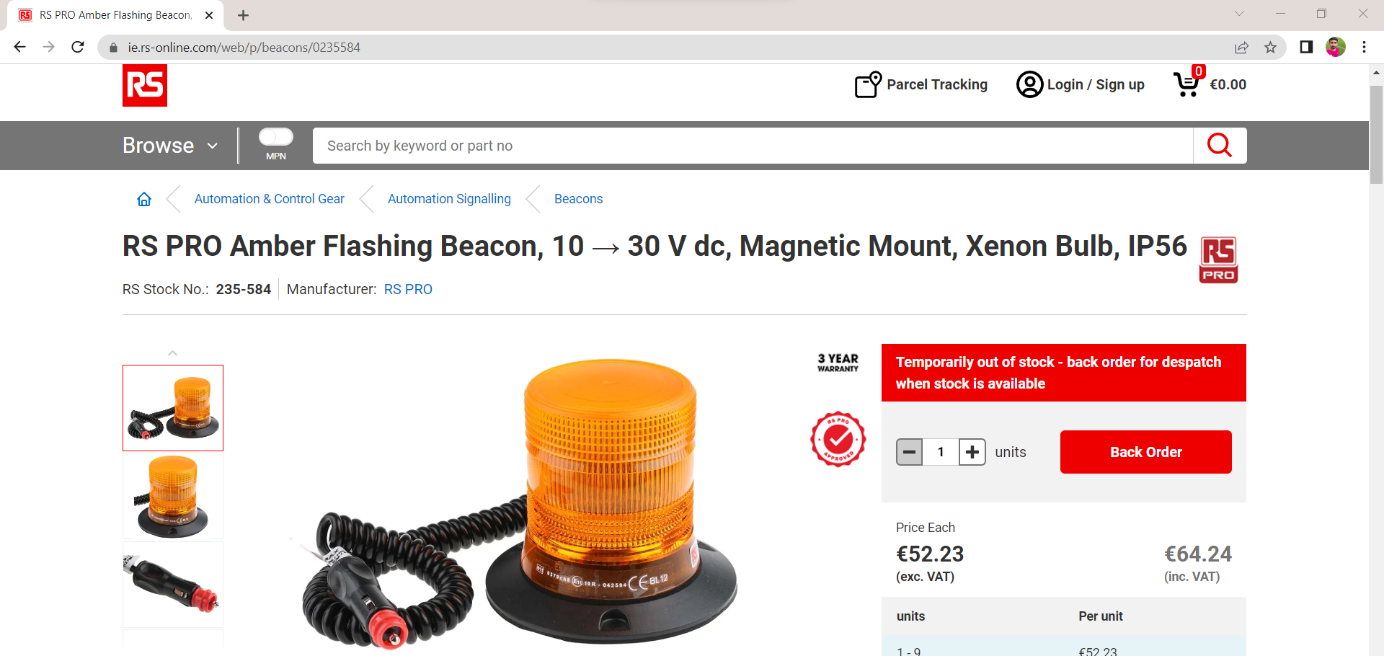

The product id (c_productid) could be parameterized, the DB could be queried to get items which has count and/or some products with no stock and could be used in the test execution

**Other Important Observations/Pre-Requisites**

**Resource Download**

Internally the main URL downloads associated non-HTML resources

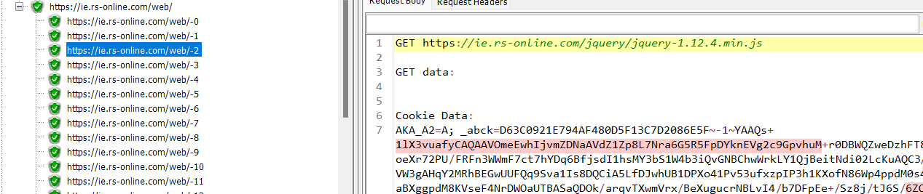

**Error: HTTP 404 - for resource unavailable**

If the resource is not there then HTTP- 404 error would be thrown

**Example:** https://ie.rs-online.com/catimages/Y2169737-01.jpg

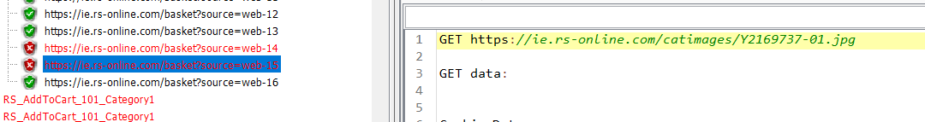

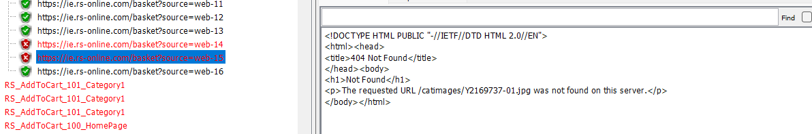

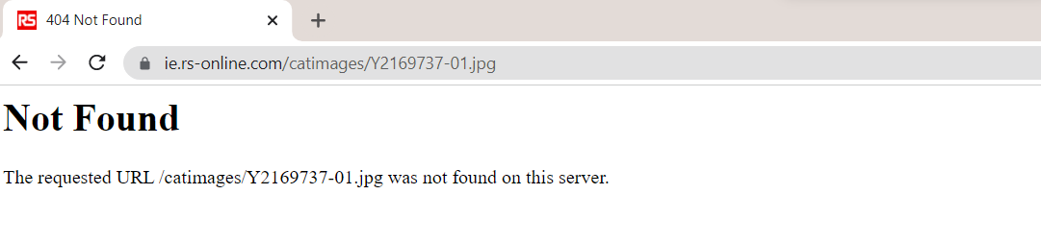

We get the main sample response but there could be extrares missing. Since these are not the main requests and only resources these can be safely ignored. Hence update the jmeter.properties with the below to ensure this does not get recorded as errors .

**httpsampler.ignore_failed_embedded_resources=true**



**Test Strategy/Scenario**

|  |  |
| --- | --- |
| No. of Scripts | 1 |
| Tool | Jmeter |
| Total Test Duration | 10 Minutes |
| Test Type | RAMP Test |
| No. of Stages | 5 Stages |
| Duration per Ramp Stage | 2 Minutes per Stage |
| Peak Throughput Per Second (TPS) | 1.5 TPS (Peak, Ramp Stage 5) |
| Additional Capabilities Listeners | • Response Time • Transactions Per Second • Summary Report • Results Tree |

The test scenario consists of Ultimate Thread group with 5 ramps, 2-3 users each.

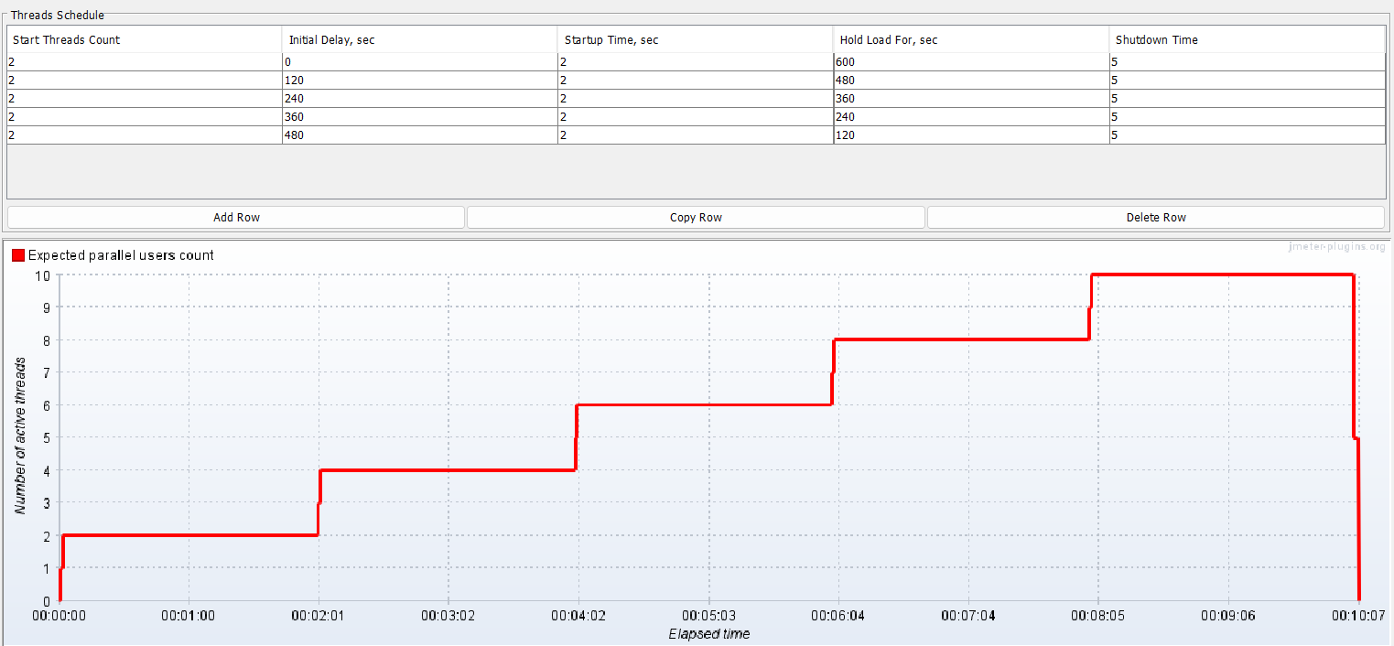

**Report**

Along with the mentioned listeners, I have added a few additional listeners

Active Threads Over Time – to see if the thread matches the given designed scenario

Synthesis Report Filtered – To filter only the last ramp Throughput

HTML report - RSTestResults.html/index.html ( Contains APDEX , Statistics , Charts and other metrics)