SECURE PRODUCT CATALOG API
Robust Error Handling, Logging & Rate Limiting
Project Documentation and Output Explanation
Technology: Node.js • Express • TypeScript • Winston • Morgan • express-rate-limit
1. Project Overview
The Secure Product Catalog API is a REST API built with Express and TypeScript. It provides product CRUD operations and demonstrates centralized error handling, request validation, security middleware, HTTP request logging, and rate limiting.
The project uses an in-memory product list for the current demonstration. Therefore, product data may reset when the server restarts. The server is configured to run at http://localhost:4000.

2. Technologies and Purpose
Technology / Component | Purpose
Express + TypeScript | Builds the API routes and provides typed server-side code.
Helmet | Adds common HTTP security headers.
express-rate-limit | Limits repeated requests and returns HTTP 429 after the configured threshold.
Winston | Writes structured application logs to log files and console.
Morgan | Logs incoming HTTP requests and forwards its output to Winston.
AppError | Custom error class containing an HTTP status code and operational-error flag.
Central error handler | Formats errors into a consistent JSON response.
Request validation | Checks incoming product fields and returns validation errors such as HTTP 422.

3. API Base URL and Main Endpoints
Base URL: http://localhost:4000
Method | Endpoint | Purpose
GET | /api/v1/products | Retrieve the product list.
GET | /api/v1/products/:id | Retrieve one product by ID.
POST | /api/v1/products | Create a product after validating the request body.
PUT | /api/v1/products/:id | Update an existing product.
DELETE | /api/v1/products/:id | Delete an existing product.
GET | / | Check whether the API server is running.
GET | /test-error | Temporary route used to demonstrate HTTP 500 handling.

4. Successful API Responses

4.1 GET all products — 200 OK
A GET request to /api/v1/products retrieves the available products. HTTP 200 means the request was processed successfully. The JSON response includes a success flag, status code, message, and product data.
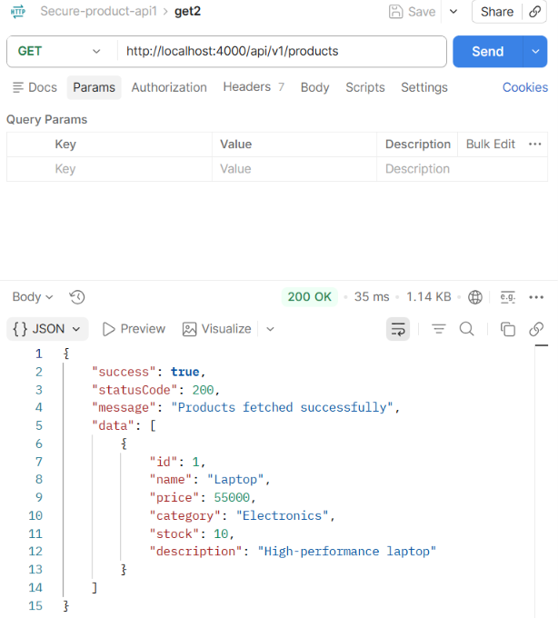

4.2 GET product by ID — 200 OK
A GET request such as /api/v1/products/1 returns the product matching ID 1. If the ID exists, the response contains the product details.
[SCREENSHOT PLACEHOLDER — GET PRODUCT BY ID — 200 OK]
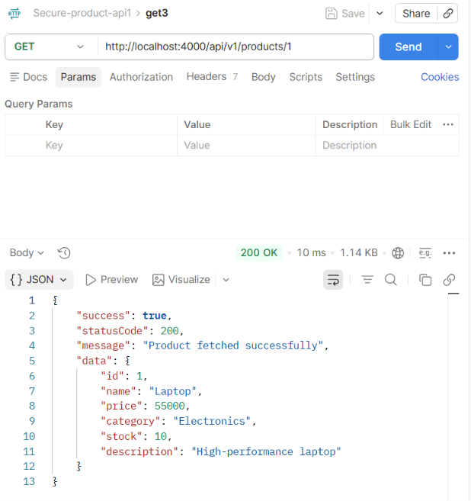

4.3 POST valid product — 201 Created
A POST request sends product information as raw JSON. When the required fields pass validation, the API creates the product and returns HTTP 201 Created with the new product ID and details.
Example request body:
{
"name": "Sample Product",
"price": 2500,
"category": "Electronics",
"stock": 10,
"description": "Sample product description"
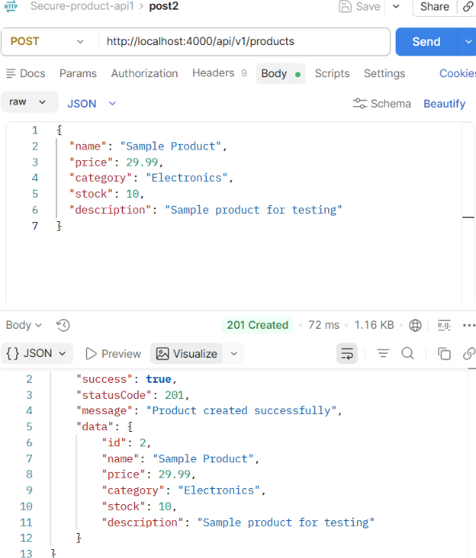

4.4 PUT update product — 200 OK
A PUT request to /api/v1/products/:id updates the selected product using the submitted JSON fields. HTTP 200 confirms that the update succeeded and the response shows the updated product.

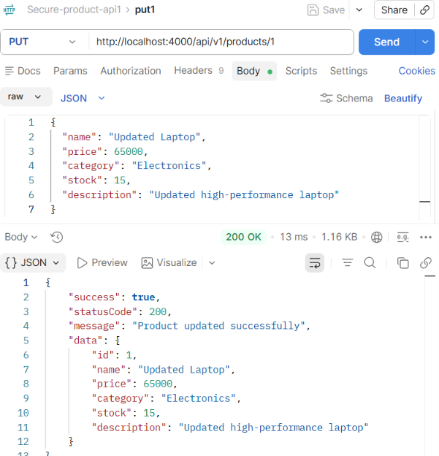

4.5 DELETE product — 204 No Content
A DELETE request to an existing product ID removes that product. HTTP 204 No Content means the deletion succeeded and the response body is intentionally empty.

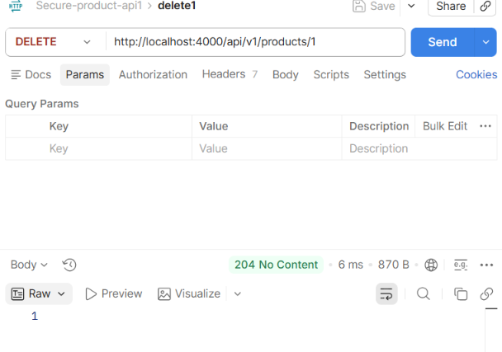

5. Error Handling and Validation Outputs

5.1 Invalid or missing product — 404 Not Found
When a requested product ID does not exist, the API returns HTTP 404. The centralized error handler formats the response with success=false, statusCode=404, and a message such as “Product not found.”
[SCREENSHOT PLACEHOLDER — PRODUCT ID NOT FOUND — 404]
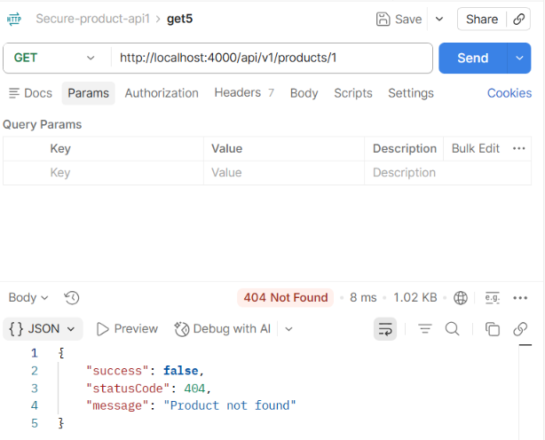

5.2 Unknown route — 404 Not Found
A request to an endpoint that is not defined, for example /unknown, reaches the catch-all route handler. The API returns HTTP 404 with a message identifying the requested path, such as “Route /unknown not found.”
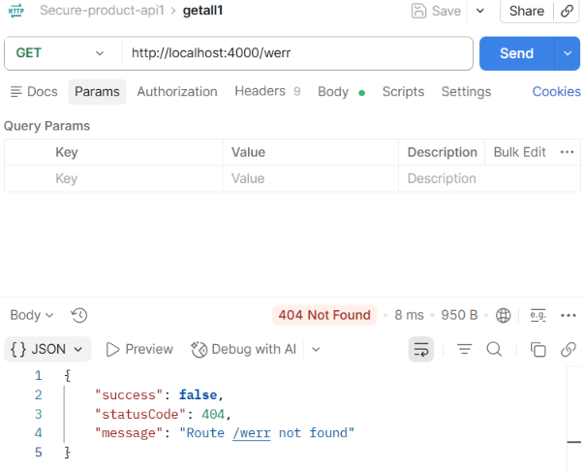

5.3 Invalid POST body — 422 Unprocessable Entity
When required product fields are missing or invalid, validation middleware stops the request before creating a product. The API returns HTTP 422 with a validation message, for example “Name is required.
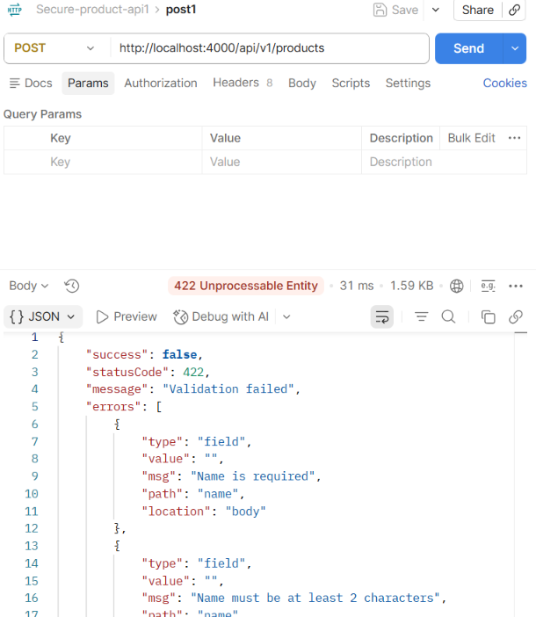

5.4 Deliberate server error — 500 Internal Server Error
The temporary GET /test-error route passes an ordinary Error to the centralized error handler. The handler returns HTTP 500 and a safe client-facing message such as “Something went wrong.” In development mode, the server-side log can include the error stack for debugging.
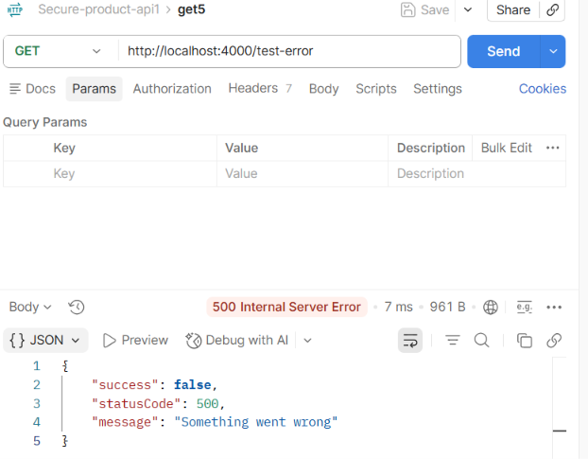

Note: Remove or disable the temporary /test-error route before deploying the API to production.

6. Rate Limiting — HTTP 429
The product routes use express-rate-limit. The current configuration allows up to 50 requests within a 10-minute window for a client IP. Requests beyond the limit receive HTTP 429 Too Many Requests and a message asking the client to try again later. The limiter is attached to /api/v1/products, so it applies to requests under that route.
For the demonstration, send repeated requests to GET http://localhost:4000/api/v1/products. With the configured threshold, requests within the limit should succeed; a request after the threshold should return 429. The limit resets after the configured time window.

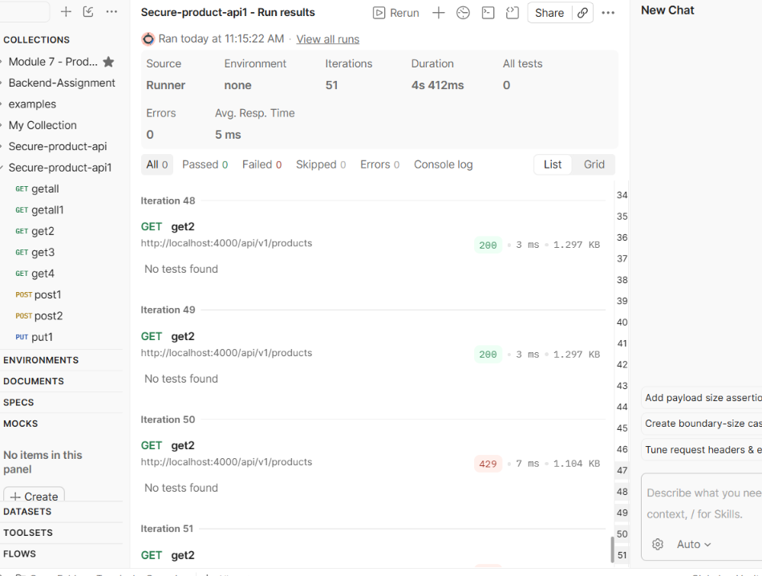

7. Logging with Winston and Morgan

7.1 Morgan HTTP request logging
Morgan records details about incoming HTTP requests, including the method, URL, response status, response time, and response size (depending on the selected format). In the current configuration, Morgan uses the “dev” format and sends output to a custom stream that forwards the log line to Winston.
The source also contains commented alternatives for “short” and “tiny”. Uncomment one format at a time if you need to demonstrate the different Morgan output formats.
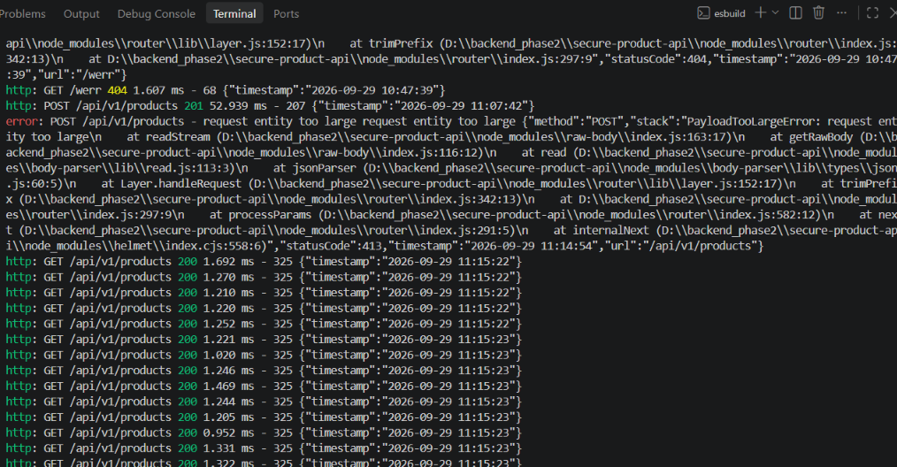

7.2 Winston log files
Winston is used for application logging. The project’s logs folder contains combined.log and error.log. The combined log stores general log entries according to its configured level, while error.log stores error-level entries. The exact entries depend on the logger configuration and which requests/errors have occurred.
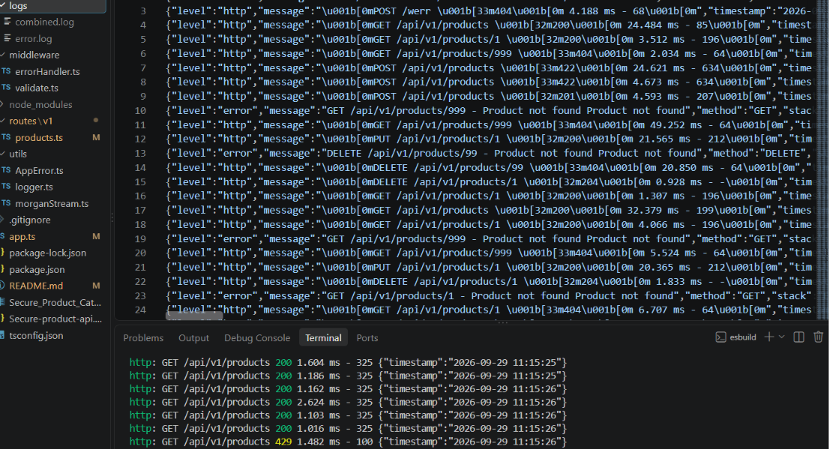

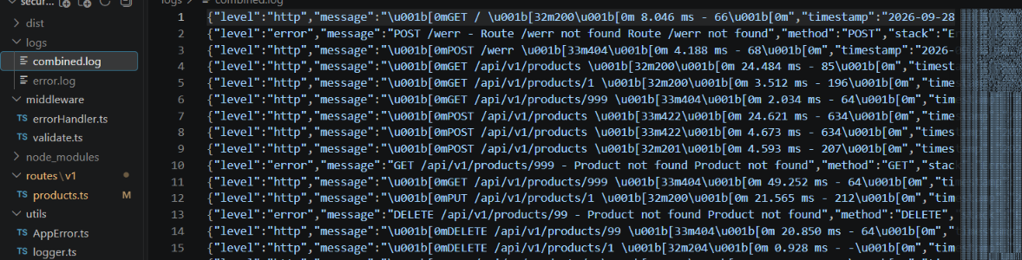

[SCREENSHOT PLACEHOLDER — error.log CONTENT]
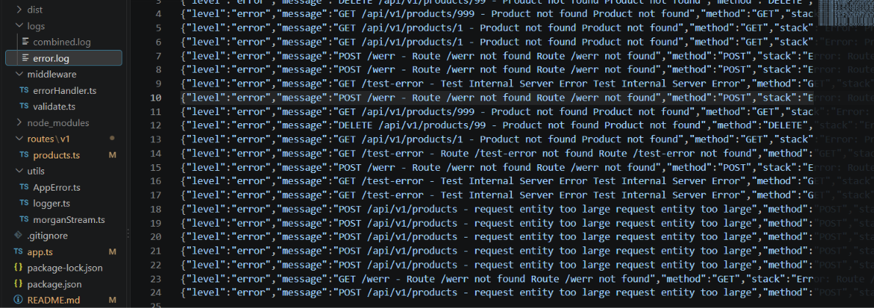

8. Security and Request Body Limits
Helmet is enabled to add common security-related HTTP headers. Express JSON and URL-encoded body parsing are configured with a 10 KB size limit. This helps reject overly large request bodies rather than accepting unlimited payloads.
If the assignment requires a separate large-payload test, send a request body larger than the configured 10 KB limit and record the resulting error response. The precise response may depend on the body-parser and error-handler configuration.
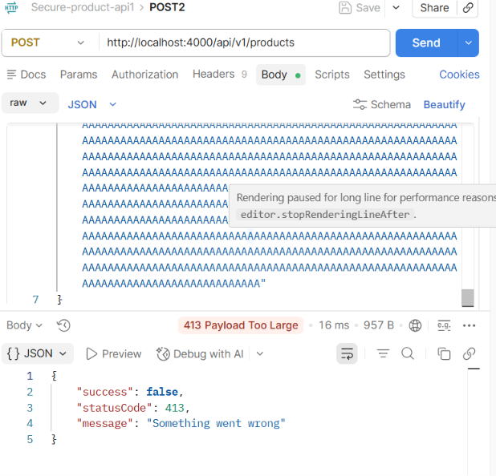

9. Output Summary
Test case | Expected status | Meaning
Get product list / existing product | 200 OK | Request succeeded.
Create valid product | 201 Created | Product was created.
Update existing product | 200 OK | Product was updated.
Delete existing product | 204 No Content | Product was deleted; no body returned.
Missing product ID / unknown route | 404 Not Found | Requested resource or route does not exist.
Invalid product fields | 422 Unprocessable Entity | Request body failed validation.
Unexpected error | 500 Internal Server Error | Server encountered an unexpected error.
Too many requests | 429 Too Many Requests | Rate limit was exceeded.

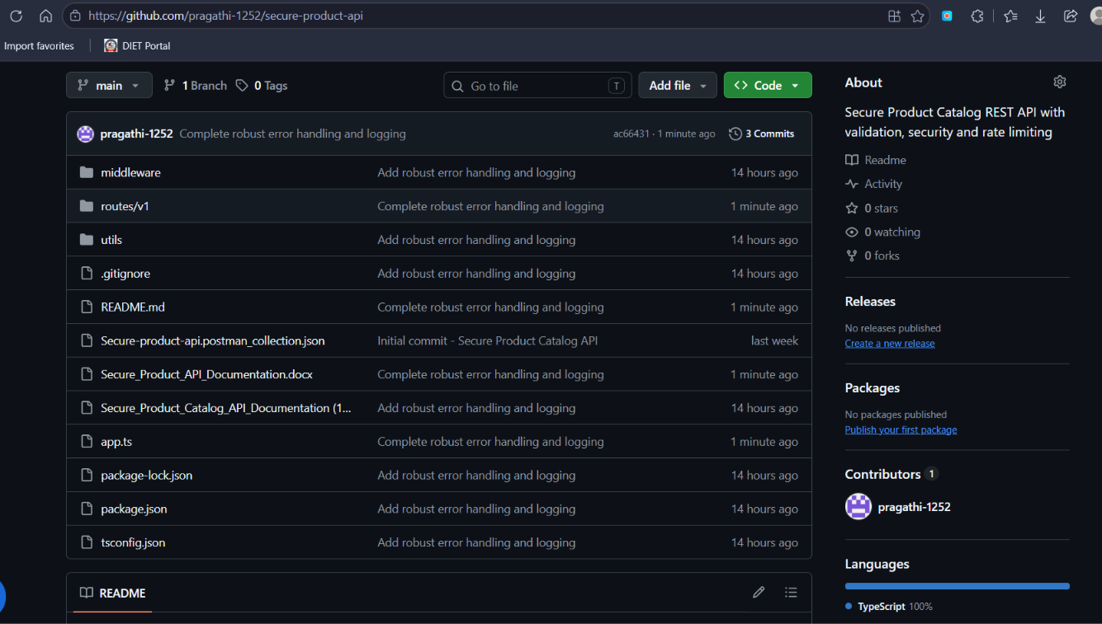

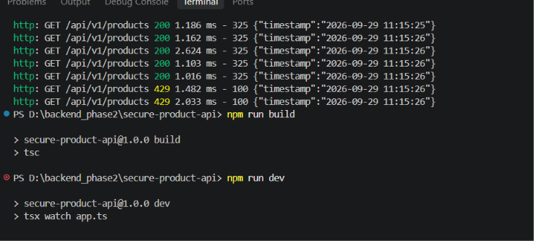

10. Conclusion
This project demonstrates a product REST API with CRUD operations, input validation, centralized error responses, request logging, security middleware, and rate limiting. Postman was used to verify successful responses and error cases. Screenshots can be inserted into the marked placeholders to complete the final assignment documentation.

Screenshot Checklist
☐ GET all products — 200
☐ GET product by ID — 200
☐ POST valid product — 201
☐ POST invalid data — 422
☐ PUT update — 200
☐ DELETE valid product — 204
☐ Missing product / unknown route — 404
☐ Temporary /test-error route — 500
☐ Rate-limit run showing 429
☐ Morgan logs in terminal
☐ Winston combined.log and error.log files and contents
☐ Large request body test, if required

