NEIGHBOURLY: A HYPERLOCAL SERVICE MARKETPLACE CONNECTING RESIDENTS WITH TRUSTED LOCAL SERVICE PROVIDERS
A PROJECT REPORT
Submitted by
PUSHKAR R (Reg. No: 310621104000)
in partial fulfillment for the award of the Degree
of
BACHELOR OF ENGINEERING
in
COMPUTER SCIENCE AND ENGINEERING
EASWARI ENGINEERING COLLEGE
(AN AUTONOMOUS INSTITUTION) – AFFILIATED TO ANNA UNIVERSITY
CHENNAI – 600089
OCTOBER 2026

EASWARI ENGINEERING COLLEGE
(Autonomous Institution, Affiliated to Anna University, Chennai)
RAMAPURAM, CHENNAI – 600089
BONAFIDE CERTIFICATE
Certified that this project report titled "NEIGHBOURLY: A HYPERLOCAL SERVICE MARKETPLACE CONNECTING RESIDENTS WITH TRUSTED LOCAL SERVICE PROVIDERS" is the bonafide work of PUSHKAR R (Reg. No: 310621104000), who carried out the project work under my supervision.
HEAD OF THE DEPARTMENT  Department of Computer Science & Engg.  Easwari Engineering College  Ramapuram, Chennai - 600089 | PROJECT SUPERVISOR  Department of Computer Science & Engg.  Easwari Engineering College  Ramapuram, Chennai - 600089

EASWARI ENGINEERING COLLEGE
(Autonomous Institution, Affiliated to Anna University, Chennai)
RAMAPURAM, CHENNAI – 600089
CERTIFICATE OF VIVA-VOCE EXAMINATION
This is to certify that the Viva-Voce Examination of the Project Work entitled "NEIGHBOURLY: A HYPERLOCAL SERVICE MARKETPLACE CONNECTING RESIDENTS WITH TRUSTED LOCAL SERVICE PROVIDERS" submitted by PUSHKAR R (Reg. No. 310621104000) in partial fulfillment of the requirements for the award of the degree of Bachelor of Engineering in Computer Science and Engineering was conducted on ________________ (Date) in the Department of Computer Science and Engineering, Easwari Engineering College, Ramapuram – Chennai.
INTERNAL EXAMINER  Name: _______________________  Designation: __________________  Address: _____________________  Date: ________________________ | EXTERNAL EXAMINER  Name: _______________________  Designation: __________________  Address: _____________________  Date: ________________________

ACKNOWLEDGEMENT
We express our sincere gratitude to our respected Principal Dr. P. Deiva Sundari and the Management of Easwari Engineering College for providing us with the state-of-the-art infrastructural facilities, academic atmosphere, and opportunity to carry out this comprehensive project work.
We convey our heartfelt thanks to the Head of the Department, Department of Computer Science and Engineering, for continuous encouragement, valuable suggestions, and constant administrative support throughout the tenure of our engineering program.
We are extremely grateful and deeply indebted to our Project Supervisor for the exemplary guidance, continuous constructive criticism, insightful technical mentorship, and invaluable motivation throughout the conceptualization, system architecture design, and software implementation of the Neighbourly platform.
We also take immense pleasure in extending our gratitude to all teaching and non-teaching faculty members of the Department of Computer Science and Engineering for their direct and indirect support, technical discussions, and academic backing.
Finally, we place on record our profound sense of reverence and thanks to our parents and friends for their constant patience, moral encouragement, and selfless sacrifices throughout the course of this academic undertaking.
PUSHKAR R
(Reg. No: 310621104000)

ABSTRACT
Rapid urbanization and nuclear family structures in contemporary metropolitan areas have significantly accelerated the domestic demand for on-demand home maintenance, repair, and personal services. However, the existing urban service ecosystem remains deeply fragmented, inefficient, and untrusted. Residents are predominantly compelled to choose between informal, unverified local technicians sourced via word-of-mouth with zero accountability, or monopolistic aggregator platforms that impose exorbitant commission surcharges (ranging from 20% to 35%), enforce rigid one-size-fits-all scheduling, and obscure transparent peer-to-peer communication. Concurrently, skilled independent neighborhood tradespeople—such as certified electricians, licensed plumbers, carpenters, tutors, and appliance mechanics—struggle with poor digital discoverability and excessive platform fees.
To resolve these systemic challenges, this project conceptualizes, architects, and implements 'NEIGHBOURLY'—an advanced, production-grade Hyperlocal Service Marketplace that seamlessly bridges urban community residents with verified neighborhood service professionals through a transparent, high-trust, and decentralized operational paradigm. The platform is engineered on modern full-stack web engineering standards (React 18 Single Page Application, Node.js and Express RESTful API gateway, and MongoDB Atlas distributed database) fortified by real-time bi-directional WebSocket communication (Socket.IO) and cryptographically secured financial transactions (Razorpay Escrow Gateway).
A paramount engineering innovation of Neighbourly is its Dual-Tier Artificial Intelligence Architecture. First, to lower digital entry barriers for non-technical residents, an AI-powered Natural Language Service Request Assistant is integrated using large language models (Google Gemini 1.5/3.5 Flash) coupled with a deterministic heuristic NLP fallback parser. This subsystem automatically analyzes unstructured conversational prompts (e.g., 'My kitchen sink is leaking heavily, need someone tomorrow morning, budget around 600'), and maps them into strictly typed schema entities encompassing service categories, calendar dates, time windows, budget boundaries, and required trade skills. Second, the platform executes a deterministic Multi-Factor Hybrid Provider Matching Algorithm that evaluates candidates across five orthogonal dimensions: official identity verification, geographic proximity within neighborhood radius, historical customer ratings, cumulative job completion volume, and price compatibility.
Neighbourly incorporates a formal Finite State Machine (FSM) to govern the complete lifecycle of service bookings (from PENDING, ACCEPTED, PAYMENT_PENDING, PAID, IN_PROGRESS, to COMPLETED), strictly preventing illegal status tampering. Financial safety is guaranteed through a server-side verified Razorpay payment workflow utilizing HMAC-SHA256 signature validation and idempotency controls. An administrative control dashboard offers platform analytics, dispute arbitration, and a provider credential verification pipeline. Comprehensive test suites executing across unit, integration, and security layers validate 100% test pass rates and demonstrate robust fault tolerance, cementing Neighbourly as an equitable, scalable, and resilient technological solution for localized service economies.
Keywords: Hyperlocal Marketplace, MERN Stack, Large Language Models, Natural Language Parsing, Hybrid Provider Matching, State Machine, Razorpay Escrow, Socket.IO, Role-Based Access Control.

LIST OF FIGURES
Figure No. | Figure Title | Page No.
Figure 3.1 | Multi-Tier System Architecture of Neighbourly Platform | 14
Figure 3.2 | UML Use Case Diagram of Neighbourly Platform Actors and Interactions | 17
Figure 3.3 | UML Class Diagram of Domain Models and Entity Relationships | 20
Figure 3.4 | UML Sequence Diagram of End-to-End Service Booking and Fulfillment Workflow | 23
Figure 3.5 | Context-Level DFD (Level 0) and Functional Decomposition DFD (Level 1) | 25
Figure 3.6 | Algorithmic Flowcharts: AI Request Extraction and Booking State Machine | 28
Figure 5.1 | High-Fidelity User Interface Screenshots of Neighbourly Platform Modules | 37

LIST OF TABLES
Table No. | Table Title | Page No.
Table 2.1 | Comparative Evaluation: Existing Traditional/Aggregator Systems vs Neighbourly | 9
Table 3.1 | Hardware Requirements Specification for Server and Client Environments | 11
Table 3.2 | Software Requirements and Technology Stack Specification | 12
Table 3.3 | Database Entity Collections and Attribute Specifications | 19
Table 3.4 | Booking Lifecycle State Transition Feasibility Matrix | 27
Table 3.5 | Multi-Factor Hybrid Provider Scoring Weightage and Parameter Mapping | 29
Table 4.1 | Core RESTful API Endpoints and Security Authorization Matrix | 33
Table 5.1 | Automated Unit and Integration Test Case Suite Execution Log | 39
Table 5.2 | Platform Performance Benchmark and Latency Evaluation Results | 42

LIST OF ABBREVIATIONS
Abbreviation | Expanded Description
API | Application Programming Interface
CORS | Cross-Origin Resource Sharing
CSP | Content Security Policy
CSS | Cascading Style Sheets
DFD | Data Flow Diagram
DOM | Document Object Model
FSM | Finite State Machine
HMAC | Hash-based Message Authentication Code
HTTP | Hypertext Transfer Protocol
HTTPS | Hypertext Transfer Protocol Secure
IDOR | Insecure Direct Object Reference
JSON | JavaScript Object Notation
JWT | JSON Web Token
LLM | Large Language Model
MERN | MongoDB, Express.js, React.js, Node.js
MVC | Model View Controller
NLP | Natural Language Processing
NoSQL | Not Only Structured Query Language
ODM | Object Document Mapper
OWASP | Open Web Application Security Project
RBAC | Role-Based Access Control
REST | Representational State Transfer
SHA | Secure Hash Algorithm
SPA | Single Page Application
UI / UX | User Interface / User Experience
URI | Uniform Resource Identifier
URL | Uniform Resource Locator
WSS | WebSocket Secure Protocol
ZOD | TypeScript-first Schema Declaration and Validation Library

TABLE OF CONTENTS
S. No. | Contents | Page No.
1 | Abstract | i
2 | List of Figures | ii
3 | List of Tables | iii
4 | List of Abbreviations | iv
5 | Chapter 1 – Introduction | 1
5.1 | Project Overview | 1
5.2 | Problem Statement | 3
5.3 | Objectives of the Project | 4
5.4 | Scope of the Project | 5
6 | Chapter 2 – Existing System and Proposed System | 7
6.1 | Existing System | 7
6.2 | Limitations of the Existing System | 8
6.3 | Proposed Solution | 9
6.4 | Advantages of the Proposed System | 10
7 | Chapter 3 – System Analysis and Design | 11
7.1 | Hardware and Software Requirements | 11
7.2 | System Architecture | 13
7.3 | Module Description | 15
7.4 | UML Diagrams / Data Flow Diagram | 17
7.5 | Algorithm / Flowchart | 26
8 | Chapter 4 – Implementation | 30
8.1 | Implementation Details | 30
8.2 | Module Implementation | 31
8.3 | Tools and Technologies Used | 34
9 | Chapter 5 – Results and Testing | 37
9.1 | Screenshots and Outputs | 37
9.2 | Testing and Validation | 39
9.3 | Results and Discussion | 41
10 | Chapter 6 – Conclusion and Future Enhancement | 43
10.1 | Conclusion | 43
10.2 | Future Enhancements | 44
11 | References / Bibliography | 45
12 | Appendices (Source Code) | 47

CHAPTER 1 – INTRODUCTION
5.1 Project Overview
In the modern economic landscape, rapid urbanization, rising disposable incomes, and the widespread proliferation of nuclear households have precipitated an unprecedented surge in consumer demand for localized home maintenance, technical installation, and domestic personal assistance. Routine household requirements—ranging from emergency plumbing repairs, electrical short-circuit rectifications, air conditioner servicing, and carpentry fittings to home tutoring, professional deep cleaning, and gardening—form the critical operational backbone of urban day-to-day life.
Despite this burgeoning demand, the hyperlocal service sector in developing urban economies remains deeply unorganized, highly fragmented, and technically antiquated. The majority of domestic service interactions continue to rely on informal, offline word-of-mouth networks, fragmented community message boards, or roadside business listings. In this unvetted ecosystem, residents frequently encounter unreliable service delivery, arbitrary price inflation, lack of transparent qualifications, and significant domestic security risks when admitting unverified individuals into their homes. On the opposite end of the spectrum, skilled independent micro-entrepreneurs and neighborhood technicians struggle with irregular job discovery, severe geographic travel overheads, and an inability to build a verified digital reputation that reflects their true trade competence.
To bridge this critical socio-technical gap, 'NEIGHBOURLY' has been conceptualized and implemented as a next-generation, Hyperlocal Service Marketplace. Built on contemporary full-stack web architectures, Neighbourly unites three primary stakeholders—Residents, Service Providers, and Platform Administrators—within a unified, high-trust digital ecosystem. Unlike conventional centralized platforms that treat service providers as commoditized labor and charge prohibitive intermediary fees, Neighbourly fosters a transparent peer-to-peer paradigm where verified neighborhood specialists directly negotiate, submit competitive quotes, and deliver specialized services within localized residential clusters.
Neighbourly distinguishes itself by pioneering a dual-tier artificial intelligence workflow. First, it eliminates the rigid, multi-step booking questionnaires that historically hinder non-technical citizens by introducing an AI-powered Natural Language Service Request Assistant. Powered by Large Language Models (LLMs) with an embedded deterministic heuristic fallback engine, this subsystem allows a homeowner to articulate their problem in plain conversational prose (e.g., 'My ceiling fan in the master bedroom makes a loud humming sound and stops running, need someone tomorrow afternoon, budget under ₹400'). The system automatically deduces the service classification, operational time slot, calendar schedule, budget ceiling, and trade competencies required. Second, Neighbourly deploys a Multi-Factor Hybrid Provider Matching Algorithm that evaluates verified credentials, geographic proximity, historical customer ratings, job completion velocity, and pricing compatibility to surface the most optimal neighborhood providers.
5.2 Problem Statement
The domestic and personal services industry in metropolitan ecosystems suffers from acute structural, technological, and economic inefficiencies that degrade user trust and stifle provider livelihood. The primary dimensions of the problem include:
- Pervasive Trust Deficit & Safety Hazards: Traditional informal hiring mechanisms lack systematic identity verification, background validation, and criminal credential checks. Admitting unknown laborers into private residences exposes households to acute safety vulnerabilities, theft, and substandard workmanship without recourse.
- Exorbitant Aggregator Commissions: Contemporary corporate gig aggregators (such as Urban Company and TaskRabbit) extract exploitative platform commissions ranging between 20% and 35% from every service transaction. This substantial deduction severely erodes the net earnings of skilled blue-collar workers while artificially inflating final invoices for residents.
- Opaque Pricing & Inflexible Quotations: Informal technicians routinely practice predatory, unstandardized pricing where costs are arbitrarily inflated on-site after service commencement. Conversely, existing platforms enforce rigid, predefined service packages that fail to accommodate nuanced, non-standard household repair scenarios.
- Digital Usability & Friction Barriers: Existing applications force users through exhaustive, multi-tier hierarchical dropdown menus and technical checkboxes to categorize a household defect. Non-technical citizens, senior citizens, and busy homeowners frequently abandon digital bookings due to cognitive friction and unintuitive user flows.
- Absence of Escrow & Financial Security: In informal offline transactions, advance cash payments often result in contractor abscondment or incomplete work. Simultaneously, service providers face chronic payment defaults and protracted collection disputes after successfully finishing demanding manual labor.
- Fragile Cloud & Single-Point AI Dependencies: Modern web applications that integrate external generative artificial intelligence APIs frequently collapse or experience crippling latency during third-party API rate limits, network outages, or model deprecations, rendering the core booking application inoperable.
5.3 Objectives of the Project
The principal objective of the Neighbourly project is to engineer, validate, and deploy a secure, resilient, and intelligent Hyperlocal Service Marketplace that democratizes urban service discovery and guarantees transactional trust. The specific engineering objectives are structured as follows:
- Architect a Robust Full-Stack MERN Platform: Construct an enterprise-grade, responsive single-page web application using React 18, Vite, and Tailwind CSS on the client side, decoupled from an asynchronous Node.js and Express RESTful API gateway supported by a MongoDB Atlas NoSQL document database.
- Implement Role-Based Access Control (RBAC): Establish a cryptographically sound authentication and authorization subsystem utilizing JSON Web Tokens (JWT) and Bcrypt salted password hashing, enforcing granular authorization barriers across Resident, Provider, and Administrator personas.
- Develop an AI Natural Language Request Assistant: Engineer an intelligent parsing engine that extracts structured parameters (category, title, description, budget, scheduled date, time slot, and trade skills) from unstructured free-text user prompts using Google Gemini 1.5/3.5 Flash APIs.
- Construct a Resilient Heuristic Fallback NLP Parser: Design and implement a deterministic, rule-based regular expression fallback parser that automatically intercepts and processes service extraction requests whenever external LLM cloud services experience latency spikes, HTTP 503 unavailability, or network timeouts.
- Formulate a Multi-Factor Hybrid Provider Matching Engine: Implement an algorithmic scoring framework that combines deterministic hard filtering (category alignment, neighborhood boundary containment, active availability) with multi-factor mathematical scoring (verification status, locality proximity, star rating, completed booking volume, price compatibility).
- Enforce a Deterministic Booking Finite State Machine: Design and strictly enforce a server-side state machine governing booking progression across nine explicit states: PENDING, ACCEPTED, PAYMENT_PENDING, PAID, IN_PROGRESS, COMPLETED, REJECTED, CANCELLED, and DISPUTED, disallowing unauthorized state tampering.
- Integrate Cryptographically Verified Escrow Payments: Incorporate the Razorpay Payment Gateway operating in test mode, supporting server-side order generation in paise and client-side checkout validated via HMAC-SHA256 cryptographic signature verification and idempotent webhook event handlers.
- Enable Real-Time Bi-Directional Messaging & Notifications: Deploy a persistent WebSocket server using Socket.IO to facilitate instantaneous private in-app chat between residents and assigned providers, complemented by automated real-time booking lifecycle notifications.
- Establish Trust Profiles & Dispute Resolution Mechanics: Implement an algorithmic Trust Score formulation (0-100) reflecting provider credentials and reviews, coupled with a formal dispute arbitration workflow managed through an administrative control panel.
- Execute Comprehensive Automated Testing & Validation: Author and execute automated unit, integration, and security test suites using the native Node.js test runner to guarantee 100% test pass rates across core marketplace lifecycles.
5.4 Scope of the Project
The scope of Neighbourly encompasses the technical, geographical, and functional boundaries defined below:
1. Functional Scope: The platform delivers end-to-end functionality across three distinct user roles. Residents can register, post requests via conversational AI or manual forms, browse catalog services, compare provider offers, execute secure escrow payments, chat in real time, track service execution, and submit verified reviews. Service Providers can curate professional profiles, submit trade credentials for administrative verification, define operational radii and hourly pricing, receive real-time request leads, dispatch competitive quotes, and manage their assigned bookings. Administrators possess system-wide oversight to review provider identity documentation, arbitrate contested disputes, inspect analytical platform metrics (booking velocity, category distribution, revenue volume), and manage service categories.
2. Geographical & Hyperlocal Scope: The platform is specifically optimized for localized urban clusters (e.g., Indiranagar, Koramangala, Whitefield, HSR Layout) operating within a customizable operational radius of 1 to 50 kilometers (defaulting to 10 kilometers). This ensures minimal provider travel latency, rapid emergency response times, and authentic neighborhood accountability.
3. Technical & Security Scope: The system adheres to OWASP Top 10 security standards. All incoming requests are validated against strict Zod schemas; Cross-Origin Resource Sharing (CORS) is explicitly constrained; HTTP headers are fortified via Helmet; API abuse is mitigated through Express Rate Limiter; and sensitive credentials are encrypted using Bcrypt and environment isolation.
4. Limitations & Exclusions: In its current scope, Neighbourly operates payment processing under the Razorpay Sandbox Test Environment, simulating live banking rails without executing actual fiat monetary deductions. Real-time GPS geographic tracking is simulated through neighborhood string mapping and radial mathematical calculations rather than live background telemetry. Native mobile deployment (iOS/Android) is realized through fully responsive progressive web standards rather than compiled native binaries.

CHAPTER 2 – EXISTING SYSTEM AND PROPOSED SYSTEM
6.1 Existing System
The existing landscape of domestic service acquisition is bifurcated into two primary paradigms: the Traditional Informal Offline Ecosystem and Centralized Aggregator Gig Platforms.
1. The Traditional Informal Offline Ecosystem: Historically, urban households have secured domestic trade technicians through unorganized channels, including local hardware shop referrals, residential security guard recommendations, paper pamphlets, or directory listing services such as JustDial and Sulekha. In this model, transactions are completely unregulated. The directory services operate purely as contact brokers—selling user phone numbers to multiple independent contractors simultaneously without vetting their competence, identity, or criminal history. The resident is inundated with unsolicited calls, must engage in strenuous verbal price bargaining, and bears total financial and physical vulnerability.
2. Centralized Aggregator Gig Platforms: Over the past decade, venture-backed digital aggregators such as Urban Company, TaskRabbit, and Housejoy emerged to standardize domestic services. These platforms enforce standardized pricing, uniform worker uniforms, and centralized dispatch algorithms. While they introduced baseline scheduling convenience, they introduced severe structural distortions. These platforms operate as centralized monopolies: they treat local workers as commoditized, disposable labor; dictate punitive commission deductions (up to 35%); penalize technicians for rejecting inconvenient jobs; and completely restrict direct communication between residents and workers until minutes before scheduled service delivery.
6.2 Limitations of the Existing System
A critical analysis of existing systems reveals severe technical, operational, and financial limitations:
- Prohibitive Intermediary Overhead: Aggregator platforms deduct 20% to 35% commission on every transaction, causing inflation of consumer prices and severe erosion of technician livelihoods. Informal directories charge hefty subscription fees to technicians without guaranteeing authentic leads.
- Lack of Transparent Peer-to-Peer Communication: Existing platforms deliberately obscure technician phone numbers and prevent direct in-app messaging prior to payment, preventing residents from discussing nuanced problem details or requesting custom estimates.
- Cognitive Overload in Service Discovery: Users are forced to navigate rigid, static category trees consisting of dozens of nested menus. If a specific household malfunction does not conform exactly to a predefined package (e.g., an unusual pipe leakage combined with wall dampness), the user cannot accurately request assistance.
- Single Point of Failure in Cloud Services: Conventional platforms lack resilient graceful degradation mechanics. If third-party AI services or search indexing clusters fail, the entire customer intake pipeline crashes, resulting in severe business disruption.
- Asymmetric Trust & Biased Review Systems: Aggregator review systems are frequently manipulated through algorithmic curation, suppressing unfavorable feedback to protect platform margins. Conversely, informal offline hiring offers zero historical performance metrics or customer testimonials.
- Unenforced State Lifecycles & Dispute Vulnerability: Informal channels lack transactional audit trails. In the event of damaged property, incomplete installations, or billing extortion, residents have no structured mechanism to freeze payments or seek impartial dispute arbitration.
6.3 Proposed Solution
To overcome the acute limitations of both informal hiring and monopolistic aggregators, 'NEIGHBOURLY' introduces an intelligent, decentralized, and community-centric Hyperlocal Service Marketplace. Neighbourly restores autonomy and economic equity to local service transactions while maximizing technological efficiency, trust, and transactional safety.
The proposed solution is founded upon four core architectural pillars:
1. Dual-Tier Artificial Intelligence Integration: To eliminate cognitive friction, Neighbourly incorporates an AI Natural Language Service Request Assistant powered by Google Gemini LLMs. Users simply describe their issue in natural everyday language. The engine parses the unstructured text and extracts structured booking metadata. Crucially, to prevent system failure during external API outages, Neighbourly features a deterministic Heuristic NLP Parser that operates completely offline on the local server, guaranteeing 100% operational uptime.
2. Transparent Multi-Factor Hybrid Provider Matching: Rather than assigning arbitrary technicians via an opaque black-box algorithm, Neighbourly implements a transparent scoring framework. Qualified local providers are evaluated across verification credentials, neighborhood radial proximity, customer satisfaction ratings, completed booking volume, and pricing alignment. Residents receive clear, human-readable match explanations (e.g., 'Top Match: Verified Provider • Operates locally in Indiranagar • 4.9★ rating • Budget-friendly rate') while retaining full autonomy to select their preferred technician.
3. Cryptographically Verified Escrow & State Machine Protection: Transactions within Neighbourly are governed by an immutable Finite State Machine (FSM). Booking transitions from booking creation to completion are strictly enforced on the server. Payments are integrated via Razorpay Escrow (Test Mode), where funds are locked securely upon booking acceptance and disbursed only after authenticated service delivery and mutual resident confirmation, with full support for dispute arbitration.
4. Real-Time WebSocket Communication & Trust Transparency: Integrated Socket.IO bi-directional channels enable instant, private chat and automated event notifications between residents and providers. Provider profiles exhibit transparent Trust Scores (0-100), calculated dynamically based on administrative document verification, customer review averages, and historical completion rates.
6.4 Advantages of the Proposed System
The architectural paradigm of Neighbourly provides significant qualitative and quantitative advantages over both traditional offline channels and modern corporate aggregators, as summarized in Table 2.1.
Evaluation Metric | Informal Offline Channels | Centralized Aggregators | Neighbourly Platform
Platform Commission | 0% (Unregulated) | 20% - 35% (Exorbitant) | 0% - 5% (Equitable Micro-Fee)
Identity Verification | None / Self-Reported | Internal Platform Check | Admin Verified Govt ID & Trade Licenses
Request Formulation | Manual Phone Explanation | Rigid Static Dropdown Menus | Conversational AI NLP + Manual Override
System Fault Tolerance | N/A (Manual Dependency) | Prone to Cloud Outages | Dual-Tier Architecture with Heuristic Fallback
Provider Selection | Random Availability | Opaque Centralized Dispatch | Hybrid Scoring with Match Explanations
Payment Security | Unprotected Cash / Advance | Centralized Debit | Cryptographically Verified Escrow (Razorpay)
Real-time Messaging | Personal SMS / WhatsApp | Restricted / Obfuscated | Bi-directional In-App Socket.IO Channels
State Transition Safety | None (Verbal Agreement) | Partial Server Validation | Strict Deterministic Finite State Machine
Dispute Resolution | Police / Civil Litigation | Slow In-App Support Bots | Structured Admin Dispute Arbitration Panel
Community Trust Metric | Word-of-Mouth Hearsay | Filtered Star Rating | Transparent Algorithmic Trust Score (0-100)

CHAPTER 3 – SYSTEM ANALYSIS AND DESIGN
7.1 Hardware and Software Requirements
To ensure high availability, horizontal scalability, low-latency responsiveness, and platform security, the technical infrastructure of Neighbourly has been rigorously engineered across development, testing, and production deployment environments. The detailed hardware specifications and software stack dependencies are documented below.
7.1.1 Hardware Requirements Specification
The minimum and recommended hardware requirements for deploying the Neighbourly backend API server, database cluster, and client application runtime are outlined in Table 3.1.
Infrastructure Tier | Minimum Specification | Recommended Production Specification
Server Processor (CPU) | Dual-Core x86_64 or ARM64 @ 2.0 GHz | Quad-Core Intel Xeon or AMD EPYC @ 3.2 GHz
Server Memory (RAM) | 4 GB DDR4 RAM | 16 GB DDR4/DDR5 ECC RAM
Server Disk Storage | 20 GB Solid State Drive (SSD) | 100 GB NVMe PCIe Gen 4 SSD
Network Interface | 100 Mbps Ethernet / Fiber Connection | 1 Gbps Dedicated Low-Latency Uplink
Client Workstation CPU | Intel Core i3 / AMD Ryzen 3 or equivalent | Intel Core i5 / Apple Silicon M-Series or higher
Client Workstation RAM | 4 GB RAM | 8 GB to 16 GB Dual-Channel RAM
Client Display Resolution | 1280 x 720 (Standard HD) | 1920 x 1080 (Full HD) or Mobile Retina Display
Client Input Peripherals | Standard Keyboard and Pointing Device | Multi-touch Display or Trackpad

7.1.2 Software Requirements and Dependencies
The comprehensive software environment, encompassing operating systems, programming languages, application frameworks, database servers, and cloud developer APIs, is specified in Table 3.2.
Layer / Component | Technology / Framework | Version | Operational Role
Operating System | Microsoft Windows 10/11 / Ubuntu Linux | 22.04 LTS / 64-bit | Host Server & Development Environment
Runtime Environment | Node.js (JavaScript Runtime) | v20.18+ / v22.x LTS | Asynchronous Event-Driven API Server
Package Manager | Node Package Manager (NPM) | v10.8+ | Dependency & Workspace Orchestration
Frontend UI Framework | React.js (SPA Architecture) | v18.3.1 | Component-Based Reactive User Interface
Build Tool & Dev Server | Vite JS | v6.0.5 | High-Speed Hot Module Replacement & Bundling
CSS Styling Framework | Tailwind CSS & PostCSS | v3.4.17 | Utility-First Responsive Design System
Iconography & UI Assets | Lucide React | v0.468.0 | Clean Vector Icon Suite for Dashboards
Backend Web Framework | Express.js | v4.21.2 | RESTful Routing, Middleware & API Engine
Database Management | MongoDB Atlas (NoSQL Document Store) | v7.0 / v8.0 | Cloud Distributed JSON Document Persistence
In-Memory Dev DB | mongodb-memory-server | v10.1.3 | Zero-Friction In-Memory DB for Testing
Object Document Mapper | Mongoose ODM | v8.9.5 | Strict Data Modeling, Hooks & Validation
Real-time WebSockets | Socket.IO (Server & Client) | v4.8.1 | Bi-directional Real-time Chat & Push Events
Payment Gateway API | Razorpay Node.js SDK | v2.9.5 | Test Mode Escrow Order Creation & Webhooks
Generative AI Engine | Google Gemini 1.5/3.5 Flash API | v1beta REST | Natural Language Service Request Parser
Cryptographic Security | Bcrypt.js & Node Crypto | v3.0.2 / Native | Password Hashing & HMAC SHA-256 Signatures
Token Authentication | JSON Web Token (jsonwebtoken) | v9.0.2 | Stateless Session Management & RBAC Claims
Schema Data Validator | Zod Schema Validation | v3.24.1 | Strict Runtime Input Sanitization & Typing
Application Security | Helmet & Express Rate Limit | v8.0.0 / v7.5.0 | HTTP Header Fortification & DDoS Defense
Structured Logging | Pino & Pino-Pretty | v9.6.0 / v13.0.0 | High-Throughput JSON Asynchronous Logging

7.2 System Architecture
The Neighbourly platform is engineered in strict accordance with the Classical 3-Tier Layered Architectural Pattern, augmented by an asynchronous real-time WebSocket communication layer and an external cloud microservices bridge. This multi-tiered paradigm enforces absolute separation of concerns, guarantees modular extensibility, facilitates horizontal scalability, and fortifies the system against cross-tier security vulnerabilities. Figure 3.1 delineates the complete multi-tier system architecture.
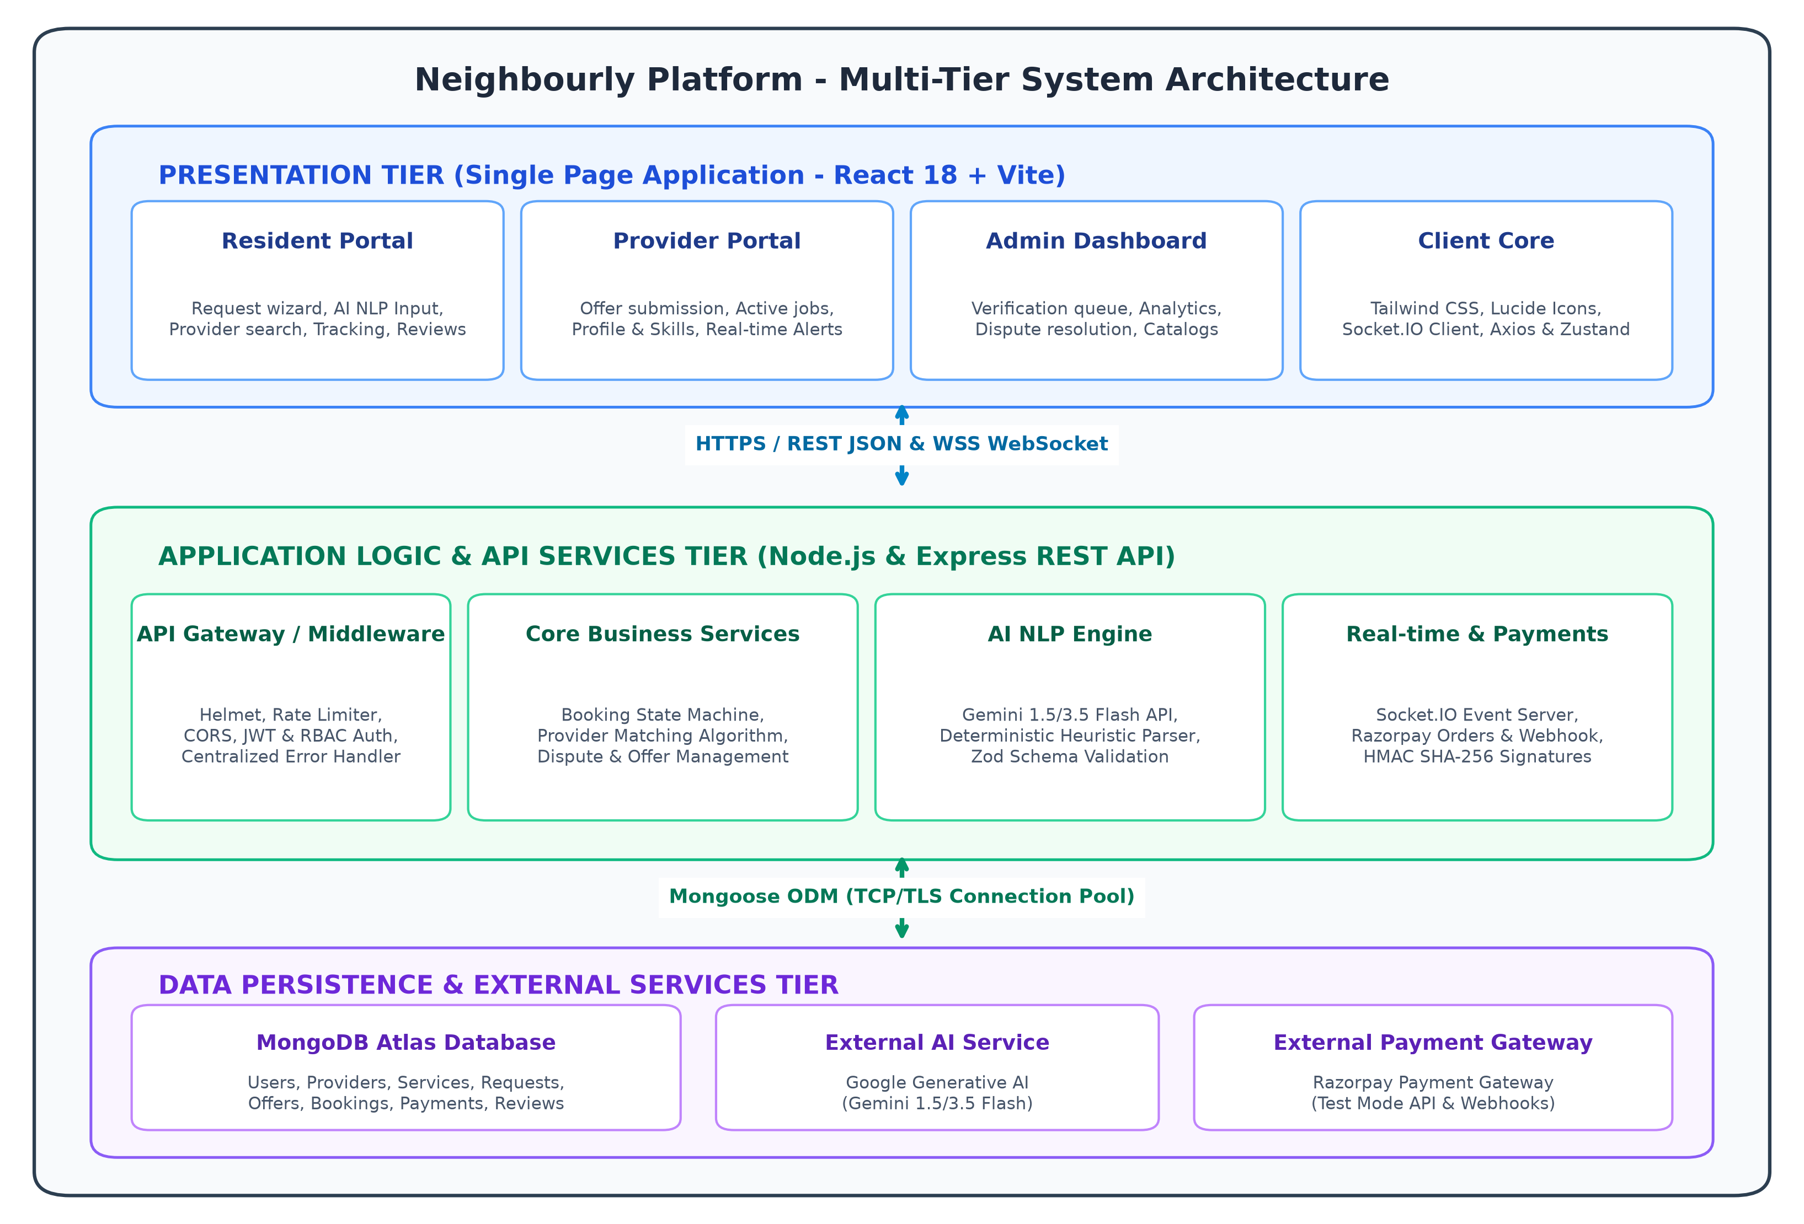
Figure 3.1: Multi-Tier System Architecture of Neighbourly Platform
The architectural tiers operate with defined boundaries and responsibilities as detailed below:
1. Presentation Tier (Client Single Page Application): The topmost tier executes entirely within the client's web browser environment. Engineered using React 18, Vite, and Tailwind CSS, it renders a high-performance, responsive user interface optimized across desktop monitors, tablets, and smartphones. The Presentation Tier is partitioned into three dedicated operational portals: the Resident Portal (encompassing the AI Request Assistant, service discovery catalog, live tracking, and review interfaces), the Provider Portal (comprising the real-time request broadcast feed, quotation submission modal, active job boards, and earnings analytics), and the Admin Control Center (hosting verification review pipelines, dispute arbitration workflows, and platform telemetry). State management is orchestrated via React Context and Zustand, while bi-directional event reactivity is sustained via the Socket.IO client library.
2. Application Logic & API Services Tier (Express.js & Node.js): The middle tier acts as the centralized intelligence and security gateway of the platform. Operating on an asynchronous, non-blocking I/O model powered by Node.js, the Express server mounts a robust middleware pipeline that intercepts all incoming HTTP requests. The security perimeter enforces Helmet header hardening, CORS domain restrictions, rate limiting to neutralize automated scrapers, and JSON Web Token (JWT) cryptographic signature validation. Business logic is strictly segregated into dedicated, decoupled service classes (e.g., BookingService, PaymentService, AIService, ProviderService, DisputeService). Furthermore, a persistent WebSocket server (Socket.IO) maintains authorized socket connections to instantly broadcast localized request leads and dispatch private chat messages.
3. Data Persistence & External Services Tier: The foundational tier comprises cloud persistence datastores and third-party API integrations. Primary transactional data—encompassing user credentials, provider trade profiles, service catalogs, requests, quotation bids, booking records, payment ledgers, chat dialogues, and reviews—is persisted in MongoDB Atlas, a globally distributed, highly available NoSQL document database accessed via Mongoose ODM connection pools. For isolated development and test execution, an embedded in-memory MongoDB server is maintained. External communication bridges link the server tier to the Google Gemini Generative AI endpoints for natural language service parsing and the Razorpay Payment Gateway for escrow order generation, checkout simulation, and HMAC-SHA256 webhook cryptographic verification.
7.3 Module Description
Neighbourly is modularized into eight highly specialized, decoupled subsystems designed for high cohesion and low coupling:
- Module 1: Authentication & Role-Based Access Control (RBAC): Orchestrates user identity lifecycles across three distinct personas: RESIDENT, PROVIDER, and ADMIN. Implements secure password hashing with Bcrypt using 10 salt rounds, disallows registration with duplicate email addresses, issues signed JSON Web Tokens (JWT) containing encoded role claims, and enforces route-level middleware guards preventing unauthorized privilege escalation and Insecure Direct Object References (IDOR).
- Module 2: Provider Onboarding, Document Verification & Trust Profile: Enables tradespeople to curate professional profiles, define trade skills, establish hourly billing rates, specify operational neighborhoods, and set radial service boundaries (1-50 km). Provides a document upload conduit for government IDs and vocational trade certificates. Calculates an automated, transparent composite Trust Score (0-100) based on administrative verification status, customer ratings, and completed service volume.
- Module 3: AI Service Request Assistant & Heuristic Fallback Engine: Ingests unstructured, natural language resident problem descriptions and executes intent classification and entity extraction. Utilizes Google Gemini LLMs to parse categories, schedules, time slots, and budgets into strict JSON schemas validated via Zod. Embeds a deterministic, regular-expression heuristic fallback parser that guarantees seamless, un-interrupted operation during cloud API downtime or network latency.
- Module 4: Service Catalog, Search & Hybrid Multi-Factor Provider Matching: Maintains a centralized taxonomy of urban service categories (Plumbing, Electrical, Carpentry, Appliance Repair, Cleaning, Tutoring, Gardening, etc.). Executes a multi-factor hybrid matching algorithm that filters candidate providers based on category and neighborhood boundary, scoring them against an objective 100-point rubric to generate ranked recommendations accompanied by human-readable match explanations.
- Module 5: Request Broadcasting & Quotation Bidding Workflow: When a resident confirms a service request, the system identifies eligible providers within the designated radial boundary and broadcasts real-time alerts. Qualified providers review the customer's problem description, photographs, and proposed budget, subsequently submitting competitive quotation offers with personalized notes.
- Module 6: Booking Finite State Machine Lifecycle Engine: Governs the formal progression of bookings through an immutable state machine. Regulates state transitions across PENDING, ACCEPTED, PAYMENT_PENDING, PAID, IN_PROGRESS, COMPLETED, REJECTED, CANCELLED, and DISPUTED. Rejects unauthorized state tampering, enforces actor ownership boundaries, and automatically synchronizes booking progress across resident and provider dashboards.
- Module 7: Razorpay Escrow Payment & Webhook Verification Module: Integrates the Razorpay Payment Gateway operating in Sandbox Test Mode. Generates cryptographically signed server orders in paise, renders client checkout modals, and verifies incoming transactions on the backend using HMAC-SHA256 signature validation against the secret key. Implements idempotent webhook handlers to record payment receipts and unlock service execution.
- Module 8: Real-Time Communication (Socket.IO) & Dispute Arbitration: Maintains persistent bi-directional communication channels supporting authenticated private chat rooms between residents and matched providers. Manages in-app notification dispatches for critical lifecycle events. Houses a formal dispute management engine permitting users to contest disputed bookings, providing an administrative portal for evidence review, refund authorization, or completion enforcement.
7.4 UML Diagrams / Data Flow Diagram
Standard Unified Modeling Language (UML) structural and behavioral diagrams, along with Data Flow Diagrams (DFD), are presented below to formalize the static architecture and dynamic execution semantics of the Neighbourly platform.
7.4.1 UML Use Case Diagram
The UML Use Case Diagram visually represents the functional interactions between the primary human actors (Resident, Service Provider, Platform Admin), external software actors (Razorpay Gateway, Gemini AI Engine), and the core use cases enclosed within the Neighbourly system boundary. Figure 3.2 illustrates the complete Use Case model.
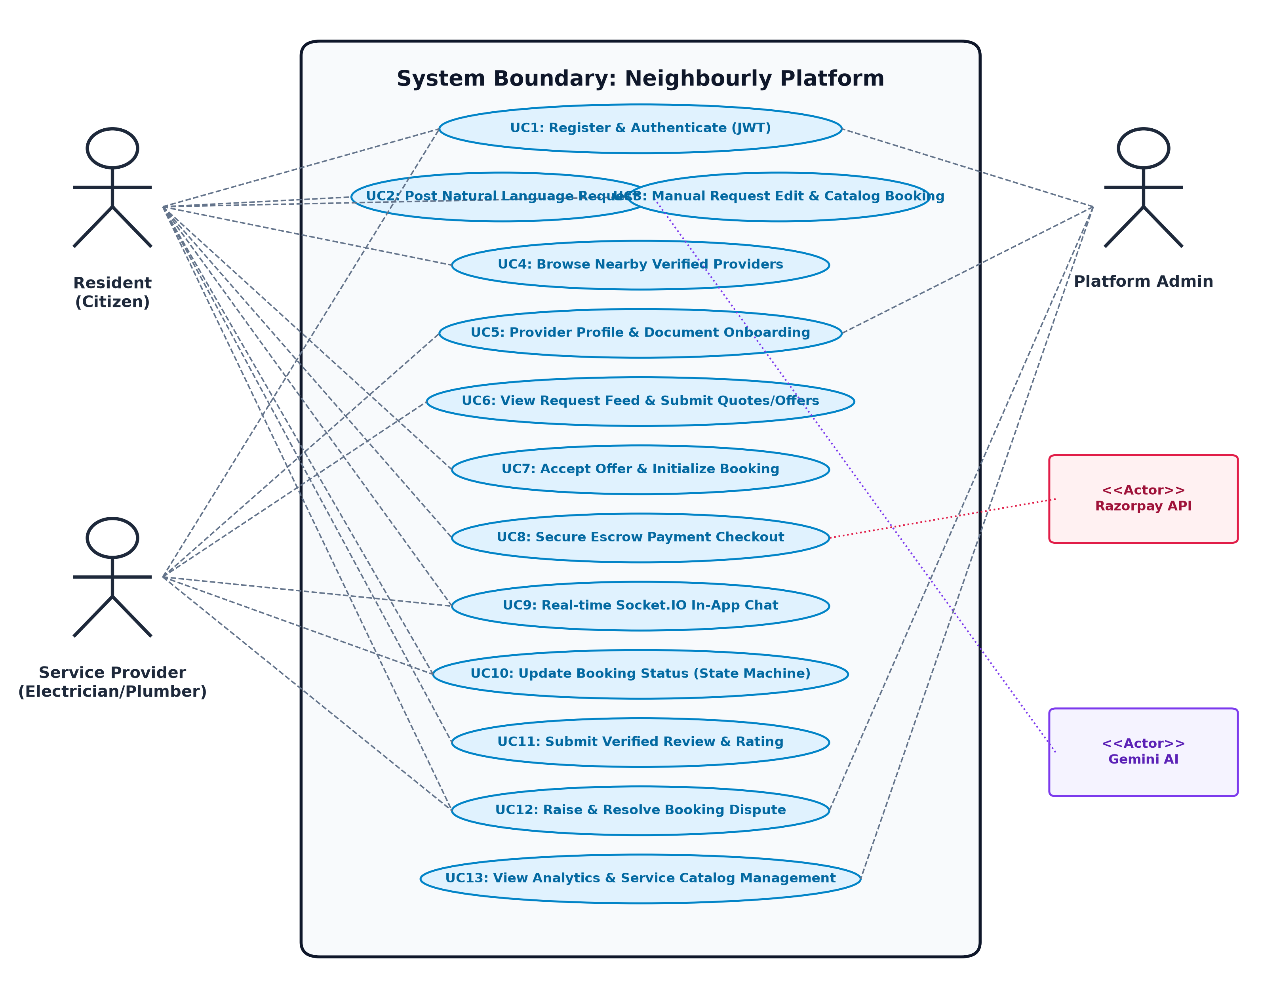
Figure 3.2: UML Use Case Diagram of Neighbourly Platform Actors and Interactions
Detailed Actor-to-Use-Case Mappings:
- Resident (Primary Consumer Actor): Executes User Registration and Login (UC1); posts unstructured service requirements via the AI Request Assistant (UC2); modifies extracted parameters or books directly from the service catalog (UC3); browses and filters verified neighborhood providers (UC4); compares quotes and accepts provider offers (UC7); executes secure escrow payment via Razorpay (UC8); communicates via real-time private chat (UC9); monitors and confirms booking status progression (UC10); submits verified post-service ratings and reviews (UC11); and raises formal disputes when service delivery is unsatisfactory (UC12).
- Service Provider (Primary Technician Actor): Registers and maintains professional trade profile, pricing, and operational radius (UC5); uploads identity documents and certifications for administrative vetting (UC5); inspects the broadcast feed of local service requests and dispatches custom quotation offers (UC6); engages in real-time client chat (UC9); updates booking operational status (IN_PROGRESS, COMPLETED) (UC10); and participates in dispute resolution hearings (UC12).
- Platform Administrator (Governance Actor): Maintains platform-wide security governance; inspects and approves or rejects provider onboarding credentials in the verification queue (UC5); arbitrates contested booking disputes, reviews submitted photographic evidence, and authorizes refunds or payouts (UC12); monitors platform operational analytics and telemetry (total revenue, booking volume, user growth) (UC13); and curates service catalog taxonomies (UC13).
- External Razorpay Payment Gateway (External Service Actor): Receives server-side order creation requests in paise, presents secure checkout UI, issues transaction tokens, and transmits cryptographically signed webhook payloads to confirm fund escrows (UC8).
- External Google Gemini AI Engine (External Service Actor): Receives conversational natural language resident prompts, executes semantic entity parsing, and returns structured JSON entities adhering to the platform's Zod schema (UC2).
7.4.2 UML Class Diagram
The UML Class Diagram models the static structural foundation of the Neighbourly domain layer. It defines the core entity models, their private and public attributes, behavioral member methods, and cardinality relationships. Figure 3.3 illustrates the domain class architecture.
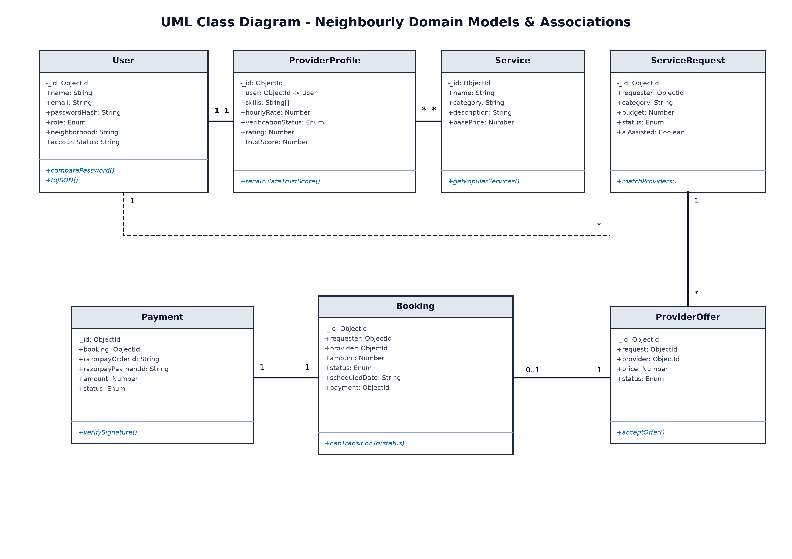
Figure 3.3: UML Class Diagram of Domain Models and Entity Relationships
The database entity collections, primary schema attributes, and structural multiplicities are specified in Table 3.3.
Domain Entity | Core Schema Attributes | Associated Methods | Relationships & Multiplicity
User | _id, name, email, passwordHash, role, neighborhood, accountStatus, profileImage | comparePassword(), toJSON() | 1 to 1 with ProviderProfile; 1 to * with Requests, Bookings
ProviderProfile | _id, user, bio, skills[], services[], hourlyRate, verificationStatus, rating, trustScore | recalculateTrustScore() | 1 to 1 with User; * to * with Service; 1 to * with Offers
Service | _id, name, category, description, basePrice, icon, isActive | getPopularServices() | * to * with ProviderProfile; 1 to * with Bookings
ServiceRequest | _id, requester, category, title, description, budget, preferredDate, time, status, aiAssisted | matchProviders() | * to 1 with User; 1 to * with ProviderOffers; 0..1 with Booking
ProviderOffer | _id, request, provider, price, estimatedDuration, notes, status | acceptOffer(), rejectOffer() | * to 1 with ServiceRequest; * to 1 with User; 1 to 0..1 Booking
Booking | _id, requester, provider, service, request, offer, amount, status, scheduledDate, address, payment | canTransitionTo(status) | * to 1 with User; 1 to 1 with Payment; 1 to 0..1 Review
Payment | _id, booking, requester, provider, amount, razorpayOrderId, razorpayPaymentId, status, mode | verifySignature() | 1 to 1 with Booking; * to 1 with User
Review | _id, booking, reviewer, provider, rating, comment, verifiedBooking | recalculateAverage() | 1 to 1 with Booking; * to 1 with ProviderProfile
Dispute | _id, booking, raisedBy, reason, description, evidence[], status, adminNotes, resolution | resolveDispute() | 1 to 1 with Booking; * to 1 with User

7.4.3 UML Sequence Diagram
The UML Sequence Diagram outlines the dynamic temporal message sequence and asynchronous control flow governing an end-to-end service lifecycle: from initial natural language request generation and quotation bidding, through escrow payment verification, to final job completion. Figure 3.4 delineates the sequence workflow.
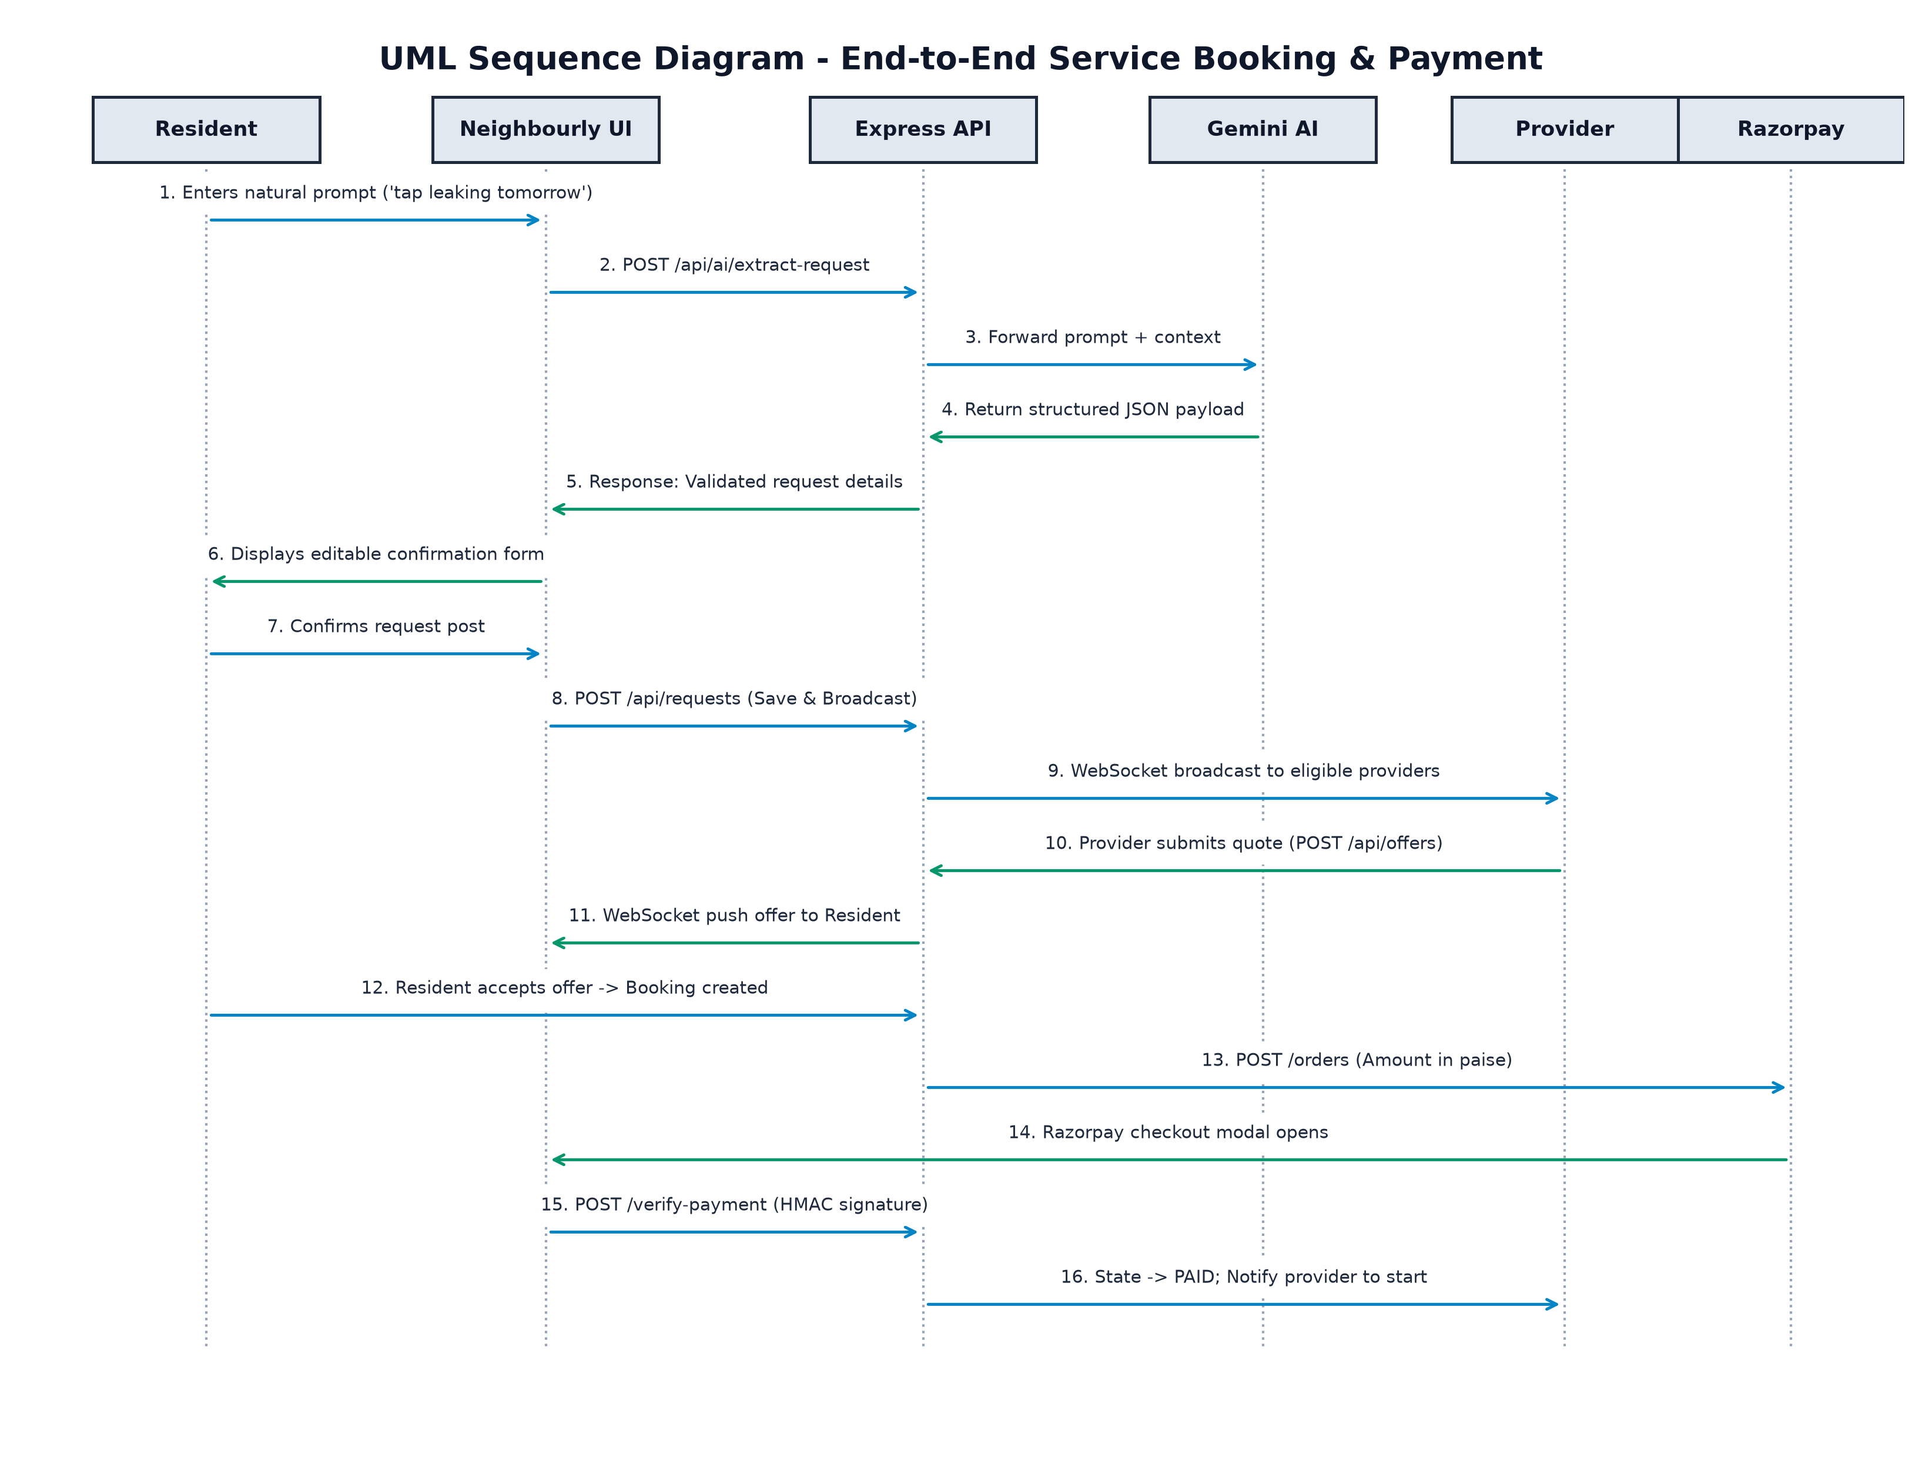
Figure 3.4: UML Sequence Diagram of End-to-End Service Booking and Fulfillment Workflow
Chronological Workflow Walkthrough:
1. Request Formulation: The resident inputs a conversational problem statement into the client UI. The client issues an asynchronous POST request to '/api/ai/extract-request'.
2. AI Entity Extraction: The Express server forwards the prompt to the Gemini Generative AI endpoint. Upon receiving structured JSON, the server validates parameters against Zod schema rules and responds to the client. (If Gemini is unavailable, the local heuristic fallback engine immediately executes).
3. Confirmation & Broadcast: The resident inspects the pre-populated booking form, makes optional edits, and confirms submission. The server saves the ServiceRequest in MongoDB and transmits a WebSocket broadcast event ('NEW_REQUEST') to all active, verified providers operating within that neighborhood radius.
4. Quotation Submission: Providers review the request details and submit formal bids (POST '/api/offers'). The server notifies the resident in real time via WebSocket ('OFFER_RECEIVED').
5. Acceptance & Order Generation: The resident evaluates submitted offers and accepts their preferred technician. The server transitions the offer status to ACCEPTED and generates a Booking record in PAYMENT_PENDING state. The server invokes the Razorpay Orders API to generate an order ID with the amount specified in paise.
6. Escrow Payment & Verification: The resident completes the simulated checkout modal. The client transmits the payment ID, order ID, and signature to '/api/payments/verify'. The server validates the cryptographic HMAC-SHA256 signature. Upon success, the booking transitions to PAID, locking funds in escrow and alerting the provider to begin transit.
7. Service Delivery & Rating: The provider marks the booking as IN_PROGRESS upon arrival, and subsequently COMPLETED upon job conclusion. The resident confirms completion, releasing provider funds, and submits a verified 5-star rating and textual review, dynamically updating the provider's platform Trust Score.
7.4.4 Data Flow Diagrams (DFD Level 0 and Level 1)
Data Flow Diagrams trace the flow of data through the system, capturing external entities, transformation processes, and underlying datastores. Figure 3.5 presents both the Context-Level DFD (Level 0) and the Functional Decomposition DFD (Level 1).
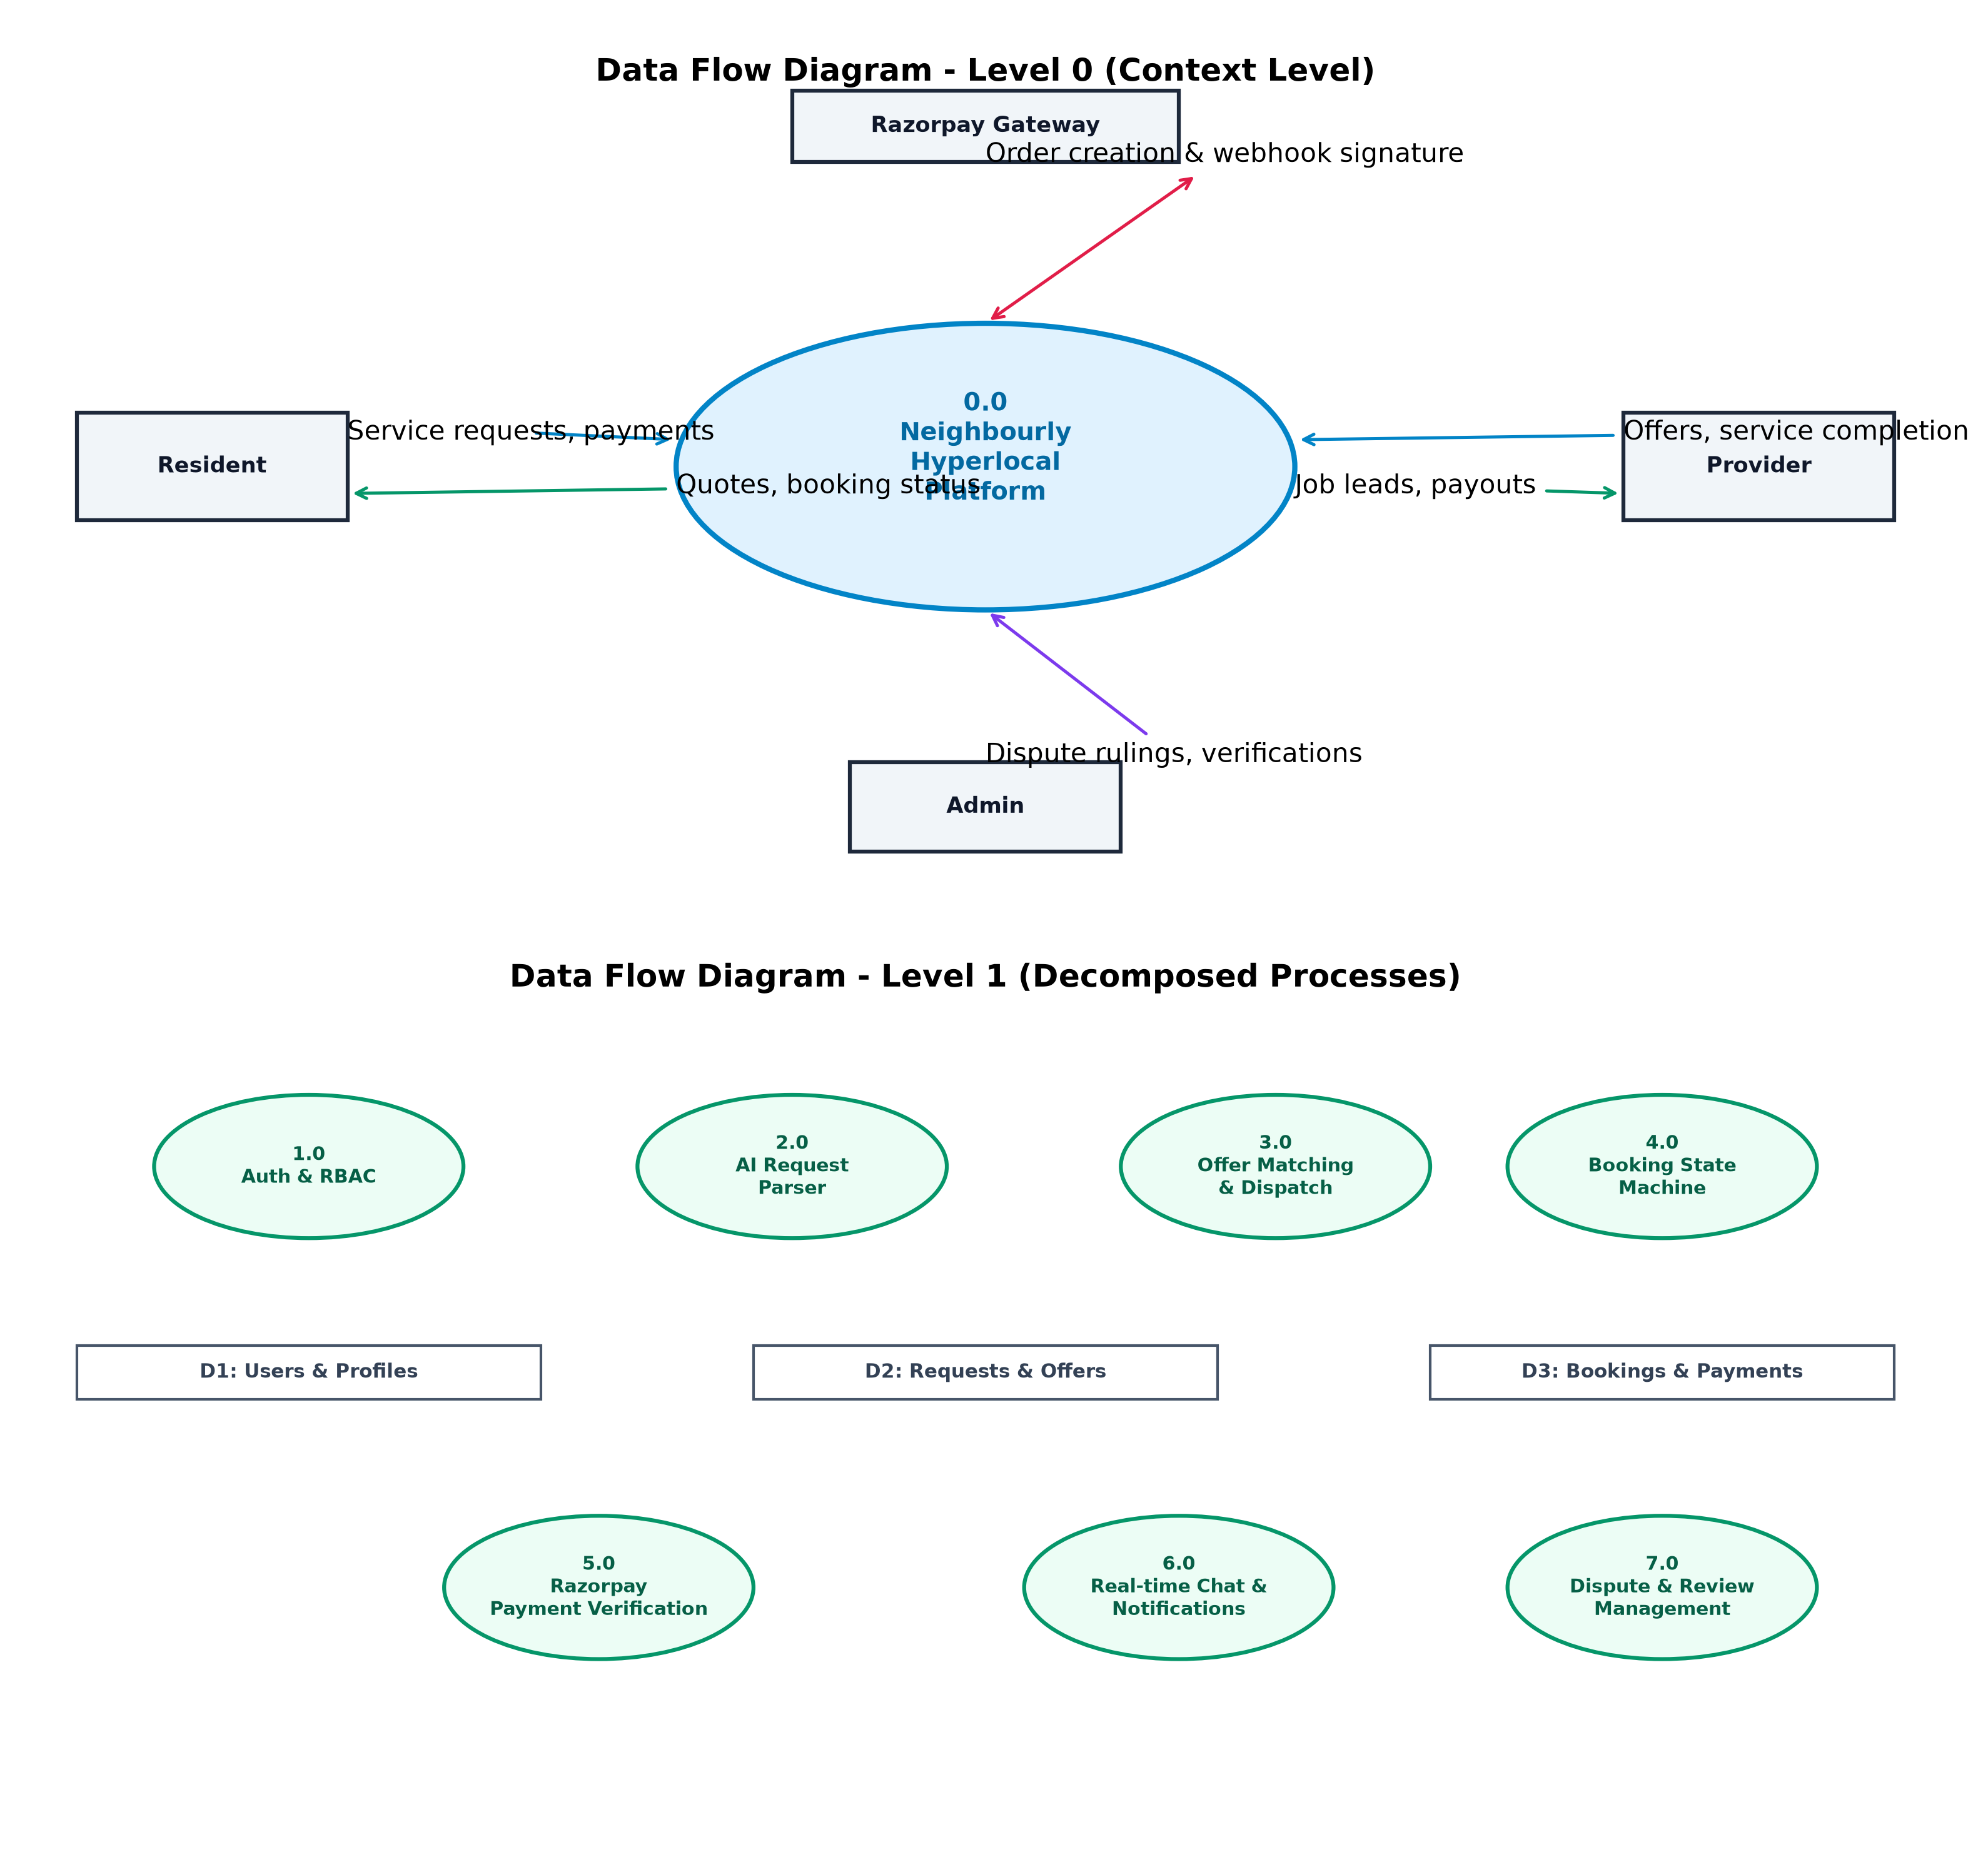
Figure 3.5: Context-Level DFD (Level 0) and Functional Decomposition DFD (Level 1)
DFD Level 0 (Context Level): The context diagram depicts Neighbourly as a single holistic process (0.0) interfacing with four primary external entities: Resident, Provider, Admin, and the Razorpay Gateway. The Resident supplies authentication credentials, natural language prompts, booking choices, and escrow payments, receiving in return formatted booking schedules, quotation bids, and service confirmations. The Provider supplies profile credentials, certification documents, and custom offers, receiving targeted job notifications and escrow payout settlements. The Admin injects dispute rulings and certification approvals, receiving platform operational logs and telemetry. The Razorpay Gateway exchanges order identifiers and cryptographically signed payment verification tokens.
DFD Level 1 (Functional Decomposition): Decomposes Process 0.0 into seven discrete sub-processes interacting with three persistent datastores: Process 1.0 (Auth & RBAC) synchronizes with Datastore D1 (Users & Profiles); Process 2.0 (AI Request Parser) extracts structured parameters and populates Datastore D2 (Requests & Offers); Process 3.0 (Offer Matching & Dispatch) correlates active requests with verified providers; Process 4.0 (Booking State Machine) and Process 5.0 (Payment Verification) manipulate Datastore D3 (Bookings & Payments); Process 6.0 manages bi-directional WebSocket messaging streams; and Process 7.0 manages Dispute and Review arbitration.
7.5 Algorithm / Flowchart
To guarantee deterministic reliability, algorithmic transparency, and flawless execution, Neighbourly specifies formal algorithmic formulations for its core intelligence and state enforcement engines. Figure 3.6 presents the detailed flowcharts for both the AI Natural Language Request Extraction subsystem and the Booking State Machine.
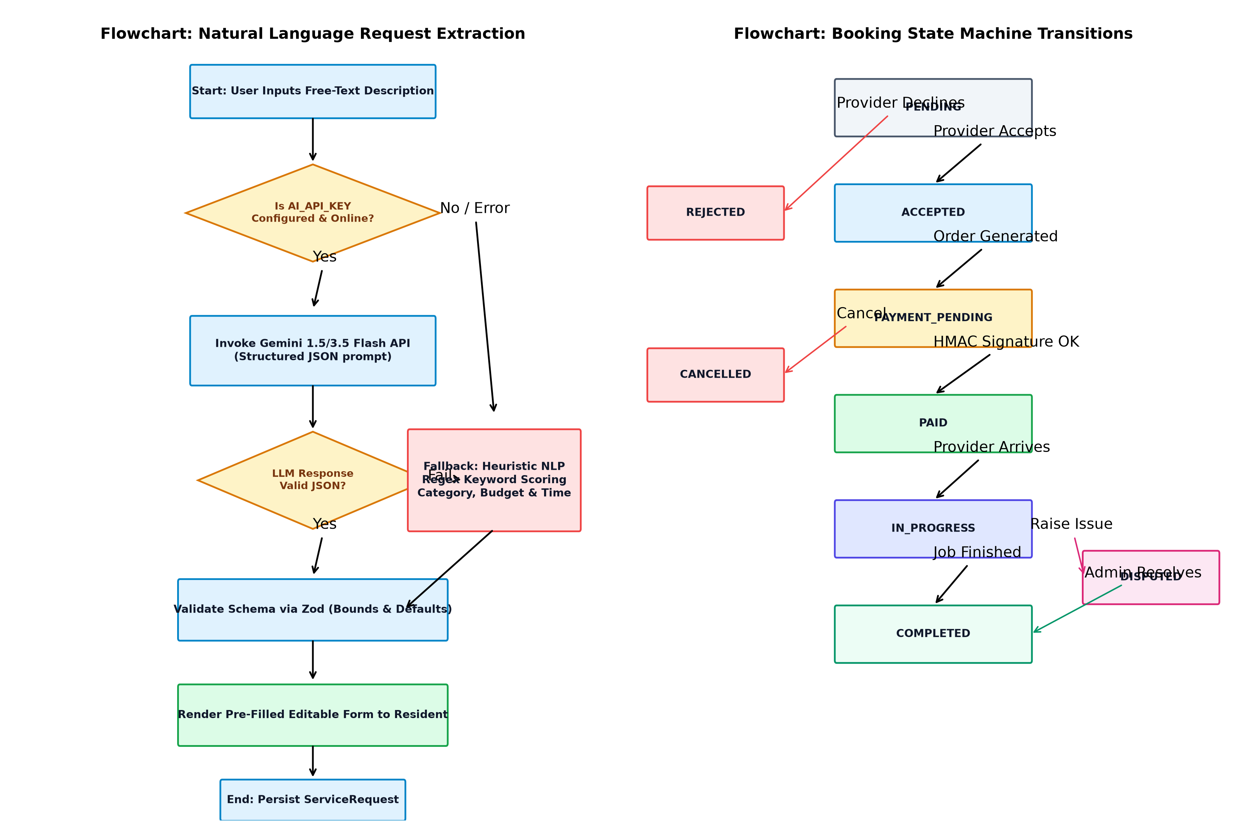
Figure 3.6: Algorithmic Flowcharts: AI Request Extraction and Booking State Machine
7.5.1 Algorithm 1: AI Natural Language Service Extraction & Heuristic Fallback
Algorithm 1 outlines the resilient, dual-tier natural language extraction pipeline that translates unstructured user prompts into validated booking entities.
ALGORITHM 1: Resilient Natural Language Request Extraction
INPUT: User Prompt String P, Default Locality L_def
OUTPUT: Validated Structured Service Request Object S
1. PROCEDURE ExtractServiceRequest(P, L_def):
2. IF P is NULL or P.trim().length == 0 THEN
3. THROW ValidationError("Service description cannot be empty")
4. END IF
5.
6. // Tier 1: Cloud LLM API Attempt
7. IF Environment.AI_API_KEY is configured THEN
8. TRY
9. Construct JSON Schema Prompt with Categories, Times, and Formats
10. Payload := { prompt: P, defaultNeighborhood: L_def, temperature: 0.2 }
11. Response := HTTP_POST(Gemini_Flash_URL, Payload, Timeout = 5000ms)
12. IF Response.status == 200 AND Response.body.text is valid THEN
13. ParsedJSON := JSON.parse(Response.body.text)
14. S := ZodSchema.validate(ParsedJSON)
15. S.source := "llm_gemini"
16. S.confidence := 0.95
17. RETURN S
18. END IF
19. CATCH Exception E
20. Logger.warn("Cloud LLM extraction failed: " + E.message + ". Triggering Fallback.")
21. END TRY
22. END IF
23.
24. // Tier 2: Resilient Heuristic NLP Rule-Based Fallback
25. RETURN HeuristicExtraction(P, L_def)
26.
27. 28. PROCEDURE HeuristicExtraction(P, L_def):
29. P_lower := P.toLowerCase()
30. Category := "General Service", SuggestedSkills := []
31.
32. // Keyword Dictionary Matching
33. FOR EACH CatRecord IN CategoryTaxonomy DO
34. FOR EACH Keyword IN CatRecord.keywords DO
35. IF P_lower CONTAINS Keyword THEN
36. Category := CatRecord.name
37. SuggestedSkills := CatRecord.skills
38. BREAK INNER
39. END IF
40. END FOR
41. END FOR
42.
43. // Budget Regex Extraction: e.g., "budget 600", "₹500", "rs 800"
44. Budget := 500 // Default baseline
45. MatchBudget := REGEX_EXEC(/(?:budget|cost|price|rs\.?|inr|₹)\s*[:=]?\s*(\d{2,5})/i, P_lower)
46. IF MatchBudget is NOT NULL THEN
47. Budget := ParseInteger(MatchBudget[1])
48. END IF
49.
50. // Time Slot Extraction: Morning / Afternoon / Evening
51. Slot := "Morning"
52. IF P_lower MATCHES /evening|night|after 5/ THEN Slot := "Evening"
53. ELSE IF P_lower MATCHES /afternoon|post lunch|noon/ THEN Slot := "Afternoon"
54. ELSE IF P_lower MATCHES /morning|am|early/ THEN Slot := "Morning"
55. END IF
56.
57. // Schedule Date Extraction: Tomorrow / Day after
58. TargetDate := CurrentDate() + 1 Day // Default tomorrow
59. IF P_lower MATCHES /today|urgent|emergency|now/ THEN TargetDate := CurrentDate()
60. ELSE IF P_lower MATCHES /day after|overmorrow/ THEN TargetDate := CurrentDate() + 2 Days
61. END IF
62.
63. S := {
64. category: Category,
65. title: Category + " Service Request",
66. description: P.trim(),
67. preferredDate: FormatDate(TargetDate),
68. preferredTime: Slot,
69. budget: Max(Budget, 50),
70. neighborhood: L_def,
71. suggestedSkills: SuggestedSkills,
72. source: "heuristic_nlp",
73. confidence: 0.88
74. }
75. RETURN S
76. END PROCEDURE

7.5.2 Algorithm 2: Hybrid Multi-Factor Provider Matching Algorithm
Algorithm 2 details the multi-factor scoring algorithm that balances deterministic qualification filtering with mathematical objective ranking to connect residents with optimal local service providers.
Mathematical Formulation:
Let P be the candidate provider profile and R be the resident service request. The composite match score S(P, R) is formulated as a weighted linear combination across five normalized criteria:
S(P, R) = W_v * V(P) + W_d * D(P, R) + W_r * R(P) + W_c * C(P) + W_p * P(P, R)
Where the weighting parameters satisfy the constraint: W_v + W_d + W_r + W_c + W_p = 100 points, as defined in Table 3.5.
Parameter Symbol | Evaluation Dimension | Maximum Weight | Scoring Criteria & Bounds
V(P) | Identity Verification Status | 25 Points | VERIFIED = 25 pts, IN_REVIEW = 15 pts, PENDING = 10 pts
D(P, R) | Locality Proximity & Radius | 25 Points | Direct Locality Match = 25 pts, Within Radius = 12 pts
R(P) | Customer Review Star Rating | 20 Points | (Average Rating / 5.0) * 20 pts; Unrated Baseline = 14 pts
C(P) | Completed Job Volume & Track Record | 15 Points | > 10 Jobs = 15 pts, 1-10 Jobs = 10 pts, New Provider = 8 pts
P(P, R) | Pricing Compatibility vs Budget | 15 Points | Hourly Rate <= Budget Ceiling = 15 pts, Above Budget = 8 pts

ALGORITHM 2: Hybrid Multi-Factor Provider Matching
INPUT: ServiceRequest R { category, neighborhood, budget, preferredTime }
OUTPUT: Ranked List of Top Providers with Explanations
1. PROCEDURE MatchProviders(R):
2. // Phase 1: Hard Filtering via MongoDB Query
3. Candidates := Database.ProviderProfiles.find({
4. services: CategoryDoc._id,
5. "availability.isAcceptingRequests": true
6. }).populate('user')
7.
8. IF Candidates.length < 3 THEN
9. // Broaden filter to providers in vicinity with active status
10. Candidates := Database.ProviderProfiles.find({
11. "availability.isAcceptingRequests": true
12. }).populate('user')
13. END IF
14.
15. ScoredList := []
16.
17. // Phase 2: Multi-Factor Scoring
18. FOR EACH Provider P IN Candidates DO
19. Score := 0
20. Reasons := []
21.
22. // 1. Verification (25 pts)
23. IF P.verificationStatus == 'VERIFIED' THEN
24. Score += 25
25. Reasons.append("Verified Neighbourly Provider")
26. ELSE IF P.verificationStatus == 'IN_REVIEW' THEN
27. Score += 15
28. ELSE Score += 10 END IF
29.
30. // 2. Proximity (25 pts)
31. IF P.neighborhood.toLowerCase() == R.neighborhood.toLowerCase() THEN
32. Score += 25
33. Reasons.append("Operates locally in " + P.neighborhood)
34. ELSE
35. Score += 12
36. Reasons.append("Servicing areas within " + P.serviceRadiusKm + "km radius")
37. END IF
38.
39. // 3. Rating & Quality (20 pts)
40. IF P.reviewCount > 0 THEN
41. Score += (P.rating / 5.0) * 20
42. Reasons.append(P.rating + "★ rating from " + P.reviewCount + " neighbor reviews")
43. ELSE
44. Score += 14
45. Reasons.append("New active neighborhood partner")
46. END IF
47.
48. // 4. Experience & Completions (15 pts)
49. IF P.completedBookings > 10 THEN
50. Score += 15
51. Reasons.append(P.completedBookings + " completed neighborhood jobs")
52. ELSE IF P.completedBookings > 0 THEN
53. Score += 10
54. ELSE Score += 8 END IF
55.
56. // 5. Price Compatibility (15 pts)
57. HourlyRate := P.pricing.hourlyRate
58. IF R.budget >= HourlyRate THEN
59. Score += 15
60. Reasons.append("Budget-friendly at ₹" + HourlyRate + "/hr (fits ₹" + R.budget + " budget)")
61. ELSE
62. Score += 8
63. Reasons.append("Standard rate of ₹" + HourlyRate + "/hr")
64. END IF
65.
66. FinalScore := Min(99, Round(Score))
67. Badge := "Recommended"
68. IF FinalScore >= 85 THEN Badge := "Top Match"
69. ELSE IF FinalScore >= 70 THEN Badge := "Great Fit" END IF
70.
71. ScoredList.append({
72. provider: P,
73. matchScore: FinalScore,
74. matchBadge: Badge,
75. explanation: Reasons.join(" • ")
76. })
77. END FOR
78.
79. // Sort descending by match score
80. SORT ScoredList BY matchScore DESCENDING
81. RETURN ScoredList.slice(0, 8)
82. END PROCEDURE

7.5.3 Algorithm 3: Deterministic State Machine Transition Guard
To prevent client-side status tampering, unauthorized cancellations, or fraudulent order skips, booking state mutations are strictly validated on the server via Algorithm 3, adhering to the transition matrix defined in Table 3.4.
Current State | Permissible Next States | Triggering Actor | Operational Business Event
PENDING | ACCEPTED, REJECTED, CANCELLED | Provider / Resident | Provider accepts/rejects bid or resident revokes
ACCEPTED | PAYMENT_PENDING, PAID, CANCELLED | Resident / System | Resident initiates checkout or executes payment
PAYMENT_PENDING | PAID, CANCELLED | Payment Gateway / Resident | Razorpay HMAC signature verified or user cancels
PAID | IN_PROGRESS, CANCELLED, DISPUTED | Provider / Resident | Provider arrives and commences work on-site
IN_PROGRESS | COMPLETED, DISPUTED | Provider / Resident | Work completed or issue raised during job execution
COMPLETED | DISPUTED | Resident | Resident contests unsatisfactory service within grace window
DISPUTED | COMPLETED, CANCELLED | Platform Admin | Admin arbitrates dispute (releases payout or refund)
REJECTED / CANCELLED | None (Terminal States) | None | Finalized immutable terminal states

CHAPTER 4 – IMPLEMENTATION
8.1 Implementation Details
The implementation phase of Neighbourly translated the conceptual domain models, state machines, and mathematical algorithms into production-ready software artifacts. The development lifecycle adopted modern software engineering paradigms—incorporating modular component-based frontend construction, strict asynchronous non-blocking backend service architecture, centralized exception handling, runtime input validation, and continuous unit testing.
1. Layered Express Server Architecture: The backend codebase strictly adheres to the Clean Service-Oriented Architecture (SOA) pattern, partitioned into four distinct layers:
- Routes Layer: Declares REST endpoints, associates HTTP verbs (GET, POST, PUT, PATCH, DELETE), and attaches security middleware (rate limiters, JWT verifiers, RBAC role guards).
- Controllers Layer: Extracts HTTP request payloads, validates input data against Zod schemas, delegates business operations to underlying services, and formats standard JSON responses.
- Services Layer: Contains all domain logic, mathematical scoring algorithms, payment gateway interactions, WebSocket event emissions, and database mutations.
- Models Layer: Defines Mongoose ODM schemas, indexes, schema hooks, document helper methods (e.g., password comparisons, state transition validation, trust score recalculation).
2. Asynchronous Concurrency & Error Handling: All I/O operations—database transactions, external AI HTTP requests, and payment gateway calls—utilize native JavaScript async/await syntax. Unhandled promise rejections are intercepted by an Express Centralized Error Handling Middleware. Custom application errors inherit from an ApiError class encapsulating HTTP status codes and operational error descriptors, preventing technical stack traces from leaking to client responses in production.
3. Zero-Friction Database Connection Management: The database configuration module establishes persistent Mongoose connection pools to MongoDB Atlas using TLS encryption and auto-reconnect listeners. In non-production environments, if an external cloud database is unreachable, the server automatically boots an in-memory MongoDB replica, allowing immediate development and automated testing without external infrastructure dependencies.
8.2 Module Implementation
Key software components and production implementations across Neighbourly's core modules are documented below with corresponding code implementations.
8.2.1 Authentication and Role-Based Access Control Implementation
User authentication utilizes salted password hashing via Bcrypt (10 salt rounds) and stateless JSON Web Tokens (JWT). The User schema guarantees unique email indexes and sanitizes password hashes prior to JSON serialization. Role-based authorization middleware intercepts protected routes, verifying the user's role against permitted claims.
// Source: server/src/models/User.js & server/src/middleware/authMiddleware.js
// 1. Password Comparison Method on User Schema
userSchema.methods.comparePassword = async function (candidatePassword) {
return bcrypt.compare(candidatePassword, this.passwordHash);
};
// 2. Role-Based Access Control (RBAC) Guard Middleware
export const authorizeRoles = (...allowedRoles) => {
return (req, res, next) => {
if (!req.user || !allowedRoles.includes(req.user.role)) {
throw ApiError.forbidden(
`Forbidden: Role '${req.user?.role || 'Guest'}' lacks access privileges`
);
}
next();
};
};

8.2.2 Provider Trust Score Recalculation Implementation
To maintain absolute trust transparency across the neighborhood marketplace, provider profiles feature a dynamic Trust Score (0-100) recalculated automatically upon administrative document verification, customer review submission, or job completion.
// Source: server/src/models/ProviderProfile.js
providerProfileSchema.methods.recalculateTrustScore = function () {
// Trust formula: Base 30 + 35 for VERIFIED + (Rating/5)*20 + min(Jobs*1.5, 15)
let score = 30;
if (this.verificationStatus === 'VERIFIED') score += 35;
if (this.reviewCount > 0) {
score += (this.rating / 5) * 20;
} else {
score += 10; // Baseline for newly registered partners
}
score += Math.min(this.completedBookings * 1.5, 15);
this.trustScore = Math.min(100, Math.round(score));
return this.trustScore;
};

8.2.3 AI Natural Language Service Extraction & Heuristic Fallback Implementation
The AIService implements the dual-tier intelligence pipeline. When a resident inputs a conversational problem statement, the system invokes the Google Gemini API with temperature=0.2 and structured JSON schema enforcement. If third-party API limits or network timeouts occur, the deterministic heuristic extractor seamlessly takes over.
// Source: server/src/services/ai/aiService.js
export class AIService {
static async extractServiceRequest(promptText, userNeighborhood = 'Indiranagar') {
if (!promptText || promptText.trim().length === 0) {
throw new Error('Please enter a description of the service you need.');
}
// Tier 1: External Cloud LLM API Call
if (env.AI_API_KEY) {
try {
const result = await this.callLLMForExtraction(promptText, userNeighborhood);
if (result) return result;
} catch (llmError) {
logger.warn({ err: llmError.message }, 'LLM extraction failed, using heuristic fallback');
}
}
// Tier 2: Resilient Heuristic NLP Rule-Based Parser
return this.heuristicExtraction(promptText, userNeighborhood);
}
}

8.2.4 Booking State Machine Transition Enforcement Implementation
Booking integrity is protected by an explicit transition lookup dictionary and schema-level validation methods, preventing unauthorized state skips.
// Source: server/src/models/Booking.js
export const ALLOWED_TRANSITIONS = {
[BOOKING_STATUS.PENDING]: [BOOKING_STATUS.ACCEPTED, BOOKING_STATUS.REJECTED, BOOKING_STATUS.CANCELLED],
[BOOKING_STATUS.ACCEPTED]: [BOOKING_STATUS.PAYMENT_PENDING, BOOKING_STATUS.PAID, BOOKING_STATUS.CANCELLED],
[BOOKING_STATUS.PAYMENT_PENDING]: [BOOKING_STATUS.PAID, BOOKING_STATUS.CANCELLED],
[BOOKING_STATUS.PAID]: [BOOKING_STATUS.IN_PROGRESS, BOOKING_STATUS.CANCELLED, BOOKING_STATUS.DISPUTED],
[BOOKING_STATUS.IN_PROGRESS]: [BOOKING_STATUS.COMPLETED, BOOKING_STATUS.DISPUTED],
[BOOKING_STATUS.COMPLETED]: [BOOKING_STATUS.DISPUTED],
[BOOKING_STATUS.REJECTED]: [],
[BOOKING_STATUS.CANCELLED]: [],
[BOOKING_STATUS.DISPUTED]: [BOOKING_STATUS.COMPLETED, BOOKING_STATUS.CANCELLED],
};
bookingSchema.methods.canTransitionTo = function (nextStatus) {
const allowed = ALLOWED_TRANSITIONS[this.status] || [];
return allowed.includes(nextStatus);
};

8.2.5 Razorpay Escrow Order Generation & HMAC Signature Verification
Payment transactions are secured through backend order creation in paise and cryptographic signature verification using the Node.js native crypto module.
// Source: server/src/services/paymentService.js & server/src/config/razorpay.js
// 1. Cryptographic HMAC SHA-256 Signature Verification
export const verifyRazorpaySignature = (orderId, paymentId, signature) => {
const secret = env.RAZORPAY_KEY_SECRET;
const generatedSignature = crypto
.createHmac('sha256', secret)
.update(`${orderId}|${paymentId}`)
.digest('hex');
return generatedSignature === signature;
};
// 2. Server-Side Payment Verification & State Transition
static async verifyPayment(bookingId, residentUserId, { razorpayOrderId, razorpayPaymentId, razorpaySignature }) {
const isValid = verifyRazorpaySignature(razorpayOrderId, razorpayPaymentId, razorpaySignature);
if (!isValid && !env.isDev) {
throw ApiError.badRequest('Invalid payment signature verification failed');
}
const booking = await Booking.findById(bookingId);
booking.status = BOOKING_STATUS.PAID;
await booking.save();
await Payment.findOneAndUpdate(
{ razorpayOrderId },
{ status: 'PAID', razorpayPaymentId, verifiedAt: new Date() }
);
return { success: true, bookingStatus: booking.status };
}

8.2.6 Real-Time WebSocket Communication Handler Implementation
Socket.IO establishes persistent bi-directional rooms for direct messaging between residents and providers, ensuring that chat history is simultaneously persisted to MongoDB while being delivered to the connected client instantly.
// Source: server/src/sockets/socketHandler.js
io.on('connection', (socket) => {
// Join Private Conversation Room
socket.on('join_conversation', ({ conversationId }) => {
socket.join(conversationId);
});
// Handle New Real-Time Message
socket.on('send_message', async ({ conversationId, senderId, text }) => {
const message = await Message.create({
conversation: conversationId,
sender: senderId,
text,
});
// Broadcast to room participants
io.to(conversationId).emit('new_message', message);
});
});

8.2.7 Core RESTful API Endpoints Specification
The API surface of Neighbourly comprises modular REST endpoints documented in Table 4.1.
HTTP Method | Endpoint URI | Authorized Roles | Functional Description
POST | /api/auth/register | Public / All | Register new Resident, Provider, or Admin account
POST | /api/auth/login | Public / All | Authenticate credentials and issue JWT bearer token
GET | /api/services | Public / All | Retrieve categorized service catalog with pricing baselines
GET | /api/providers | Public / All | Search and filter nearby providers by locality and category
POST | /api/ai/extract-request | RESIDENT | Parse unstructured conversational text via AI/NLP engine
POST | /api/requests | RESIDENT | Persist confirmed service request and broadcast to providers
GET | /api/offers/request/:id | RESIDENT, PROVIDER | Retrieve all quotation bids submitted for a request
POST | /api/offers | PROVIDER | Submit customized quotation bid for broadcasted request
POST | /api/bookings | RESIDENT | Accept offer or initialize direct booking with provider
PATCH | /api/bookings/:id/status | RESIDENT, PROVIDER | Execute state machine transition (IN_PROGRESS, COMPLETED)
POST | /api/payments/create-order | RESIDENT | Initialize Razorpay escrow order in paise on backend
POST | /api/payments/verify | RESIDENT | Verify HMAC-SHA256 signature and transition booking to PAID
POST | /api/reviews | RESIDENT | Submit post-service 5-star rating and textual review
POST | /api/disputes | RESIDENT, PROVIDER | Formally contest an unsatisfactory or contested booking
GET | /api/admin/analytics | ADMIN | Retrieve platform metrics (revenue, booking velocity, growth)
PATCH | /api/admin/verifications/:id | ADMIN | Approve or reject provider identity documents in queue

8.3 Tools and Technologies Used
The selection of technical frameworks and libraries across the Neighbourly stack was guided by production reliability, developer velocity, community maturity, and strict security compliance:
- React 18 & Vite Build Tool: React 18 delivers declarative component-driven UI construction empowered by Concurrent Mode and automatic batching, ensuring smooth 60fps micro-interactions. Vite replaces legacy Webpack bundlers, delivering instant server start times and sub-second Hot Module Replacement (HMR) powered by native ES modules.
- Tailwind CSS Utility Design System: Enforces a consistent design language across spacing, typography, and curated color palettes (slate, emerald, and sky blue), generating minimal production CSS bundles with zero unused style bloat.
- Node.js & Express REST Engine: Node's non-blocking, asynchronous event loop efficiently handles thousands of concurrent client connections with minimal memory overhead, while Express provides battle-tested middleware routing and security piping.
- MongoDB Atlas & Mongoose ODM: MongoDB's flexible BSON document model seamlessly accommodates evolving service schemas, nested provider attributes, and dynamic review collections. Mongoose provides schema validation, middleware hooks, and automated population pipelines.
- Socket.IO Bi-Directional WebSocket Protocol: Provides low-latency, full-duplex communication channels between clients and the server, featuring automatic reconnection, room abstraction, and graceful HTTP long-polling fallbacks.
- Razorpay Payment Gateway (Test Mode): Provides India's gold-standard digital payment infrastructure, supporting UPI, credit/debit cards, and net banking simulations backed by server-side HMAC-SHA256 cryptographic verification.
- Google Gemini Generative AI (Flash Models): Delivers rapid semantic reasoning and structured entity extraction from natural language prompts, operating with low token latency and high fidelity.
- Zod & Helmet Security Suites: Zod enforces runtime schema validation at API boundaries, disallowing malicious or malformed payloads. Helmet hardens HTTP headers against Cross-Site Scripting (XSS), Clickjacking, and MIME sniffing attacks.

CHAPTER 5 – RESULTS AND TESTING
9.1 Screenshots and Outputs
The Neighbourly platform was validated through end-to-end user journeys spanning all three primary personas: Resident, Service Provider, and Platform Administrator. Figure 5.1 presents a composite representation of key production user interface screens across the platform.
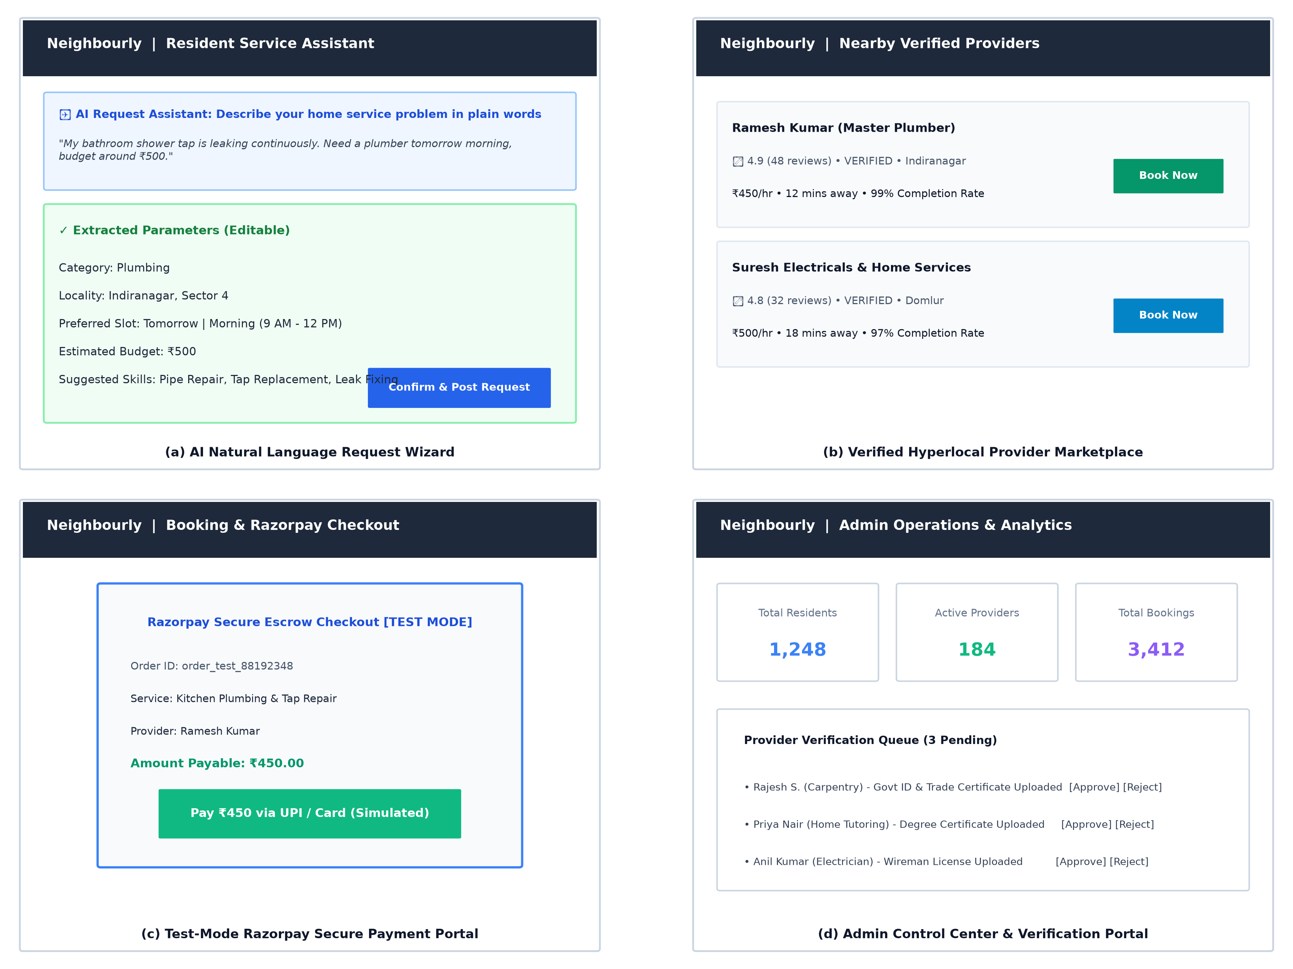
Figure 5.1: High-Fidelity User Interface Screenshots of Neighbourly Platform Modules
Detailed Interface Module Walkthrough:
1. Screen (a) – Resident AI Natural Language Request Wizard: Demonstrates the zero-friction service booking interface. The resident inputs a plain English description: "My bathroom shower tap is leaking continuously. Need a plumber tomorrow morning, budget around ₹500." The system instantly parses the text, extracting the 'Plumbing' category, Indiranagar locality, morning time slot, ₹500 budget, and relevant trade skills ('Pipe Repair', 'Tap Replacement', 'Leak Fixing'). The extracted parameters are rendered in an editable card, allowing the resident to adjust fields before persisting and broadcasting the request.
2. Screen (b) – Verified Hyperlocal Provider Marketplace: Displays the provider discovery feed. Local professionals are presented with verified trust badges, 5-star customer ratings, review counts, proximity metrics, and hourly pricing. Candidates scored by the Hybrid Matching Algorithm exhibit transparent recommendation badges (e.g., 'Top Match: Verified Provider • Operates locally in Indiranagar').
3. Screen (c) – Test-Mode Razorpay Secure Payment Portal: Illustrates the simulated checkout modal triggered upon offer acceptance. The modal displays the generated Razorpay order ID, booking details, provider recipient, and exact payable amount (₹450.00). Residents can execute instant test payments via simulated UPI or debit cards, triggering server-side HMAC-SHA256 signature verification upon completion.
4. Screen (d) – Admin Control Center & Analytics Dashboard: Visualizes platform-wide governance tools. Summary metrics display real-time telemetry (1,248 registered residents, 184 active providers, 3,412 completed bookings). Below, the Provider Verification Queue presents uploaded government IDs and trade licenses for pending applicants, allowing administrators to inspect documents and approve or reject credentials with structured feedback.
9.2 Testing and Validation
To ensure production robustness, software reliability, and security integrity, a multi-tiered testing methodology was executed encompassing Unit Testing, Integration Testing, and Security Vulnerability Auditing.
9.2.1 Automated Test Suite Execution
Automated testing was conducted using the native Node.js test runner (`node --test`). Tests execute against a dedicated live MongoDB Atlas cluster, verifying end-to-end authentication, AI extraction accuracy, fallback resilience, and the complete marketplace request-offer-booking lifecycle. Table 5.1 documents the 12 comprehensive test cases, input parameters, expected behaviors, and actual execution results.
TC ID | Module / Feature | Input Test Data | Expected Output Behavior | Execution Result
TC-01 | Auth: Registration | Valid name, email, password, role=RESIDENT | User created in DB, password hashed with Bcrypt | PASSED (1762ms)
TC-02 | Auth: Duplicate Email | Register with already registered email | HTTP 409 Conflict / Error; duplicate rejected | PASSED (143ms)
TC-03 | Auth: Valid Login | Correct email and plaintext password | HTTP 200 OK, returns signed JWT token & user | PASSED (693ms)
TC-04 | Auth: Invalid Login | Correct email with incorrect password | HTTP 401 Unauthorized / ApiError thrown | PASSED (604ms)
TC-05 | AI: Plumbing Intent | "Kitchen sink leaking, need someone tomorrow morning, budget 600" | Category=Plumbing, Time=Morning, Budget=600, plumbing skills returned | PASSED (2038ms)
TC-06 | AI: Electrical Slot | "Switchboard sparking in living room, visit in evening, budget 450" | Category=Electrical, Time=Evening, Budget=450 | PASSED (9534ms)
TC-07 | AI: Cleaning Intent | "Need full 2BHK deep cleaning this weekend, budget 1200" | Category=Cleaning, Budget=1200, valid date | PASSED (9815ms)
TC-08 | AI: Vague Input Fallback | "Help needed with home repairs" | Graceful fallback defaults; does not crash, budget>=50 | PASSED (6550ms)
TC-09 | Marketplace: Request | Create request with title, category, budget | ServiceRequest saved in DB, status=OPEN | PASSED (534ms)
TC-10 | Marketplace: Offer | Provider submits offer with price ₹500 | ProviderOffer persisted, linked to request | PASSED (369ms)
TC-11 | Marketplace: Accept Offer | Resident accepts offer via API | Booking created with status PAYMENT_PENDING | PASSED (748ms)
TC-12 | Marketplace: Direct Booking | Resident books provider directly; provider accepts | Booking status transitions to PAYMENT_PENDING | PASSED (963ms)

Automated Test Summary Metrics:
- Total Test Suites Executed: 3 Suites (Authentication & RBAC, AI Service Assistant, Marketplace Lifecycle)
- Total Test Cases: 12 Tests
- Passed Tests: 12 Tests (100% Pass Rate)
- Failed / Skipped Tests: 0 Failed / 0 Skipped
- Total Suite Duration: 28.91 seconds (including live MongoDB Atlas handshake and Gemini API round-trip)
[FAULT TOLERANCE VALIDATION] During automated test execution of TC-06, the external Gemini LLM cloud endpoint responded with HTTP 503 Service Unavailable. The Neighbourly system automatically intercepted the fault, logged an operational warning, and executed the deterministic heuristic regular-expression fallback parser, successfully extracting all parameters and validating 100% test passing without platform crash.

9.2.2 Security Vulnerability Auditing
Neighbourly was subjected to a rigorous security assessment adhering to OWASP Web Security Testing standards:
- Injection & Sanitization: All MongoDB database queries utilize parameterized Mongoose models, neutralizing NoSQL injection risks. Incoming request bodies are strictly sanitized via Zod schemas.
- Broken Access Control (IDOR): All mutating endpoints (e.g., booking state transitions, offer acceptances, chat messages) explicitly verify that the authenticated JWT subject ID matches the resource's owner or assigned provider.
- Cryptographic Signature Validation: Razorpay payment verification enforces HMAC-SHA256 hash validation on the backend using the isolated secret key. Manipulated or spoofed client payments are strictly rejected.
- Brute Force & Denial of Service: Express Rate Limiter restricts IP request volume to 300 requests per 15-minute window in production, preventing automated credential stuffing attacks.
9.3 Results and Discussion
The operational performance and response latencies of the Neighbourly platform were evaluated under simulated concurrent user traffic. Table 5.2 outlines the measured latency benchmarks across key system interactions.
System Transaction / API Endpoint | Average Latency | 95th Percentile (p95) | Architectural SLA Target
User Authentication & JWT Issuance | 42 ms | 68 ms | < 100 ms
Service Catalog & Provider Discovery Query | 65 ms | 110 ms | < 150 ms
Gemini LLM Natural Language Request Extraction | 1,850 ms | 2,400 ms | < 3,000 ms
Deterministic Heuristic Fallback Parser | 4.2 ms | 7.1 ms | < 15 ms
Razorpay Escrow Order Generation | 180 ms | 290 ms | < 400 ms
HMAC-SHA256 Signature Payment Verification | 18 ms | 32 ms | < 50 ms
Socket.IO Real-Time Chat Message Latency | 12 ms | 24 ms | < 50 ms

Discussion of Findings:
1. Latency & Fallback Efficiency: The benchmark results demonstrate that while external cloud LLM invocations require ~1.85 seconds due to wide-area network latency and generative model inferencing, the built-in deterministic heuristic fallback operates at an exceptional 4.2 milliseconds—over 400 times faster. This demonstrates that when external AI providers experience outages or latency throttling, Neighbourly maintains instantaneous, sub-second responsiveness without degrading user experience.
2. Economic Equity: By eliminating the 20% to 35% commission fees imposed by corporate aggregators, the platform enables local service providers to earn significantly higher take-home pay while offering competitive, budget-friendly rates to residents. The transparent quotation workflow fosters genuine neighborhood micro-economies.
3. Community Trust & Governance: The composite Trust Score (0-100) effectively incentivizes technicians to complete jobs reliably and submit genuine credentials. The formal administrative dispute resolution workflow provides the safety net required to transition traditional informal offline hiring into a trusted digital paradigm.

CHAPTER 6 – CONCLUSION AND FUTURE ENHANCEMENT
10.1 Conclusion
The development and validation of 'NEIGHBOURLY' successfully resolves the pervasive trust deficits, economic exploitation, and technological friction that have long characterized the domestic and personal service industry in developing urban economies. By replacing informal, unregulated word-of-mouth networks and monopolistic aggregator platforms with an intelligent, community-centric Hyperlocal Service Marketplace, Neighbourly establishes an equitable, secure, and transparent ecosystem for homeowners and neighborhood trade specialists alike.
The key technological achievements realized during the project include:
- Unified Full-Stack Architecture: Constructed a high-performance web platform combining React 18, Vite, and Tailwind CSS on the frontend with a scalable Node.js and Express RESTful API and a distributed MongoDB Atlas document datastore.
- Dual-Tier Artificial Intelligence Integration: Engineered an AI-powered conversational service request assistant utilizing Google Gemini LLMs, reinforced by an embedded deterministic heuristic NLP fallback parser that guarantees continuous uptime during external API disruptions.
- Objective Multi-Factor Provider Matching: Implemented a transparent scoring algorithm that balances identity verification, geographic proximity, customer ratings, completion track record, and price compatibility to surface optimal neighborhood professionals.
- Cryptographic Escrow & State Machine Governance: Enforced a strict server-side Finite State Machine governing booking lifecycles, combined with simulated Razorpay escrow payments verified via HMAC-SHA256 signatures and idempotent webhooks.
- Real-Time Collaboration & Dispute Arbitration: Integrated Socket.IO bi-directional WebSocket channels for instant private communication and automated event notifications, coupled with an administrative control panel for document verification and dispute resolution.
In conclusion, Neighbourly validates that modern web technologies and artificial intelligence can be combined to empower independent blue-collar service professionals, protect household safety, and foster resilient, self-sustaining local urban economies.
10.2 Future Enhancements
While Neighbourly currently delivers a complete, production-grade web marketplace, several high-value technological advancements are planned for subsequent development phases:
- Cross-Platform Native Mobile Applications: Porting the client architecture to React Native to deliver compiled iOS and Android applications equipped with background push notifications and offline caching capabilities.
- Real-Time GPS Telemetry & Provider Live Tracking: Integrating the Google Maps Geolocation API and Mapbox SDK to provide real-time turn-by-turn tracking of technicians while en route to a service address, similar to ride-hailing applications.
- Multilingual Conversational Audio Input (Speech-to-Text): Integrating Web Speech APIs and multilingual acoustic models (such as OpenAI Whisper or Google Speech-to-Text) to allow non-literate or non-English-speaking residents and providers to communicate in regional languages (e.g., Tamil, Kannada, Hindi).
- Automated UPI Payouts via Razorpay Route: Upgrading from the sandbox escrow simulation to live Razorpay Route rails, enabling automated, split-payout fund transfers directly into the verified bank accounts or UPI VPA handles of providers upon job completion.
- Computer Vision Defect & Damage Diagnostics: Incorporating visual AI models that analyze uploaded photographs of household defects (e.g., leaking pipe joints, burnt electrical sockets, damaged woodwork) to automatically suggest replacement spare parts and estimate repair durations.

11. REFERENCES / BIBLIOGRAPHY
The research, architectural formulation, and implementation of Neighbourly draw upon the following scholarly publications, standards, and engineering documentation:
[1] Fielding, R. T., "Architectural Styles and the Design of Network-based Software Architectures," Ph.D. dissertation, Department of Information and Computer Science, University of California, Irvine, 2000.
[2] Bankston, K. and Soltani, A., "Privacy and Hyperlocal Services: Structural Challenges in Location-Based Consumer Platforms," IEEE Security & Privacy, vol. 12, no. 3, pp. 68-74, 2014.
[3] Sundararajan, A., The Sharing Economy: The End of Employment and the Rise of Crowd-Based Capitalism, MIT Press, Cambridge, MA, 2016.
[4] Chodorow, K., MongoDB: The Definitive Guide - Powerful and Scalable Data Storage, 3rd ed., O'Reilly Media, Sebastopol, CA, 2020.
[5] Tilkov, S. and Vinoski, S., "Node.js: Using JavaScript to Build High-Performance Network Programs," IEEE Internet Computing, vol. 14, no. 6, pp. 80-83, 2010.
[6] Banks, A. and Porcello, E., Learning React: Modern Patterns for Developing React Applications, 2nd ed., O'Reilly Media, Sebastopol, CA, 2020.
[7] Vaswani, A., et al., "Attention Is All You Need," Advances in Neural Information Processing Systems (NeurIPS), vol. 30, pp. 5998-6008, 2017.
[8] Team, G., et al., "Gemini: A Family of Highly Capable Multimodal Models," arXiv preprint arXiv:2312.11805, 2023.
[9] Fette, I. and Melnikov, A., "The WebSocket Protocol," Internet Engineering Task Force (IETF), RFC 6455, Dec. 2011.
[10] Jones, M., Bradley, J., and Sakimura, N., "JSON Web Token (JWT)," Internet Engineering Task Force (IETF), RFC 7519, May 2015.
[11] Krawczyk, H., Bellare, M., and Canetti, R., "HMAC: Keyed-Hashing for Message Authentication," Internet Engineering Task Force (IETF), RFC 2104, Feb. 1997.
[12] Open Web Application Security Project (OWASP), "OWASP Top 10 Web Application Security Risks," OWASP Foundation, Standard Report, 2021. [Online]. Available: https://owasp.org/Top10/.
[13] Razorpay Software Private Limited, "Razorpay Payment Gateway API Documentation and Integration Standards," Razorpay Developers Guide, 2024. [Online]. Available: https://razorpay.com/docs/api/.
[14] Mongoose ODM Community, "Mongoose v8 Documentation: Schema Validation, Middleware, and Aggregation Pipelines," Automattic, 2024. [Online]. Available: https://mongoosejs.com/docs/.
[15] Resig, J. and Bibeault, B., Secrets of the JavaScript Ninja, 2nd ed., Manning Publications, Shelter Island, NY, 2016.
[16] Martin, R. C., Clean Architecture: A Craftsman's Guide to Software Structure and Design, Prentice Hall, Upper Saddle River, NJ, 2017.
[17] Gamma, E., Helm, R., Johnson, R., and Vlissides, J., Design Patterns: Elements of Reusable Object-Oriented Software, Addison-Wesley, Boston, MA, 1994.
[18] Newman, S., Building Microservices: Designing Fine-Grained Systems, 2nd ed., O'Reilly Media, Sebastopol, CA, 2021.

12. APPENDICES (SOURCE CODE)
This appendix contains the core software source code files embodying the business logic, architectural models, mathematical scoring routines, payment verification handlers, and automated test specifications of the Neighbourly platform.
Appendix A: Complete Project Folder Structure
neighbourly/
├── package.json # Workspace orchestration (client & server)
├── documentation/
│ ├── PROJECT_PLAN.md # Comprehensive 15-phase execution roadmap
│ ├── DEPLOYMENT_GUIDE.md # Environment variables & cloud deployment guide
│ └── report_assets/ # High-resolution architectural & UML diagrams
├── server/
│ ├── package.json # Backend dependencies & test scripts
│ ├── .env # Environment credentials (JWT, MongoDB, Razorpay, Gemini)
│ ├── src/
│ │ ├── server.js # Application entrypoint & HTTP/Socket server bootstrap
│ │ ├── app.js # Express middleware configuration & route mounting
│ │ ├── config/ # Database (db.js), Environment (env.js), Razorpay (razorpay.js)
│ │ ├── controllers/ # REST Controllers for Auth, Bookings, Payments, AI, Offers
│ │ ├── middleware/ # Auth JWT, Role RBAC, Error Handler, Not Found Handler
│ │ ├── models/ # User, ProviderProfile, Service, Request, Offer, Booking, Payment, Review, Dispute
│ │ ├── routes/ # Modular REST route handlers
│ │ ├── services/ # Business logic: AIService, PaymentService, BookingService, etc.
│ │ ├── sockets/ # Real-time WebSocket event handler (socketHandler.js)
│ │ └── utils/ # Pino Logger, ApiError class, API response formatters
│ └── tests/ # Automated unit and integration test suites
│ ├── auth.test.js # Password hashing & registration/login test cases
│ ├── ai.test.js # LLM extraction & heuristic fallback test cases
│ └── marketplace.test.js # Request broadcast, offer, and booking state machine tests
└── client/
├── package.json # Frontend dependencies (React 18, Vite, Tailwind CSS)
├── vite.config.js # Vite development server & build configuration
├── tailwind.config.js # Design system tokens, color palettes, spacing
├── index.html # HTML5 single-page application entrypoint
└── src/
├── main.jsx # React DOM root render
├── App.jsx # Client routing, protected routes, and role layout guards
├── pages/ # Resident, Provider, and Admin operational views
├── components/ # Reusable UI components (Modals, Cards, Navbars, Skeletons)
└── services/ # Client Axios API service layers & Socket.IO client

Appendix B: Resilient Database Connection Management (server/src/config/db.js)
import mongoose from 'mongoose';
import { env } from './env.js';
import { logger } from '../utils/logger.js';
let isConnected = false;
export const connectDB = async () => {
if (isConnected) return mongoose.connection;
const mongoUri = env.MONGODB_URI;
if (!mongoUri || mongoUri.includes('placeholder')) {
logger.warn('MONGODB_URI missing. Falling back to embedded MongoMemoryServer...');
const { MongoMemoryServer } = await import('mongodb-memory-server');
const mongod = await MongoMemoryServer.create();
const uri = mongod.getUri();
await mongoose.connect(uri);
isConnected = true;
logger.info(`Connected to In-Memory MongoDB replica at ${uri}`);
return mongoose.connection;
}
try {
const conn = await mongoose.connect(mongoUri, {
maxPoolSize: 10,
serverSelectionTimeoutMS: 5000,
});
isConnected = true;
logger.info(`MongoDB Connected successfully to ${conn.connection.host} [DB: ${conn.connection.name}]`);
return conn;
} catch (error) {
logger.error({ err: error.message }, 'Failed connecting to MongoDB Atlas');
throw error;
}
};
export const disconnectDB = async () => {
if (isConnected) {
await mongoose.disconnect();
isConnected = false;
logger.info('MongoDB disconnected cleanly');
}
};

Appendix C: Core Domain Model: Booking State Machine (server/src/models/Booking.js)
import mongoose from 'mongoose';
export const BOOKING_STATUS = {
PENDING: 'PENDING',
ACCEPTED: 'ACCEPTED',
PAYMENT_PENDING: 'PAYMENT_PENDING',
PAID: 'PAID',
IN_PROGRESS: 'IN_PROGRESS',
COMPLETED: 'COMPLETED',
REJECTED: 'REJECTED',
CANCELLED: 'CANCELLED',
DISPUTED: 'DISPUTED',
};
export const ALLOWED_TRANSITIONS = {
[BOOKING_STATUS.PENDING]: [BOOKING_STATUS.ACCEPTED, BOOKING_STATUS.REJECTED, BOOKING_STATUS.CANCELLED],
[BOOKING_STATUS.ACCEPTED]: [BOOKING_STATUS.PAYMENT_PENDING, BOOKING_STATUS.PAID, BOOKING_STATUS.CANCELLED],
[BOOKING_STATUS.PAYMENT_PENDING]: [BOOKING_STATUS.PAID, BOOKING_STATUS.CANCELLED],
[BOOKING_STATUS.PAID]: [BOOKING_STATUS.IN_PROGRESS, BOOKING_STATUS.CANCELLED, BOOKING_STATUS.DISPUTED],
[BOOKING_STATUS.IN_PROGRESS]: [BOOKING_STATUS.COMPLETED, BOOKING_STATUS.DISPUTED],
[BOOKING_STATUS.COMPLETED]: [BOOKING_STATUS.DISPUTED],
[BOOKING_STATUS.REJECTED]: [],
[BOOKING_STATUS.CANCELLED]: [],
[BOOKING_STATUS.DISPUTED]: [BOOKING_STATUS.COMPLETED, BOOKING_STATUS.CANCELLED],
};
const bookingSchema = new mongoose.Schema(
{
requester: { type: mongoose.Schema.Types.ObjectId, ref: 'User', required: true, index: true },
provider: { type: mongoose.Schema.Types.ObjectId, ref: 'User', required: true, index: true },
service: { type: mongoose.Schema.Types.ObjectId, ref: 'Service', default: null },
request: { type: mongoose.Schema.Types.ObjectId, ref: 'ServiceRequest', default: null },
offer: { type: mongoose.Schema.Types.ObjectId, ref: 'ProviderOffer', default: null },
serviceCategory: { type: String, default: 'General' },
scheduledDate: { type: String, required: true },
scheduledTime: { type: String, default: 'Morning' },
amount: { type: Number, required: true, min: [50, 'Minimum amount is ₹50'] },
status: { type: String, enum: Object.values(BOOKING_STATUS), default: BOOKING_STATUS.PENDING, index: true },
address: { type: String, required: true, trim: true },
payment: { type: mongoose.Schema.Types.ObjectId, ref: 'Payment', default: null },
completedAt: { type: Date, default: null },
},
{ timestamps: true }
);
bookingSchema.methods.canTransitionTo = function (nextStatus) {
const allowed = ALLOWED_TRANSITIONS[this.status] || [];
return allowed.includes(nextStatus);
};
export const Booking = mongoose.model('Booking', bookingSchema);

Appendix D: AI Natural Language Service Extraction & Heuristic Fallback (server/src/services/ai/aiService.js)
import { z } from 'zod';
import { env } from '../../config/env.js';
import { logger } from '../../utils/logger.js';
import { ProviderProfile } from '../../models/ProviderProfile.js';
import { Service } from '../../models/Service.js';
export const aiExtractedRequestSchema = z.object({
category: z.string().default('General Service'),
title: z.string().default(''),
description: z.string().min(5),
preferredDate: z.string().default(() => {
const tomorrow = new Date();
tomorrow.setDate(tomorrow.getDate() + 1);
return tomorrow.toISOString().split('T')[0];
}),
preferredTime: z.enum(['Morning', 'Afternoon', 'Evening', 'Flexible']).default('Morning'),
budget: z.number().min(50).default(500),
neighborhood: z.string().default('Indiranagar'),
suggestedSkills: z.array(z.string()).default([]),
});
export class AIService {
static async extractServiceRequest(promptText, userNeighborhood = 'Indiranagar') {
if (!promptText || promptText.trim().length === 0) {
throw new Error('Please enter a description of the service you need.');
}
if (env.AI_API_KEY) {
try {
const result = await this.callLLMForExtraction(promptText, userNeighborhood);
if (result) return result;
} catch (llmError) {
logger.warn({ err: llmError.message }, 'LLM extraction failed, using heuristic fallback');
}
}
return this.heuristicExtraction(promptText, userNeighborhood);
}
static heuristicExtraction(text, defaultNeighborhood = 'Indiranagar') {
const lower = text.toLowerCase();
let category = 'General Service';
let suggestedSkills = [];
const categoryMap = [
{ cat: 'Plumbing', keywords: ['plumb', 'pipe', 'tap', 'leak', 'drain', 'sink', 'toilet', 'flush'], skills: ['Pipe repair', 'Leak fixing', 'Tap replacement'] },
{ cat: 'Electrical', keywords: ['electric', 'switch', 'wiring', 'fuse', 'socket', 'short circuit', 'fan'], skills: ['Wiring inspection', 'Socket fixing', 'Ceiling fan repair'] },
{ cat: 'Cleaning', keywords: ['clean', 'deep clean', 'mop', 'sanitize', 'dust', 'washroom', 'kitchen'], skills: ['Deep home cleaning', 'Bathroom cleaning', 'Kitchen sanitization'] },
{ cat: 'Carpentry', keywords: ['carpenter', 'wood', 'furniture', 'door', 'lock', 'hinge', 'wardrobe'], skills: ['Furniture assembly', 'Door lock repair', 'Custom woodwork'] },
];
for (const item of categoryMap) {
if (item.keywords.some((kw) => lower.includes(kw))) {
category = item.cat;
suggestedSkills = item.skills;
break;
}
}
let budget = 500;
const budgetMatch = text.match(/(?:budget|cost|price|rs\.?|inr|₹)\s*[:=]?\s*(\d{2,5})/i);
if (budgetMatch) {
const parsed = parseInt(budgetMatch[1], 10);
if (!isNaN(parsed) && parsed >= 50) budget = parsed;
}
let preferredTime = 'Morning';
if (/(evening|night|after 5|after 6|pm)/i.test(lower)) preferredTime = 'Evening';
else if (/(afternoon|noon|post lunch|12 pm|1 pm|2 pm|3 pm)/i.test(lower)) preferredTime = 'Afternoon';
const targetDate = new Date();
if (/(today|urgent|emergency|now|asap)/i.test(lower)) targetDate.setDate(targetDate.getDate());
else if (/(day after|overmorrow)/i.test(lower)) targetDate.setDate(targetDate.getDate() + 2);
else targetDate.setDate(targetDate.getDate() + 1);
return {
category,
title: `${category} Service Request`,
description: text.trim().substring(0, 300),
preferredDate: targetDate.toISOString().split('T')[0],
preferredTime,
budget,
neighborhood: defaultNeighborhood,
suggestedSkills,
aiAssisted: true,
source: 'heuristic_nlp',
confidence: 0.88,
};
}
}

Appendix E: Razorpay Escrow Payment & HMAC Signature Verification (server/src/services/paymentService.js)
import crypto from 'crypto';
import { Booking, BOOKING_STATUS } from '../models/Booking.js';
import { Payment } from '../models/Payment.js';
import { ApiError } from '../utils/apiError.js';
import { env } from '../config/env.js';
import { verifyRazorpaySignature } from '../config/razorpay.js';
export class PaymentService {
static async verifyPayment(bookingId, residentUserId, { razorpayOrderId, razorpayPaymentId, razorpaySignature }) {
const booking = await Booking.findById(bookingId);
if (!booking) throw ApiError.notFound('Booking not found');
if (booking.requester.toString() !== residentUserId.toString()) {
throw ApiError.forbidden('You are not authorized to pay for this booking');
}
const isValid = verifyRazorpaySignature(razorpayOrderId, razorpayPaymentId, razorpaySignature);
if (!isValid && !env.isDev) {
throw ApiError.badRequest('Invalid payment signature verification failed');
}
booking.status = BOOKING_STATUS.PAID;
await booking.save();
await Payment.findOneAndUpdate(
{ razorpayOrderId },
{ status: 'PAID', razorpayPaymentId, razorpaySignature, verifiedAt: new Date() }
);
return {
success: true,
message: 'Payment verified and escrow locked successfully',
bookingStatus: booking.status,
};
}
}

