**HEALTH CARE MANAGEMENT SYSTEM FOR DOCTOR**

**K. Harshith**

**B. Tech II Year**

**Department of CSE**

**SR Engineering College**

**harshithkota6@gmail.com**

**K. Rishitha**

**B. Tech II Year**

**Department of CSE**

**SR Engineering College**

**rishithachikki9@gmail.com**

**K. Ravi Chythanya**

**Assistant Professor**

**Department of CSE**

**SR Engineering College**

**chythu536@gmail.com**

**K. Pragathi**

**B. Tech II Year**

**Department of CSE**

**SR Engineering College**

**pragathikota003@gmail.com**

**Areefa**

**B. Tech II Year**

**Department of CSE**

**SR Engineering College**

**areefahnk@gmail.com**

**Abstract -** The keystone concern that avails between a patient-doctor relation is the utmost health care which usually the patient expects and at the same time doctor puts all his efforts to meet the expectations relatively. Health care of the patient comprises gathering the data of the diagnosis to understanding the patient’s health issue, planning the treatment to accomplishing the compliance and healing the problem at the same time guiding for a suitable diet and providing the extreme support. The major hectic flaw comes in maintaining and managing the patient’s health records. In many hospitals where patient’s approaches for the routine course for their treatment of their health issue, face problems in maintaining all the reports and doctor prescriptions. At every appointment, they need to carry their health book or repeat detailing about their issue to the particular doctor. Thus, this is creating a traumatic confusion both for the patient and the doctor.

Hence, the Health Care ManagementSystem, a java portal that acts as a medium between the patient and doctor ensuring the strategies of health care hand in hand. Thisapplication proposed to be implemented for an Online health care management system should implement services for two types of users like Doctors, Staff. The staff is the ones at the registration desk in the hospital who are involved in the process for New Patient Registration. This health care portal would create feasible access to the health profiles of every individual patient and overall details of the treatment including diet.

**Keywords** – health care, ensure patient-doctor integrity, patient records, replacing conflicts, simple java application

1. **INTRODUCTION**

Health Care Management System For Doctors is a java based application that helps in implementing the health care strategies such that the doctor has efficient access to his/her patient’s health issues and treatment suggested. It helps doctors to access the patient’s health records easily on one platform. Health Care Management System application proposed to be implemented for Online accessibility by the doctor and staff of the Clinic should implement the services for both the doctor and staff where staff plays the role of registering new patients and managing patients list records corresponding to the specified doctors whereas, the doctors must be able to login and enter the specific patient ID and access that patient profile and make updates relatively.

Thus, the health care management portal helps to minimize all the concerns and confusion that generally arise between a doctor and patient. An individual patient’s complete details regarding his/her health problem and diagnosis via treatment plans will be on whole on a single platform and helps the doctor to meet the expectations of the patient.

1. **OBJECTIVE:**

The main objective of this project is to design an effective application portal for ensuring health care The main aim of this project is to design an effective application portal for ensuring health care management strategies in a clinic where the patients' health issues and the records of the treatment can be maintained so that a proper improvement in health can be assessed easily for the doctors and the patient need not to detail about his/her health issue to the doctor every time specifically.

The health care management portal must include the modules for both the doctor and the staff by supporting the following strategies:

* Allow New patients to register by selecting the doctors from the doctors' available list.
* Doctors to be able to view the patients' list.
* Easy access for a doctor to get his/ her patient’s health issue history and about the previous appointment prescription by him/her by their ID.
* Display of particular patient profile based on their Id such that no need for the patient to explain about his/her health issue again and again.
* The patient’s profile must be editable only by the doctor.
* For the next appointment, the profile will be updatable (To add any other health issues or medicines)
* The patient to be guided about his health care and diet.
* The printed diet prescription avoids the conflict by doctor’s hand-writing.

Thus, the main objective of this project is to integrate the doctor-patient relationship regarding health care on a single platform. This even manages the patient registration process as an additional service.

1. **ELEMENTS USED:**

We used the Eclipse IDE to build this application. In which we approached the Window Builder to design our screens involved relatively including the elements and Swing concepts. Files are the medium that we used in storing the data and retrieving the data respectively in an efficient way.

SWINGS:It is used to create a window-based application and is built on the top of AWT (Abstract Windowing Toolkit) API (Application Programming Interface) and is entirely written in java.

* Layout: Absolute Layout
* Container
  + Frames
  + JPannel
  + JLayeredPane
* Components
  + Jlabel
  + JCheckBox
  + JTable
  + JSeperator
  + JTextField
  + JButton
  + JRadioButton
  + JPasswordField
  + JScrollBar
  + JTextArea
* ActionListener
* KeyListener
* MouseListener
* Iterator
* I/O Streams
* Exceptional Handling in Java
* Serialization and Deserialization

Thus, these are the elements that we have used in designing the application windows in eclipse IDE.

1. **DESIGN AND IMPLEMENTATION**

**MODULES:**

* **Clinic Staff:**
* Register the new patients into patients list
* Segregate the patient’s list based on the patient’s selection of doctor from available doctors.
* **Doctor’s Access:**
* Doctor Login
* Login Authentication (Display Doctor name)
* Total Patient’s List (Segregate based on doctor’s name)
* Enter Patient ID
* Patient Profile holding that entered patient ID
* If new patient update whole profile(since it holds Null values initially)
* Update option (To update the details like medicines, health issue, etc.,)
* Recommend Patient Diet and Print
  1. **DESIGN – EXPECTATION (rough sketches of frames)**

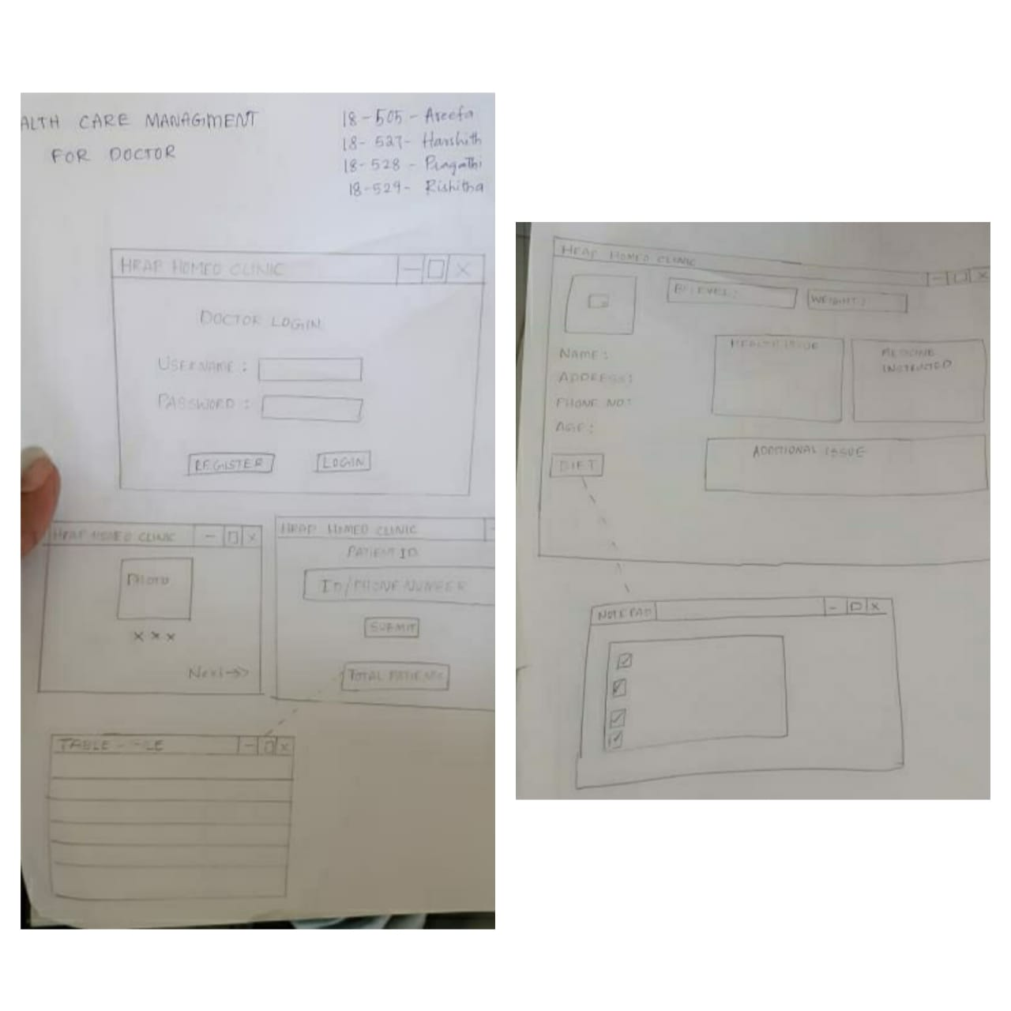

**Fig. 4.1.i. Rough sketches of windows**

* 1. **ORIGINAL SCREENS**

1. 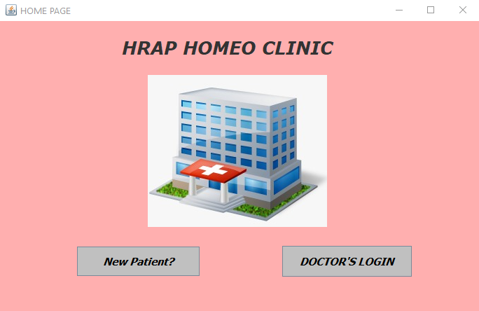**HOME PAGE:**

**Fig 4.2.i: Home page**

**MODULE WISE SCREENS:**

1. **STAFF (**If the patient is new then, he/she will be registered at the registration desk)

* 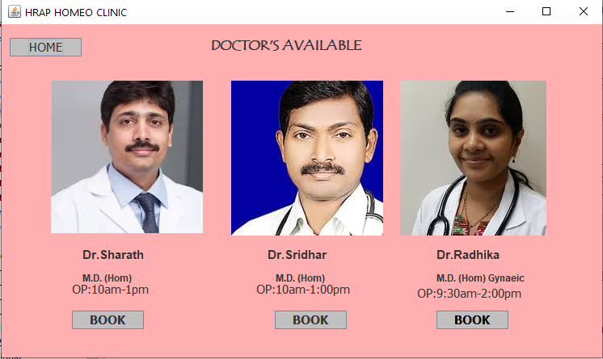New patients must be able to select the doctor to whom they want to select.

**Fig 4.2.ii: Doctor’s display**

* New patient registration by giving the details:

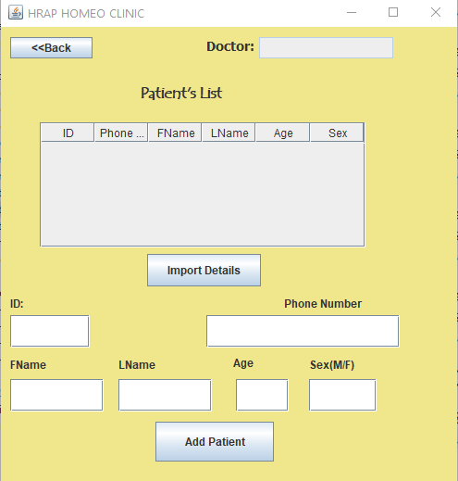

**Fig 4.2.iii: New Patient Register**

1. **DOCTOR LOGIN**

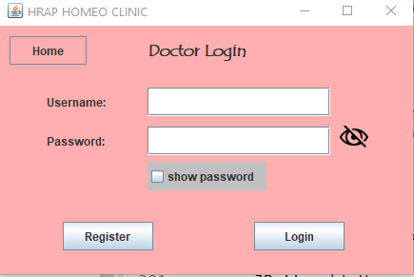

**Fig 4.2.iv: Doctor Login**

1. **Doctor Photo Display:**

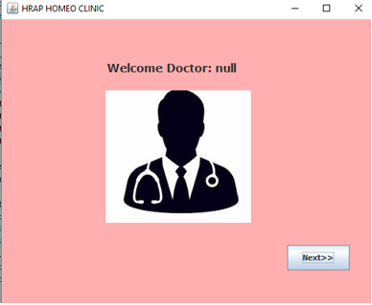

**Fig 4.2.v: Doctor Display (when login is successful)**

1. **Patient Login:**

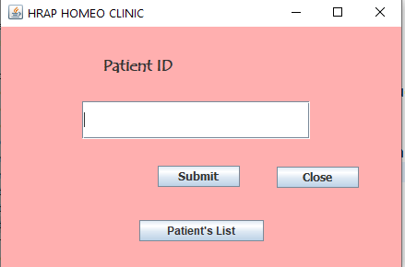

**Fig 4.2.vi: Patient Login**

1. **Total Patients’ List Display:**

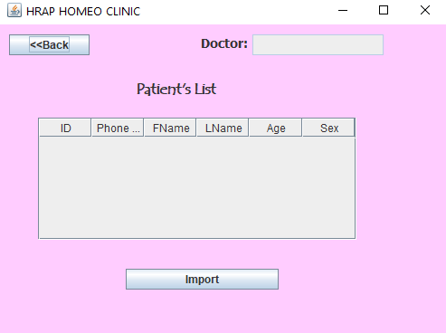

**Fig 4.2.vii: Patient List Display**

1. **Particular Patient Profile**

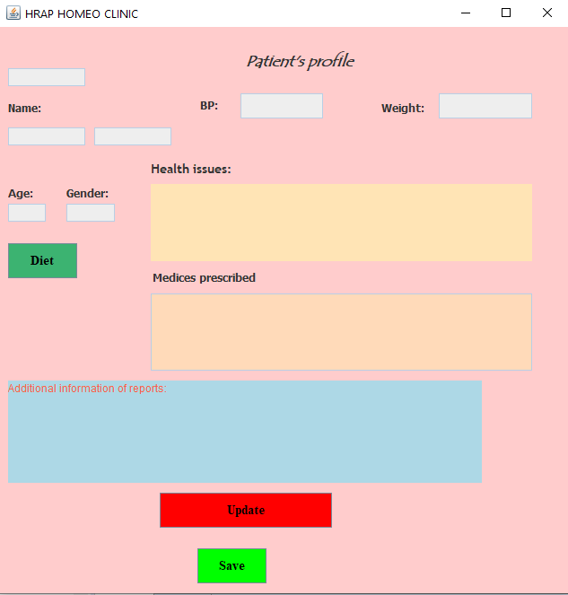

**Fig 4.2.viii: Patient Profile**

1. 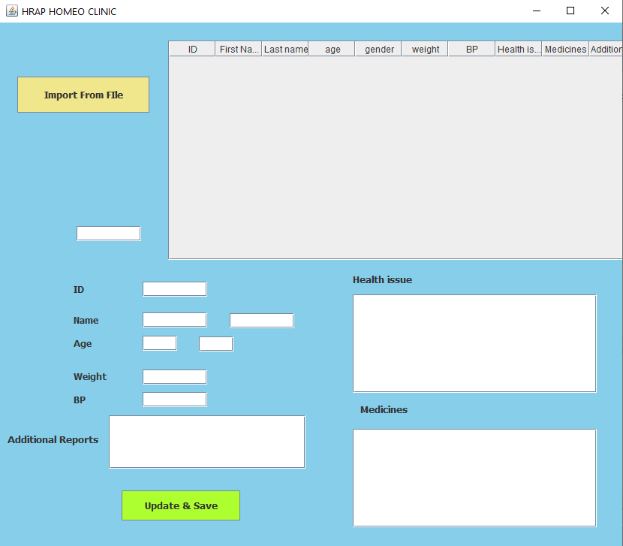**Update Patient Profile:**

**Fig 4.2.ix: Update Patient Profile**

1. **DIET:**

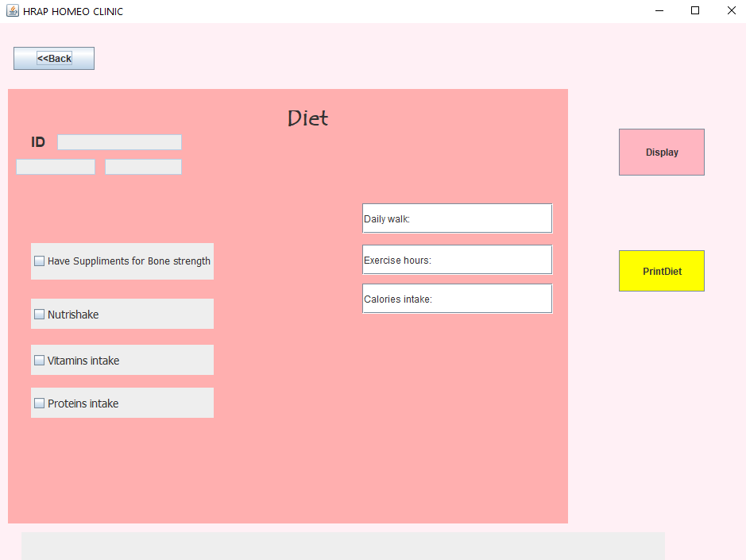

**Fig 4.2.x: Diet (Set)**

1. **TESTING**
   1. **MODULE : STAFF (Register New Patient)**

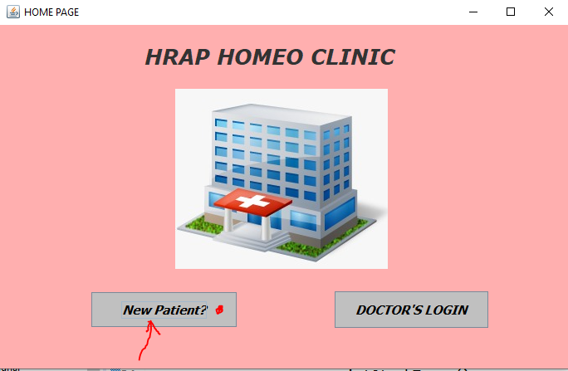

**Fig 5.1.i. Home Page (Go to New Register?)**

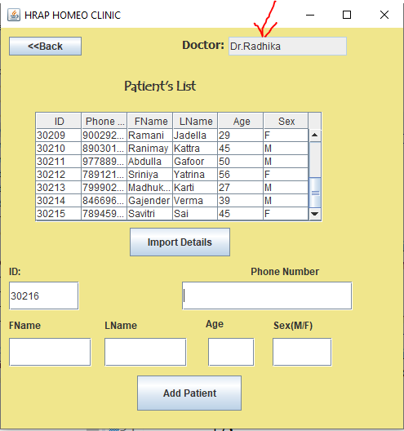

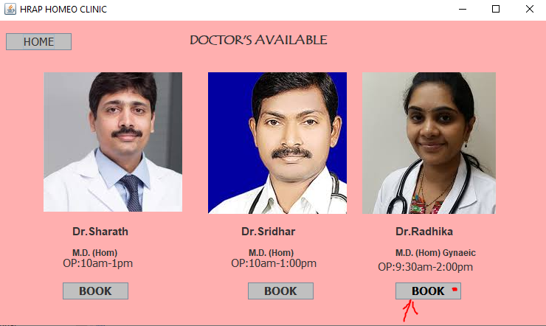**Patient Choose Doctor**

**Fig 5.1.ii. New Patient selects the doctor**

**Fig 5.1.iii. Staff register**

**the patient (ID generates)**

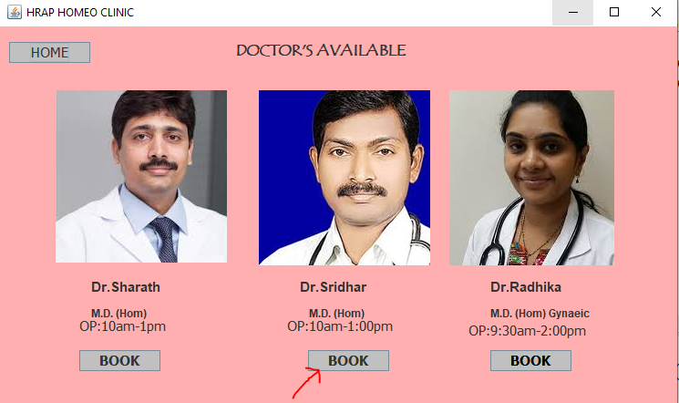

**Fig 5.1.iv. Another new patientient selecting other doctor**

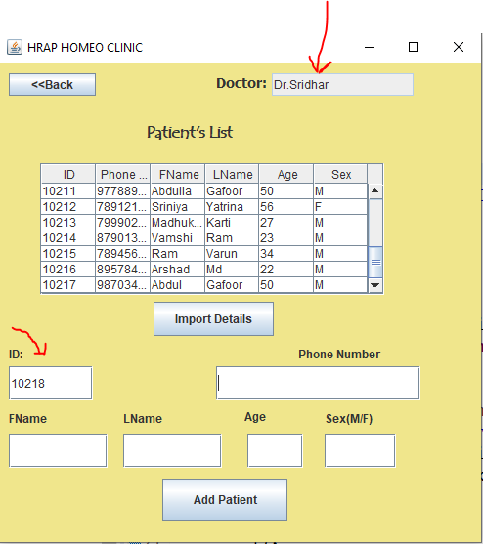

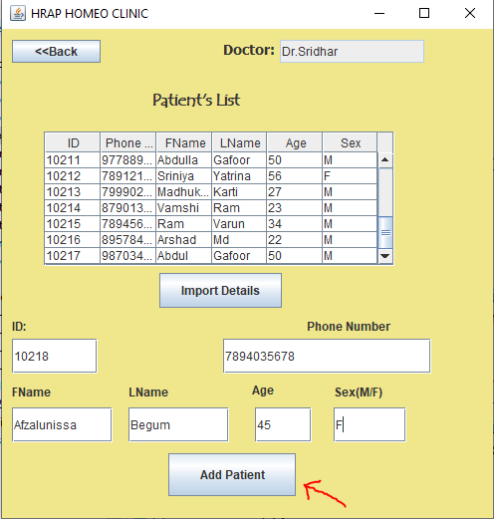

**Fig 5.1.vi. Staff enters the details of new patient and clicks add patient button**

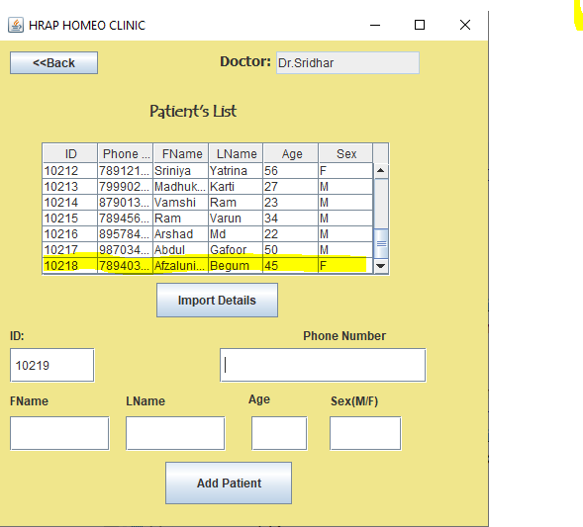

**Fig 5.1.vii. That particular patient details added**

* 1. **MODULE : DOCTOR ACCESS**

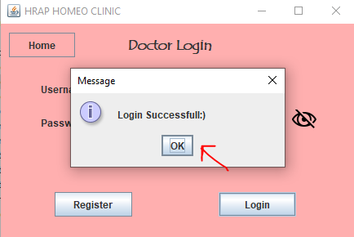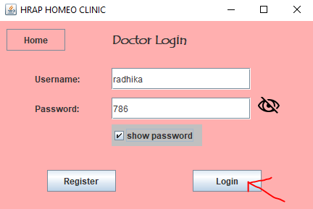

**Fig 5.2.i. Doctor Login(enter credentials) Fig 5.2.ii. Login Successful**

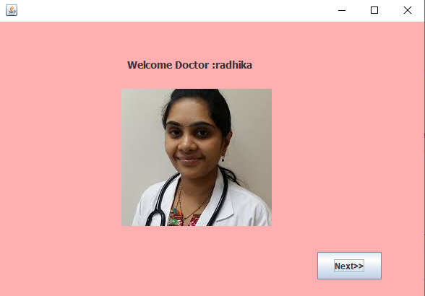

**Fig 5.2.iii. Display that respective doctor photo**

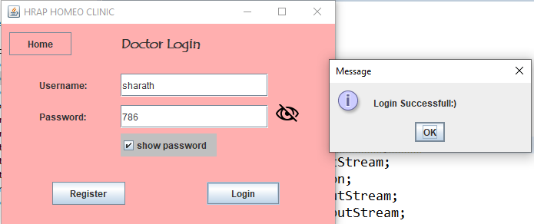

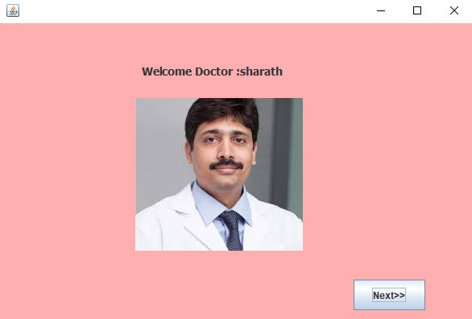

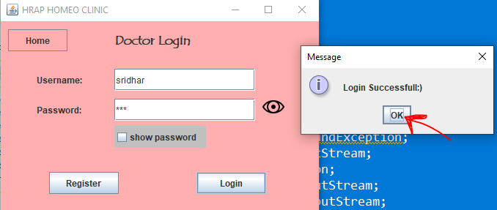

**Fig 5.2.iv. Another Doctor Login**

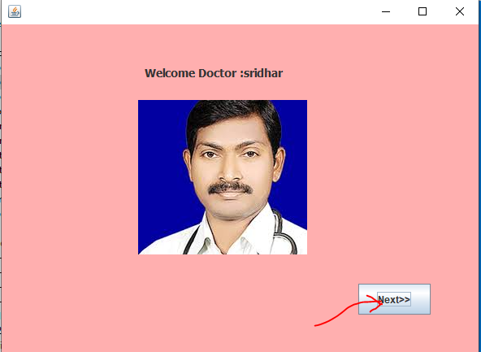

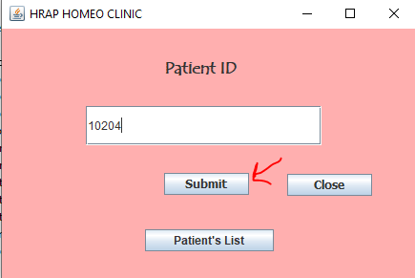

**Fig 5.2.v. Doctor Photo Display Fig 5.2.vi. Enter Patient ID**

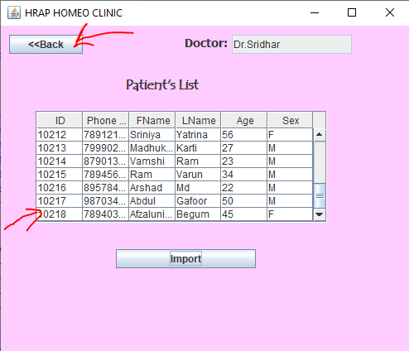

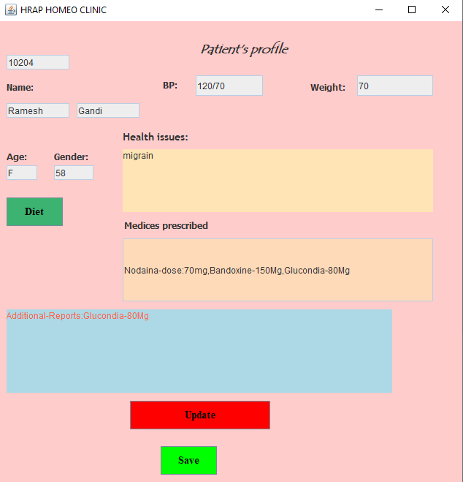



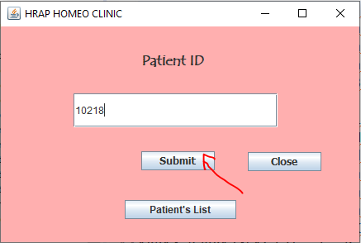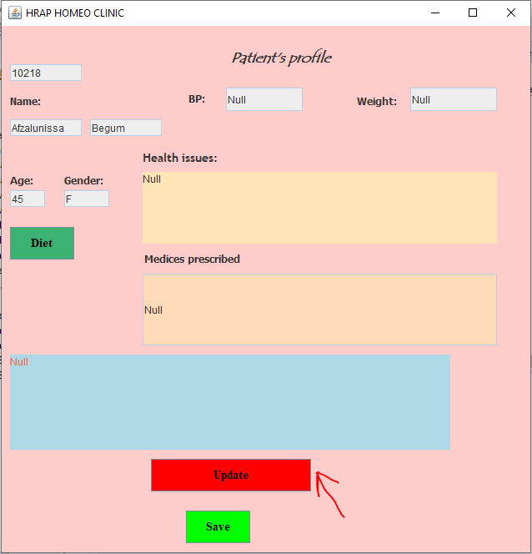**Fig 5.2.vii. Old Patient Profile (generates)**

**Fig 5.2.viii.New Patient ID**

**Fig 5.2.ix. New Patient Profile (default have Null)**

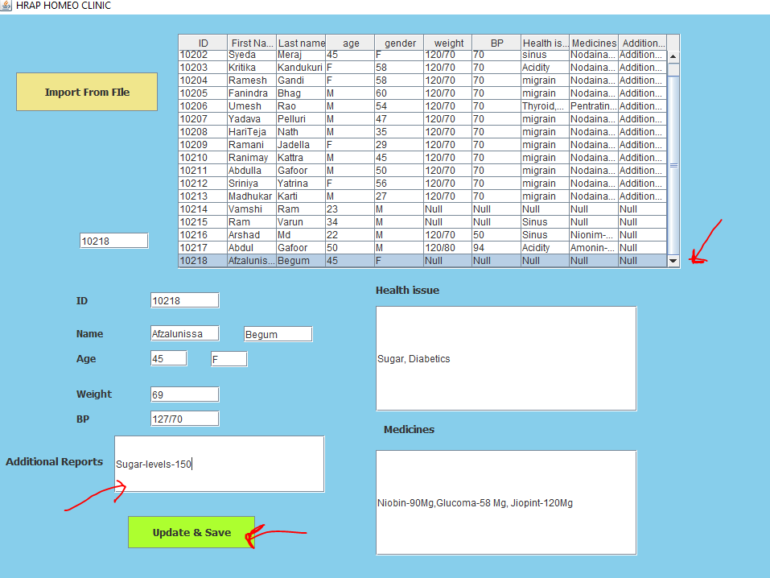

**Fig 5.2.x. Update profile (by selecting particular row)**

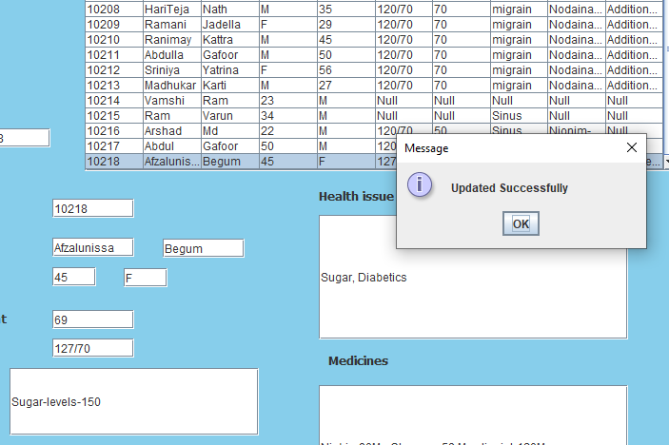

**Fig 5.2.xi. Updated Successfully**

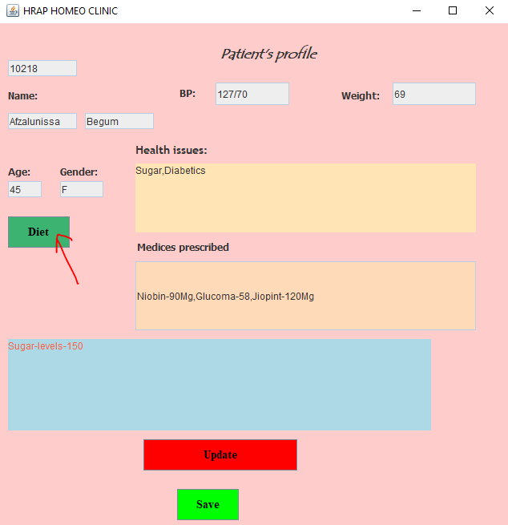

**Fig 5.2.xii. Updated Particular Patients Profile**

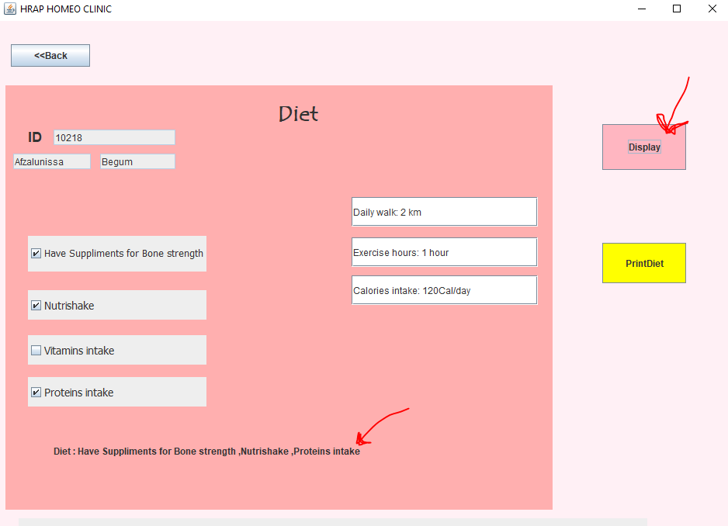

**Fig 5.2.xiii. That Patient Diet (Displayed)**

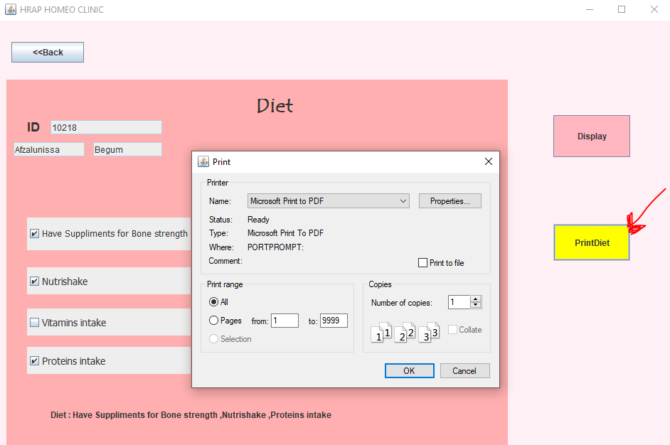

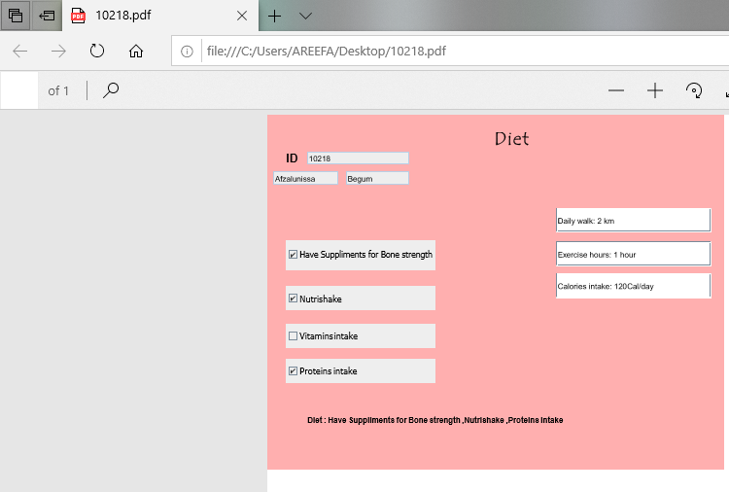

**Fig 5.2.xiv. That Patient Diet Fig 5.2.xv. That Patient Diet Exported to Printer Demo shown in Pdf(Printed)**

1. **RESULTS**

The Health Care Management Portal for doctors is helpful to maintain the patient’s records and integrates both the doctor and the patient without any conflicts.

By this, patient need not to carry the previous appointment prescriptions or reports and patient need not to detail about health issue again. Doctor can easily enter the patient’s particular ID and view the previous appointment history in the respective profile and make updates if any easily. Thus, there is no need of even writing the prescription onto the receipt by the doctor and this even avoids the conflicts by the doctor’s messy hand writing since, diet plan prescription would be given printed.

Additionally the same application can be utilized by the staff for registering the new patients by entering their details and generating ID’s. All the details of the patients are efficiently stored and retrieved from file. Thus,

Thus, one java application can lead to solving the concerns between the patient and the doctor. At last, we would conclude that, health care management plays a major role in producing a happy outcome after a particular treatment and thus, health care management portal for doctors helps in implementing the above strategies.

**REFERENCES**

**Websites:**

1. <https://youtu.be/DJEXpgLyAtQ>
2. <https://youtu.be/wJ4vdWEYF0M>
3. <https://www.javatpoint.com/Displaying-image-in-swing>
4. <http://www.beginwithjava.com/java/file-input-output/writing-text-file.html>
5. <https://stackoverflow.com/questions/6548157/how-to-write-an-arraylist-of-strings-into-a-text-file>
6. <https://youtu.be/BLGjPlDbIcY>
7. <https://youtu.be/f_eZbvD1Grg>
8. <https://www.javatpoint.com/java-awt>
9. <https://www.w3adda.com/java-swing-tutorial>
10. <https://www.w3schools.com/java/>