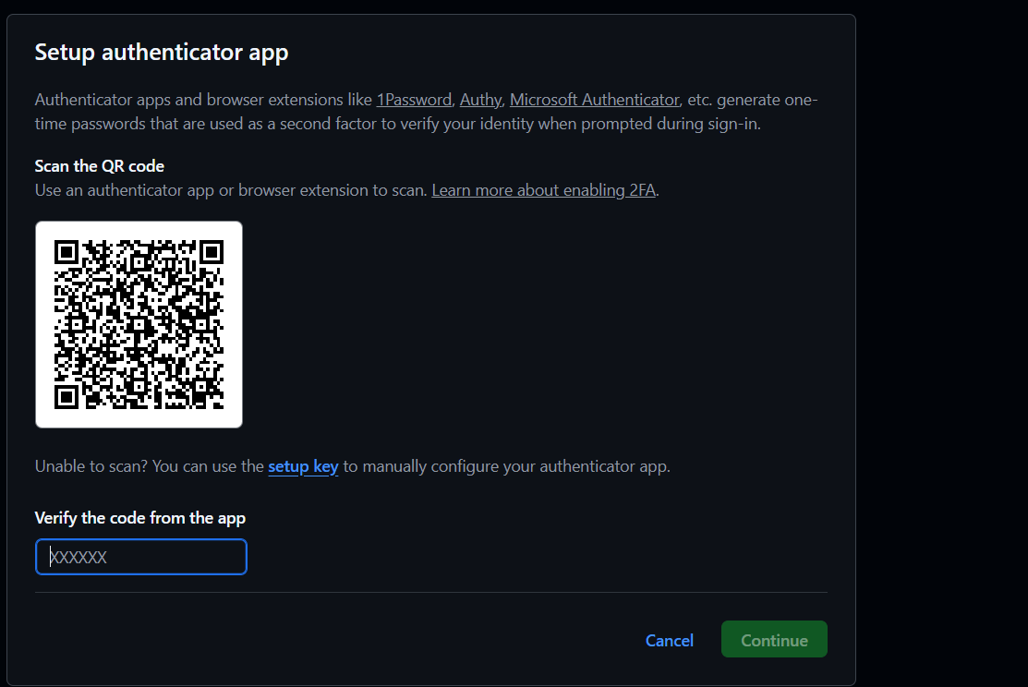
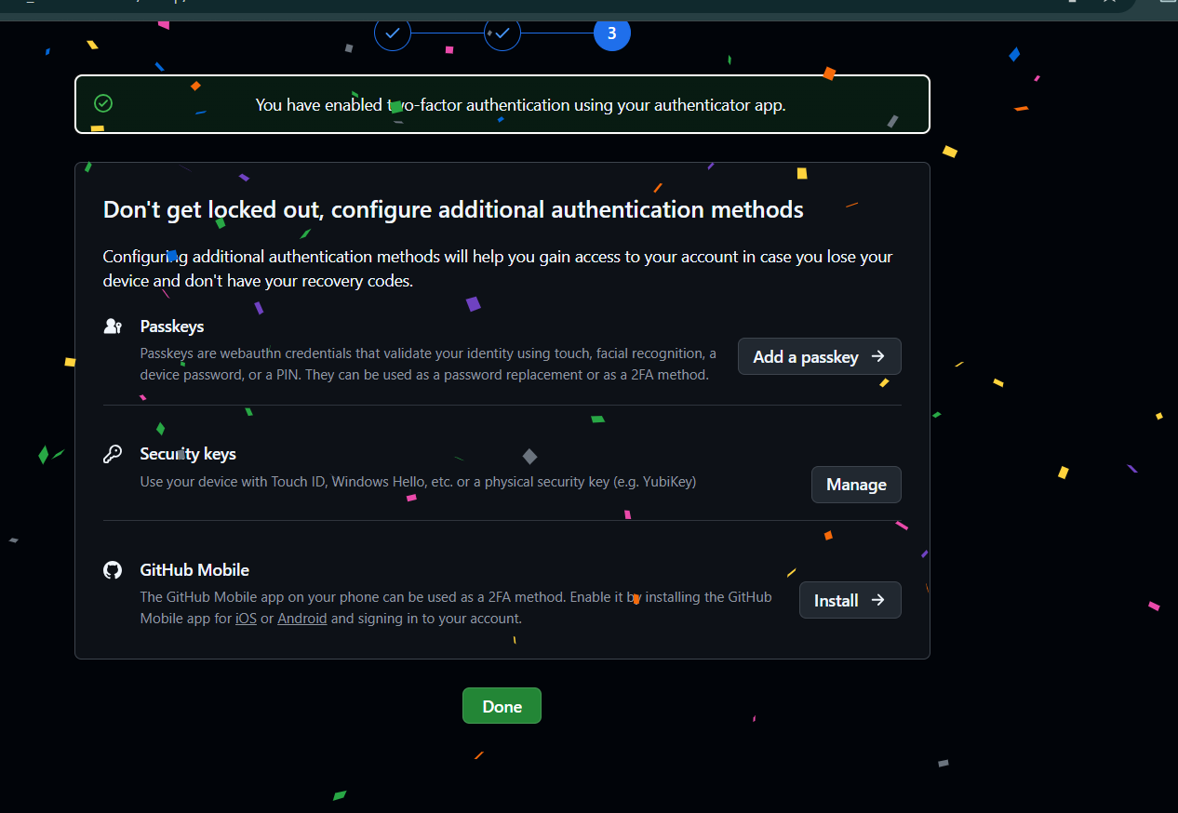
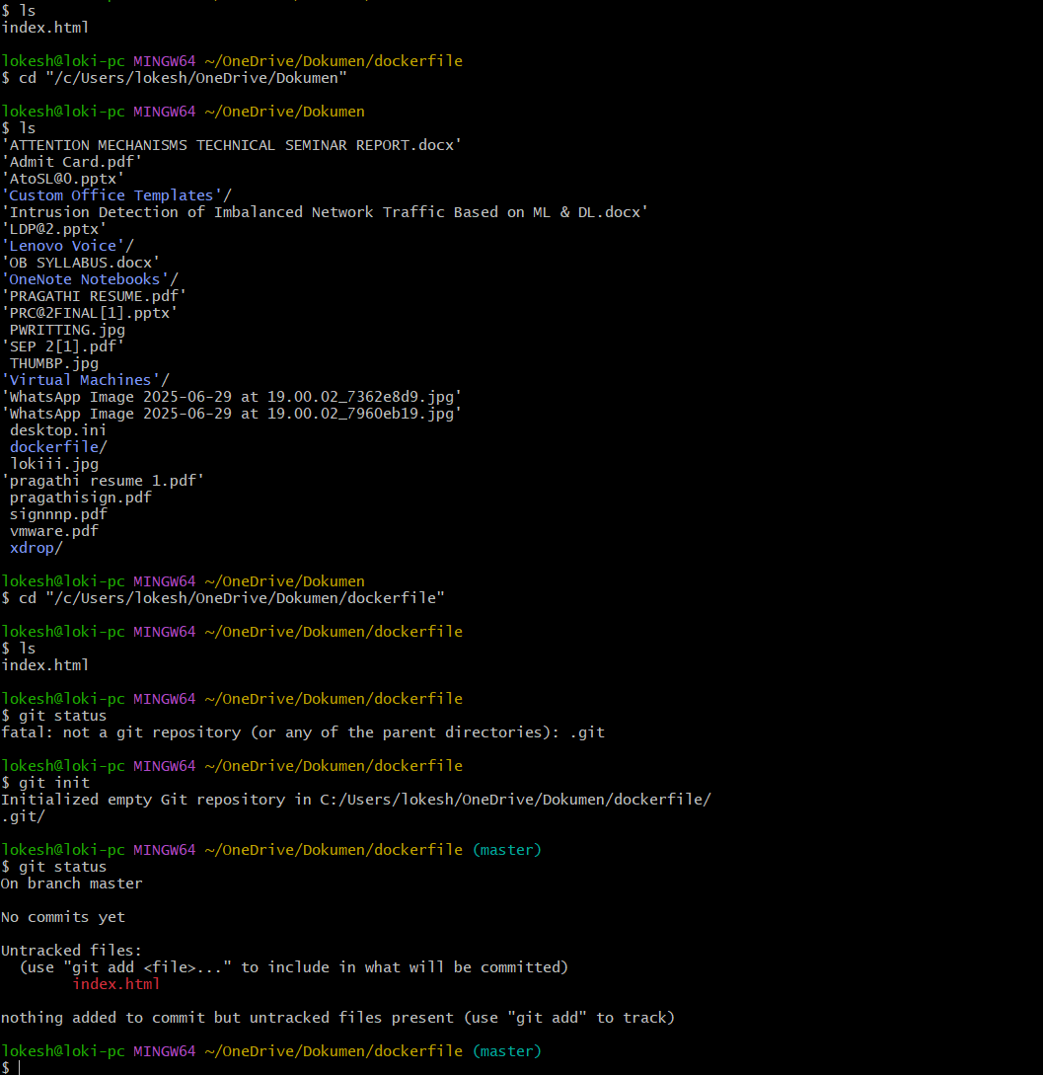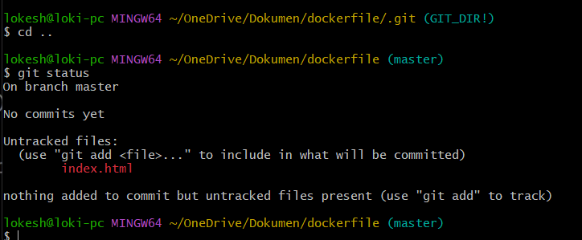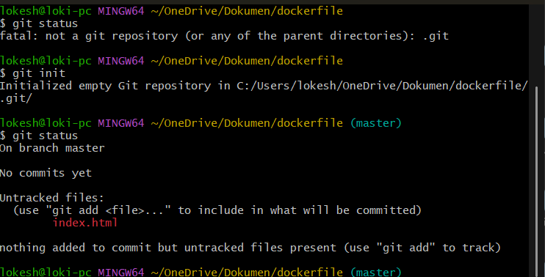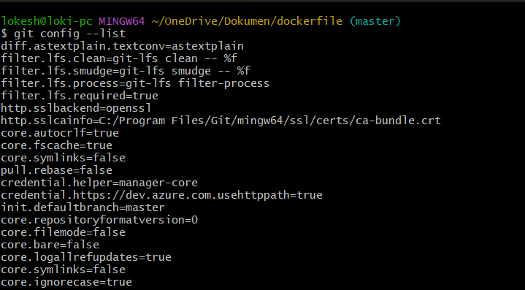
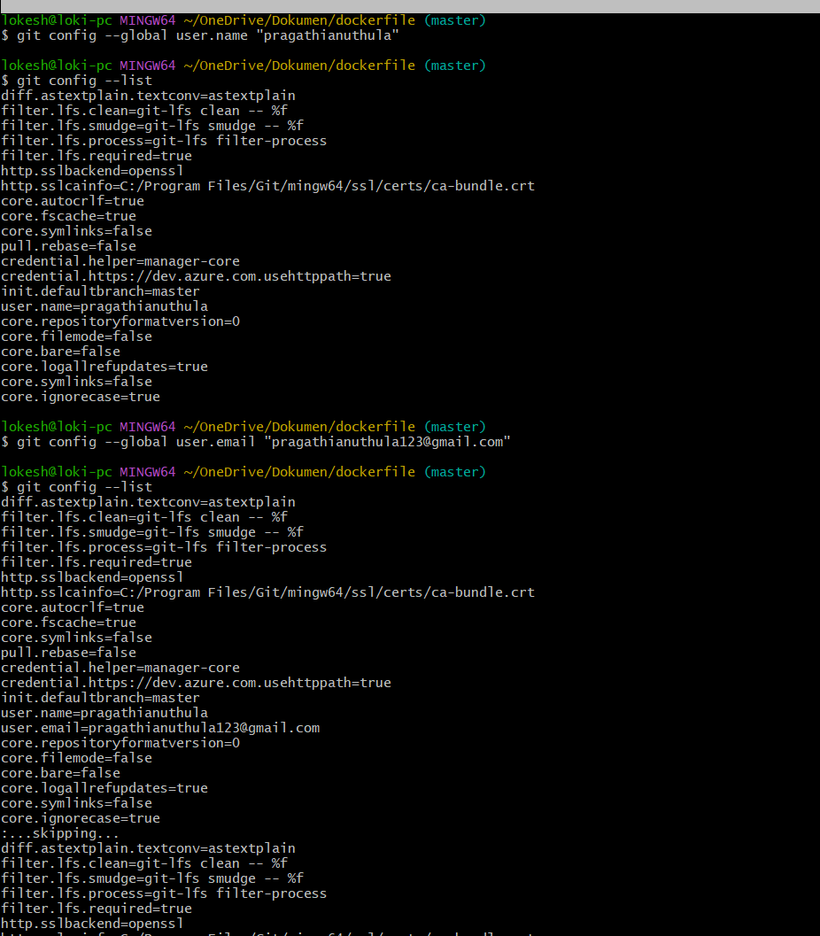

Git add index.htm

lI was working inside a Git project folder.
- First, I checked the status using git status and saw that index.html was an untracked file, meaning Git was not tracking it yet.
- Then I used git add index.html, which means I told Git to start tracking that file and move it to the staging area.
- After that, I created multiple empty files using touch a b c ... p.
- When I checked git status again, I saw:
  - index.html was staged (ready to commit)
  - All other files were untracked
- Then I used git add ., which means I told Git to track all files in the folder and add them to staging.
- Finally, all files became ready to be committed, meaning Git is now prepared to save a snapshot of all these files.
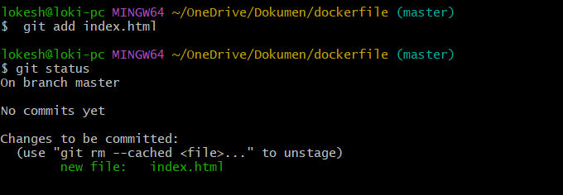|
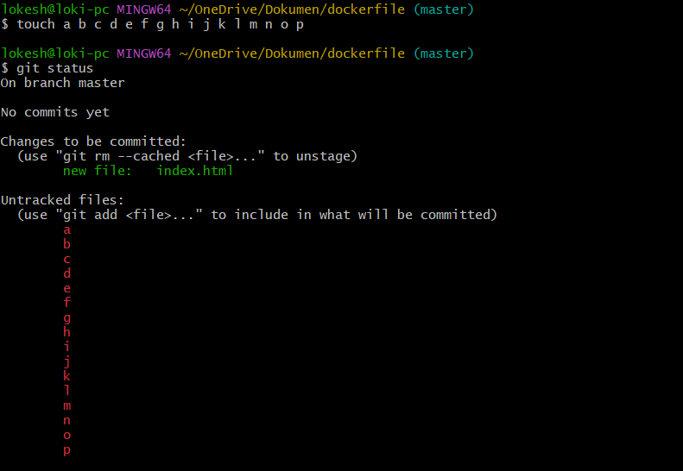

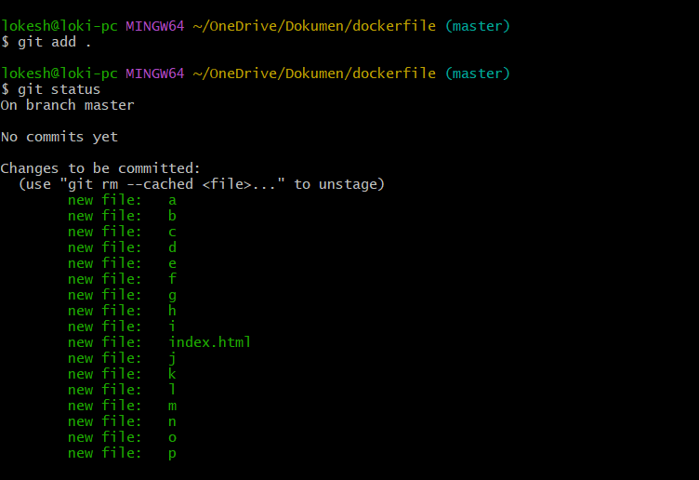

Git commit:
1. Working in Git folder
You were inside a Git initialized project:
~/OneDrive/Dokumen/dockerfile (master)

🔹 2. Tried wrong commit command
git commit -m "added couple of files" origin
📌 Result:
- Error occurred
📌 Reason:
- origin is NOT used in git commit
- Git thought “origin” is a file name → but no such file exists

🔹 3. Correct commit command
git commit -m "added couple of files"

🔹 4. First commit created (Root Commit)
[master (root-commit) ec76d2e]
📌 Meaning:
- master → current branch
- root-commit → first commit in repository
- ec76d2e → unique commit ID

🔹 5. Files saved in commit
Git stored snapshot of:
- index.html
- a
- b
- c
- d
- e
- f
- g
- h
- i
- j
- k
- l
- m
- n
- o
- p
📌 Total: 17 files
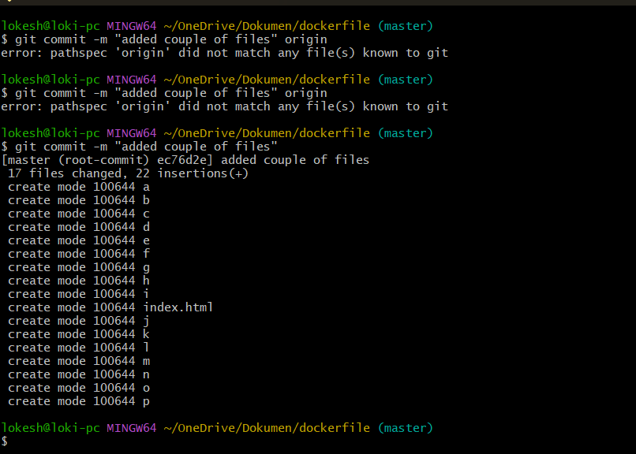

First, I ran git status and Git showed:
- I am on the master branch
- There is nothing to commit
- The working tree is clean, meaning all changes are already saved in Git and there are no new modifications.
Then I used ls to list all files in the folder. It showed 17 files:
- index.html
- files named from a to p
This means all these files are already present in the project and already tracked/saved in Git, so no new changes are pending.
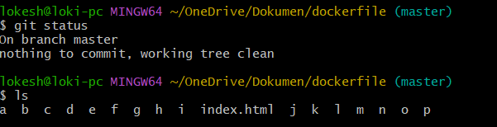

Gitlog:
ec76d2e] -commit id
I ran git log inside my Git repository to check the commit history.
It showed one commit:
- Commit ID: ec76d2e13ae10dfeeee1268782b08c3707071dac
- Current branch: master (HEAD is pointing here)
- Author: pragathianuthula
- Date: Mon May 18 2026
- Commit message: “added couple of files”
This means my project has one saved commit, and Git is currently tracking the latest version of my files in the master branch. 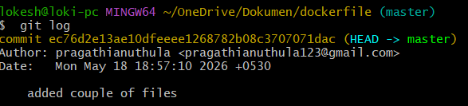

I created a new file called sp using touch sp.
Then I staged it using git add sp, which means I told Git to start tracking that file.
After that, I committed the change using:
git commit -m "added sp to the project"
This created a new commit:
- Commit ID: b3e6dab
- Message: “added sp to the project”
Finally, I checked the history using git log, and it showed:
- My latest commit (added sp to the project)
- Previous commit (added couple of files)
This means my project now has two commits, and Git is tracking the updated version including the new file sp.
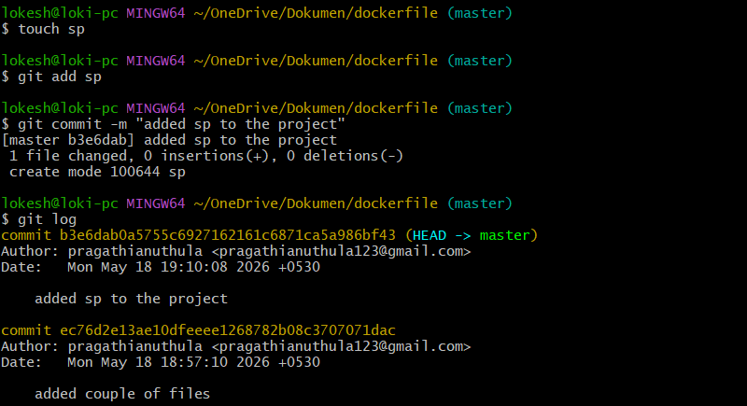

Git push:
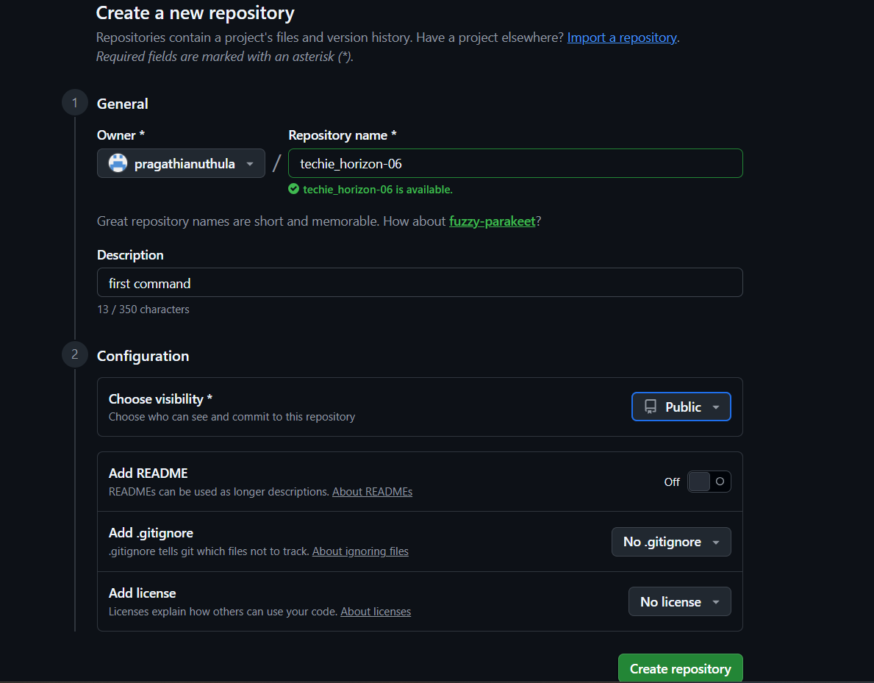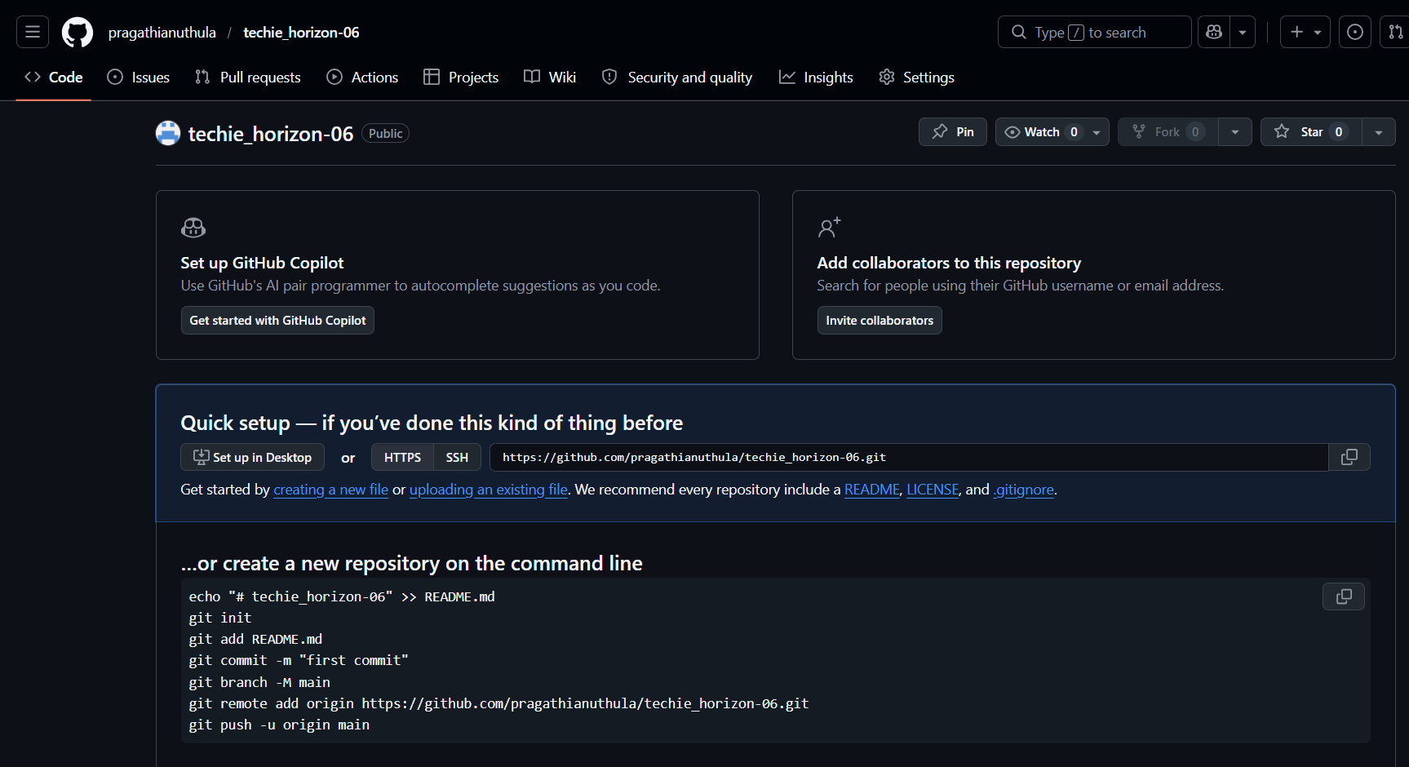https://github.com/pragathianuthula/techie_horizon-06.git
ssh-git@github.com:pragathianuthula/techie_horizon-06.git
I tried to push my local Git commits to GitHub using git push, but it failed because no remote repository was configured yet.
So I checked existing remotes using git remote -v, and it showed nothing (no output), meaning no GitHub connection was set.
Then I added a remote repository using:
git remote add origin git@github.com:pragathianuthula/techie_horizon-06.git
After that, I verified it again with git remote -v, and it showed:
- origin is now connected to my GitHub repository
- Fetch and push URLs are correctly set
Now my local Git project is successfully linked to GitHub, and I can push my code to the remote repository.
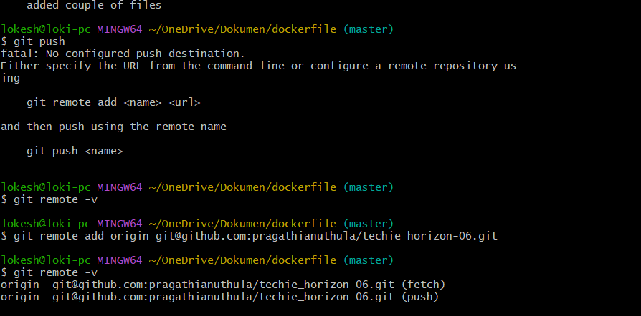I tried to push my local Git repository to GitHub using git push, but it failed initially.
🔹 1. Remote was already configured
I checked the remote using git remote -v and confirmed:
- origin was correctly set to my GitHub repository.

🔹 2. Push failed due to missing upstream branch
When I ran:
git push
Git showed an error:
- “current branch master has no upstream branch”
👉 This means my local branch was not linked to the remote branch.

🔹 3. I tried setting upstream and pushing
I used:
git push -u origin master

🔹 4. SSH authentication issue occurred
Git asked to verify GitHub host (first-time SSH connection), which I accepted by typing yes.
Then I got this error:
- Permission denied (publickey)
👉 This means GitHub is expecting an SSH key, but my system has not been configured with one.

🔹 5. I started fixing SSH issue
I mistakenly tried:
ssh -key gen
→ This was incorrect command.
Then I used the correct command:
ssh-keygen
👉 This generates an SSH key pair (private + public key).
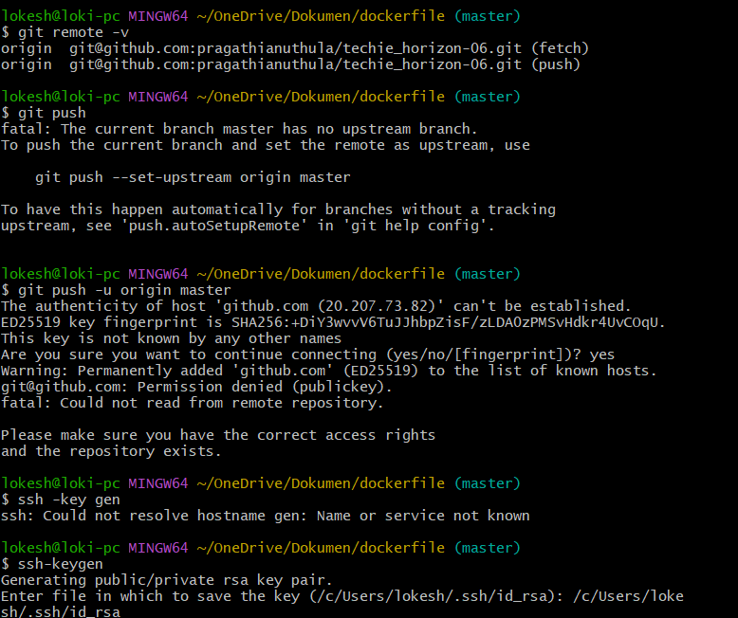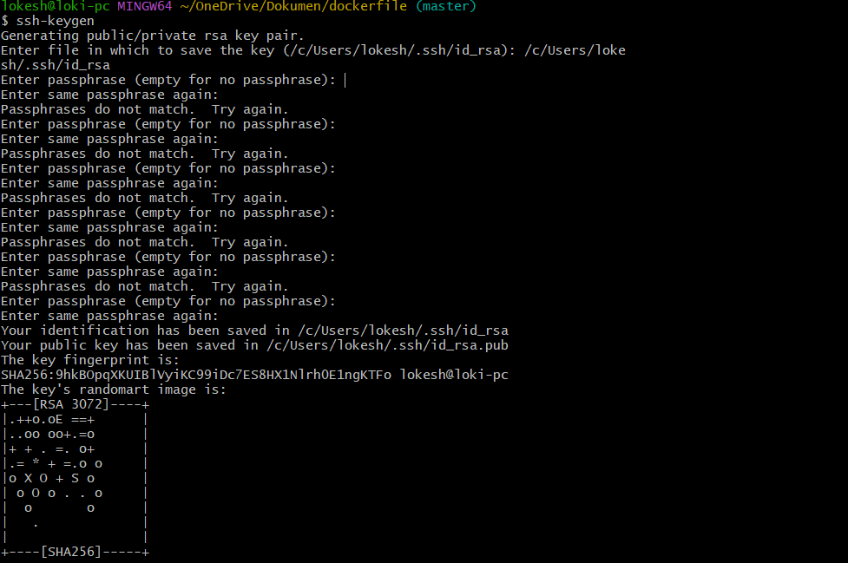
1. SSH Key Generation Started
I ran the command:
ssh-keygen
📌 This command is used to create an SSH key pair for secure authentication with GitHub.

🔹 2. Passphrase Setup
During the process, the system asked for a passphrase:
- I initially entered mismatched passphrases
- Then I re-entered correctly
📌 Meaning:
A passphrase is an optional security password used to protect the SSH key.

🔹 3. SSH Key Successfully Created
The system generated and saved two files:
- Private Key:
/c/Users/lokesh/.ssh/id_rsa
- Public Key:
/c/Users/lokesh/.ssh/id_rsa.pub
📌 Meaning:
- Private key stays in local system (secret)
- Public key is shared with GitHub for authentication

🔹 4. Key Verification
The system displayed:
- Key fingerprint
- Randomart image
📌 Meaning:
This confirms that the SSH key pair was successfully generated.

🔹 5. Mistake (Important Note)
I ran:
cat /c/Users/lokesh/.ssh/id_rsa
📌 Result:
- This displayed the private SSH key
⚠️ Important:
- Private key should NEVER be shared or exposed
- It is sensitive and used for authentication

🔹 6. Purpose of SSH Key Setup
This SSH key setup is done to:
- Connect local Git repository to GitHub securely
- Avoid using username/password every time
- Enable secure git push and git pull
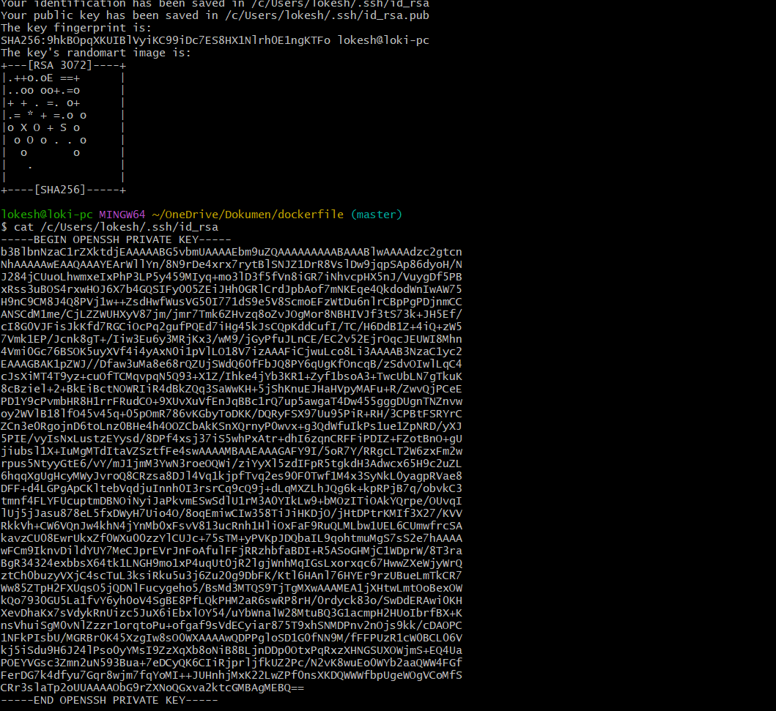
1. Tried to add SSH key to GitHub
You were setting up SSH authentication so you can connect Git with GitHub securely.

🔹 2. GitHub rejected the key
You got this error:
“Key is invalid. You must supply a key in OpenSSH public key format”
📌 Meaning:
GitHub did not accept the key you pasted because it was not in the correct format.

🔹 3. Cause of the issue
This happened because:
- You likely copied the wrong key file
- You may have used the private key (id_rsa) instead of public key (id_rsa.pub)
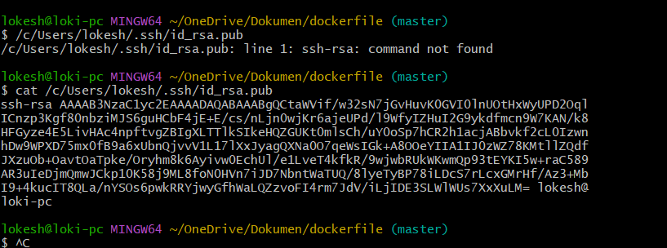
I ran git push -u origin master to upload my local Git commits to GitHub.
Git successfully transferred all my files and commits to the remote repository. On GitHub, a new branch called master was created.
It also set up tracking between my local master branch and GitHub’s origin/master, so now both are connected.
From now on, I can simply use git push without writing -u origin master again.
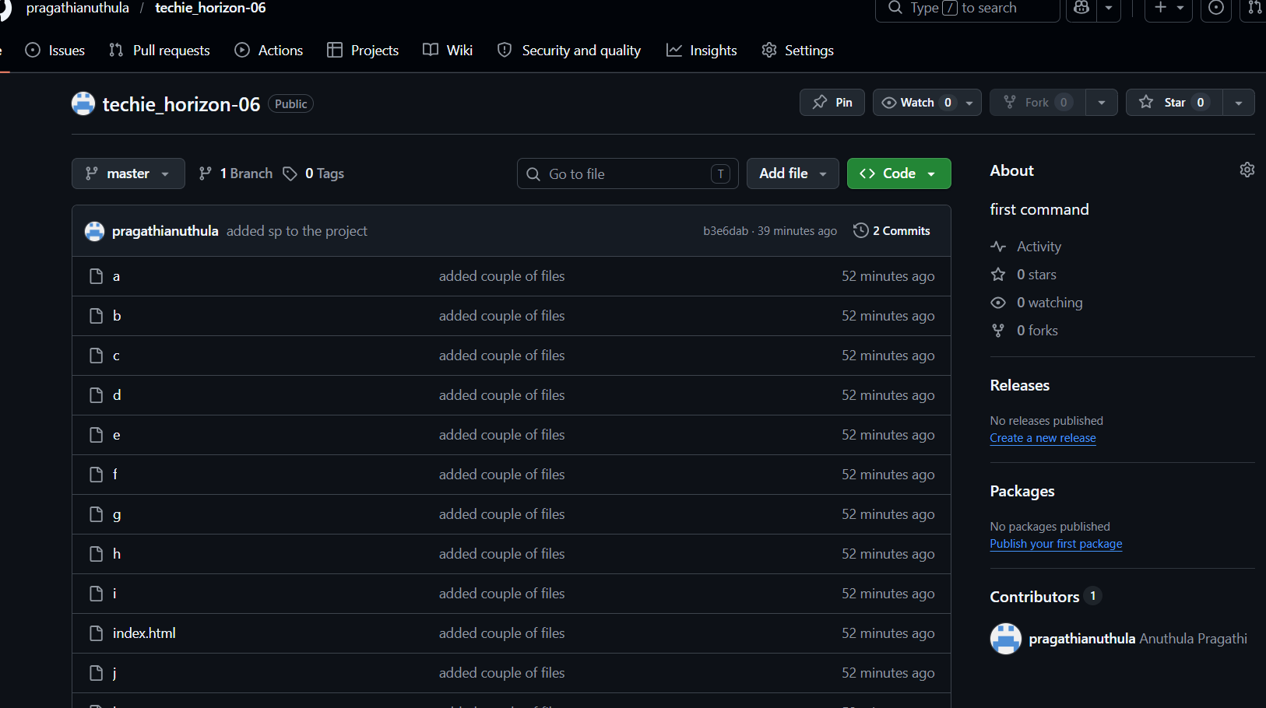

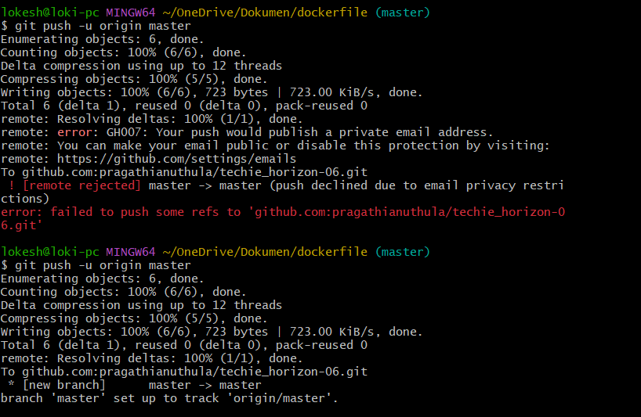

Deleted dockerfile
First, I added all files to staging area using:
git add .
This command tells Git to track all new and changed files.
Then I committed the changes using:
git commit -m "added a file bcd"
This saved my changes in my local repository with a message, and Git created a commit ID for it.
Output showed:
- One file was created (bcd)
- No insertions or deletions because the file was empty
Next, I tried to push my code to GitHub using:
git push -u origin master
But Git rejected it because the remote repository already had some changes that were not present in my local repository.
The error:
(fetch first)
This means Git is asking me to first pull the latest changes from GitHub, merge them into my local repo, and then push again.
So the solution is:
git pull origin master --allow-unrelated-histories
git push -u origin master
This will first download and merge remote changes, then upload my local changes successfully.
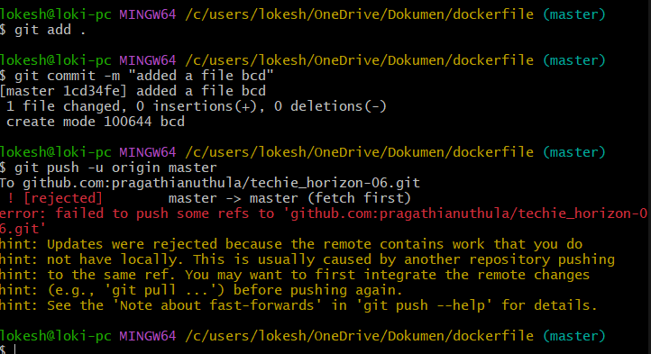 I ran:
git pull
This command downloaded the latest changes from GitHub and merged them into my local repository.
What happened:
- Git connected to GitHub
- It checked for new files/changes in remote repository
- It found updates on the master branch
- It downloaded those changes
- Git merged them with my local files automatically
This line:
Merge made by the 'ort' strategy
means Git successfully merged local and remote changes using its merge method called ort strategy.
This line:
create mode 100644 sruthi
means a new file named sruthi was added from GitHub to my local repository.
Then I checked files using:
ls
This displayed all files in the folder, and I could see:
sruthi
That confirms the pull was successful and the remote file was added to my local system.
Now my local repository and GitHub repository are synced.
Next step is to push my own committed file (bcd) using:
git push -u origin master
This will upload your local changes to GitHub.
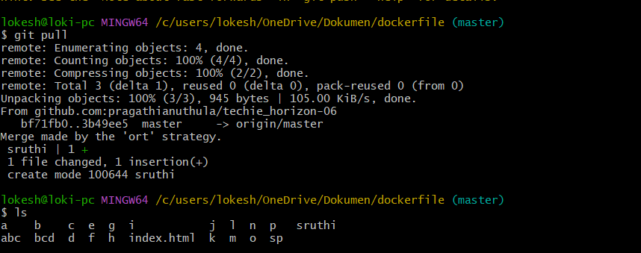 After pulling the latest changes from GitHub, I pushed my local changes using:
git push -u origin master
What happened:
- Enumerating objects → Git checked which files/changes need to upload.
- Counting objects → Git counted total files/changes.
- Compressing objects → Git compressed data to upload faster.
- Writing objects → Git uploaded my files to GitHub.
- Resolving deltas → Git processed file differences on GitHub.
This line:
3b49ee5..d349039 master -> master
means:
- 3b49ee5 → previous commit ID on GitHub
- d349039 → new commit ID after my push
- master -> master → local master branch successfully updated remote master branch
This line:
branch 'master' set up to track 'origin/master'
means:
My local master branch is now connected to GitHub master branch, so next time I can simply use:
git push
instead of:
git push -u origin master
Final result:
My file bcd was successfully uploaded to GitHub, and now both:
- Local repository (my computer)
- Remote repository (GitHub)
are fully synced. ✅
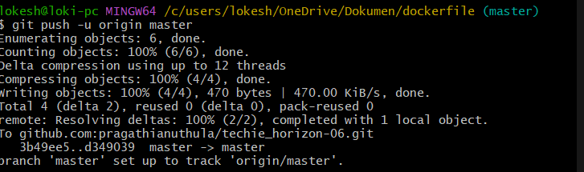 I cloned the GitHub repository using:
git clone git@
git clone means copy the complete remote repository from GitHub to my local system.
What happened:
- Git connected to GitHub
- Downloaded all repository files
- Downloaded commit history
- Created a new folder:
techie_horizon-06
This output:
Receiving objects: 100% done
Resolving deltas: 100% done
means Git successfully downloaded and arranged all repository data.
Then I checked files using:
ls
It showed:
techie_horizon-06/
This confirms the cloned repository folder was created.
Then I entered that folder:
cd techie_horizon-06/
Now I am inside the cloned repository.
Then I checked files again:
ls
It showed all repository files:
- a
- b
- abc
- bcd
- index.html
- sruthi
- etc.
This confirms cloning was successful and all files from GitHub are now copied to my local system.
Difference:
- git pull → updates an existing local repository
- git clone → creates a completely new local copy of the repository
So here, I created a fresh copy of my GitHub repository inside the folder techie_horizon-06. ✅
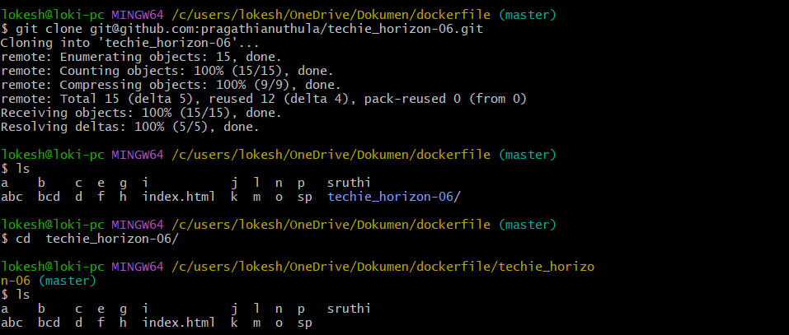 1. Created a new file
git touch alphabet
(You actually used touch alphabet)
This created a new empty file named alphabet.
Then:
ls
showed the file exists in the folder.

2. Checked Git status
git status
Git showed:
Untracked files:
alphabet
This means:
Git can see the file exists, but it is not tracking it yet.
“Untracked” means the file is new and Git has not added it to version control.

3. Added file to staging
git add .
This staged the file.
Meaning:
You told Git:
“Track this file and prepare it for commit.”

4. Checked status again
git status
Git showed:
Changes to be committed:
new file: alphabet
This means:
The file is now in the staging area, ready to be committed.

5. Removed file from staging
git reset
This command unstaged the file.
It did NOT delete the file.
It only removed it from the staging area.

6. Checked status again
git status
Git showed:
Untracked files:
alphabet
This means:
- File still exists in folder
- Git is no longer tracking it for commit
- It is back to untracked state
