1-Install git
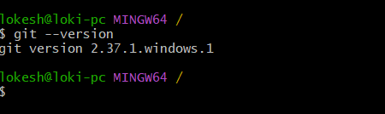
2- Create a repo in github with README.md and .ignore file.
I created a new GitHub repository.
1. Selected Owner
Owner: pragathianuthula
This means the repository will be created under your GitHub account.

2. Entered Repository Name
myproject
This is the name of your new repository.
GitHub showed:
myproject is available
This means no one else in your account is using that repo name.

3. Added Description
DevOps practice tasks and Git learning files
This explains what the repository is for.
It helps others understand the project.

4. Selected .gitignore option
You opened:
Choose a .gitignore template
A .gitignore file tells Git:
“Ignore these files and don’t upload them to GitHub.”
Examples:
*.log
node_modules/
.env
You selected:
No .gitignore
That means Git will track all files unless you create .gitignore later.

5. README option
If ON, GitHub creates:
README.md
This file is used to write project details.
Example:
# My Project
Git practice repository

6. License option
You selected:
No license
This means no usage permissions are defined for others.
For practice, this is fine.

Final meaning:
You are creating a new GitHub repository named myproject for practicing:
- Git commands
- GitHub push/pull
- DevOps tasks
- Learning version control
Next step:
Click Create Repository ✅
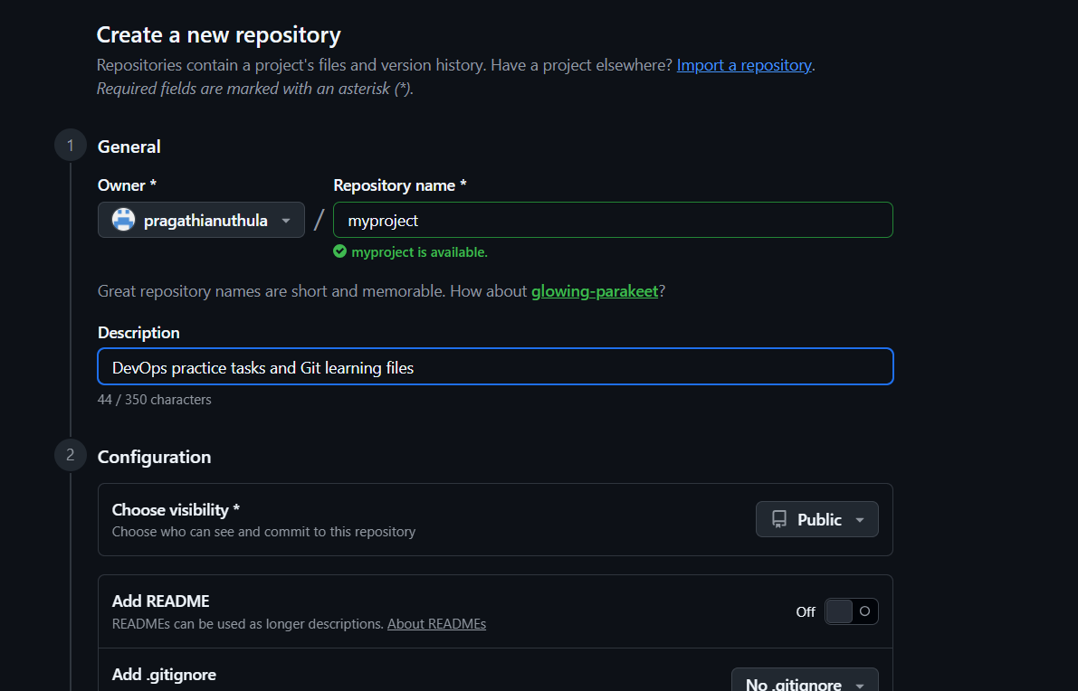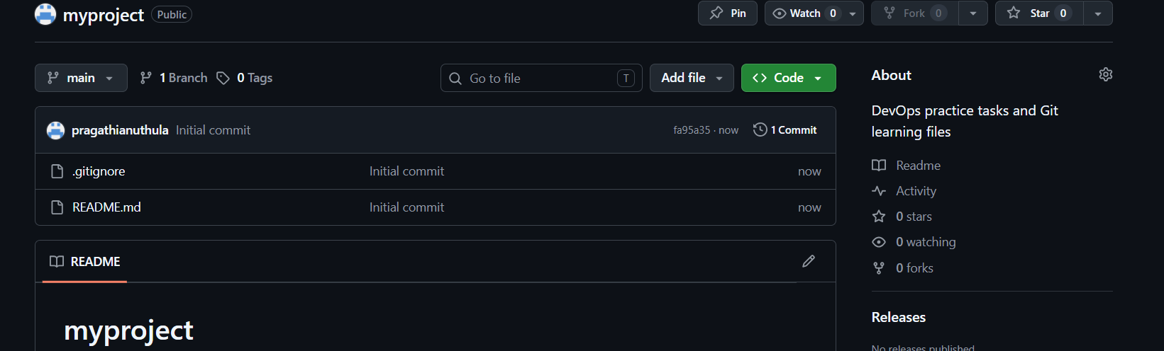
3- Clone the created repo to local

I cloned the created GitHub repository to my local system using the git clone command.
Command:
git clone <repository-url>
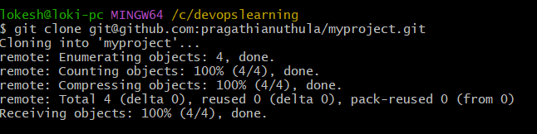
4- Create two files in local repo.
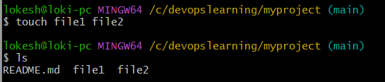
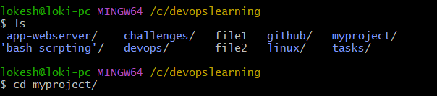
First, I checked all folders and files in my current directory using:
ls
This displayed all available folders/files inside:
/c/devopslearning
It showed:
- app-webserver/
- challenges/
- github/
- myproject/
- linux/
- tasks/
- and other files
This confirms that the myproject repository exists locally.

Then I moved into the cloned repository using:
cd myproject/
What happened:
- cd means change directory
- It moved me from:
/c/devopslearning
to:
/c/devopslearning/myproject
4- I created two new files inside my local Git repository using:
touch file1 file2
What happened:
- touch command created empty files
- file1 and file2 are the names of the files
- These files were created inside my local repository:
/c/devopslearning/myproject

Then I checked the files using:
ls
Output:
README.md file1 file2
This means:
- README.md was already there (created when repo was initialized on GitHub)
- file1 → newly created file
- file2 → newly created file
This confirms both files were created successfully.

5- Commit two files and push to central Repository.
1. Checked repository status
git status
Git showed:
Untracked files:
file1
file2
This means:
- file1 and file2 exist in my local repository
- Git can see them
- But Git is not tracking them yet
So they are called untracked files.

2. Added files to staging area
git add .
What happened:
- Git added both files to the staging area
- This tells Git:
“Track these files and prepare them for commit.”

3. Committed the files
git commit -m "added file1 and file2"
Output:
[main c850acb] added file1 and file2
2 files changed
create mode 100644 file1
create mode 100644 file2
Meaning:
- main → current branch
- c850acb → unique commit ID
- added file1 and file2 → commit message
- 2 files changed → two files committed
- create mode 100644 → new files created and tracked
This means the files are now saved in my local Git repository history.

4. Pushed files to GitHub
git push origin main
What happened:
Git uploaded my local commit to GitHub.
This line:
fa95a35..c850acb main -> main
means:
- fa95a35 → old commit on GitHub
- c850acb → new commit after push
- main -> main → local main branch updated remote main branch
This confirms push was successful.
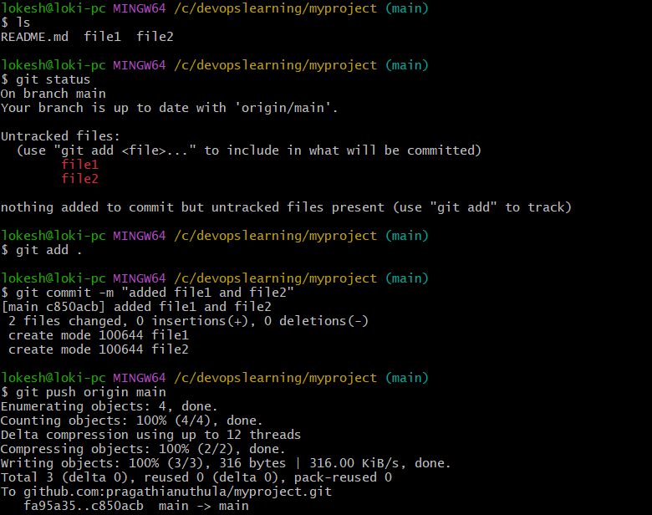
6- Create a branch in local and create a sample file and push to central.
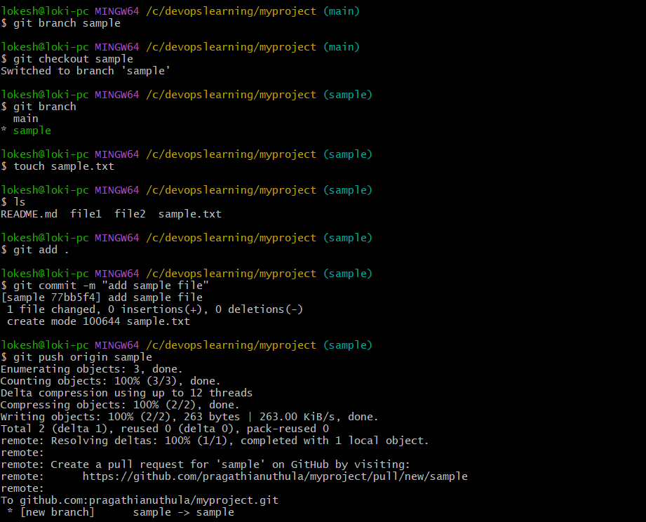 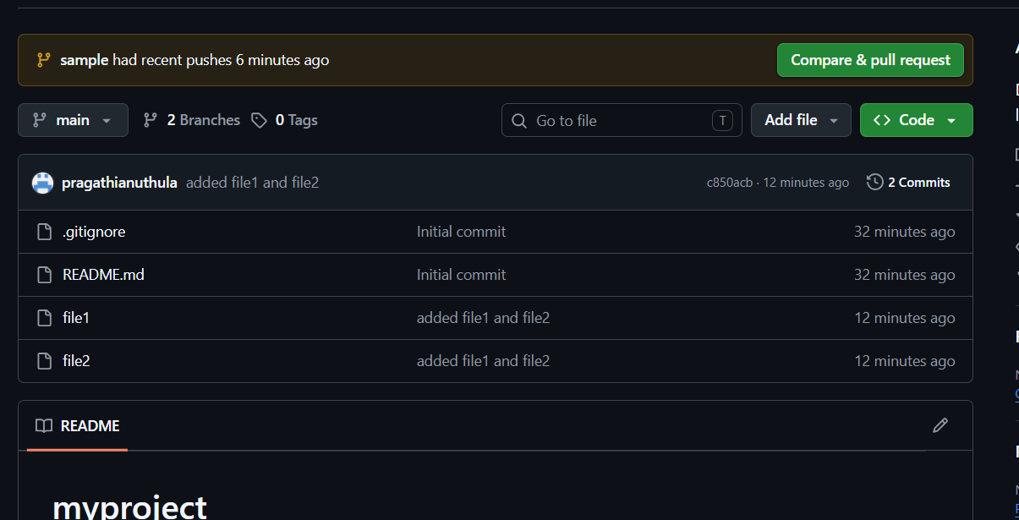
Step 1: Created a new local branch
I ran:
git branch sample
What it did:
- Created a new branch called sample
- The branch was created locally in my system
- I was still working in the main branch after creating it
That’s why prompt showed:
(main)

Step 2: Switched to the sample branch
I ran:
git checkout sample
Output:
Switched to branch 'sample'
What it did:
- Moved from main branch to sample branch
- Now any changes I make will happen inside the sample branch only
Prompt changed to:
(sample)
This confirms branch switch was successful.

Step 3: Verified current branch
I ran:
git branch
Output:
main
* sample
What it means:
- main → existing branch
- * sample → currently active branch
The * symbol shows which branch I am working on.

Step 4: Created a sample file
I ran:
touch sample.txt
What it did:
- Created a new empty file called:
sample.txt
This file was created inside the sample branch

Step 5: Verified file creation
I ran:
ls
Output:
README.md file1 file2 sample.txt
What it means:
Repository now contains:
- README.md
- file1
- file2
- sample.txt ← newly created file
This confirms file creation was successful.

Step 6: Added file to staging area
I ran:
git add .
What it did:
- Added all new changes to Git staging area
- Prepared sample.txt for commit
This tells Git:
Track this file and get ready to save it

Step 7: Committed the file
I ran:
git commit -m "add sample file"
Output:
[sample 77bb5f4] add sample file
1 file changed
create mode 100644 sample.txt
What it means:
- sample → branch name
- 77bb5f4 → unique commit ID
- add sample file → commit message
- 1 file changed → one file committed
- create mode 100644 → new file created and saved
This saved the file permanently in local Git history.

Step 8: Pushed branch to GitHub
I ran:
git push origin sample
What it did:
- Uploaded local sample branch to GitHub
- Uploaded commit and file
Output:
[new branch] sample -> sample
Meaning:
- New branch created on GitHub
- Local sample branch successfully pushed to remote repository

Step 9: GitHub suggested Pull Request
GitHub showed:
Create a pull request for 'sample'
This means:
GitHub is asking if I want to merge sample branch into main branch.
A Pull Request is used to review and merge branch changes.

7- Create a branch in github and clone that to local. 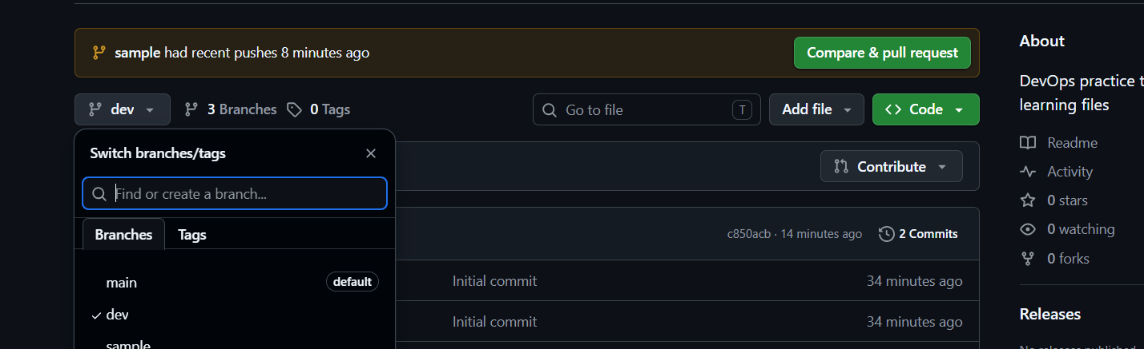 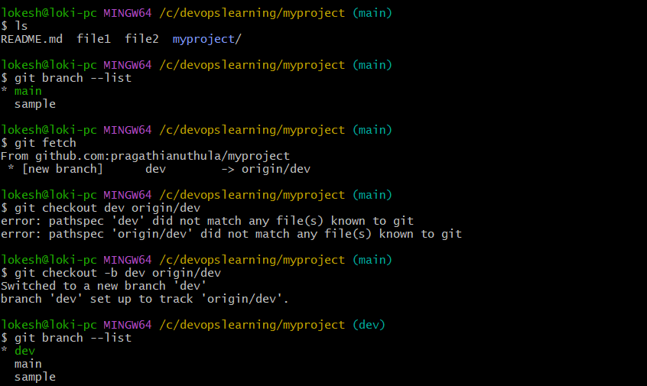 First, I checked the files in my repository using:
ls
This showed all files and folders in my local repository like README.md, file1, file2, and the myproject folder. This confirmed that my repository files are present locally.

Then I checked which branches are available locally using:
git branch --list
It showed:
- main
- sample
The * symbol was on main, which means I was currently working in the main branch.

After that, I fetched updates from GitHub using:
git fetch
This command checked the remote repository and downloaded branch references. It showed that a new branch called dev exists in GitHub as origin/dev.
That means the branch was available remotely, but not yet created locally.

Next, I tried switching directly to the dev branch using:
git checkout dev origin/dev
This gave an error because the local dev branch did not exist yet.
Git could not switch to a branch that was not created locally.

So I created the local branch and linked it to the remote branch using:
git checkout -b dev origin/dev
This command did three things:
- Created a new local branch called dev
- Connected it to the remote branch origin/dev
- Switched me into the dev branch
After this, my terminal changed from:
(main)
to:
(dev)
This confirmed I successfully switched to the dev branch.

Finally, I verified all local branches again using:
git branch --list
It showed:
- dev
- main
- sample
The * symbol was on dev, which means I am now working in the dev branch.

Final explanation:
I first checked my repository files and local branches. Then I fetched updates from GitHub and found a remote branch called dev. My first attempt to switch failed because the branch did not exist locally. So I created the local dev branch from the remote branch, linked it for tracking, and switched to it successfully. Now I can work locally in the dev branch and push changes back to GitHub whenever needed. ✅
8- Merge the created branch with master in git local.
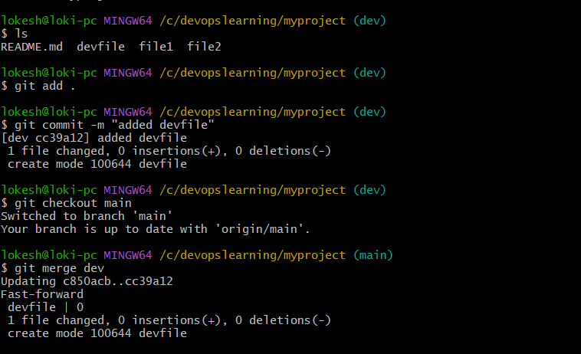 Step 1: Checked files in dev branch
I ran:
ls
Output:
README.md devfile file1 file2
This showed all files present in my current branch.
It confirmed that the new file:
devfile
was successfully created inside the dev branch.

Step 2: Added file to staging area
I ran:
git add .
What it did:
- Added all new changes to Git staging area
- Prepared devfile for commit
This tells Git:
“Track this file and get it ready to save permanently.”

Step 3: Committed the file
I ran:
git commit -m "added devfile"
Output:
[dev cc39a12] added devfile
1 file changed
create mode 100644 devfile
This means:
- dev → current branch
- cc39a12 → unique commit ID
- added devfile → commit message
- 1 file changed → one file was committed
- create mode 100644 → new file was created and saved
This saved the file permanently in the local dev branch history.

Step 4: Switched to main branch
I ran:
git checkout main
Output:
Switched to branch 'main'
Your branch is up to date with 'origin/main'
This means:
- I moved from dev branch to main branch
- My local main branch is already synchronized with GitHub
Now I am working inside:
(main)

Step 5: Merged dev branch into main
I ran:
git merge dev
Output:
Updating c850acb..cc39a12
Fast-forward
devfile
This means Git merged the changes from dev branch into main branch.

What “Fast-forward” means
Git noticed that:
- Main branch had no separate changes
- Dev branch was simply ahead of main
So instead of creating a merge commit, Git just moved main forward to match dev.
This is called:
Fast-forward merge
It is the cleanest type of merge.

Step 6: devfile was added to main
Git showed:
create mode 100644 devfile
This means:
The file:
devfile
was copied from dev branch into main branch successfully.
Now both branches contain the same file.

Final Explanation
First, I verified that devfile existed in the dev branch. Then I added it to Git staging using git add . and committed it locally using git commit. After saving the changes in the dev branch, I switched to the main branch using git checkout main. Then I merged the dev branch into main using git merge dev. Git performed a fast-forward merge, which means the main branch was updated directly to match the dev branch. As a result, the devfile is now successfully merged into the local main branch. ✅

9- Merge the created branch with master in github by sending a pull request.
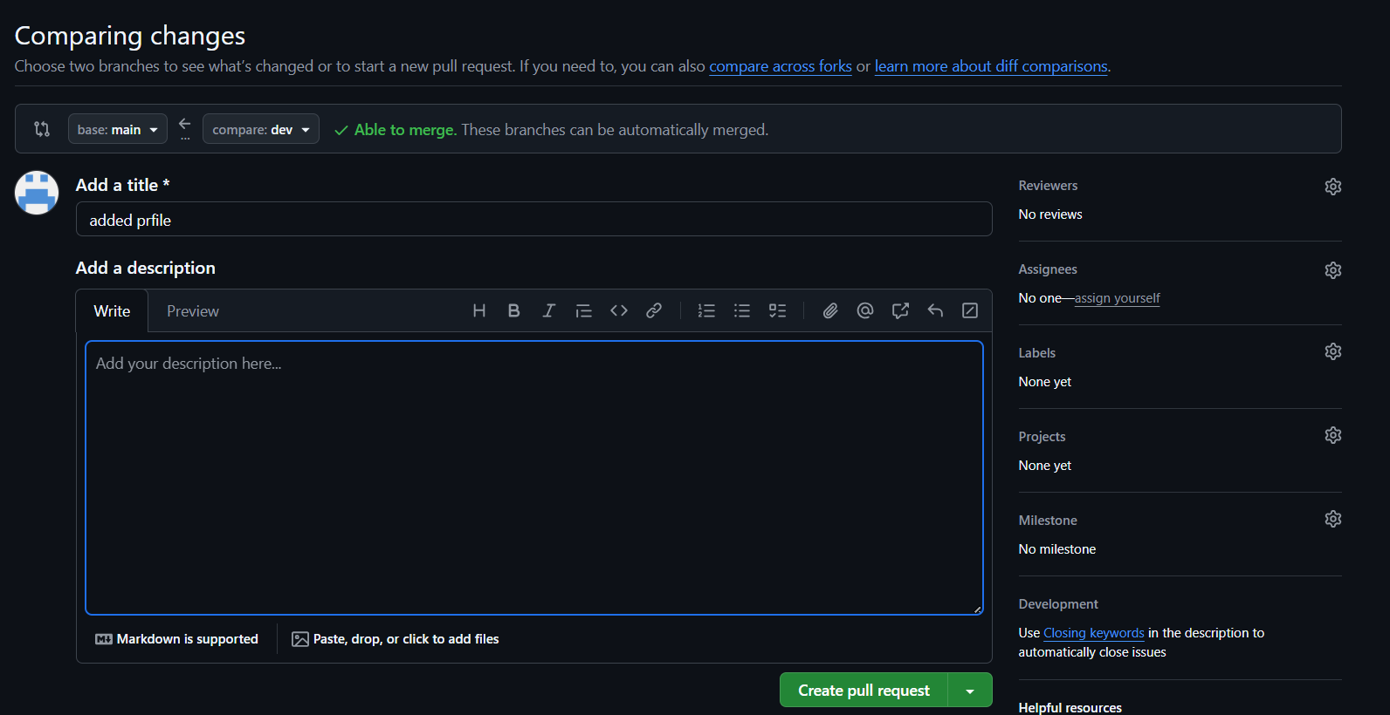 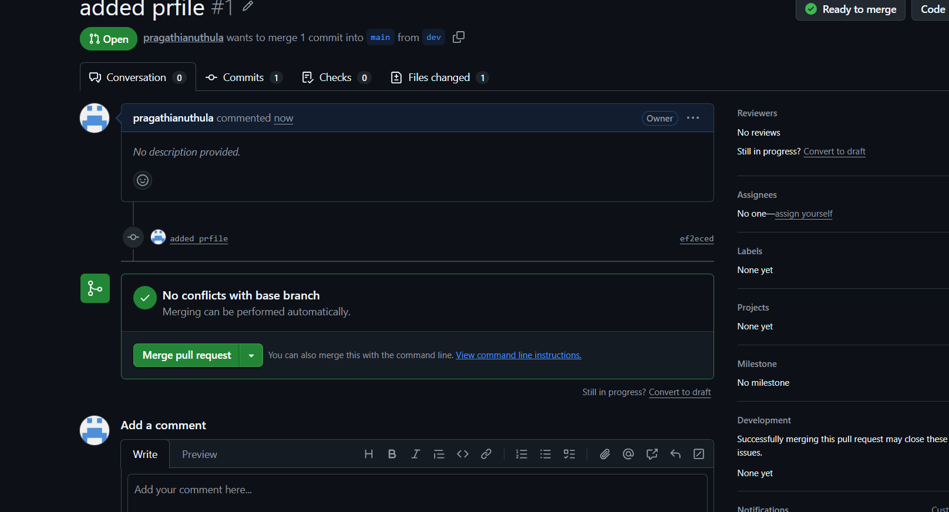 Here’s a simple way to explain what you did to someone:

I was working in a Git project with two branches: main and dev.
First, I switched to the dev branch because I wanted to make changes there without affecting the main code.
Then I created a new file called prfile using the touch command.
After that, I added the file to Git using git add ., which means I staged it for saving.
Next, I saved the change using a commit message: "added prfile". This means Git recorded my change in the dev branch history.
Finally, I uploaded my changes to GitHub using git push origin dev, so the dev branch on GitHub now has my new file.
Now my change is only in the dev branch, and the next step is to create a Pull Request, so I can merge dev into main after review.
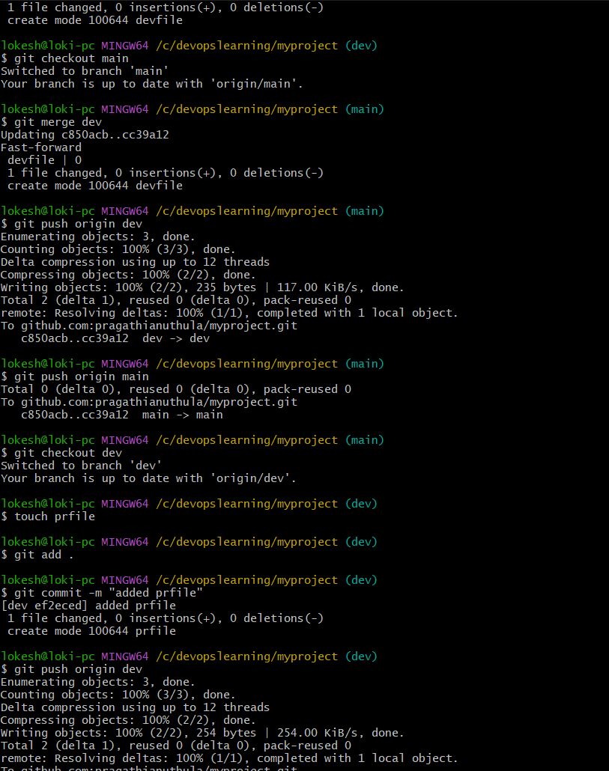

10- Create a file in local and send that to branch in github.
I was working in a Git project on the dev branch. First, I created a new file called devopsfile in my local project folder.
Then I checked the Git status to see the state of my files, and Git showed that the new file was untracked, meaning Git was not tracking it yet.
After that, I added the file to Git using git add ., so Git started tracking it.
Next, I committed the change using git commit -m "added devopsfile", which means I saved the change in my local Git history with a message.
Finally, I pushed the changes to GitHub using git push origin dev, so the file is now available in the dev branch on GitHub.

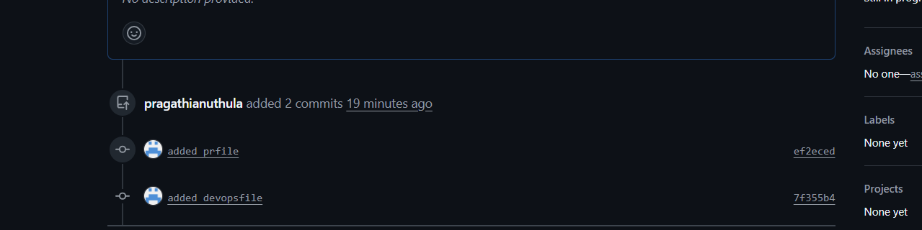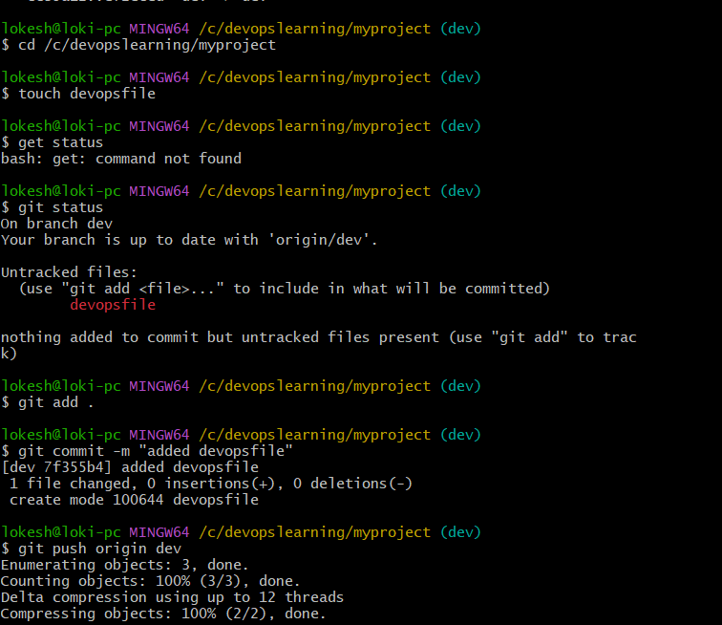
11- Clone only a branch from github to local.

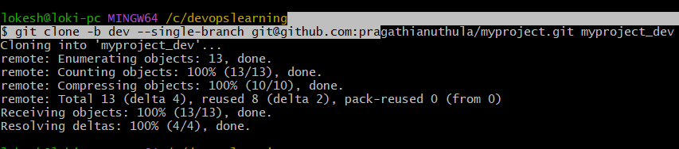 git clone -b dev --single-branch git@github.com:pragathianuthula/myproject.git myproject_dev
Explanation:
- This command clones only the dev branch
- Creates a new folder named myproject_dev
- Avoids conflict with existing folder

✔️ Output:
Cloning into 'myproject_dev'...
Receiving objects: 100% (13/13)
Resolving deltas: 100% (4/4)
Explanation:
- Repository downloaded successfully
- Only dev branch content is copied to local system

12- Create a file with all passwords and make that untrackable with git.
1. Checked .gitignore
cat .gitignore
Explanation:
- You opened the .gitignore file.
- It already contains many ignore rules (like .log, .jar, .zip, etc.).
- You also added:
secrets.txt
password.txt
👉 This means Git should ignore these two files.

✔️ 2. Checked Git status
git status
Output:
On branch sample
nothing to commit, working tree clean
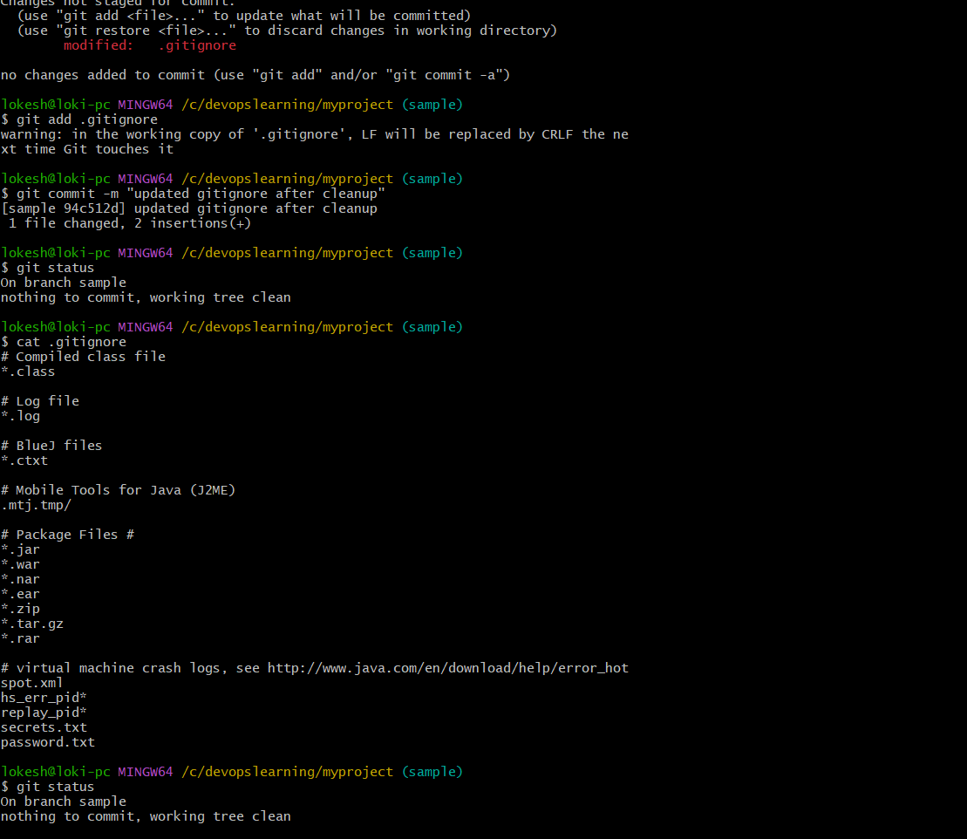
13- Make a commit and make that commit reset without savings changes.
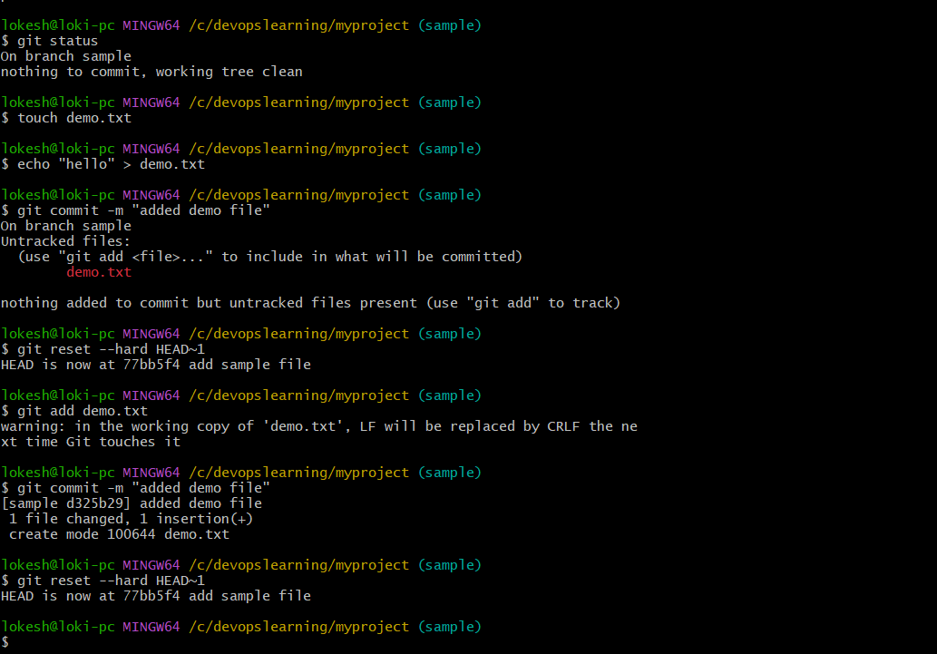
To create a file, commit it to Git, and then remove the commit using a hard reset.

🧾 Steps Performed

✔️ Step 1: Create a file and add content
touch demo.txt
echo "hello" > demo.txt
Explanation:
- A new file named demo.txt was created.
- The text "hello" was added into the file.

❌ Step 2: Attempt to commit without staging
git commit -m "added demo file"
Output:
- Git showed that demo.txt is untracked.
- No commit was created.
Explanation:
- Git does not commit untracked files.
- The file was not added to staging area.

✔️ Step 3: Stage the file
git add demo.txt
Warning observed:
- LF will be replaced by CRLF
Explanation:
- File was added to the staging area.
- Warning is related to line endings (Linux vs Windows) and is not an error.

✔️ Step 4: Commit the file
git commit -m "added demo file"
Output:
- Commit created successfully.
- Commit ID: d325b29
- File demo.txt was added to Git history.

✔️ Step 5: Reset the commit (hard reset)
git reset --hard HEAD~1
Explanation:
- The last commit was removed completely.
- Repository was moved back one commit (77bb5f4).
- Changes in demo.txt were also deleted from working directory.

📊 Final Result
- demo.txt was created
- It was successfully committed
- The commit was removed using git reset --hard HEAD~1
- Repository returned to previous clean state
14- Revert a commited commit to the older version
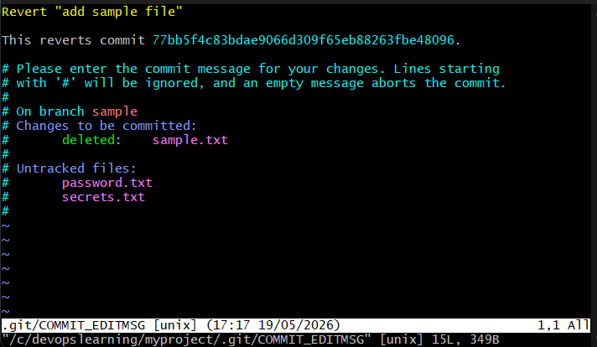 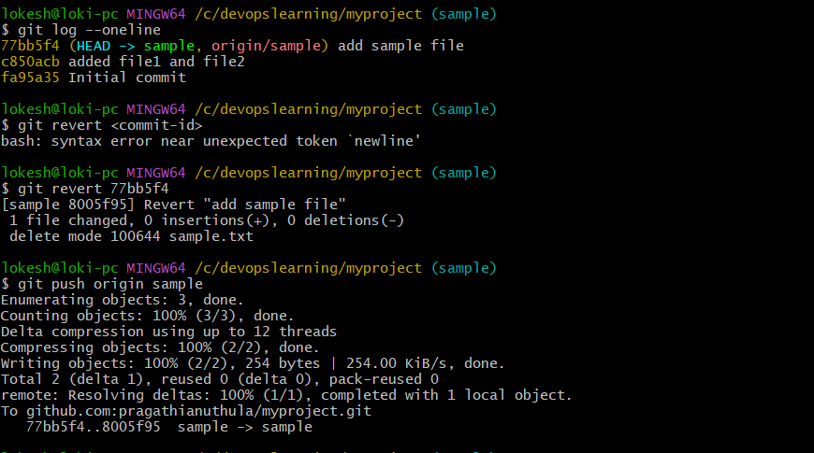 Git Practice: Reverting a Commit to an Older Version

🎯 Objective
To revert a committed change in Git and restore the repository to a previous state using a safe method without deleting history.

🧾 Steps Performed

✔️ Step 1: View commit history
git log --oneline
Output:
77bb5f4 (HEAD -> sample, origin/sample) add sample file
c850acb added file1 and file2
fa95a35 Initial commit
Explanation:
- Displays commit history in short format.
- Helps identify the commit ID to revert.

❌ Step 2: Incorrect revert syntax (mistake)
git revert <commit-id>
Error:
bash: syntax error near unexpected token
Explanation:
- < > symbols are placeholders and should not be used in actual commands.
- Correct usage requires a real commit ID.

✔️ Step 3: Revert a commit
git revert 77bb5f4
Output:
Revert "add sample file"
delete mode 100644 sample.txt
Explanation:
- Git created a new commit that undid the changes from commit 77bb5f4.
- The file sample.txt was removed as part of the revert.
- Original commit history remains unchanged.

✔️ Step 4: Push changes to remote repository
git push origin sample
Output:
77bb5f4..8005f95 sample -> sample
Explanation:
- The revert commit was successfully pushed to GitHub.
- Remote repository now reflects the reverted changes.

📊 Final Result
- Commit 77bb5f4 remains in history.
- A new commit 8005f95 was created to undo changes.
- Repository was safely rolled back without deleting history.

15- Push a file to stash without savings the changes and work on another file. 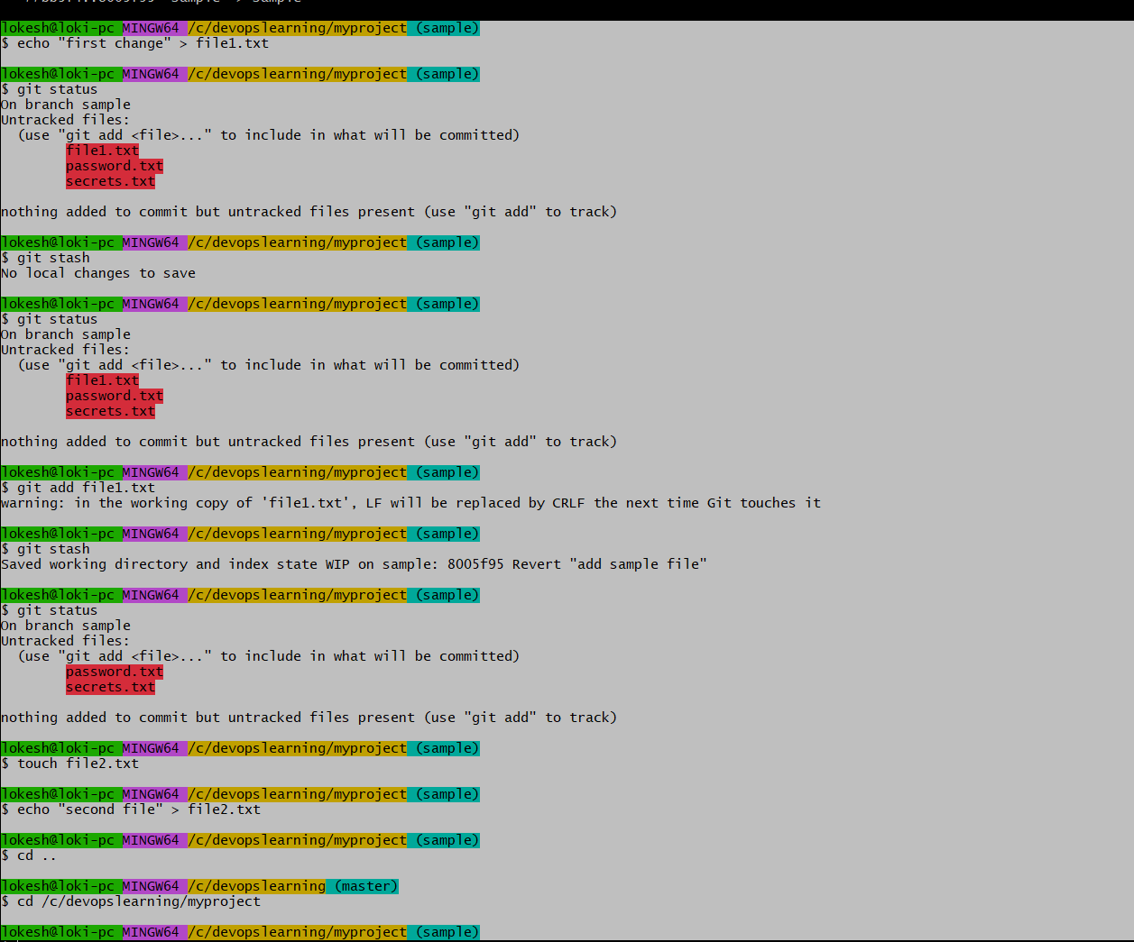
1. Checked Git status
You ran:
git status
Meaning:
- Git showed 3 untracked files:
  - file1.txt
  - password.txt
  - secrets.txt
👉 These files exist in your folder but Git is NOT tracking them yet.

✔️ 2. Staged one file
git add file1.txt
Meaning:
- You told Git:
👉 “Start tracking only file1.txt for now”
- The other files stayed untracked.

✔️ 3. Used stash
git stash
Meaning:
- Git saved only:
  - file1.txt (staged file)
- Git did NOT save:
  - password.txt
  - secrets.txt
👉 Because stash only works on tracked/staged changes

✔️ 4. Checked status again
git status
Result:
- file1.txt is gone from working area (stashed ✔️)
- password.txt and secrets.txt are still there (untracked)

✔️ 5. Created new file
touch file2.txt
echo "second file" > file2.txt
Meaning:
- You started new work after saving old work in stash
- This is normal DevOps workflow

🎯 Final Understanding
You did this workflow:
- Created multiple files
- Staged only one file (file1.txt)
- Stashed the staged changes
- Left untracked files untouched
- Continued working on a new file (file2.txt)

💡 Simple explanation you can write
“I created multiple files and staged one of them. Then I used git stash to temporarily save the staged changes, which removed them from the working directory. The untracked files were not included in stash, and I continued working by creating a new file.”

16- Undo the stash file and start working on that again.
1. Checked saved stash
git stash list
Meaning:
- Git showed that you have one saved stash
- That stash contains your previously saved work

✔️ 2. Restored stash
git stash apply
Meaning:
- You brought back the saved changes into your working folder
- The stash was restored but NOT deleted
What came back:
- file1.txt (staged file)
- file2.txt (untracked)
- password.txt (untracked)
- secrets.txt (untracked)

✔️ 3. Checked status
git status
Meaning:
- Git confirmed restored files are back
- Some files are staged, some are untracked

✔️ 4. Continued work on file
echo "updated work" >> file1.txt
Meaning:
- You added new content to file1.txt
- You continued working on restored file

✔️ 5. Staged file
git add file1.txt
Meaning:
- You prepared the updated file for commit

✔️ 6. Committed changes
git commit -m "continued work after stash restore"
Meaning:
- Your updated work is now saved in Git history
- New commit was created successfully

🎯 Final Summary
You did this flow:
👉 Saved work earlier using stash
👉 Restored that saved work using git stash apply
👉 Continued editing the file
👉 Staged and committed the final changes

💡 Simple explanation you can write
“I restored previously stashed changes using git stash apply, continued working on the file, then staged and committed the updated changes.”

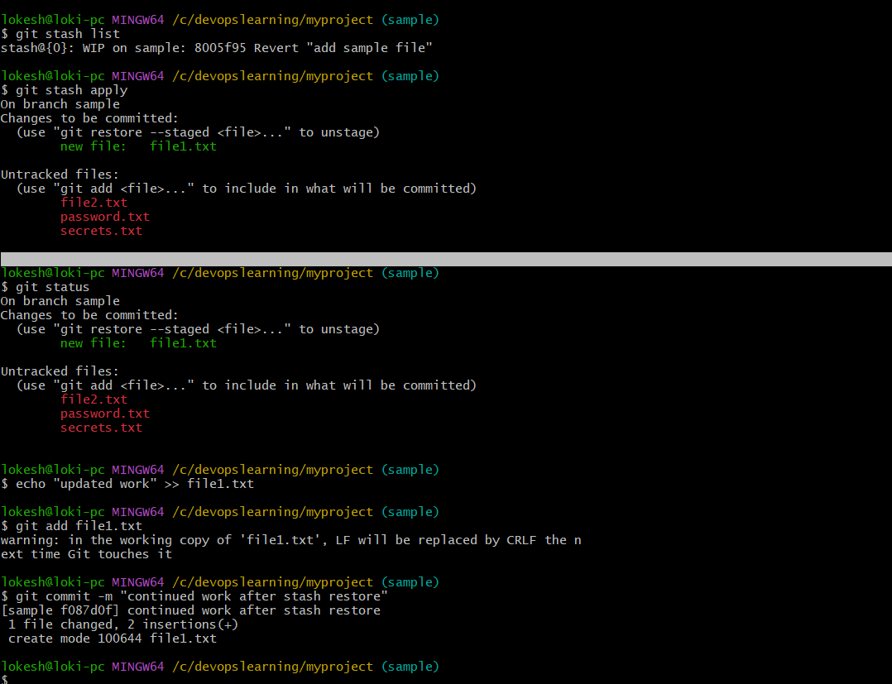

17- Generate a ssh-keygen and configure into github
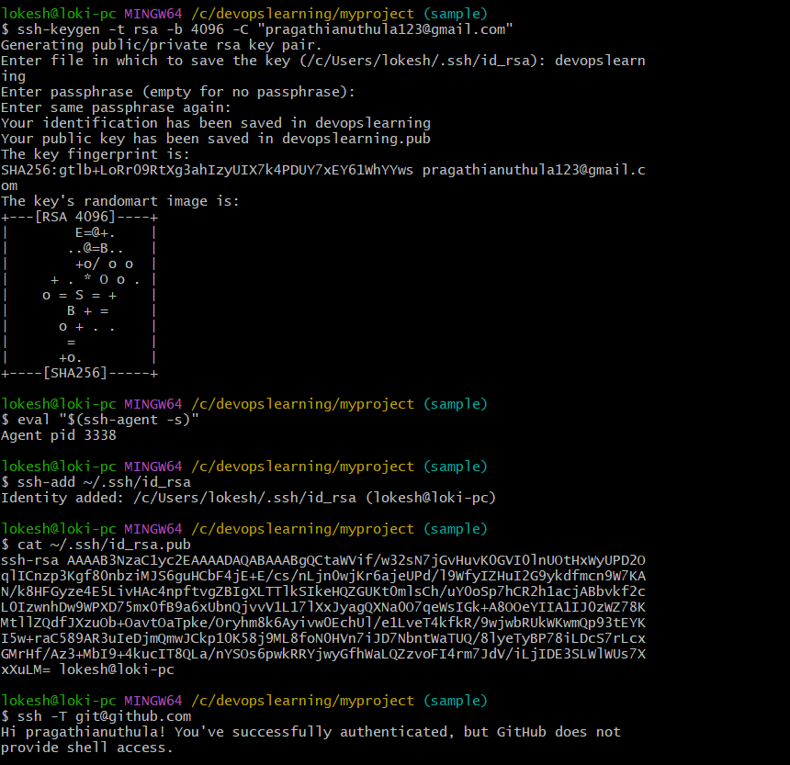
Step 1: Generate SSH key pair
ssh-keygen -t rsa -b 4096 -C "pragathianuthula123@gmail.com"
Explanation:
- Created a new SSH key pair using RSA algorithm
- 4096 bit encryption used for strong security
- Email was added as a label for identification
Custom input:
- Key file name given: devopslearning
- This created:
  - Private key: devopslearning
  - Public key: devopslearning.pub

✔️ Step 2: Start SSH agent
eval "$(ssh-agent -s)"
Explanation:
- Started SSH authentication service (agent)
- Agent manages SSH keys in memory

✔️ Step 3: Add SSH private key to agent
ssh-add ~/.ssh/id_rsa
Explanation:
- Added private key to SSH agent
- Enables system to use SSH key for authentication

✔️ Step 4: Display public key
cat ~/.ssh/id_rsa.pub
Explanation:
- Displayed public key content
- This key is shared with GitHub
- Used for authentication verification

✔️ Step 5: Add SSH key to GitHub
GitHub steps:
GitHub → Settings → SSH and GPG keys → New SSH Key
Explanation:
- Public key was copied and added to GitHub account
- This links local machine with GitHub securely

✔️ Step 6: Test SSH connection
ssh -T git@github.com
Output:
Hi pragathianuthula! You've successfully authenticated
Explanation:
- Connection between local system and GitHub is successful
- Authentication is working using SSH key (not password)

📊 Final Result
- SSH key pair successfully generated
- SSH agent configured
- Public key added to GitHub
- Secure authentication established
- GitHub access verified successfully

🧠 Key Learnings
- SSH keys provide passwordless authentication
- Private key stays on local system (secure)
- Public key is added to GitHub
- SSH improves security and automation in Git workflows

⚖️ Important Concept
Component | Purpose
Private key | Stored locally (secret)
Public key | Shared with GitHub
ssh-agent | Manages authentication
ssh -T | Tests connection

📌 Conclusion
This exercise demonstrates successful SSH key-based authentication setup between local machine and GitHub, enabling secure and passwordless Git operations.

18- Configure webhooks to github.
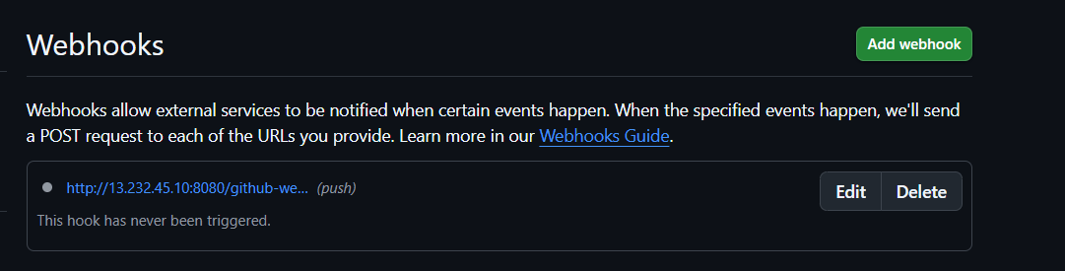
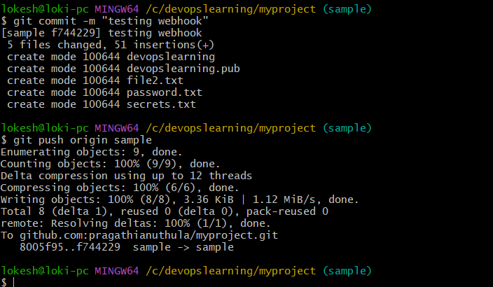 What You Did Step-by-Step

✔️ Step 1: Opened Webhook Settings in GitHub
You navigated to:
Repository → Settings → Webhooks → Add webhook
Explanation:
- This is where GitHub allows integration with external systems
- Webhooks are configured per repository

✔️ Step 2: Set Payload URL
http://13.232.45.10:8080/github-webhook/
Explanation:
- This is your Jenkins server endpoint
- GitHub will send data (events) to this URL
- This enables automation between GitHub and Jenkins

✔️ Step 3: Selected Content Type
application/json
Explanation:
- Data from GitHub will be sent in JSON format
- Jenkins easily reads and processes JSON payloads

✔️ Step 4: Enabled SSL Verification
Enable SSL verification
Explanation:
- Ensures secure communication between GitHub and server
- GitHub verifies the server certificate before sending data

✔️ Step 5: Selected Event Trigger
You chose:
Just the push event
Explanation:
- Webhook triggers only when code is pushed to repository
- This is the most common CI/CD trigger

✔️ Step 6: Activated Webhook
Active ✔
Explanation:
- Webhook is now enabled
- GitHub will automatically send POST requests when events occur

⚙️ What Happens Now (Flow)
You push code to GitHub
↓
GitHub detects push event
↓
Webhook sends POST request (JSON)
↓
Jenkins receives request at /github-webhook/
↓
Jenkins automatically triggers build/job

📊 Final Result
- GitHub is now connected to Jenkins
- Push events automatically trigger builds
- Manual execution is no longer required
- CI/CD automation is enabled

🧠 Key Learnings
- Webhooks create real-time communication between systems
- GitHub acts as event sender
- Jenkins acts as event receiver
- Push-based CI/CD automation is achieved

📌 Conclusion
You successfully configured a GitHub webhook that connects your repository to Jenkins. This enables automatic build triggers whenever code is pushed, forming the foundation of a CI/CD pipeline.
19- Basic understanding of .git file.
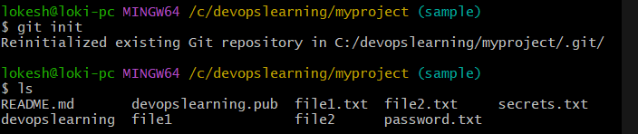 What is .git?
The .git folder is the heart of a Git repository.
It is a hidden directory created when you run:
git init

🧠 Simple Meaning
👉 .git is where Git stores all tracking information and history of your project.
Without .git, Git does not exist for that folder.

📦 What does .git contain?
Inside .git, Git stores everything needed to manage your project:
1. 📜 Commit History
- All commits you make
- Changes over time
Stored in:
.git/objects

2. 🌿 Branch Information
- main, dev, sample branches
- HEAD pointer (current branch)
Stored in:
.git/refs
.git/HEAD

3. 📁 Staging Area (Index)
- Tracks files added using git add
Stored in:
.git/index

4. ⚙️ Configuration
- Repository settings (user name, email, remote URL)
Stored in:
.git/config

5. 🔗 Remote Repository Info
- GitHub link (origin)
Stored in:
.git/config

🔄 How Git works with .git
Working Directory → Staging Area → .git (Repository)
Meaning:
- You edit files (working area)
- You stage files (git add)
- You commit (git commit) → saved inside .git

📌 Example
When you run:
git commit -m "added file"
👉 Git stores:
- file snapshot
- commit message
- author info
- timestamp
Inside .git

⚠️ Important Points
- .git is hidden by default
- Deleting .git = project is no longer a Git repository
- Copying .git copies full Git history

🧠 Key Learnings
- .git is the database of Git
- It stores history, branches, and configuration
- Git works only because of .git
- It enables version control

📌 Conclusion
The .git folder is the core storage system of Git. It tracks every change, commit, branch, and configuration, making version control possible.
20- Check all the logs of git.
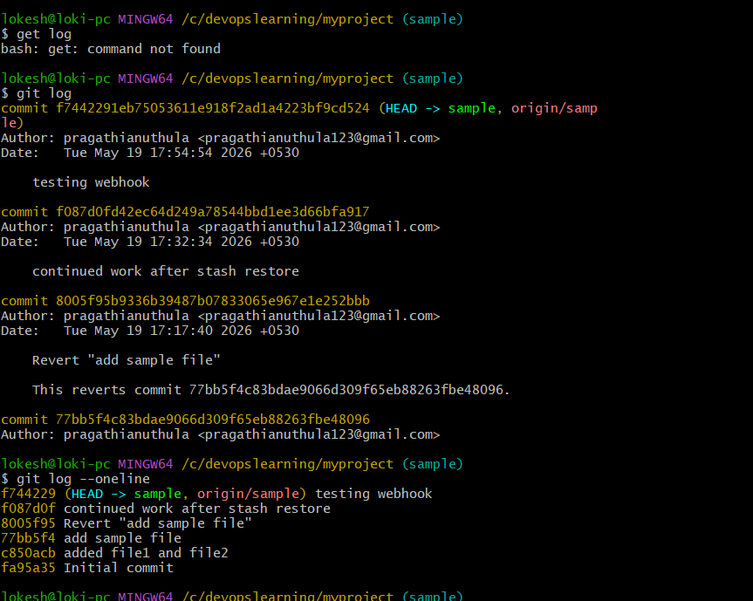 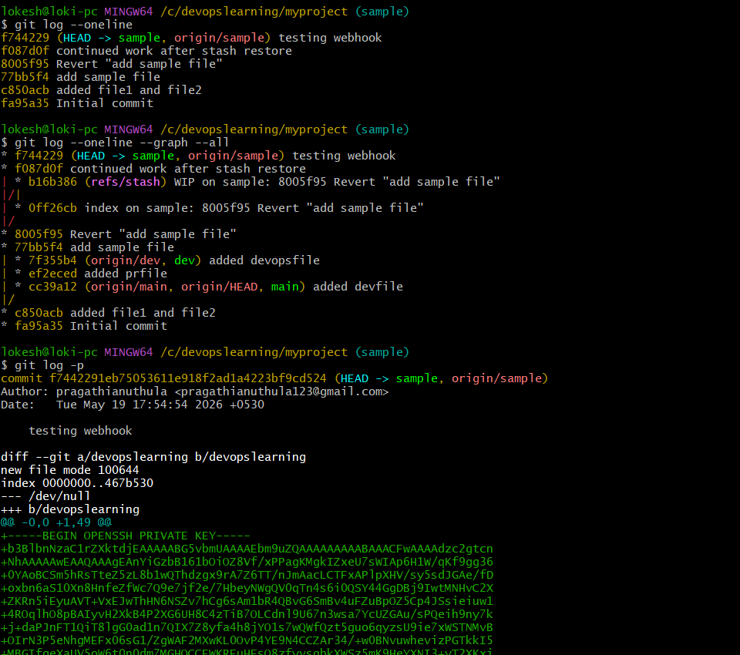 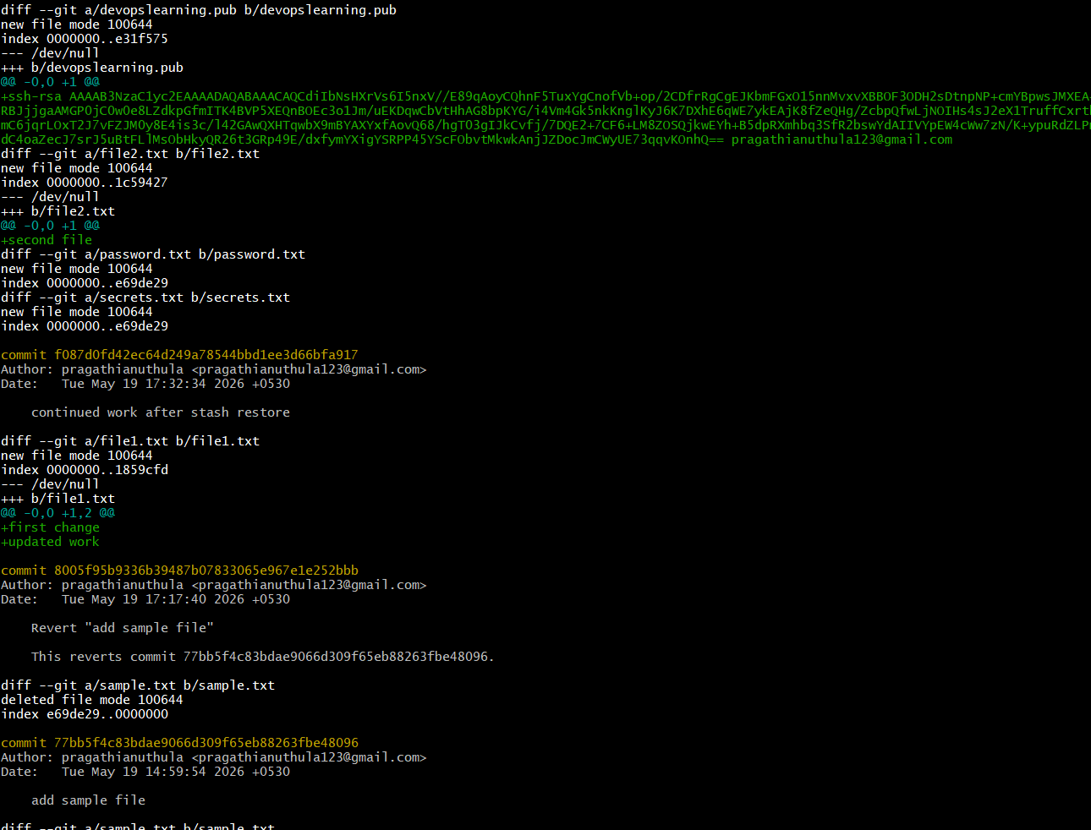 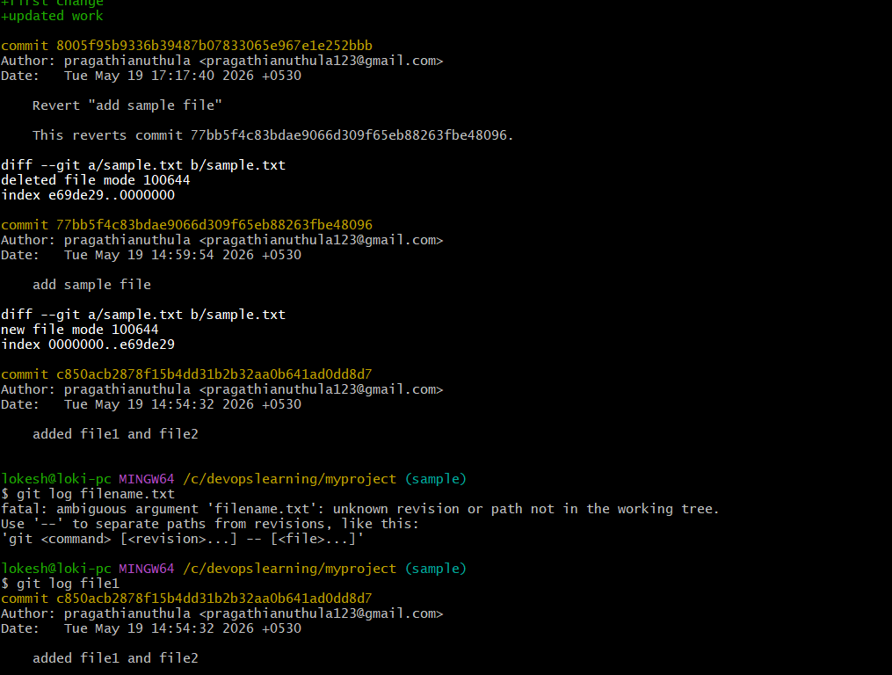 What I did with Git log
I used Git log commands to see the history of my project and understand what changes happened over time.

✔️ 1. I checked full commit history
I used:
git log
👉 This showed me:
- All commits in detail
- Who made changes
- When changes were made
- What messages were written for each commit

✔️ 2. I checked short history
I used:
git log --oneline
👉 This showed me:
- All commits in one line
- Easy to quickly understand project history

✔️ 3. I saw branch structure
I used:
git log --oneline --graph --all
👉 This showed me:
- How branches like main, dev, and sample are connected
- How commits are moving between branches
- Stash history also appeared

✔️ 4. I checked file changes in commits
I used:
git log -p
👉 This showed me:
- Actual changes inside files
- What lines were added or removed in each commit

✔️ 5. I tried checking history of a file
I used:
git log filename.txt ❌ (wrong file name)
👉 It gave an error because:
- That file does not exist
Then I used:
git log file1
👉 This showed:
- Only commits related to that file

🧠 In simple words
I learned that:
- Git keeps full history of everything I do
- I can see all commits anytime
- I can check changes for full project or single file
- I can also see branch structure visually

📌 Final line (how you can say it in interview)
👉 “I used git log commands to view commit history, check branch structure, and inspect file-level changes in my repository.”
21- Rename the commit message. 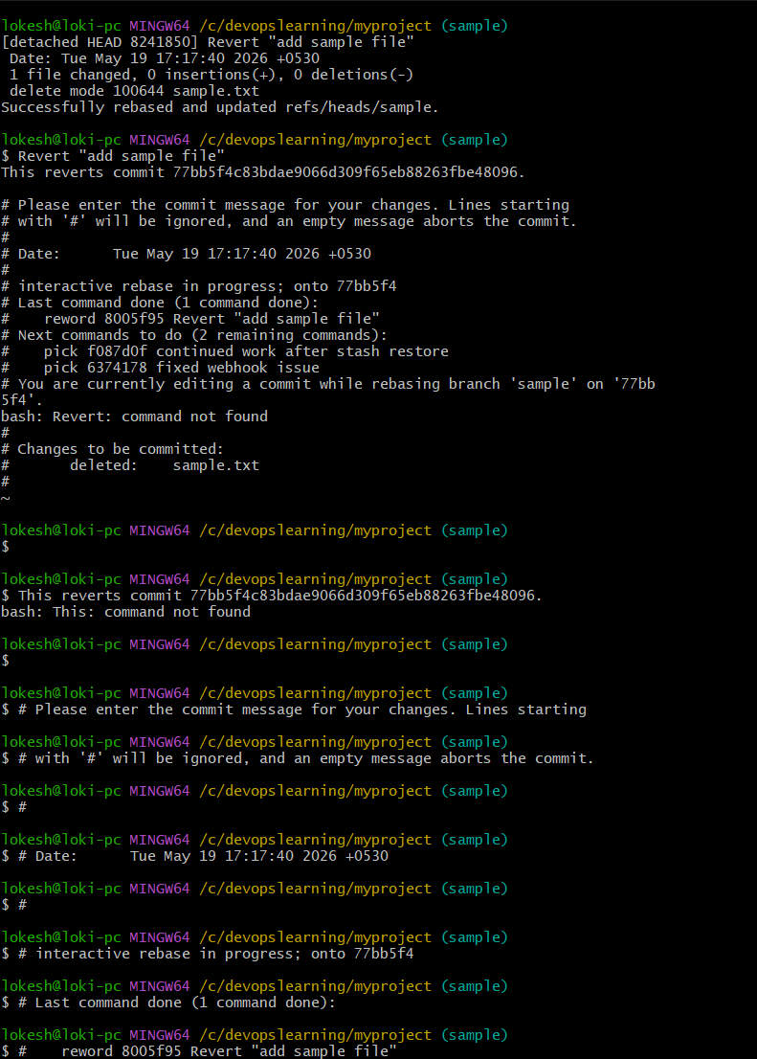 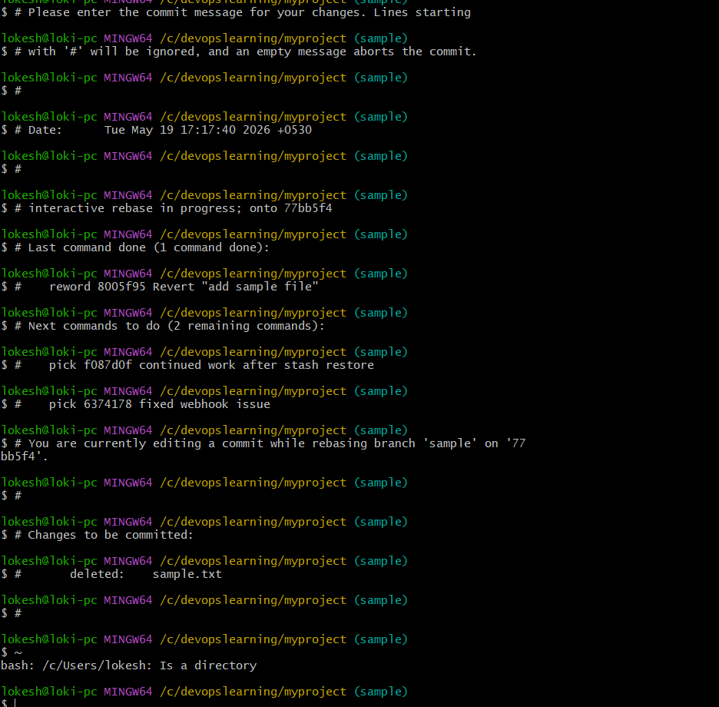 What I did (Git Rebase + Revert Commit + Editor Confusion)
🎯 Objective
I was working on Git history using interactive rebase and modifying a commit that removes a file (sample.txt) using a revert commit.

🧾 Step-by-step explanation
1. I started an interactive rebase
Git showed:
interactive rebase in progress; onto 77bb5f4
👉 This means:
- I am rewriting commit history starting from commit 77bb5f4
- Git is replaying commits one by one

2. Git stopped at a commit for editing (reword)
reword 8005f95 Revert "add sample file"
👉 This means:
- I selected reword
- Git paused and asked me to edit the commit message

3. Git opened commit message editor
I saw this message:
Revert "add sample file"
This reverts commit 77bb5f4...
👉 This is NOT a terminal command
👉 This is a text editor (commit message editor)

4. I mistakenly typed commit text in terminal
I entered:
Revert "add sample file"
This reverts commit ...
👉 This caused errors like:
bash: Revert: command not found
bash: This: command not found
❌ Why error happened?
Because I typed editor content in terminal, but Git was expecting:
- Only commit message inside editor
- Not shell commands

5. Git was still in rebase mode
It showed:
Changes to be committed:
deleted: sample.txt
👉 Meaning:
- Git already applied commit changes
- sample.txt was deleted as part of revert commit

6. I accidentally ran shell commands instead of editing file
Lines starting with # like:
# interactive rebase in progress
👉 These are comments only
👉 I tried running them in terminal → ignored / errors

⚠️ Key mistake I made
- I treated Git editor screen like terminal
- I typed commit message lines as commands

🧠 Correct understanding
When Git shows commit message screen:
✔ You should ONLY:
- Edit text message
- Save file
- Exit editor
❌ You should NOT:
- Run those lines in terminal

📌 Final result
Successfully rebased and updated refs/heads/sample
👉 This means:
- Rebase completed successfully
- Commit history updated
- Branch sample is now rewritten cleanly

🧾 Simple explanation (how to say it in interview)
👉 “I performed an interactive rebase to modify commit history. Git paused to let me edit a commit message using reword. I accidentally typed editor content in terminal, but later I understood that Git expects changes only inside the editor, not the shell. Finally, rebase completed successfully and history was updated.”

22- Merge multiple commits into single commit.
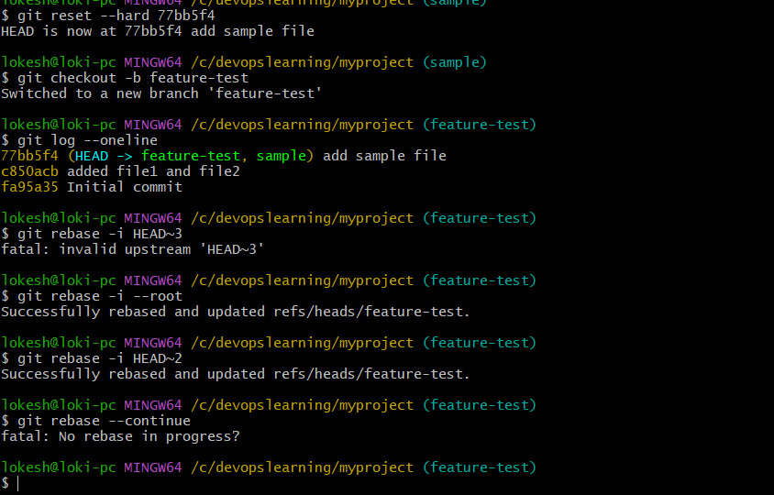 1. First error
git rebase -i HEAD~3
fatal: invalid upstream 'HEAD~3'
👉 Meaning:
- Your branch doesn’t have enough commits
- So Git cannot go back 3 steps

2. You fixed it correctly
git rebase -i --root
Successfully rebased and updated refs/heads/feature-test.
👉 Meaning:
- You started rebase from first commit
- Git successfully rewrote history
- Your branch is now clean for editing commits

3. Then you ran again
git rebase -i HEAD~2
👉 Meaning:
- You are trying another interactive rebase
- Now Git will again open editor for last 2 commits

🧠 What state you are in NOW
✔ Rebase is ACTIVE again
✔ Git is waiting for you in editor
✔ You are about to modify commits again

🎯 What you should do inside editor
You will see something like:
pick c850acb added file1 and file2
pick 77bb5f4 add sample file

If your goal is: MERGE commits
Change it to:
pick c850acb added file1 and file2
squash 77bb5f4 add sample file

🧠 Meaning
- pick → keep first commit
- squash → merge into previous commit

📌 After saving editor
Git will open another screen:
👉 You must write final commit message like:
Final commit: project setup and sample file added

🚀 Final step
After saving:
git rebase --continue

⚠️ Important warning
- You are currently rewriting history multiple times
- That is OK for learning
- But don’t do repeatedly on production/shared branches

🧾 Simple explanation (for notes)
👉 “I used git rebase -i --root to start rewriting commit history from the first commit, then used HEAD~2 rebase to modify and combine commits using squas
0000n

