1-Create one IAM user and assign EC2 and S3 full access roles.
Step 1: Open IAM Service
- Logged into AWS Management Console.
- Navigated to IAM service.
- Selected Users and clicked Create User.
Step 2: Create IAM User
- Entered username: ec2-s3-user.
- Created the IAM user.

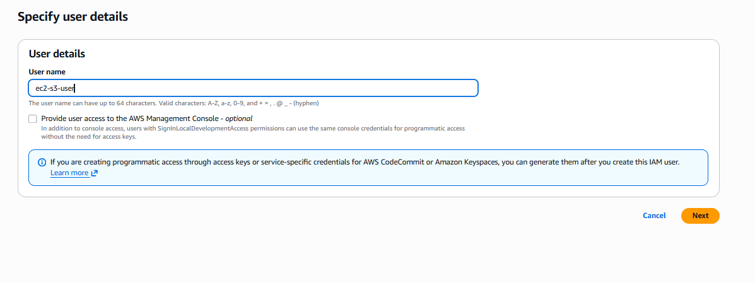Step 3: Assign Permissions
- Selected Attach Policies Directly.
- Attached:
  - AmazonEC2FullAccess
  - AmazonS3FullAccess
- Created the user.
Step 4: Enable Console Access
- Enabled AWS Console access.
- Generated login credentials.
- Logged in using the IAM user.
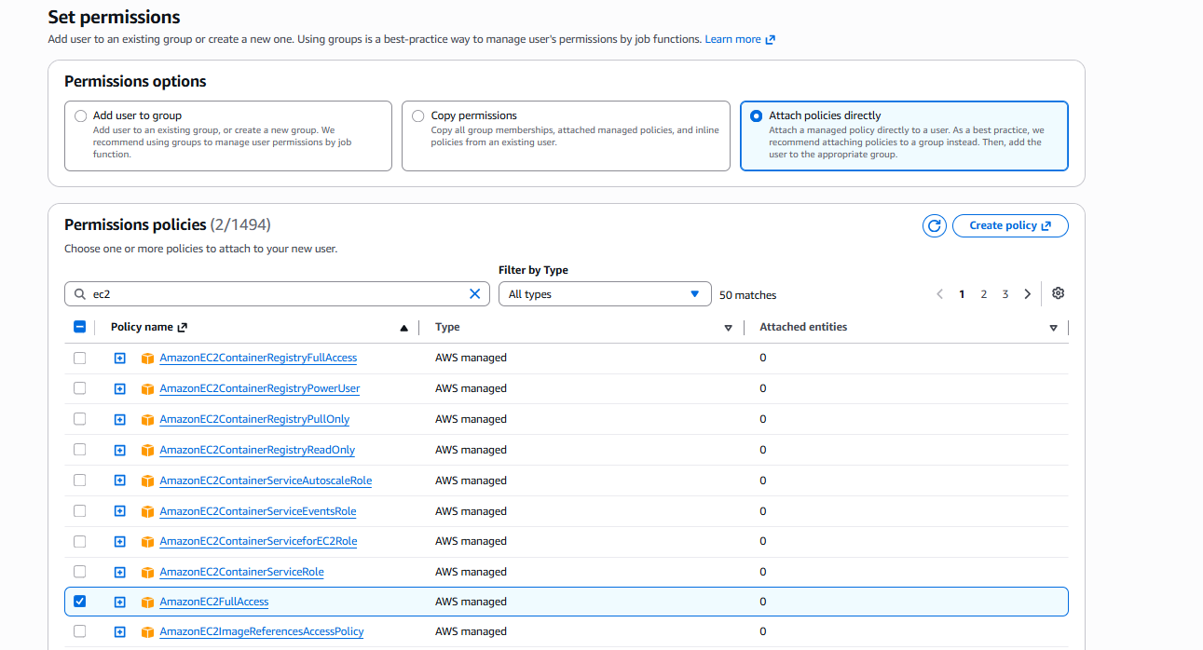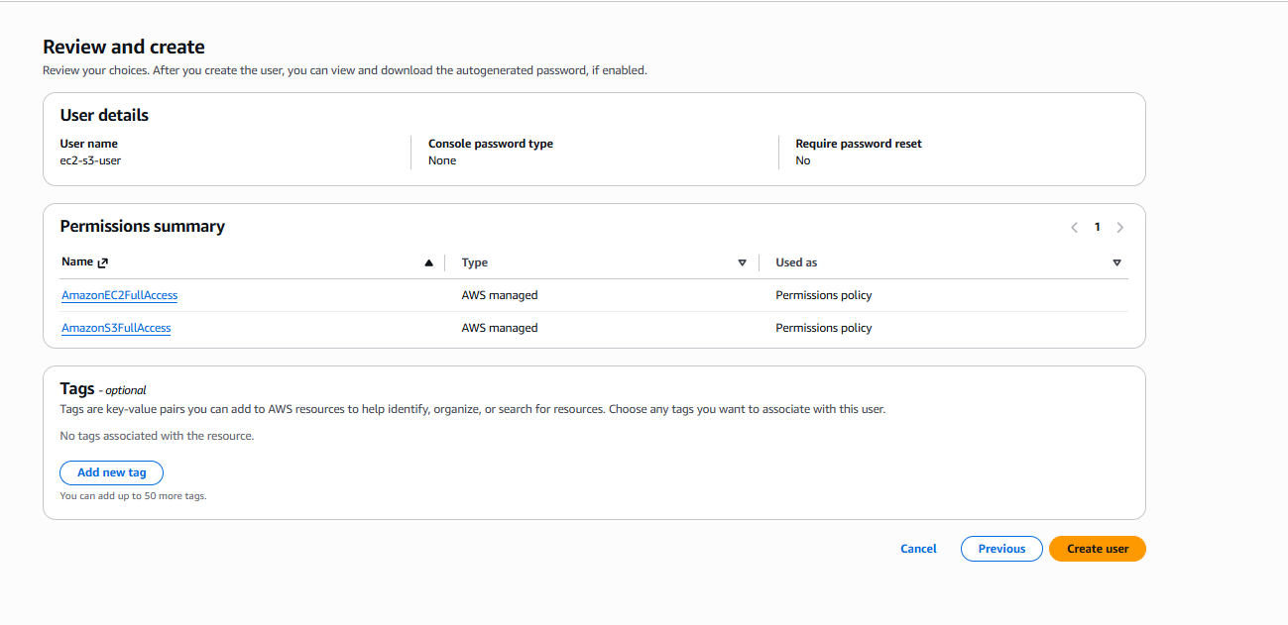Step 5: Verify EC2 Access
- Logged in as IAM user.
- Opened EC2 Dashboard.
- Created an EC2 instance successfully.
- Verified that EC2 permissions were working.
Step 6: Verify S3 Access
- Opened S3 service.
- Created an S3 bucket successfully.
- Verified that S3 permissions were working.
Result
- Successfully created IAM user ec2-s3-user.
- Granted full access to EC2 and S3 using AWS managed policies.
- Verified access by creating both an EC2 instance and an S3 bucket.
z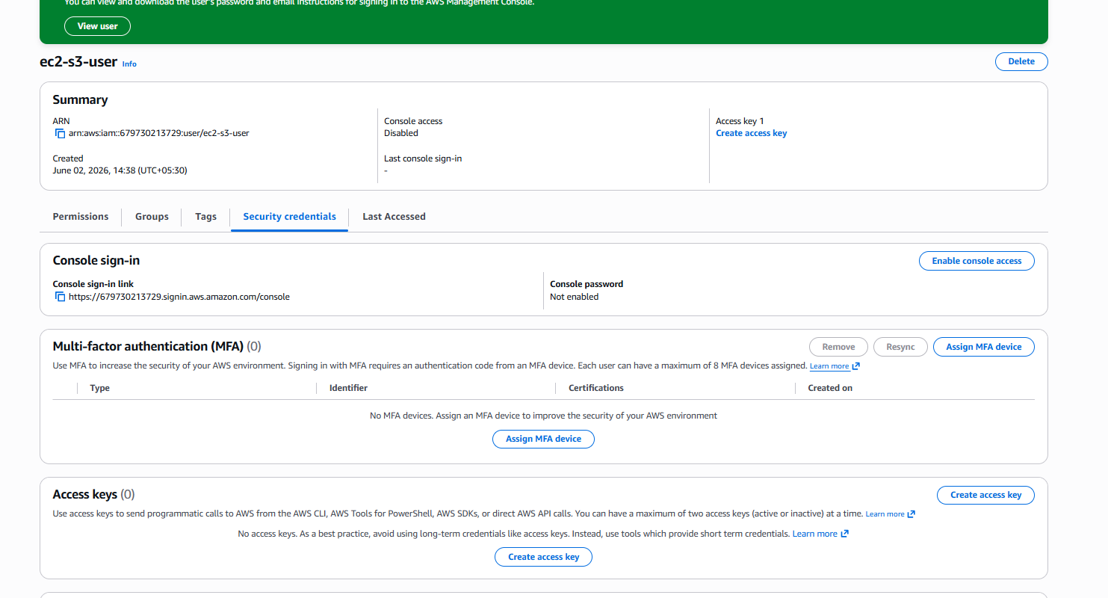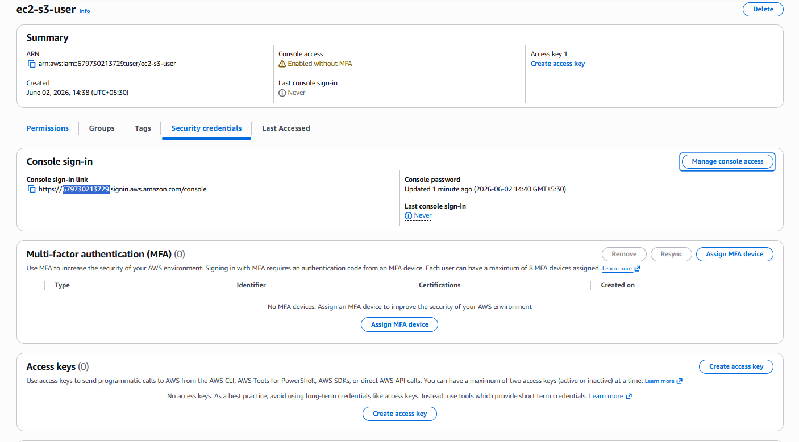Step 5: Verify EC2 Access
- Logged in as IAM user.
- Opened EC2 Dashboard.
- Created an EC2 instance successfully.
- Verified that EC2 permissions were working.
Step 6: Verify S3 Access
- Opened S3 service.
- Created an S3 bucket successfully.
- Verified that S3 permissions were working.
Result
- Successfully created IAM user ec2-s3-user.
- Granted full access to EC2 and S3 using AWS managed policies.
- Verified access by creating both an EC2 instance and an S3 bucket.
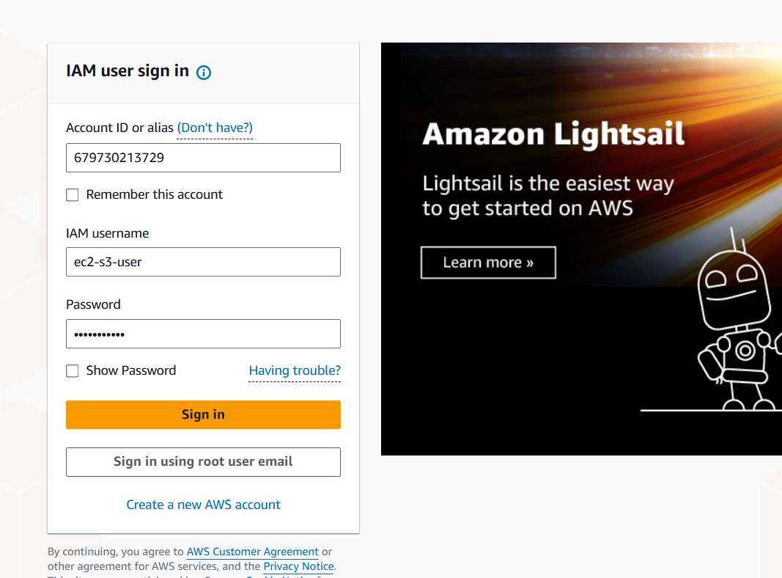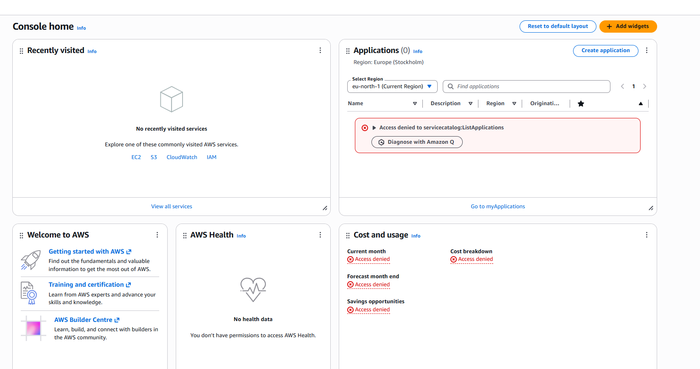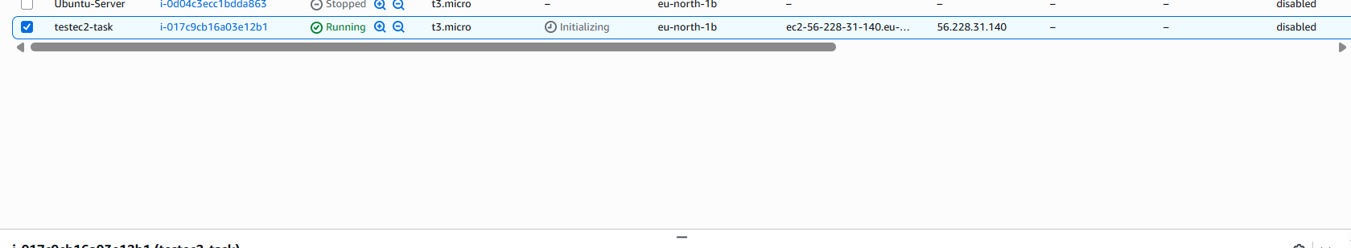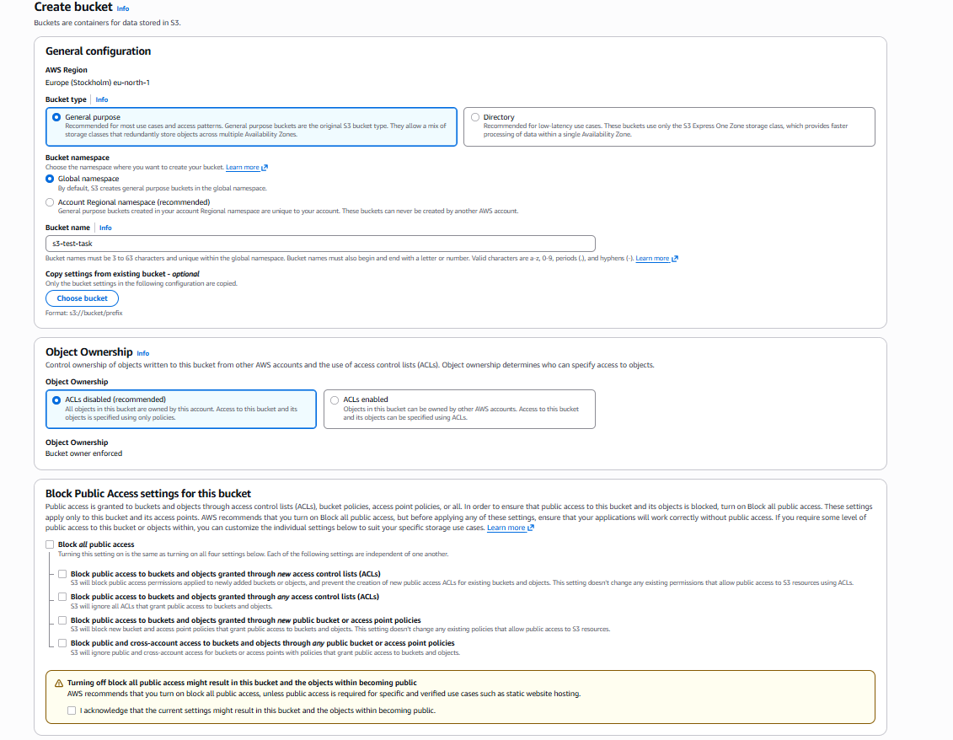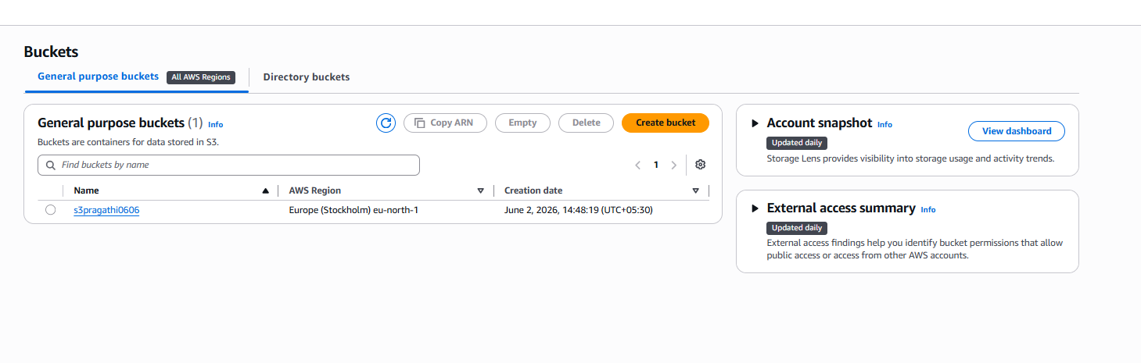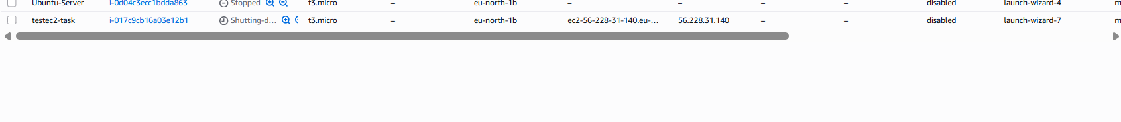
2-Create one group in IAM and assign read access for EC2.
Objective
Create one IAM group and assign read-only access for EC2.
To verify the group permission properly, I created a new IAM user named:
ec2-readonly-user
This user was added only to the EC2 read-only group.
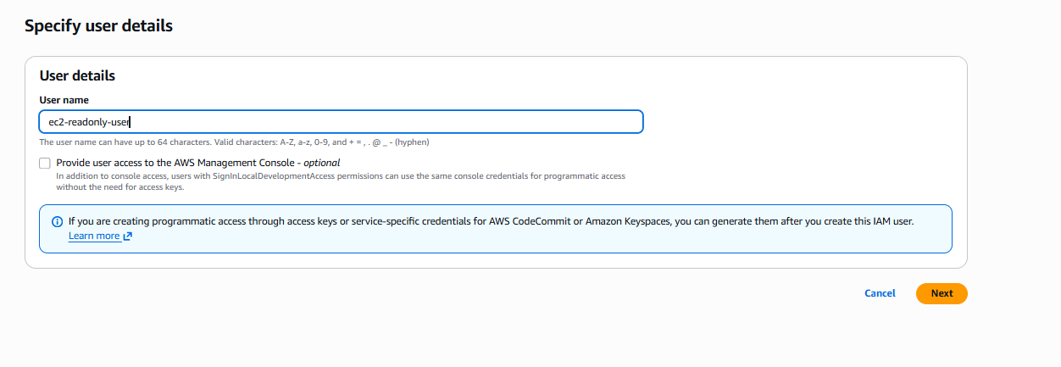Step 1: Open IAM Service
- Logged in to AWS Management Console.
- Searched for IAM.
- Opened the IAM Dashboard.

Step 2: Create IAM User Group
- In IAM, clicked User groups.
- Clicked Create group.
- Entered group name:
EC2-ReadOnly-Group
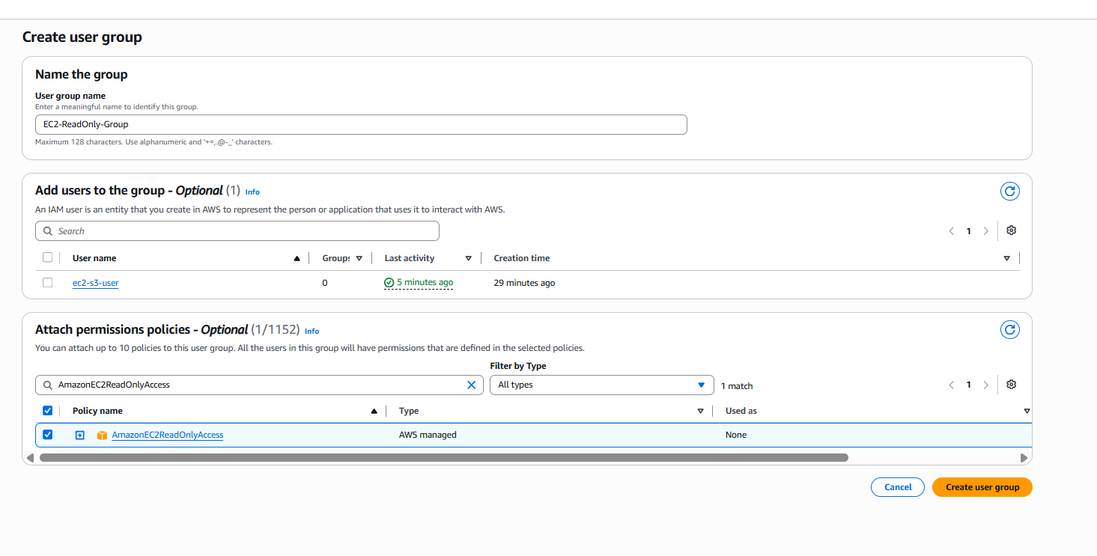ec2-readonly-user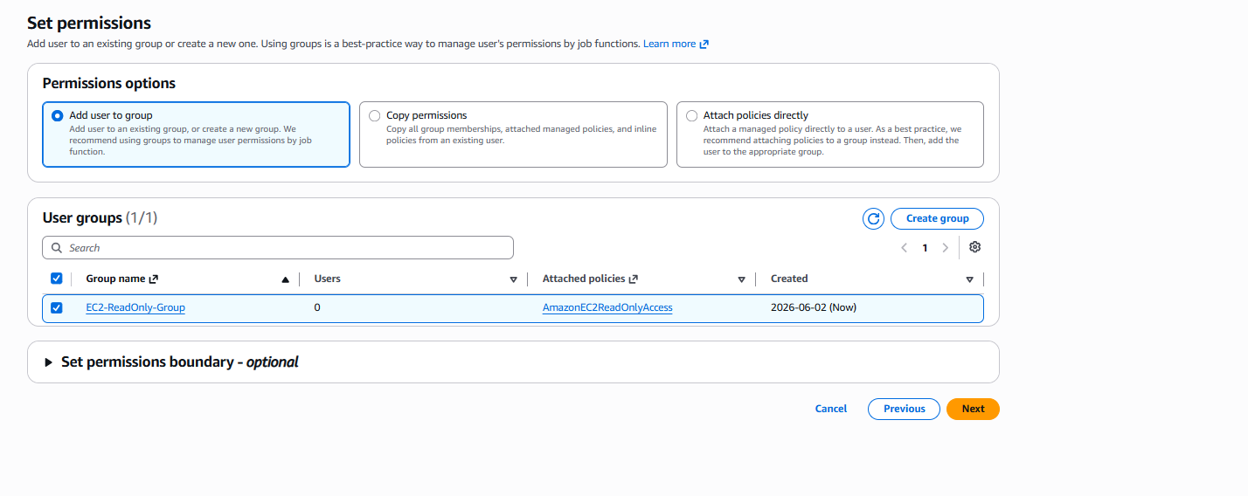
Step 3: Attach EC2 Read-Only Policy
- In the permissions section, searched for:
AmazonEC2ReadOnlyAccess
- Selected the policy.
- This policy gives only view access to EC2 resources.
It allows the user to view:
- EC2 instances
- Security groups
- Volumes
- VPC details
- Subnets
It does not allow the user to:
- Launch instances
- Stop instances
- Terminate instances
- Create security groups

Step 4: Create New IAM User for Testing
I created a new IAM user named:
ec2-readonly-user
I did this because my previous IAM user had EC2 Full Access, so it could still launch instances.
To test read-only access correctly, the new user was created without direct EC2 full access.

Step 5: Add User to Group
- Added ec2-readonly-user to the group:
EC2-ReadOnly-Group
- The user inherited permissions from the group.
- No full access policy was attached directly to this user.

Step 6: Verify EC2 Read-Only Access
- Logged in as ec2-readonly-user.
- Opened the EC2 Dashboard.
- Tried to launch an EC2 instance.
The launch failed with an authorization error:
ec2-readonly-user is not authorized to perform ec2:CreateSecurityGroup

Result
This confirms that the IAM group permission is working correctly.
The user can view EC2 resources, but cannot create or modify EC2 resources.

Final Explanation
I created an IAM group named EC2-ReadOnly-Group and attached the AWS managed policy AmazonEC2ReadOnlyAccess. Then I created a new IAM user named ec2-readonly-user and added it to this group. After logging in with this user, I verified that the user could view EC2 resources but could not launch an EC2 instance. The access denied error confirms that the user has only read-only access.
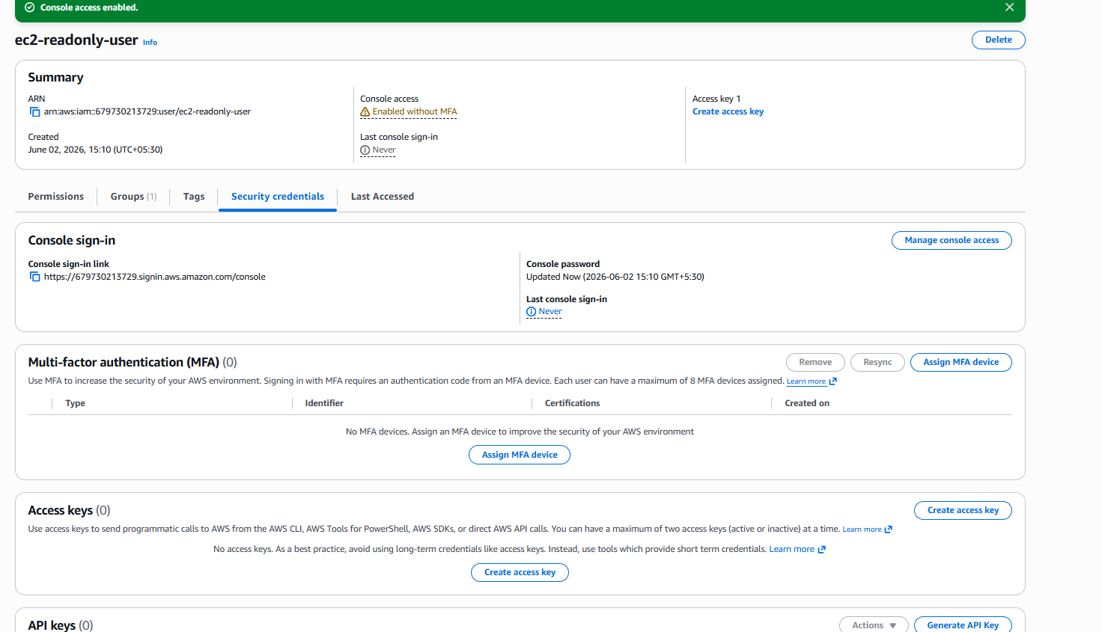https://679730213729.signin.aws.amazon.com/console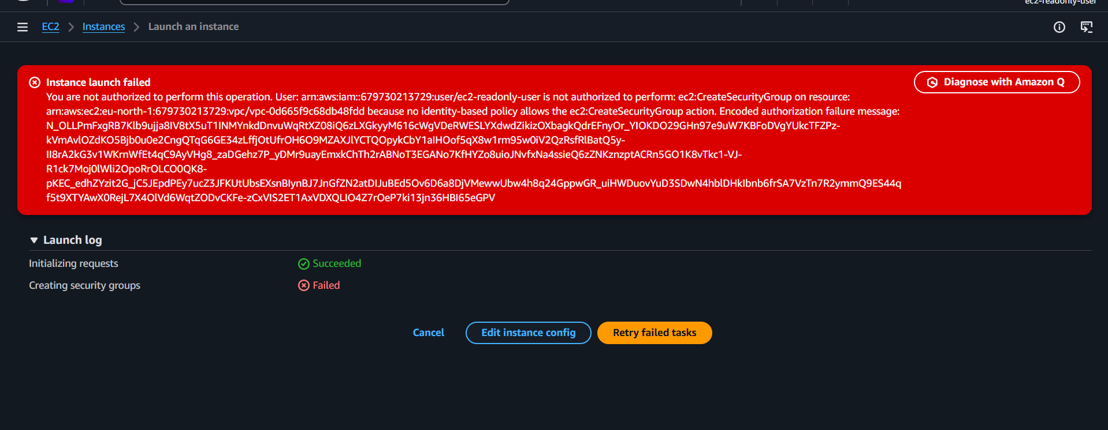

3-Create a new user named "Devops" and add to the group created in task 2.

Objective
In this task, we need to create a new IAM user named Devops and add that user to the group we created in Task 2.
The group created in Task 2 is:
EC2-ReadOnly-Group
This group already has the policy:
AmazonEC2ReadOnlyAccess
So once we add the Devops user to this group, the user will automatically get EC2 read-only permissions.

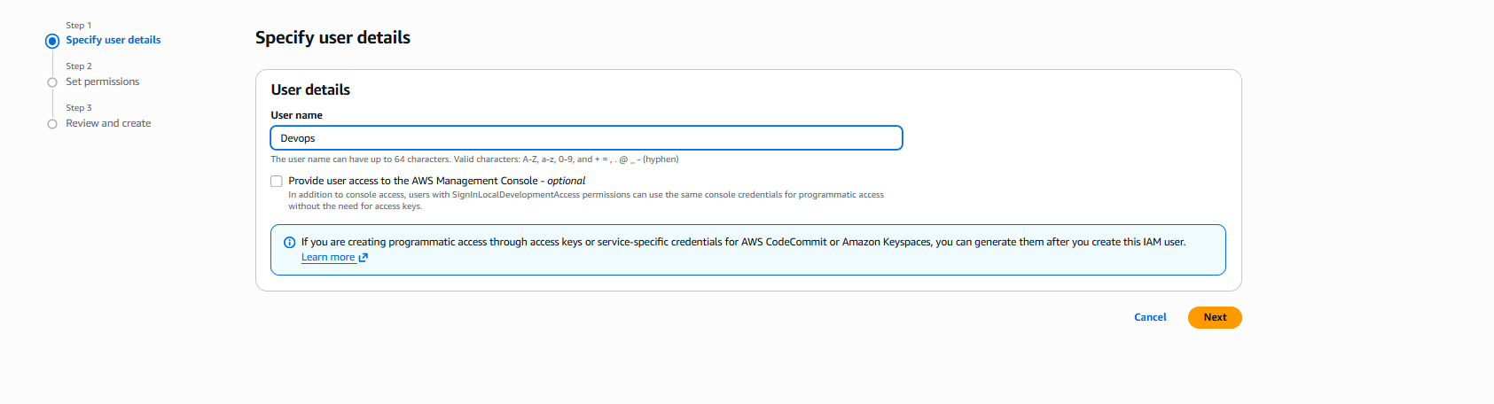Step 1: Open IAM Service
First, I logged in to the AWS Management Console.
Then I searched for IAM in the search bar and opened the IAM service.

Step 2: Go to Users
Inside IAM, I clicked on Users from the left-side menu.
This page shows all IAM users created in the AWS account.

Step 3: Create New User
I clicked Create user.
In the user name field, I entered:
Devops
Then I clicked Next.
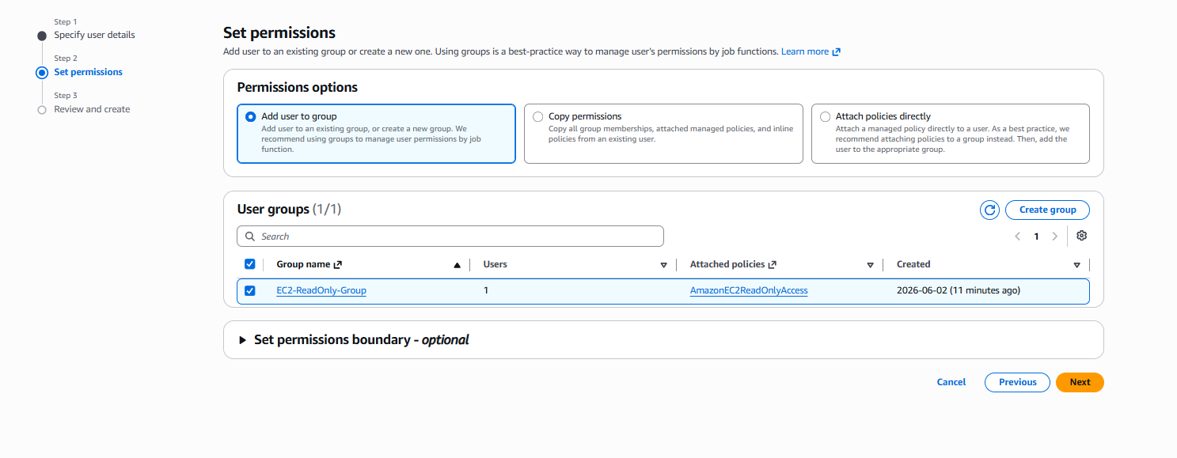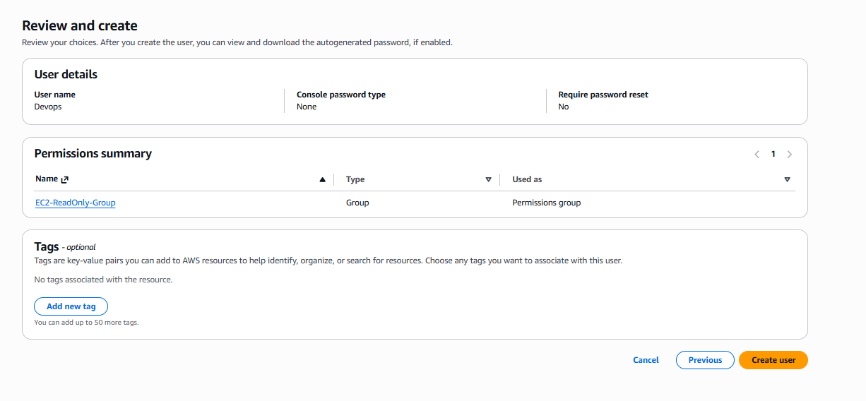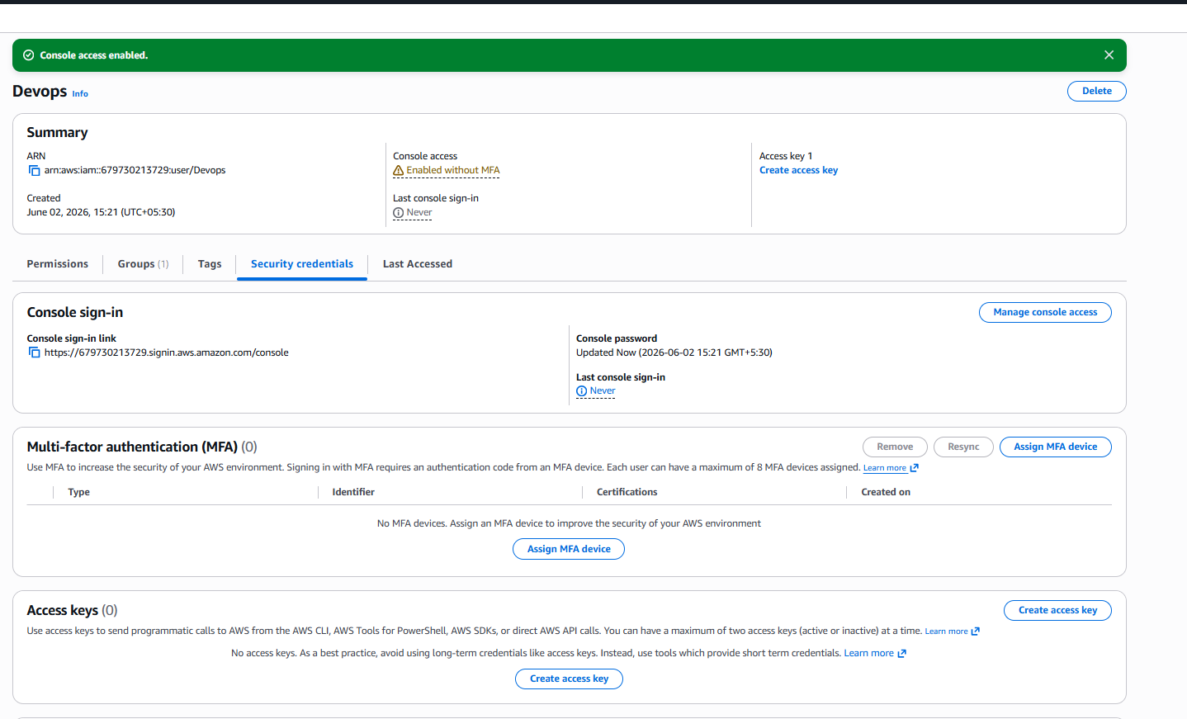Step 4: Add User to Existing Group
On the permissions page, I selected:
Add user to group
Then I selected the group created in Task 2:
EC2-ReadOnly-Group
This group already has AmazonEC2ReadOnlyAccess, so I did not attach any separate policy directly to the user.
Then I clicked Next.

Step 5: Review and Create User
On the review page, I checked the details:
User name: Devops
Group: EC2-ReadOnly-Group
Permission inherited: AmazonEC2ReadOnlyAccess
After reviewing everything, I clicked Create user.

Step 6: Verify User Creation
After the user was created, I opened the Devops user.
Then I checked the Permissions tab.
I verified that the user is part of:
EC2-ReadOnly-Group
This confirms that the user inherited EC2 read-only access from the group.

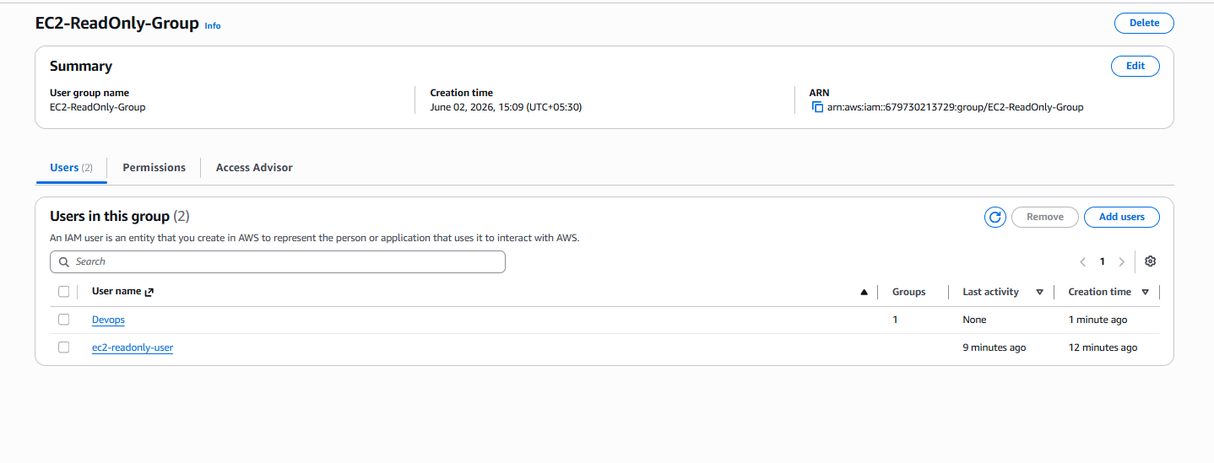 Step 7: Verify Access
To test the access, I logged in as the Devops IAM user.
Then I opened the EC2 service.
The user should be able to view EC2 resources like instances, volumes, security groups, and VPC details.
But the user should not be able to launch, stop, terminate, or modify EC2 resources because the user only has read-only access.

Result
The IAM user Devops was successfully created and added to the EC2-ReadOnly-Group.
Since the group has the AmazonEC2ReadOnlyAccess policy, the Devops user received EC2 read-only access through the group.

4- Write a bash script to create an IAM user with VPC full access. Task 4: Write a Bash Script to Create an IAM User with VPC Full Access Using AWS CloudShell
Objective
The objective of this task is to automate the creation of an IAM user and assign VPC Full Access permissions using a Bash script executed in AWS CloudShell.

Step 1: Open AWS CloudShell
- Logged in to the AWS Management Console.
- Clicked the CloudShell icon from the top navigation bar.
- Waited for the CloudShell terminal to initialize.
CloudShell provides a browser-based command-line environment with AWS CLI pre-installed and pre-configured.

Step 2: Verify AWS CLI Access
To verify that CloudShell was connected to the AWS account, I executed:
aws sts get-caller-identity
This command displays the AWS account and user details currently being used by CloudShell.

Step 3: Create a Bash Script File
I created a new Bash script file named:
create_vpc_user.sh
using the command:
nano create_vpc_user.sh

Step 4: Write the Bash Script
I added the following commands to the script:
#!/bin/bash
aws iam create-user --user-name VPCUser
aws iam attach-user-policy \
--user-name VPCUser \
--policy-arn arn:aws:iam::aws:policy/AmazonVPCFullAccess
echo "User created successfully with VPC Full Access"
The script performs two actions:
- Creates an IAM user named VPCUser
- Attaches the AWS managed policy AmazonVPCFullAccess

Step 5: Save the Script
After entering the script content, I saved the file and exited the Nano editor.

Step 6: Assign Execute Permission
I granted execute permission to the script using:
chmod +x create_vpc_user.sh
This allows the script to be executed as a program.

Step 7: Execute the Script
I executed the script using:
./create_vpc_user.sh
The script automatically created the IAM user and attached the VPC Full Access policy.

Step 8: Verify User Creation
To verify the IAM user was created, I executed:
aws iam get-user --user-name VPCUser

Step 9: Verify Policy Attachment
To confirm that the VPC Full Access policy was attached, I executed:
aws iam list-attached-user-policies --user-name VPCUser
The output displayed:
AmazonVPCFullAccess
confirming that the policy was successfully attached.

Result
Successfully created an IAM user named VPCUser using a Bash script in AWS CloudShell and assigned the AmazonVPCFullAccess policy. The user now has full permissions to manage VPC resources such as VPCs, subnets, route tables, internet gateways, NAT gateways, and security groups.

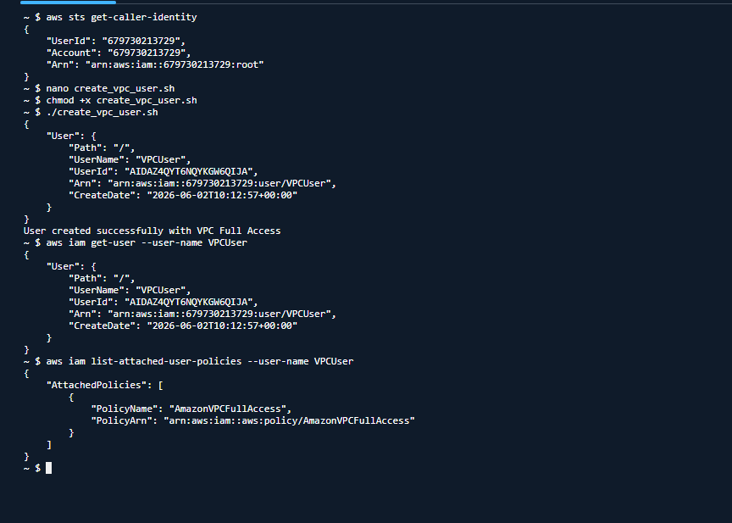

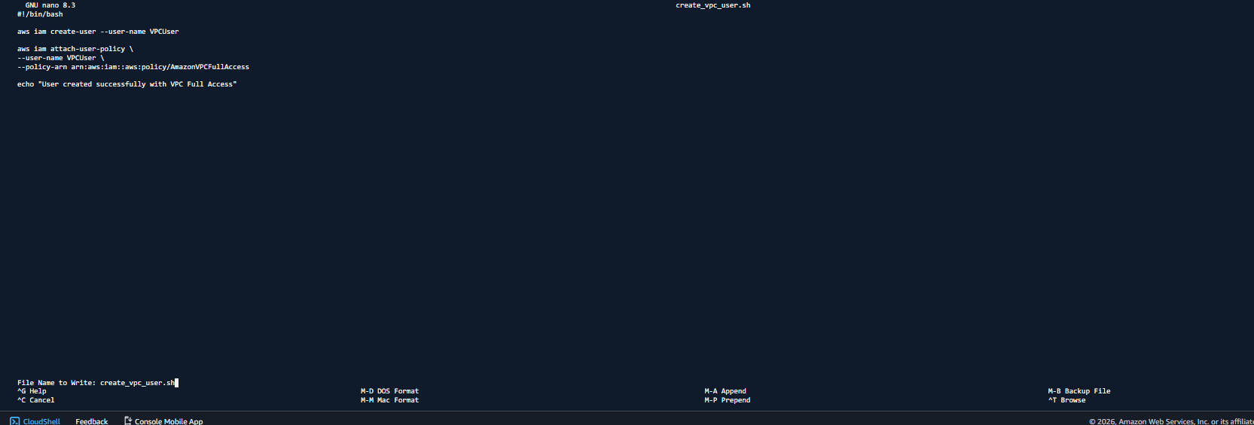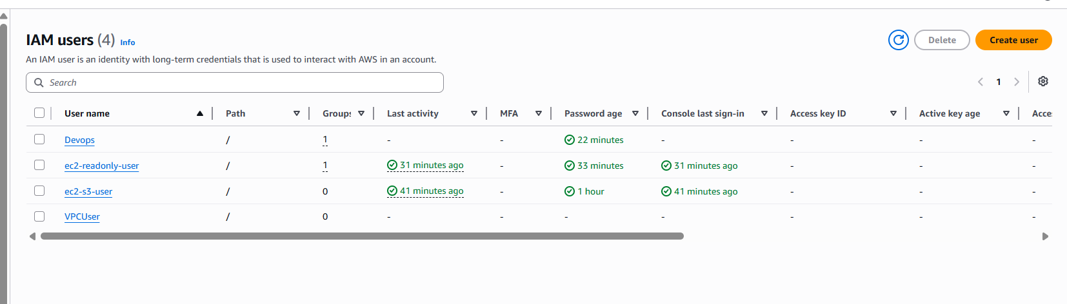

5- Create an IAM policy to allow EC2 access for a specific user in specific regions only.
Objective
The objective of this task is to create a custom IAM policy that allows a user to access and manage EC2 resources only within a specific AWS region. This helps enforce regional restrictions and ensures that resources can be created and managed only in approved locations.

Step 1: Open IAM Service
First, I logged in to the AWS Management Console and opened the IAM service.
IAM is used to manage users, groups, roles, and permissions within AWS.

Step 2: Navigate to Policies
From the left navigation pane, I selected Policies and clicked Create Policy.
This option allows us to create custom permissions based on organizational requirements.

Step 3: Select JSON Editor
In the policy creation page, I selected the JSON tab.
The JSON editor provides complete control over permissions and conditions that can be applied to AWS services.

Step 4: Create Custom Region-Based Policy
I created a custom IAM policy that allows EC2 actions only in the eu-north-1 region.
The policy uses the AWS condition key aws:RequestedRegion to restrict EC2 access to a specific region.
Policy Used:
{
"Version": "2012-10-17",
"Statement": [
{
"Sid": "EC2SpecificRegion",
"Effect": "Allow",
"Action": "ec2:*",
"Resource": "*",
"Condition": {
"StringEquals": {
"aws:RequestedRegion": "eu-north-1"
}
}
}
]
}
This policy allows all EC2 operations only when the request is made in the eu-north-1 region.

Step 5: Create the Policy
After validating the JSON policy, I clicked Next and provided the following details:
Policy Name: EC2-EUNorthOnly-Policy
Description: Allows EC2 access only in the eu-north-1 region.
Then I clicked Create Policy.

Step 6: Attach the Policy to a Specific User
After creating the policy, I navigated to:
IAM → Users
I selected the required IAM user and opened the Permissions tab.
I clicked Add Permissions, selected Attach Policies Directly, searched for the custom policy EC2-EUNorthOnly-Policy, selected it, and attached it to the user.

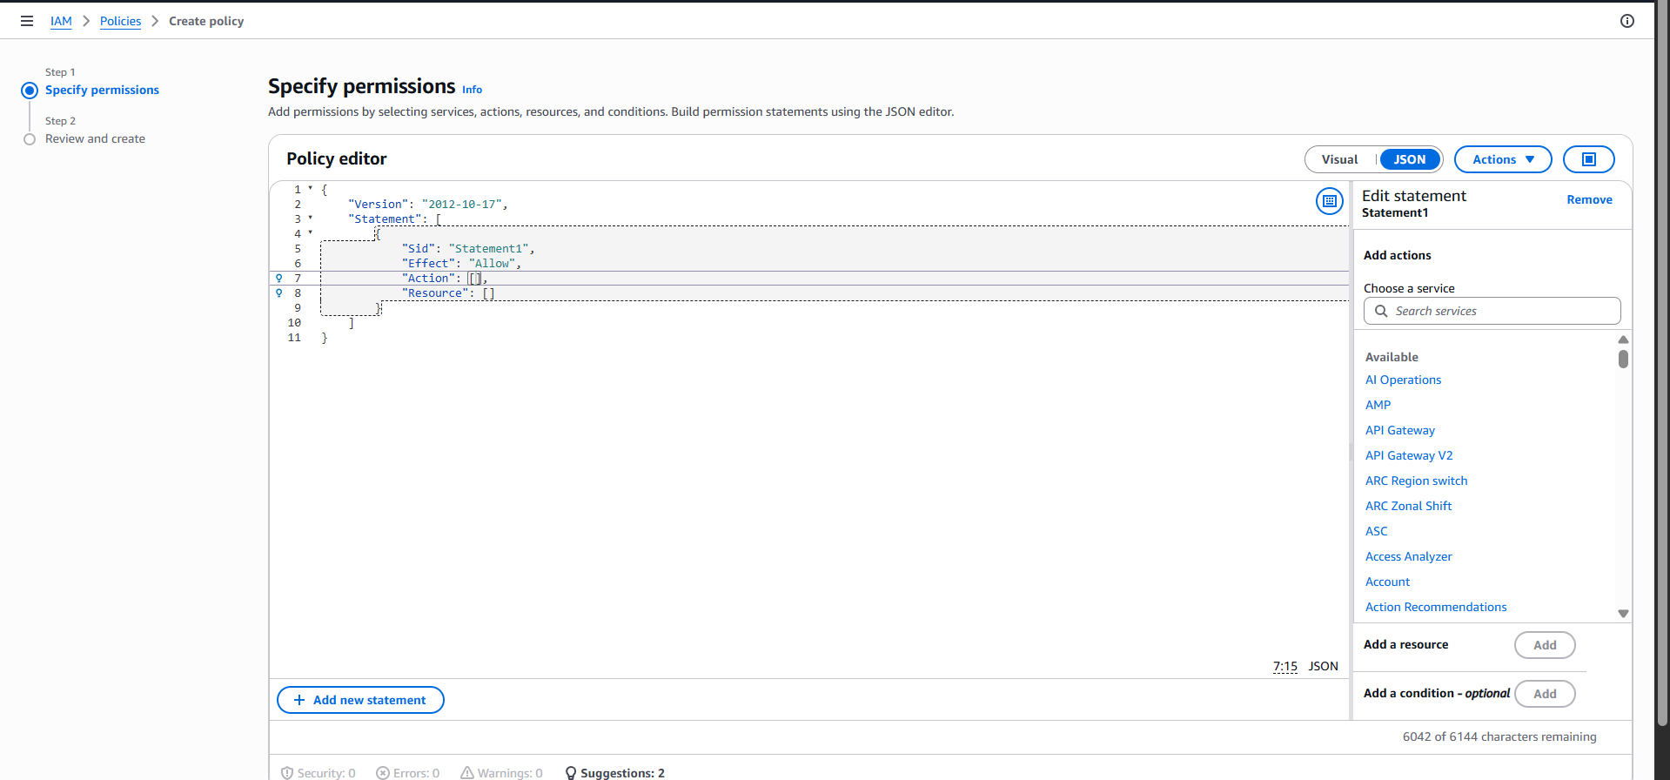 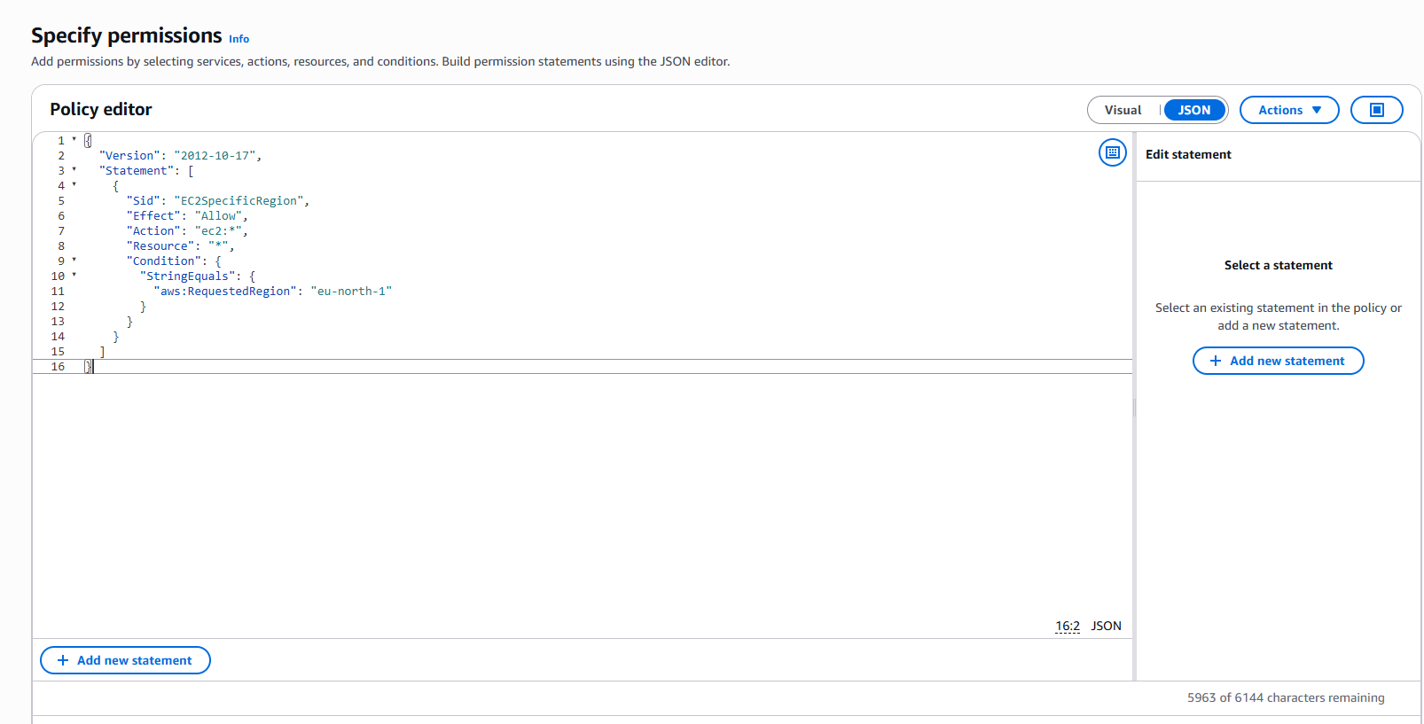 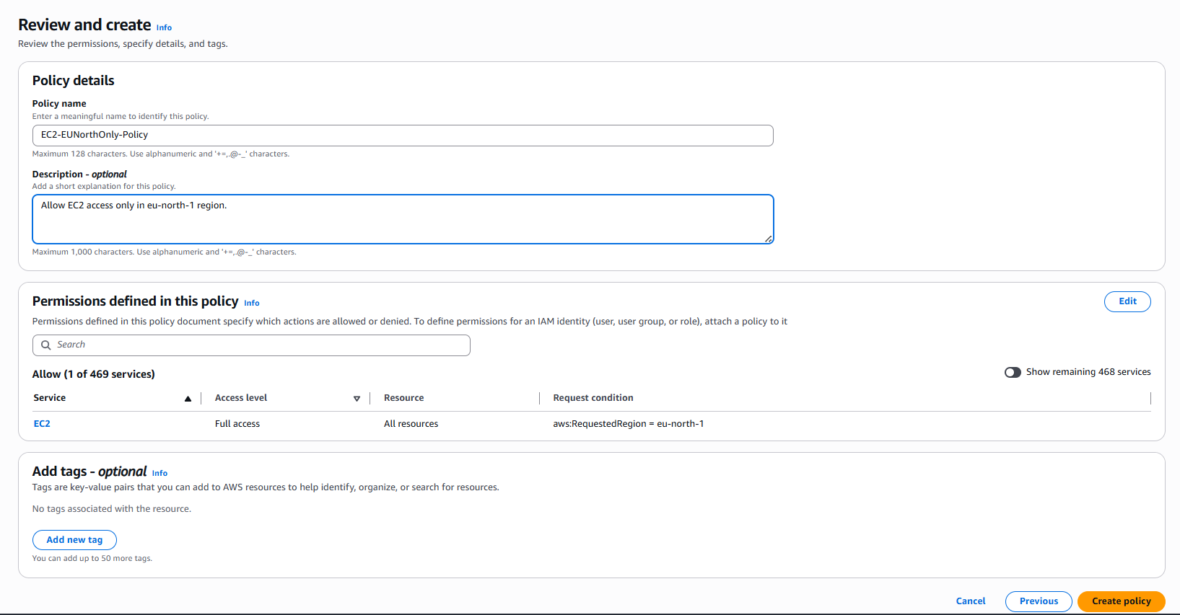 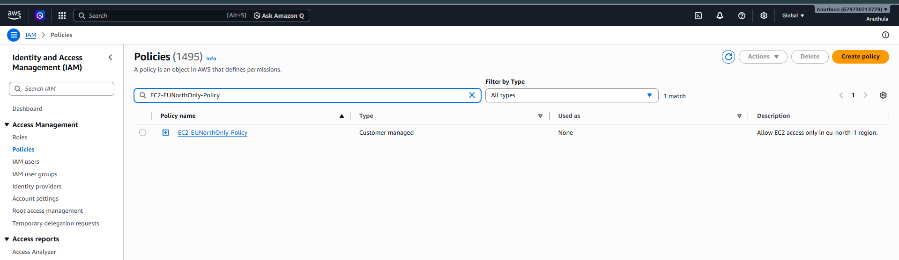 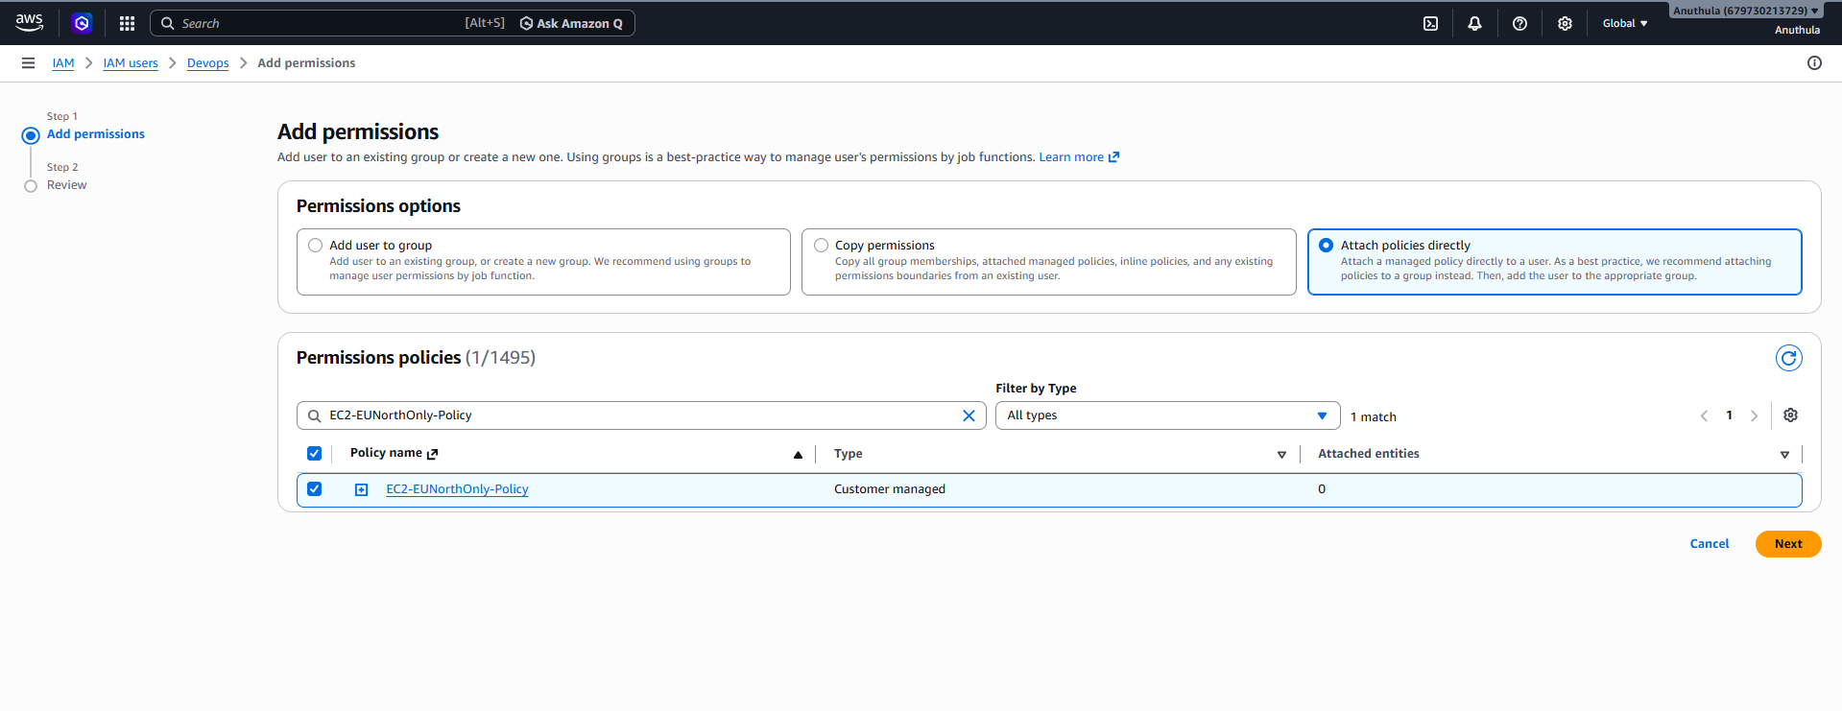 Step 7: Verify the Policy
I logged in using the IAM user and tested EC2 access in different regions.
When the user accessed EC2 in the eu-north-1 region, EC2 operations were allowed.
When the user switched to another AWS region, EC2 operations were restricted according to the policy configuration.
This confirmed that the region-based access control was working correctly.

Result
Successfully created a custom IAM policy that restricts EC2 access to a specific AWS region and attached it to a designated IAM user. The user can perform EC2 operations only in the approved region, improving governance, compliance, and access control within the AWS environment.
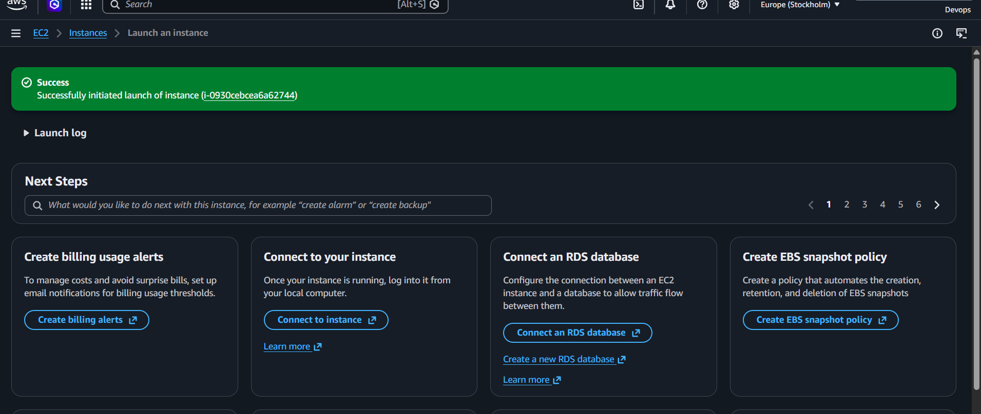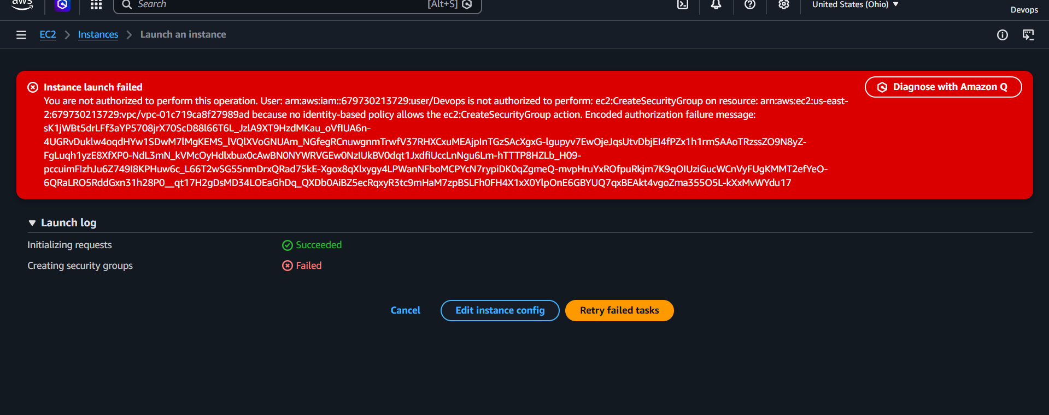

Task 6: Configure Cross-Account S3 Access Between AWS Account A and Account B
Objective
The objective of this task is to allow an IAM user from AWS Account A to access an Amazon S3 bucket located in AWS Account B. This demonstrates Cross-Account Access using AWS IAM and S3 Bucket Policies, a common real-world and interview scenario.

Architecture
AWS Account A
-------------------------
IAM User: accountA-user
|
| Cross-Account Access
|
V
AWS Account B
-------------------------
S3 Bucket: accountb-shared-bucket

Prerequisites
- Access to two AWS accounts:
  - Account A (Source Account)
  - Account B (Target Account)
- IAM permissions to create users and manage S3 bucket policies.
- AWS Management Console access.

Step 1: Create an IAM User in Account A
- Log in to AWS Account A.
- Navigate to IAM Service.
- Select Users.
- Click Create User.
- Enter the username:
accountA-user
- Enable AWS Management Console access if required.
- Assign the following policy:
AmazonS3ReadOnlyAccess
- Complete the user creation process.
Verification
- Verify that the user is listed under IAM Users.
- Confirm that the AmazonS3ReadOnlyAccess policy is attached.
Evidence Required
- Screenshot of IAM User Creation.
- Screenshot showing attached permissions.
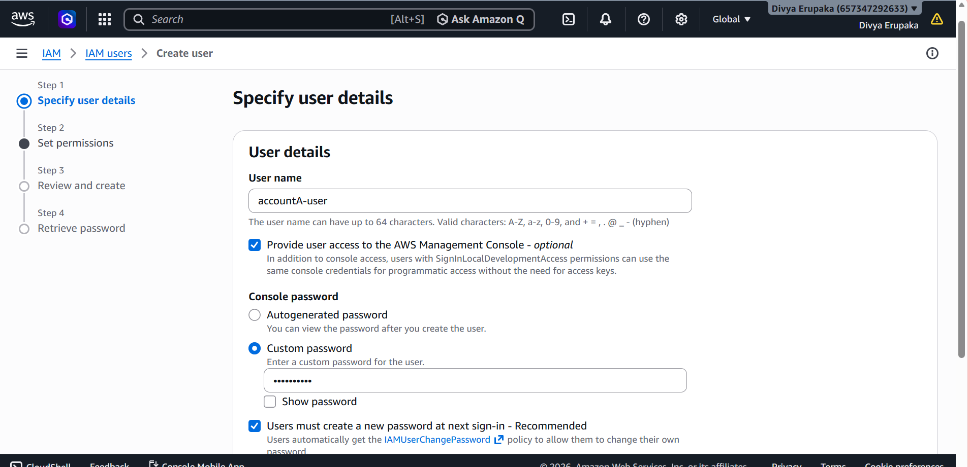
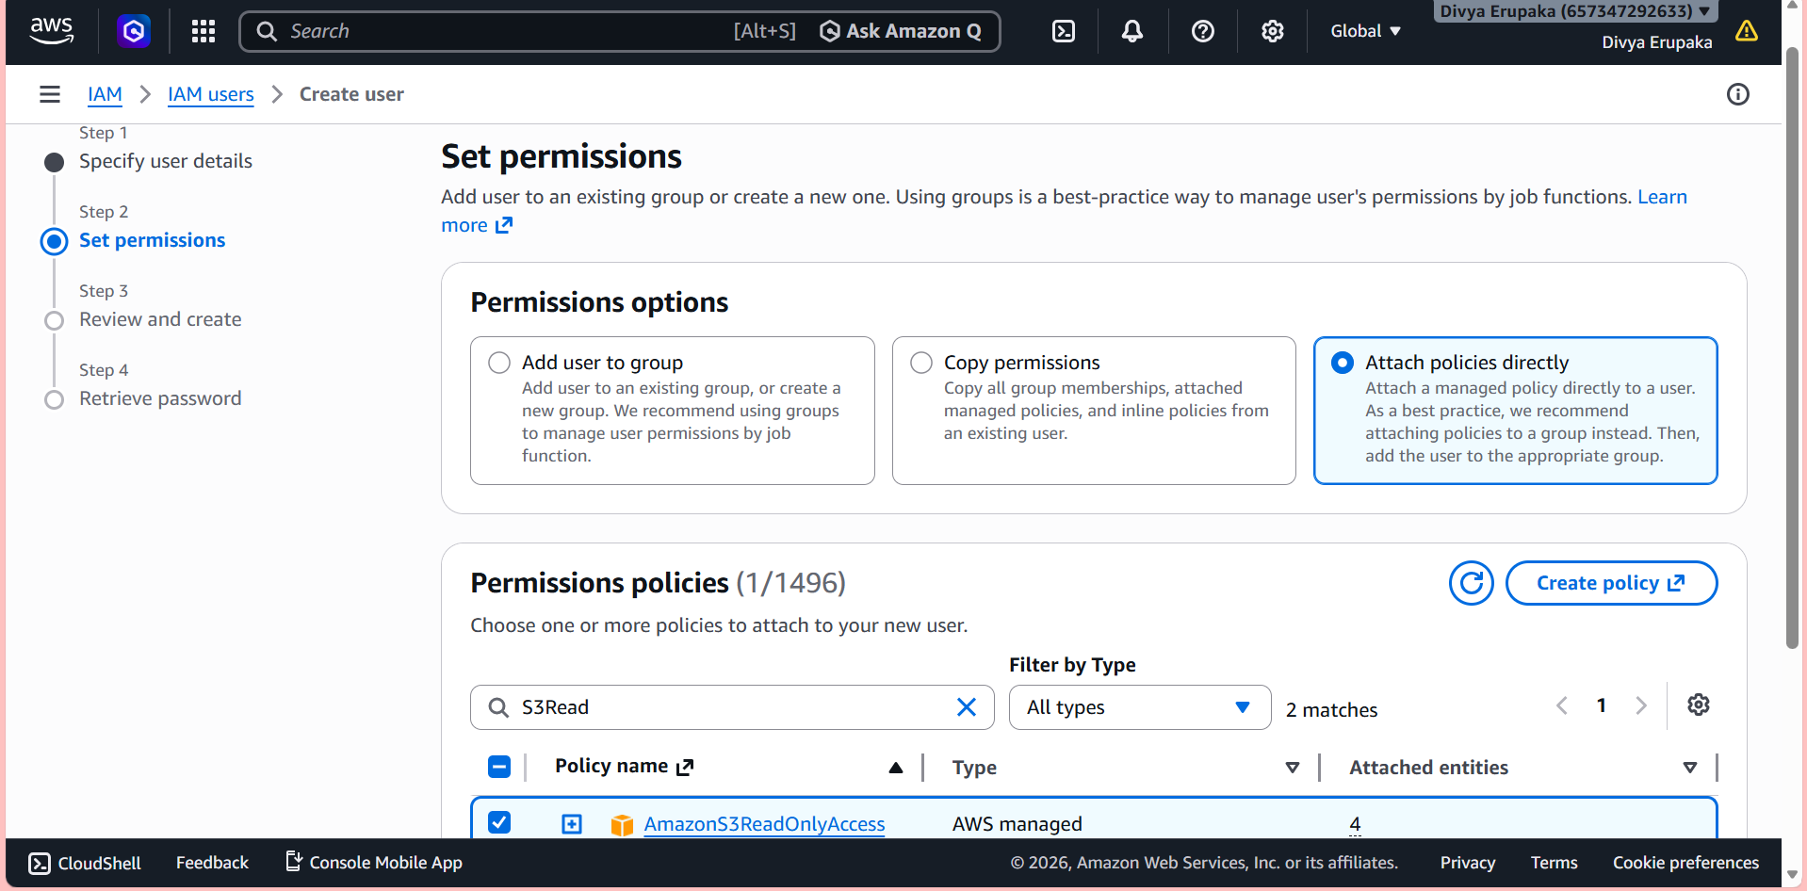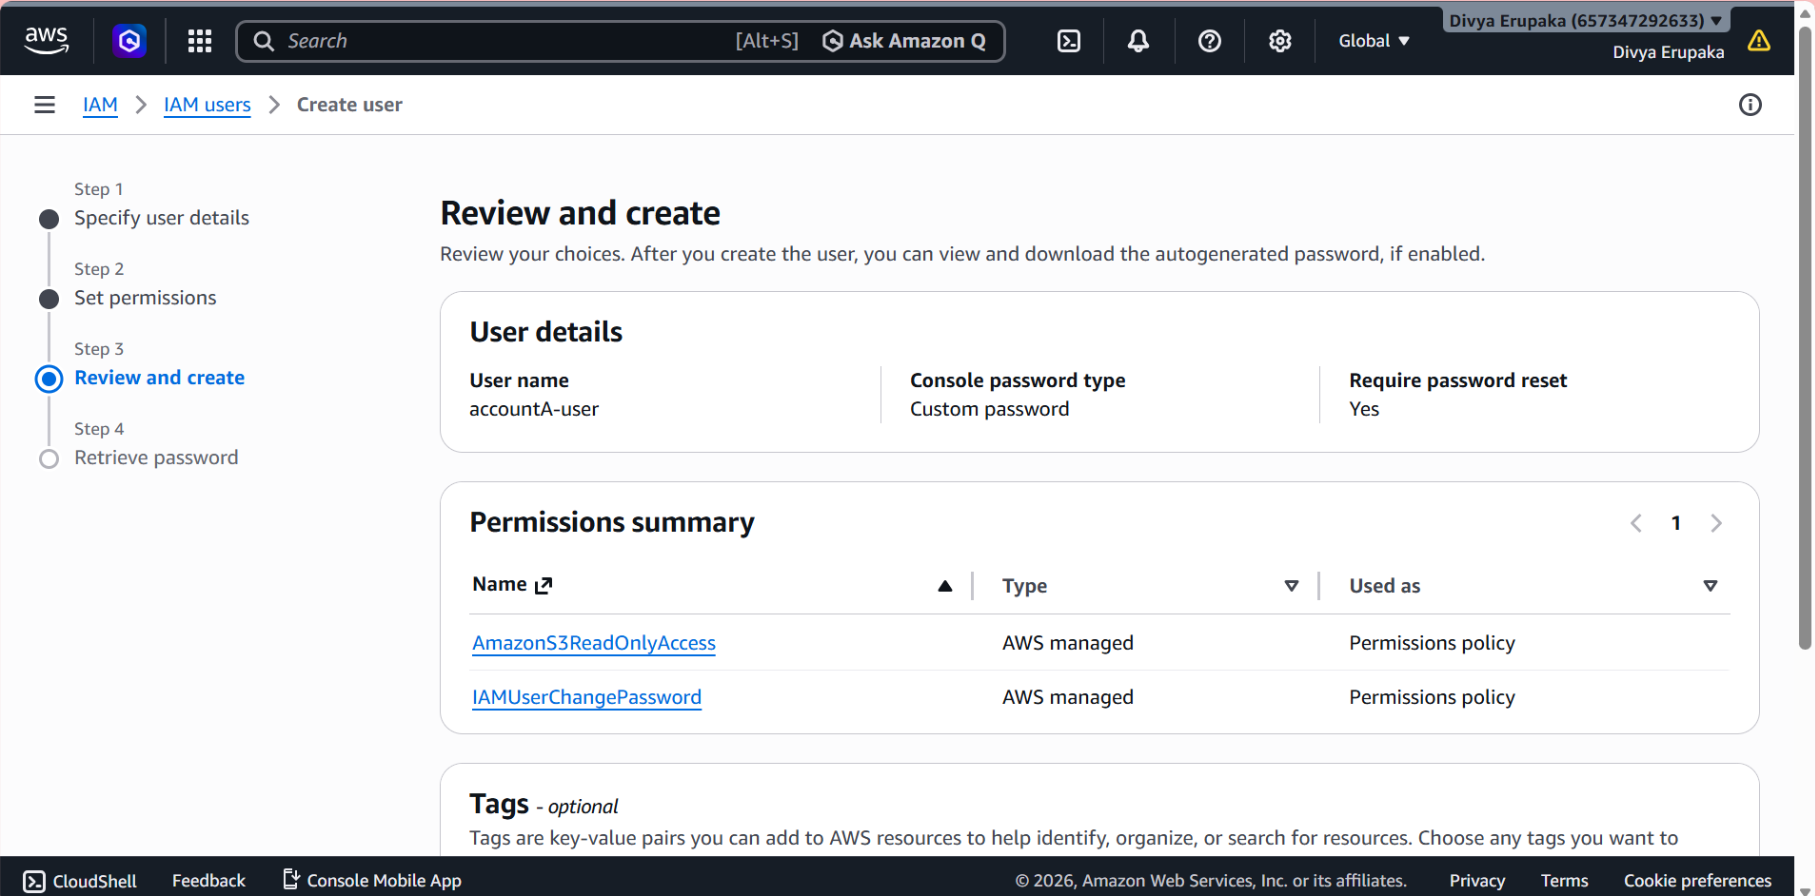

Step 2: Create an S3 Bucket in Account B
- Log in to AWS Account B.
- Navigate to Amazon S3.
- Click Create Bucket.
- Enter the bucket name:
accountb-shared-bucket
- Create the bucket.
- Upload a test file:
test.txt
Verification
- Confirm bucket creation.
- Verify that test.txt is uploaded successfully.
Evidence Required
- Screenshot of S3 Bucket.
- Screenshot showing uploaded file.

Step 4: Configure Bucket Policy in Account B
- Log in to AWS Account B.
- Navigate to:
S3 → accountb-shared-bucket → Permissions → Bucket Policy
- Add the following bucket policy:
{
"Version": "2012-10-17",
"Statement": [
{
"Sid": "AllowAccountAAccess",
"Effect": "Allow",
"Principal": {
"AWS": "arn:aws:iam::111111111111:root"
},
"Action": [
"s3:ListBucket",
"s3:GetObject"
],
"Resource": [
"arn:aws:s3:::accountb-shared-bucket",
"arn:aws:s3:::accountb-shared-bucket/*"
]
}
]
}
- Replace:
  - 111111111111 with Account A Account ID.
  - accountb-shared-bucket with your bucket name.
- Save the bucket policy.
Verification
- Bucket policy saves successfully without errors.
Evidence Required
- Screenshot of Bucket Policy.

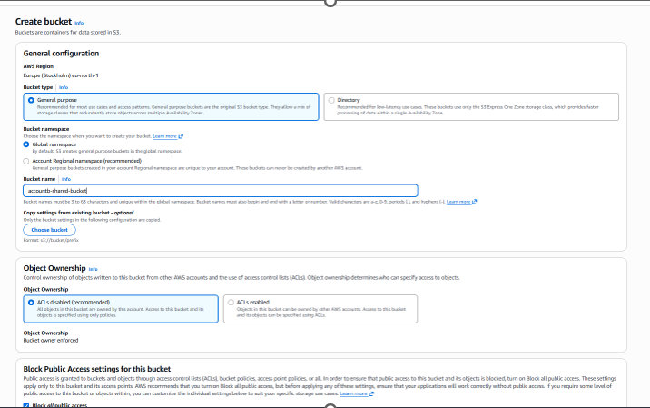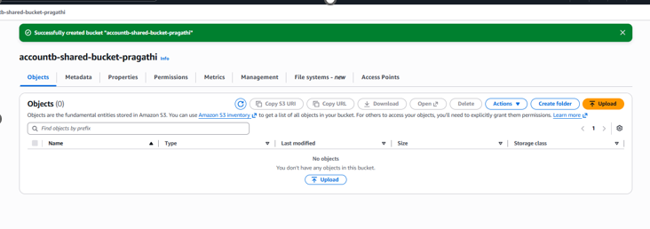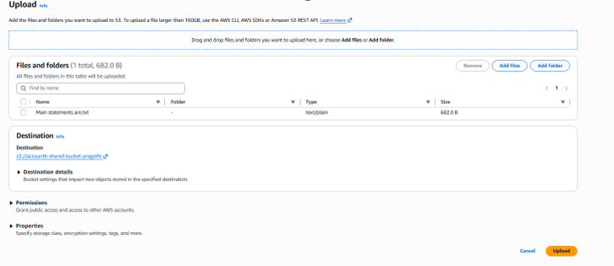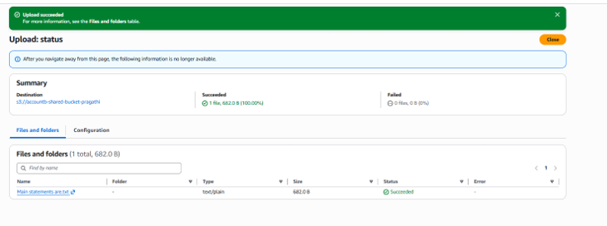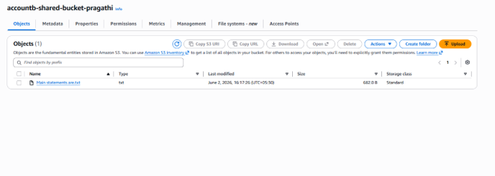
Step 3: Obtain Account A AWS Account ID
- Log in to Account A.
- Click on the account name in the top-right corner.
- Copy the AWS Account ID.
Alternatively, execute:
aws sts get-caller-identity
Example Output:
{
"Account": "111111111111"
}
Evidence Required
- Screenshot showing AWS Account ID.
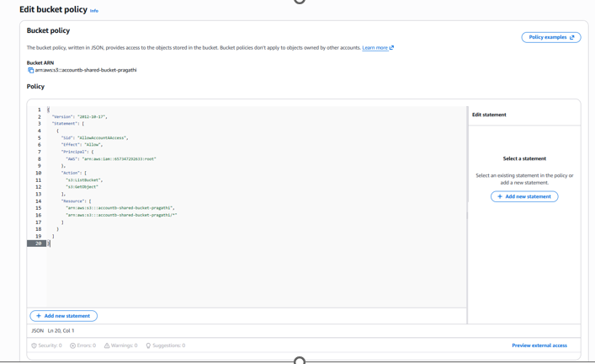
Step 5: Verify Access from Account A
Method 1: AWS Management Console
- Log in using accountA-user.
- Navigate to Amazon S3.
- Open the bucket:
accountb-shared-bucket
Expected Result
- Bucket is visible.
- Objects are visible.
- test.txt is accessible.
- File download is successful.
Evidence Required
- Screenshot showing bucket access.
- Screenshot showing object visibility.
- Screenshot showing successful download.
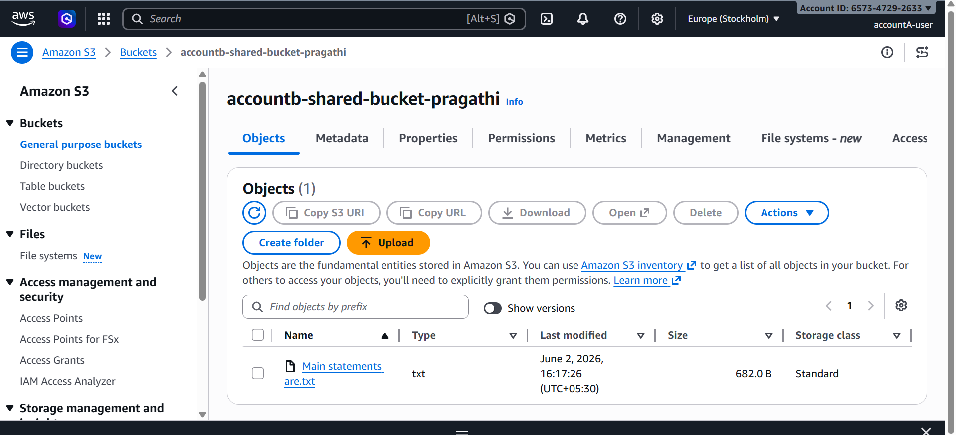
Step 6: Verify Access Using AWS CLI
Configure AWS CLI using accountA-user credentials.
List bucket contents:
aws s3 ls s3://accountb-shared-bucket
Expected Output:
test.txt
Download the file:
aws s3 cp s3://accountb-shared-bucket/test.txt .
Expected Output:
download: s3://accountb-shared-bucket/test.txt
Evidence Required
- Screenshot of successful bucket listing.
- Screenshot of successful file download.

Troubleshooting
Access Denied Error
Verify the following:
- Bucket policy is configured correctly.
- Correct AWS Account ID is used.
- IAM user in Account A has S3 permissions.
- Bucket name is correct.
- Object exists in the bucket.

Result
Successfully configured Cross-Account S3 Access between AWS Account A and AWS Account B. The IAM user in Account A was able to access and download objects from the S3 bucket located in Account B through a bucket policy, demonstrating secure resource sharing across AWS accounts.

