S3-Bucket-Task
1-Creating an Amazon S3 Bucket and Uploading Objects
Objective
The objective of this task is to create an Amazon S3 bucket and upload website files into the bucket. Amazon S3 is an object storage service used to store and retrieve files such as HTML pages, images, videos, documents, and backups.

Architecture
Local System
│
▼
Amazon S3 Bucket
│
├── index.html
├── error.html
├── PallaviKidz_Badangpet_Website.html
├── preview.html
├── preview (1).html
└── preview (2).html

Step 1: Login to AWS Console
- Logged in to AWS Management Console.
- Searched for Amazon S3.
- Opened the S3 Dashboard.

Step 2: Create an S3 Bucket
- Clicked Create Bucket.
- Entered bucket name:
pallavikidz-badangpet-demo-12345-679730213729-eu-north-1-an
- Selected Region:
Europe (Stockholm)
eu-north-1
- Kept default bucket settings.
- Clicked Create Bucket.

Step 3: Open the Bucket
After successful creation, opened the bucket:
pallavikidz-badangpet-demo-12345-679730213729-eu-north-1-an

Step 4: Upload Website Files
Clicked Upload and uploaded the following objects:
File Name | Type
index.html | HTML
error.html | HTML
PallaviKidz_Badangpet_Website.html | HTML
preview.html | HTML
preview (1).html | HTML
preview (2).html | HTML

Step 5: Verify Uploaded Objects
Verified that all uploaded files are visible inside the bucket.
Current Object Count:
6 Objects
All objects are stored using:
Storage Class: Standard

Understanding S3 Components
Bucket
Definition
A bucket is a container used to store objects in Amazon S3.
Example
pallavikidz-badangpet-demo-12345-679730213729-eu-north-1-an

Object
Definition
Any file uploaded to an S3 bucket is called an Object.
Examples
index.html
error.html
preview.html

Storage Class
Definition
Storage Class determines how Amazon S3 stores files and how much it costs.
Current Storage Class
Standard
Usage
Used for frequently accessed files.

Benefits of Amazon S3
- Highly Durable Storage
- Highly Scalable
- Secure Object Storage
- Supports Static Website Hosting
- Supports Versioning
- Supports Lifecycle Policies
- Supports Backup and Archival Storage

Result
Successfully created an Amazon S3 bucket named:
pallavikidz-badangpet-demo-12345-679730213729-eu-north-1-an
and uploaded six website-related HTML files into the bucket. The uploaded files are stored as S3 objects using the Standard storage class and are available for further use such as static website hosting.

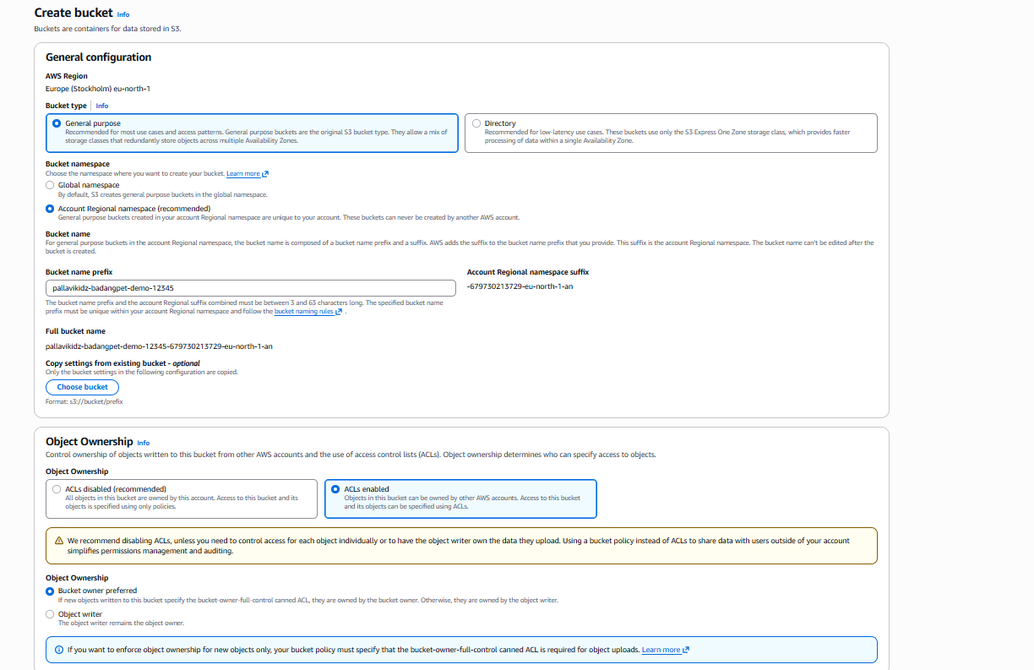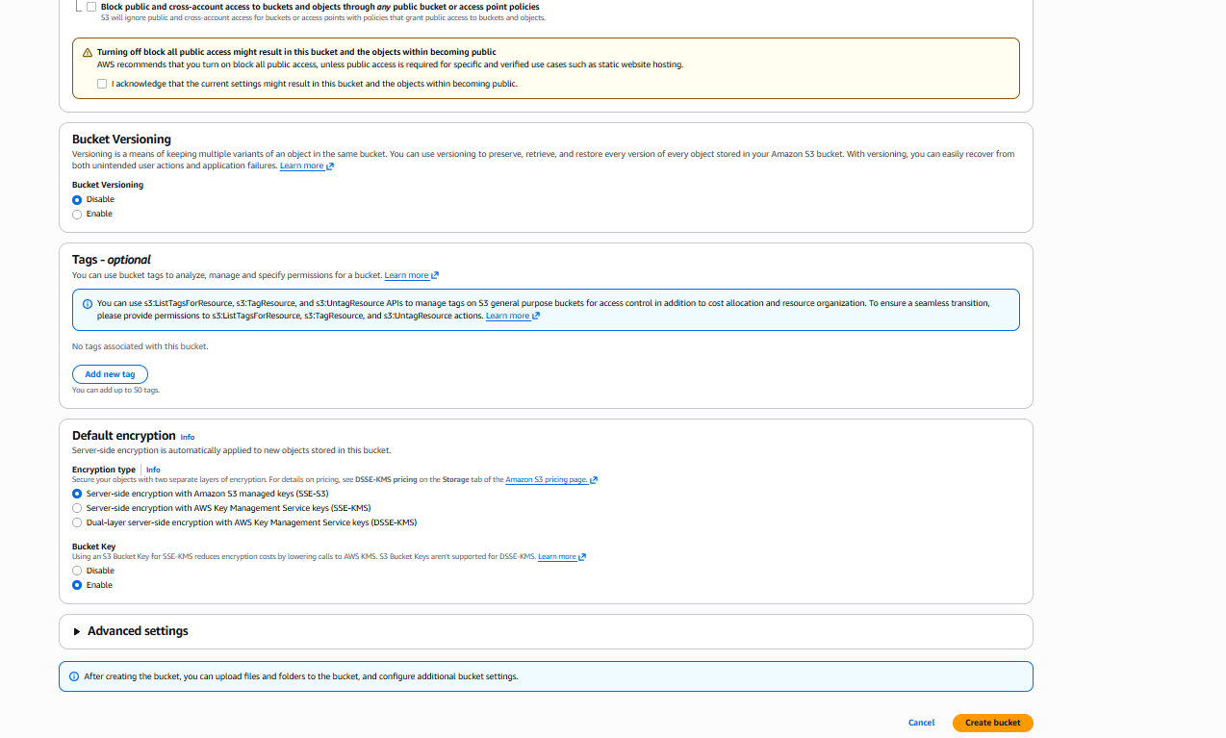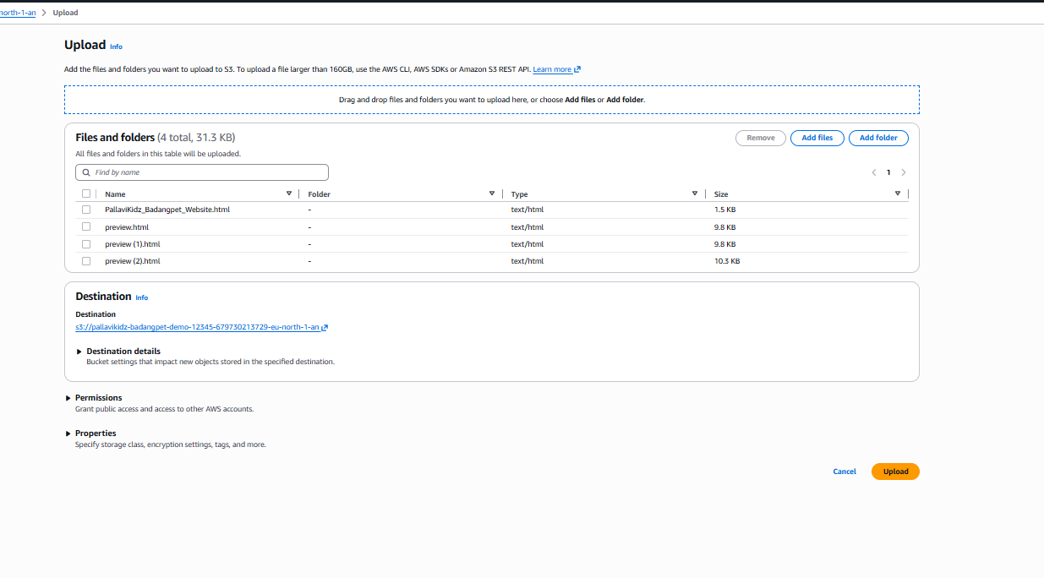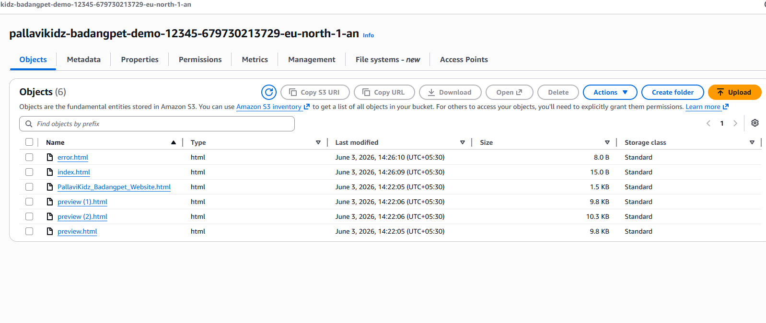

Task 2: Deploy a Static Website in Amazon S3
Objective
The objective of this task is to host a static website using Amazon S3. Static website hosting allows HTML pages, CSS files, JavaScript files, images, and other static content to be served directly from an S3 bucket without using a web server such as Apache or Nginx.

Overview
In this task, a new S3 bucket named:
pragathi-static-website-679730213729
was created to host a static website.
Website files such as:
index.html
error.html
were uploaded to the bucket and configured for website hosting.

Step 1: Create an S3 Bucket
A new Amazon S3 bucket was created.
Bucket Details
Property | Value
Bucket Name | pragathi-static-website-679730213729
Region | Europe (Stockholm) – eu-north-1
Storage Type | Object Storage
Purpose
The bucket acts as a storage location for website files.

Step 2: Upload Website Files
The following files were uploaded into the bucket:
File Name | Purpose
index.html | Main webpage
error.html | Error page
Purpose
These files contain the website content that will be displayed to users.

Step 3: Enable Static Website Hosting
Static Website Hosting was enabled from the bucket properties.
Configuration
Index Document:
index.html
Error Document:
error.html
Purpose
- index.html is displayed when users access the website.

- error.html is displayed when a requested page is not found.

Step 4: Configure Public Access
By default, S3 buckets are private.
To allow website visitors to access the website:
- Block Public Access settings were modified.
- Public access was enabled for the bucket.
Purpose
Without public access, users would receive:
Access Denied
when opening the website URL.

Step 5: Configure Bucket Policy
A bucket policy was added to grant read access to website visitors.
Bucket Policy Purpose
The policy allows:
s3:GetObject
permission on all objects within the bucket.
This enables users to access:
index.html
images
css files
javascript files
through a browser.

Step 6: Access Website Endpoint
After enabling static website hosting, Amazon S3 generated a website endpoint URL.
Example:
http://pragathi-static-website-679730213729.s3-website.eu-north-1.amazonaws.com
Purpose
The endpoint URL is used to access the hosted website through a web browser.

Architecture Diagram
User Browser
│
▼
S3 Website Endpoint
│
▼
S3 Bucket
│
├── index.html
└── error.html

Benefits of S3 Static Website Hosting
- No EC2 server required
- Low-cost hosting solution
- Highly scalable
- Highly available
- Easy to configure
- Supports HTML, CSS, JavaScript, and images

Result
Successfully deployed a static website using Amazon S3. The website files were uploaded to the bucket, static website hosting was enabled, public access was configured, and the website became accessible through the S3 Website Endpoint URL.
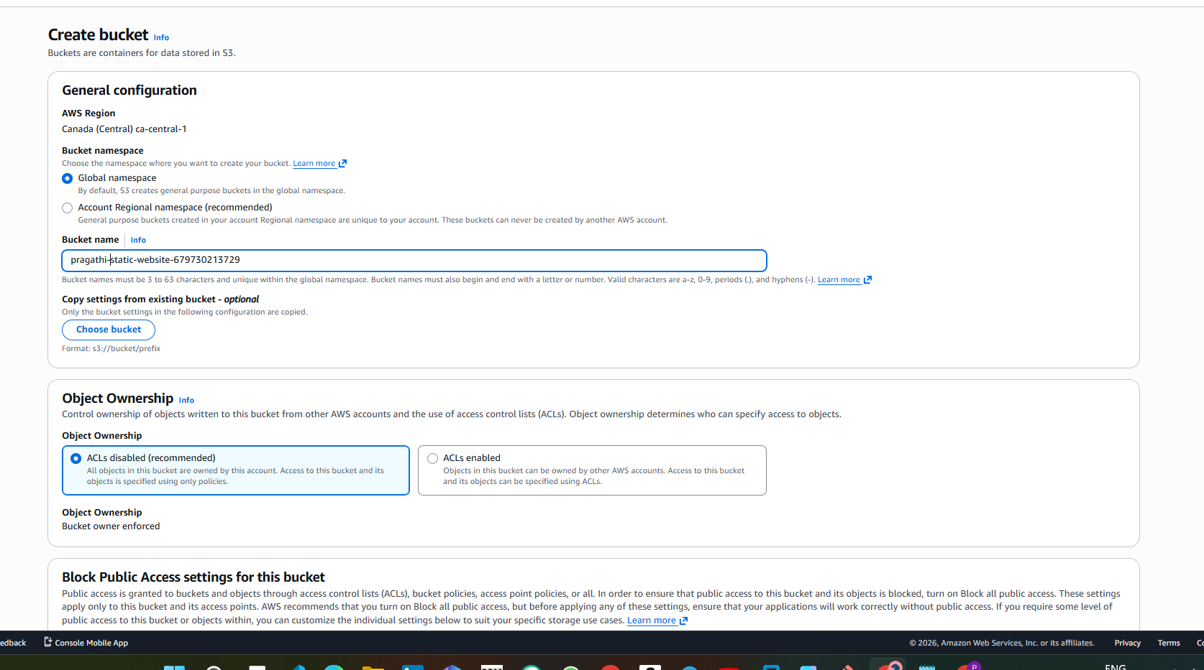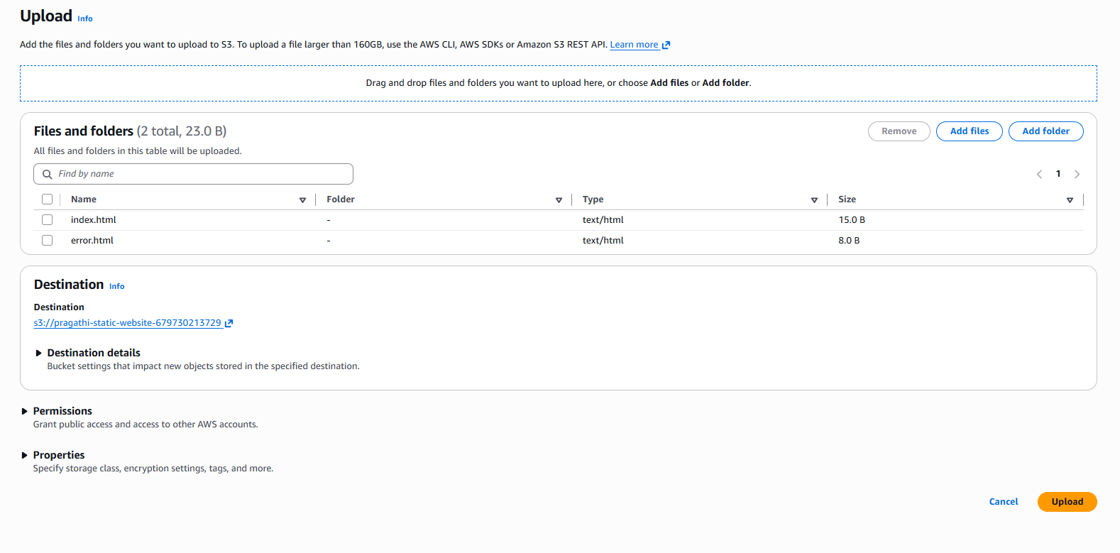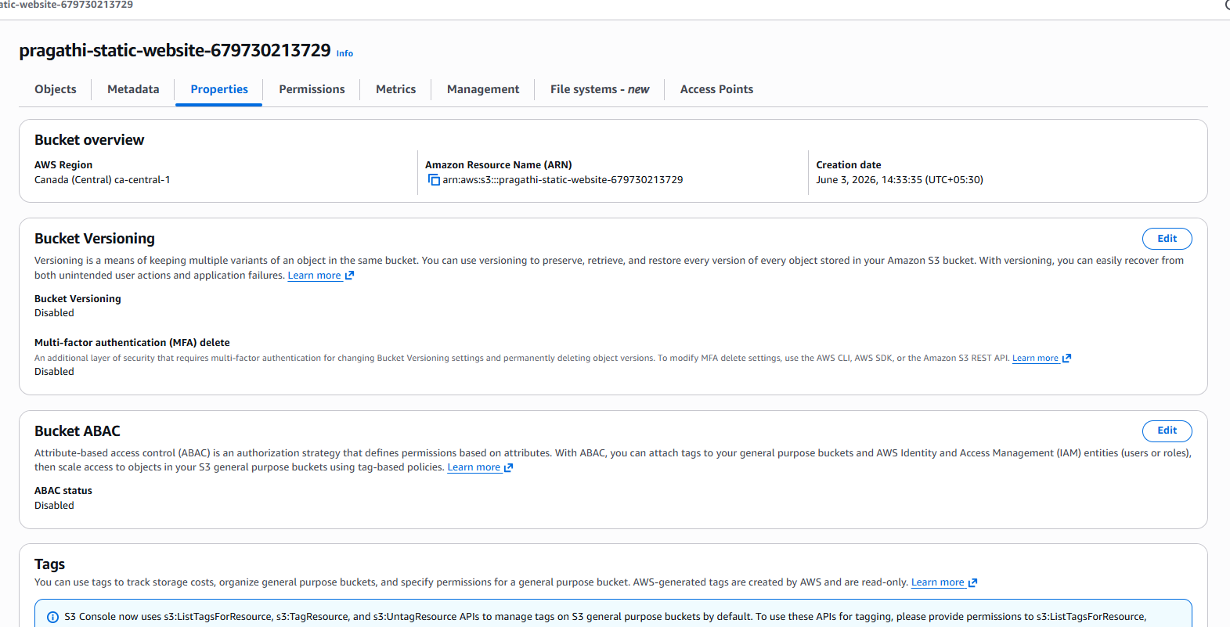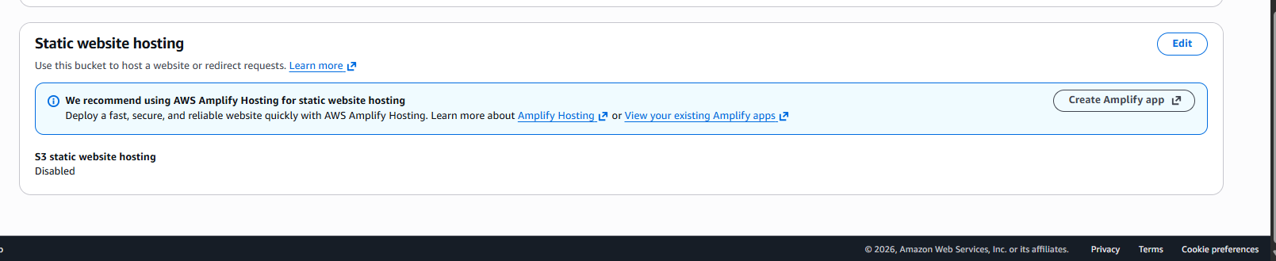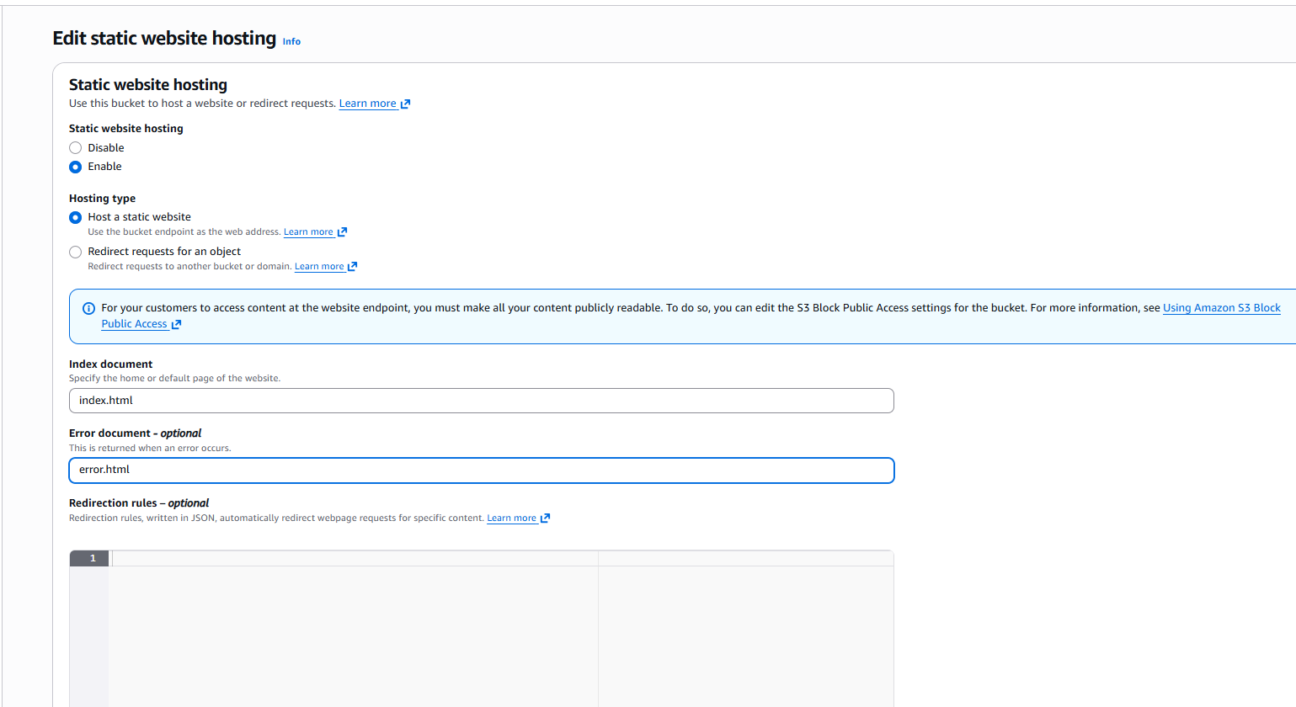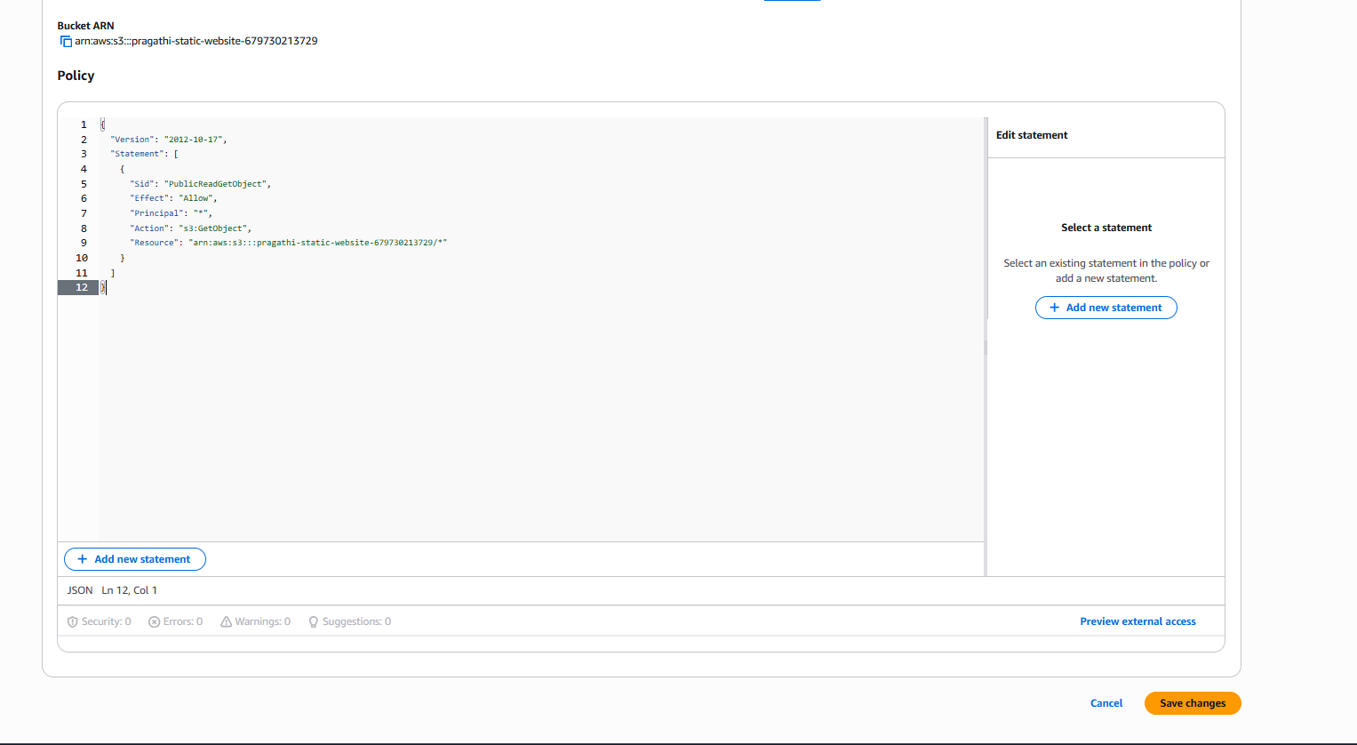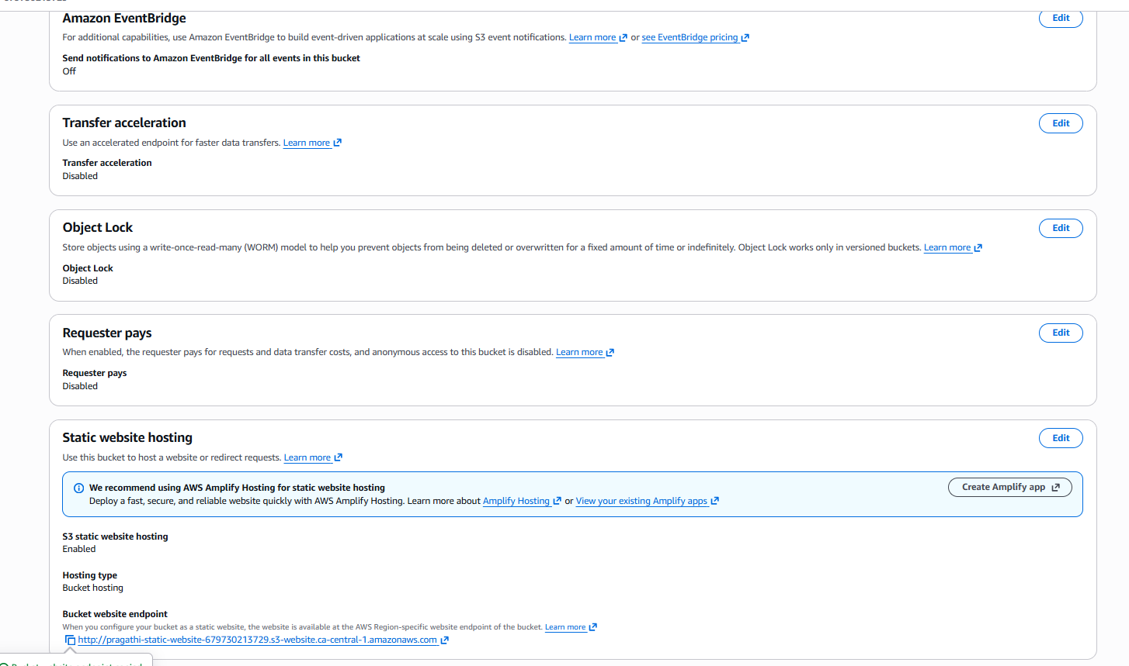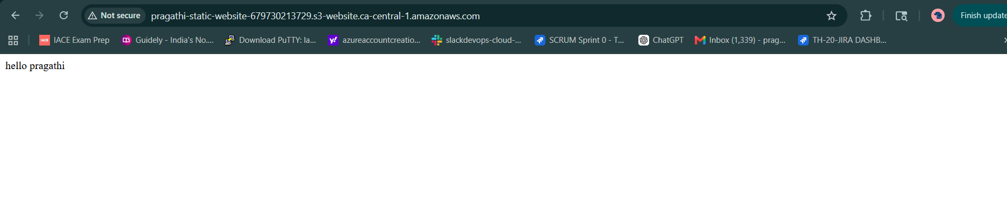

Task 3: Enable Cross-Region Replication (CRR) on Amazon S3 Buckets
Objective
The objective of this task is to configure Amazon S3 Cross-Region Replication (CRR) between two S3 buckets located in different AWS regions. CRR automatically copies objects from a source bucket to a destination bucket, providing disaster recovery, backup, and high availability.

Architecture
Source Bucket (Canada Central)
pragathi-static-website-679730213729
│
│ Cross-Region Replication
▼
Destination Bucket (Mumbai)
pragathi-static-website-backup-679730213729

Prerequisites
- Two Amazon S3 Buckets
- Buckets created in different AWS Regions
- Bucket Versioning enabled on both buckets
- IAM Role for replication

Step 1: Create Source and Destination Buckets
Source Bucket
Property | Value
Bucket Name | pragathi-static-website-679730213729
Region | Canada Central (ca-central-1)
Destination Bucket
Property | Value
Bucket Name | pragathi-static-website-backup-679730213729
Region | Asia Pacific (Mumbai) (ap-south-1)

Step 2: Enable Bucket Versioning
Enabled Versioning on both source and destination buckets.
Source Bucket
Properties
→ Bucket Versioning
→ Enable
→ Save Changes
Destination Bucket
Properties
→ Bucket Versioning
→ Enable
→ Save Changes
Purpose
Versioning is mandatory for Cross-Region Replication because Amazon S3 replicates versioned objects between buckets.

Step 3: Create Replication Rule
Navigated to:
Source Bucket
→ Management
→ Replication Rules
→ Create Replication Rule
Configured:
Setting | Value
Rule Name | CRR-Rule
Status | Enabled
Replication Scope | Entire Bucket

Step 4: Configure Destination Bucket
Selected destination bucket:
pragathi-static-website-backup-679730213729
Destination Region:
Asia Pacific (Mumbai)
ap-south-1
Purpose
The destination bucket receives replicated objects from the source bucket.

Step 5: Configure IAM Role
Selected:
Create New IAM Role
Amazon S3 automatically created the required IAM role and permissions to perform replication between buckets.
Purpose
The IAM role allows Amazon S3 to read objects from the source bucket and write them to the destination bucket.

Step 6: Save Replication Rule
Saved the replication configuration and enabled the replication rule.
Replication Rule Name:
CRR-Rule
Status:
Enabled

Step 7: Verify Replication
Uploaded a test object to the source bucket.
Example:
test-crr.txt
Verified that the object was automatically replicated to the destination bucket after a few minutes.

Benefits of Cross-Region Replication
- Disaster Recovery
- Automatic Backup
- High Availability
- Data Protection
- Compliance Requirements

Result
Successfully configured Amazon S3 Cross-Region Replication between the source bucket pragathi-static-website-679730213729 in Canada Central (ca-central-1) and the destination bucket pragathi-static-website-backup-679730213729 in Mumbai (ap-south-1). A replication rule named CRR-Rule was created, enabling automatic replication of new objects uploaded to the source bucket.
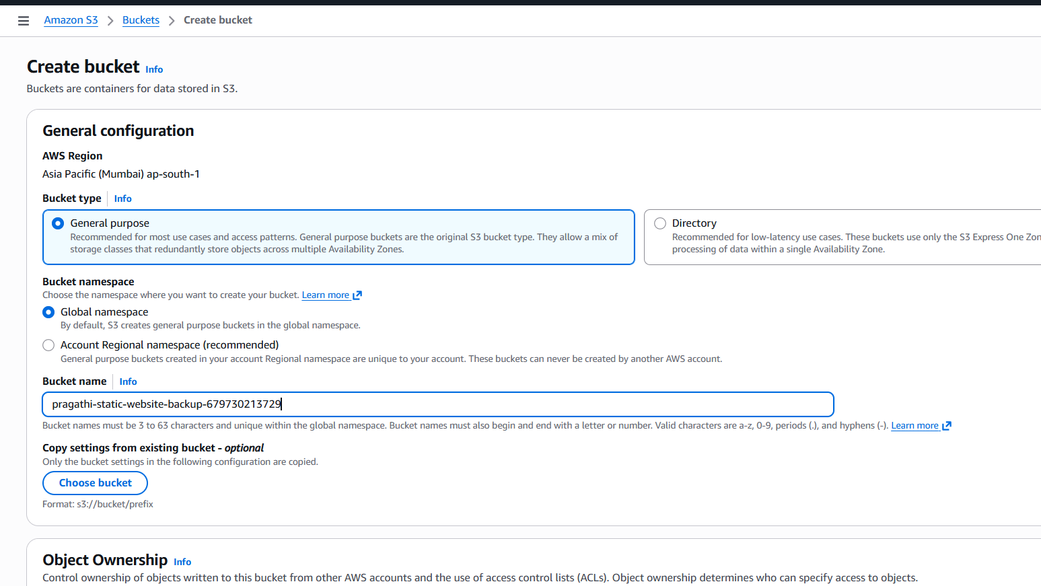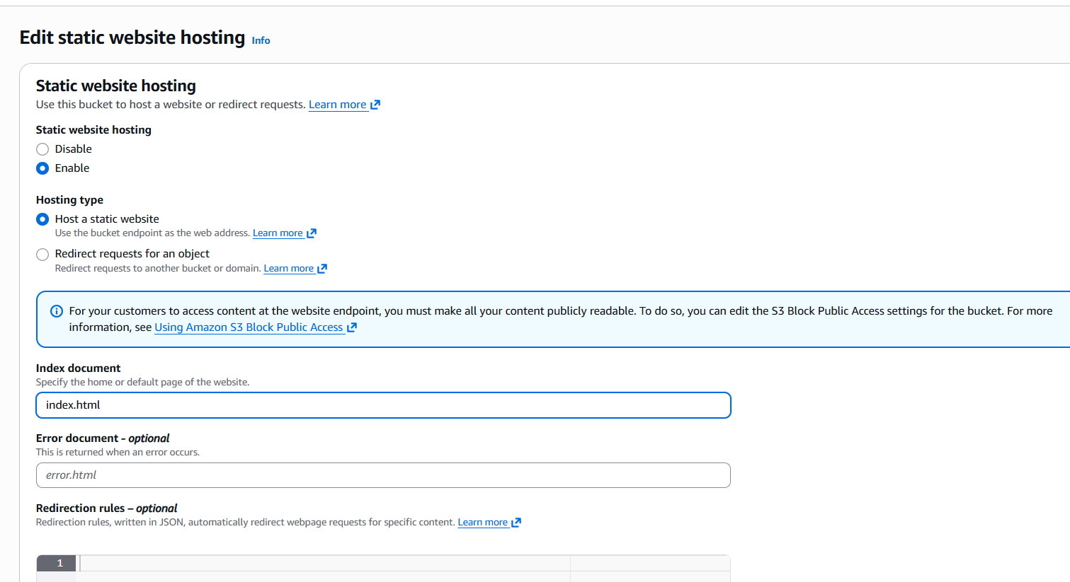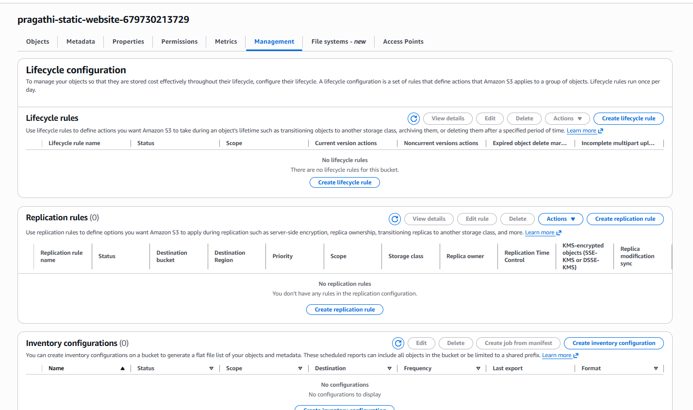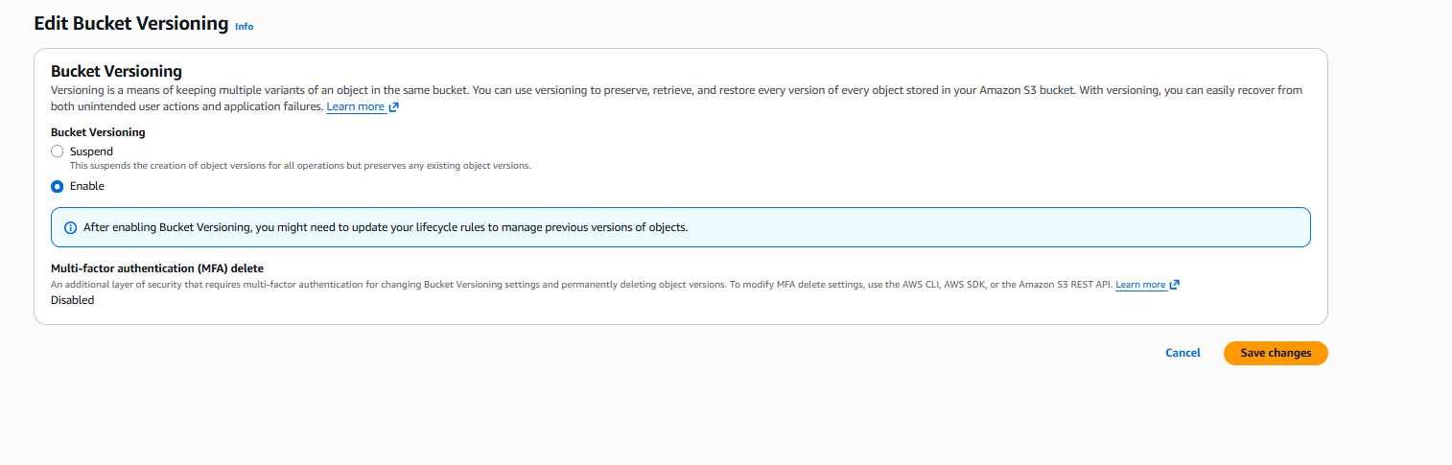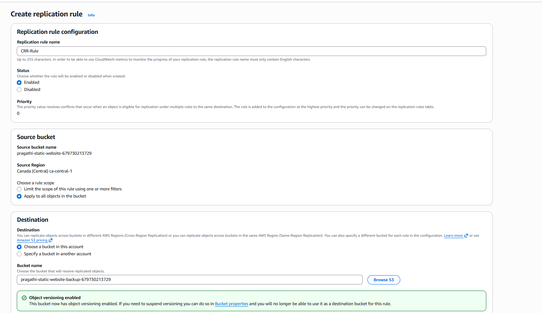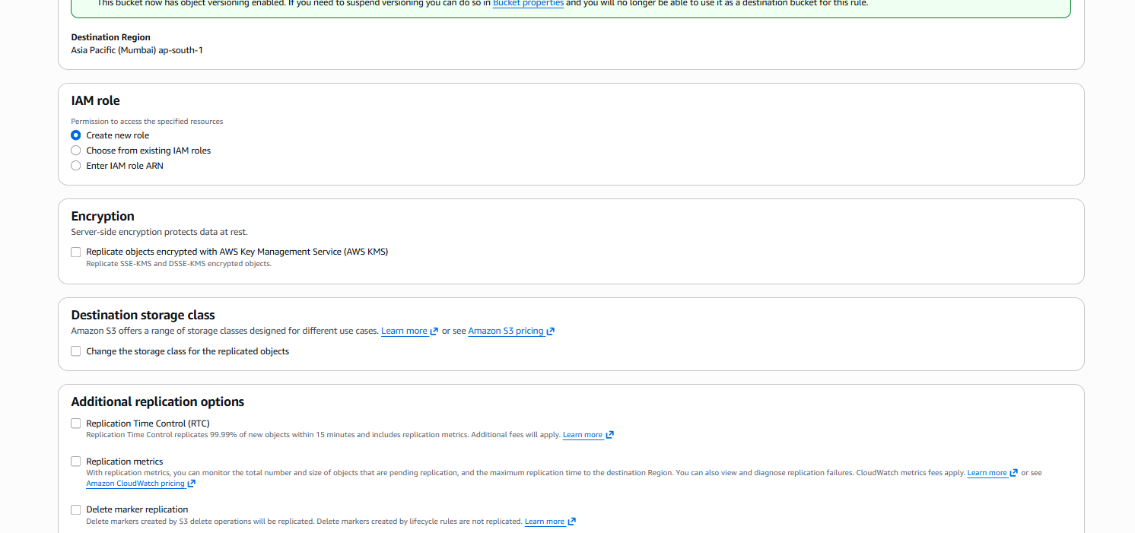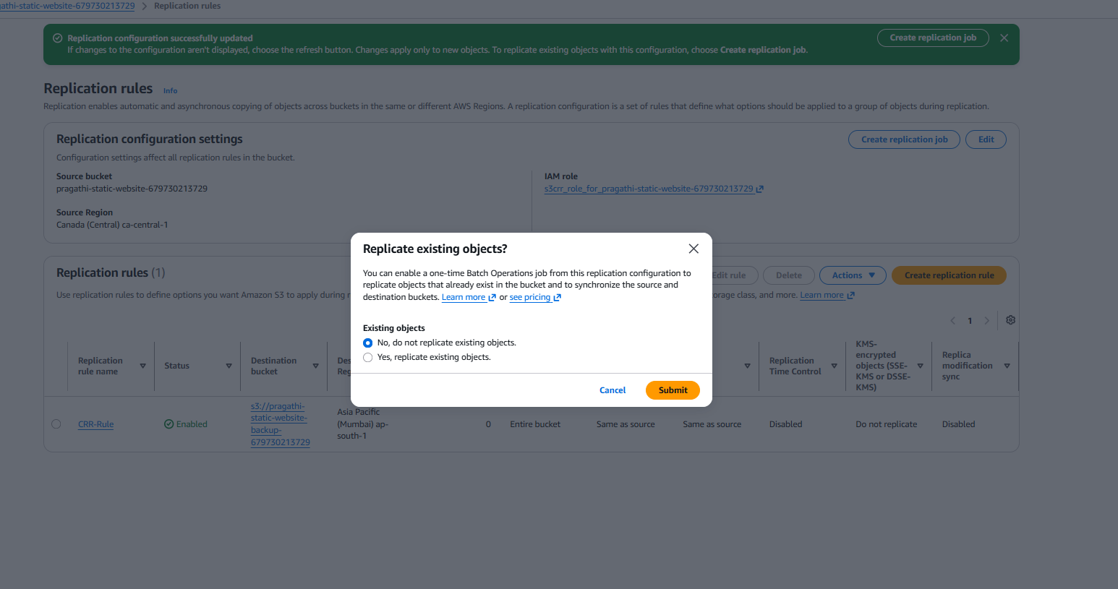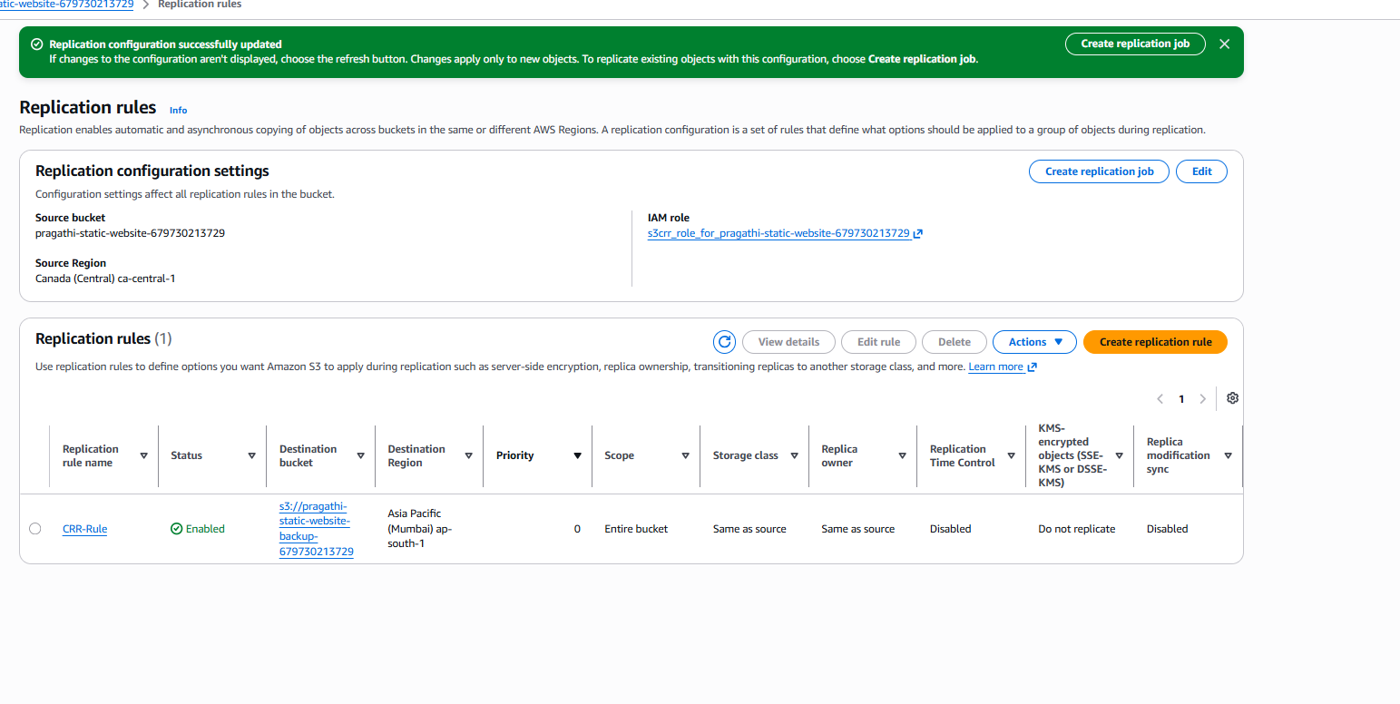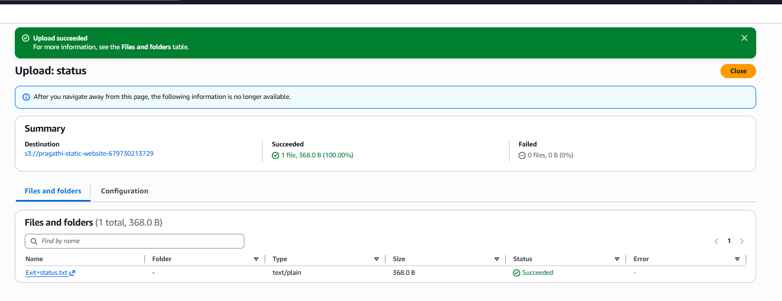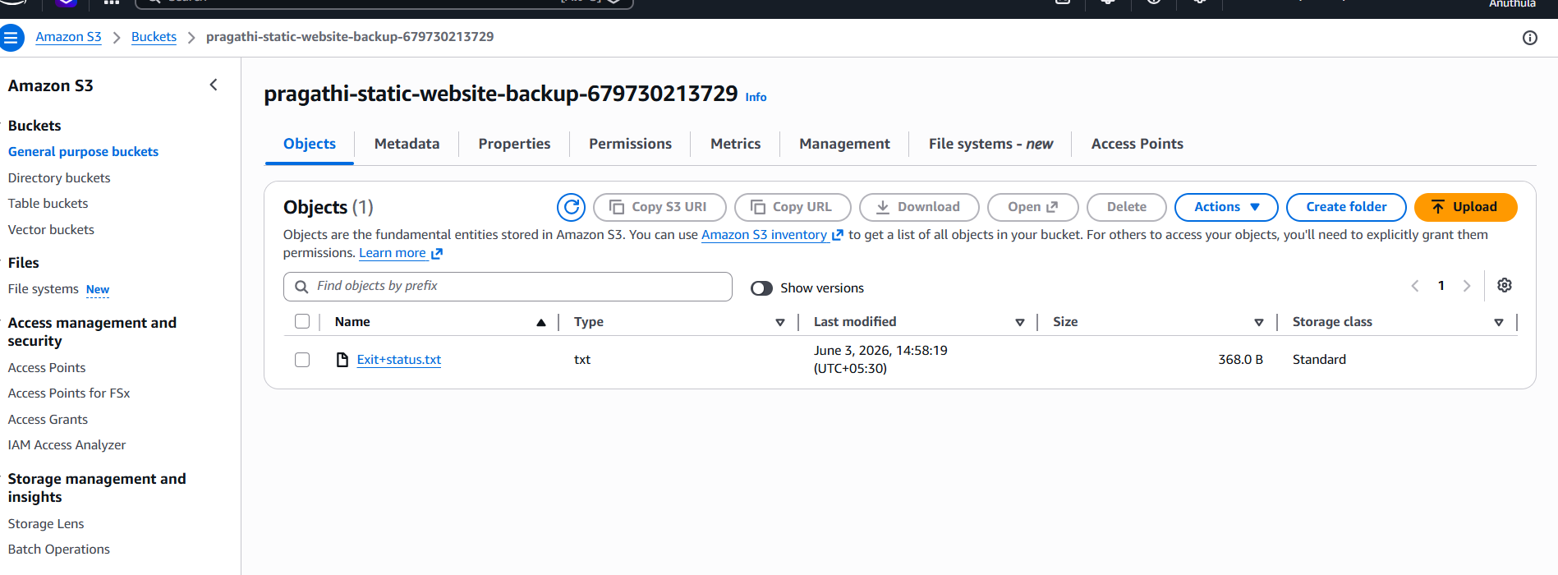
Task 4: Configure a Bucket Policy so Only the Admin User Can Access S3 Objects
Objective
To configure an Amazon S3 bucket policy that allows only the IAM Admin user (Devops) to access and view objects stored in the S3 bucket.

Step 1: Identify the IAM User
- Logged in to the AWS Management Console.
- Navigated to:
IAM → Users
- Identified the IAM user:
Devops
- Copied the IAM User ARN:
arn:aws:iam::679730213729:user/Devops

Step 2: Open the S3 Bucket
- Navigated to:
Amazon S3 → Buckets
- Selected the bucket:
pragathi-static-website-679730213729

Step 3: Edit Bucket Policy
- Opened:
Permissions → Bucket Policy → Edit
- Added a bucket policy to allow access only to the IAM user Devops.
Policy permissions included:
s3:ListBucket
s3:GetObject
These permissions allow the user to:
- View bucket contents
- List objects in the bucket
- Download and read objects

Step 4: Save the Policy
- Validated the policy.
- Clicked:
Save Changes
- Successfully applied the bucket policy.

Step 5: Verify Access
- Logged in using the IAM user:
Devops
- Navigated to:
Amazon S3 → Buckets
- Verified that the user could:
- View the bucket
- Access bucket objects
- Read files stored in the bucket

Result
Successfully configured an Amazon S3 bucket policy that restricts bucket access and allows only the IAM user Devops to view and access objects stored in the S3 bucket.
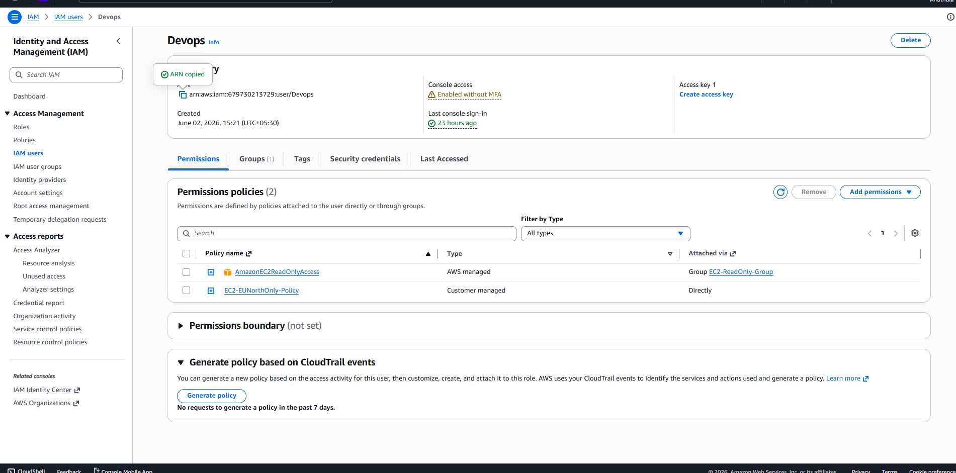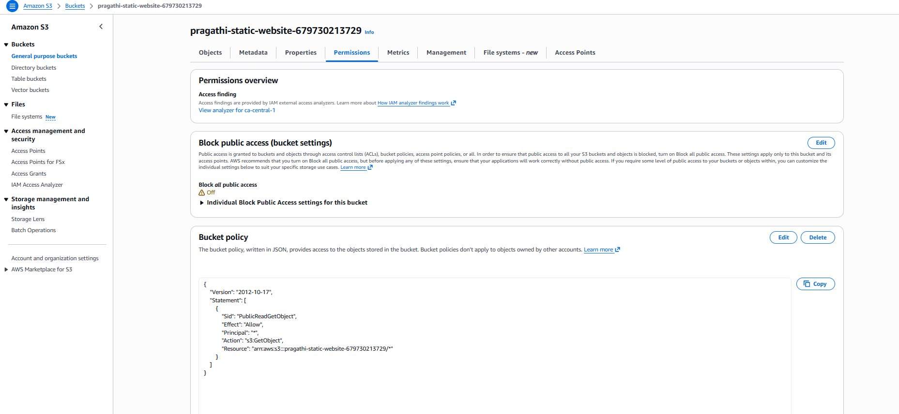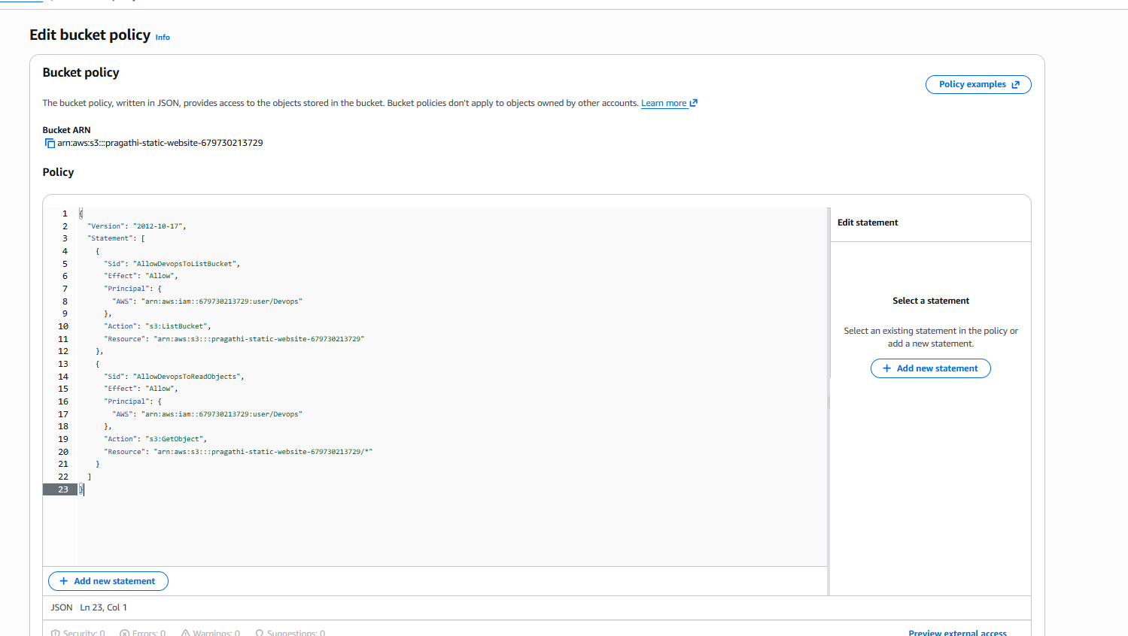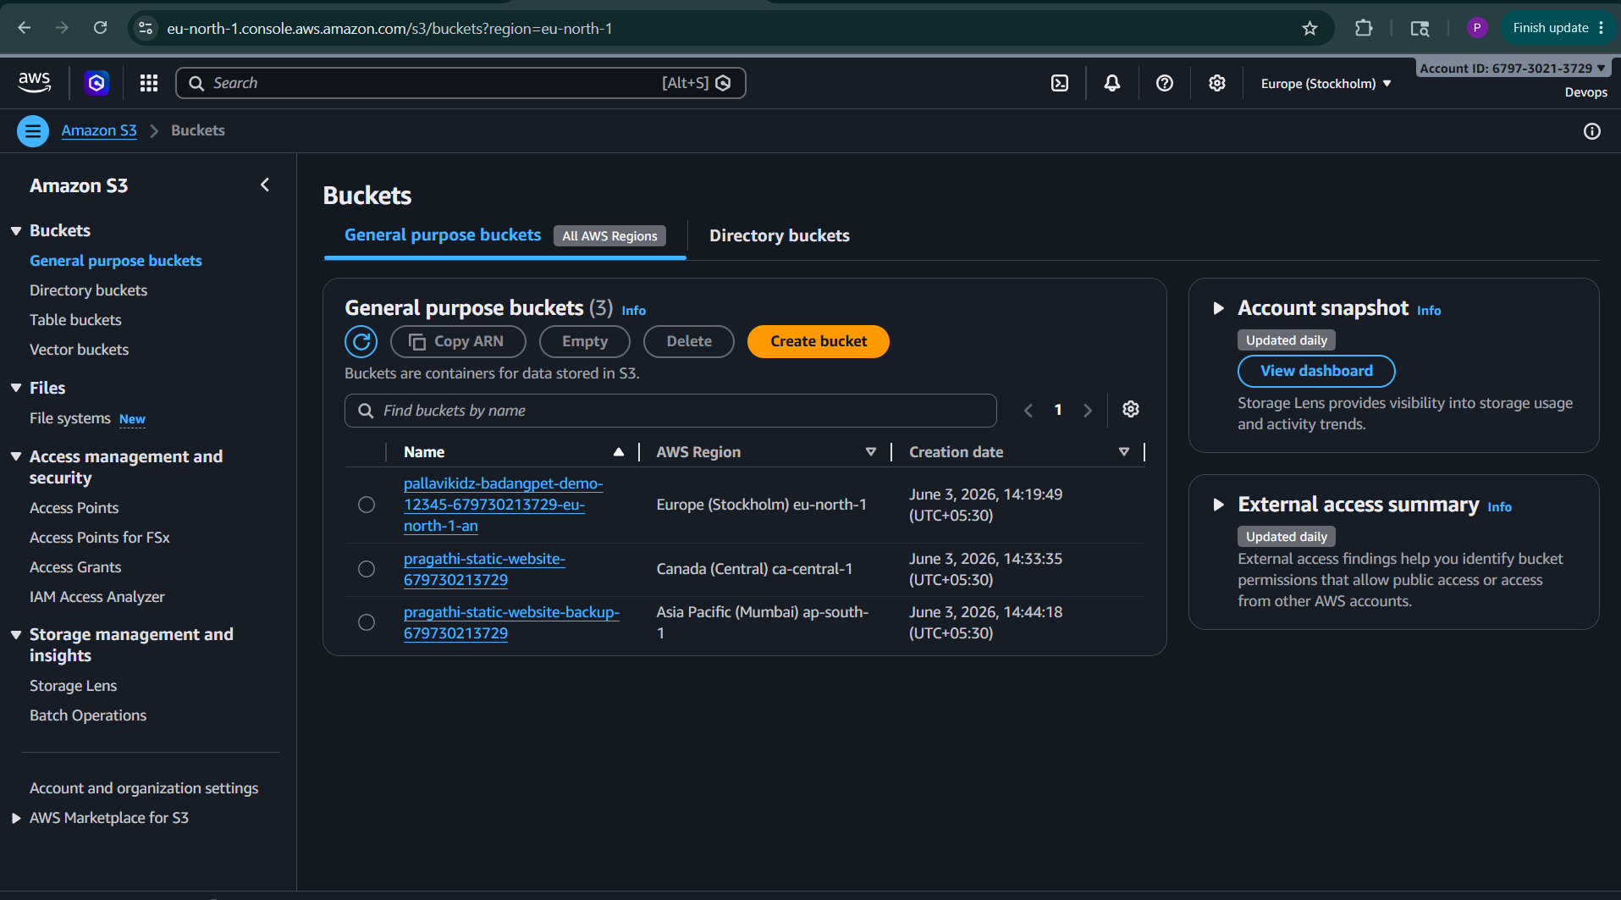

Task 5: Configure S3 Lifecycle Policy
Objective
The objective of this task is to configure an Amazon S3 Lifecycle Policy that automatically manages objects stored in the bucket by deleting them after a specified period. This helps reduce storage costs and automates data management.

Prerequisites
- AWS Account
- Amazon S3 Bucket Created
- Appropriate S3 Permissions
Bucket Used:
pragathi-static-website-679730213729

Step 1: Open the S3 Bucket
- Logged in to the AWS Management Console.
- Navigated to:
Amazon S3 → Buckets
- Selected the bucket:
pragathi-static-website-679730213729

Step 2: Navigate to Lifecycle Rules
- Opened the bucket.
- Clicked the Management tab.
- Under Lifecycle Rules, selected:
Create Lifecycle Rule

Step 3: Configure Lifecycle Rule
Entered the Lifecycle Rule Name:
Delete-Old-Objects
Selected:
Apply to all objects in the bucket
Acknowledged that the rule applies to all objects stored in the bucket.

Step 4: Configure Lifecycle Action
Under Lifecycle Rule Actions, selected:
Expire current versions of objects
This action automatically removes objects after a specified number of days.

Step 5: Configure Object Expiration
Entered:
30 Days
This means:
Objects older than 30 days will be automatically deleted by Amazon S3.

Step 6: Create Lifecycle Rule
Reviewed the configuration and clicked:
Create Rule
The Lifecycle Policy was successfully created and enabled.

Verification
Navigated to:
Bucket → Management → Lifecycle Rules
Verified that the rule:
Delete-Old-Objects
was displayed with status:
Enabled

Architecture
Object Uploaded
│
▼
Amazon S3 Bucket
│
▼
Lifecycle Rule Evaluates Object Age
│
▼
30 Days Reached
│
▼
Object Automatically Deleted

Benefits of Lifecycle Policies
- Reduces storage costs
- Automates object management
- Removes outdated files automatically
- Improves storage efficiency
- Helps meet retention policies

Result
Successfully configured an Amazon S3 Lifecycle Policy named Delete-Old-Objects on the bucket pragathi-static-website-679730213729. The policy automatically deletes objects after 30 days, reducing storage costs and eliminating the need for manual cleanup.
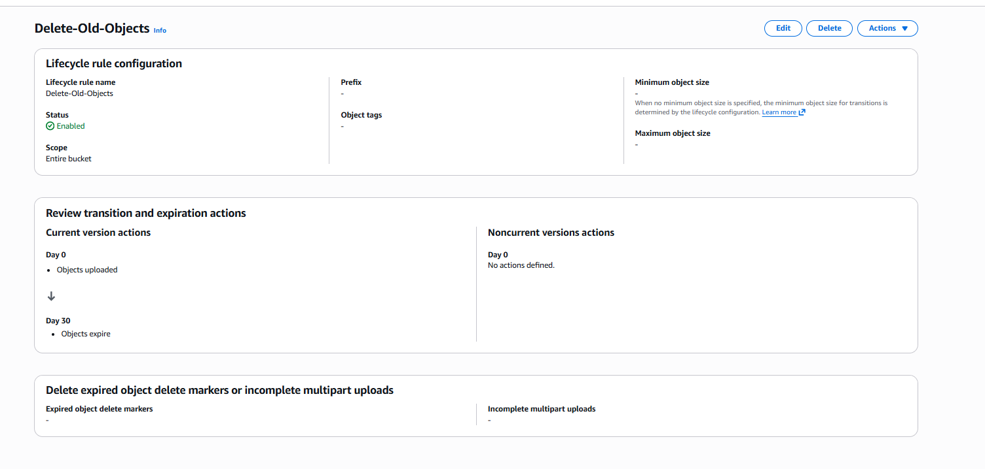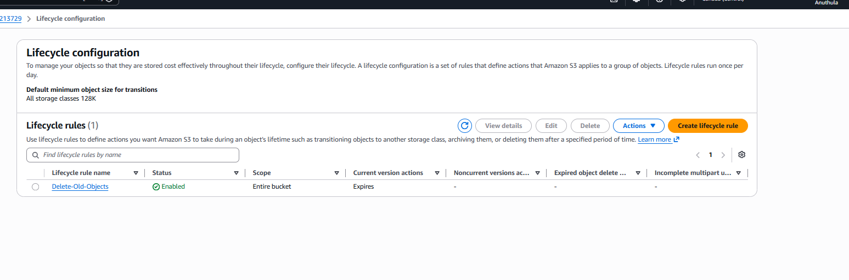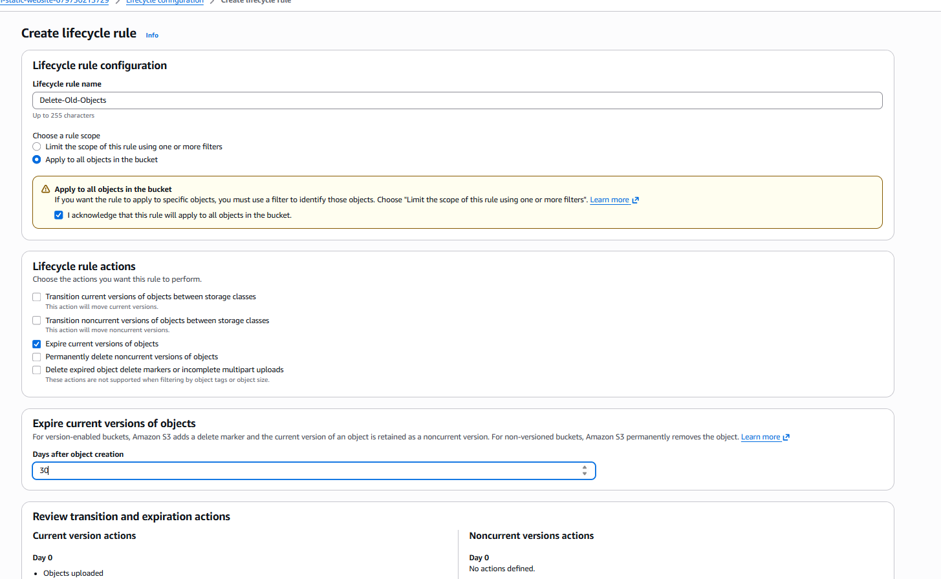

Task 6: Push Objects to Amazon S3 Using AWS CLI
Objective
The objective of this task is to upload files from a local machine to an Amazon S3 bucket using the AWS Command Line Interface (AWS CLI).

Prerequisites
- AWS Account
- S3 Bucket Created
- AWS CLI Installed
- AWS CLI Configured with IAM Credentials
Bucket Used:
pragathi-static-website-679730213729

Step 1: Verify AWS CLI Installation
Open Terminal or Git Bash and run:
aws --version
Expected Output:
aws-cli/2.x.x

Step 2: Configure AWS CLI
Run:
aws configure
Enter:
AWS Access Key ID
AWS Secret Access Key
Region Name: ca-central-1
Output Format: json
Example:
aws configure
AWS Access Key ID [None]: ****************
AWS Secret Access Key [None]: ****************
Default region name [None]: ca-central-1
Default output format [None]: json

Step 3: Create a Test File
Create a sample file:
echo "Hello from AWS CLI" > test.txt
Verify:
cat test.txt
Output:
Hello from AWS CLI

Step 4: Upload File to S3
Run:
aws s3 cp test.txt s3://pragathi-static-website-679730213729/
Example Output:
upload: ./test.txt to s3://pragathi-static-website-679730213729/test.txt

Step 5: Verify Upload
List bucket contents:
aws s3 ls s3://pragathi-static-website-679730213729
Example Output:
2026-06-03 15:30:20 20 test.txt

Step 6: Upload Multiple Files
Create files:
touch file1.txt file2.txt file3.txt
Upload:
aws s3 cp . s3://pragathi-static-website-679730213729/ --recursive
This uploads all files from the current directory.

Alternative: Upload Entire Folder
Example folder:
website/
├── index.html
├── error.html
└── images/
Upload folder:
aws s3 cp website/ s3://pragathi-static-website-679730213729/ --recursive

Verification
Using AWS Console:
Amazon S3
→ Buckets
→ pragathi-static-website-679730213729
→ Objects
Verify uploaded files are visible.

Architecture
Local Machine
│
│ AWS CLI
▼
Amazon S3 Bucket
│
▼
Objects Uploaded Successfully

Result
Successfully uploaded objects from the local machine to the Amazon S3 bucket pragathi-static-website-679730213729 using AWS CLI commands. Verified the uploaded files through both AWS CLI and the AWS Management Console.
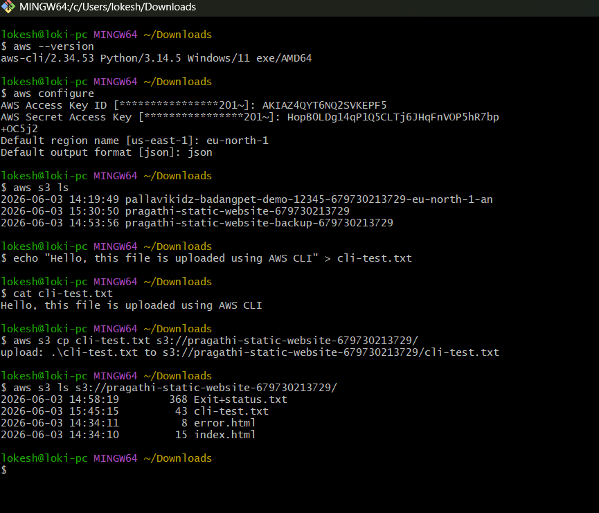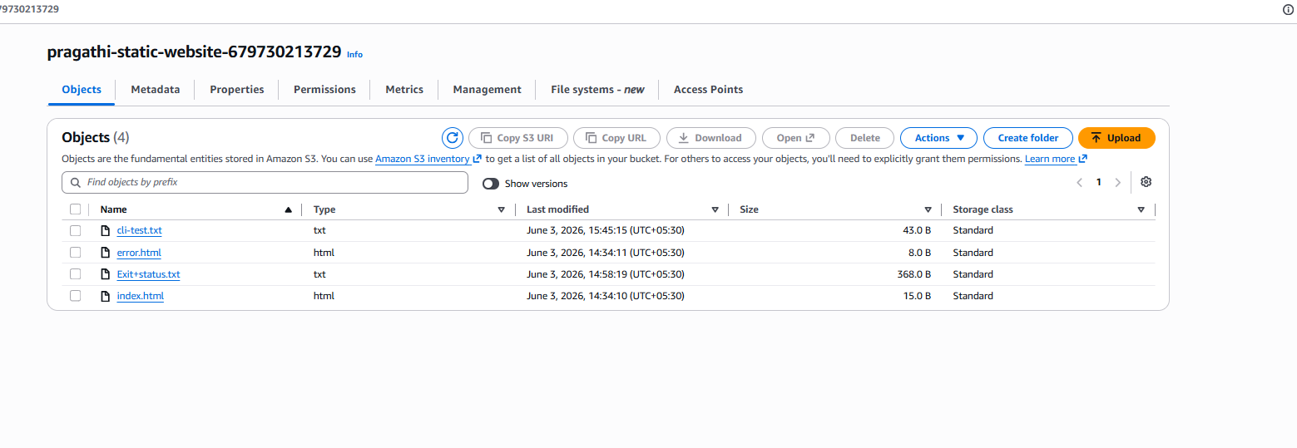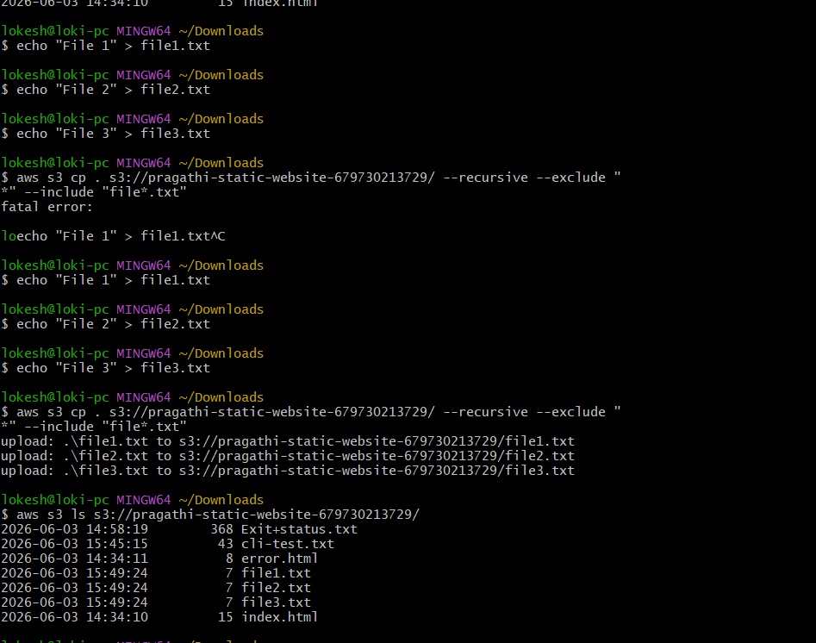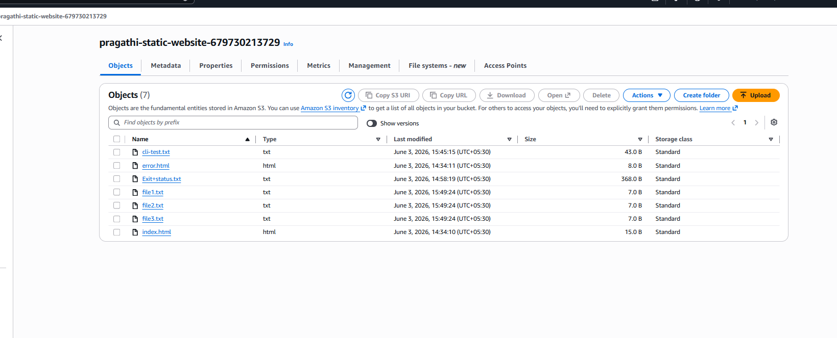
7- Task 7: Create an Amazon S3 Bucket Using a Bash Script
Objective
The objective of this task is to automate the creation of an Amazon S3 bucket using a Bash script and AWS CLI. This demonstrates how Bash scripting can be used to automate AWS resource provisioning and reduce manual effort.

Prerequisites
- AWS Account
- AWS CLI Installed
- AWS CLI Configured with Valid Credentials
- Linux Terminal or Git Bash

Step 1: Create a Bash Script
Created a Bash script named:
create_bucket.sh
The script contains AWS CLI commands to create an Amazon S3 bucket.

Step 2: Define Bucket Name and Region
Configured the bucket name and AWS region within the script.
Example:
Bucket Name: pragathi-demo-bucket
Region: eu-north-1
The bucket name must be globally unique across AWS.

Step 3: Create the S3 Bucket
Used the AWS CLI command:
aws s3api create-bucket
to create the S3 bucket in the specified AWS region.

Step 4: Assign Execute Permission
Granted execution permission to the script using:
chmod +x create_bucket.sh
This allows the script to be executed from the command line.

Step 5: Execute the Script
Executed the script using:
./create_bucket.sh
The script successfully created the S3 bucket and displayed a confirmation message.

Step 6: Verify Bucket Creation
Verified the bucket creation using:
aws s3 ls
The newly created bucket appeared in the list of available S3 buckets.

Commands Used
chmod +x create_bucket.sh

./create_bucket.sh

aws s3 ls

Architecture
Bash Script
│
▼
AWS CLI
│
▼
Amazon S3
│
▼
S3 Bucket Created

Result
Successfully created an Amazon S3 bucket using a Bash script and AWS CLI. The script automated the bucket creation process and eliminated the need to manually create the bucket through the AWS Management Console. The bucket was successfully created and verified using AWS CLI commands.

Conclusion
This task demonstrated how Bash scripting can be integrated with AWS CLI to automate cloud resource creation. Automation through scripting improves efficiency, consistency, and reduces manual administrative effort.
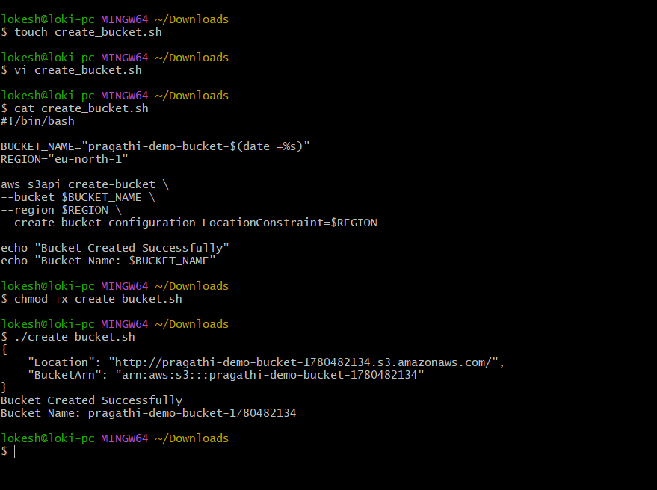 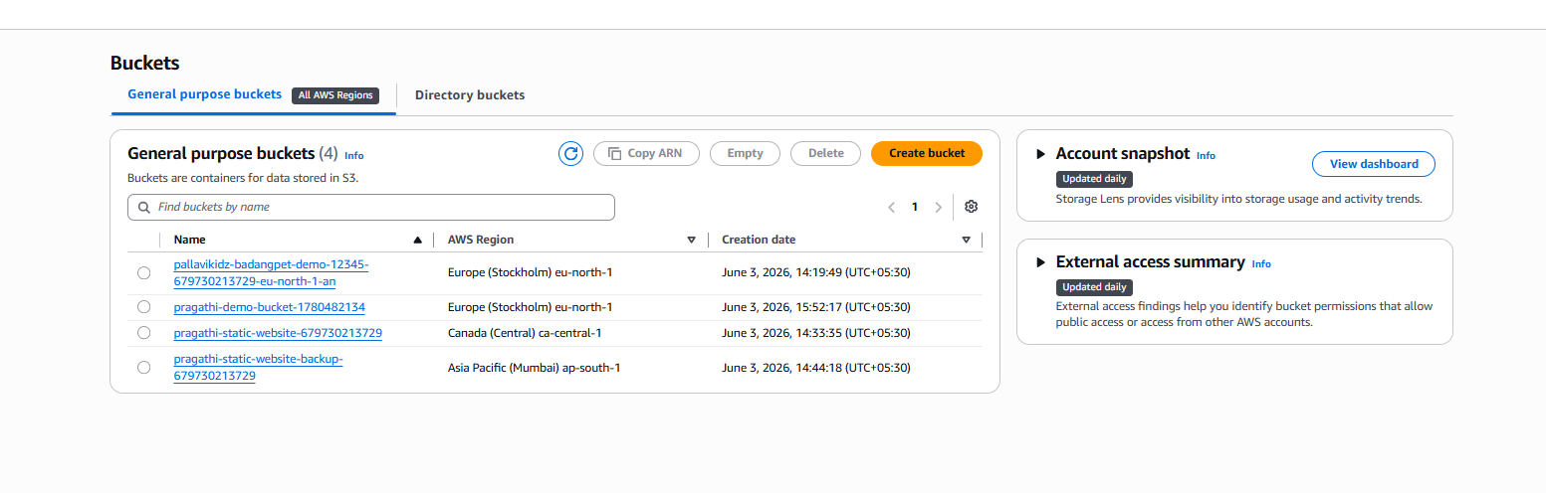 Task 8: Upload a 1 GB File to S3 Using AWS CLI
Objective
The objective of this task is to create a 1 GB test file on the local machine and upload it to an Amazon S3 bucket using AWS CLI.

Step 1: Open Git Bash
Opened Git Bash from the local machine.
Working directory:
~/Downloads

Step 2: Create a 1 GB Test File
Executed the following command:
dd if=/dev/zero of=1GB-TestFile.bin bs=1M count=1024
Explanation
- dd is used to create a test file.
- if=/dev/zero generates empty data.
- of=1GB-TestFile.bin creates the output file.
- bs=1M sets block size to 1 MB.
- count=1024 creates 1024 MB, which is equal to 1 GB.

Step 3: Verify File Creation
The command output showed:
1073741824 bytes (1.1 GB, 1.0 GiB) copied
This confirms that the 1 GB file was created successfully.

Step 4: Upload File to S3
Uploaded the file to the S3 bucket using AWS CLI:
aws s3 cp 1GB-TestFile.bin s3://pragathi-static-website-679730213729/

Step 5: Verify Upload Using AWS CLI
Verified the uploaded file using:
aws s3 ls s3://pragathi-static-website-679730213729/
The file 1GB-TestFile.bin was visible in the bucket.

Step 6: Verify Upload in AWS Console
Opened:
Amazon S3 → Buckets → pragathi-static-website-679730213729 → Objects
Confirmed that the file was uploaded successfully.

Result
Successfully created a 1 GB test file and uploaded it to the Amazon S3 bucket using AWS CLI.
