
Project Report
Bachelor of Computer Applications (BCA)
Semester – V

Sub: Deep Learning
Topic: Comparison of Deep Learning Architectures

By
Name: Pragathi BR
Reg no: 2411021240037
Date of Submission: 31/08/2026

Faculty Name: Nagasri. P
Faculty Signature: _______________

Department of Computer Application
Alliance University
Chandapura - Anekal Main Road,
Anekal Bengaluru – 562 106
August 2026
Comparison of Deep Learning Architectures

Introduction
Deep Learning encompasses a family of neural network architectures, each designed to work well with a particular type of data and problem. This report studies three foundational architectures - the Feedforward Neural Network (FNN), the Convolutional Neural Network (CNN), and the Recurrent Neural Network (RNN) - and compares them based on their structure, the type of input data they are best suited for, and their common real-world applications.
Different types of deep learning architectures are designed for different types of data and problems. Choosing an appropriate architecture is important because the structure of the network determines how information is processed.

Three fundamental deep learning architectures are:
- Feedforward Neural Networks (FNNs)
- Convolutional Neural Networks (CNNs)
- Recurrent Neural Networks (RNNs)

Feedforward Neural Networks are mainly used for structured or fixed-size input data. CNNs are particularly effective for image and spatial data because they can automatically detect local patterns such as edges, shapes, and textures. RNNs are designed for sequential or time-dependent data because they maintain information from previous inputs.

This project studies the basic architecture, working principles, suitable applications, advantages, limitations, and differences between these three architectures.

OBJECTIVES
The main objectives of this project are:
- To understand the basic architecture of Feedforward Neural Networks, CNNs, and RNNs.
- To understand how each architecture processes information.
- To identify the types of input data suitable for each architecture.
- To study real-world applications of FNNs, CNNs, and RNNs.
- To compare the architectures based on their structure, input data, and applications.
- To understand the advantages and limitations of each architecture.
- To identify which architecture is appropriate for different deep learning problems.

OVERVIEW OF DEEP LEARNING
Deep Learning uses artificial neural networks inspired by the way biological neurons process information. A neural network generally consists of interconnected processing units called neurons.
A typical neural network contains:
- Input Layer
- Hidden Layer(s)
- Output Layer
The input layer receives the data, hidden layers perform transformations and learn patterns, and the output layer produces the final prediction.
The major difference between neural network architectures is how the network processes information.

For example:
- FNN processes information mainly in one direction.
- CNN processes spatial relationships using convolution operations.
- RNN processes sequential information while maintaining information from previous time steps.
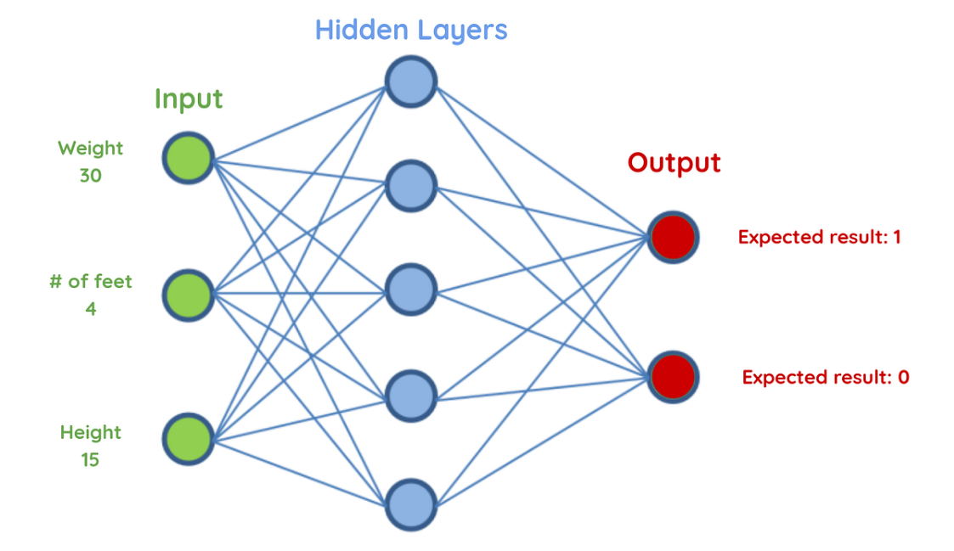

Figure 1: General structure of a deep learning model.

Task 1: Basic Architecture of Each Network
1.1 Feedforward Neural Network (FNN)
A Feedforward Neural Network is the simplest type of artificial neural network. Information moves in only one direction - from the input layer, through one or more hidden layers, to the output layer - with no cycles or loops in the connections.
- Input layer: receives the raw feature values (e.g. pixel intensities, sensor readings, or tabular features).
- Hidden layer(s): each neuron computes a weighted sum of its inputs, adds a bias, and applies a non-linear activation function (such as ReLU or sigmoid).
- Output layer: produces the final prediction, such as a class label or a continuous value.
- Connections: every neuron in one layer is typically connected to every neuron in the next layer (fully connected/dense layers), and each connection has its own independent weight.
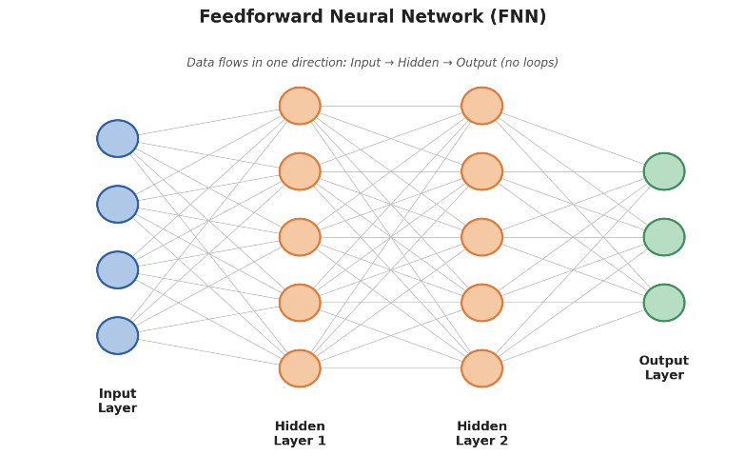

Figure 1: A Feedforward Neural Network with an input layer, two hidden layers, and an output layer.

Working
The input data passes through each layer sequentially. Each neuron calculates a weighted sum of its inputs, adds a bias, and applies an activation function. The processed information is then passed to the next layer until the final output is generated.

1.2 Convolutional Neural Network (CNN)
A Convolutional Neural Network is designed to process grid-structured data, most commonly images. Instead of connecting every neuron to every input value, CNNs use small filters (kernels) that slide across the input to detect local patterns.
- Convolutional layer: applies learnable filters across the input to produce feature maps that highlight patterns such as edges, textures, and shapes.
- Activation (ReLU): introduces non-linearity after each convolution so the network can learn complex patterns.
- Pooling layer: downsamples the feature maps (e.g. max pooling), reducing spatial size and computation while retaining important information.
- Fully connected layer: after several convolution and pooling stages, the resulting features are flattened and passed through dense layers to produce the final classification or prediction, often via a softmax output.
- Parameter sharing: the same filter is reused across the entire input, which greatly reduces the number of parameters compared to a fully connected network of similar size.

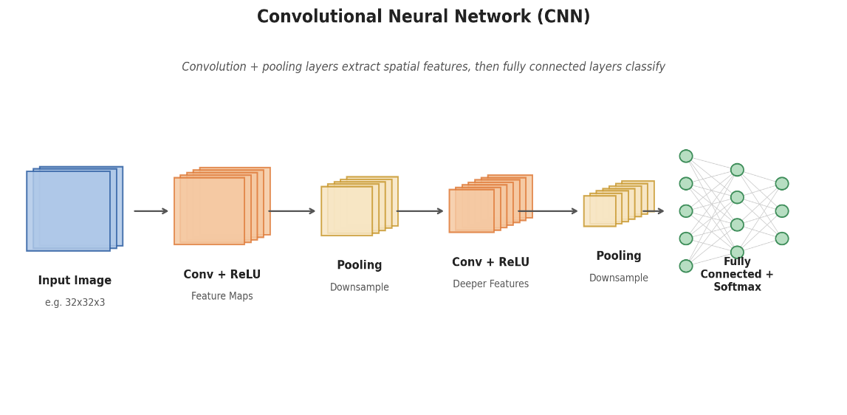

Figure 2: A CNN pipeline - convolution and pooling layers extract features, followed by fully connected layers for classification.
Working
The CNN first receives an image. Convolution filters scan different regions of the image and detect features. Pooling reduces the size of the feature maps. As the data moves through deeper layers, the network learns increasingly complex features. Finally, the extracted features are used to make a prediction.
1.3 Recurrent Neural Network (RNN)
A Recurrent Neural Network is designed for sequential data, where the order of inputs matters. Unlike FNNs and CNNs, an RNN has a
- feedback loop: the output of a cell at one time step is fed back in as part of the input at the next time step, giving the network a form of memory.
- Recurrent cell: at each time step t, the cell takes the current input x(t) and the previous hidden state h(t-1), and produces a new hidden state h(t) and an output y(t).
- Shared weights: the same set of weights is applied at every time step, which allows the network to handle sequences of varying length.
- Hidden state (memory): carries forward information from earlier elements of the sequence, allowing the network to model context and order.
- Variants: plain RNNs can struggle to retain information over long sequences; architectures such as LSTM (Long Short-Term Memory) and GRU (Gated Recurrent Unit) were developed to address this limitation.
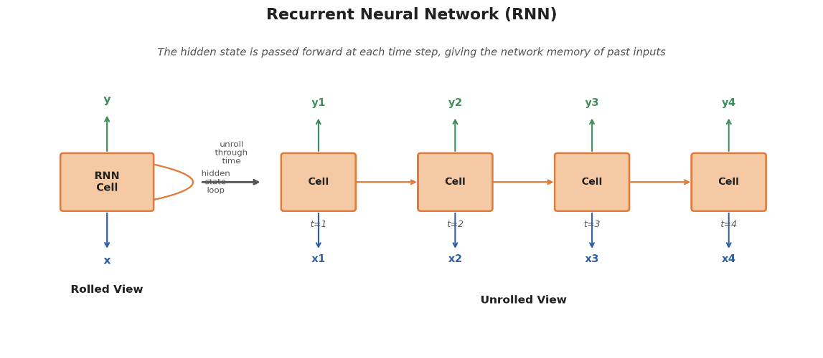

Figure 3: An RNN shown in its compact rolled form (left) and unrolled across four time steps (right).

Working
An RNN processes data sequentially. At each time step, it receives the current input and combines it with information stored in the previous hidden state. This allows the network to consider the order and context of the data.
For example, in a sentence:
The → student → is → studying → ______
The RNN uses information from the previous words to understand the sequence and predict the next
word.

Architecture | Basic Structure | Main Data Type | Key Feature
FNN | Input → Hidden → Output | Structured/Fixed-size data | Forward information flow
CNN | Convolution → Pooling → Fully Connected → Output | Images/Spatial data | Spatial feature extraction
RNN | Input → Hidden State → Output | Sequential/Time-series data | Maintains previous information
Architecture Summary

Task 2: Suitable Applications for Each Architecture
Different Deep Learning architectures are designed to handle different types of data. Therefore, selecting the appropriate architecture depends on the nature of the problem and the type of input data.

2.1 Applications of Feedforward Neural Networks (FNN)
Feedforward Neural Networks are suitable for structured, numerical, and fixed-size data. They are commonly used for classification and regression problems.
Suitable Applications
- Customer Churn Prediction
Predicting whether a customer is likely to leave a service using customer information such as age, usage, and contract details.
- Sales Prediction
Predicting future sales based on factors such as product, price, quantity, region, and previous sales information.
- Fraud Detection
Identifying potentially fraudulent transactions using transaction-related features.
- Credit Risk Assessment
Predicting whether a customer is likely to repay a loan based on financial and personal information.
- Medical Diagnosis
Classifying patients into different categories based on structured medical data.
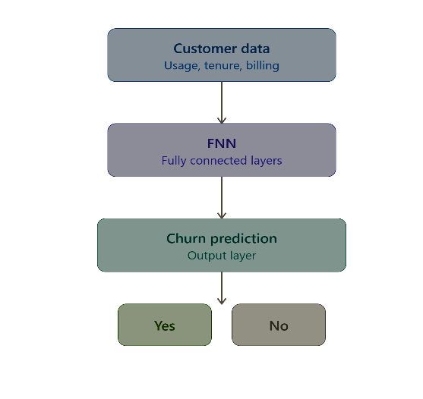
Example:

2.2 Applications of Convolutional Neural Networks
Convolutional Neural Networks are mainly suitable for image, video, and spatial data. They are particularly effective at identifying patterns such as edges, textures, shapes, and objects.
Suitable Applications
- Image Classification
Classifying images into categories such as cats, dogs, cars, or plants.
- Face Recognition
Identifying individuals based on facial features.
- Object Detection
Detecting and locating objects such as vehicles, pedestrians, and traffic signs.
- Medical Image Analysis
Analyzing X-rays, MRI scans, CT scans, and other medical images.
- Autonomous Vehicles
Processing camera images to identify roads, vehicles, pedestrians, and traffic signs.
- Facial Expression Recognition
Identifying expressions such as happy, sad, angry, or neutral.

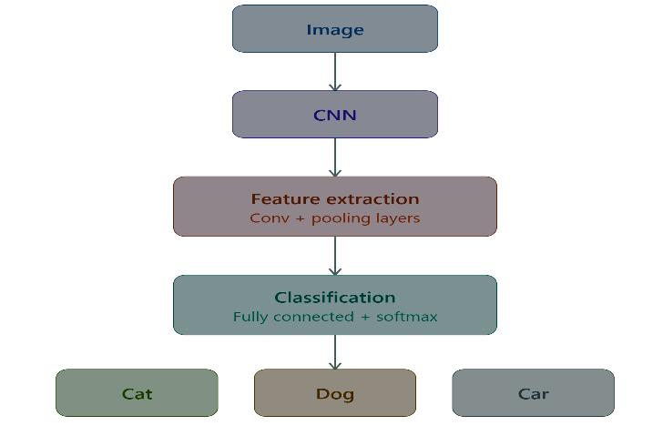
Example:

2.3 Applications of Recurrent Neural Networks

Recurrent Neural Networks are suitable for sequential, temporal, and time-dependent data, where the order of the input is important.
Suitable Applications
- Natural Language Processing (NLP)
Processing sequences of words for tasks such as text classification and language modeling.
- Speech Recognition
Processing sequences of audio signals and converting speech into text.
- Time-Series Forecasting
Predicting future values based on previous observations.
- Text Prediction
Predicting the next word or character in a sequence.
- Sentiment Analysis
Analyzing a sequence of words to determine whether a text expresses a positive, negative, or neutral sentiment.
- Machine Translation
Processing sequences of words to translate text from one language to another.
- Sales Forecasting
Using historical sales values to predict future sales trends.
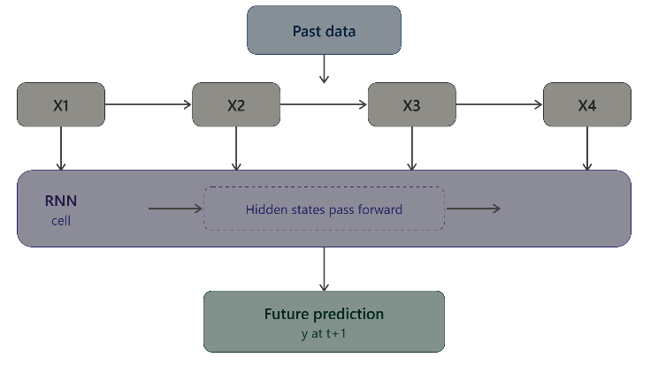
Example:
Task 3: Comparison of Architectures
Feedforward Neural Networks (FNNs), Convolutional Neural Networks (CNNs), and Recurrent Neural Networks (RNNs) are different deep learning architectures designed to handle different types of data. The main differences are in their network structure, type of input data, information processing method, and applications.

Comparison Table

Comparison Factor | Feedforward Neural Network (FNN) | Convolutional Neural Network (CNN) | Recurrent Neural Network (RNN)
Basic Structure | Input → Hidden Layers → Output | Convolution → Pooling → Fully Connected → Output | Input → Hidden State → Output
Information Flow | Moves only forward | Moves through convolutional and pooling layers | Sequential flow with recurrent connections
Input Data | Structured/tabular data | Images, videos, spatial data | Text, speech, time-series and sequential data
Main Feature | Learns relationships between features | Learns spatial features | Learns sequential and temporal patterns
Memory | No memory of previous inputs | No recurrent memory | Maintains information through hidden states
Important Operation | Weighted connections | Convolution and pooling | Recurrent connections
Relationship Captured | General feature relationships | Spatial relationships | Temporal/sequential relationships
Typical Applications | Classification, regression, prediction | Image classification, object detection, face recognition | Text processing, speech recognition, forecasting
Example | Customer churn prediction | Face recognition | Text prediction
Main Advantage | Simple and effective for structured data | Excellent for visual and spatial data | Suitable for sequential data
Main Limitation | Poor at spatial and sequential relationships | Computationally expensive | Standard RNNs may struggle with long-term dependencies

Conclusion
Deep Learning provides different architectures that are designed to solve different types of problems. In this project, Feedforward Neural Networks (FNNs), Convolutional Neural Networks (CNNs), and Recurrent Neural Networks (RNNs) were studied and compared based on their architecture, input data, and applications.\
FNNs are suitable for structured and fixed-size data and are commonly used for classification and regression tasks. CNNs are highly effective for image and spatial data because they can automatically identify features such as edges, shapes, and objects. RNNs are designed for sequential and time-dependent data and are commonly used in text processing, speech recognition, and time-series forecasting.
The comparison shows that there is no single architecture that is best for every problem. The appropriate architecture should be selected based on the type of data and the requirements of the application. Understanding these differences helps in designing efficient deep learning solutions for real-world problems.
Overall, FNNs focus on general feature relationships, CNNs focus on spatial patterns, and RNNs focus on sequential patterns. This understanding provides a strong foundation for selecting and applying deep learning architectures effectively.

