CSE/EEE 120
Simulation Lab 2 Answer Sheet
4-Bit Full Adder, Multiplexer, Decoder & Buffer
Name:_____Pragathi Gopal________
Date:_______10/16/2016__________
Task 2-1: Design a Full Adder
Write down the canonical SOP expressions for the C_{out} and SUM function of a full adder. Be sure to check the lab manual for more detailed information.
SUM = A'B'C_{in} + A'BC_{in}' + AB'C_{in}' + ABC_{in}
C_{out} = AB + AC_{in} + BC_{in}
Include a picture of your Logisim circuit that implements your canonical SUM and _{Co}ut functions here:
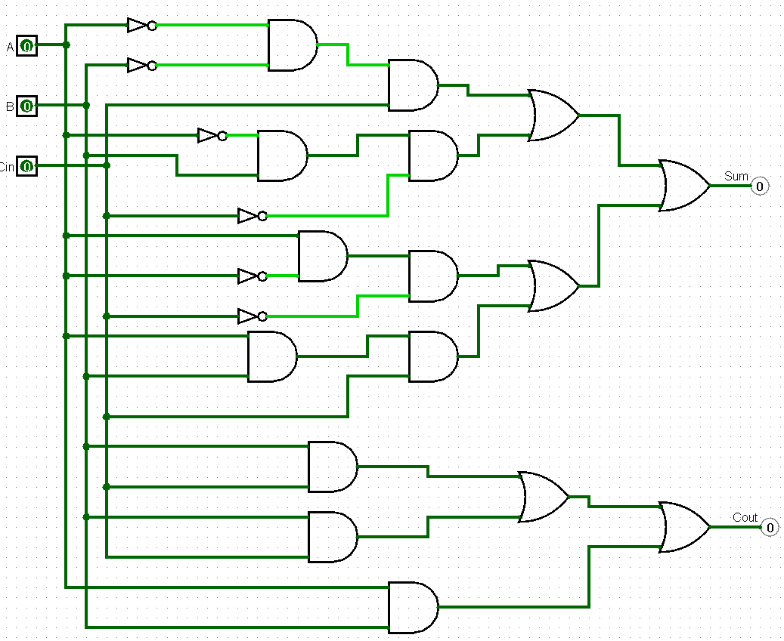
Follow the testing procedures outlined in the laboratory manual on your circuit and record your results in Error: Reference source not found. Place a mark in the checkmark column of Table 3 to indicate the values you checked.
Table 1 |  |  |  |  | Debug Checkmark  (X)
A | B | C_{in} | C_{out} | SUM | Debug Checkmark  (X)
0 | 0 | 0 | 0 | 0 | X
0 | 0 | 1 | 0 | 1 | X
0 | 1 | 0 | 0 | 1 | X
0 | 1 | 1 | 1 | 0 | X
1 | 0 | 0 | 0 | 1 | X
1 | 0 | 1 | 1 | 0 | X
1 | 1 | 0 | 1 | 0 | X
1 | 1 | 1 | 1 | 1 | X

Task 2-2: Build, Debug and Test a 1-Bit Full Adder
Include a picture of your Logisim 1-bit minimal form full-adder circuit here:
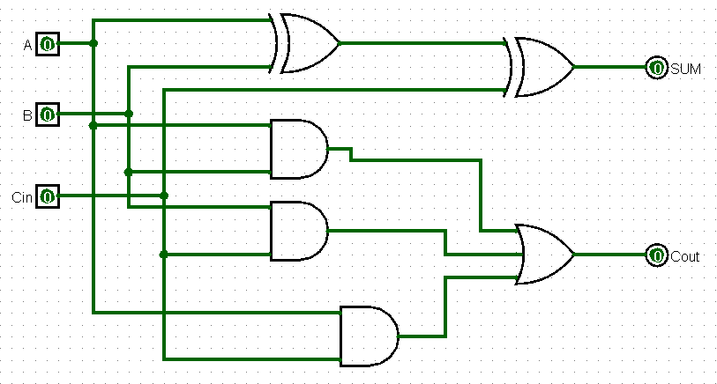

Test your minimal form full-adder circuit and record your results in Table 1. Place a mark in the checkmark column of Table 3 to indicate the values you checked.
Table 1 |  |  |  |  | Debug Checkmark  (X)
A | B | C_{in} | C_{out} | SUM | Debug Checkmark  (X)
0 | 0 | 0 | 0 | 0 | X
0 | 0 | 1 | 0 | 1 | X
0 | 1 | 0 | 0 | 1 | X
0 | 1 | 1 | 1 | 0 | X
1 | 0 | 0 | 0 | 1 | X
1 | 0 | 1 | 1 | 0 | X
1 | 1 | 0 | 1 | 0 | X
1 | 1 | 1 | 1 | 1 | X

Include a picture of your Logisim 1-bit full adder subcircuit symbol here:
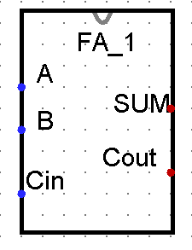
Task 2-3: Design, Build and Test a 4-Bit Full Adder
Include a picture of your Logisim 4-bit full-adder circuit here:
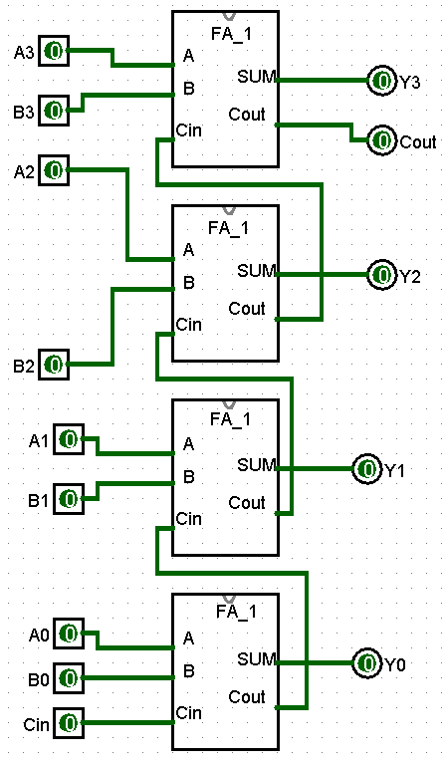
Include a picture of your Logisim 4-bit full-adder testing set up. Connect a multi-bit input pin to the inputs A and B as well as a hex digit display to SUM. 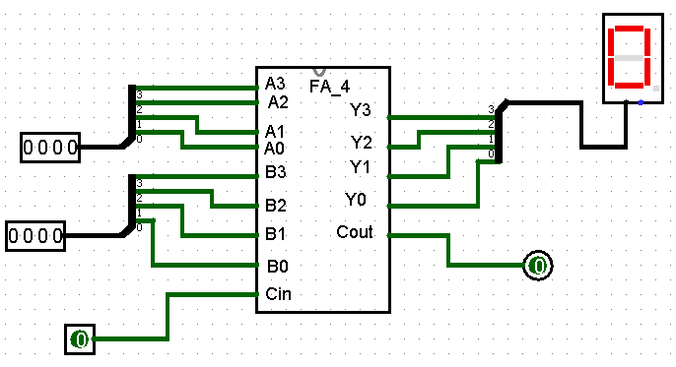

Develop a test plan and record your results in Table 2 (Note: Do NOT test all input combinations. Table 2 may not need to be entirely filled in). It is left to you to decide what constitutes a sufficient test set. Give justification as to why completing your tests make it likely that the 4-bit full-adder circuit is operating correctly:
Essentially, in order to test this circuit, I inputted values into the table that I was certain in regards to the expected output due to the material that we learned in class. To further test the implementation I used values where the Cin would be zero as well as one. The output will help support the accuracy of the implementation.
Test your circuit and place a mark in the checkmark column of Table 2 next to values you used to verify your circuit.
Table 2 |  |  |  |  | Debug Checkmark  (X)
A  (4-bit binary) | B  (4-bit binary) | C_{in} | C_{out} | SUM  (hex) | Debug Checkmark  (X)
0010 | 0001 | 0 | 0 | 3 | x
0010 | 0001 | 1 | 0 | 4 | X
1100 | 0001 | 0 | 0 | D | X
1100 | 0001 | 1 | 0 | E | X
1111 | 1111 | 0 | 1 | E | X
1111 | 1111 | 0 | 1 | F | X

Include a picture of your Logisim 4-bit full-adder subcircuit symbol here:
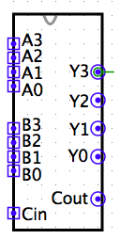

Task 2-4: Design, Build and Test a MUX
Include a picture of your Logisim 1-bit 2-to-1 MUX circuit here:

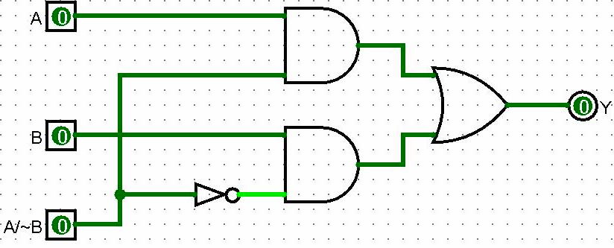

Test your 1-bit 2-to-1 MUX circuit and record your results in Table 3. Place a mark in the checkmark column of Table 3 to indicate the values you checked.
Table 3 |  |  |  | Debug checkmark  (X)
A/~B | A | B | Y | Debug checkmark  (X)
0 | 0 | 0 | 0 | X
0 | 0 | 1 | 1 | X
0 | 1 | 0 | 0 | X
0 | 1 | 1 | 1 | X
1 | 0 | 0 | 0 | X
1 | 0 | 1 | 0 | X
1 | 1 | 0 | 1 | X
1 | 1 | 1 | 1 | X

Include a picture of your Logisim 1-bit 2-to-1 MUX subcircuit symbol here:
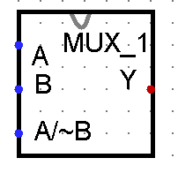
Task 2-5: Build a 2-Input 4-Bit Multiplexer
Include a picture of your Logisim 4-bit MUX circuit here:
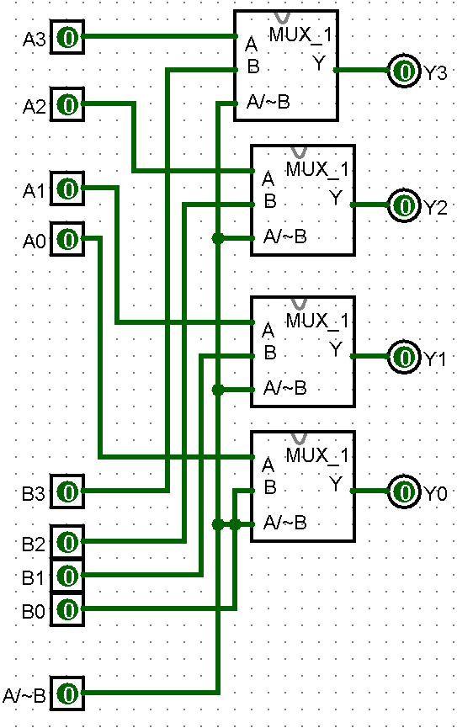
Test your MUX and record your results in Table 4. It is left to you to decide what test combination to use. Note all of Table 5 may not need to be filled in. Include a picture of your Logisim 4-bit MUX circuit testing set up (You may test it with the Multi-Bit Input Pin and Hex Digit Display).
Table 4
A  (4-bit binary) | B  (4-bit binary) | A/~B | Y  (hex) | Debug checkmark  (X)
0 | 0 | 0 | 1 | X
0 | 1 | 1 | 1 | X
1 | 0 | 1 | 1 | X
1 | 1 | 1 | 1 | X
0 | 0 | 0 | 1 | X
0 | 1 | 0 | 1 | X
1 | 0 | 1 | 0 | X
1 | 0 | 1 | 1 | X
1 | 1 | 1 | 1 | X

Include a picture of your Logisim 4-bit MUX subcircuit symbol here:
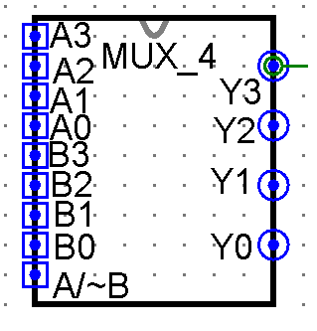

Task 2-6: Build and Test a 1-to-2 Decoder
Include a picture of your Logisim 1-bit, 1-to-2 decoder circuit here:
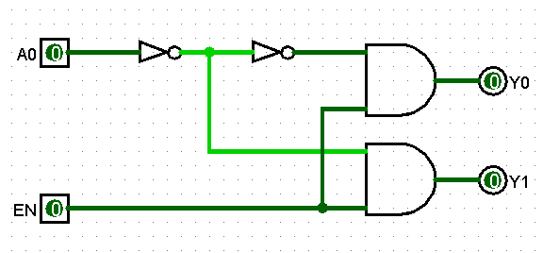
Test your 1-bit, 1-to-2 decoder circuit and record the results in Error: Reference source not found. Place a mark in the checkmark column of Table 3 to indicate the values you checked.
Table 6 |  |  |  | Debug checkmark  (X)
EN | A0 | Y0 | Y1 | Debug checkmark  (X)
0 | 0 | EN | 0 | X
0 | 1 | 0 | EN | X
1 | 0 | 0 | 0 | X
1 | 1 | 0 | 0 | X

Include a picture of your Logisim 1-bit, 1-to-2 decoder subcircuit symbol here:
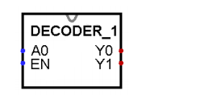
Task 2-7: Build and Test a 2-to-4 Decoder
Include a picture of your Logisim 2-to-4 decoder circuit here:

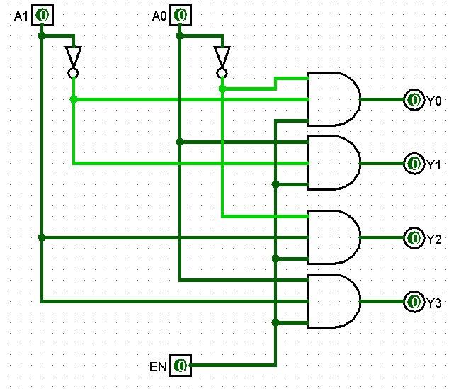

Test your 2-to-4 decoder circuit and record your results in Table 3. Place a mark in the checkmark column of Table 3 to indicate the values you checked.

Table 7 |  |  |  |  |  |  | Debug checkmark  (X)
EN | A1 | A0 | Y0 | Y1 | Y2 | Y3 | Debug checkmark  (X)
0 | 0 | 0 | 1 | 1 | 1 | 1 | X
0 | 0 | 1 | 1 | 1 | 1 | 1 | X
0 | 1 | 0 | 1 | 1 | 1 | 1 | X
0 | 1 | 1 | 0 | 1 | 1 | 1 | X
1 | 0 | 0 | 1 | 0 | 1 | 1 | X
1 | 0 | 1 | 1 | 1 | 0 | 1 | X
1 | 1 | 0 | 1 | 1 | 1 | 0 | X
1 | 1 | 1 | 1 | 1 | 1 | 1 | X

Include a picture of your Logisim 2-to-4 decoder subcircuit symbol here:
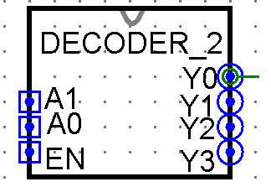

Task 2-8: Design, Build & Test a 4-to-16 Decoder Using 2-to-4 Decoders
Include a picture of your Logisim 4-to-16 decoder circuit, constructed from copies of the subcircuit developed in Task 2-7, here:
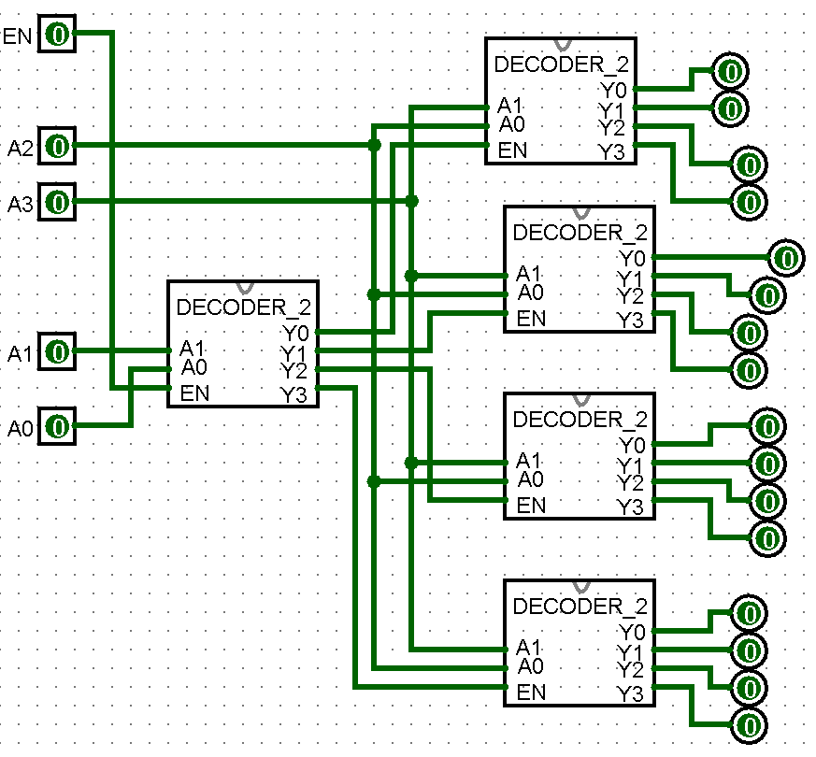

Test your circuit, with EN set to 1, and record your results in Table . Place a mark in the checkmark column of Table next to values that you tested.
Table 8 |  |  |  |  |  |  |  |  |  |  |  |  |  |  |  |  |  |  |  | Debug checkmark  (X)
A3 | A2 | A1 | A0 | Y0 | Y1 | Y2 | Y3 | Y4 | Y5 | Y6 | Y7 | Y8 | Y9 | Y10 | Y11 | Y12 | Y13 | Y14 | Y15 | X
0 | 0 | 0 | 0 | 1 | 1 | 1 | 0 | 1 | 1 | 1 | 1 | 1 | 1 | 1 | 1 | 0 | 1 | 1 | 1 | X
0 | 1 | 0 | 0 | 1 | 1 | 1 | 1 | 0 | 1 | 1 | 1 | 1 | 1 | 1 | 0 | 1 | 0 | 1 | 1 | X
1 | 0 | 0 | 0 | 0 | 1 | 1 | 1 | 1 | 0 | 1 | 1 | 1 | 1 | 0 | 1 | 1 | 1 | 0 | 1 | X
1 | 1 | 0 | 0 | 1 | 0 | 1 | 1 | 1 | 1 | 0 | 1 | 1 | 0 | 1 | 1 | 1 | 1 | 1 | 0 | X
1 | 0 | 1 | 1 | 1 | 1 | 0 | 1 | 1 | 1 | 1 | 0 | 0 | 1 | 1 | 1 | 1 | 1 | 1 | 1 | X

Include a picture of your Logisim 4-to-16 decoder subcircuit symbol here:
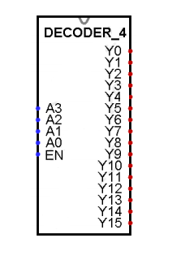
Task 2-9: Build a 4-Bit Buffer
Include a picture of your Logisim 4-bit buffer circuit here:
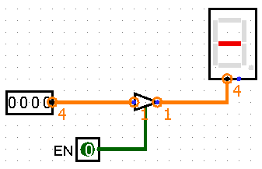
Test your circuit and record your results in Error: Reference source not found. Place a mark in the checkmark column of Error: Reference source not found next to values you used to verify your circuit. Describe your testing procedures and results for the 4-bit buffer here:
In order to test the circuit, I used a 1-bit tri-state buffer due to the two sources that are shared within the microprocessor using a communication bus. Through this test, the outputs of the data should not conflict with the method.

Table 9
A  (4-bit binary) | EN | Y  (4-bit binary output) | Debug  Checkmark  (X)
0 | X | 0 | X
1 | X | 1 | X
0 | 1 | 0 | X
1 | 1 | 1 | X
0 | 0 | 0 | X

Task 2-10: Backup Your Files
Did you backup your files to a NEW directory?____ YES___

Simulation Lab 2: Lab Report Grade Sheet

Name: | Pragathi Gopal

Instructor Assessment
Grading Criteria | Max Points | Points Lost
Template
Neatness, Clarity, and Concision | 1
Description of Assigned Tasks, Work Performed & Outcomes Met
Task 2-1: Design a Full Adder | 3
Task 2-2: Build, Debug and Test a 1-Bit Full Adder | 2
Task 2-3: Design, Build and Test a 4-Bit Full Adder | 3
Task 2-4: Design, Build and Test a MUX | 3
Task 2-5: Build a 2-Input 4-Bit Multiplexer | 2
Task 2-6: Build and Test a 1-to-2 Decoder | 2
Task 2-7: Build and Test a 2-to-4 Decoder | 3
Task 2-8: Design, Build & Test a 4-to-16 Decoder Using 2-to-4 Decoders | 3
Task 2-9: Build a 4-Bit Buffer | 3
Self-Assessment Worksheet (The content of the self-assessment worksheet will not be graded. Full credit is given for including the completed worksheet.) | (2 extra points)
 | Points Lost
Lab Score (25 points total) | Late Lab
 | Lab Score

Self-Assessment Worksheet

Put “X’s” in the table below indicating how strongly you agree or disagree that the outcomes of the assigned tasks were achieved. Use ‘5’ to indicate that you ‘strongly agree’, ‘3’ to indicate that you are 'neutral', and ‘1’ to indicate that you ‘strongly disagree’. Use ‘NA’, ‘Not Applicable’, when the tasks you performed did not elicit this outcome. Credit will be given for including this worksheet with your lab report; however, your responses will not be graded. They are for your instructor’s information only.
Table __: Self-Assessment of Outcomes for Simulation Lab 2: 4-Bit Full Adder, Multiplexer & Decoder.
After completing the assigned tasks and report, I am able to: | 5 | 4 | 3 | 2 | 1 | NA
A POS or SOP form of a full adder. | X
A 4-bit full adder. | X
A 2-to-1 multiplexer. | X
A 4-bit, 2-to-1 multiplexer. | X
A 1-to-2 decoder. | X
A 2-to-4 decoder. | X
A 4-to-16 decoder. | X
A 4-bit buffer. | X

Write below any suggestions you have for improving this laboratory exercise so that the stated learning outcomes are achieved.

