CSE/EEE 120
Simulation Lab 3 Answer Sheet
Arithmetic and Logic Unit
Name: Pragathi Gopal
Date:__________10/31/2016____
Task 3-1: Build the NOT/NEG Circuit
Include a picture of your Logisim NOT/NEG circuit here:
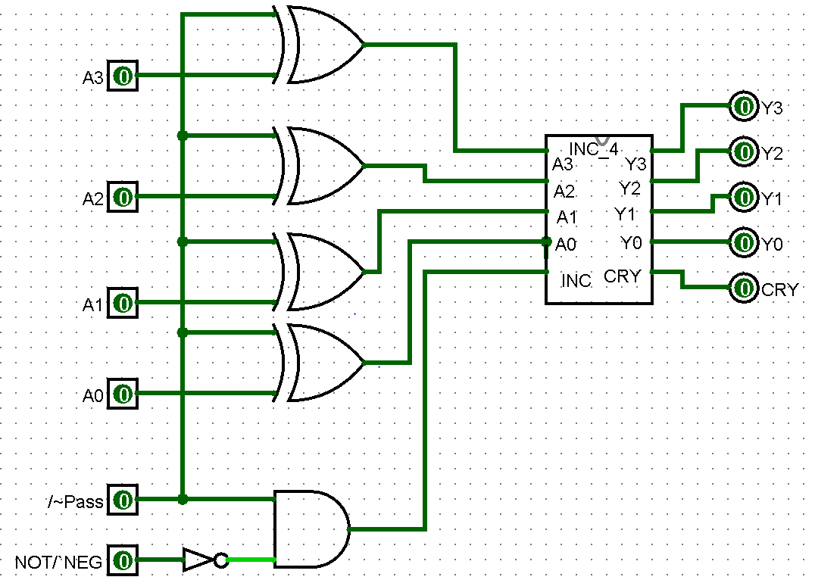
Table 1 lists the functionality of the NOT/NEG circuit based on the input control values. Perform the testing procedures outlined in the laboratory manual on your circuit and record your results in Error: Reference source not found. Place a mark in the checkmark column of Error: Reference source not found next to values you used to verify your circuit. Explain your test plan here:

Essentially I will test the respective inputs that I calculated from the content that we learned in class to ensure that it has the desired output.
Table 1
/~Pass | NOT/~NEG | Function
0 | 0 | Pass-through
0 | 1 | Pass-through
1 | 0 | Two’s complement
1 | 1 | One’s complement

Table 2 *
 |  |  |  |  |  |  |  |  |  |  | Debug
/~Pass | NOT/~NEG | A3 | A2 | A1 | A0 | Y3 | Y2 | Y1 | Y0 | Cout | Checkmark  (X)
0 | 0 | 0 | 0 | 0 | 1 | 0 | 0 | 0 | 1 | 0 | X
0 | 0 | 0 | 0 | 1 | 1 | 0 | 1 | 1 | 1 | 0 | X
0 | 1 | 0 | 1 | 0 | 1 | 0 | 0 | 0 | 1 | 0 | X
0 | 1 | 0 | 1 | 1 | 1 | 0 | 1 | 1 | 1 | 0 | X
1 | 0 | 1 | 0 | 0 | 1 | 0 | 1 | 1 | 1 | 0 | X
1 | 0 | 1 | 0 | 1 | 1 | 0 | 0 | 0 | 1 | 0 | X
1 | 1 | 1 | 1 | 0 | 1 | 0 | 1 | 1 | 1 | 0 | X
1 | 1 | 1 | 1 | 1 | 1 | 0 | 0 | 0 | 0 | 0 | x

*You may add lines to this table if you see that it is necessary.
Include a picture of your Logisim NOT/NEG subcircuit symbol here:
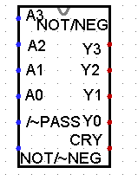
Task 3-2: Build and Test the OR/ADD Circuit
Copy the tabular information from Table 2 in the lab manual into Table 2 (see Table 1 as an example).

Include a picture of your Logisim circuit, which implements the logic shown in Figure 5 of the laboratory manual, here:
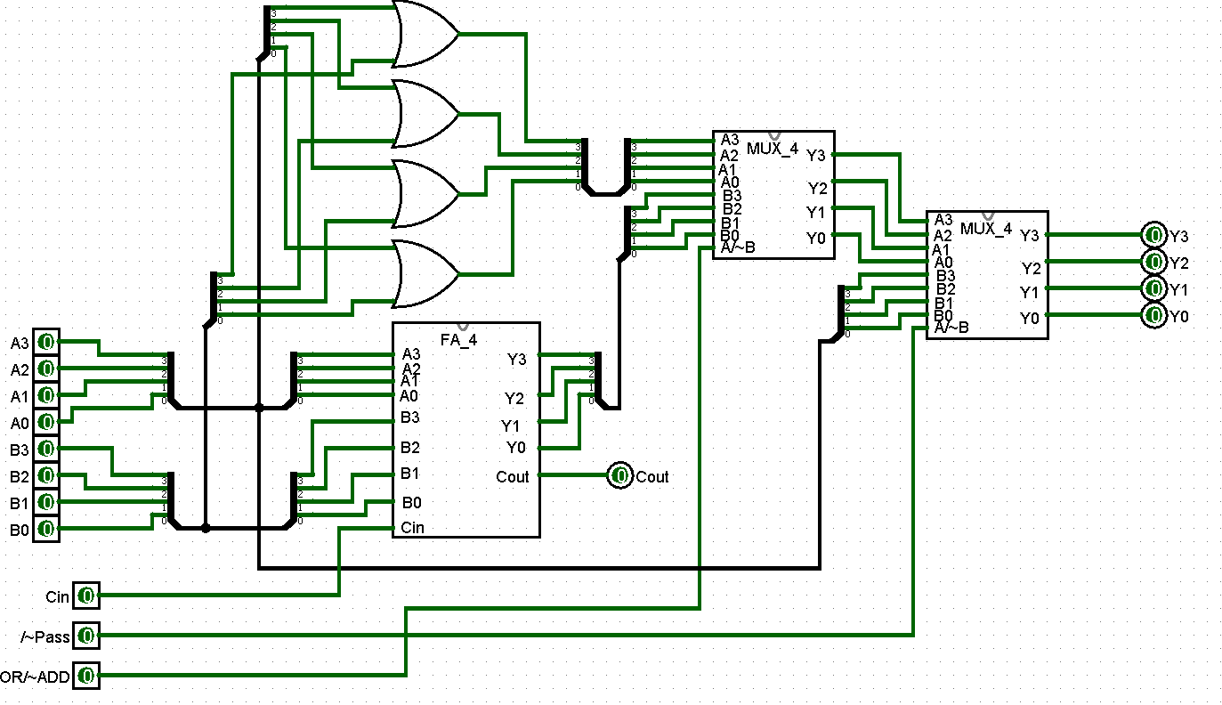
Test your circuit and record your results in Table 3. Place a mark in the checkmark column of Error: Reference source not found next to values you used to verify your circuit. Explain and justify your test procedure here:
To ensure that the circuit was set up correctly, I used the respective inputs
Table 2*
/~Pass | OR/~ADD | Function
0 | 0 | PASS THROUGH
0 | 1 | PASS THROUGH
1 | 0 | ADD
1 | 1 | AND
*Be sure to list functionality in column 3 of Table 2.

Table 3
Function = Pass-Through ( /~Pass = 0 ) |  |  |  |  |  |  |  |  |  |  |  |  | Debug
A3 | A2 | A1 | A0 | B3 | B2 | B1 | B0 | Y3 | Y2 | Y1 | Y0 | Cout | Checkmark  (X)
0 | 0 | 0 | 0 | 1 | 1 | 1 | 1 | 0 | 0 | 0 | 0 | 0 | X
0 | 1 | 0 | 1 | 0 | 1 | 0 | 1 | 0 | 1 | 0 | 1 | 0 | X
1 | 1 | 1 | 1 | 1 | 1 | 1 | 1 | 1 | 1 | 1 | 1 | 1 | X
Function = ADD ( /~Pass = 1 )
A3 | A2 | A1 | A0 | B3 | B2 | B1 | B0 | Y3 | Y2 | Y1 | Y0 | Cout
0 | 0 | 0 | 0 | 1 | 1 | 1 | 1 | 1 | 1 | 1 | 1 | 0 | X
0 | 1 | 0 | 1 | 0 | 1 | 0 | 1 | 1 | 0 | 1 | 0 | 0 | X
1 | 1 | 1 | 1 | 1 | 1 | 1 | 1 | 1 | 1 | 1 | 0 | 1 | X
Function = ADD ( /~Pass = 1 )
A3 | A2 | A1 | A0 | B3 | B2 | B1 | B0 | Y3 | Y2 | Y1 | Y0 | Cout
0 | 0 | 0 | 0 | 1 | 1 | 1 | 1 | 0 | 0 | 0 | 0 | 0 | X
0 | 1 | 0 | 1 | 0 | 1 | 0 | 1 | 0 | 1 | 0 | 1 | 0 | x
1 | 1 | 1 | 1 | 1 | 1 | 1 | 1 | 1 | 1 | 1 | 1 | 1 | X

Include a picture of your Logisim subcircuit symbol for Task 3-2 here:
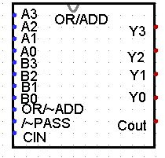
Task 3-3: Build and Test the ALU Circuit
Include a picture of your Logisim ALU circuit, shown in Figure 7 of the laboratory manual, here:
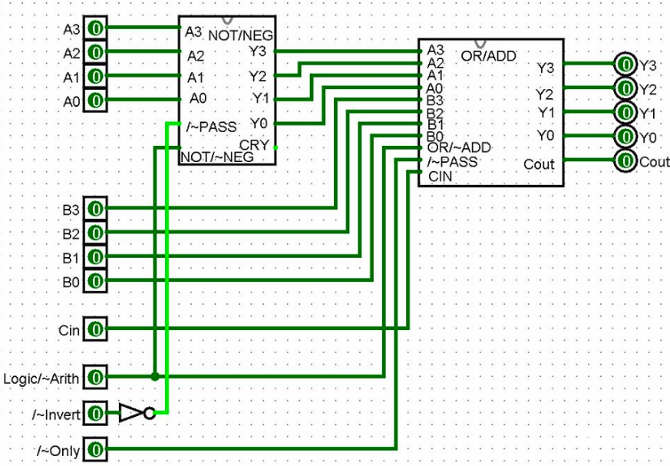

Record the function performed for different combinations of inputs in Table 4. Test your ALU circuit and record the results of your testing in Table 5. Place a mark in the checkmark column of Error: Reference source not found next to values you used to verify your circuit. Describe and justify your testing procedure here:
To make sure that the circuit works accurately, I tested the respective inputs with calculated outputs.
Table 4
/~A_Only | Logic/~Arith | /~Invert | Function
0 | 0 | 0 | -A
0 | 0 | 1 | A
0 | 1 | 0 | A’
0 | 1 | 1 | A
1 | 0 | 0 | (-A)+B
1 | 0 | 1 | Arithmetic Sum, A+B
1 | 1 | 0 | A’*B
1 | 1 | 1 | A*B

Table 5
Function = (/~A_Only = 0 Logic/~Arith = 0 /~Invert= 0 ) |  |  |  |  |  |  |  |  |  |  |  |  | Debug
A3 | A2 | A1 | A0 | B3 | B2 | B1 | B0 | Y3 | Y2 | Y1 | Y0 | Cout | Checkmark  (X)
0 | 0 | 0 | 0 | 1 | 1 | 1 | 1 | 0 | 0 | 0 | 0 | 0 | X
0 | 1 | 0 | 1 | 0 | 1 | 0 | 1 | 0 | 1 | 0 | 1 | 0 | X
1 | 1 | 1 | 1 | 1 | 1 | 1 | 1 | 1 | 1 | 1 | 1 | 1 | X
Function = (/~A_Only = 0 Logic/~Arith = 0 /~Invert= 1 )
A3 | A2 | A1 | A0 | B3 | B2 | B1 | B0 | Y3 | Y2 | Y1 | Y0 | Cout
0 | 0 | 0 | 0 | 1 | 1 | 1 | 1 | 1 | 1 | 1 | 1 | 1 | X
0 | 1 | 0 | 1 | 0 | 1 | 0 | 1 | 1 | 0 | 1 | 0 | 0 | X
1 | 1 | 1 | 1 | 1 | 1 | 1 | 1 | 0 | 0 | 0 | 0 | 0 | X
Function = (/~A_Only = 0 Logic/~Arith = 1 /~Invert= 0 )
A3 | A2 | A1 | A0 | B3 | B2 | B1 | B0 | Y3 | Y2 | Y1 | Y0 | Cout
0 | 0 | 0 | 0 | 1 | 1 | 1 | 1 | 0 | 0 | 0 | 0 | 0 | X
0 | 1 | 0 | 1 | 0 | 1 | 0 | 1 | 0 | 1 | 0 | 1 | 0 | X
1 | 1 | 1 | 1 | 1 | 1 | 1 | 1 | 1 | 1 | 1 | 1 | 1 | X
Function = (/~A_Only = 0 Logic/~Arith = 1 /~Invert= 1 )
A3 | A2 | A1 | A0 | B3 | B2 | B1 | B0 | Y3 | Y2 | Y1 | Y0 | Cout
0 | 0 | 0 | 0 | 1 | 1 | 1 | 1 | 0 | 0 | 0 | 0 | 0 | X
0 | 1 | 0 | 1 | 0 | 1 | 0 | 1 | 1 | 0 | 1 | 1 | 1 | X
1 | 1 | 1 | 1 | 1 | 1 | 1 | 1 | 0 | 0 | 0 | 1 | 1 | X
Function = (/~A_Only = 1 Logic/~Arith = 0 /~Invert= 0 )
A3 | A2 | A1 | A0 | B3 | B2 | B1 | B0 | Y3 | Y2 | Y1 | Y0 | Cout
0 | 0 | 0 | 0 | 1 | 1 | 1 | 1 | 1 | 1 | 1 | 1 | 0 | X
0 | 1 | 0 | 1 | 0 | 1 | 0 | 1 | 0 | 0 | 0 | 0 | 1 | X
1 | 1 | 1 | 1 | 1 | 1 | 1 | 1 | 0 | 0 | 0 | 0 | 1 | X
Function = (/~A_Only = 1 Logic/~Arith = 0 /~Invert= 1 )
A3 | A2 | A1 | A0 | B3 | B2 | B1 | B0 | Y3 | Y2 | Y1 | Y0 | Cout
0 | 0 | 0 | 0 | 1 | 1 | 1 | 1 | 1 | 1 | 1 | 1 | 0 | X
0 | 1 | 0 | 1 | 0 | 1 | 0 | 1 | 1 | 0 | 1 | 0 | 0 | X
1 | 1 | 1 | 1 | 1 | 1 | 1 | 1 | 1 | 1 | 1 | 0 | 1 | X
Function = (/~A_Only = 1 Logic/~Arith = 1 /~Invert= 0 )
A3 | A2 | A1 | A0 | B3 | B2 | B1 | B0 | Y3 | Y2 | Y1 | Y0 | Cout
0 | 0 | 0 | 0 | 1 | 1 | 1 | 1 | 1 | 1 | 1 | 1 | 1 | X
0 | 1 | 0 | 1 | 0 | 1 | 0 | 1 | 0 | 0 | 0 | 0 | 0 | X
1 | 1 | 1 | 1 | 1 | 1 | 1 | 1 | 0 | 0 | 0 | 0 | 0 | X
Function = (/~A_Only = 1 Logic/~Arith = 1 /~Invert= 1 )
A3 | A2 | A1 | A0 | B3 | B2 | B1 | B0 | Y3 | Y2 | Y1 | Y0 | Cout
0 | 0 | 0 | 0 | 1 | 1 | 1 | 1 | 0 | 0 | 0 | 0 | 0 | X
0 | 1 | 0 | 1 | 0 | 1 | 0 | 1 | 0 | 1 | 0 | 1 | 0 | X
1 | 1 | 1 | 1 | 1 | 1 | 1 | 1 | 1 | 1 | 1 | 1 | 1 | X

Include a picture of your Logisim ALU subcircuit symbol here:
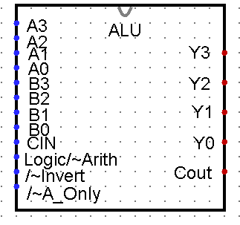

Task 3-4: Backup Your Files
Did you backup your files to a NEW directory? Yes

Simulation Lab 3: Lab Report Grade Sheet

Name: | Pragathi Gopal

Instructor Assessment: Task Oriented
Grading Criteria | Max Points | Points Lost
Template
Neatness, Clarity, and Concision | 2
Description of Assigned Tasks, Work Performed & Outcomes Met
Task 3-1: Build the NOT/NEG Circuit | 8
Task 3-2: Build and Test the Logic/ADD Circuit | 8
Task 3-3: Build and Test the ALU Circuit | 12
Self-Assessment Worksheet (The content of the self-assessment worksheet will not be graded. Full credit is given for including the completed worksheet.) | (2 extra points)
 | Points Lost
Lab Score (30 points total) | Late Lab
 | Lab Score

Self-Assessment Worksheet

Put “X’s” in the table below indicating how strongly you agree or disagree that the outcomes of the assigned tasks were achieved. Use ‘5’ to indicate that you ‘strongly agree’, ‘3’ to indicate that you are 'neutral', and ‘1’ to indicate that you ‘strongly disagree’. Use ‘NA’, ‘Not Applicable’, when the tasks you performed did not elicit this outcome. Credit will be given for including this worksheet with your lab report; however, your responses will not be graded. They are for your instructor’s information only.
Table __: Self-Assessment of Outcomes for Simulation Lab 3: Arithmetic and Logic Unit.
After completing the assigned tasks and report, I am able to: | 5 | 4 | 3 | 2 | 1 | NA
Build, test, debug, and imbed in a subcircuit, an elementary arithmetic and logic unit (ALU). | X
Describe the arithmetic and logical operations of which the ALU is capable. | X
Describe the input control line values that correspond to each arithmetic and logical operation of the ALU. | X
Write a top-down description of a complex logic circuit. | X

Write below any suggestions you have for improving this laboratory exercise so that the stated learning outcomes are achieved.

