CSE/EEE 120
Simulation Lab 4 Answer Sheet
The Microprocessor
Name: Pragathi Gopal
Date: 12/1/2016
Task 4-1: Build the Brainless Central Processing Unit
Include a picture of your Logisim Brainless Central Processing Unit circuit here:
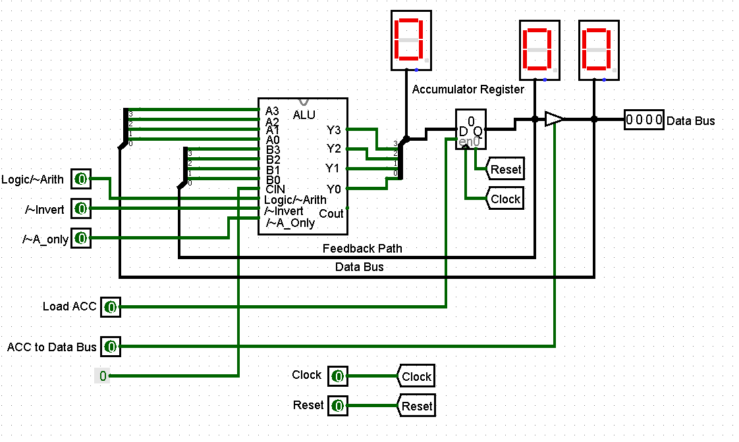
Task 4-2: Test and Control the Brainless Central Processing Unit
Perform the testing procedures outlined in the laboratory manual and fill in the blanks below. (Note that these questions appear in the text of the laboratory manual.)
- Record the first number placed on the data bus here: 5
- What do the following three switches need to be set to in order to perform the pass-through operation? /~A_Only = 0 /~Invert= 1 Logic/~Arith= X - Don’t Care
- Enter the second number you entered into the data bus here: 1
- What do the following three switches need to be set to in order to perform the ADD operation? /~A_Only = 1 /~Invert= 1 Logic/~Arith= 0
- Write down the number that appears in the accumulator here: 6
Describe other numerical additions and other operations you checked in order to verify your brainless CPU here:
To add a 1 to the total each time I needed to toggle the clock input a few times. In order to lock the ALU output into the Accumulator I used different numbers on the data bus and toggled the clock’s input pin twice. Afterwards a new number was added to the data bus, toggled the clock was toggled twice and checked that it was adding the number to the stored sum.
After you are convinced your circuit is working properly, remove the 4-bit binary keyboard and set the ACC to Data Bus pin to 1. Did the output of the accumulator appear on the data bus? Yes
How does the output of the ALU change?
It changes from an error to the sum. It’s the output of the Accumulator + the output of the Accumulator.
If the 4-bit binary keyboard was not removed and the ACC to Data Bus switch is set to 1, what would you expect to see displayed in the hex digit display attached to the data bus? A conflict in the data would occur. The output of the accumulator was given into the output of the 4-bit binary keyboard. No error would occur if the binary keyboard and the Accumulator outputs are the same.
Add the 4-bit binary keyboard back into your circuit and observe the hex digit display on the data bus for various keyboard values. Is the value on the hex digit display what you expected? Yes
Explain: The data bus only receives one input because if it allows 2 different inputs a data error will occur. But by enabling the 3 state buffer by setting the ACC to Data bus and setting it to 1, it go to the Accumulator Register to the Data Bus.
Why do you think the register at the output of the ALU is called the ‘accumulator’?
At every clock toggle rises, it accumulates the output of the ALU.

Task 4-3: Build the Addressing Logic

Include a picture of your Logisim addressing logic circuit here:

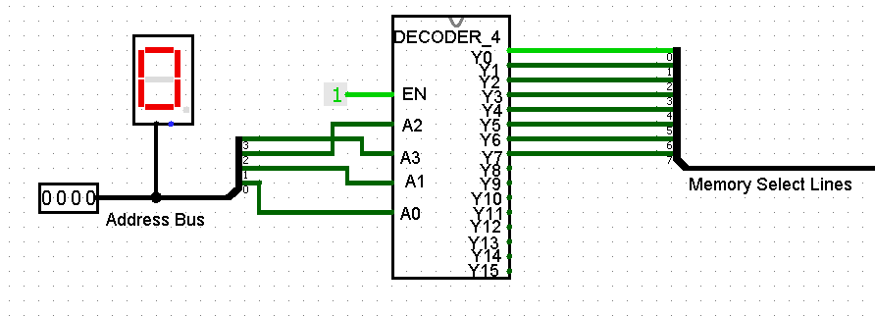
Test your circuit and record the results in Table 1. Include a picture of your Logisim addressing logic circuit testing set up.

Table 1
A  (4-bit binary) | Y0 | Y1 | Y2 | Y3 | Y4 | Y5 | Y6 | Y7
0000 | 1 | 0 | 0 | 0 | 0 | 0 | 0 | 0
0001 | 0 | 1 | 0 | 0 | 0 | 0 | 0 | 0
0101 | 0 | 0 | 0 | 0 | 0 | 1 | 0 | 0
0111 | 0 | 0 | 0 | 0 | 0 | 0 | 0 | 1

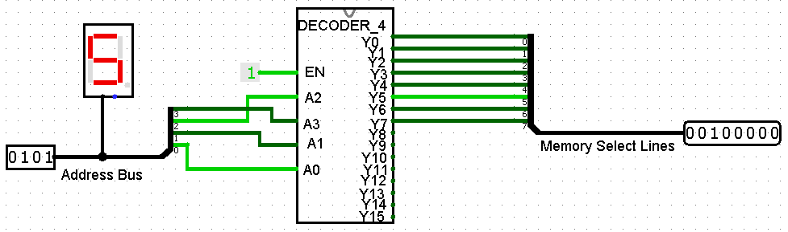
Task 4-4: Build a 4-Bit ROM Memory Cell
Include a picture of your Logisim 4-bit ROM circuit here:
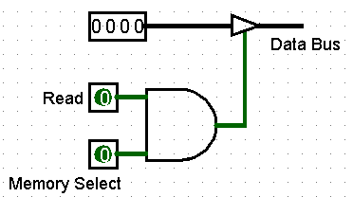
Test your circuit and record the results in Table 2. Include a picture of your Logisim 4-bit ROM circuit testing set up.
Table 2
A  (4-bit binary) | Read | Memory Select | Y  (Data Bus)
1111 | 0 | 0 | X
0000 | 1 | 1 | 0
0101 | 1 | 1 | 5
0101 | 0 | 1 | X
0101 | 1 | 0 | X
1000 | 1 | 1 | 8

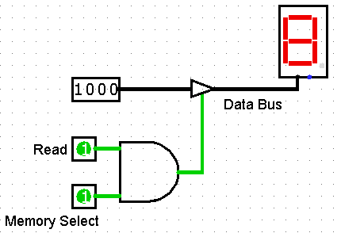
Task 4-5: Build 4-Bit Output Port
Include a picture of your Logisim 4-bit output port circuit here:
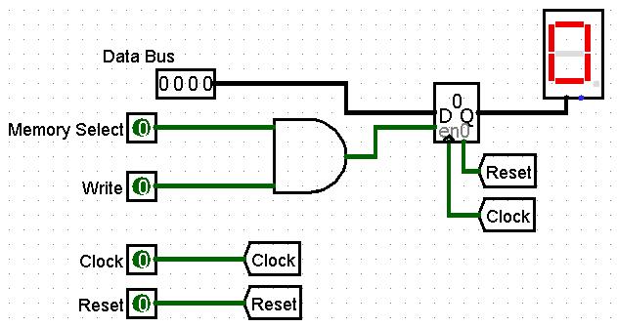
Test your circuit and record the results in Table .
Table 3
Data Bus (4-bit binary) | Write | Memory Select | Q
0101 | 0 | 0 | 0
0101 | 0 | 1 | 0
0101 | 1 | 1 | 5
0001 | 1 | 1 | 1
0001 | 1 | 0 | 1
0001 | 0 | 0 | 1
0001 Reset | 0 | 0 | 0
0001 Clock | 1 | 1 | 1

Task 4-6: Build the 4-Bit RAM Cell
Include a picture of your Logisim 4-bit RAM circuit here:
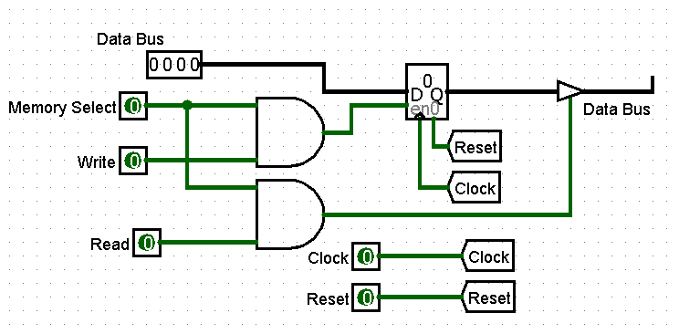
Test your circuit and record the results in Table . Include a picture of your Logisim 4-bit RAM circuit testing set up.
Table 4
Data Bus  (4-bit binary) | Write | Memory Select | Read | Q {between register and buffer} | Data Bus {after buffer}
0011 | 0 | 0 | 0 | 0 | X
0011 | 1 | 1 | 0 | 3 | X
0011 | 1 | 1 | 1 | 3 | 3
0111 | 0 | 1 | 1 | 3 | 3
0111 | 1 | 1 | 1 | 7 | 7
0111 | 1 | 1 | 0 | 7 | X

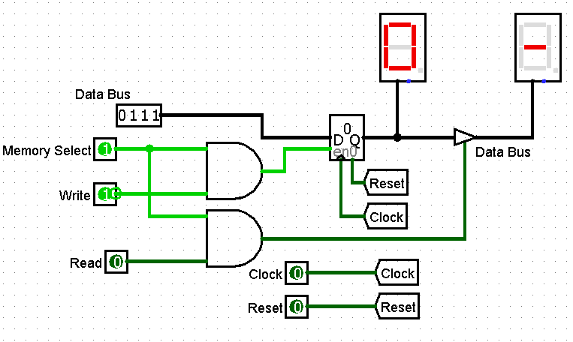
Task 4-7: Build the Brainless Microprocessor
Include a picture of your Logisim brainless microprocessor circuit here:
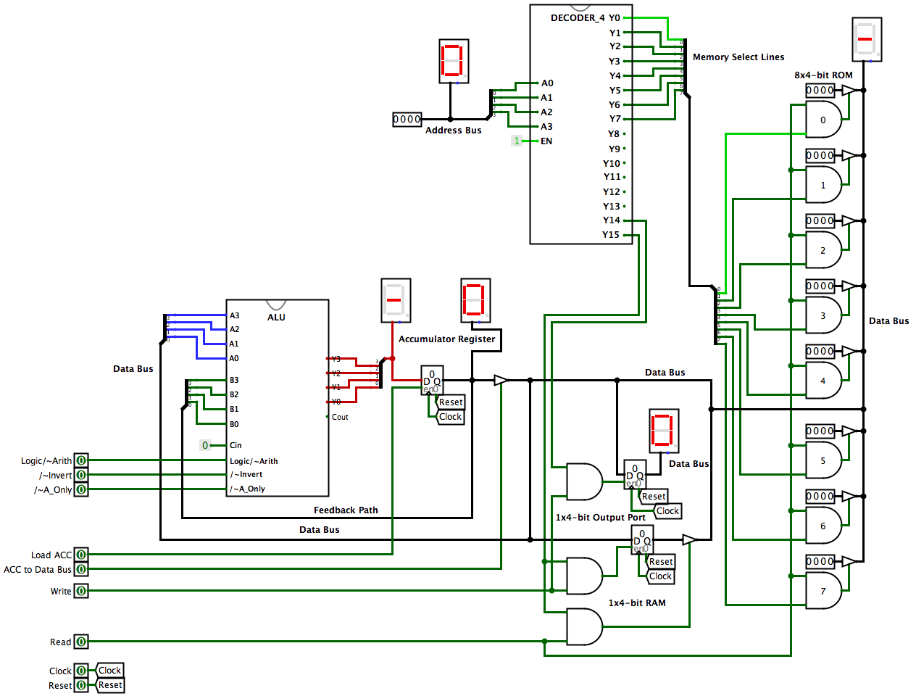
Task 4-8: Testing and Controlling the Brainless Microprocessor
Follow steps 1 through 3 outlined in the laboratory manual to test your brainless microprocessor circuit. List in Table the control lines you needed to control to store the accumulator (ACC) to RAM. (If the control line value has no impact, place a dash ‘-‘ in the value column).
Table 5
Control line | Value
4-bit binary keyboard  (Address Bus) | 1111
Write | 1
Read | 0
ACC to Data Bus | 1
Load ACC | 0
/~A_Only | -
/~Invert | -
Logic/~Arith | -

Describe any other tests that you performed. NOTE: the laboratory manual gives you a minimum set of items to test:
The test that I used first includes the two’s complement of 7. Essentially, I loaded 0111(7) into the ROM Address Bus when the value equaled 0. Furthermore, the logic was set to 0 and the inverter was set to 0. The clock was toggled into the ACC and loaded onto a 1x4- bit RAM.
Another test that I did was subtract the value of 3 from 5, which would be 5 + -3. Then, I loaded the ACC with the 5 and traced the steps with an outline for question 2 in this task. The two’s complement was performed on 3 and it stored a 2 in a 1x4-bit RAM.
I performed a third test that used the AND logical operation and has various combinations of the numbers. When the value of 6 was entered the values in the ROM Address Bus correlated accordingly to the changes that I predicted. When I switched the Address Bus to 3, I used the value of 9(1001) to perform the Logic AND Operation between 6 and 9 giving an output of 0 from the ALU.
The last test I used was the Logic Inversion or using the One’s Complement of 7, which stored the result in the RAM. Thus, when I entered 7 into the ROM of the Address Bus with a value of 0, the stored output would be 8 into the ACC. The value of 8 is then stored in the ACC and on the 1x4-bit RAM.
Error: Reference source not found is an example, for the ADD command, of how to fill out tables to record the values of the control lines during every clock cycle.
Table 6
Instruction [ Add operand to Accumulator (ACC) ]
Control Line | Value
4-bit Binary Keyboard (Address Bus) | Address of operand
Write | 0
Read | 1
ACC to Data Bus | 0
Load ACC | 1
/~A_Only | 1
/~Invert | 1
Logic/~Arith | 0

For all of the instructions you performed (i.e. Subtract, Load ACC, etc.) record the values of the control lines during every clock cycle in Error: Reference source not found, Error: Reference source not found and Error: Reference source not found.

Table 7
Instruction [ Subtract operand from ACC ]
Control Line | Value
4-bit Binary Keyboard (Address Bus) | 0001
Write | 0
Read | 1
ACC to Data Bus | 0
Load ACC | 1
/~A_Only | 1
/~Invert | 0
Logic/~Arith | 0

Table 8
Instruction [ Load ACC with operand ]
Control Line | Value
4-bit Binary Keyboard (Address Bus) | 0000
Write | 0
Read | 1
ACC to Data Bus | 0
Load ACC | 1
/~A_Only | 0
/~Invert | 1
Logic/~Arith | X
Instruction [OR operand with ACC]
Control Line | Value
4-bit Binary Keyboard (Address Bus) | 0001
Write | 0
Read | 1
ACC to Data Bus | 0
Load ACC | 1
/~A_Only | 1
/~Invert | 1
Logic/~Arith | 1
Instruction [ Store ACC to RAM ]
Control Line | Value
4-bit Binary Keyboard (Address Bus) | 1111
Write | 1
Read | 0
ACC to Data Bus | 1
Load ACC | 1
/~A_Only | X
/~Invert | X
Logic/~Arith | X

Table 9
Instruction [ Not (operand) to ACC ]
(1’s complement)
Control Line | Value
4-bit Binary Keyboard (Address Bus) | 0000
Write | 0
Read | 1
ACC to Data Bus | 0
Load ACC | 1
/~A_Only | 0
/~Invert | 0
Logic/~Arith | 1
Instruction [ Negate(operand) to ACC ]
(2’s complement)
Control Line | Value
4-bit Binary Keyboard (Address Bus) | 0000
Write | 0
Read | 1
ACC to Data Bus | 0
Load ACC | 1
/~A_Only | 0
/~Invert | 0
Logic/~Arith | 0

Task 4-9: Build the Memory-Address-Generation Circuit
Include a picture of your Logisim memory address generation circuit here:

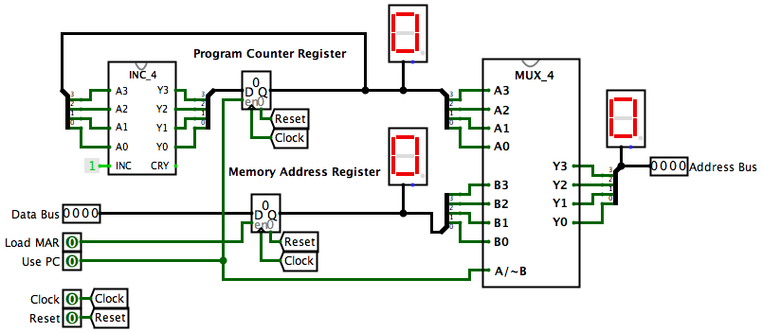
Task 4-10: Build the Controller Circuit
Include a picture of your Logisim controller circuit here:
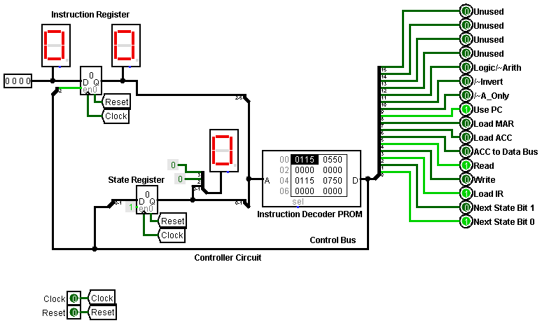

Task 4-11: Build the Complete Microprocessor Circuit
Include a picture of your Logisim complete microprocessor circuit, with controller, here:
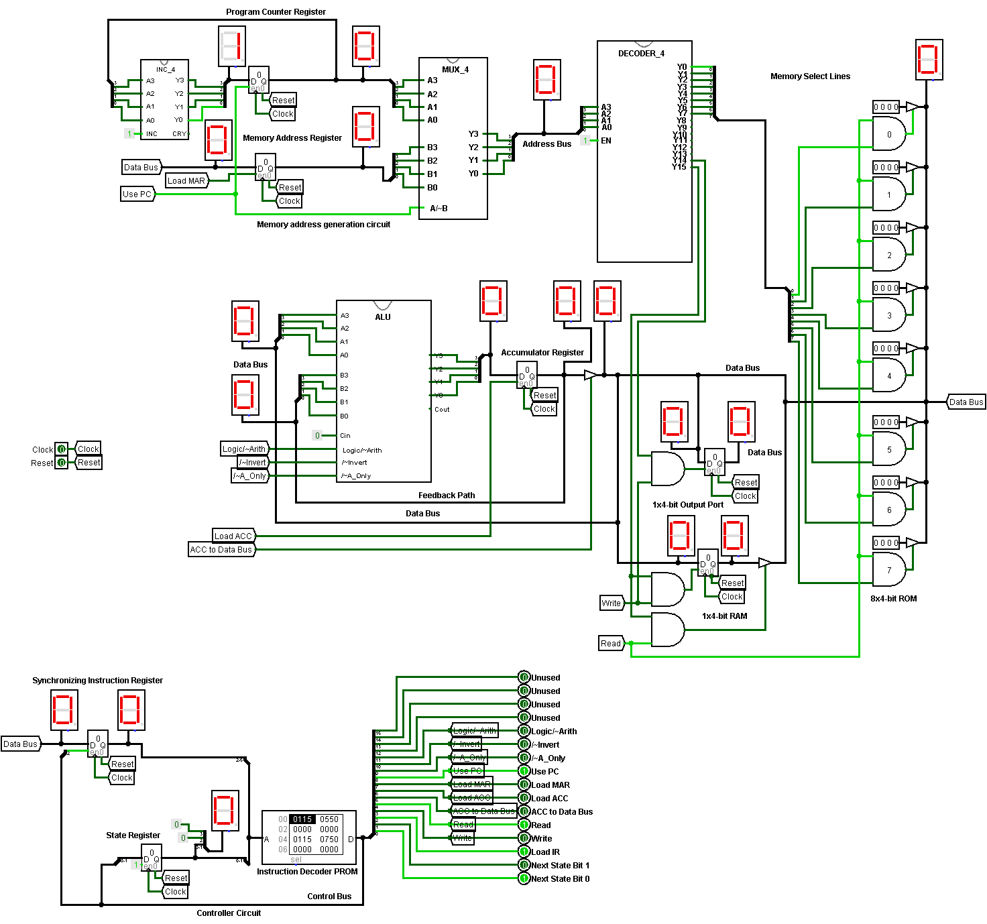
Task 4-12: Write and Execute a Simple Program for Your Microprocessor
Write the program given in your laboratory manual into the appropriate memory locations. Observe the operation of each step of your program (i.e. observe the values of the control lines and record whether data is being moved properly according to those control line settings). Did you get an 8 stored into the accumulator with you initial test? Yes
If not, what error(s) did you find during your debugging process? In order to debug the circuits I watched the Sim Lab videos and saw how what my design process was.
Task 4-13: Add the ‘OR’, ‘Zero’, ‘Subtract’, and ‘Store ACC’ Instructions
Use Table and Table to enter your values into the microinstruction definition table for each of the four instructions asked for in the laboratory manual. Be sure to label the name of each and every instruction.
Table 10
 | Instruction | OR |  |  |  | ZERO
 | Opcode | 3 |  |  |  | 4
 | Pres. State | 00 | 01 | 02 | 03 | 00 | 01 | 02 | 03
Description | Pin number
Next State Bits | 1-0 | 1 | 0 | 0 | 0 | 1 | 0 | 0 | 0
Load IR | 2 | 1 | 0 | 0 | 0 | 1 | 0 | 0 | 0
Write | 3 | 0 | 0 | 0 | 0 | 0 | 0 | 1 | 0
Read | 4 | 1 | 1 | 1 | 0 | 1 | 1 | 0 | 1
ACC to Data Bus | 5 | 0 | 0 | 0 | 0 | 0 | 0 | 1 | 0
Load ACC | 6 | 0 | 1 | 1 | 0 | 0 | 1 | 0 | 1
Load MAR | 7 | 0 | 0 | 0 | 0 | 0 | 0 | 0 | 0
Use PC | 8 | 1 | 1 | 1 | 0 | 1 | 1 | 1 | 1
/~A_only | 9 | X | 0 | 1 | 0 | X | 0 | X | 0
/~Invert | 10 | X | 1 | 1 | 0 | X | 1 | X | 0
Logic/~Arith | 11 | X | X | 1 | 0 | X | X | X | 0
X | 12 | X | X | X | 0 | X | X | X | X
X | 13 | X | X | X | 0 | X | X | X | X
X | 14 | X | X | X | 0 | X | X | X | X
X | 15 | X | X | X | 0 | X | X | X | X
 | HEX equiv | 0115 | 0550 | 0F50 | 0000 | 0115 | 0550 | 0128 | 0150

Table 11
 | Instruction | Subtract |  |  |  | Store ACC
 | Opcode | 5 |  |  |  | 6
 | Pres. State | 00 | 01 | 02 | 03 | 00 | 01 | 02 | 03
Description | Pin number
Next State Bits | 1-0 | 1 | 0 | 0 | 0 | 1 | 0 | 0 | 0
Load IR | 2 | 1 | 0 | 0 | 0 | 1 | 0 | 0 | 0
Write | 3 | 0 | 0 | 0 | 0 | 0 | 0 | 0 | 1
Read | 4 | 1 | 1 | 1 | 0 | 1 | 1 | 1 | 0
ACC to Data Bus | 5 | 0 | 0 | 0 | 0 | 0 | 0 | 0 | 1
Load ACC | 6 | 0 | 1 | 1 | 0 | 0 | 1 | 0 | 0
Load MAR | 7 | 0 | 0 | 0 | 0 | 0 | 0 | 1 | 0
Use PC | 8 | 1 | 1 | 1 | 0 | 1 | 1 | 0 | 0
/~A_only | 9 | X | 0 | 1 | 0 | X | 0 | 0 | X
/~Invert | 10 | X | 1 | 0 | 0 | X | 1 | 1 | X
Logic/~Arith | 11 | X | X | 0 | 0 | X | X | X | X
X | 12 | X | X | X | 0 | X | X | X | X
X | 13 | X | X | X | 0 | X | X | X | X
X | 14 | X | X | X | 0 | X | X | X | X
X | 15 | X | X | X | 0 | X | X | X | X
 | HEX equiv | 0115 | 0550 | 0350 | 0000 | 0115 | 0550 | 0490 | 0028

Test your instructions by writing and executing programs. Record at least four programs and the output of each program in tables like that of Table .
Table 12
Program #0 ( Example: ADD = 3+5)
Address | Value | Operation (In English)
0 | 0 | The 'Load ACC' Opcode
1 | 3 | The number '3' to be loaded into the Accumulator
2 | 1 | The 'Add to ACC' Opcode
3 | 5 | The number '5' to be added to the Accumulator
4 | 2 | The 'Stop' Opcode
What was the final output of your program? ___8__
Was the program successful? YES_
If not what error(s) did you find in your circuit?

Program # 1 ( 0101 AND 0110)
Address | Value | Operation (In English)
0 | 0 | The ‘Load ACC’ Opcode
1 | 5 | The number ‘5’ to be loaded into the Accumulator
2 | 1 | The ‘AND’ Opcode
3 | 6 | The number ‘6’ to AND with the ACC
4 | 2 | The Stop Opcode
What was the final output of your program? 4
Was the program successful? Yes
If not what error(s) did you find in your circuit? No errors

Program # 2 ( Zero )
Address | Value | Operation (In English)
0 | 0 | The ‘Load ACC’ Opcode
1 | 5 | The number ‘5’ to be loaded into the Accumulator
2 | 1 | The ‘Write ACC to Data Bus’ Opcode
3 | 5 | Number ‘5’ is loaded to the Data Bus
3 | 2 | The ‘Add to ACC’ Opcode
4 | -5 | The two’s Complement ‘-5’ is added to the Accumulator
5 | 3 | The Stop Opcode
What was the final output of your program? 0
Was the program successful? Yes
If not what error(s) did you find in your circuit? No errors

Program # 3 ( Subtract)
Address | Value | Operation (In English)
0 | 0 | The ‘Load ACC’ Opcode
1 | 5 | The number ‘5’ is loaded into the Accumulator
2 | 1 | The ‘Subtract from Accumulator’ Opcode
3 | 1 | The number ‘1’ to subtract from Accumulator
4 | 2 | The Stop Opcode
What was the final output of your program? 0
Was the program successful? Yes
If not what error(s) did you find in your circuit? No errors

Program #4 (Store ACC)
Address | Value | Operation (In English)
0 | 0 | The ‘Load ACC’ Opcode
1 | 5 | The number ‘5’ to be loaded into the Accumulator
2 | 1 | The ‘Load MAR’ Opcode
3 | 15 | The number ‘15’ to be loaded into the MAR
4 | 2 | The ‘Write ACC to Data Bus’ and “Load to RAM’ Opcode
5 | 5 | The number ‘5’ is loaded to RAM
6 | 3 | The Stop Opcode
What was the final output of your program? 5
Was the program successful? Yes
If not what error(s) did you find in your circuit? No errors

Task 4-14: Invent Your Own Instruction (Extra Credit)
Fill in the following two tables for your invented instruction.
 | Instruction | ADD = 3+5 |  |  |  | Store ACC to RAM
 | Opcode | 7
 | Pres. State | 00 | 01 | 02 | 03 | 00 | 01 | 02 | 03
Description | Pin number
Next State Bits | 1-0
Load IR | 2
Write | 3
Read | 4
ACC to Data Bus | 5
Load ACC | 6
Load MAR | 7
Use PC | 8
/~A_only | 9
/~Invert | 10
Logic/~Arith | 11
X | 12
X | 13
X | 14
X | 15
 | HEX equiv

Program # ( )
Address | Value | Operation (In English)
What was the final output of your program? _____
Was the program successful? Yes or No_
If not what error(s) did you find in your circuit?

Simulation Lab 4: Lab Report Grade Sheet

Name:

Instructor Assessment: Task Oriented
Grading Criteria | Max Points | Points Lost
Template
Neatness, Clarity, and Concision | 2
Description of Assigned Tasks, Work Performed & Outcomes Met
Task 4-1: Build the Brainless Central Processing Unit | 3
Task 4-2: Test and Control the Brainless Central Processing Unit | 7
Task 4-3: Build the Addressing Logic | 2
Task 4-4: Build a 4-Bit ROM Memory Cell | 2
Task 4-5: Build 4-Bit Output Port | 2
Task 4-6: Build the 4-Bit RAM Cell | 2
Task 4-7: Build the Brainless Microprocessor | 6
Task 4-8: Testing and Controlling the Brainless Microprocessor | 7
Task 4-9: Build the Memory-Address-Generation Circuit | 3
Task 4-10: Build the Controller Circuit | 3
Task 4-11: Build the Complete Microprocessor Circuit | 6
Task 4-12: Write and Execute a Simple Program for your Microprocessor | 3
Task 4-13: Add the ‘OR’, ‘Zero’, ‘Subtract’, and ‘Store ACC’ Instructions | 12
Task 4-14: Invent Your Own Instruction | (3 extra points)
Self-Assessment Worksheet (The content of the self-assessment worksheet will not be graded. Full credit is given for including the completed worksheet.) | (2 extra points)
 | Points Lost
Lab Score (60 points total) | Late Lab
 | Lab Score

Self-Assessment Worksheet

Put ‘X’s’ in the table below indicating how strongly you agree or disagree that the outcomes of the assigned tasks were achieved. Use ‘5’ to indicate that you ‘strongly agree’, ‘3’ to indicate that you are 'neutral', and ‘1’ to indicate that you ‘strongly disagree’. Use ‘NA’, ‘Not Applicable’, when the tasks you performed did not elicit this outcome. Credit will be given for including this worksheet with your lab report; however, your responses will not be graded. They are for your instructor’s information only.
Table __: Self-Assessment of Outcomes for Simulation Lab 4: The Brainless Microprocessor
After completing the assigned tasks and report, I am able to: | 5 | 4 | 3 | 2 | 1 | NA
Build, debug and control a simulation of a central processing unit (CPU) | X
Build, debug and control a simulation of a ROM, RAM and an output port. | X
Build and debug a simulation of a microprocessor that is absent a controller. | X
Act as the controller for an elementary microprocessor. | X
Design a PROM-based controller for an elementary microprocessor. | X
Create an instruction set for an elementary microprocessor. | X
Use the language of your instruction set to create a program and enter it into memory. | X
Execute a program on your simulated microprocessor. | X

Write below any suggestions you have for improving this laboratory exercise so that the stated learning outcomes are achieved.

