**Learner’s Academy**

Learner’s Academy is a school that has an online management system. The system keeps track of its classes, subjects, students, and teachers. It has a back-office application with a single administrator login.

**The admin login details are: username is *admin* and password is *admin***.

This document contains sections for:

● Sprint planning and Task completion

● Core concepts used in project

● Conclusions

The code for this project is available at [ServletDemo/LearnerAcadDemo at main · pragathihebbarkm/ServletDemo (github.com)](https://github.com/pragathihebbarkm/ServletDemo/tree/main/LearnerAcadDemo) this project is developed by Pragathi Hebbar.

Sprints planning and Task completion

The project is planned to be completed in a single sprint. Tasks that are assumed to be completed in this sprint are :

* Creating the flow of the application
* Initializing git repository to track changes as development progresses.
* Writing the program to fulfil the requirements of the project.
* Pushing code to GitHub.
* Creating this specification document highlighting application capabilities, appearance, and user interactions.

Core concepts used in project

The application is based on JSP, Java, Servlets and MySql database.

Demonstrating the product capabilities, appearance, and user interactions

We have 7 operations available:

1. Admin Login
2. List of Classes
3. List of Students taking a particular subject
4. List of Teachers
5. List of Students
6. List of Subjects
7. Admin Logout

Flow of Application

1. For Login/Logout a simple JSP and Servlet are used (login.jsp), that handles the operation of Login/Logout.
2. The MYSQL connection is achieved through DbRetrieve.java class which establishes the connection between database and the eclipse editor for performing all the operations on database.
3. Servlet for all admin operations like Listing Students, Classes, Subjects and Teachers is created in AdminControllerServlet.
4. The Dashboard Page is created using left-list.jsp which holds the links to display the details of Teachers ,Students, Subjects and Classes.
5. The details of Class, Students, Teachers and Subjects are displayed with the help of jsp files (classes-list.jsp, list-students.jsp, subjects-list.jsp and teachers-list.jsp) created which retrieves the details from database.
6. The class report is displayed by clicking on the List link available in the class list, this is displayed with the help of class-students.jsp file.

Pushing the code to GitHub repository

● Open your command prompt and navigate to the folder where you have created your files.

**cd <folder path>**

● Initialize repository using the following command:

**git init**

● Add all the files to your git repository using the following command:

**git add .**

● Commit the changes using the following command:

**git commit -m <commit message>**

● Push the files to the folder you initially created using the following command:

**git push -u origin master**

**Application View:**

1. Login Page

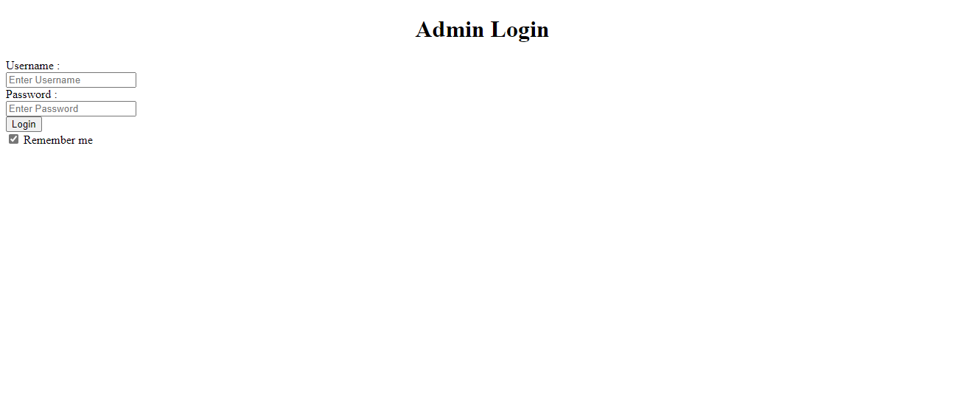

1. Dashboard

1. List of Subjects

1. List of Teachers

1. List of students

1. Class report listing students enrolled in a particular subject

