Sql queries (study )

SQL> create table product(
2 product_id int unique ,
3 product_name varchar(25),
4 category varchar(20),
5 price number ,
6 stock int);

Table created.

SQL> desc product; Name Null? Type

PRODUCT_ID NUMBER(38) PRODUCT_NAME VARCHAR2(25) CATEGORY VARCHAR2(20) PRICE NUMBER STOCK NUMBER(38)
SQL> insert into product values(201,'laptop','electronics',55000,10);
1 row created.
SQL> insert into product values(202,'keyboard','accessories',1500,25);
1 row created.
SQL> insert into product values(203,'monitor','electronics',12000,8);
1 row created.
SQL> insert into product values(204,'mouse','accessories',800,40);
1 row created.
SQL> insert into product values(205,'printer','electronics',18000,5);
1 row created.
SQL> select * from products; select * from products * ERROR at line 1: ORA-00942: table or view does not exist
SQL> select * from product;
PRODUCT_ID PRODUCT_NAME CATEGORY PRICE STOCK

201 laptop electronics 55000 10
202 keyboard accessories 1500 25
203 monitor electronics 12000 8
204 mouse accessories 800 40
205 printer electronics 18000 5

1. Write an SQL query to display the PRODUCT_NAME and PRICE of products whose price is greater than 10,000.
SQL> select product_name, price from product where price >10000;
PRODUCT_NAME PRICE

laptop 55000 monitor 12000 printer 18000
2.Write an SQL query to display the PRODUCT_NAME, CATEGORY, and PRICE of products that:
- belong to Electronics
- AND have a price greater than ₹15,000

SQL> select product_name, category,price from product where category ='electronics' and price >15000;

PRODUCT_NAME CATEGORY PRICE
------------------------- -------------------- ----------
laptop electronics 55000
printer electronics 18000
Q3 — OR operator
Write an SQL query to display:
PRODUCT_NAME, CATEGORY, and PRICE
of products that satisfy either of these conditions:
- Category is Accessories
OR
- Price is greater than ₹50,000
SQL> select product_name, category,price from product where category ='accessories' or price >50000;

PRODUCT_NAME CATEGORY PRICE
------------------------- -------------------- ----------
laptop electronics 55000
keyboard accessories 1500
mouse accessories 800

Q4 — BETWEEN 🔥
Write an SQL query to display:
PRODUCT_NAME, PRICE
of products whose price is between ₹1,000 and ₹20,000.

SQL> select PRODUCT_NAME, PRICE from product where price between 1000 and 20000;

PRODUCT_NAME PRICE
------------------------- ----------
keyboard 1500
monitor 12000
printer 18000
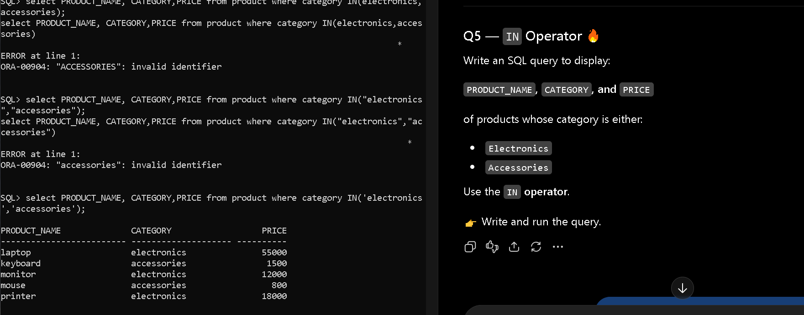

q 6

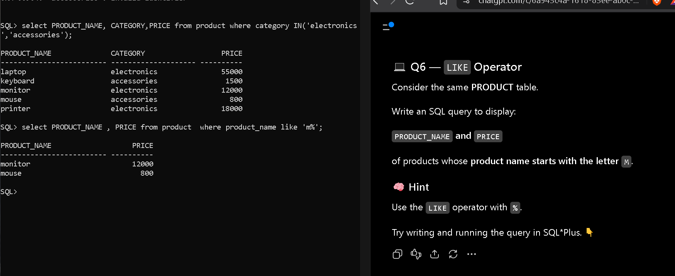
order by
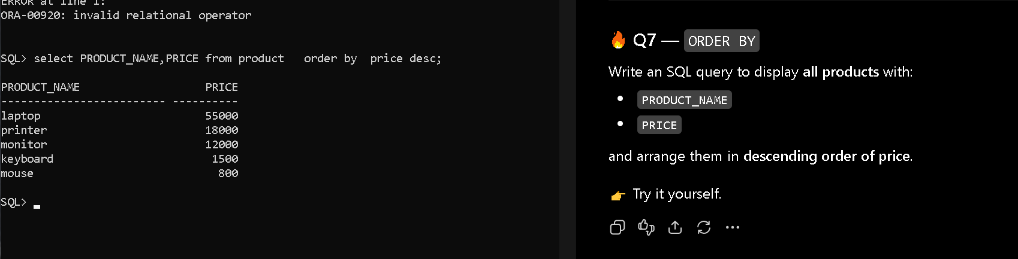
avg ()
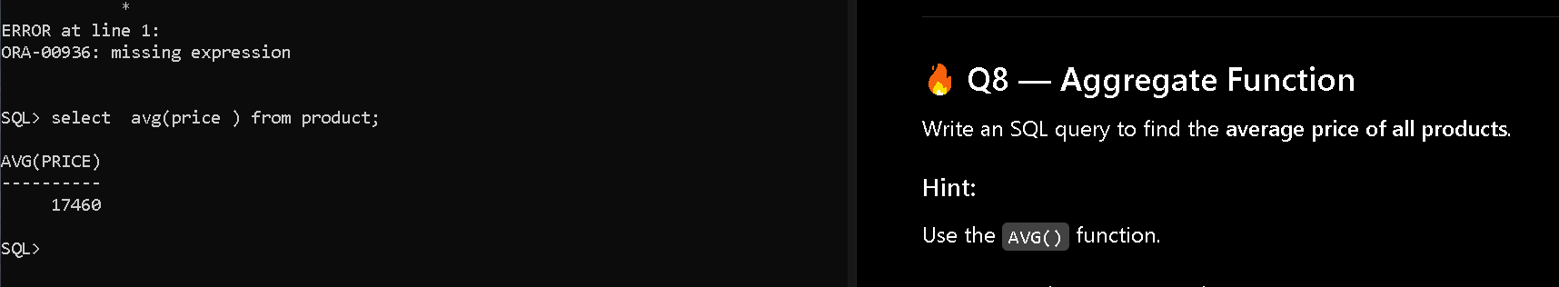
aggragate fn ()
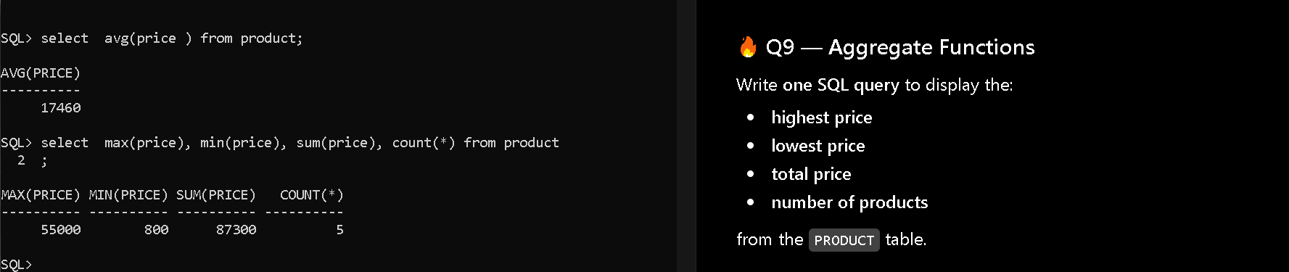
group by
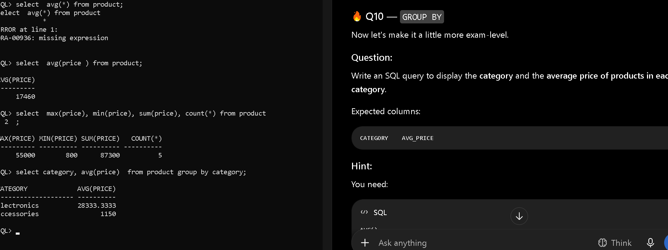
having
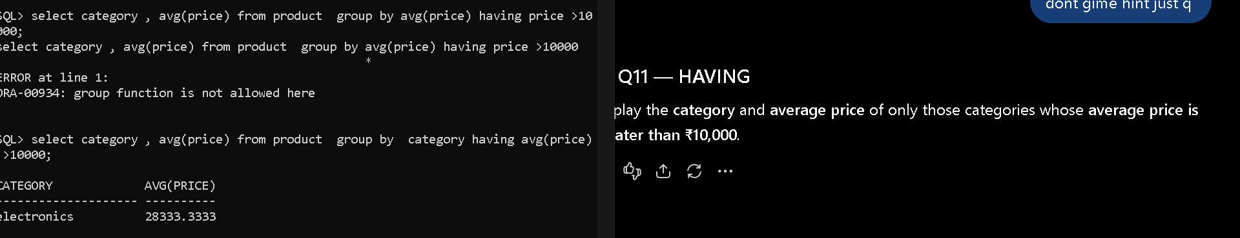

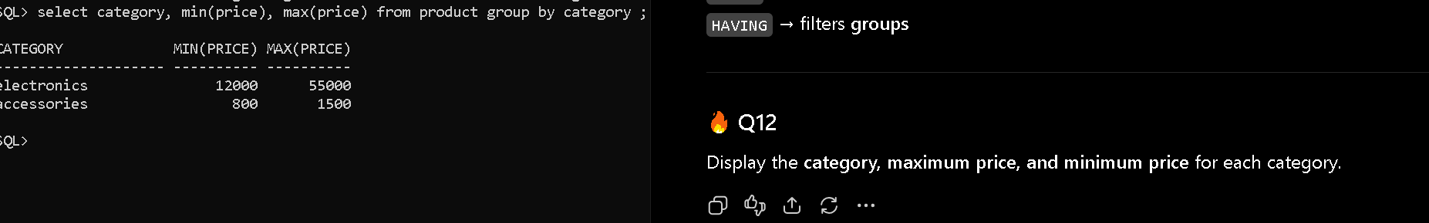
group by
where and order

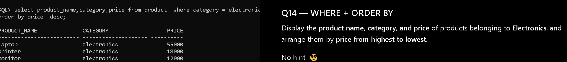
distinct
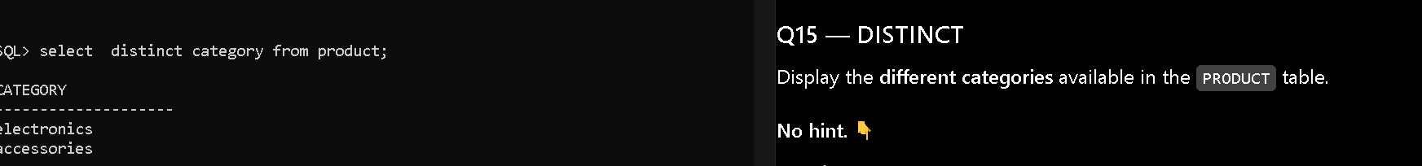
q

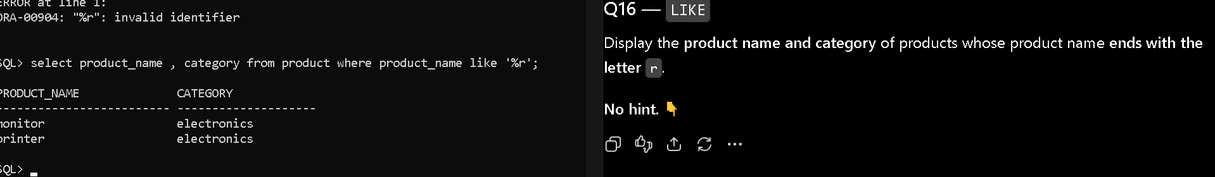
q

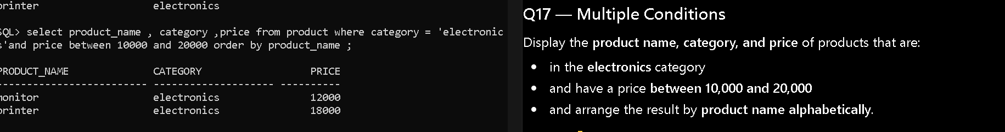
update


