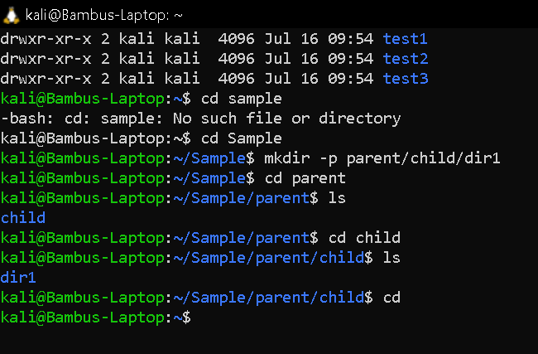kali@Bambus-Laptop:~$ cd "my pictures"
kali@Bambus-Laptop:~/my pictures$ cd
kali@Bambus-Laptop:~$ cd my\pictures
-bash: cd: mypictures: No such file or directory
kali@Bambus-Laptop:~$ cd my\ pictures
kali@Bambus-Laptop:~/my pictures$ man ls

