Digital Image Processing Lab


Name : Pragati Bansal Submitted to :
Section : 3H (2) Mr. Ajay Kumar Mahato
Roll No. : 48
University Roll No. : 2315001609

Contents:
Exp No. | Aim of the Experiment | Date of Performance | Page Number | Remarks
1. | Matrix Information
2. | Matrix Manipulation
3. | Basic Commands(Magic, One, Zeroes Function)
4. | Basic Operation and Extraction of colour bands
5. | Generate a sin wave curve
6. | Gray Transformation
7. | Convert the image into gray scale and binary
8. | Arithmetic operation on image
9. | Import Digital Image and perform logical (AND,OR,NOT)operation.
10. | Negative Image
11. | To select a Digital Image and Perform Basic Intensity "Logarithmic Transformation"
12. | To select a Digital Image and Perform Basic Intensity Transformation "Power Law Transformation"
13. | Contrast stretching

Experiment : 1
Matrix formation
a = [1 2 3; 4 5 6; 7 8 9];
b = [1,2,3; 4,5,6; 7,8,9];
display(b)
c = [1 2 3 4 5 6 7 8 9 10]
d = [1:20]
e = 1:12
i = 1:3:12
f = [1:4; 5:8; 9:12]
g = [1:2:10]
h = [1:2:20; 21:2:40; 41:2:60; 61:2:80; 81:2:100; 101:2:120; 121:2:140; 141:2:160; 161:2:180; 181:2:200]
i= [1:2:10; 11:2:20; 21:2:30; 31:2:40; 41:2:50; 51:2:60; 61:2:70; 71:2:80; 81:2:90]
Output :

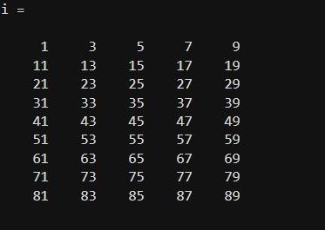

Experiment : 2
Matrix Manipulation
a = [1,2,3,4,5,6,7,8,9,10,11,12];
display(a)
b = [13,14,15,16,17,18,19,20,21,22,23,24];
display(b)
Row concatenation :
c = [a; b];
display(c)
Column concatenation :
d = [a b];
display(d)
Indexing :
a = [1,2,3,4,5,6];
b = a(5);
display(b)
a = [1,2,3,4,5,6];
c = a(2:5);
display(c)
clc;
close all;
clear all;
Randomization :
A = rand(4);
display(A)
B = rand(5,9);
display(B)

Random values (0 to 1) :
c = rand(4,3);
display(c)
Integer Matrix :
d = randi([21,70], 3, 4);
display(d)
Sorting :
A = rand(3);
B = sort(A);
display(A)
C = sort(A, 'descend');
display(C)
Circular Shift :
A = [1:5; 6:10; 11:15; 16:20; 21:25];
display(A)
B = circshift(A, [3,0]);
display(B)
Reshaping :
A = [1,2,3; 4,5,6; 7,8,9; 10,11,12];
display(A)
B = reshape(A, 2, 6);
display(B)

Rotation :
A = [1,2,3; 4,5,6; 7,8,9; 10,11,12];
display(A)
B = rot90(A);
display(B)
C = rot90(B);
display(C)
D = rot90(C);
display(D)
E = rot90(D);
display(E)
Flip Function :
A = [1,2,3; 4,5,6; 7,8,9];
display(A)
B = fliplr(A);
display(B)
C = flipud(A);
display(C)
Integer Matrix :
d = randi([21,70], 3,4);
display('Random Integer Matrix (d):');
display(d);

Output :
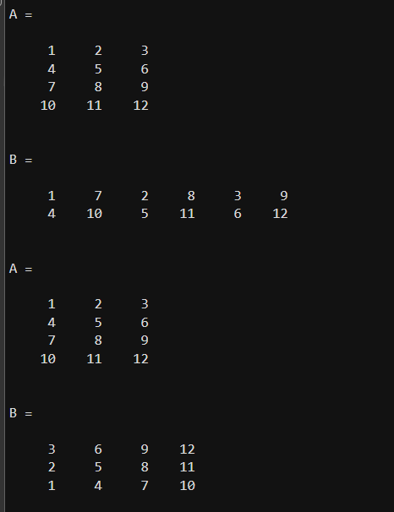
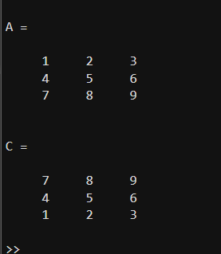
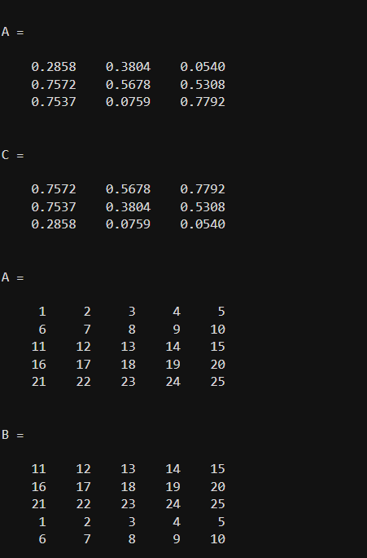
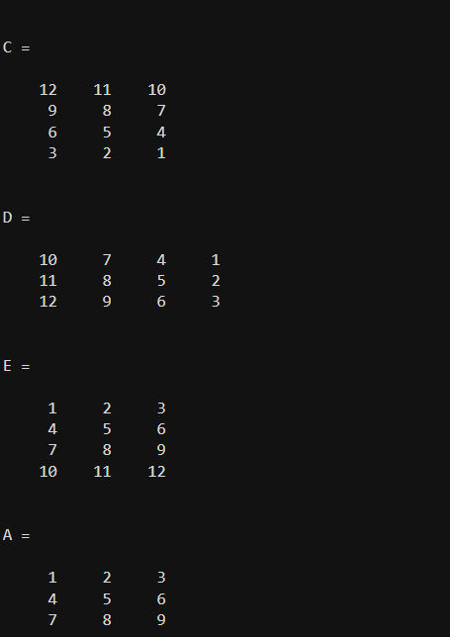

Experiment : 3
Basic Commands(Magic, One, Zeroes Function)
Magic Function :
a = magic(4);
display(a)
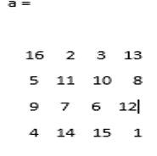
Ones Function :
b = ones(4);
display(b)
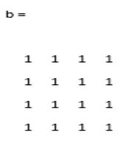

Zeros Function :
c = zeros(4);
display(c)
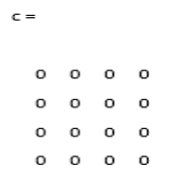
Zeros with dimension :
d = zeros(4,2);
display(d)
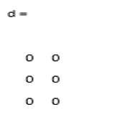

Experiment 4:
Basic Operations
a = [1 2 3; 4 5 6; 7 8 9];
display(a)
b = [10 11 12; 13 14 15; 16 17 18];
display(b)
Addition :
A = a + b;
display(A)
Subtraction :
B = b - a;
display(B)
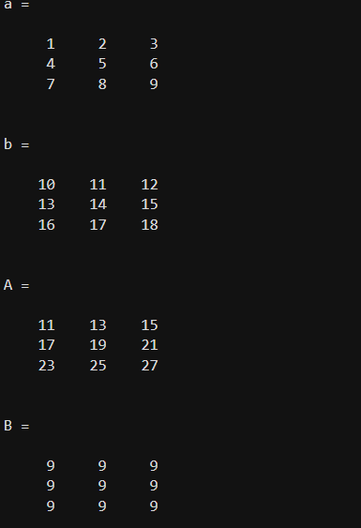

Matrix Multiplication :
C = a * b;
display(C)
Element-wise Division (corrected: was Display with capital D) :
D = a * b;
display(D)
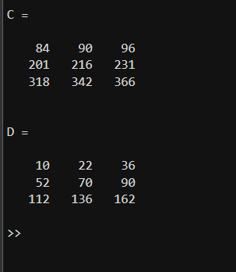

Extraction of Colour Bands :
clc
clear all
close all
A = imread('DIP IMAGE.jpg');
R = A(:,:,1);
G = A(:,:,2);
B = A(:,:,3);
figure()
subplot(221), imshow(A), title('Original Image');
subplot(222), imshow(R), title('Red Band');
subplot(223), imshow(G), title('Green Band');
subplot(224), imshow(B), title('Blue Band')
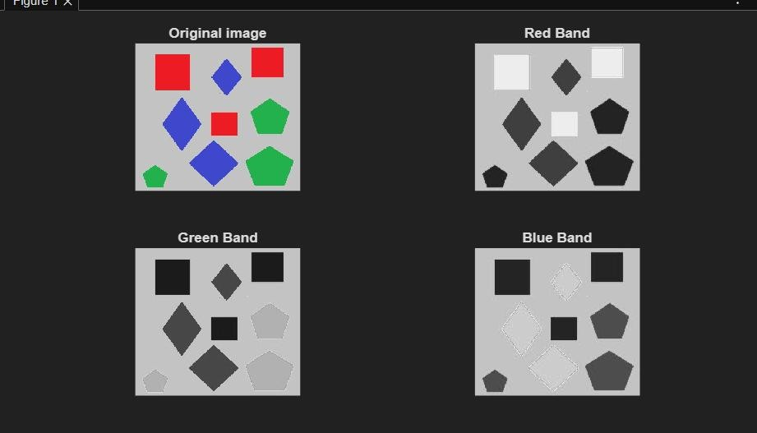
Output :
Experiment : 5
Generate a Sin Wave
clc;
clear all;
close all;
f = 1;
t = 0:0.01:2*pi;
y = sin(2*pi*f*t);
plot(t, y)
xlabel('Time')
ylabel('Amplitude')
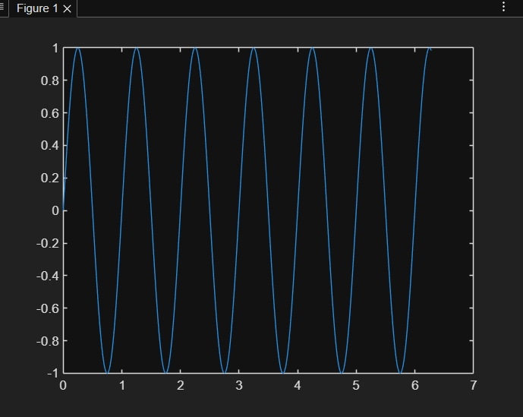
title('Sine Curve')

Stem plot version :
figure()
stem(t, y)
xlabel('Time')
ylabel('Amplitude')
title('Sine Curve - Stem')
Matrix operations :
A = [1 2 3; 4 5 6; 7 8 9];
display(A)
B = [10 11 12; 13 14 15; 16 17 18];
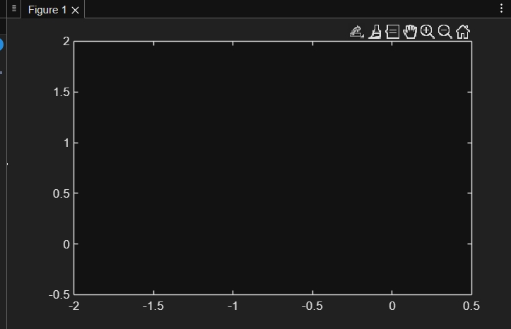
display(B)

C = A + B;
display(C)

D = A - B;
display(D)

E = A * B;
display(E)

F = A .* B;
display(F)
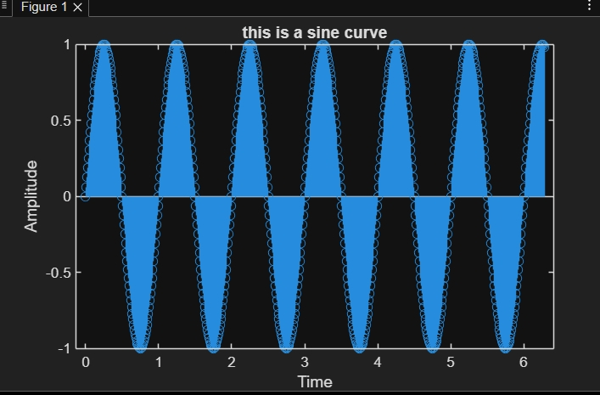
Output :

Experiment : 6
Gray Transformation

clc;
clear all;
close all;

a = imread('cameraman.tif');
b = (a >= 120);

figure();
subplot(1,2,1);
imshow(a);
title('Gray Image');

subplot(1,2,2);
imshow(b);
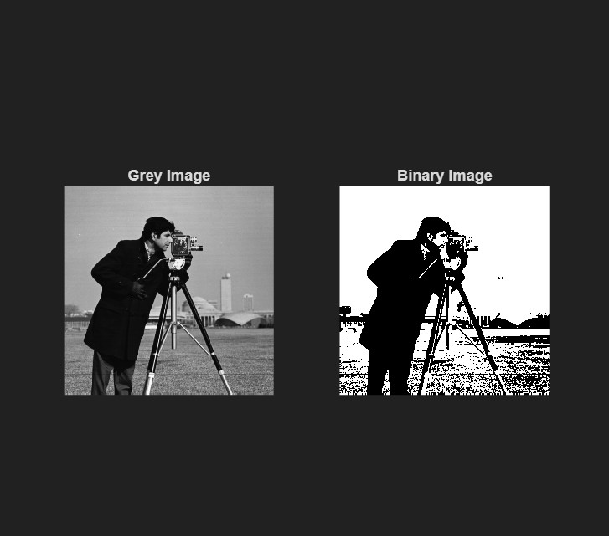
title('Binary Image')
Experiment : 7
Convert the image into gray scale and binary
clc;
clear all;
close all;
Original Image :
a = imread('peppers.png');
subplot(2,2,1);
imshow(a);
title('Original Image');
b = rgb2gray(a);
subplot(2,2,2);
imshow(b);
title('Grayscale Image');
c = imbinarize(b);
subplot(2,2,3);
imshow(c);
title('Binary Image');
d = imadjust(b);
subplot(2,2,4);
imshow(d);
title('Adjusted Image');

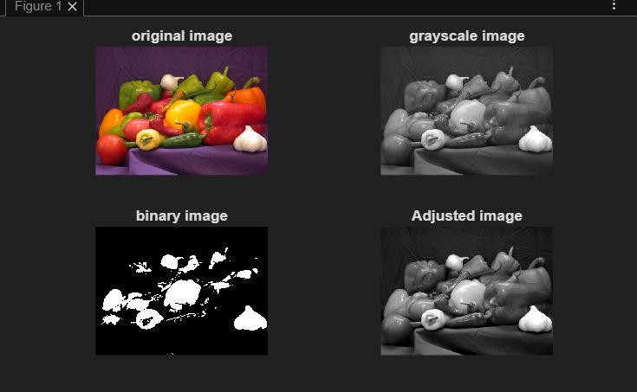
Gray to Binary Image Convesion :
clc;
clear all;
close all;

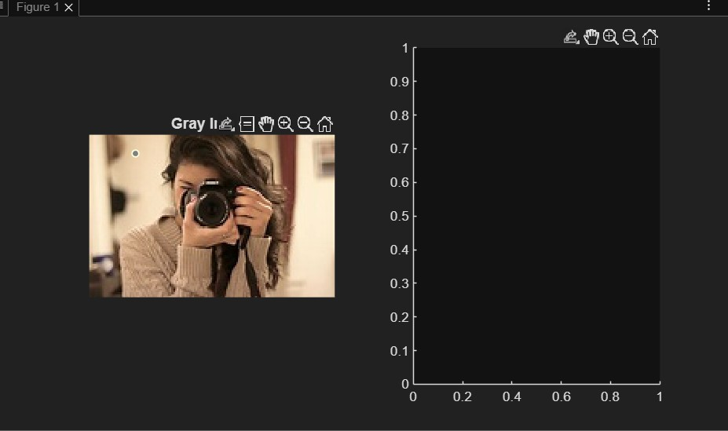
A = imread('cameraman.tif');
B = (A >= 120);

figure;
subplot(1,2,1);
imshow(A);
title('Gray Image');

subplot(1,2,2);
imshow(B);
title('Binary Image');

figure;

B = imresize(A, 0.5);

subplot(1,3,1);
imshow(A);
title('Original Image');

subplot(1,3,2);
imshow(B);
title('Resized (0.5x)');

C = imresize(A, [128 512]);

subplot(1,3,3);
imshow(C);
title('Resized (128x512)');

Output :

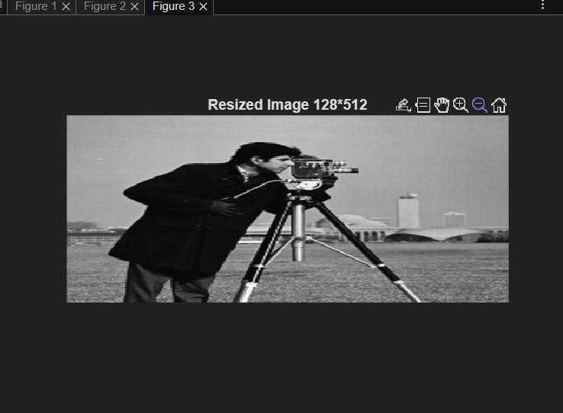
Experiment 8 :
Arithmetic Operations on Images
clc;
clear all;
close all;

A = imread('cameraman.tif');
B = imread('rice.png');

A = im2double(A);
B = im2double(B);

B = imresize(B, [size(A,1), size(A,2)]);

added_img = A + B;
subtracted_img = A - B;
multiplied_img = A .* B;

figure;

subplot(2,3,1);
imshow(A);
title('Image A (Cameraman)');

subplot(2,3,2);
imshow(B);
title('Image B (Rice)');

subplot(2,3,3);
imshow(added_img, []);
title('Added (A + B)');

subplot(2,3,4);
imshow(subtracted_img, []);
title('Subtracted (A - B)');

subplot(2,3,5);
imshow(multiplied_img, []);
title('Multiplied (A * B)');
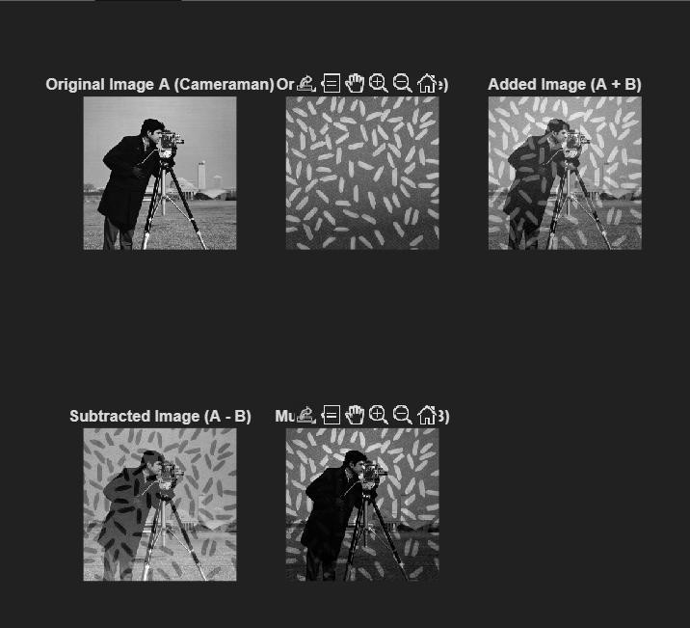
Output :

Experiment : 9
Logical Operations (AND, OR, NOT) and Arithmetic Operations

clc;

clear all;

close all;

A = imread('cameraman.tif');

B = imread('rice.png');

A = imbinarize(A);

B = imbinarize(B);

Logical Operations :

And_img = A & B;

Or_img = A | B;

Not_img = ~A;

Arithmetic Operations :

Add_img = imadd(A, B);

Sub_img = imsubtract(A, B);

subplot(2,3,1);

imshow(A);

title('Original Image A (Cameraman)');

subplot(2,3,2);

imshow(B);

title('Original Image B (Rice)');

subplot(2,3,3);

imshow(Add_img);

title('Arithmetic: A + B');

subplot(2,3,4);

imshow(And_img);

title('Logic: A AND B');

subplot(2,3,5);

imshow(Or_img);

title('Logic: A OR B');

subplot(2,3,6);

imshow(Not_img);

title('Logic: NOT A');

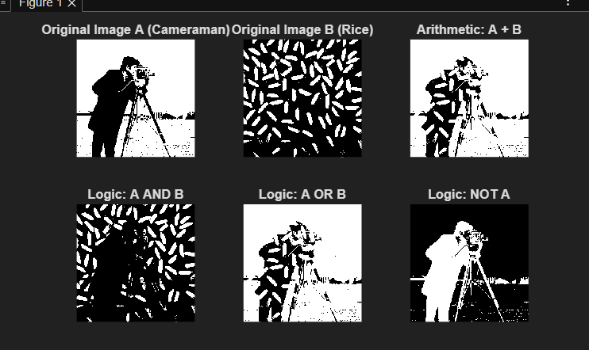
Output :
Experiment : 10
Negative Image

r = imread('cameraman.tif');

subplot(1,2,1);
imshow(r);
title('Original Image');

L = 256; (2^8 for 8-bit image)

neg = (L-1) - r;

subplot(1,2,2);
imshow(neg);
title('Negative Image');

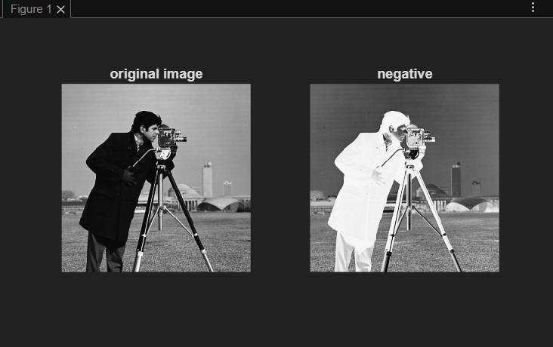
Output :

Experiment : 11
Logarithmic Transformation
clc;
clear all;
close all;
img = imread('cameraman.tif'); % Use this if photographer.jpeg not available
subplot(1,2,1);
imshow(img);
title('Original Image');
r = double(img);
c = 1;
s = c * log(1 + r);
t = 255 / (c * log(1 + 255));
b = uint8(t * s);222222222222222222
subplot(1,2,2);
imshow(b);
title('Log Transformation');
Output :
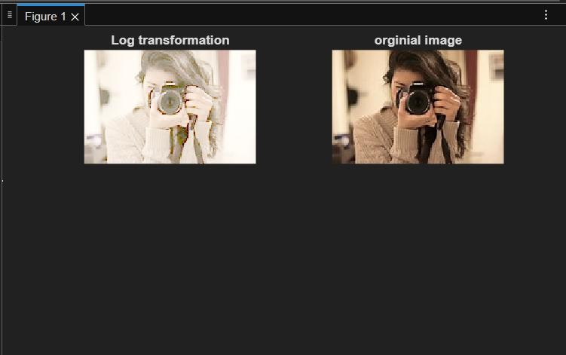

Experiment : 12
Power Law Transformation (Gamma Correction)
clc;
clear all;
close all;

img = imread('cameraman.tif'); % Use this if photographer.jpeg not available
subplot(1,2,1);
imshow(img);
title('Original Image');

r = double(img);
G = 0.6;
C = 1;

S = C * (r .^ G);
T = 255 / (C * (255 ^ G));
O = uint8(T * S);

subplot(1,2,2);
imshow(O);
title('Power Law Transformation');

Output :
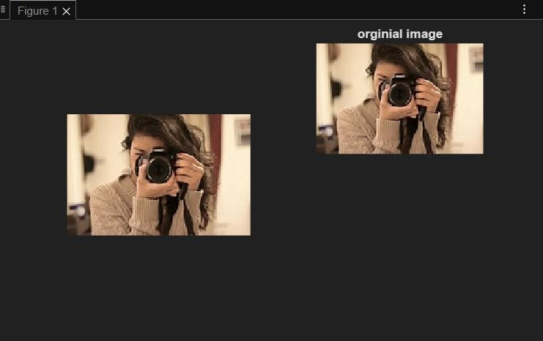

Experiment : 13
Contrast Stretching

clc;
clear all;
close all;

A = imread('cameraman.tif'); % Use cameraman.tif if photographer.jpeg unavailable
A = double(A);

[rmin, rmax] = bounds(A, 'all');

Smin = input('Enter the Smin value: ');
Smax = input('Enter the Smax value: ');

[M, N] = size(A);
B = zeros(M, N);

for i = 1:M
for j = 1:N
B(i,j) = ((Smax - Smin) / (rmax - rmin)) * (A(i,j) - rmin) + Smin;
end
end

B = uint8(B);

figure();
imshow(uint8(A));
title('Original Image');

figure();
imshow(B);
title('Contrast Stretched Image')

Output :
